Multiplying & Dividing Decimals  Quiz KEY | Name:  Date:

- Multiply the following: 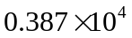 1. __3870____________

- Multiply the following: 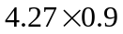 2. ___3.843__________

- Multiply the following: 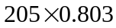 3. ___164.615_________

- Divide the following: 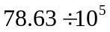 4. ___0.0007863_______

- Divide the following: 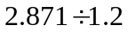 5.___2.3925_________

- Divide the following and round your answer to the tenths place. 6.__4.5_____________

