SUPPLEMENTAL INSTRUCTION ACTIVITY

TOPIC: Logarithms

APPLICABLE COURSES: All math courses starting from Math 070 and other courses in other disciplines.

LEARNING OUTCOME: (What will students be able to do by the end of the workshop?)

After completing this workshop, students should be able to sketch the graph of a logarithmic function, specify its domain and range, evaluate and simplify logarithmic expression.

CONTENT: (What do students need to know to accomplish the outcome?)

- Define a logarithmic function;
- Use the definition of a logarithmic function to evaluate various logarithmic expressions;
- Sketch the graph of a logarithmic function and specify its domain, range and asymptote;
- Utilize the properties of logarithms to simplify logarithmic expressions.

METHOD: (How will the instructor deliver content? Short lecture, handouts, Powerpoint, other audio-visual presentation)

Short lecture followed by active learning exercise and worksheet (45minutes)

- Teach/Practice 1 and 2 (20 minutes)
- Teach/Practice 3 and 4 (25 minutes)

The lesson is divided into segments composed of lecture and examples followed by student practice and sharing.

- First, the instructor distributes the exercise worksheet and any supporting handouts.
- Then the instructor presents segment 1and 2.
- After this brief lecture with examples, students individually think about how they will solve the set of problems for these segments (2 min), and then complete them (5 min).
- Next, in pairs, students each take a turn to explain to their partner how they solved one of the problems (3 min). At the end of this 10-minute segment, the instructor posts the solutions/answers on the screen for students to check their work.
- Follow the same lecture/practice procedure for segments 3 and 4.

Note: If time is short, only one student explains his/her process to the partner for each segment of the lesson, taking turns for each segment.

ACTIVE LEARNING STRATEGIES: (How will students apply their knowledge? Solve a problem, create a project, analyze a case, and explain a process)

Students reflect on the exercises and teach each other by verbalizing the steps they took to reach their conclusions.

ASSESSMENT METHOD: (How will the instructor know that the students met the outcome? Check for understanding. )
(12 minutes.)

Students complete a quiz. After completing the quiz, the instructor posts the solutions/answers on the screen. Students check their results. The instructor can also look over the quizzes while the students are completing the self-reflection activity to give feedback to students.
If students do not successfully complete the worksheet quiz, they may be referred to individual tutoring or a guided learning activity.

SELF-REFLECTION ACTIVITY: (What will the instructor do to get students to reflect on how they learned the content? What they learned, how they learned it, how they will apply it in their coursework)
(3 minutes.)

-Which segment of the logarithmic expressions/functions was most challenging for you?
-What steps are you going to take to learn this subject?

Logarithms  Handout | Name:  Date:

Objective: Logarithmic Expression and Functions

Segment 1: Definition of a Logarithmic Function

The inverse of an exponential function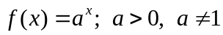 is called the logarithmic function. We write it using “log” notation
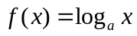

which is read as “log of x to the base a.” Note that the base a of the exponential function becomes the base of the corresponding logarithmic function.
Logarithmic Function Base a
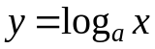 if and only if 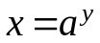
Domain: 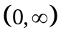 Range: 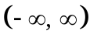

Note! A logarithm is an exponent that the base a is raised to in order to obtain x.

When no base is indicated, the notation logx is interpreted to mean 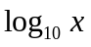 which is also called the common logarithm.

The notation lnx is used to indicate that logarithm to the base e. since lnx is the inverse of the natural exponential function 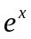, it is called the natural logarithm.

Example-1 Write each logarithmic equation in exponential form.

- 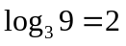

- 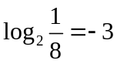

- 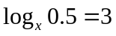

Example-2 Write each exponential equation in logarithmic form.

- 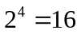

- 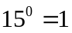
- 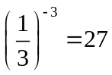

Segment 2: Evaluation of Logarithmic Expressions
Recall that a logarithm is an exponent. For example, if we want to evaluate 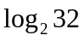, then we need to find the exponent of the base 2 that gives us 32. If we raise 2 to the exponent 5, we obtain 32. Therefore, 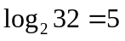

Example-3 Evaluate each logarithmic expression.

- 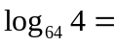
- 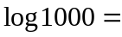

- 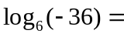

Practice- 1 Write the logarithmic equation in exponential form.

- 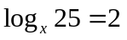

- 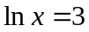

Practice-2 Write the exponential equation in logarithmic form.

- 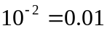

- 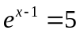
Practice-3 Evaluate each logarithmic expression
a) 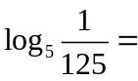
b) 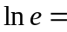

c) 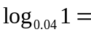

Segment 3: Graphing Logarithmic Functions

While graphing logarithmic functions it is important to remember that the domain of a logarithmic function,
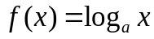, is . Also, in order to obtain integer values for the y-coordinate, you may want to choose values of the x-coordinate which are the perfect powers of the base. For example, if the base of a logarithmic function is 2, then you can let the x be …1/8, 1/4, 1/2, 1, 2, 4, …

Example-4 Graph 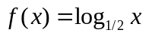. Specify its domain, range, and asymptote.

x | y
1/4 | 2
1/2 | 1
1 | 0
2 | -1
4 | -2

Example-5 Graph 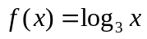. Specify its domain, range , and asymptote.

x | y
1/9 | -2
1/3 | -1
1 | 0
3 | 1
9 | 2

Practice -4 Graph 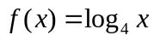. Specify its domain, range, and asymptote.

Practice- 5 Graph 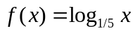. Specify its domain, range, and asymptotes.

Segment 4: Simplifying Logarithmic Expressions Using Properties
Let x and y be positive numbers.
Property 1: 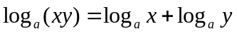
Property 2: 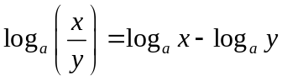
Property 3: 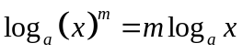

Property 4: 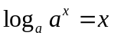

Property 5: 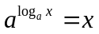

Change of Base Formula
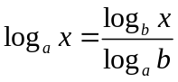

Example 6: Write as a single logarithm with a coefficient 1.
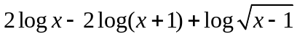=

Practice 6: Write as a single logarithm with a coefficient 1.
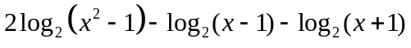=

Practice 7: Write as a single logarithm with a coefficient 1.
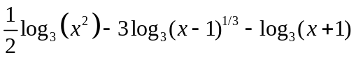

Example-7: Write as a sum and/or difference of logarithms.
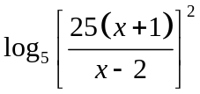

Practice-8: Write as a sum and/or difference of logarithms.

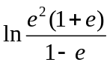

Logarithms  Handout-Answers | Name:  Date:

Objective: Logarithmic Expression and Functions

Segment 1: Definition of a Logarithmic Function

The inverse of an exponential function is called the logarithmic function. We write it using “log” notation

which is read as “log of x to the base a.” Note that the base a of the exponential function becomes the base of the corresponding logarithmic function.
Logarithmic Function Base a
if and only if
Domain: Range:

Note! A logarithm is an exponent that the base a is raised to in order to obtain x.

When no base is indicated, the notation logx is interpreted to mean which is also called the common logarithm.

The notation lnx is used to indicate that logarithm to the base e. since lnx is the inverse of the natural exponential function , it is called the natural logarithm.

Example-1 Write each logarithmic equation in exponential form.

- Answer: 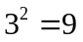
- Answer: 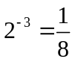
- Answer: 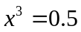

Example-2 Write each exponential equation in logarithmic form.

- Answer: 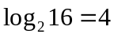
- Answer: 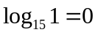
- Answer: 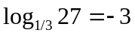
Segment 2: Evaluation of Logarithmic Expressions
Recall that a logarithm is an exponent. For example, if we want to evaluate , then we need to find the exponent of the base 2 that gives us 32. If we raise 2 to the exponent 5, we obtain 32. Therefore,

Example-3 Evaluate each logarithmic expression.
- 1/3
- 3
- not defined

Practice- 1 Write the logarithmic equation in exponential form.
- Answer: 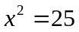
- Answer: 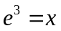

Practice-2 Write the exponential equation in logarithmic form.
- Answer: 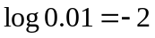
- Answer: 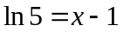

Practice-3 Evaluate each logarithmic expression
a) -3
b) 1
c) 0

Segment 3: Graphing Logarithmic Functions
While graphing logarithmic functions it is important to remember that the domain of a logarithmic function,
, is . Also, in order to obtain integer values for the y-coordinate, you may want to choose values of the x-coordinate which are the perfect powers of the base. For example, if the base of a logarithmic function is 2, then you can let the x be …1/8, 1/4, 1/2, 1, 2, 4, …

Example-4 Graph . Specify its domain, range, and asymptote.
x | y
1/4 | 2
1/2 | 1
1 | 0
2 | -1
4 | -2

Example-5 Graph . Specify its domain, range , and asymptote.
x | y
1/9 | -2
1/3 | -1
1 | 0
3 | 1
9 | 2

Practice -4 Graph . Specify its domain, range, and asymptote.

Practice- 5 Graph . Specify its domain, range, and asymptotes.

Segment 4: Simplifying Logarithmic Expressions Using Properties

Let x and y be positive numbers.
Property 1:
Property 2:
Property 3:

Property 4:

Property 5:

Change of Base Formula

Example 6: Write as a single logarithm with a coefficient 1.
= Answer: 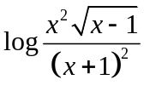
Practice 6: Write as a single logarithm with a coefficient 1.
= Answer: 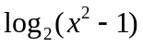
Practice 7: Write as a single logarithm with a coefficient 1.
Answer: 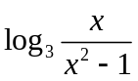
Example-7: Write as a sum and/or difference of logarithms.
Answer: 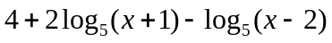
Practice-8: Write as a sum and/or difference of logarithms.
Answer: 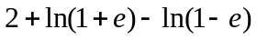

Logarithms  Quiz | Name:  Date:

- Write the exponential equation in logarithmic form.
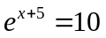

- Write the logarithmic equation in exponential form.
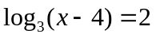

- Graph the function. Specify its domain, range, and asymptote.

- Write as a single logarithm.
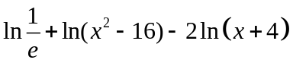

- Write as a sum and/or difference of logarithms.
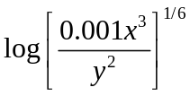

SELF-REFLECTION:
Which segment of the logarithms was most challenging for you?

What steps are you going to take to learn this subject?

Logarithms  Quiz-Answer | Name:  Date:

- Write the exponential equation in logarithmic form.
Answer: 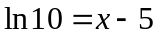

- Write the logarithmic equation in exponential form.

Answer: 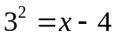

- Graph the function. Specify its domain, range, and asymptote.

- Write as a single logarithm.
Answer: 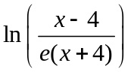

- Write as a sum and/or difference of logarithms.
Answer: 