SUPPLEMENTAL INSTRUCTION ACTIVITY

TOPIC: Order of Operations

APPLICABLE COURSES: All math courses and other courses in other divisions.

LEARNING OUTCOME: (What will students be able to do by the end of the workshop?)
- Students will study how to follow the order of operations to evaluate expressions accurately.

CONTENT: (What do students need to know to accomplish the outcome?)
1. Explain the order of operations agreement (can be explained in 4 steps) (5 min)
Step 1: Perform operations inside grouping symbols: (),{},[],absolute value, fraction bar
Step 2: Simplify exponents
Step 3: Do multiplication and division as they occur from left to right
Step 4: Do addition and subtraction as they occur from left to right

- Practice evaluating exponential expressions such as 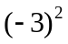and 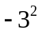 (5 min)
- Practice evaluating absolute value expressions such as 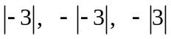 (5 min)
- Practice evaluating expressions with one grouping symbol such as
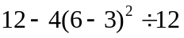 and 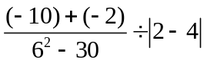 (10min)
- Practice evaluating expressions with grouping symbols inside grouping symbols and with fractions.
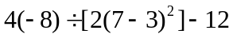 and 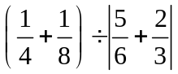 (10min)

METHOD: (How will the instructor deliver content? Short lecture, handouts, Powerpoint, other audio-visual presentation)

The lesson is divided into segments composed of lecture and examples followed by student practice and sharing.

First, the instructor distributes the exercise worksheet and any supporting handouts.

Then the instructor presents segments 1 (Order of operations agreement) with brief lecture with examples (5min). Next students individually think about how they will evaluate simple exponential and absolute value expressions for segments 2 and 3 (2 min) and then complete them (5 min). Next, in pairs, students each take a turn to explain to their partner how they solved one of the problems (3 min). At the end of this 10 minute segment, the instructor posts the solutions/answers on the screen for students to check their work.

Follow the same lecture/practice procedure for segment 4 (evaluating expressions with one grouping symbol) and segment 5 (evaluating expressions with grouping symbols inside grouping symbols and with fractions).

Note: If time is short, only one student explains his/her process to the partner for each segment of the lesson, taking turns for each segment.

Next students complete a quiz where they are asked to perform After completing the quiz, the instructor posts the solutions/answers on the screen. Students check their results.

Then they complete the self-reflection activity. The instructor can also look over the quizzes while the students are completing the self-reflection activity to give feedback to students.

ACTIVE LEARNING STRATEGIES: (How will students apply their knowledge? Solve a problem, create a project, analyze a case, explain a process)

Students reflect on the exercises and teach each other by verbalizing the steps they took to reach their conclusions.

ASSESSMENT METHOD: (How will the instructor know that the students met the outcome? Check for understanding. )
(10 minutes.)
Students complete a quiz where they are asked to perform order of operations. After completing the quiz, the instructor posts the solutions/answers on the screen. Students check their results. The instructor can also look over the quizzes while the students are completing the self-reflection activity to give feedback to students.
If students do not successfully complete the worksheet quiz, they may be referred to individual tutoring or a guided learning activity.

SELF-REFLECTION ACTIVITY: (What will the instructor do to get students to reflect on how they learned the content? What they learned, how they learned it, how they will apply it in their coursework)
(5 - 10 minutes.)

-Which segment of the order of operations was most challenging for you?

-What steps are you going to take to learn this subject?

Order of Operations  Handout | Name_________________________  Date__________________________

Objective: To practice using order of operations to simplify expressions
Segment 1:
To evaluate expressions consistently, we follow the accepted order of operations. We agree to do the operations in this order:
The Order of Operations Agreement
Step 1: Perform operations inside grouping symbols: (),{},[],absolute value, fraction bar
Step 2: Simplify exponents
Step 3: Do multiplication and division as they occur from left to right
Step 4: Do addition and subtraction as they occur from left to right

Practice: Fill in the operation that begins with each letter.
P____________________ E____________________ M____________________

D____________________ A____________________ S _____________________

Note: “Please Excuse My Dear Aunt Sally” is one phrase people use to remember the order of operations.

Practice: Fill in the blanks and answer the question.

According to the ____________ of _______________ , which phrase describes 3 × 4 + 5?

- 5 more than 3 times 4 (b) 3 times the sum of 4 and 5

Segment 2: Evaluate exponential expressions.
- 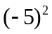 (b) 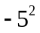 (c)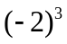 (d) 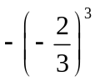

Segment 3: Evaluate absolute value expressions.

- 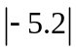 (b) 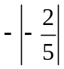 (c)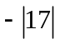 (d) 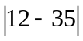

Segment 4: Evaluating expressions with one grouping symbol.

Practice: Simplify.
- (b)

Segment 5: Evaluating expressions with grouping symbols inside grouping symbols and with fractions.

Note: Perform operations inside the innermost grouping symbol first.

Practice: Simplify.
- (b) 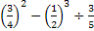

SELF-REFLECTION ACTIVITY

- Which segment of the order of operations was most challenging for you?

- What steps are you going to take to learn this subject?

Order of Operations  Handout | Name_________________________  Date__________________________

Objective: To practice using order of operations to simplify expressions
Segment 1:
To evaluate expressions consistently, we follow the accepted order of operations. We agree to do the operations in this order:
The Order of Operations Agreement
Step 1: Perform operations inside grouping symbols: (),{},[],absolute value, fraction bar
Step 2: Simplify exponents
Step 3: Do multiplication and division as they occur from left to right
Step 4: Do addition and subtraction as they occur from left to right

Practice: Fill in the operation that begins with each letter.
Parentheses Exponents Multiplication

Division Addition Subtraction

Note: “Please Excuse My Dear Aunt Sally” is one phrase people use to remember the order of operations.

Practice: Fill in the blanks and answer the question.

According to the order of operation, which phrase describes 3 × 4 + 5? Ans: (a)

- 5 more than 3 times 4 (b) 3 times the sum of 4 and 5

Segment 2: Evaluate exponential expressions.
- (b) (c) (d)

Ans: 25 Ans: -25 Ans: -8 Ans:

Segment 3: Evaluate absolute value expressions.

- (b) (c) (d)

Ans: 5.2 Ans: Ans: -17 Ans: 23

Segment 4: Evaluating expressions with one grouping symbol.

Practice: Simplify.
- (b)

Ans: -6 Ans: 13

Segment 5: Evaluating expressions with grouping symbols inside grouping symbols and with fractions.

Note: Perform operations inside the innermost grouping symbol first.

Practice: Simplify.
- (b)

Ans: -1 Ans:

Worksheet Quiz for Order of Operations
Simplify:
- 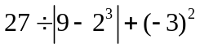 ________________

- 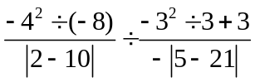 ________________

- 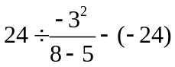 ________________

- 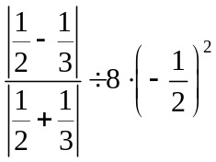 ________________

- 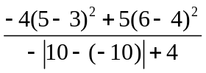 ________________

Worksheet Quiz for Order of Operations
Simplify:
- Answer: 36

- Answer: Undefined

- Answer : 16

- Answer: 1/160

- Answer: 1/4

