SUPPLEMENTAL INSTRUCTION ACTIVITY

TOPIC: Division of Polynomials by Polynomials

APPLICABLE COURSES: All math courses starting from Math 060 and other courses in other disciplines.

LEARNING OUTCOME: (What will students be able to do by the end of the workshop?)
After completing this workshop, students should be able use long division to divide polynomials by polynomials.

CONTENT: (What do students need to know to accomplish the outcome?)

- Apply the “long division algorithm” of integers to the division of polynomials
- Utilize the Quotient and Product Properties of exponents

METHOD: (How will the instructor deliver content? Short lecture, handouts, Powerpoint, other audio-visual presentation)
Short lecture followed by active learning exercise and worksheet (40 minutes)

- Teach 1 and 2 (15 minutes)
- Practice 1 and 2 (15 minutes)

The lesson is divided into segments composed of lecture and examples followed by student practice and sharing.
- First, the instructor distributes the exercise worksheet and any supporting handouts.
- Then the instructor presents segment 1and 2.
- After this brief lecture with examples, students individually think about how they will solve the set of problems for these segments (2 min), and then complete them (10 min).
- Next, in pairs, students each take a turn to explain to their partner how they solved one of the problems (3 min). At the end of this 10-minute segment, the instructor posts the solutions/answers on the screen for students to check their work.

Note: If time is short, only one student explains his/her process to the partner for each segment of the lesson, taking turns for each segment.

ACTIVE LEARNING STRATEGIES: (How will students apply their knowledge? Solve a problem, create a project, analyze a case, and explain a process)

Students reflect on the exercises and teach each other by verbalizing the steps they took to reach their conclusions.

ASSESSMENT METHOD: (How will the instructor know that the students met the outcome? Check for understanding. )
(20 minutes.)

Students complete a quiz where they are asked to different polynomial long division problems. After completing the quiz, the instructor posts the solutions/answers on the screen. Students check their results. The instructor can also look over the quizzes while the students are completing the self-reflection activity to give feedback to students.
If students do not successfully complete the worksheet quiz, they may be referred to individual tutoring or a guided learning activity.

SELF-REFLECTION ACTIVITY: (What will the instructor do to get students to reflect on how they learned the content? What they learned, how they learned it, how they will apply it in their coursework)
(5 minutes.)

-Which segment of the long division of polynomials was most challenging for you?
-What steps are you going to take to learn this subject?

Long Division of Polynomials  Handout | Name:  Date:

Objective: Long Division of Polynomials

Segment 1: Using the Long Division Algorithm to Divide Integers

Example-1 Divide 6586 by 28. Write the answer in 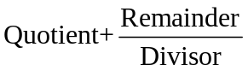form.

Segment 2: We can divide polynomials by polynomials by factoring and dividing out common factors. For those polynomials, however, do not factor easily, we can use a more general procedure that follows a “long division algorithm” similar to the algorithm used for dividing integers.

Steps that can be used when dividing polynomials

- Write the dividend and divisor in descending powers of the variable.

- Insert placeholders with zero coefficients for missing powers of the variable.

- Divide the first term in the dividend by the first term in the divisor. The result will be the first term in the quotient.

- Multiply every term in the divisor by the first term in the quotient. Write the resulting product beneath the dividend with similar terms under each other.

- Subtract the product from the dividend.

- Bring down the next term in the original dividend and write it next to the remainder to form a new dividend.

- Use the new expression as the dividend and repeat this process until the remainder can no longer be divided. That is, the degree of the remainder is less than that of the divisor.

Example-2 Divide 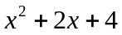by 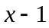

Example -3 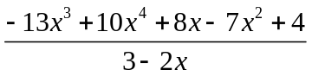

Example -4 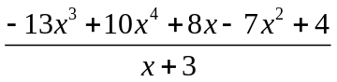

Practice- 1 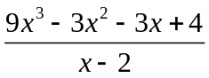

Practice-2 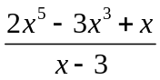

Practice 3 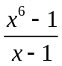

Practice 4 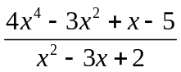

Long Division of Polynomials  Handout-Answers | Name:  Date:

Objective: Long Division of Polynomials

Segment 1: Using the Long Division Algorithm to Divide Integers

Example-1 Divide 6586 by 28. Write the answer in form.

Segment 2: We can divide polynomials by polynomials by factoring and dividing out common factors. For those polynomials, however, that do not factor easily, we can use a more general procedure that follows a “long division algorithm” similar to the algorithm used for dividing integers.
Steps that can be used when dividing polynomials

- Write the dividend and divisor in descending powers of the variable.

- Insert placeholders with zero coefficients for missing powers of the variable.

- Divide the first term in the dividend by the first term in the divisor. The result will be the first term in the quotient.

- Multiply every term in the divisor by the first term in the quotient. Write the resulting product beneath the dividend with similar terms under each other.

- Subtract the product from the dividend.

- Bring down the next term in the original dividend and write it next to the remainder to form a new dividend.

- Use the new expression as the dividend and repeat this process until the remainder can no longer be divided. That is, the degree of the remainder is less than that of the divisor.

Example-2 Divide by Answer: 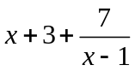

Example -3 Answer: 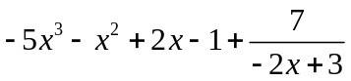

Example -4 Answer: 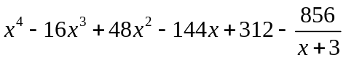

Practice- 1 Answer: 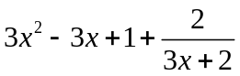

Practice-2 Answer: 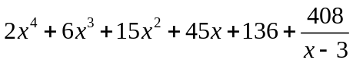

Practice 3 Answer: 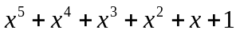

Practice 4 Answer: 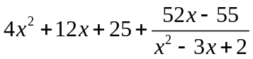

Long Division of Polynomials  Quiz | Name:  Date:

- 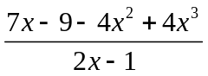

- 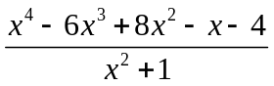

- 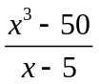

SELF-REFLECTION:

Which segment of the long division of polynomials was most challenging for you?

What steps are you going to take to learn this subject?

Long Division of Polynomials  Quiz-Answers | Name:  Date:

- Answer: 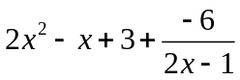

- Answer: 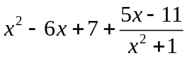

- Answer: 