SUPPLEMENTAL INSTRUCTION ACTIVITY

TOPIC: Scientific Notation

APPLICABLE COURSES: All math courses starting from Math 058/059and other courses in other disciplines

LEARNING OUTCOME: (What will students be able to do by the end of the workshop?)
After completing this workshop, students should be able to convert standard decimal notation to scientific notation, convert scientific notation to standard decimal notation, and use the properties of exponents to perform operations with scientific notation.

CONTENT: (What do students need to know to accomplish the outcome?)

- Definition of Scientific Notation
- Conversions between Standard Decimal and Scientific Notations
- Properties of Exponents to Perform Operations with Scientific Notation

METHOD: (How will the instructor deliver content? Short lecture, handouts, Powerpoint, other audio-visual presentation)
Short lecture followed by active learning exercise and worksheet (40 minutes)

- Teach 1 and 2 (10 minutes)
Practice 1 and 2 (10 minutes)
- Teach 3 (10 minutes)
Practice 3 (10 minutes)

- The lesson is divided into segments composed of lecture and examples followed by student practice and sharing.
- First, the instructor distributes the exercise worksheet and any supporting handouts.
- Then the instructor presents segments 1 and 2 (Definition of Scientific Notation and Conversions between Standard Decimal and Scientific Notations).
- After this brief lecture with examples, students individually think about how they will solve the set of problems for these segments (2 min), and then complete them (5 min).
- Next, in pairs, students each take a turn to explain to their partner how they solved one of the problems (3 min). At the end of this 10-minute segment, the instructor posts the solutions/answers on the screen for students to check their work.
- Follow the same lecture/practice procedure for segments 3 (Using the Properties of Exponents to Perform Operations with Scientific Notation).

Note: If time is short, only one student explains his/her process to the partner for each segment of the lesson, taking turns for each segment.

ACTIVE LEARNING STRATEGIES: (How will students apply their knowledge? Solve a problem, create a project, analyze a case, and explain a process)

Students reflect on the exercises and teach each other by verbalizing the steps they took to reach their conclusions.

ASSESSMENT METHOD: (How will the instructor know that the students met the outcome? Check for understanding. )
(15 minutes.)

Students complete a quiz where they are asked to work various problems involving scientific notation. After completing the quiz, the instructor posts the solutions/answers on the screen. Students check their results. The instructor can also look over the quizzes while the students are completing the self-reflection activity to give feedback to students.
If students do not successfully complete the worksheet quiz, they may be referred to individual tutoring or a guided learning activity.

SELF-REFLECTION ACTIVITY: (What will the instructor do to get students to reflect on how they learned the content? What they learned, how they learned it, how they will apply it in their coursework)
(5 minutes.)

-Which segment of scientific notation was most challenging for you?
-What steps are you going to take to learn this subject?

Scientific Notation  Handout | Name:  Date:
Objective:
- Conversion between Standard Decimal and Scientific notation
- Using the Properties of Exponents to Perform Operations with Scientific Notation

Segment 1: we use two types of notation to write numbers: decimal notation and scientific notation.

Definition

A number in scientific notation is written using the times symbol in the form
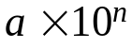
where 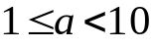 and n is an integer.

Segment 2: Converting Scientific Notation to Standard Decimal Notation
- Determine the number of places to move the decimal point by examining the exponent on the 10.
- Move to the right for a positive exponent and to the left for a negative exponent.

Example 1 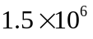=
Example 2 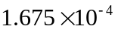 =

Converting Standard Decimal Notation to Scientific Notation
- Count the number of places (n) that the decimal must be moved so that it will follow the first nonzero digit of the number.
- If the original number was larger than 10, use 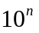.
- If the original number was smaller than 1, use 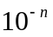.

Example 3 980,000,000 =
Example 4 0.0000000000753 kg =
Practice 1 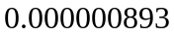=
Practice 2 89,000,000,000 =
Practice 3 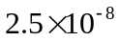=
Practice 4 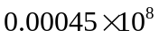 =

Segment 3: Using the Properties of Exponents to Perform Operations with Scientific Notation

The Properties of Exponents make it relatively straightforward to perform operations with numbers written in scientific notation.
Perform the indicated operations. Express your answer in scientific notation.
Example 5 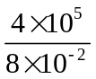 =
Example 6 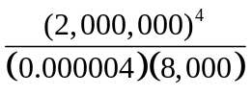=

Example 7 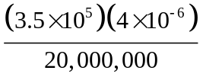 =

Practice 5 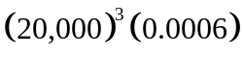 =

Practice 6 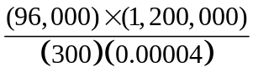 =

Scientific Notation  Handout-Answers | Name:  Date:
Objective:
- Conversion between Standard Decimal and Scientific notation
- Using the Properties of Exponents to Perform Operations with Scientific Notation

Segment 1: we use two types of notation to write numbers: decimal notation and scientific notation.

Definition

A number in scientific notation is written using the times symbol in the form
where and n is an integer.

Segment 2: Converting Scientific Notation to Standard Decimal Notation
- Determine the number of places to move the decimal point by examining the exponent on the 10.
- Move to the right for a positive exponent and to the left for a negative exponent.

Example 1 = 150,0000
Example 2 = 0. 0001675
Converting Standard Decimal Notation to Scientific Notation
- Count the number of places (n) that the decimal must be moved so that it will follow the first nonzero digit of the number.
- If the original number was larger than 10, use .
- If the original number was smaller than 1, use .

Example 3 980,000,000 = 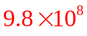
Example 4 0.0000000000753 kg =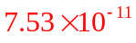
Practice 1 =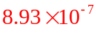
Practice 2 89,000,000,000 = 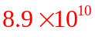
Practice 3 = 0.000000025
Practice 4 = 45000

Segment 3: Using the Properties of Exponents to Perform Operations with Scientific Notation

The Properties of Exponents make it relatively straightforward to perform operations with numbers written in scientific notation.
Perform the indicated operations. Express your answer in scientific notation.
Example 5 = 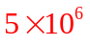
Example 6 = 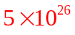

Example 7 = 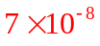

Practice 5 = 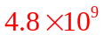

Practice 6 = 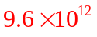

Scientific Notation  Quiz | Name_________________________  Date__________________________

Write each number in standard decimal notation without the use of exponents.
- 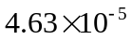 =
- 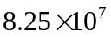 =

Write each number in scientific notation.

- 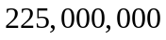 =

- 0.0000000000125 =

Perform the indicated operations. Write the answer in scientific notation.

- 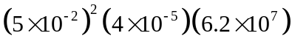=

- 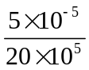=

- 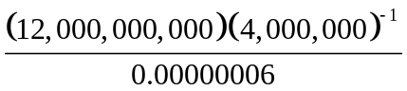 =

- 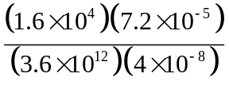 =

SELF-REFLECTION ACTIVITY

- Which segment of Scientific Notations was the most challenging for you?

- What steps are you going to take to learn this subject?

Scientific Notation  Quiz-Answers | Name_________________________  Date__________________________

Write each number in standard decimal notation without the use of exponents.
- = 0.0000463

- = 82,500,000

Write each number in scientific notation.

- = 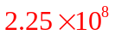

- 0.0000000000125 = 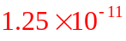

Perform the indicated operations. Write the answer in scientific notation.

- = 

  