Worksheet Quiz for Order of Operations
Simplify:
- 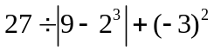 ________________
Answer: 36

- 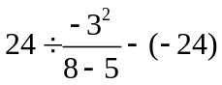 ________________
Answer : 16

- 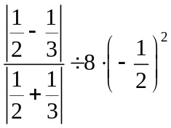 ________________
Answer: 1/160

- 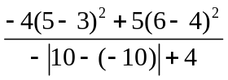 ________________

Answer: - 1/4

