SUPPLEMENTAL INSTRUCTION ACTIVITY
TOPIC: Online Research
APPLICABLE COURSES: All courses requiring research
LEARNING OUTCOMES: (What will students be able to do by the end of the workshop?)
- Define the purpose and parameters of the research
- Locate and recognize appropriate websites/databases for specific research assignments
- Define key concepts related to online research
- Plan an online search strategy appropriate to a specific research assignment
CONTENT: (What do students need to know to accomplish the outcome?)
- Content of the Library web page and Online Databases page
- Basic search terms and vocabulary
- How to define an information need (level of information, scope of information, how to focus topic)
- The basic steps for planning an online search strategy (define information need, use library web page to identify appropriate databases, start research, focus and refine topic, if necessary)
METHOD: (How will the instructor deliver content? Short lecture, handouts, Powerpoint, other audio-visual presentation)
- Short lecture and online demonstration of research sites.
- Handouts
- Group projects with report-out to the entire group
ACTIVE LEARNING STRATEGIES: (How will students apply their knowledge? Solve a problem, create a project, analyze a case, explain a process)
- Students will work in small groups to analyze a database, assess its ease of use and projects for which it might be appropriate. Each group will be assigned one of four topics. They will report their findings to the entire class at the end of the session.
ASSESSMENT METHOD: (How will the instructor know that the students met the outcome? Check for understanding. )
- The instructor will listen to and evaluate the group reports at the end of the session and ask appropriate follow-up questions.
SELF-REFLECTION ACTIVITY: (What will the instructor do to get students to reflect on how they learned the content? What they learned, how they learned it, how they will apply it in their coursework)
The instructor will ask students to list one class for which they must research; identify a database that would help with research for that class; and explain how it would help.
Online Research — Library Databases
This handout lists and describes some key online databases available to you through the COC library. If you have any questions, ask your workshop instructor, or call the library during open hours at 661-362-3362, or 661-362-3358.
- ProQuest Direct** (contains citations, abstracts and in many cases full-text articles and graphics from more than 10,000 magazines, journals and newspapers). You can find information on almost any topic in magazine and journal articles. This database will be helpful for most research projects.
- Biography Resource Center** (features biographical information on more than 165,000 individuals, covering broad historical periods and subject areas)
- Contemporary Authors** (provides complete biographical and bibliographical information and references on more than 120,000 U.S. and international authors)
- CountryWatch** (contains up-to-date economic, political and social data about every country on the globe)
- CQ Researcher** (the online version of the highly-respected current-events resource on topics ranging from social and teen issues to education, environment, and science)
- Daily Life Through History** (a comprehensive, cross-disciplinary resource that supports history, social studies, English, and language students; gives life to history and context to current events)
- Encyclopedia Britannica** (the famed encyclopedia with additional full-length articles on many topics and links to relevant websites)
- Issues & Controversies** (includes articles, editorials, historical documents, graphics and statistics on controversial issues; covers over 250 topics)
- LearningExpress Library** (offers information, practice tests, skills improvement, etc. for college preparation, GED, job search, U.S. citizenship)
- NetLibrary** (COC's collection of electronic books, eBooks, from NetLibrary; currently 5834 titles)
- Scribner Writers Series** (includes fifteen- to twenty-page signed essays on more than 1,600 authors and literary genres drawn from thirteen Scribner print series)
- Twayne's Authors Series** (contains full-text of 200 Twayne’s Literary Masters books on individual World, U.S. or English authors, for a total of 600 full-text titles)
These databases are accessible free of charge from any networked computers on campus.
Most databases allow the user to print, email, or save to a flash drive articles and information found during a database search.
**Databases with asterisks (**) are also accessible from off-campus by students, faculty and staff of College of the Canyons but require passwords. Contact the reference desk at 661-362-3358 or 661-362-3362 for off-campus access to these databases.
Online Research — Key Vocabulary and Terms
- Subject—a broad or expansive area of interest, such as biology, education, sports, etc. A subject is usually too broad to be an appropriate focus for a research paper.
- Topic—a focused area of interest. A good research topic may involve answering a specific question that the researcher has (which may be written as a thesis statement). Example: Subject—Biology; Topic: The effect of global warming on the arctic biosphere.
- Search Engine—a website designed to gather and report information available on the Internet.
- Googling—Using the Google search engine to obtain information about something on the World Wide Web.
- Wikipedia—a Web site featuring “encyclopedia” articles submitted and edited by its readers.
- Database—a collection of data arranged for ease and speed of search and retrieval.
- Key Word—a significant or descriptive word. A word used as a reference point for finding other words or information. Example: keywords related to the topic “global warming” might be a) ozone, b) polar ice-cap, c) climate change.
- Controlled Vocabulary—a carefully selected list of words and phrases, which are used to tag units of information in a document or web page so that they may be more easily retrieved by a search. Examples: subject headings in a library catalog or online database such as ProQuest.
Online Research — Worksheet / Group Activity
Each pair or small group will be assigned one of the following topics to research.
LIST OF TOPICS FOR THIS ACTIVITY
Topic A: Global Warming (search for statistics concerning global warming in the United States)
Topic B: Legalizing Marijuana: the debate (find an essay that presents both sides of the argument)
Topic C: Student Right to Free Speech (search for relevant journal articles and identify one U.S. Supreme Court case that deals with this topic)
Topic D: Women in Shakespeare (find relevant journal articles)

STEPS FOR EACH SMALL GROUP TO COMPLETE THE ACTIVITY
STEP 1: Brainstorm key words to use in your search.
STEP 2: Determine which COC Library database/s are appropriate for this research topic and explain why.
STEP 3: For topic A: Search the database and find at least two relevant statistical charts or graphs. Print them out or list the exact source for the information found.
For topic B: Search the database and identify and list two arguments on each side of the marijuana debate.
For topic C: Search the database and identify one appropriate article and name a relevant Supreme Court case (made-up example: California vs. Student Speaking Mind).
For topic D: Search the database and identify two appropriate articles and print out the first page, or cite the articles below in MLA format.
STEP 4: Report back to the whole group on the results of your search (i.e. were you successful?); on the features of the database that were easy to use; on any problems that you encountered during your search.

Self Reflection
- Now that you have had a chance to explore many aspects of online searches, think about one or two things you used to do when searching online that you no longer think are good search practices. Write them below.
- After looking at all the databases available at the college, which one/s do you think are going to be most useful to you and why?
Online Research − Answer Key
Topic A: Global Warming (search for statistics concerning global warming in the United States)
- Key words—climate change, global warming, greenhouse gases
- Databases—Issues and Controversies, CQ Researcher, ProQuest
- Relevant charts—
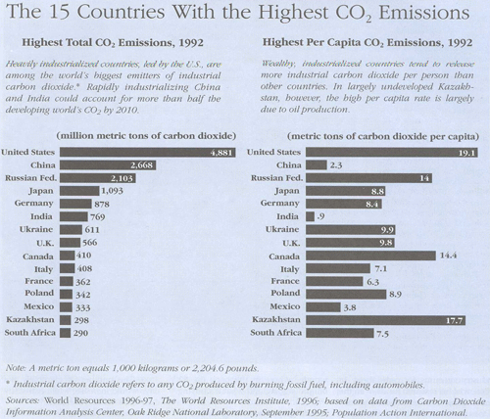
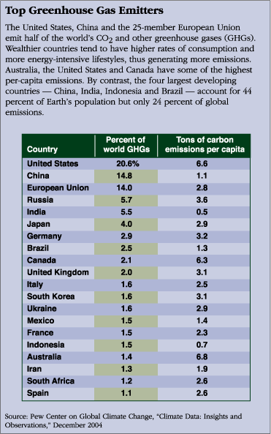

Topic B: Legalizing Marijuana: the debate (find an essay that presents both sides of the argument)
- Key words—legalizing marijuana, medical marijuana, marijuana laws, drug legalization
- Databases—Issues and Controversies, CQ Researcher
- Both sides of the issue—
CON:
- Smoking marijuana is more dangerous than smoking tobacco, opponents assert, because marijuana cigarettes contain even more carcinogenic (cancer-causing) substances than tobacco ones. All major medical associations, including the American Cancer Society and the National Eye Institute, oppose medical-marijuana use. (CQ Researcher—“Medical Marijuana”)
- Opponents of drug legalization point to these statistics when arguing that legalizing drugs will encourage increased use among adolescents more than any other group. Although marijuana use is on the rise, the rate of high school seniors who report using illicit drugs is much lower than the level of alcohol and cigarette use. Legalize these illicit drugs and make them more easily obtainable by adults, and drug abuse among adolescents eager to experiment will only rise, opponents say. (Issues and Controversies—“Drug Legalization”)
PRO:
- Take away the profit margin by decriminalizing drugs and lowering their prices and the intense competition is removed and the lucrative black market is destroyed, drug-legalization proponents argue. Needless violence will then be reduced, they say. To back up their arguments, proponents of legalization point to the years between 1919 and 1933, when the sale of alcohol was prohibited in the U.S. Organized crime surged then as gangs profited heavily from trafficking illegal alcohol, and many people were killed in the violent battles between rival gangs. (Issues and Controversies—“Drug Legalization”)
- Meanwhile, a 1982 IOM report on medicinal marijuana, “Marijuana and Health,” said cannabis and its derivatives have “shown promise in the treatment of a variety of disorders,” including some kinds of glaucoma, severe asthma, chemotherapy-induced nausea, seizures and other nervous-system disorders. “Marijuana has been accepted as capable of relieving distress of great numbers of very ill people, and doing so with safety under medical supervision,” Young continued. (CQ Researcher—“Marijuana laws”)

Topic C: Student Right to Free Speech (search for relevant journal articles and identify one U.S. Supreme Court case that deals with this topic)
- Key words—supreme court decisions and student free speech, Proquest Advanced Search, “Supreme Court decisions” and “students”
- Databases—ProQuest, CQ Researcher, Issues and Controversies
- Court case
The appellate court in Harper ruled in favor of school authorities who prohibited a student from wearing a T-shirt with phrases that besmirched homosexuality (e.g., "Homosexuality Is Shameful, Romans 1:27" and "Be Ashamed, Our School Embraced What God Has Condemned").9 Instead of relying on Tinker's disruption standard, the court relied on Tinker's second prong allowing school authorities to curtail student expression that collides with the rights of others.10 The court reasoned the messages on the shirt interfered with the rights of others "in the most fundamental way" and concluded that "[p]ublic school students who may be injured by verbal assaults on the basis of a core identifying characteristic such as race, religion, or sexual orientation, have a right to be free from such attacks while on school campuses."11
Curtailing Degrading Student Expression: Is a Link to a Disruption Required?
Martha McCarthy. Journal of Law and Education. Baltimore: Oct 2009. Vol. 38, Iss. 4; pg. 607, 15 pgs

Topic D: Women in Shakespeare (find relevant journal articles)
- Key words—women in Shakespeare, Shakespeare and feminism, Shakespeare and women
- Databases—ProQuest
- Relevant journal articles
Modern Language Review “The Merry Wife of William”
Shakespeare Quarterly “Shakespeare and Women”
American Theater “Enter the Body: Women and Representation on Shakespeare’s Stage”

