

Mkbhd



Mrwhosetheboss

Database

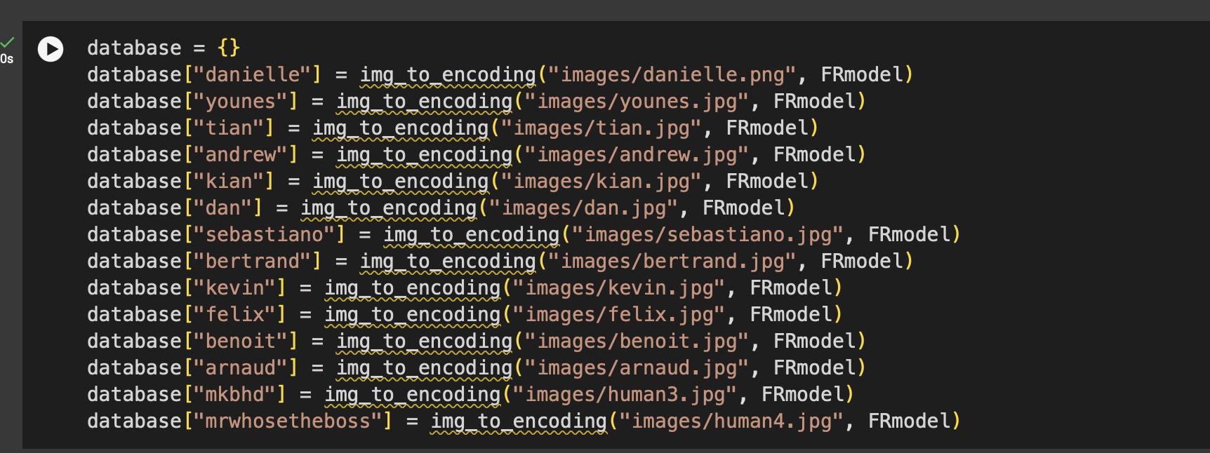

Verifying person 1

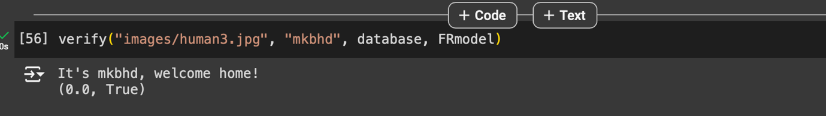

Verifying person 2

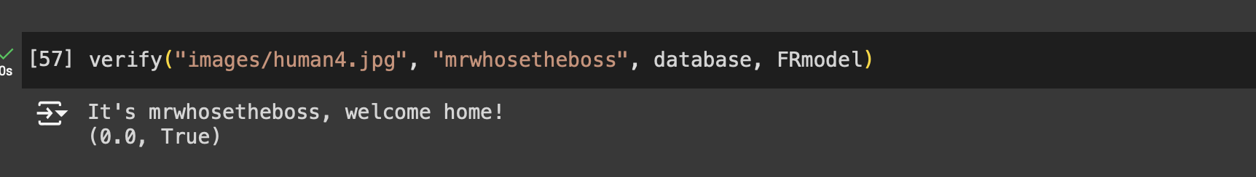

Output

