Demography

7th December 2019

- Mechanisms
  - Population Structure
The population is stratified according to the Districts of Residence. The 2018 census [1] reports with respect to the following listing of districts, which can also be grouped by Region (see Table). This is adopted in the model. To provide ease of use, a unique District_Num is assigned to each district.

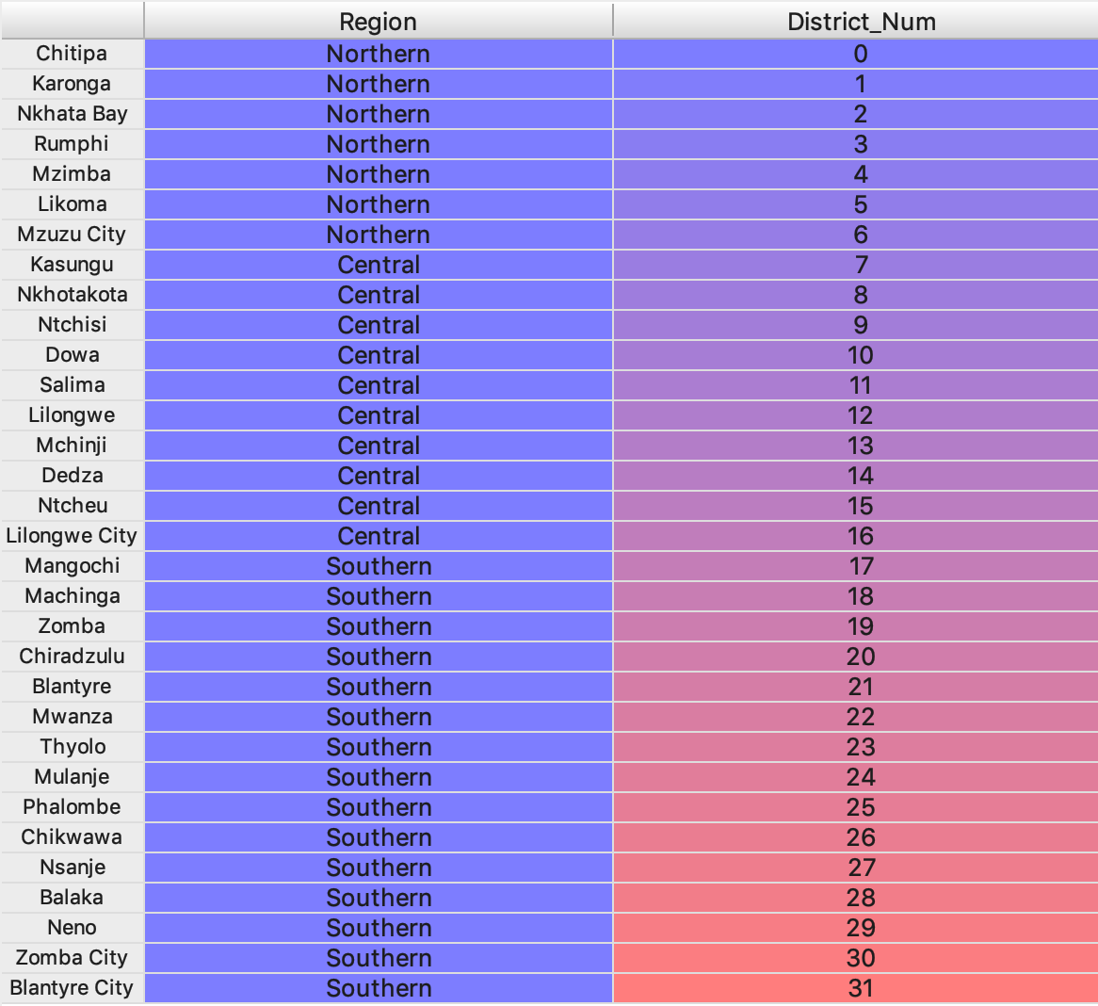

  - Initial Population Structure and District Breakdown

The 2018 census [1] provides a break-down of the population in that year with respect to district and sex, and separately with respect to district and age. These two tables were combined to give a breakdown with respect to sex, age and district under the assumption that the age-breakdown within each district was the same for each sex. This population structure was scaled so as to match the total population size for the start year of the simulation (2010) as reported by the World Population Prospect [2].

  - Births
The occurrence of births is handled by the ‘Contraception’ module. The fraction of babies that are male in any year taken from the WPP [2] estimates for the corresponding five-year period. Babies are assumed to be resident in the same place as their mothers. no further discussion is provided here.

  - Deaths
Deaths due to most causes are handled by specific ‘disease modules’. When a disease module causes the death of an individual, they enact the InstantaneousDeath event, which logs the death.

However, during development a rate of all-cause mortality is applied in order that the correct population structure is maintained. This is implemented using a monthly poll (‘OtherDeathPoll’) which causes death and logs the cause as ‘Other’. The risk of dying from all causes are taken from the World Population Prospect 2019 [2].

When all disease modules are implemented, this functionality will modified so as to represent only that risk of death that is not captured by any of the disease modules.*

- Calibration
Before comparison to any data there is scaling procedure whereby all outputs from the model that are in the form of counts of events or persons are scaled by a factor that is equal to the ratio of total population size of Malawi in the 2018 census [1] and the total model population size in the same year.

The output of the model is compared against the following data:
- Population size
  - Census 2018 in Malawi [1] – total and age/sex/district composition.
  - WPP estimates [2] – total and breakdown by age/sex and future trend

- Number of births over time and breakdown by district
  - Census 2019 in Malawi [1] – total and breakdown by district
  - WPP estimates [2] – total and future trend

- Number of deaths
  - Malawi Census [1] – breakdown by age/sex/region
  - WPP estimate [2] – total and breakdown by age/sex and future trend
  - GBD estimates [3] – total and breakdown by age/sex and future trend

References
[1] 2019 Malawi Population and House Census Main Report. National Statistical Office. May 2019, Lilongwe. (Available from: http://www.nsomalawi.mw/index.php?option=com_content&view=article&id=226&Itemid=, last accessed: 6-11-19)

[2] World Population Prospects 2019. United Nations Department of Economic and Social Affairs. (Available from: https://population.un.org/wpp/Download/Standard/Population/, last accessed: 12-11-10)

[3] Global Burden of Disease Collaborative Network. Global Burden of Disease Study 2017 (GBD 2017) Results. Seattle, United States: Institute for Health Metrics and Evaluation (IHME), 2018. (Available from http://ghdx.healthdata.org/gbd-results-tool, last accessed: 12-11-19)

Known Limitations and Action Items
* When developing this new function, use GBD data to specify which causes of death are to be included or not.
** In new version of logger, let the output be notified as to whether they should be subject to scaling.

Appendix: Current Calibrations

