Acute Lower Respiratory Infection (ALRI) Module 2
Background 2
The Thanzi La Onse Model 2
General approach to decisions on modelling causal influences and effects of interventions 2
Demographic and social characteristics modelled 2
Approach to modelling ALRI: rationale for model structure & choice of parameter values 3
Summary 3
Case definitions and clinical classification 3
Conceptualisation of ALRI model structure 4
Properties and parameters of the natural history 9
Limitations in the design of ALRI model concept 16
Integrating ALRI with the Health System 18
Health care seeking 18
Care management at the community level (facility level 0) 19
Care management at the primary level (facility level 1) 20
Care management at the secondary level (facility level 2) 21
Example model outputs 24
Health worker’s performance vs IMCI ‘gold-standard’ vs underlying ‘true’ ALRI disease 24
Policy questions for ALRI model 26
How are policy questions formulated? – Baseline analysis 26
Key questions/ outputs from the model 26
Key question 1 – Implementation of RSV vaccine 26
Key question 2 – Scale-up of pulse oximetry 27
Key question 3 – Scale-up of oxygen therapy 27
Key question 4 – Improved health worker sensitivity 27
End goal of proposed analyses 27
ALRI Properties update 28
References 34

Acute Lower Respiratory Infection (ALRI) Module

Background

The Thanzi La Onse Model
As part of the Thanzi La Onse program a model is being developed which aims to capture the health experiences of the population of Malawi and the consequent interactions with the health care system. The intent is that this model will help to inform future delivery of health care in Malawi. The model is an individual based model – which means we explicitly simulate the individual life and health experiences of a representative proportion of population of Malawi. The simulation initiates on 1 Jan 2010 and we attempt to simulate the attributes of the population at that point. We can run the model forward to any specified future time point. Each potential intervention and its associated diseases are being modelled. This is being divided into separate disease/intervention modules. This document describes the module on acute lower respiratory tract infections (ALRI).

General approach to decisions on modelling causal influences and effects of interventions
This module was designed in the context of an overall approach to modelling causal effects in general and causal effects of interventions in particular. The overall intent is to adopt as simple a structure as can be conceived, whilst still capturing the essential elements of a disease and the interventions used to prevent or treatment. We include a causal link between a “variable” (by which we mean a characteristic or property of an individual, whether that be demographic, social or biologic), and risk of disease or another variable if there is strong evidence from an overall body of studies that such a causal link exists and is at least moderately strong. In informing such decisions we place particular value on RCTs or studies with a quasi-experimental design such as analyses based on an instrumental variable. There is no expectation that such studies will be from Malawi or even from Africa. If there are such local studies and in the unlikely event that they provide strong evidence to suggest that the causal link is substantively different in Malawi then the intent is that this is taken into account and the Malawi-specific link included.
In the special case of a potential causal variable which relates to whether an individual has experienced or is experiencing an intervention the intent is to only include interventions if there is substantial RCT evidence of their beneficial effect, based on trials with objectively ascertained clinical endpoints with low risk of serious bias. Whilst DCP-3 (and to some extent the Malawi EHP) provides an initial list of such interventions and the evidence to support them, where possible our intent has been to form our own opinion on intervention efficacy based on the source trials.
Unless there is evidence to the contrary, the intent is to summarize and incorporate intervention effects into the model as relative risks or rates rather than absolute differences due to the fact that such measures are less likely to differ substantively by context. Interactions between characteristics (on the multiplicative scale) are only to be incorporated if there is strong evidence. Again, we have not intended to rely on data from Malawi or Africa for such evidence but if local evidence exists which strongly suggests a different effect than elsewhere then the intent is that this modified effect is incorporated in the model.

Demographic and social characteristics modelled
Based on data on the distribution of the population in Malawi according to geographic location we assign individuals a geographic location, which maps onto whether they are classified as living in a rural or urban area. Informed largely by data from the Malawi DHS, variables are also created indicating the person’s wealth level (based on 5 quintiles), whether the person has access to improved sanitation, clean drinking water, hand washing facilities, and whether they experience indoor air pollution (wood burning stove). We assign individuals a current education status (none, primary, secondary) which is updated 3 monthly from age 5 to 20. From age 15 BMI (in 5 groups) is assigned, as well as using tobacco, drinking excess alcohol, having low exercise, high salt intake, high sugar intake. The status with regard to such variables for individuals can change over time. The influences between these variables are described in detail in a separate document.

Approach to modelling ALRI: rationale for model structure & choice of parameter values

Summary
Acute lower respiratory infections (ALRI) in children under 5 years of age remains one of the leading causes of childhood morbidity and mortality¹, with 90% of this burden being reflected in low-middle income countries². A significant proportion of the ALRI disease burden is accounted by bronchiolitis and pneumonia, with the latter being the most severe manifestation of ALRI.
For the TLO programme, we aim to model the underlying disease conditions of a sick child, who will present for care with signs and symptoms, then based on diagnostic algorithm and diagnostic tests the healthcare system will assign a disease classification and treat accordingly. This document describes the modelling methods for childhood ALRI, and their interaction with the health systems: assessment, classification and treatment of disease.
The ALRI module updates the lower respiratory tract disease status every 3 months. It is responsible for assigning new ALRIs to children under 5 years of age, and scheduling health system interactions. These new ALRI events are differentiated into diseases: viral pneumonia, bacterial pneumonia and viral bronchiolitis; updating on the occurrence of complications derived from the disease states, as well as symptoms, and death or recovery. When seeking care at different facility level (community, primary, secondary level), the quality of care (correct disease classification and treatment) is incorporated and consumables are used in the health system interaction event.

Case definitions and clinical classification
In the medical textbook: “Harrison’s principles of internal medicine”, pneumonia is defined as an infection of the pulmonary parenchyma caused by various organisms. It states that pneumonia is not a single disease entity but a group of specific infections, each with different epidemiology, pathogenesis and clinical course³. To date, there is a lack of clarity in the definition and classification of pneumonia in the field of pneumonia care and research⁴, as well as the lack of a safe and effective ‘gold-standard’⁵ to identify the causative organisms, further limiting an accurate diagnosis.
Guidelines for the management of community-acquired pneumonia in both high-income countries and low- and middle-income countries focus the initial diagnosis on the clinical assessment⁶. This is a major step in determining the severity of the disease and consequently to decide on what care should be provided. Though there are a range of severity scores described for adults⁷, no score systems have been validated for young children. Many low- and lower-middle-income countries have adapted the WHO recommendations for assessing the severity of childhood pneumonia.
WHO has placed standardized guidelines into the global Integrated Management of Childhood Illness (IMCI) programme, to facilitate clinical decision making by first level health workers in managing children presenting with acute respiratory symptoms. A suspected case of pneumonia is determined by its clinical symptoms (Table 1). The WHO’s clinical definition of childhood pneumonia is also the most frequently used in field studies and in the estimation of the global burden of childhood pneumonia⁸. However, this definition has low specificity and includes bacterial and viral pneumonia, viral bronchiolitis, bacterial and viral bronchitis⁹ – conditions that can co-exist. Empiric antibiotic therapy is high, particularly in low-resource settings.
Table 1 - Classification of clinical pneumonia by WHO original (2005) and revised guidelines (2014) for children aged 2-59 months
Original guidelines 2005 |  | Revised guidelines 2014
Severity | Signs and symptoms | Severity | Signs and symptoms
(non-severe) pneumonia | Cough and/or difficult breathing, and | (non-severe) pneumonia
 | Fast breathing for age,
 | No chest indrawing |  | Cough and/or difficult breathing, and
 | No danger signs |  | Fast breathing for age, or
 | No stridor when calm |  | Lower chest indrawing
Severe pneumonia | Cough and/or difficult breathing, and |  | No danger signs
 | Lower chest indrawing |  | No stridor when calm
 | No danger signs
 | No stridor when calm
Very severe pneumonia | Cough and/or difficult breathing, and | Severe pneumonia | Cough and/or difficult breathing, and
 | Any general danger sign, or |  | Any general danger sign, or
 | Stridor when calm |  | Stridor when calm
*In 2014, the WHO updated the guidelines to define lower chest indrawing as a sign of non-severe pneumonia for ages between 2-59 months, where previously was a sign of severe pneumonia. With this change, the clinical definitions of pneumonia has now two stages of disease severity, whereas the original guidelines had three.
Malawi has started using the revised guidelines since February 2018. In the conceptualisation of the model, the new definitions are used.
Fast breathing: <2 months – 60 breaths per minute or more; 2 months up to 12 months – 50 breaths per minute or more; 12 months up to 5 years – 40 breaths per minute or more
†Danger signs are any of the following: inability to drink and/or breastfeed, persistent vomiting, lethargy or unconscious, convulsions, and apnoea (if 0–2 months of age) central cyanosis (hospital); severe respiratory distress (hospital)
Key clinical symptom defining pneumonia severity in bold.

Conceptualisation of ALRI model structure
The figure below (Figure 1) shows the flow diagram of the natural history of community-acquired ALRIs without input of the healthcare system interventions. The model structure proposed here focuses on capturing the most severe manifestations and mortality drivers of lower respiratory tract infections: pneumonia and bronchiolitis in infants.
Figure 1 - Schematic diagram of the natural history of community-acquired ALRI
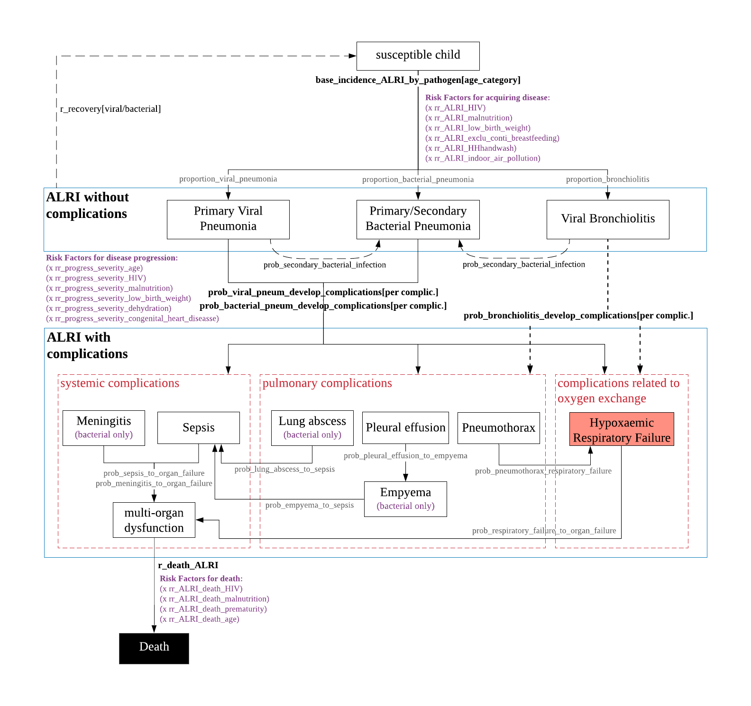

Incidence of ALRI and risk factors
The attributable pathogens are informed by the PERCH study results¹⁰. The aetiology is age-specific – the overall incidence of acute respiratory infections is highest in early childhood and decreases gradually with age¹¹, which reflects the pattern of exposure to infection, and the development of the child’s immunity. The development and localization of disease in the lower respiratory tract depends on a complex interaction between the pathogen, the host, and environmental factors. The incidence of ALRI disease is associated with host-related risk factors, such as, low birth weight, undernutrition – weight-for-age less than 2 standard deviations, and HIV infection and external/environment-related factors, such as, lack of exclusive breastfeeding, household crowding – more than 7 persons per household, exposure to indoor air pollution, and incomplete immunization¹².
In any community-based study on pneumonia incidence, the measured entity is not pneumonia itself but rather the incidence of children who fulfil the case definition of childhood pneumonia. Using the WHO’s case definition of pneumonia greatly overestimates the incidence of pneumonia. Nevertheless, it was designed to ensure early use of antibiotics in resource-limited countries to have an impact on the high levels of mortality. With such model design, I attempt to capture the underlying ALRI condition that require antibiotics (those with bacterial aetiology, as primary or secondary cause, and with severe disease that may require preventive antibiotic administration) and those that do not require (viral aetiology only, non-severe).
In the estimation of ALRI incidence by pathogen by age group, there are two steps: 1st – For each age group [1-11, 12-23, 24-59 months], I determine the incidence of pneumonia by each pathogen and the incidence of bronchiolitis by each pathogen (for <2 years of age). 2nd – Then, the two disease incidences for each pathogen are added together, which will be the estimate for the incidence of ALRI by pathogen.
The key study used in informing the parameters of ALRI model is the Pneumonia Etiology Research for Child Health (PERCH) hospital-based case-control study. Its results inform the model about the infective agents causing of severe and very severe pneumonia (WHO 2005 definitions) among children aged 1-59 months. Among those with clinical severe and very severe pneumonia that fulfilled the study’s inclusion criteria, 41.8% were confirmed diagnosis with abnormal chest x-ray scans (CXR). The pathogen attributable fractions (AFs) for CXR+ results were estimated using a Bayesian, partial latent class analysis to estimate probabilities of aetiological agents at the individual and population level, incorporating case and control data¹⁰. The top 10 pathogens were added in the model. However, the parameter values for the attributable pathogens is only referenced for severe and very severe pneumonia states (WHO 2005 definitions), thus non-severe/ fast-breathing pneumonia were not calculated for. This should be a minor issue, as most cases that fall under that classification are not ‘true’ pneumonia (expert opinion of Eric McCollum). Thus, I will assume the pathogens determined for chest indrawing-pneumonia apply for the fast-breathing pneumonia.
To calculate the WHO-pneumonia incidence, I have used McCollum ED et al. 2017 observational study¹³ data: cases from hospitals health centres and community health workers in two districts in Malawi with dates of admission between January and June 2012 were included, as during this period, the PCV13 vaccination coverage was less than 50%¹³. During that time period, the incidence rate of WHO-defined pneumonia in Malawi was estimated to be 62.49/100 child-years among children aged less than 12 months, 35.02/100 child-years for ages 12 to 23 months and 12.23/100 child-years for ages 24 to 59 months (Table 2).
Table 2 - Parameters in the calculation of incidence using McCollum ED et al. 2017 study¹³ data*
 | Children aged under 12 months |  | Children aged 12-23 months |  | Children aged 24-59 months
 | cases | Population | cases | Population | cases | Population
total number | 2396 | 43119 | 1222 | 39930 | 1147 | 108617
no. of severe & very severe cases in village clinics and health centres | 215 |  | 81 |  | 57
total minus referred cases | 2246 |  | 1165 |  | 1107
rate per 100,000 child-months |  | 5207.71 |  | 2918.37 |  | 1019.27
rate per 100 child-years |  | 62.49 |  | 35.02 |  | 12.23
Cases include all pneumonia cases seen at the hospital, health centre and village clinics within the study during the admission dates. pop0_11 – population aged 0 to 11 months, pop12_23 – population aged 12-23 months, pop24_59 – population aged 24 to 59 months (underlying population served by the health facilities in the study, estimates derived from Malawi Census 2008 Main Report)
*Admission dates between January and June 2012

Considering that ‘’severe and ‘very severe’ pneumonia cases seen at health centres and village clinics are required to be referred to a health facility for further management, the number of cases seen at in those facilities were subtracted from the total to avoid duplication, with an assumption that only 70% reached the hospital for further management (this can be changed depending on data to inform this). For the incidence calculated above, the cases are children for whom care was sought at the health facilities included in the study. However, not all children with pneumonia symptoms will have a health system interaction, particularly for milder disease. I have not added to the incidence those that did not seek care at a health facility – the DHS has data on children under 5 with symptoms of acute respiratory infections (cough in the past two weeks, with short, rapid breathing which was chest related) for whom advice or treatment was sought from a health facility or provider, however this is based on mother’s report and may not be accurate, which can lead to an overestimation of incidence of pneumonia/ALRIs.
Chest x-ray (CXR) are the most widely employed test to confirm the diagnosis, however, this method is not indicated in ambulatory settings and cannot distinguish viral and bacterial pneumonia¹⁴. Although negative CXR excludes pneumonia in majority of children¹⁵, chest radiographs may not show evidence of pneumonia in early stages of infection, and there is variation in intraobserver and interobserver agreement.
Therefore, I propose to distil from the incidences of clinical pneumonia estimated using the PCV13 study data, and calculate the incidence of pneumonia as the underlying pathology of clinical disease using the data from PERCH: for severe cases – the proportion with a positive CXR was 46.26%; for very severe cases, the proportion with a positive CXR was 40.58% - overall 41.8% of clinical pneumonia cases from the study had a radiological confirmation. This proportion of CXR+ confirmed pneumonia diagnosis is consistent with Begom et al 2018 study, assessing the clinical and radiological parameters of severe pneumonia (revised guidelines) in children aged 2-59 months from Bangladesh, whereby 40% were diagnosed as pneumonia and 60% were diagnosed as bronchiolitis radiologically¹⁶. Previous studies showed for non-severe pneumonia, 14% had radiological evidence of pneumonia¹⁷.
Next, using the values of CXR sensitivity and specificity from a meta-analysis study comparing the accuracy of lung ultrasound and CXR for the diagnosis of paediatric community-acquired pneumonia, using as ‘gold standard’ the expert paediatrician clinical diagnosis of pneumonia, the proportion of CXR+ from PERCH were adjusted to account for those that might have not be picked up. The CXR sensitivity and specificity values are respectively 86.8% and 98.2% ¹⁸.
Table 3 - Proportion of CXR+ among severe and very severe cases included in the PERCH study vs. adjustment with paediatrician clinical diagnosis of pneumonia as ‘gold’ standard
Age group (months) | Proportion of CXR+ | If 100% sensitivity & specificity
1-5 | 42.68% | 48.13%
6-11 | 46.81% | 52.82%
12-23 | 48.28% | 54.52%
24-59 | 39.38% | 44.21%

In the calculation of the overall incidence of pneumonia (CXR-confirmed):
- Among 1-11 months old: 62.49 episodes/100 child-years (Table 2) subtracted by the proportion of other underlying conditions matching clinical IMCI-pneumonia (malaria – 5%, diarrhoea – 5% sepsis – 2%) = 54.99 episodes/100 child-years multiplied by 0.50475 (mean value of the proportion of CXR+ if 100% sensitivity and specificity for ages 1-5 and 6-11 months, Table 3) = 27.756 episodes/100 child-years
- Among 12-23 months old: 35.02 episodes/100 child-years (Table 2) subtracted by the proportion of other underlying conditions matching clinical IMCI-pneumonia (malaria – 5%, diarrhoea – 5% sepsis – 2%) = 30.82 episodes/100 child-years multiplied by 0.5452 (proportion of CXR+ if 100% sensitivity and specificity, Table 3) = 16.80 episodes/100 child-years
- Among 24-59 months old: 12.23 episodes/100 child-years (Table 2) subtracted by the proportion of other underlying conditions matching clinical IMCI-pneumonia (malaria – 5%, diarrhoea – 5% sepsis – 2%) = 10.76 episodes/100 child-years multiplied by 0.5452 (proportion of CXR+ if 100% sensitivity and specificity, Table 3) = 4.76 episodes/100 child-years
Next, the attributable fractions of the 10 pathogens from THE PERCH is applied on these incidences to calculated pathogen-specific incidence of pneumonia by age group. By adjusting the incidence of pneumonia to those who would have a positive x-ray reading, this new incidence calculated above will reflect underlying pneumonia cases.
For the calculation of incidence of bronchiolitis, I will use the attributable fractions from PERCH for all cases (both CXR positive and negative) in their Supplementary figure 7 – then with the AFs for the 1769 CXR+ and the 3981 all cases, I can calculate the AFs for the 2212 CXR-, which would be considered bronchiolitis for those under 2 years of age, of the associated viral pathogens.
Below (Table 4) is an example for the calculation of RSV ALRI incidence. Calculations for all pathogens is displayed in Table 8.
Table 4 - Calculation of the incidence of ALRI by RSV per 100 child-years
Age group | Total pneumonia incidence | RSV attributable fraction | Pneumonia incidence by RSV | Total bronchiolitis incidence | RSV attributable fraction | Bronchiolitis incidence by RSV | ALRI (pneumonia + bronchiolitis) incidence by RSV
1-11 | 27.76 | 0.397 | 11.02 | 27.23 | 0.60 | 16.33 | 27.35
12-23 | 16.80 | 0.164 | 2.75 | 14.02 | 0.60 | 8.41 | 11.16
24-59 | 4.76 | 0.165 | 0.78 | - | - | - | 0.78
Total pneumonia incidence and total bronchiolitis incidence is derived from the McCollum E. et al., 2014 study in Malawi.
Attributable fraction (AF) of RSV for the incidence of pneumonia is informed by the PERCH study results; the AF of RSV for bronchiolitis incidence is a dummy value, will be updated with suitable data.

A limitation that need to be addressed here is the proportions in table 3 reflect only for ‘severe’’ and ‘very severe’ cases by the WHO IMCI definition, ‘non-severe’ would have a lower proportion of underlying pneumonia cases – I will use McCollum E. et al., 2014 data to extract the number of cases that were ‘non-severe’, ‘severe’ and ‘very severe’, apply the proportions of CXR+ for each severity level (assuming 14% CXR+ among ‘non-severe’ pneumonia) and only then, calculate the incidences of ‘true’ pneumonia.

Table 5 - Calculation of ALRI incidence by pathogen by age group
 | Pneumonia |  |  |  |  |  | Bronchiolitis |  |  |  | Total ALRI
Age group | 1-11 |  | 12-23 |  | 24-59 |  | 1-11 |  | 12-23 |  | 1-11 | 12-23 | 24-59
Pathogens | AFs | Incidence | AFs | Incidence | AFs | Incidence | AFs | Incidence | AFs | Incidence | Incidence | Incidence | Incidence
RSV | 0.397 | 11.019 | 0.164 | 2.755 | 0.165 | 0.785 | 0.60 | 16.338 | 0.60 | 8.412 | 27.357 | 11.167 | 0.785
Rhinovirus | 0.029 | 0.805 | 0.152 | 2.554 | 0.159 | 0.757 | 0.05 | 1.3615 | 0.05 | 0.701 | 2.166 | 3.255 | 0.757
HMPV | 0.083 | 2.304 | 0.063 | 1.058 | 0.059 | 0.281 | 0.05 | 1.3615 | 0.05 | 0.701 | 3.665 | 1.759 | 0.281
Parainfluenza | 0.078 | 2.165 | 0.067 | 1.126 | 0.068 | 0.324 | 0.05 | 1.3615 | 0.05 | 0.701 | 3.526 | 1.827 | 0.324
Streptococcus | 0.047 | 1.305 | 0.106 | 1.781 | 0.092 | 0.438 | - | - | - | - | 1.314 | 1.792 | 0.438
H. influenzae | 0.059 | 1.638 | 0.067 | 1.126 | 0.044 | 0.209 | - | - | - | - | 1.650 | 1.133 | 0.209
Staphylococcus | 0.037 | 1.027 | 0.009 | 0.151 | 0.012 | 0.057 | - | - | - | - | 1.035 | 0.152 | 0.057
Influenza | 0.016 | 0.444 | 0.029 | 0.487 | 0.032 | 0.152 | 0.05 | 1.3615 | 0.05 | 0.701 | 1.806 | 1.188 | 0.152
P.jirovecii | 0.030 | 0.833 | 0.004 | 0.067 | 0.002 | 0.010 | - | - | - | - | 0.839 | 0.068 | 0.010
Adenovirus | - | - | - | - |  | - | 0.05 | 1.3615 | 0.05 | 0.701 | 1.727 | 0.906 | -
Coronavirus | - | - | - | - |  | - | 0.05 | 1.3615 | 0.05 | 0.701 | 1.727 | 0.906 | -
Bocavirus | - | - | - | - |  | - | 0.05 | 1.3615 | 0.05 | 0.701 | 1.727 | 0.906 | -
Other pathogens | 0.098 | 2.720 | 0.274 | 4.603 | 0.282 | 1.342 | 0.05 | 1.3615 | 0.05 | 0.701 | 4.082 | 5.304 | 1.342
Total |  | 27.76 |  | 16.8 |  | 4.76 |  | 27.23 |  | 14.02 | 52.619 | 30.362 | 4.355
The pathogen attributable fractions for the incidence of bronchiolitis are dummy values. These will be updated once data from PERCH is provided for further estimation of these AFs. The majority of bronchiolitis cases are caused by RSV therefore, a high AF of 60%.
Total ALRI incidence by pathogen in each age group is expressed as cases per 100 children per year – in the parameters Table 7, these are expressed per 1 child per year

Prognosis, signs and symptoms of ALRI
The most common lower respiratory infection in infants is viral bronchiolitis, where smaller airway (bronchiole) diameter predisposes to airway obstruction – viral infection causing inflammation, mucous secretions and sloughing of epithelial cells into the bronchiole lumen results in varying degrees of airway obstruction¹⁹. The most common viral agent is the Respiratory Syncytial Virus (RSV). The epidemiology of RSV at sites with warm temperatures and high humidity, such as Malawi, tends to be continuous throughout the year, peaking in summer and autumn (rainy season)²⁰.
1 – 2 days following an initial upper respiratory prodrome, including cough, sneezing, nasal congestion, poor feeding and low-grade fever²¹, the child will display increased respiratory effort, tachypnoea (fast breathing for age), wheezing, and hyperinflation caused by air trapping in the alveoli. These are common features of bronchiolitis. If there is a complete obstruction of the bronchiole, it stops alveolar ventilation as gases are absorbed into the circulation and the alveolus collapses – localised atelectasis¹⁹ (or lung collapse).
Pathogen invasion and proliferation into the lung parenchyma (where gas exchange occurs) and the host’s inflammatory response against it causes the clinical syndrome of pneumonia. Bacterial causes of pneumonia tend to produce more severe disease than viral pneumonia¹⁰. Inflammation and exudative fluid accumulates in the pulmonary parenchyma compromises respiratory function²²; related symptoms include cough, difficulty breathing, fast breathing, drawing the muscles under the chest when breathing, and poor feeding, and in young infants, apnoea, grunting and head nodding as signs of severe respiratory distress²³.
A single pathogen can cause several clinical illnesses at once, in particular respiratory viruses. For this model, only the more severe disease will be registered as the underlying condition: ascending severity is viral bronchiolitis, viral pneumonia, to bacterial pneumonia. Hence, in the natural history model structure, the ALRIs are grouped into three disease categories: Primary Viral Pneumonia, Primary/Secondary Bacterial Pneumonia which includes viral/ bacterial co-infection, and Viral Bronchiolitis. This choice of grouping primary bacterial pneumonia with a co/secondary bacterial pneumonia is backed up by evidence that children with bacterial infections alone or with viral-bacterial co-infection have worse outcomes than children with a single or dual viral infection alone²⁴. Bacterial co-infections during viral bronchiolitis have been associated with worse clinical outcomes²⁵. Additionally, there is no strong evidence in the literature regarding co-infections having worst outcomes, besides influenza virus followed by streptococcus. A third of children with ALRI have evidence of viral-bacterial co-infection²⁶. Antibiotic treatment for pneumonia disease is targeted for those with a bacterial aetiology or the potential for a bacterial superinfection, however, empiric antibiotic therapy is substantial, and in particular in low- and middle- income countries, due to the challenge of specific aetiology diagnosis. The synergy between viruses and bacteria is not yet fully understood, though the consensus theory, with evidence to back-up, is that progress to pneumonia can occur more rapidly if there is a pre-existing respiratory viral infection, as it increases bacterial adherence and invasion²⁷. A study trial in South Africa, showed that 9-valent pneumococcal conjugate vaccine prevents 31% of pneumonias associated with respiratory virus in children, corroborating the hypothesis that bacterial pathogens, such as Streptococcus pneumonia, play a role in the development of pneumonia associated with respiratory viruses²⁸. For viral bronchiolitis, a probability of acquiring bacterial pneumonia (by random chance) is applied in the model.
The proportions of viral pneumonia and bronchiolitis in the ALRI incidence are simply obtained by calculating the ratio between the incidence of each disease and the incidence of ALRI per pathogen. In the RSV example, from the incidence of ALRI by RSV, 34.1% will be given the disease state ‘viral pneumonia’, and 65.1% will be ‘bronchiolitis’ in the property ri_ALRI_disease_type (see Table 4). A probability of co-infection or secondary bacterial pneumonia is then applied and the status of that property will be ‘bacterial pneumonia’, as in the model structure Primary/Secondary Bacterial Pneumonia.

ALRI complications
Depending on the site of infection, as well as, the type of the invasive pathogen, viral or bacterial cause, or co-infection, the host will deploy an array of innate and acquired cellular and humoral defences²⁹, and a range of disease-associated symptoms and complications may arise.
Complications arising from ALRI include those that occur locally in the pulmonary system, systemically if the infection gets into the blood stream or trigger an excessive immune response, and complications related to oxygen exchange. The complications included in the model (Table 5) are the most common ones arising from pneumonia and bronchiolitis, for which the management is included in the WHO guidelines of hospital inpatient care for children³⁰. Generally, complications are more common in bacterial pneumonia than atypical or viral pneumonia. Complications are more likely to occur in neonates and at younger age, low birth weight, premature infants, patients with underlying heart or lung conditions, and impaired immune system, such as, children with untreated HIV infection, and malnutrition.
Table 6 - Complications included in the ALRI structure
Complications | Definitions
Hypoxaemic Respiratory failure | respiratory failure type I, hypoxia, is a life-threatening impairment of oxygenation, in which the level of oxygen in the blood becomes dangerously low(ICD-11)³¹. Signs of respiratory failure include increasing hypoxia and respiratory distress leading to exhaustion³⁰.
Pleural effusion | the presence of fluid in the pleural cavity resulting from excessive transudation or exudation from the pleural surfaces (ICD-11)³¹
Empyema | suppurative inflammation of the pleural space, typically due to acute bacterial infection (ICD-11)³¹
Lung abscess | caused by bacteria, a thick-walled cavity in the lung that contains purulent material resulting from suppuration and necrosis of the involved lung parenchyma³⁰
Pneumothorax | usually secondary to an accumulation of air in the pleural spaces from alveolar rupture, causing partial or complete lung collapse³⁰;
Sepsis | a life-threatening organ dysfunction caused by a dysregulated host response to infection (ICD-11)³¹
Meningitis | a serious infection of the meninges, the membranes covering the brain and spinal cord (WHO)
Multi-organ dysfunction | failure of function of more than one organ or organ system
Continued work of breathing (in the form of tachypnoea and/or lower chest wall retractions), leads to exhaustion, resulting in serious symptoms, such as, apnoea (cessation of breathing) in young infants, lethargy, and dehydration, which further complicates clinical status. If respiratory function is severely compromised, it can cause respiratory failure type I, hypoxia. Signs of respiratory failure include increasing hypoxia and respiratory distress leading to exhaustion³⁰. The lack of oxygen flow to the vital organs can cause multi-organ dysfunction.
In the pulmonary system, complications arising from both bronchiolitis and pneumonia include pneumothorax, which can induce or further complicate respiratory failure, and pleural effusion; in Primary/Secondary Bacterial Pneumonia, as the disease progresses, bacteria can colonize the pleural fluid and generate an empyema; bacteria can also develop lung abscesses, and both bacteria-associated complications can further develop into bacteraemia or sepsis.
Bacteraemia is the most common pneumonia complication and occurs when the pathogen causing pneumonia spreads into the bloodstream. This can then cause metastatic infections such as meningitis, or trigger sepsis, a dysregulated host response to infection potentially leading to septic shock where blood pressure drops to a dangerous level, causing life-threatening organ dysfunction³².
Death from pneumonia is due to related complications: sepsis, meningitis, and respiratory failure, all potentially leading to multi-organ failure. Risk factors associated with death are HIV status, malnutrition, low birth weight, and younger age¹¹ ³³.

Properties and parameters of the natural history
The ALRI module updates information on each individual (under 5 years of age) with regards to ALRI status every 3 months. The variables describing the state of the disease include the primary causal pathogen, the secondary (bacterial) causal pathogen, the ALRI disease type, complications associated with disease, the date of acquiring that ALRI episode, date of progression to severe states and date of recovery and death, as described in Table 6.
Table 7 - Proposed properties of the ALRI module
Variable name (Properties) | Property type + categories | Description
ri_current_ALRI_status | Boolean  (True/False) | ALRI status for the current simulation run
ri_primary_ALRI_pathogen | Categorical  ‘RSV', 'rhinovirus', 'HMPV', 'parainfluenza', 'Strep_pneumoniae_PCV13',  'Strep_pneumoniae_non_PCV13',  'Hib', 'H.influenzae_non_type_b',  'Staphylococcus aureus', 'Enterobacteriaceae'*, 'other_Strepto_Enterococci'**  'influenza', 'P. jirovecii', ‘adenovirus’, ‘bocavirus’, ‘other_viral_pathogen’***, ‘other_bacterial_pathogen’**** | Attributable pathogen for the current acute lower respiratory infection
ri_secondary_bacterial_pathogen | Categorical  'Strep_pneumoniae_PCV13',  'Strep_pneumoniae_non_PCV13',  'Hib', 'H.influenzae_non_type_b',  'Staph_aureus', 'Enterobacteriaceae', 'other_Strepto_Enterococci', 'other_bacterial_pathogens' | Secondary bacterial co-infection pathogens
ri_ALRI_disease_type | Categorical  ‘viral pneumonia’, ‘bacterial pneumonia’, ‘bronchiolitis’ + ['none'] | ALRI is divided into:  primary viral pneumonia,  primary or secondary bacterial pneumonia, and viral bronchiolitis
ri_ALRI_complications | List  [pneumothorax, pleural effusion, empyema, lung abscess;  sepsis, meningitis;  respiratory failure, multi-organ failure]  + no complications + ['not_applicable'] | Complications associated with ALRI event
ri_current_ALRI_symptoms | 'fever', 'cough', ‘difficult_breathing', 'convulsions', 'lethargy', 'not_eating', 'restlessness', 'bulging_fontanel', 'fast_breathing', 'chest_indrawing', 'grunting', 'chest_pain', 'loss_of_appetite',  'photophobia', 'nuchal_rigidity',  'cyanosis', 'respiratory_distress', 'hypoxia', 'tachypnoea', 'cough_with_sputum',  'weight_loss', 'nausea',  'hemoptysis', 'tachycardia', 'decreased_chest_movement', 'fatigue', ‘no_urination_in_last_12h',  'hemoptysis', 'danger_signs'  + ['not_applicable'] | List of symptoms of the current ALRI event
ri_ALRI_date_of_onset | Date | Date of onset of the last/ or current ALRI symptoms
ri_ALRI_recovered_date | Date | Date of recovery and resolve of symptoms
ri_ALRI_severe_complication_date | Date | Date of progression to any severe complication (respiratory failure, sepsis, meningitis) of the current/last episode
ri_ALRI_death_date | Date | Date of death from ALRI
ri_ALRI_tx_start_date | Date | Date of treatment start
ri_ALRI_antibiotic_treatment_administered | Categorical  'benzyl penicillin injection', 'amoxicillin', 'cotrimoxazole', 'other_antibiotic', 'chlorampheniciol', 'prednisolone' | Antibiotic treatment given for the ALRI
ri_peripheral_oxygen_saturation | Categorical  'SpO2<90%', 'SpO2_90-92%', 'SpO2>92%' | Level of peripheral oxygen saturation to be read by a pulse oximetry
ri_chest_auscultations_signs | 'decreased_breath_sounds', 'bronchial_breaths_sounds', 'crackles', 'wheeze', 'abnormal_vocal_resonance', 'pleural_rub' + ['none'] + ['not_applicable'] | Findings during chest auscultation examination
oxygen_therapy_given | Boolean  (True/False) | Oxygen therapy received at the hospital (for severe cases)
‘ri_’ stands for respiratory infection – as a prefix representation of properties within the ALRI module.
Assumption: viral/bacterial co-infections will fall under the category ‘bacterial pneumonia’ as viral is considered to be the primary infection initiating the disease pathogenesis while bacterial superinfection (as secondary infection) is the driver of disease severity, which we want to capture.
RSV – respiratory syncitial virus; HMPV – human metapneumovirus; Strep_pneumoniae_PCV13 – Streptococcus pneumoniae Pneumococcal Conjugate Vaccine 13, Hib – Haemophilus influenzae type b
*Enterobacteriaceae includes E. coli, Enterobacter species, and Klebsiella species
**other_Strepto_Enterococci includes Streptococcus pyogenes and Enterococcus faecium
***other_viral_pathogens includes Coronaviruses NL63, 229E OC43 and HKU1, Cytomegalovirus, Parechovirus/Enterovirus
****other_bacterial_pathogens includes Bordetella pertussis, Chlamydophila pneumoniae, Legionella species, Mycoplasma pneumoniae, Moraxella catarrhalis, Non-fermenting gram-negative rods (Acinetobacter species and Pseudomonas species), Neisseria meningitides
Table 7 lists the parameters of the ALRI model and respective values.
Table 8 - Parameters of the ALRI module
Parameter | Description | Value | Notes
base_inc_rate_ALRI_by_RSV | incidence of ALRI attributed to RSV in each age group [1-11, 12-23, 24-59] | 0.2749, 0.1102, 0.0088 | The incidence of ALRI by pathogen is calculated using McCollum ED et al. 2017 study data to estimate the incidence of WHO-defined pneumonia - then applied a fraction of CXR+ cases (published data) from the PERCH study to calculate the proportions that are 'true' underlying pneumonia, plus adjusted for sensitivity and specificity with a paediatrician's 'gold standard'. Then, using the pathogen attributable fraction estimates from the PERCH study, apply to that proportion of estimated 'true' pneumonia to get the incidence of pneumonia by pathogen per age group. Then the other proportion of the WHO-defined pneumonia incidence derived in the first step is assumed to be 'true' underlying bronbchiolitis (CXR-) for which the pathogen AFs were not published in the PERCH article, thus currently dummy values. I have requested them, and it was confirmed to be provided, by a member of PERCH. The incidence of ALRI by pathogen in each age group equals to the addition of the incidences of pneumonia and bronchiolitis.
base_inc_rate_ALRI_by_Rhinovirus | incidence of ALRI attributed to rhinovirus in each age group [1-11, 12-23, 24-59] | 0.0217, 0.035, 0.0085
base_inc_rate_ALRI_by_HMPV | incidence of ALRI attributed to hMPV in each age group [1-11, 12-23, 24-59] | 0.0382, 0.0184, 0.0031
base_inc_rate_ALRI_by_Parainfluenza | incidence of ALRI attributed to parainfluenza in each age group [1-11, 12-23, 24-59] | 0.0367, 0.0192, 0.0036
base_inc_rate_ALRI_by_Strep_pneumoniae_PCV13 | incidence of ALRI attributed to Streptococcus pneumoniae PCV13-type in each age group [1-11, 12-23, 24-59] | 0.0072, 0.0099, 0.0024
base_inc_rate_ALRI_by_Strep_pneumoniae_non_PCV13 | incidence of ALRI attributed to Streptococcus pneumoniae non-PCV13-type in each age group [1-11, 12-23, 24-59] | 0.0072, 0.0099, 0.0024
base_inc_rate_ALRI_by_Hib | incidence of ALRI attributed to Heamophilus influenzae type b in each age group [1-11, 12-23, 24-59] | 0.009, 0.0063, 0.0012
base_inc_rate_ALRI_by_H.influenzae_non_type_b | incidence of ALRI attributed to Heamophilus influenzae non-type b in each age group [1-11, 12-23, 24-59] | 0.009, 0.0063, 0.0012
base_inc_rate_ALRI_by_Staph_aureus | incidence of ALRI attributed to Staphylococcus aureus in each age group [1-11, 12-23, 24-59] | 0.0113, 0.0017, 0.0006
base_inc_rate_ALRI_by_Enterobacteriaceae | incidence of ALRI attributed to Enterobacteriaceae in each age group [1-11, 12-23, 24-59] | 0.0103, 0.0036, 0.0016 | PERCH's AFs of CXR+ for S. pneumoniae non-PCV13, H. influenzae non-type b, Enterobacteriaceae, Streptococcus and Enterococci spp, adenovirus, coronavirus and bocavirus are not provided in the article. These are currently not included in deriving the incidence of pneumonia
base_inc_rate_ALRI_by_other_Strepto_Enterococci | incidence of ALRI attributed to other Streptococcus and Enterococci spp. in each age group [1-11, 12-23, 24-59] | 0.0103, 0.0036, 0.0016
base_inc_rate_ALRI_by_Influenza | incidence of ALRI attributed to influenza in each age group [1-11, 12-23, 24-59] | 0.0177, 0.012, 0.0017
base_inc_rate_ALRI_by_P.jirovecii | incidence of ALRI attributed to P. jirovecii in each age group [1-11, 12-23, 24-59] | 0.0092, 0.0007, 0.0001
base_inc_rate_ALRI_by_Bocavirus | incidence of ALRI attributed to bovavirus in each age group [1-11, 12-23, 24-59] | 0.0128, 0.0066, 0 | PERCH's AFs of CXR+ for adenovirus, bocavirus, other viral and other bacterial pathogens are not provided in the article. These are currently not included in deriving the incidence of pneumonia
base_inc_rate_ALRI_by_Adenovirus | incidence of ALRI attributed to adenovirus in each age group [1-11, 12-23, 24-59] | 0.0128, 0.0066, 0
base_inc_rate_ALRI_by_other_viral_pathogens | incidence of ALRI attributed to other viral pathogens in each age group [1-11, 12-23, 24-59] | 0.0001, 0.0001, 0.0001
base_inc_rate_ALRI_by_other_bacterial_pathogens | incidence of ALRI attributed to other bacterial pathogens in each age group [1-11, 12-23, 24-59] | 0.0428, 0.0579, 0.015
rr_ALRI_Hhhandwashing | relative rate of acquiring ALRI for children with household handwashing practice | dummy
rr_ALRI_indoor_air_pollution | relative rate of acquiring ALRI for children exposed to indoor air pollution | OR 1.57 (1.06-2.31) | meta-analysis results on risk factors for severe ALRI - it was applied the WHO-pneumonia case definition, in which many non-severe (fast-breathing only) pneumonia/ALRI are not true cases of pneumonia. Reference: Jackson, S. et al. 2013
rr_ALRI_not_excl_breastfeeding | relative rate of acquiring ALRI for children who are NOT exclusively breastfed | OR 2.34 (1.42-3.88)
rr_ALRI_low_birth_weight | relative rate of acquiring ALRI for children who have low birth weight - applicable till 6 months | OR 3.18 (1.02-9.90)
rr_ALRI_HIV | relative rate of acquiring ALRI for children who are HIV positive | OR 4.15 (2.57-9.74)
rr_ALRI_underweight | relative rate of acquiring ALRI for children who are underweight (weight-for-age <2 SD) | OR 4.47 (2.10-9.49) | will need to include protein-energy malnutrition (weight-for-height)
rr_ALRI_PCV13 | relative rate of acquiring ALRI for children who are vaccinated with PCV13 | 0.8 | dummy value
rr_ALRI_hib_vaccine | relative rate of acquiring ALRI for children who are vaccinated with hib | 0.9 | dummy value
rr_ALRI_RSV_vaccine | relative rate of acquiring ALRI for children who are vaccinated with RSV-vaccine | 0.6 | still in clinical trials
prob_viral_pneumonia_bacterial_coinfection | probability of viral-bacterial co-infection / or secondary bacterial infection | 0.15 | these are the probabilities for developing a certain complication, as illustrated in the natural history diagram
porportion_bacterial_coinfection_pathogen | proportion of causal pathogens of the secondary infection [Strep_pneumoniae_PCV13', 'Strep_pneumoniae_non_PCV13', 'Hib', 'H.influenzae_non_type_b', 'Staph_aureus', 'Enterobacteriaceae', 'other_Strepto_Enterococci', 'other_bacterial_pathogens'] | [0.125, 0.125, 0.125, 0.125, 0.125, 0.125, 0.125, 0.125] | dummy values
prob_secondary_bacterial_infection_in_bronchiolitis | probability of bacterial infection in bronchiolitis | 0.03 | dummy value
prob_respiratory_failure_by_viral_pneumonia | probability of respiratory failure in viral pneumonia | 0.095 | dummy value
prob_respiratory_failure_by_bacterial_pneumonia | probability of respiratory failure in bacterial pneumonia | 0.095 | dummy value
prob_respiratory_failure_by_bronchiolitis | probability of respiratory failure in bronchiolitis | 0.095 | dummy value
prob_respiratory_failure_to_multiorgan_dysfunction | probability of respiratory failure leading to multi-organ dysfunction | 0.5 | dummy value
prob_sepsis_by_viral_pneumonia | probability of sepsis in viral pneumonia | 0.095 | dummy value
prob_sepsis_by_bacterial_pneumonia | probability of sepsis in bacterial pneumonia | 0.095 | dummy value
prob_sepsis_to_multiorgan_dysfunction | probability of sepsis leading to multi-organ dysfunction | 0.5 | dummy value
prob_meningitis_by_bacterial_pneumonia | probability of meningitis in bacterial pneumonia | 0.095 | dummy value
prob_pleural_effusion_by_bacterial_pneumonia | probability of pleural effusion in bacterial pneumonia | 0.095 | dummy value
prob_pleural_effusion_by_viral_pneumonia | probability of pleural effusion in viral pneumonia | 0.095 | dummy value
prob_pleural_effusion_by_bronchiolitis | probability of pleural effusion in bronchiolitis | 0.095 | dummy value
prob_pleural_effusion_to_empyema | probability of pleural effusion developing into empyema (for bacterial causes only) | 0.5 | dummy value
prob_empyema_to_sepsis | probability of empyema leading to sepsis | 0.5 | dummy value
prob_lung_abscess_by_bacterial_pneumonia | probability of lung abscess in bacterial pneumonia | 0.095 | dummy value
prob_lung_abscess_to_sepsis | probability of lung abscess leading to sepsis | 0.5 | dummy value
prob_pneumothorax_by_bacterial_pneumonia | probability of pneumothorax in bacterial pneumonia | 0.095 | dummy value
prob_pneumothorax_by_viral_pneumonia | probability of pneumothorax in viral pneumonia | 0.095 | dummy value
prob_atelectasis_by_bronchiolitis | probability of atelectasis in brochiolitis | 0.095 | dummy value
prob_pneumothorax_to_respiratory_failure | probability of pneumothorax leading to respiratory failure | 0.095 | dummy value
r_death_from_ALRI | death rate from ALRI - death from severe complication | 0.186 | dummy value
rr_death_ALRI_age12to23mo | relative rate of death for ages 12-23 months | 0.7 | dummy value
rr_death_ALRI_age24to59mo | relative rate of death for ages 24-59 months | 0.5 | dummy value
rr_death_ALRI_low_birth_weight | relative rate of death for infants with low birth weight | 1.5 | dummy value
rr_death_ALRI_HIV | relative rate of death for HIV untreated | 1.5 | dummy value
rr_death_ALRI_SAM | relative rate of death for severe acute malnutrition | 1.4 | dummy value
proportion_viral_pneumonia_by_RSV | proportion of RSV-ALRI causing viral pneumonia | 0.5 | To be calculated from the Table 8 on ALRI incidence values
proportion_viral_pneumonia_by_Rhinovirus | proportion of rhinovirus-ALRI causing viral pneumonia | 0.5
proportion_viral_pneumonia_by_HMPV | proportion of HMPV-ALRI causing viral pneumonia | 0.5
proportion_viral_pneumonia_by_Parainfluenza | proportion of parainfluenza-ALRI causing viral pneumonia | 0.5
proportion_viral_pneumonia_by_Influenza | proportion of influenza-ALRI causing viral pneumonia | 0.5
proportion_viral_pneumonia_by_Adenovirus | proportion of adenovirus-ALRI causing viral pneumonia | 0.5
proportion_viral_pneumonia_by_Bocavirus | proportion of bocavirus-ALRI causing viral pneumonia | 0.5
proportion_viral_pneumonia_by_other_viral_pathogens | proportion of other virus-ALRI causing viral pneumonia | 0.5
prob_fever_uncomplicated_ALRI_by_disease_type | probability of fever developing in each uncomplicated ALRI disease | 0.5, 0.5, 0.5 | respectively for [bacterial pneumonia, viral pneumonia, bronchiolitis]
prob_cough_uncomplicated_ALRI_by_disease_type | probability of cough developing in each uncomplicated ALRI disease | 0.9, 0.9, 0.9
prob_difficult_breathing_uncomplicated_ALRI_by_disease_type | probability of difficult breathing developing in each uncomplicated ALRI disease | 0.9, 0.9, 0.9
prob_fast_breathing_uncomplicated_ALRI_by_disease_type | probability of fast breathing developing in each uncomplicated ALRI disease | 0.9, 0.9, 0.9
prob_chest_indrawing_uncomplicated_ALRI_by_disease_type | probability of chest indrawing developing in each uncomplicated ALRI disease | 0.2995, 0.2995, 0.2995
prob_danger_signs_uncomplicated_ALRI_by_disease_type | probability of danger signs developing in each uncomplicated ALRI disease | 0.095, 0.095, 0.095
prob_loss_of_appetite_adding_from_pleural_effusion | probability of loss of appetite developing in each uncomplicated ALRI disease | 0.8 | dummy value
prob_loss_of_appetite_adding_from_empyema | probability of loss of appetite developing due to empyema | 0.8 | dummy value
prob_severe_respiratory_distress_adding_from_respiratory_failure | probability of severe respiratory distress developing due to respiratory failure | 0.8 | dummy value
prob_severe_respiratory_distress_adding_from_sepsis | probability of severe respiratory distress developing due to sepsis | 0.8 | dummy value
days_between_treatment_and_cure | days between treatment and resolving of symptoms | 10 | dummy value
prob_chest_pain_adding_from_lung_abscess | probability of chest pain developing due to lung abscess | 0.8 | dummy value
prob_tachypnoea_adding_from_lung_abscess | probability of tachypnoea developing due to lung abscess | 0.8 | dummy value
prob_cough_sputum_adding_from_lung_abscess | probability of cough with sputum developing due to lung abscess | 0.8 | dummy value
prob_fever_adding_from_lung_abscess | probability of fever developing due to lung abscess | 0.8 | dummy value
prob_hemoptysis_adding_from_lung_abscess | probability of hemoptysis developing due to lung abscess | 0.8 | dummy value
prob_weight_loss_adding_from_lung_abscess | probability of weight loss developing due to lung abscess | 0.8 | dummy value
prob_tachycardia_adding_from_lung_abscess | probability of tachycardia developing due to lung abscess | 0.8 | dummy value
prob_chest_pain_adding_from_pleural_effusion | probability of chest pain developing due to pleural effusion | 0.8 | dummy value
prob_cough_sputum_adding_from_pleural_effusion | probability of cough with sputum developing due to pleural effusion | 0.8 | dummy value
prob_fever_adding_from_pleural_effusion | probability of fever developing due to pleural effusion | 0.8 | dummy value
prob_difficult_breathing_adding_from_pleural_effusion | probability of difficulty in breathing developing due to pleural effusion | 0.8 | dummy value
prob_chest_pain_adding_from_empyema | probability of chest pain developing due to empyema | 0.8 | dummy value
prob_cough_sputum_adding_from_empyema | probability of cough with sputum developing due to empyema | 0.8 | dummy value
prob_fever_adding_from_empyema | probability of fever developing due to empyema | 0.8 | dummy value
prob_respiratory_distress_adding_from_empyema | probability of respiratory distress developing due to empyema | 0.8 | dummy value
prob_chest_pain_adding_from_pneumothorax | probability of chest pain developing due to pneumothorax | 0.8 | dummy value
prob_cyanosis_adding_from_pneumothorax | probability of cyanosis developing due to pneumothorax | 0.8 | dummy value
prob_tachycardia_adding_from_pneumothorax | probability of tachycardia developing due to pneumothorax | 0.8 | dummy value
prob_difficult_breathing_adding_from_pneumothorax | probability of difficulty in breathing developing due to pneumothorax | 0.8 | dummy value
prob_fatigue_adding_from_pneumothorax | probability of fatigue developing due to pneumothorax | 0.8 | dummy value
prob_decreased_chest_movement_adding_from_pneumothorax | probability of decreased chest movement due to pneumothorax | 0.8 | dummy value
prob_difficult_breathing_adding_from_respiratory_failure | probability of difficulty in breathing developing due to respiratory failure | 0.8 | dummy value
prob_cyanosis_adding_from_respiratory_failure | probability of cyanosis developing due to respiratory failure | 0.8 | dummy value
prob_tachypnoea_adding_from_respiratory_failure | probability of tachypnoea developing due to respiratory failure | 0.8 | dummy value
prob_tachycardia_adding_from_respiratory_failure | probability of tachycardia developing due to respiratory failure | 0.8 | dummy value
prob_lethargy_adding_from_respiratory_failure | probability of lethargy developing due to respiratory failure | 0.8 | dummy value
prob_restlessness_adding_from_respiratory_failure | probability of restlessness developing due to respiratory failure | 0.8 | dummy value
prob_fever_adding_from_sepsis | probability of fever developing due to sepsis | 0.8 | dummy value
prob_fatigue_adding_from_sepsis | probability of fatigue developing due to sepsis | 0.8 | dummy value
prob_tachypnoea_adding_from_sepsis | probability of tachypnoea developing due to sepsis | 0.8 | dummy value
prob_lethargy_adding_from_sepsis | probability of lethargy developing due to sepsis | 0.8 | dummy value
prob_convulsions_adding_from_sepsis | probability of convulsions developing due to sepsis | 0.8 | dummy value
prob_not_eating_adding_from_sepsis | probability of not eating developing due to sepsis | 0.8 | dummy value
prob_vomiting_adding_from_sepsis | probability of vomiting developing due to sepsis | 0.8 | dummy value
prob_no_urination_in_last_12h_adding_from_sepsis | probability of no urination in 12h due to sepsis | 0.8 | dummy value
prob_headache_adding_from_meningitis | probability of headache developing due to meningitis | 0.8 | dummy value
prob_fever_adding_from_meningitis | probability of fever developing due to meningitis | 0.8 | dummy value
prob_bulging_fontanel_adding_from_meningitis | probability of bulging fontanel developing due to meningitis | 0.8 | dummy value
prob_convulsions_adding_from_meningitis | probability of convulsions developing due to meningitis | 0.8 | dummy value
prob_nausea_adding_from_meningitis | probability of nausea developing due to meningitis | 0.8 | dummy value
prob_vomiting_adding_from_meningitis | probability of vomiting developing due to meningitis | 0.8 | dummy value
prob_photophobia_adding_from_meningitis | probability of photophobia developing due to meningitis | 0.8 | dummy value
prob_nuchal_rigidity_adding_from_meningitis | probability of nuchal rigidity developing due to meningitis | 0.8 | dummy value
prob_of_cure_for_uncomplicated_pneumonia_given_IMCI_pneumonia_treatment | probability of cure for uncomplicated ALRI given IMCI pneumonia treatment | 0.9 | dummy value
prob_of_cure_for_pneumonia_with_severe_complication_given_IMCI_severe_pneumonia_treatment | probability of cure for ALRI with severe complications given IMCI pneumonia treatment | 0.9 | dummy value
prob_seek_follow_up_care_after_treatment_failure | probability of seeking care following treatment failure and child's condition not improving | 0.6 | dummy value
Currently ALRI estimates are for post-neonatal children, neonatal pneumonia has a distinct epidemiology and aetiology, which will be added to the model.

Limitations in the design of ALRI model concept
The complex pathogenesis of respiratory tract infections, as well as the clinical overlap between them present major challenges in conceptualising a natural history model of specific diseases of ALRIs. In addition, the lack of a gold-standard case definition and classification systems of pneumonia³⁴, as well as the lack of a safe and effective gold-standard for aetiological identification also present a challenge in using published data and studies on causal pathogens and underlying ‘true’ disease.
The proposed natural history model assumes causation of the selected pathogens, however, the attributable fractions estimated in the PERCH study can at best suggest an association. The identification of respiratory pathogens relies on specimens distant to the site of infection, such as nasopharyngeal, blood, and urine samples. Therefore, regardless of the highly sensitive techniques in identifying the organisms, it will lack specificity for establishing causality.
The PERCH study is the largest evaluation of the WHO methodology for the standardized interpretation of paediatric CXRs. The proportions of CXR+ cases in PERCH are used to calculate the incidence of pneumonia as the underlying condition of respiratory symptoms presenting to care, as well as the incidence of bronchiolitis as the underlying condition considered for the remaining proportion (CXR-). However, without a safe and effective gold-standard for the diagnosis of pneumonia⁵, clinical signs of pneumonia and radiological findings may be correlated, without being correlated to ‘true’ pneumonia³⁵. Although, chest radiographs accurately identifies established pathological consolidation, it may miss early stages of infection. Additionally, there is a lack of high concordance on distinguishing normal CXR from other infiltrates³⁶, in which the latter imaging feature can overlap with bronchiolitis in infants, with evidence of hyperinflation and localised atelectasis.

Integrating ALRI with the Health System
Bacterial pneumonia require oral antibiotics, which are often prescribed at a health centre, and can be diagnosed and treated at the community level by trained community health workers through integrated Community Case Management (iCCM) services. Whereas viral causes of ALRI require supportive care (e.g. oxygen therapy) or antiviral therapy depending on the aetiology. However, given the challenges of aetiological diagnosis, empiric antibiotic treatment is high. Hospitalization is only recommended for the severe cases of pneumonia. The case-fatality rate in untreated children with pneumonia can be as high as 20%³⁷ and death can occur as early as 3 days after the onset of illness³⁸. Early initiation of antibiotic treatment after the onset of symptoms such as fast breathing in a child with cough, reduces the progression of a pneumonia infection³⁹. In the absence of an early intervention, bacterial penumonia can progress to a severe state where even intraveneous antibiotics have limited impact, leading to the high hospital case-fatality rates for children⁴⁰.

Health care seeking
Natural history models reflect the underlying disease conditions of a sick child, who will present for care with signs and symptoms, then based on these clinical algorithms and diagnostic tests, the healthcare worker will assign a disease diagnosis or classification and treat accordingly.
A set of signs and symptoms arising from the ALRI module are incorporated in the Symptoms Manager. This is a module in the TLO model that manges all symptoms coming from all disease modules and organises them for Health Seeking Behaviour module's use. The latter will then assign a probability of care seeking based on the Ng’ambi et al. 2020 analyses of the 2016 Malawi Integrated Household Survey data⁴¹. Those who sought care will then interact will the health system.
The ALRI module generates a range of signs and symptoms. The probability of developing a particular symptom is yet to be determined. This will require review of studies with published data on proportion of each symptom displayed by cases, to then be correlated to IMCI clinical algorithm. Currently, the signs and symptoms developed by a child with uncomplicated ALRI are listed in Table 9, with dummy values for their probabilities.
Table 9 – Probabilities of each disease state developing each symptom
 | Uncomplicated ALRI
Signs and Symptoms | Viral Pneumonia | Bacterial Pneumonia | Bronchiolitis
fever | 0.6 | 0.8 | 0.4
cough | 0.9 | 0.9 | 0.9
difficult breathing | 0.9 | 0.9 | 0.9
tachypnoea | 0.9 | 0.9 | 0.9
chest wall indrawing | 0.6 | 0.6 | 0.4
lethargy or unconsciousness* | 0.01 | 0.01 | 0.01
inability to breastfeed/drink* | 0.01 | 0.01 | 0.01
convulsions* | 0.01 | 0.01 | 0.01
vomiting everything* | 0.01 | 0.01 | 0.01
*general danger signs by IMCI

For each complication arising from an ALRI event, a set of signs and symptoms are developed by the individual. Currently in the model, dummy values of 0.8 for each complication’s probability of developing certain symptom.
Table 10 - Probabilities of each complication adding extra signs and symptoms to ALRI event
ALRI with complications | Signs and Symptoms
Pleural effusion | chest pain, cough with sputum, fever, difficult breathing
Empyema | chest pain, cough with sputum, fever respiratory distress
Pneumothorax | chest pain, tachycardia, cyanosis, fatigue, decreased chest movement
Lung abscess | chest pain, tachypnoea, cough with sputum, hemoptysis, fever, weight loss, tachycardia
Respiratory failure | cyanosis, tachypnoea, tachycardia, lethargy, restlessness, difficult breathing
Meningitis | fever, headache, bulging fontanel, convulsions, nausea, vomiting, photophobia, nuchal rigidity
Sepsis | fever, fatigue, tachypnoea, lethargy, convulsions, not eating, vomiting, no urination in 12h

From the natural course of the ALRI disease, the signs and symptoms developed are used to compute the IMCI-defined pneumonia and used in the differential diagnosis at the hospital level.

Care management at the community level (facility level 0)
Every sick child presenting symptoms of any disease, who seek care from a local HSA, will be sent to the dx_algorithm_child module in their first interaction with the health systems in the community. Within this module the algorithm for community health worker’s performance is deployed – the HSA will identify the child’s problems, classify the disease and decide whether to refer or to treat at home. Then, based on the treatment decision, the respective HSI event will occur.
The probability of correct identification of the problem and classification of the illness will depend on the training⁴², supportive supervision, and guideline adherence⁴³. (not yet added in the model)
In the community case management of cough or difficult breathing, trained HSAs can treat fast breathing-pneumonia with provision of antibiotics and home care counselling, while other cases are referred to a health facility for further management.

Figure 2 - Clinical error pathway for iCCM cough assessment
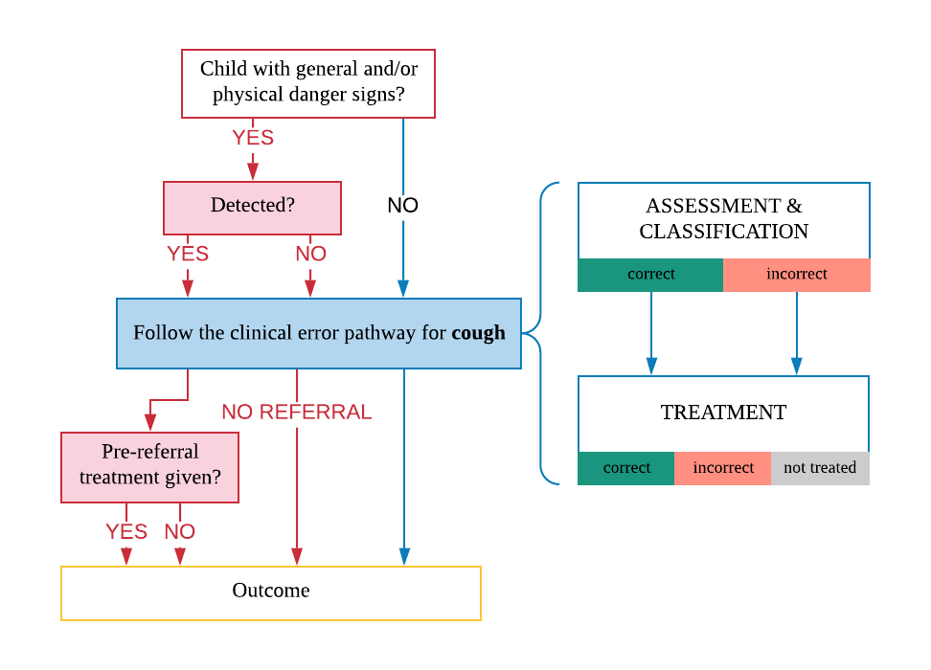
All children coming to the HSA for a health assessment should be checked for general and physical danger signs and assessed for the presence of cough, fever, and diarrhoea. General danger signs are as defined in the IMCI. Physical danger signs in iCCM that also need urgent referral are chest indrawing, palmar pallor, red on MUAC tape and swelling of both feet. If the HSA has detected a danger sign, he should carry on with the assessment of the three main symptoms, and identify a pre-referral treatment. If the HSA has not detected any danger signs and assessed the child for the main symptoms, will give first dose of treatment and counsel the mother to treat at home.
In Figure 2 above, a clinical error pathway is shown as the assessment and classification of disease by the HSA is not 100% correct and there is possibility of misdiagnosis and treatment that we want to capture in the model of this intervention. A child with a cough or difficult breathing and:
- presents fast breathing with any of the general danger signs, should be classified as fast breathing with danger sign (severe pneumonia), referred immediately to a health facility and given a first dose of antibiotic.
- presents fast breathing with no general danger signs and a negative RDT, should be classified as fast breathing (pneumonia) and treated at home.
- presents with cough and no fast breathing, should be classified as common cold or cough, and not treated.
- If a child with cough for over 21 days, should be classified as other and referred to a health facility for further diagnosis.
Figure 3 – HSA’s performance of iCCM assessment and classification of cough or difficult breathing

Figure 3 shows an approach to determine the quality of care provided by the HSAs for WHO-defined pneumonia. Based on the signs and symptoms derived in the natural history model, the iCCM classification of ‘no pneumonia’, ‘non-severe pneumonia’ and ‘severe pneumonia’ will be generated in the diagnostic algorithm module, and presented as the ‘gold standard’. Then, a sensitivity of correct classification by the HSA is applied, if the case was not correctly classified, it will be given a probability of a classification of the other two possible classifications
Following the assessment and classifications given by the HSA, the probability of correct decision to treat or refer is assigned. For the community level, the Health System Interaction (HSI) events are:
- HSI_iCCM_Pneumonia_Treatment_level_0,
- HSI_iCCM_Severe_Pneumonia_Treatment_level_0

Care management at the primary level (facility level 1)
Within the health system at the primary care level, clinical diagnosis of pneumonia follows the WHO IMNCI approach, a simplified guide to detect fast breathing, chest-indrawing and general danger signs (Table 1). Suspected cases are further classified as ‘non-severe’ or ‘severe’ on the basis of the severity of symptoms, and managed accordingly. Classification indicates severity rather than an exact diagnosis. It does not include chest examination with auscultatory findings including, wheeze, crackles, bronchial breath sounds, percussion findings⁴⁴. At the first referral level (district hospital and CHAM hospital) chest radiograph may be performed in combination with clinical findings for further differential diagnosis of respiratory conditions, including complications related to ALRI.
Illustrated in Figure 3, is the approach to determine the quality of service provided by health workers at the first level health facility (health centres and community hospitals) for WHO-defined pneumonia. Depending on symptoms generated in the natural history model, an IMCI classification of ‘no pneumonia/common cold’, ‘non-severe pneumonia’ and ‘severe pneumonia’ will be generated in the diagnostic algorithm module, and presented as the ‘gold standard’. Then, a sensitivity of correct classification by the health worker is applied, if the case was not correctly classified, it will be given a probability of a classification of the other two possible classification. E.g. a child presenting symptoms that fall into the IMCI ‘severe pneumonia’ can be either given the right classification, or the other two ‘non-severe pneumonia’ or ‘no pneumonia’ classification, which will then be treated accordingly.
Figure 4 – Quality of IMCI service provision for ALRI assessment and classification (2-59 months)
This rationale will be applied for the other childhood-related diseases within the IMCI, starting with the assessment of main symptoms: cough/difficult breathing (for pneumonia), fever, diarrhoea, nutritional status, HIV status check and immunization check. Then, apply the sensitivity of correct classification and following action plan. Similarly, Figure 5, is the approach to determine whether a child with IMCI classification of pneumonia has been given its correct respective treatment.
Figure 5 – Quality of IMCI service provision for correct pneumonia treatment (2-59 month)
In the same rationale as the assessment and classification of IMCI pneumonia, the quality of service provision in terms of correct treatment given is also part of the diagnostic algorithm module, and as of an important step as in the assessment and classification. If classification of ‘no pneumonia’ only supportive care at home is advised and no antibiotics are given; ‘non-severe pneumonia’ classification requires antibiotics only; and ‘severe pneumonia’ requires referral for further care, antibiotics and oxygen therapy. Since over-prescription of antibiotics is a common practice in Malawi facilities for children presenting cough or difficult breathing without IMCI pneumonia classification⁴⁵, this would be an important issue to measure and address.
The HSI events for cough/ difficult breathing at the facility level 1 include:
HSI_IMCI_No_Pneumonia_Treatment_level_1 (no consumables/ home care advice)
HSI_IMCI_Pneumonia_Treatment_level_1
HSI_IMCI_Severe_Pneumonia_Treatment_level_1

Care management at the secondary level (facility level 2)

Signs and symptoms from Hospital Pocketbook:
Severe pneumonia diagnosis – cough or difficulty in breathing, plus at least one of the following:
- Central cyanosis or oxygen saturation < 90% on pulse oximetry
- Severe respiratory distress (e.g. grunting, very severe chest indrawing)
- Signs of pneumonia with a general danger sign: inability to breastfeed or drink, lethargy or unconscious, convulsions.
- In addition some or all of the other signs of pneumonia may be present:
  - fast breathing age 2-11 months >=50/min, age 1-5 years >=40/min
  - chest indrawing
  - chest auscultation signs: decreased breath sounds, bronchial breath sounds, crackles, abnormal vocal resonance (decreased over pleural effusion or empyema, increased over lobar consolidation), pleural rub.
Investigations:
Measure oxygen saturation with pulse oximetry in all children suspected of having pneumonia
If possible, obtain chest X-ray to identify pleural effusion, empyema, pneumothorax, pneumatocoele, interstitial pneumonia, pericardial effusion.

Pneumonia diagnosis – cough or difficulty in breathing, plus at least one of the following:
- fast breathing age 2-11 months >=50/min, age 1-5 years >=40/min
- lower chest wall indrawing
In addition either crackles or pleural rub may be present on chest auscultation. Check that there are no signs of severe pneumonia, such as:
– oxygen saturation < 90% on pulse oximetry or central cyanosis
– severe respiratory distress (e.g. grunting, very severe chest indrawing)
– inability to breastfeed or drink or vomiting everything
– convulsions, lethargy or reduced level of consciousness
– auscultatory findings of decreased or bronchial breath sounds or signs of pleural effusion or empyema.#

Pleural effusion and empyema diagnosis:
- On examination, the chest is dull to percussion, and breath sounds are reduced or absent over the affected area
- A pleural rub may be heard at an early stage before the effusion is fully developed.
- A chest X-ray shows fluid on one or both sides of the chest.
- When empyema is present, fever persists despite antibiotic therapy, and the pleural fl uid is cloudy or frankly purulent.
Treatment – drainage and antibiotic therapy, failure to improve – test for HIV and assess for TB

Lung abscess diagnosis:
Common signs and symptoms:
- Fever
- Pleuritic chest pain
- Sputum production or haemoptysis
- Weight loss
- On examination: reduced chest movement, decreased breath sounds, dullness to percussion, crackles, and bronchial breathing.
- Chest X-ray: solitary, thick-walled cavity in the lung with or without air fluid level.
- Ultrasonography and CT scan: to localize the lesion and guide drainage or needle aspiration.
Treatment – antibiotics treatment, surgical management

Pneumothorax diagnosis:
- Signs and symptoms may vary according to the extent of lung collapse, degree of intrapleural pressure, and rapidity of onset.
- On examination: chest bulging on the affected side if one side is involved, shift of cardiac impulse away from the site of the pneumothorax, decreased breath sounds on the affected side, grunting, severe respiratory distress and cyanosis may occur late in the progression of the complication.
- Differential diagnosis include lung cyst, lobar emphysema, bullae, diaphragmatic hernia
- Chest X-ray is crucial in the confirmation of diagnosis.
Treatment – need for compression, chest drainage

Bronchiolitis diagnosis:
– First episode of wheeze in a child aged < 2 years – Wheeze episode at time of seasonal bronchiolitis – Hyperinflation of the chest – Prolonged expiration – Reduced air entry (if very severe, airway obstruction) – Poor or no response to bronchodilators – Apnoea in young infants, especially if born preterm

Typical features of bronchiolitis, on examination, include:
- wheezing that is not relieved by up to three doses of a rapid-acting bronchodilator
- hyperinflation of the chest, with increased resonance to percussion
- lower chest wall indrawing
- fine crackles and wheeze on auscultation of the chest
- difficulty in feeding, breastfeeding or drinking owing to respiratory distress
- nasal discharge, which can cause severe nasal obstruction.

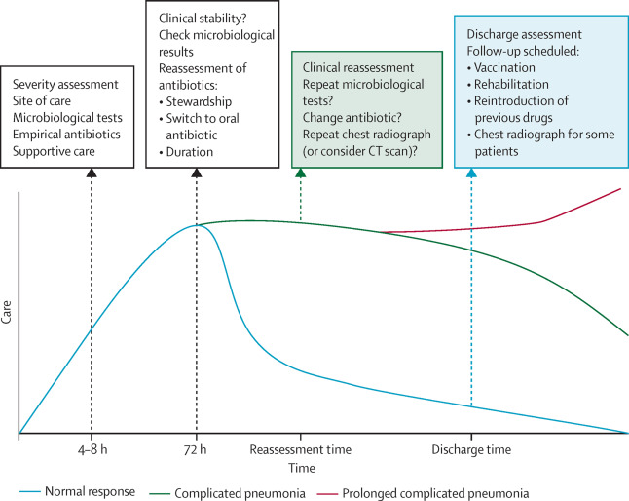
Necrosis and cavitation are rare complications with a pure pneumococcal aetiology

Example model outputs

Health worker’s performance vs IMCI ‘gold-standard’ vs underlying ‘true’ ALRI disease
In a simulation run from 01/01/2010 to 01/02/2015, population size N=50,000, displayed in Figure 6 is the average number of cases per year (y-axis) with the proportions of different diagnosis by the health workers represented by the bars, for each IMCI ‘gold-standard’ classification (x-axis).
Figure 6 - IMCI pneumonia classifications by health workers (at facility level 1)
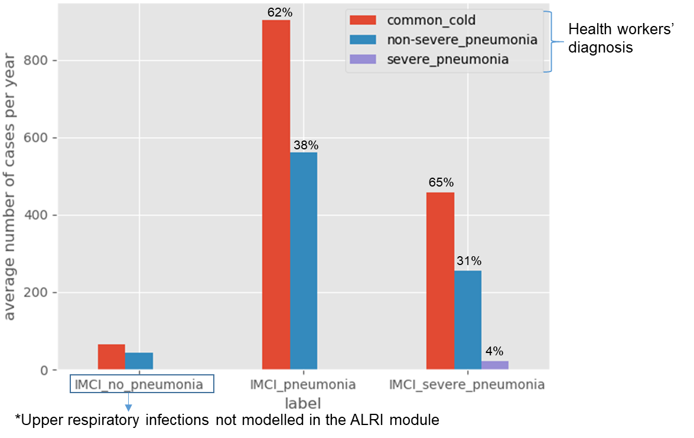
The IMCI classifications in the y-axis, are computed using the signs and symptoms outputted from the natural history model. Based on the sensitivities of correct and incorrect IMCI-classifications (Figure 7), the health workers’ performance is tabulated across the IMCI ‘gold-standard’.
Figure 7 - Sensitivities of correct IMCI classifications inputted in the model
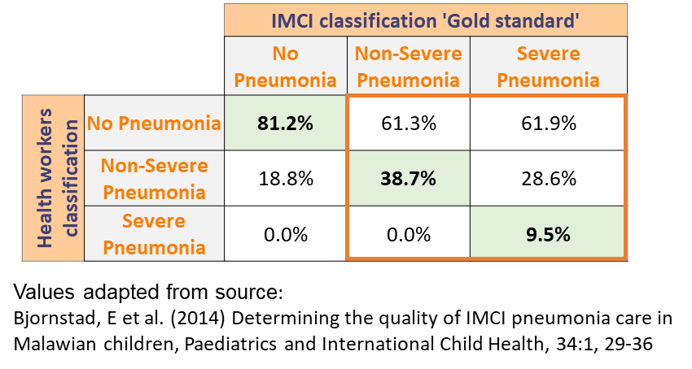

The following figure (Figure 8) displays the underlying ‘true’ condition (x-axis) and the respective IMCI classifications that the clinical signs and symptoms fall under, represented by the bars.
Figure 8 - IMCI classifications for underlying ALRI condition
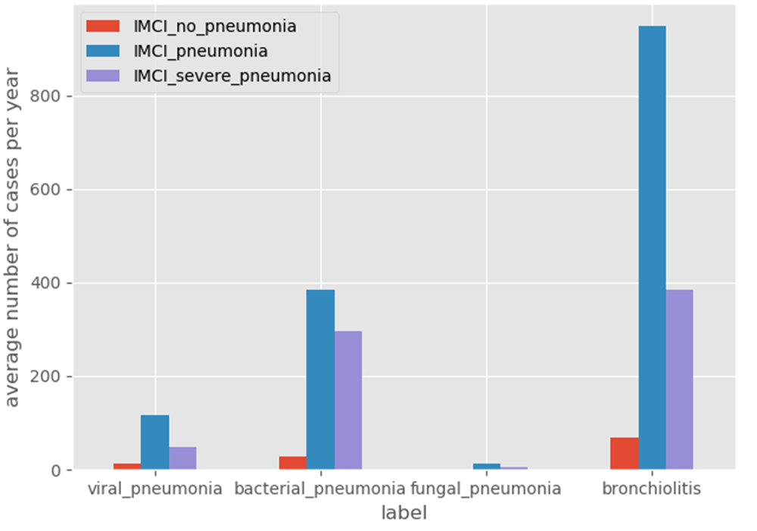
The following figure (Figure 9) displays the underlying ‘true’ condition (x-axis) and the respective health workers’ classifications given based on the sensitivity of correct/ incorrect classifications.
Figure 9 - Health worker classifications for underlying ALRI condition
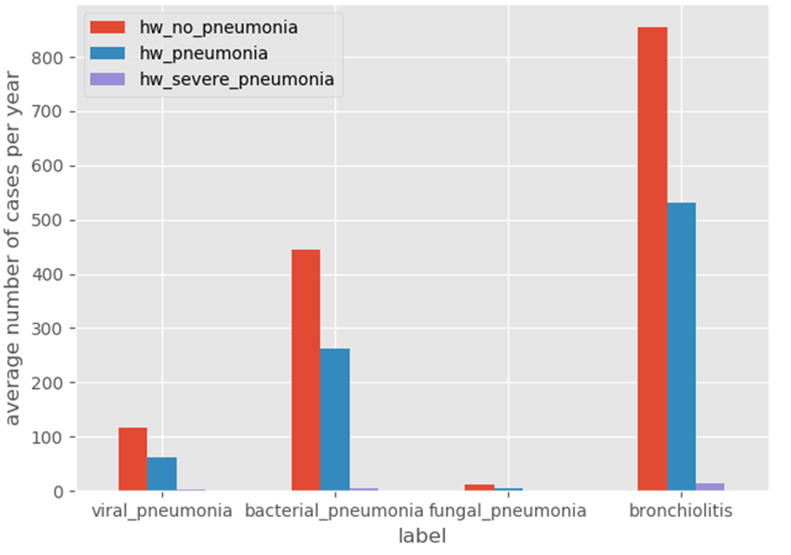

Policy questions for ALRI model

How are policy questions formulated? – Baseline analysis
Using disease and intervention models built in Python, we can simulate the epidemiology of acute lower respiratory infections in children, namely pneumonia and bronchiolitis. From this simulation, we can analyse different scenarios of improved quality of care at the health system level on health outcomes; as well as scenarios with new or improved implementation of effective interventions.
From the natural history of the disease (ALRI) – signs and symptoms are generated with a certain probability informed by published studies. Then, using these signs and symptoms, we compute those that would match the IMCI classification of (non-severe) pneumonia and severe pneumonia. Therefore, this can be the initial simple analysis of the ALRI natural history model: IMCI classification of pneumonia based on the algorithm with the use of symptoms arising from the natural history, and see what proportions are missed classifications. Similarly, we can analyse cases with severe complications (sepsis, meningitis, respiratory failure) that fall into IMCI-severe pneumonia classification, and missed cases by using the algorithm.
Additionally, an analysis of the current health system delivery of care for children presenting with respiratory symptoms, with the DxTest function from the HealthSystem module, we can “set the scene” in terms of the current performance of the IMCI algorithm, and consequent assessment, classification, and treatment of sick children. This is assigned through the sensitivity value of correct classification and probabilities of incorrect classification to other categories. Then, following basic analyses, we can perform more complex questions, described next.

Key questions/ outputs from the model
We can add new interventions or improve the quality/implementation of existing ones. For example, we can use the model to quantify the benefits of an implementation of RSV vaccine, with ranging effectiveness and coverage, on the epidemiology of ALRI and child mortality; scale-up of pulse oximetry as a diagnostic tool; scale-up of oxygen therapy including bubble CPAP in hospitals and quantify its effects on mortality.
Question 1: Implementation of RSV vaccine (multiple effectiveness and coverage values) see the effect on pneumonia incidence and mortality rate.
Question 2: Adding pulse oximetry in the assessment process of a sick child – see changes in IMCI classification / missed cases by the algorithm, consequent treatment, and outcomes
Question 3: Scale-up of oxygen therapy in hospitals – effect on mortality
Question 4: Improve health workers’ sensitivity on DxTest – see the effect on treatment rate of ALRI and outcome.
Overall, using the model to explore how much diagnosis improve, and how much can mortality be reduced.

Key question 1 – Implementation of RSV vaccine
Table 11 - Properties needed for the analysis of Question 1
Properties | Type | Description
ri_RSV_vaccination_status | Boolean | RSV vaccination status  Yes/No
Table 12 - Parameters needed for the analysis of Question 1
Parameters | Type | Description
RSV_vaccine_effectiveness | List  [50%, 75%, 90%, 100%] | List of a range of effectiveness values
RSV_vaccine_coverage | List  [50%, 75%, 90%, 100%] | List of a range of coverage values

With a RSV vaccination programme, it is expected to see a reduction in the incidence of ALRI, as well as reduction in mortality due to ALRI, dependent on the effectiveness and coverage of vaccination programme.
Planned outputs from code:
- Two scenarios: incidence of each attributable pathogens before and after RSV vaccine – see the changes in the epidemiology of ALRI pathogens.
- Graph showing two scenarios: before and after introduction of a RSV vaccine programme on ALRI-specific under-5 mortality / all-cause under-5 mortality
OR
- Graph showing trend in ALRI-specific mortality, with added introduction of RSV vaccine at one time point, and see its effect on the mortality trend

Key question 2 – Scale-up of pulse oximetry
The goal with analyses regarding the scale-up of pulse oximetry is to help us answer policy-relevant questions such as, ‘How can the addition of pulse oximetry improve IMCI classification and consequent treatment and outcomes for children with pneumonia’
Table 13 - Properties needed for the analysis of Question 2
Properties | Type | Description
ri_peripheral_oxygen_saturation | Categorical  ‘SpO₂ < 90%’, ‘SpO₂ 90-92%’, ‘SpO₂ > 92%’, ‘missing-pulse oximetry attempted’, ‘missing-no pulse oximetry’ | Level of peripheral oxygen saturation to be read by a pulse oximetry

Planned outputs from code:
- Graph showing the IMCI classification rate using pulse oximetry (only) vs. IMCI algorithm (only) – with health workers sensitivity for IMCI classification assumed to be 100%.
- Graph showing the added advantage of using pulse oximetry in the IMCI algorithm for classification of IMCI pneumonia – improved detection of IMCI-pneumonia, comparison between non-use vs in combination with the algorithm.

Key question 3 – Scale-up of oxygen therapy
The goal with analyses regarding the scale-up of oxygen therapy is to quantify the benefit of scaling up this equipment on mortality.
Planned outputs from code:
- Current availability of oxygen therapy vs. scale-up of oxygen therapy and its effect on ALRI-specific under-5 mortality. – Graph of two scenarios

Key question 4 – Improved health worker sensitivity
The goal with analyses regarding the improvement of health workers’ skills is to help us answer policy-relevant questions such as, ‘How will improvements in health worker diagnosis of childhood pneumonia using IMCI improve treatment and outcomes for children with pneumonia?’
Planned outputs from code:
- Improved health worker’s sensitivity in classification of IMCI based on algorithm alone, see its effects on treatment rate and all-cause mortality.

End goal of proposed analyses
Targeted audience for sharing and use of the results include:
1st – guide Malawi’s Ministry of Health in their investment in child health in the next Health Sector Strategic Plan III (2022-2027).
2nd – inform WHO of the benefits and issues with the current guidelines on assessment, classification and treatment of IMCI-pneumonia; what potential improvements are there with the introduction of pulse oximetry in the algorithm.
3rd – other researchers to build on this work to further their research

ALRI Properties update
At initiation of the simulation, the ALRI property values for the initial population are set such that there are no individuals with ALRI. Property name & initial state at T0:
Table 14 – ALRI Property names and values at initiation
Property name | State at T0
ri_ALRI_status | False
ri_primary_ALRI_pathogen | not_applicable
ri_secondary_bacterial_pathogen | not_applicable
ri_ALRI_disease_type | not_applicable
ri_current_ALRI_symptoms | not_applicable
ri_ALRI_complications | not_applicable
ri_ALRI_event_date_of_onset | pd.NaT
ri_ALRI_event_recovered_date | pd.NaT
ri_ALRI_event_death_date | pd.NaT
ri_end_of_last_alri_episode | pd.NaT
ri_ALRI_on_treatment | False
ri_ALRI_tx_start_date | pd.NaT
ri_chest_auscultations_signs | not_applicable
ri_ALRI_antibiotic_administered | not_applicable
ri_peripheral_oxygen_saturation | not_applicable
ri_oxygen_therapy_given | False

When the simulation is run, the model updates information on each individual with regards to ALRI status every 3 months. In this section, the following diagrams illustrate how the ALRI module updates its properties in the simulation run, which are determined by parameters.

- Updating ALRI status based on the incidence of infection by a certain pathogen
Property name: ri_ALRI_status, Type: Boolean
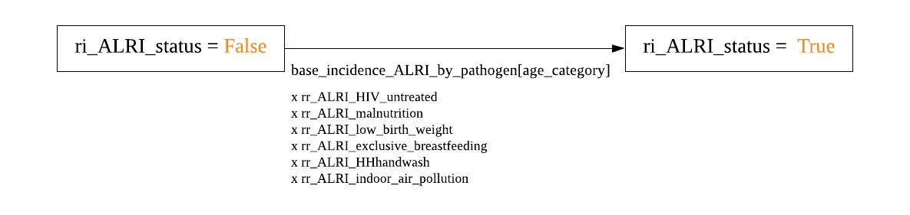
Based on pathogen-specific incidences of ALRI and the relative risk of risk factors for disease acquisition, an individual can acquire an ALRI status. Therefore updating the property ri_ALRI_status to ‘True’.
As the ALRI status is ‘True’ so will the other ALRI properties be updated.

- Updating the primary pathogen causing ALRI
Property name: ri_primary_ALRI_pathogen, Type: Categorical
Further detailing the move between ‘False’ and ‘True’ of the ri_ALRI_status property, at T0 the ri_primary_ALRI_pathogen status is ‘not_applicable’ as there is no infection. When an ALRI infection is acquired based on the pathogen-specific incidences and the effects of risk factors on disease acquisition, the causal pathogen for that episode is updated.
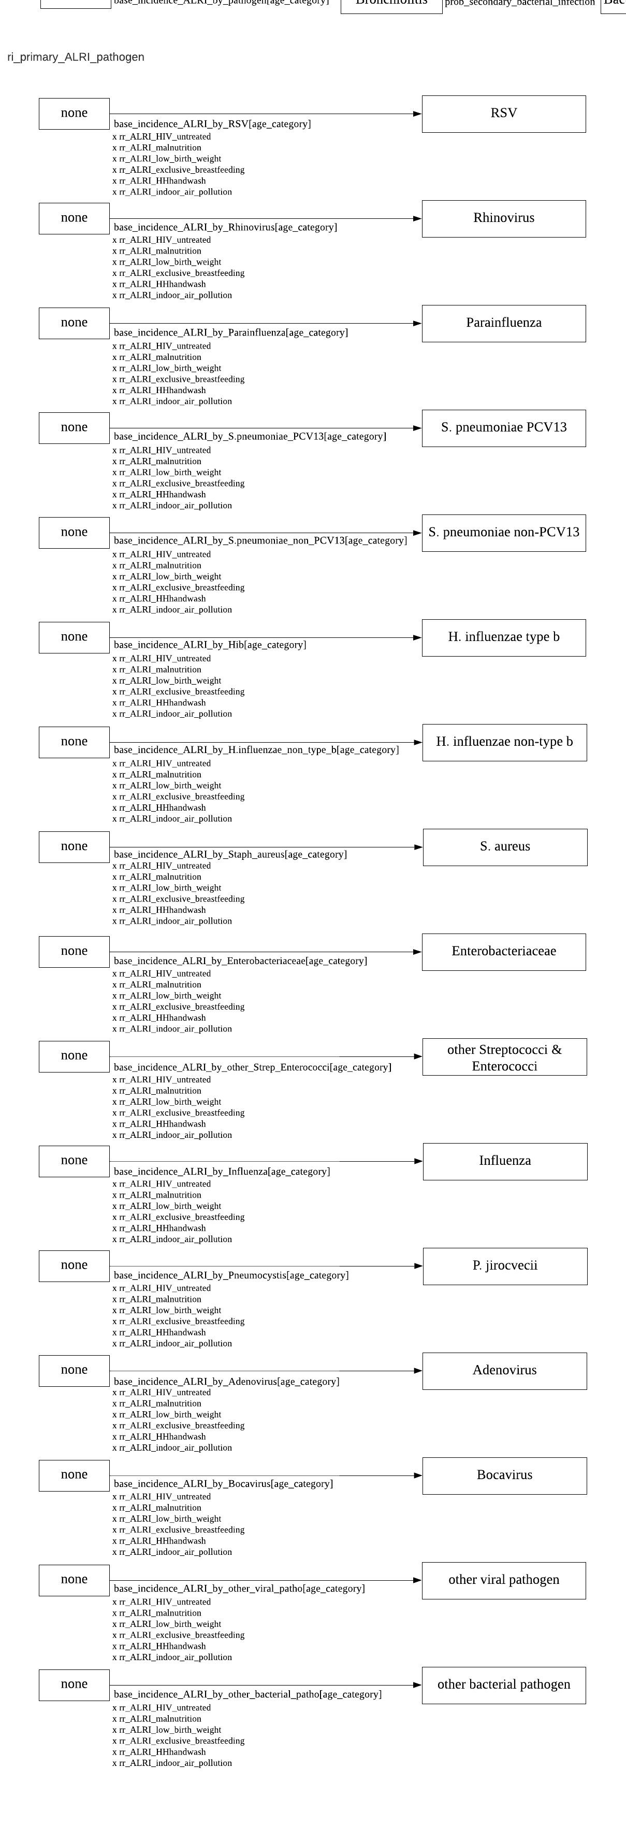
Continued….


- Updating ALRI disease type following acquisition of primary pathogen
Property name: ri_ALRI_disease_type, type: Categorical
Upon acquisition of a primary pathogen causing ALRI, the disease type is updated to Viral Pneumonia, Bronchiolitis, Bacterial Pneumonia, and Fungal Pneumonia. If viral pathogen was acquired, dependent on the causal agent a certain proportion will cause Viral Pneumonia and the other proportion will cause Bronchiolitis. A probability of a co-infection/secondary bacterial infection is applied for these two viral disease states and the disease type will then be Bacterial Pneumonia. If bacterial pathogen was acquired, the disease type is automatically set as Bacterial Pneumonia; same as for fungal pathogen which will update to Fungal Pneumonia.
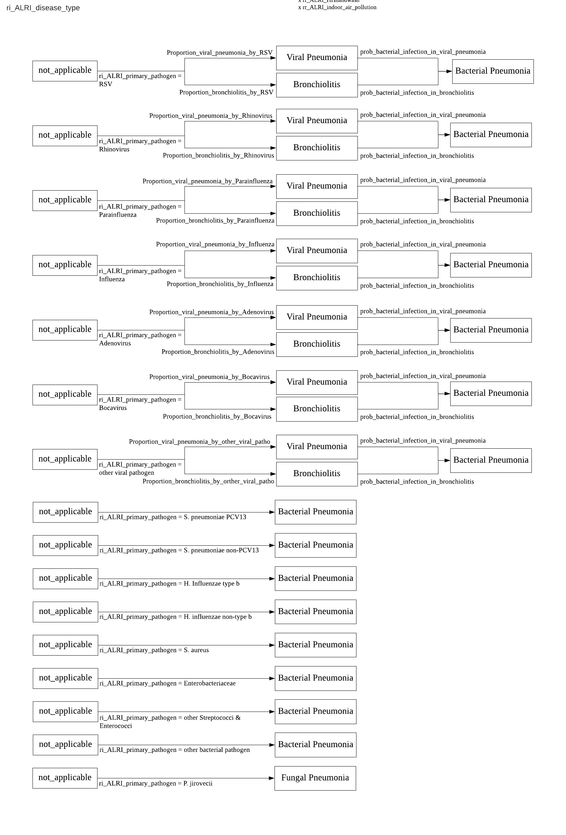

- When a co-infection /secondary bacterial infection is acquired, the causal bacterial pathogen is updated
Property name: ri_secondary_bacterial_pathogen, type: Categorical
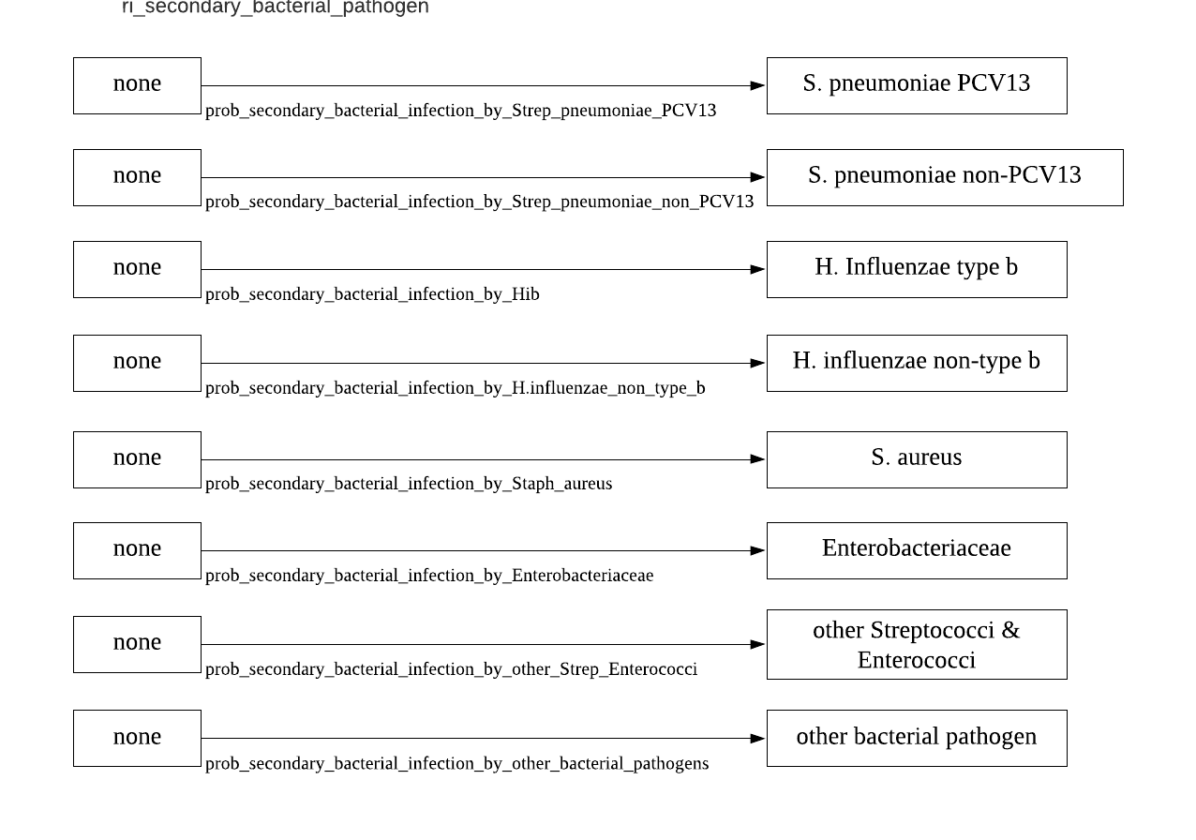
For individuals who do not have an ALRI infection, the category for ri_secondary_bacterial_pathogen is ‘not_applicable’, as it is at T0. Following a ALRI status as ‘True’, the property updating on secondary bacterial pathogens is set to ‘none’.

- Updating ALRI complications
Property name: ri_ALRI_complications. Type: List
Individuals can have one or multiple complications. At initiation, with no ALRI infections, the ri_ALRI_complications is set as ‘not_applicable’, once the ALRI status is ‘True’, the value is set to ‘none’. Then, based on probability of each disease type developing each complication and progression, the list is updated.

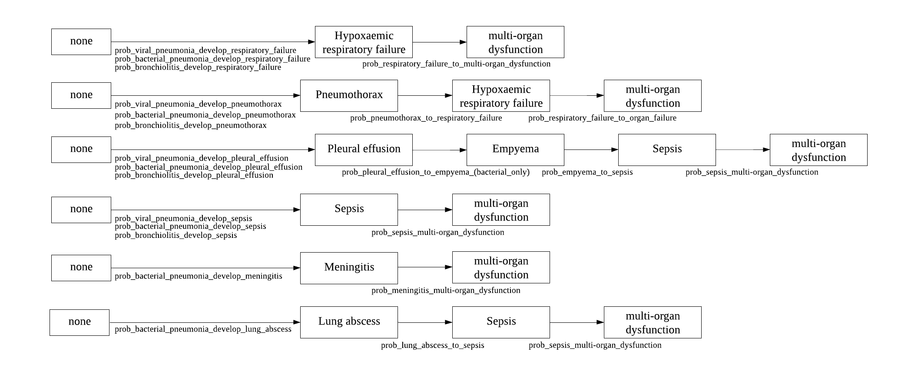

References
1. Liu, L. et al. Global, regional, and national causes of under-5 mortality in 2000–15: an updated systematic analysis with implications for the Sustainable Development Goals. Lancet 388, 3027–3035 (2016).
2. Wardlaw, T., Johansson, E. W. & Hodge, M. PNEUMONIA THE FORGOTTEN KILLER OF CHILDREN. (2006).
3. Braunwald, E. et al. Harrison’s principles of internal medicine. (McGraw Hill, 2001).
4. Mackenzie, G. The definition and classification of pneumonia. Pneumonia 8, 14 (2016).
5. Feikin, D. R. et al. The Enduring Challenge of Determining Pneumonia Etiology in Children: Considerations for Future Research Priorities. Clin. Infect. Dis. (2017). doi:10.1093/cid/cix143
6. Berti, E., Galli, L., De Martino, M. & Chiappini, E. International guidelines on tackling community-acquired pneumonia show major discrepancies between developed and developing countries. Acta Paediatr. Int. J. Paediatr. 102, 4–16 (2013).
7. Rylance, J. & Waitt, P. Pneumonia severity scores in resource poor settings. Pneumonia 5, 30–37 (2014).
8. Rudan, I., Tomaskovic, L., Boschi-Pinto, C. & Campbell, H. Global estimate of the incidence of clinical pneumonia among children under five years of age. Bull. World Health Organ. 82, 895–903 (2004).
9. Duke, T. What the PERCH study means for future pneumonia strategies. The Lancet 394, 714–716 (2019).
10. O, K. L. et al. Articles Causes of severe pneumonia requiring hospital admission in children without HIV infection from Africa and Asia: the PERCH multi-country case-control study. (2019). doi:10.1016/S0140-6736(19)30721-4
11. Walker, C. L. F. et al. Global burden of childhood pneumonia and diarrhoea. Lancet (London, England) 381, 1405–1416 (2013).
12. Jackson, S. et al. Risk factors for severe acute lower respiratory infections in children - a systematic review and meta-analysis. Croat. Med. J. 54, 110–121 (2013).
13. McCollum, E. D. et al. Impact of the 13-Valent Pneumococcal Conjugate Vaccine on Clinical and Hypoxemic Childhood Pneumonia over Three Years in Central Malawi: An Observational Study. PLoS One 12, e0168209 (2017).
14. O’Grady, K.-A. F., Torzillo, P. J., Frawley, K. & Chang, A. B. The radiological diagnosis of pneumonia in children. Pneumonia 2014 51 5, 38–51 (2014).
15. Lipsett, S. C., Monuteaux, M. C., Bachur, R. G., Finn, N. & Neuman, M. I. Negative Chest Radiography and Risk of Pneumonia. Pediatrics 142, (2018).
16. Begom, A. et al. Clinical and Radiological Evaluation of Children Aged 2 Months to 5 Years with Severe Pneumonia According to WHO Guideline. Mymensingh Med. J. 27, 702–709 (2018).
17. Hazir, T. et al. Chest radiography in children aged 2-59 months diagnosed with non-severe pneumonia as defined by World Health Organization: Descriptive multicentre study in Pakistan. Br. Med. J. 333, 629–631 (2006).
18. Balk, D. S. et al. Lung ultrasound compared to chest X-ray for diagnosis of pediatric pneumonia: A meta-analysis. Pediatr. Pulmonol. 53, 1130–1139 (2018).
19. Meissner, H. C. Viral Bronchiolitis in Children. N. Engl. J. Med. 374, 62–72 (2016).
20. Piedimonte, G. & Perez, M. K. Respiratory syncytial virus infection and bronchiolitis. Pediatr. Rev. 35, 519–530 (2014).
21. Napierkowski, D. B. Diagnosing and treating respiratory syncytial virus bronchiolitis. Nurse Pract. 41, 1–4 (2016).
22. Quinton, L. J., Walkey, A. J. & Mizgerd, J. P. Integrative physiology of pneumonia. Physiol. Rev. 98, 1417–1464 (2018).
23. Cawcutt, K. & Kalil, A. C. Pneumonia with bacterial and viral coinfection. Curr. Opin. Crit. Care 23, 385–390 (2017).
24. Nolan, V. G. et al. Etiology and Impact of Coinfections in Children Hospitalized With Community-Acquired Pneumonia. doi:10.1093/infdis/jix641
25. Ericksen, R. T., Guthrie, C. & Carroll, T. The Use of Procalcitonin for Prediction of Pulmonary Bacterial Coinfection in Children With Respiratory Failure Associated With Viral Bronchiolitis. Clin. Pediatr. (Phila). 58, 288–294 (2019).
26. Ruuskanen, O., Lahti, E., Jennings, L. C. & Murdoch, D. R. Viral pneumonia. The Lancet 377, 1264–1275 (2011).
27. Ishizuka, S. et al. Effects of Rhinovirus Infection on the Adherence of Streptococcus pneumoniae to Cultured Human Airway Epithelial Cells. J. Infect. Dis. 188, 1928–1939 (2003).
28. Madhi, S. A., Klugman, K. P. & The Vaccine Trialist Group. A role for Streptococcus pneumoniae in virus-associated pneumonia. Nat. Med. 10, 811–813 (2004).
29. Siegel, S. J. & Weiser, J. N. Mechanisms of Bacterial Colonization of the Respiratory Tract. Annu. Rev. Microbiol. 69, 425–444 (2015).
30. HOSPITAL CARE FOR CHILDREN WHO ISBN 978 92 4 154837 3.
31. ICD-11 - Mortality and Morbidity Statistics. Available at: https://icd.who.int/browse11/l-m/en. (Accessed: 24th May 2020)
32. Haque, K. N. Definitions of bloodstream infection in the newborn. Pediatr. Crit. Care Med. 6, S45–S49 (2005).
33. Lazzerini, M. et al. Mortality and its risk factors in Malawian children admitted to hospital with clinical pneumonia, 2001-12: A retrospective observational study. Lancet Glob. Heal. (2016). doi:10.1016/S2214-109X(15)00215-6
34. Goodman, D. et al. Challenges in the diagnosis of paediatric pneumonia in intervention field trials: recommendations from a pneumonia field trial working group. The Lancet Respiratory Medicine 7, 1068–1083 (2019).
35. Fancourt, N. et al. Chest radiograph findings in childhood pneumonia cases from the multisite PERCH study. Clin. Infect. Dis. 64, S262–S270 (2017).
36. Nicholas Fancourt, Maria Deloria Knoll, Breanna Barger-Kamate, John de Campo, Margaret de Campo, Mahamadou Diallo, Bernard E. Ebruke, Daniel R. Feikin, Fergus Gleeson, Wenfeng Gong, Laura L. Hammitt, Rasa Izadnegahdar, Anchalee Kruatrachue, Shabir A. Madh, K. L. O. Standardized Interpretation of Chest Radiographs in Cases of Pediatric Pneumonia From the PERCH Study. Clin. Infect. Dis. S253–S261 (2017).
37. Benguigui, Y. [Magnitude and control of acute respiratory infections in children]. Salud Publica Mex. 30, 362–9
38. Hortensia, R. et al. Infant Mortality Due to Acute Respiratory Infections: The influence of Primary Care Processes. Health Policy Plan. 12, 214–230 (1997).
39. Ghimire, M., Pradhan, Y. V. & Maskey, M. K. Community-based interventions for diarrhoeal diseases and acute respiratory infections in Nepal. Bull. World Health Organ. 88, 216–221 (2010).
40. Berkley, J. A. et al. Prognostic indicators of early and late death in children admitted to district hospital in Kenya: Cohort study. Br. Med. J. 326, 361–364 (2003).
41. Ng’ambi, W. et al. Factors associated with healthcare seeking behaviour for children in Malawi: 2016. Trop. Med. Int. Heal. (2020). doi:10.1111/tmi.13499
42. Nguyen, D. T. K., Leung, K. K., McIntyre, L., Ghali, W. A. & Sauve, R. Does Integrated Management of Childhood Illness (IMCI) Training Improve the Skills of Health Workers? A Systematic Review and Meta-Analysis. PLoS One 8, e66030 (2013).
43. Uwemedimo, O. T. et al. Distribution and determinants of pneumonia diagnosis using Integrated Management of Childhood Illness guidelines: a nationally representative study in Malawi. BMJ Glob. Heal. 3, e000506 (2018).
44. WHO Recommendations on the Management of Diarrhoea and Pneumonia in HIV-Infected Infants and Children. WHO Recommendations on the Management of Diarrhoea and Pneumonia in HIV-Infected Infants and Children: Integrated Management of Childhood Illness (IMCI) (World Health Organization, 2010).
45. Johansson, E. W., Nsona, H., Carvajal-Aguirre, L., Amouzou, A. & Hildenwall, H. Determinants of Integrated Management of hildhood Illness (IMCI) non-severe pneumonia classification and care in Malawi health facilities: Analysis of a national facility census. J. Glob. Health 7, (2017).

Christian Health Association of Malawi (CHAM)

