Modelling of Epilepsy and use and effect of Antiepileptics within the Thanzi La Onse Model

Background: The Thanzi La Onse Model
As part of the Thanzi La Onse program a model is being developed which aims to capture the health experiences of the population of Malawi and the consequent interactions with the health care system. The intent is that this model will help to inform future delivery of health care in Malawi. The model is an individual based model – which means we explicitly simulate the individual life and health experiences of a representative proportion of population of Malawi. The simulation initiates on 1 Jan 2010 and we attempt to simulate the attributes of the population at that point. We can run the model forward to any specified future time point. Each potential intervention and its associated diseases are being modelled. This is being divided into separate disease/intervention modules. This document describes the module on depression and use of antidepressants.

Background: General approach to decisions on modelling causal influences and effects of interventions
This module was designed in the context of an overall approach to modelling causal effects in general and causal effects of interventions in particular. The overall intent is to adopt as simple a structure as can be conceived, whilst still capturing the essential elements of a disease and the interventions used to prevent or treatment. We include a causal link between a “variable” (by which we mean a characteristic or property of an individual, whether that be demographic, social or biologic), and risk of disease or another variable if there is strong evidence from an overall body of studies that such a causal link exists and is at least moderately strong. In informing such decisions we place particular value on RCTs or studies with a quasi-experimental design such as analyses based on an instrumental variable There is no expectation that such studies will be from Malawi or even from Africa. If there are such local studies and in the unlikely event that they provide strong evidence to suggest that the causal link is substantively different in Malawi then the intent is that this is taken into account and the Malawi-specific link included.
In the special case of a potential causal variable which relates to whether an individual has experienced or is experiencing an intervention the intent is to only include interventions if there is substantial RCT evidence of their beneficial effect, based on trials with objectively ascertained clinical endpoints with low risk of serious bias. Whilst DCP-3 (and to some extent the Malawi EHP) provides an initial list of such interventions and the evidence to support them, where possible our intent has been to form our own opinion on intervention efficacy based on the source trials.
Unless there is evidence to the contrary, the intent is to summarize and incorporate intervention effects into the model as relative risks or rates rather than absolute differences due to the fact that such measures are less likely to differ substantively by context. Interactions between characteristics (on the multiplicative scale) are only to be incorporated if there is strong evidence. Again, we have not intended to rely on data from Malawi or Africa for such evidence but if local evidence exists which strongly suggests a different effect than elsewhere then the intent is that this modified effect is incorporated in the model.

Background: Demographic and social characteristics modelled
Based on data on the distribution of the population in Malawi according to geographic location we assign individuals a geographic location, which maps onto whether they are classified as living in a rural or urban area. Informed largely by data from the Malawi DHS, variables are also created indicating the person’s wealth level (based on 5 quintiles), whether the person has access to improved sanitation, clean drinking water, hand washing facilities, and whether they experience indoor air pollution (wood burning stove). We assign individuals a current education status (none, primary, secondary) which is updated 3 monthly from age 5 to 20. From age 15 we assign BMI in 5 categories, tobacco use status, drinking excess alcohol, having low exercise, high sugar intake, high salt intake, and marital status (never, currently, widowed/divorced). The status with regard to such variables for individuals can change over time. The influences between these variables are described in detail in a separate document.

Approach to modelling epilepsy and anti-epileptics: rationale for model structure and choice of parameter values
Variables modelled
The model updates information on each individual with regard to epilepsy status every 3 months. information that we create for each individual in relation to epilepsy is seizure status (never seizures, previous seizures not current, current infrequent seizures, current frequent seizures), whether the person is currently on antiepileptics (yes/no), whether the person has died with epilepsy as a direct cause in the period. This is indicated in Figure 1 and Table 1. There are relatively few data available from Malawi on epidemiology of epilepsy and we rely largely on other studies from sub-Saharan Africa to inform model parameter values.
Incidence of epilepsy / seizures
Informed by Ngugi et al 2012, we assume a rate of initial epilepsy development of 0.003 per 3 month period over all ages up to age 20, with a relative rate of 0.3 for ages above 20, and that a proportion 0.1 of incident cases are of frequent seizures (> 3 per month) rather than infrequent. At this point we do not attempt to model causes of epilepsy such as neonatal conditions, infections, or trauma. As more evidence and data accrue we may be able to include this. This incidence rate, together with the other parameter values described below leads to the model outputs in Table 3, such as an overall prevalence of epilepsy of 1.25% (0.8% with current infrequent seizures, 0.05% with current frequent seizures, 0.4% with previous seizures not current).
Deterioration of seizure status (in absence of treatment)
We did not identify direct data on the rate of deterioration in epilepsy status in people with current infrequent seizures, to having frequent seizures, or in people with previous but not current seizures to revert to again having seizures, although this is partially informed by the course of patients in control arms of placebo controlled trials (Shorvon et al 2018). In the absence of strong evidence for a substantial rate of deterioration of status we assume a low rate of 0.02 per 3 months.
Improvement in seizure status (in absence of treatment)
Partially informed by the course of the condition for patients in control arms of placebo controlled trials (Shorvon et al 2018) we assume a rate of improvement in seizure status (from frequent to infrequent or previous seizures not current, and from infrequent seizures to previous seizures not current) in the absence of treatment of 0.05 per 3 months.
Initiation and stopping of antiepileptics
We assume a rate of initiation of antiepileptics in people with frequent seizures (who are not currently on antiepileptics) of 0.06 per 3 months. This low rate is informed by the known large treatment gap (Dent el at 2005, BaDiop et al, 2014). We assume the rate of initiation of antiepileptics in people with infrequent seizures is 0.8 times this rate. Informed by known lack of persistence with treatment (Jost et al 2018, BaDiop et al 2014) we assume a rate per 3 months of stopping antiepileptics in people with previous seizures not current of 0.05, and a relative rate of stopping antiepileptics if having current infrequent or frequent seizures of 1. These parameter values lead to (Table 3) 11.8% of people with infrequent seizures being on antiepileptics, 11.5% of those with frequent seizures and 18.8% of those with previous seizures not current, with a total of 33,000 people being on antiepileptics.
Effect of antiepileptics
Treatment effectiveness is informed by a recent meta-analysis (Shorvon et al 2018). The effect of treatment is assumed to act with the same relative effect on all transitions between seizure status (relative rate of 5-fold for positive transitions and 1/5 = 0.2 fold for negative transitions.
Risk of epilepsy death
We assume a rate of death in people with current infrequent or frequent seizures of 0.001 per 3 months, informed by Ngugi et al 2012 and the resulting outcomes shown in Table 3.

Disability weights
Seizure-free, treated epilepsy = code 862
Infrequent seizures we map to Less severe epilepsy = code 861
Frequent seizures we map to severe epilepsy = code 860

Health System Interactions
Care Seeking & Diagnosis
Blood in urine or pelvic pain are assumed to trigger healthcare seeking to a Non-Emergency Generic Appointment at Facility Level 1, whereupon referral to further health system interaction is indicated. In that appointment, a cytoscopy is undertaken. If that investigation confirms Bladder Cancer and if the stage of cancer is not metastatic then the patient undergoes treatment. If the cancer is confirmed and is in metastatic, the patient is referred to Palliative Care.
We aim for these rates to eventually be informed by data on stage of bladder cancer at diagnosis from the cancer registry, although in the initial report from the registry for very few cancer cases was there a cancer stage at diagnosis recorded (Msyamboza et al, 2012).
Treatment Initiation & Monitoring
Treatment is implemented for the patient in a separate single appointment, following diagnosis of any form of stage prior to stage 4 (low/high grade dysplasia and stages 1-3). The patient is monitored every year thereafter, and if the patients has progressed to stage 4, the patient is initiated on Palliative Care.
Palliative Care
Patients initiated on palliative care remain on palliative care and received a monitoring appointment each month. No benefit for the patient is in effect.

Main Limitations
The main limitations at this point are the uncertainty in uptake and use of antiepileptics in Malawi. We expect to identify sources of data that will allow this uncertainty to be diminished. We make the simplifying assumption that antiepileptics can be treated generically, although we recognise that there are some differences in effectiveness and some resistance to some drugs.

Outstanding Issues
At this point we do not attempt to model causes of epilepsy such as neonatal conditions, infections, or trauma. As more evidence and data accrue we may be able to include this.
Contributors to this module

Figure 1. Diagrams illustrating model structure and parameters.
(a) seizure status
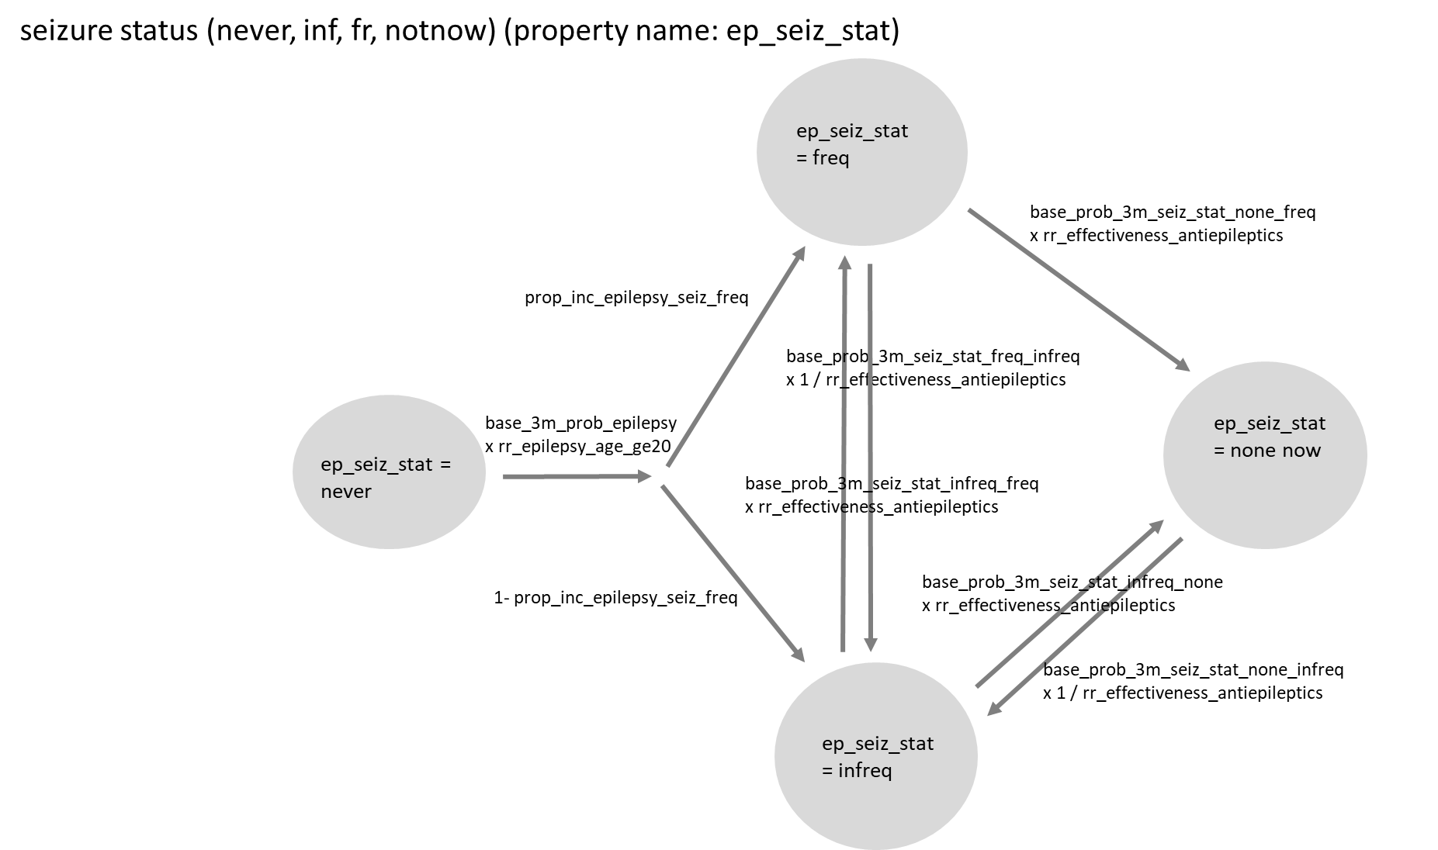

(b) Currently on antiepileptics
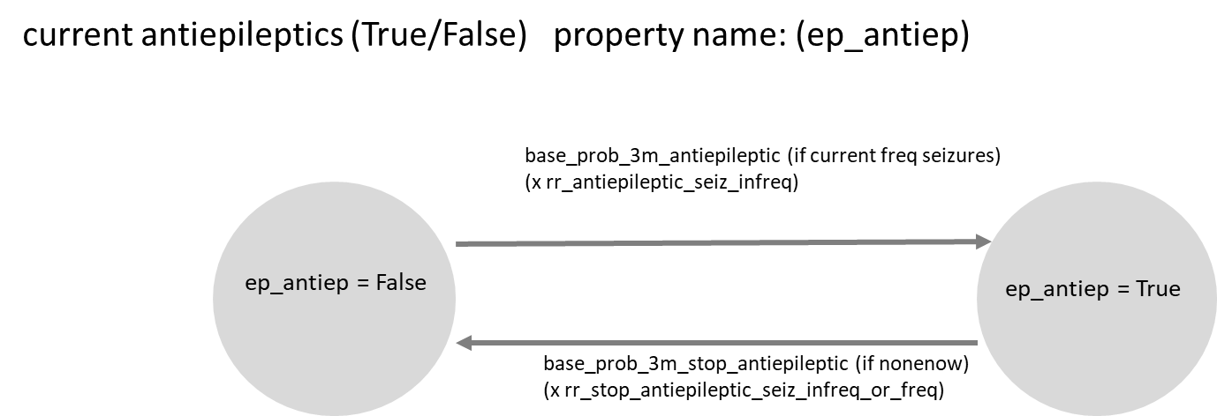

(c) Epilepsy death
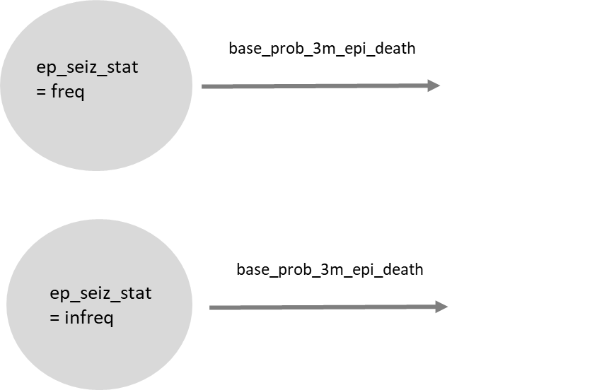

Table 1. Description of variables created relating to epilepsy

Variable | Description | Notes
ep_seiz_stat | epilepsy seizure status (0 = never epilepsy, 1 = previous seizures none now, 2 = infrequent seizures, 3 = frequent seizures) | Frequent defined as > 3 per month
ep_antiep | on anti-epileptic
ep_epi_death | death caused directly by epilepsy | This is death from a seizure

Table 2. Description of parameters and proposed values.
Parameter | Proposed value | Description | Notes
init_epil_seiz_status | 0.9740, 0.0175, 0.0070, 0.0015 | proportions in each seizure status category at baseline | Estimates of prevalence of epilepsy vary by setting but are in this region for sub Saharan Africa (Ba-Diop et al 2014)
init_prop_antiepileptic | 0, 0.15, 0.15, 0.20 | initial proportions on antiepileptic by seizure status | Ba-Diop et al 2014 provide estimates of treatment gap in SSA - based on text description, treatment gap is likely to often be larger in practice
base_3m_prob_epilepsy | 0.003 | base probability of epilepsy per 3 month period if age < 20 | informed by Ngugi 2012
rr_epilepsy_age_ge20 | 0.3 | rate ratio for incidence of epilepsy for age > 20 vs < 20 | age 20 is not a clearly established threshold, but rate declines with age (Ngugi 2012, Ba-Diop 2014)
prop_inc_epilepsy_seiz_freq | 0.1 | proportion of incident epilepsy cases with frequent (vs infrequent) seizures (frequent defined as >= 3 per month, Ngugi et al) | Ngugi et al 2012
rr_effectiveness_antiepileptics | 5 | relative rate of seizure status transitions if on antiepileptic (for negativetransitions, effect is 1/ rr_effectiveness_antiepileptics | effect of treatment - assumed to act with the same relative effect on all transitions between seizure status - difficult to ascertain effect of treatment per se rather than each specific drug (assume 0.2) - informed by Shorvon et al 2018*
base_prob_3m_seiz_stat_freq_infreq | 0.02 | base probability per 3 months of seizure status infrequent if current frequent | no direct estimate identified but rate assumed low*
base_prob_3m_seiz_stat_infreq_freq | 0.05 | base probability per 3 months of seizure status infrequent if current frequent | few data identified on natural transitions without treatment - informed partially by rate in placebo arms of trials (Shorvon et al)*
base_prob_3m_seiz_stat_none_freq | 0.05 | base probability per 3 months of seizure status nonenow if current frequent | few data identified on natural transitions without treatment - informed partially by rate in placebo arms of trials (Shorvon et al)*
base_prob_3m_seiz_stat_infreq_none | 0.02 | base probability per 3 months of seizure status infrequent if nonenow | no direct estimate identified but rate assumed low*
base_prob_3m_seiz_stat_none_infreq | 0.05 | base probability per 3 months of seizure status nonenow if current infrequent | few data identified on natural transitions without treatment =- assume 0.05 per 3 months but expect to modify in future once further data identifed*
base_prob_3m_antiepileptic | 0.06 | base probability per 3 months of starting antiepileptic, if frequent seizures | Known to be a large treatment gap (Dent el at 2005, BaDiop et al 2014). Depends on access - will depend on health care system component - using place-holder value for now (relevant data in US Faught et al 2018, suggest ~ 0.1 / per 3 months)*
rr_antiepileptic_seiz_infreq | 0.8 | relative rate of starting antiepileptic if infrequent seizures | depends on drug access and eligibility policy *
base_prob_3m_stop_antiepileptic | 0.10 | base probability per 3 months of stopping antiepileptic, if nonenow seizures | low persistence of treatment in many settings (Jost et al 2018)
rr_stop_antiepileptic_seiz_infreq_or_freq | 0.5 | relative rate of stopping antiepileptics if having infrequent or frequent seizures
base_prob_3m_epi_death | 0.001 | base probability per 3 months of epilepsy death | informed by Ngugi et al 2012 but data not directly comparable*
prob_start_anti_epilep_when_seizures_detected_in_generic_first_appt | 0.5 | Probability of starting anti-epileptics medication following seizure | Calibrated to provided overall expected proportion of those with seizures that are on anti-epileptics.
* all these parameter values are together consistent with the initial values for prevalence and treatment use described (init_epil_seiz_status and init_prop_antiepileptic

Table 3. Model outputs (for 2019) and observed data from Malawi.

Measure (all ages) | Model output | Observed data / Notes
Incidence of epilepsy (per 100,000 per year) | 82 | 77 in Kenya (Ngugi 2012)  range of estimates in Ba-Diop et al 2014 (64 – 187)
Prevalence of current infrequent seizures (ep_seiz_stat=2) | 0.8% | 1.3% for current epilepsy regardless of frequency in door-to-door studies (Ba Diop et al 2014)
Prevalence of current frequent seizures (ep_seiz_stat=3) | 0.05% | as above
Prevalence of previous seizures, not current (ep_seiz_stat=1) | 0.4% | as above
Number of people with ever or current seizures | 232,000 | no data identified  GBD 2016: 55,000 for idiopathic only
Prevalence of anti-epileptic use in people with previous seizures, not current | 18.8% | “Treatment gap” is known to be large in sub Saharan Africa in general and in Malawi (Munthali et al 2013), but no estimates from Malawi identified
Prevalence of anti-epileptic use in people with current infrequent seizures | 11.8% | as above
Prevalence of anti-epileptic use in people with current frequent seizures | 11.5% | as above (lower prevalence than in people with previous seizures is driven by the effectiveness of treatment)
Number of people on antiepileptic drugs | 33,000 | no data identified
Number of epilepsy deaths per year | 350 | GBD (2016): 439 (idiopathic only)
Rate of epilepsy deaths per 1000 people with epilepsy per year in people with ever seizures / current frequent or infrequent seizures | 1.5 / 2.3 | 3.3 / 1000 in Kilifi, Kenya (Ngugi 2012)
Rate of epilepsy deaths (per 100,000 per year) | 1.8
Calibration Figures

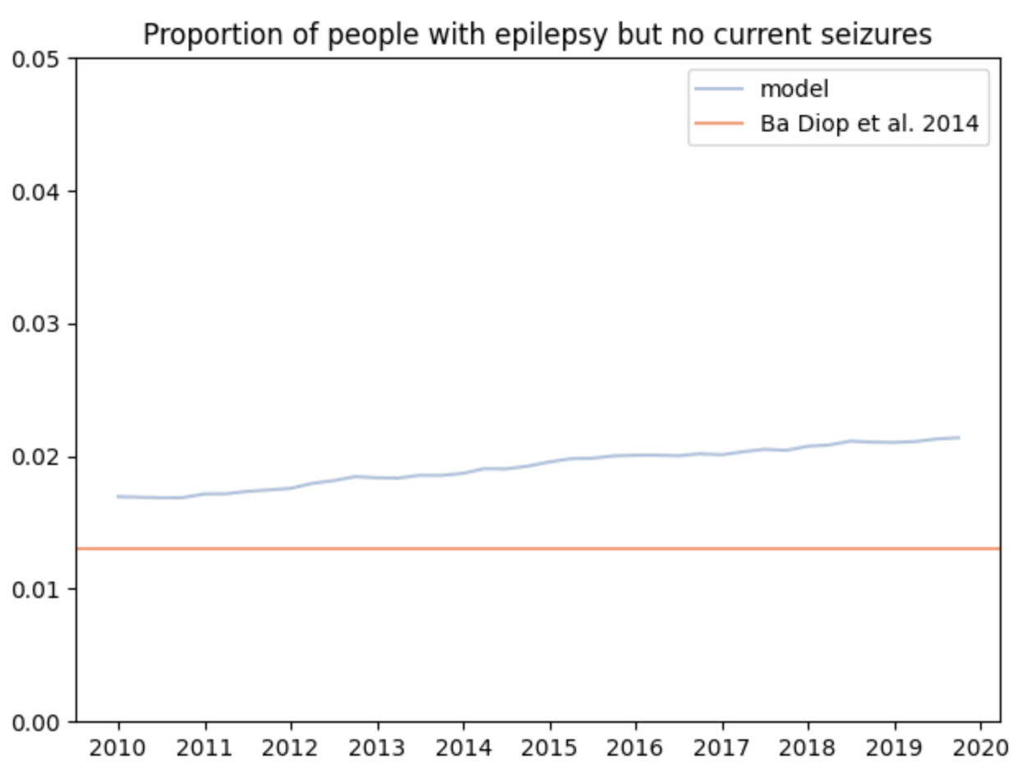
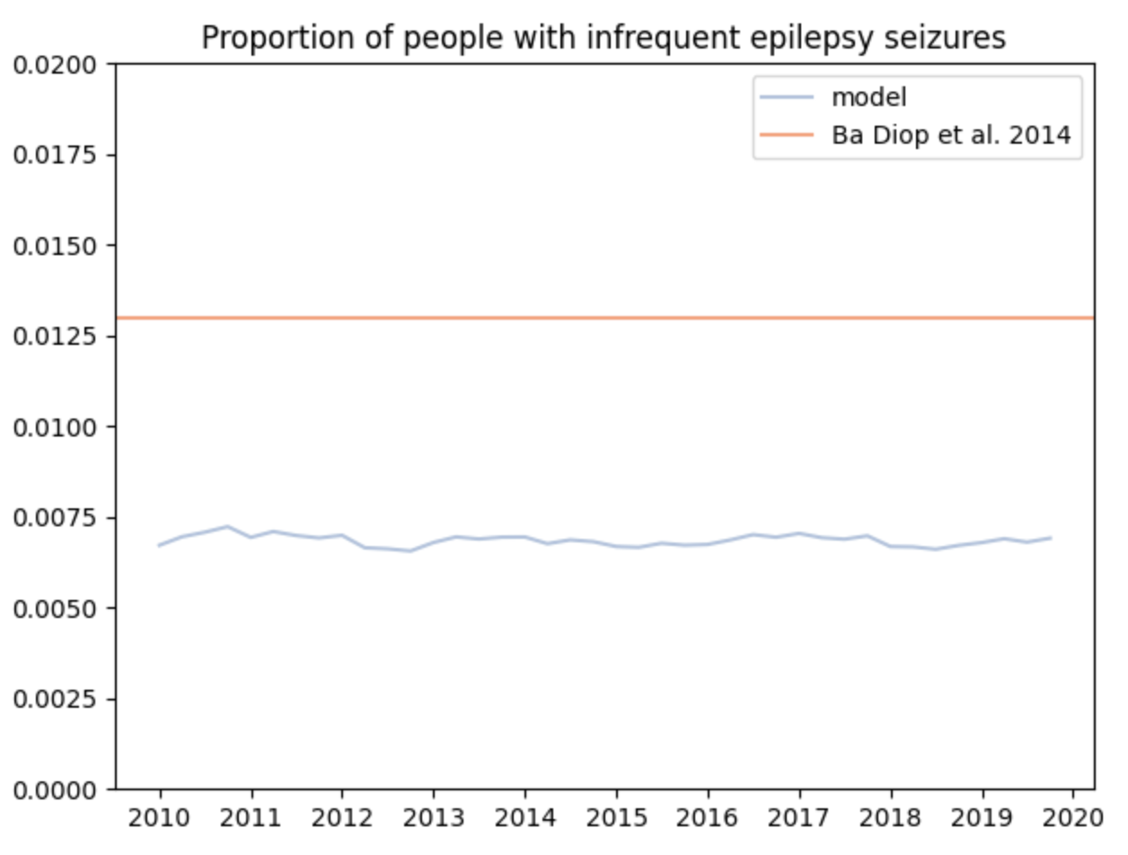
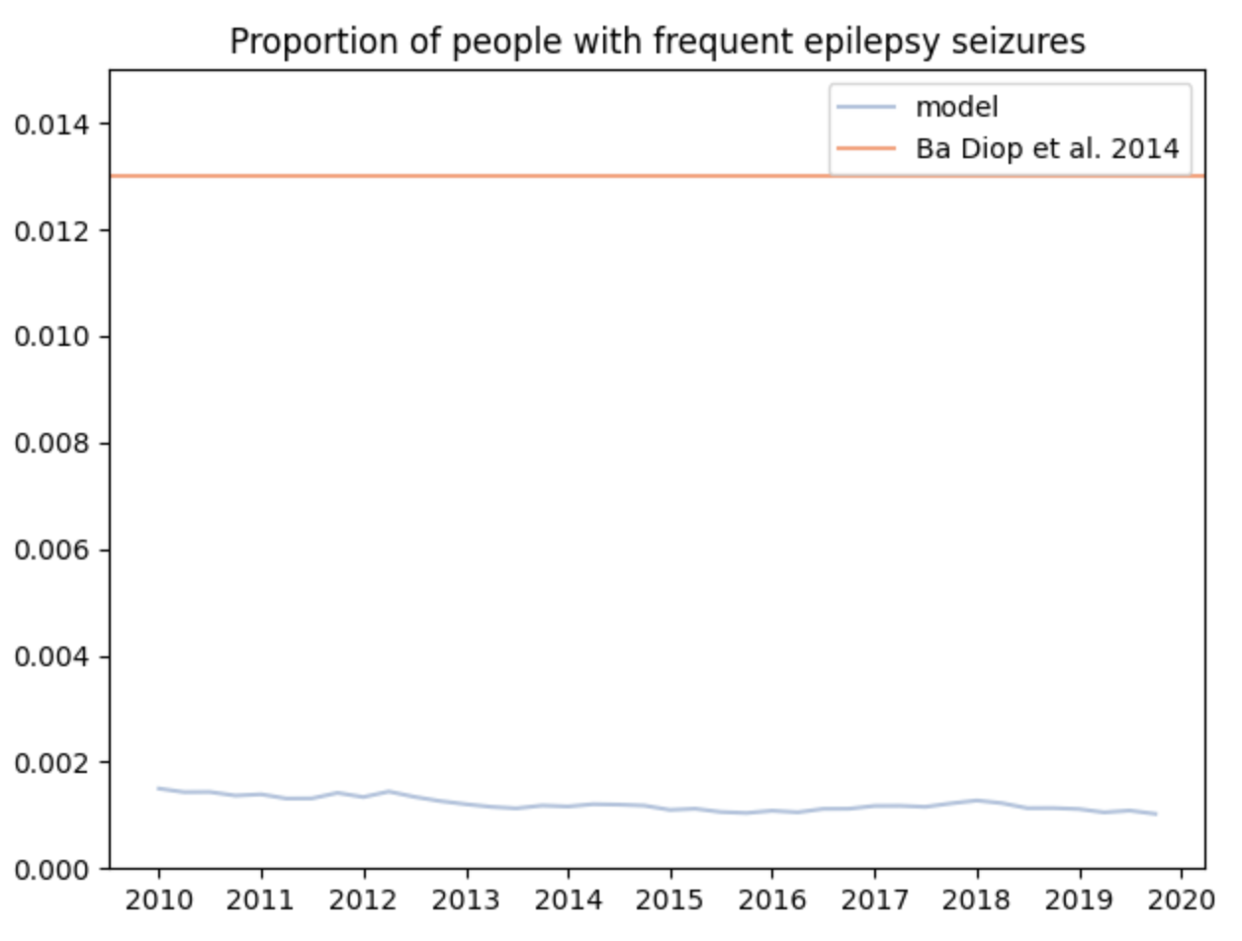
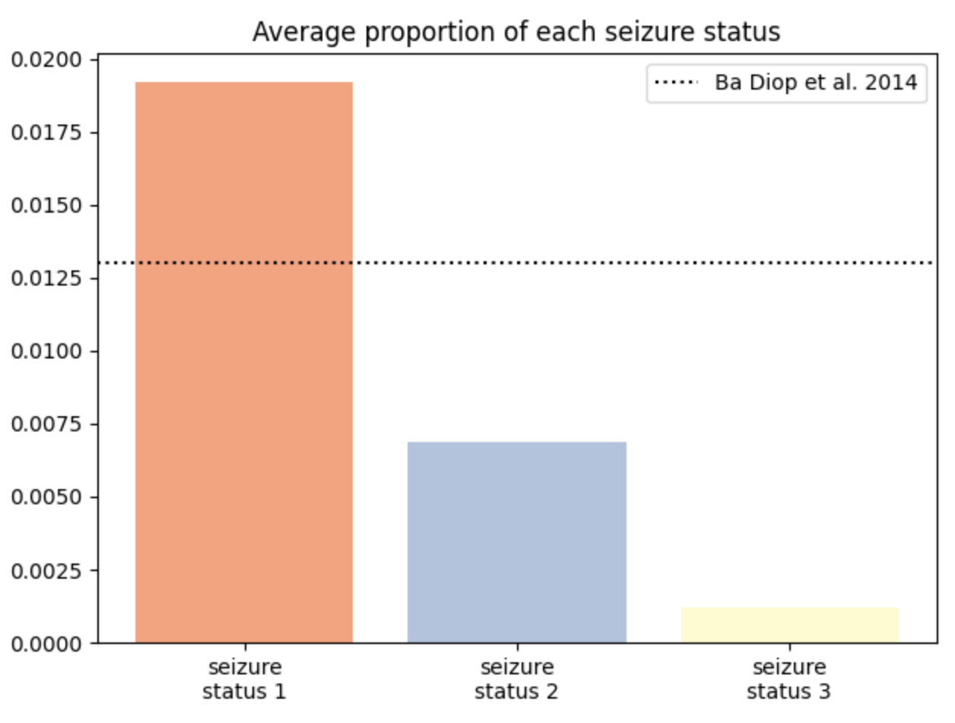

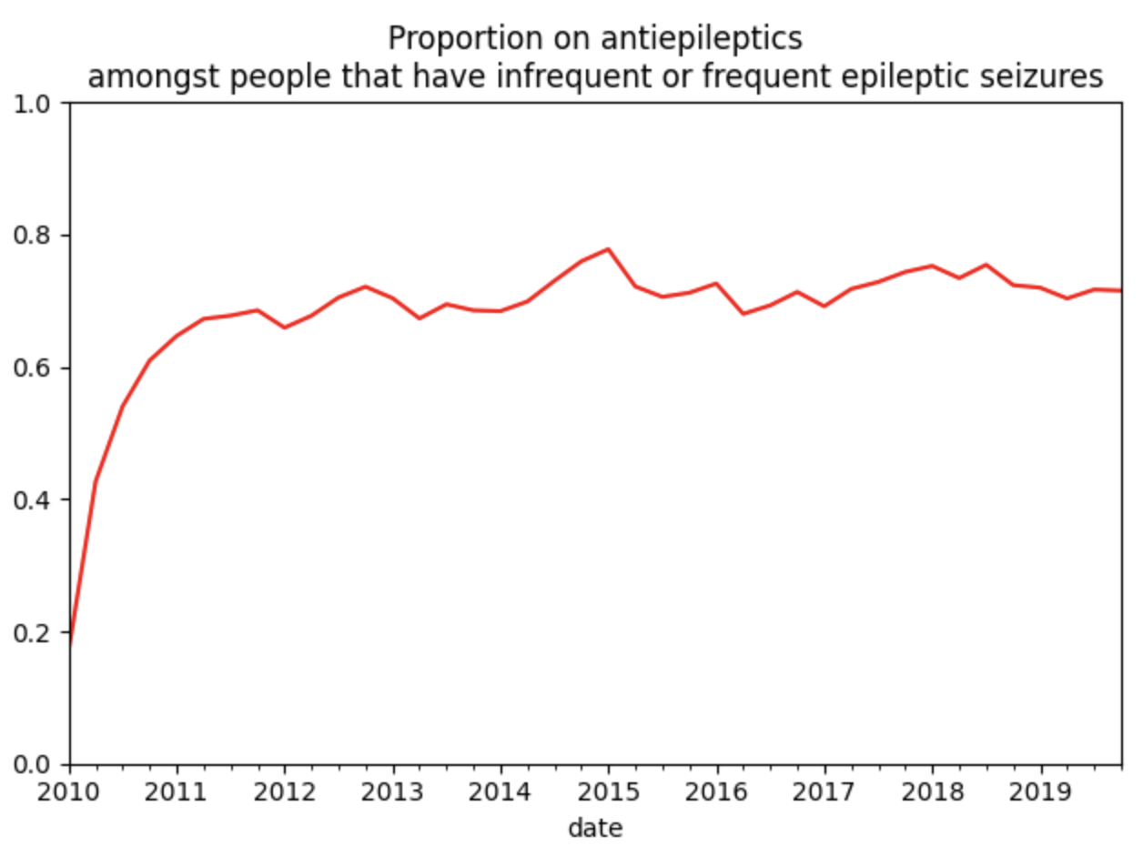

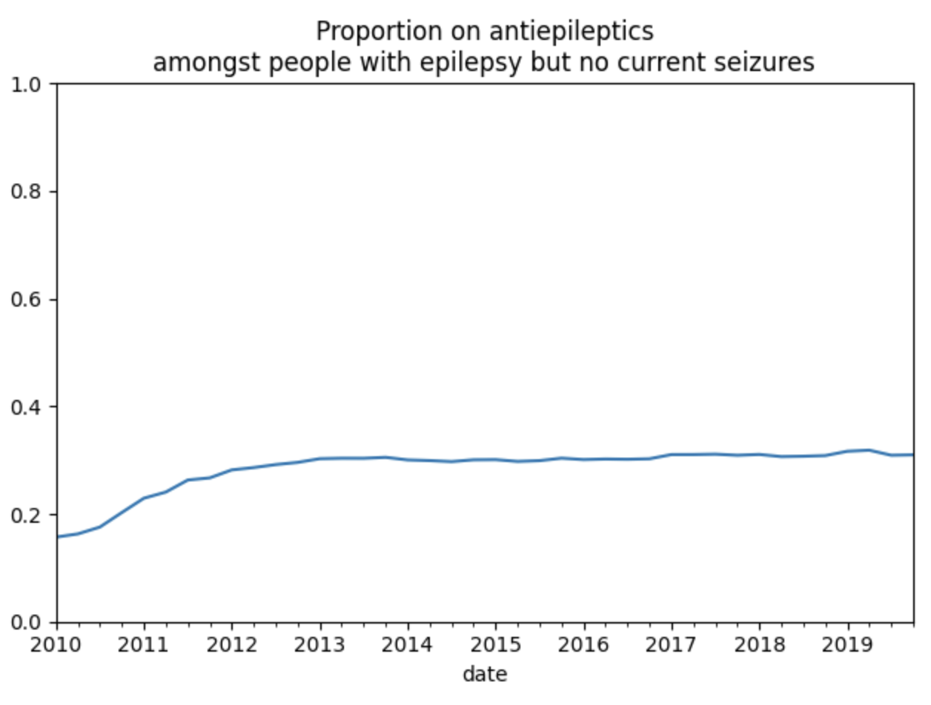

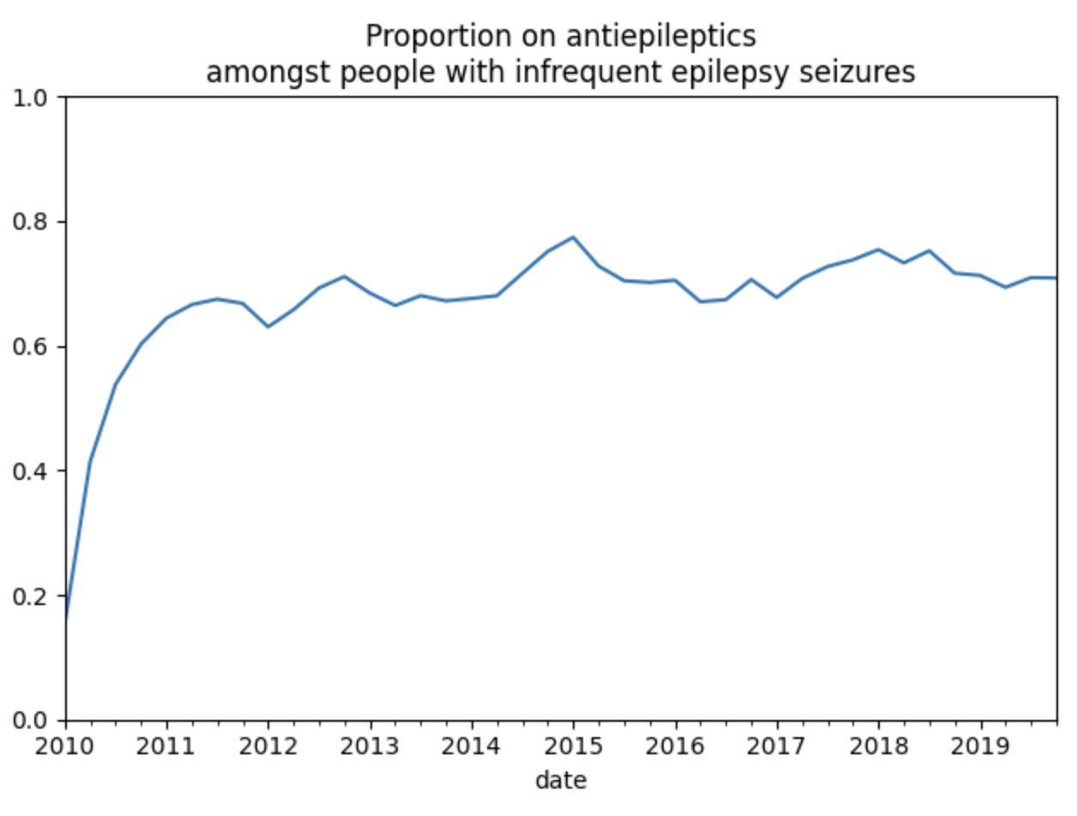
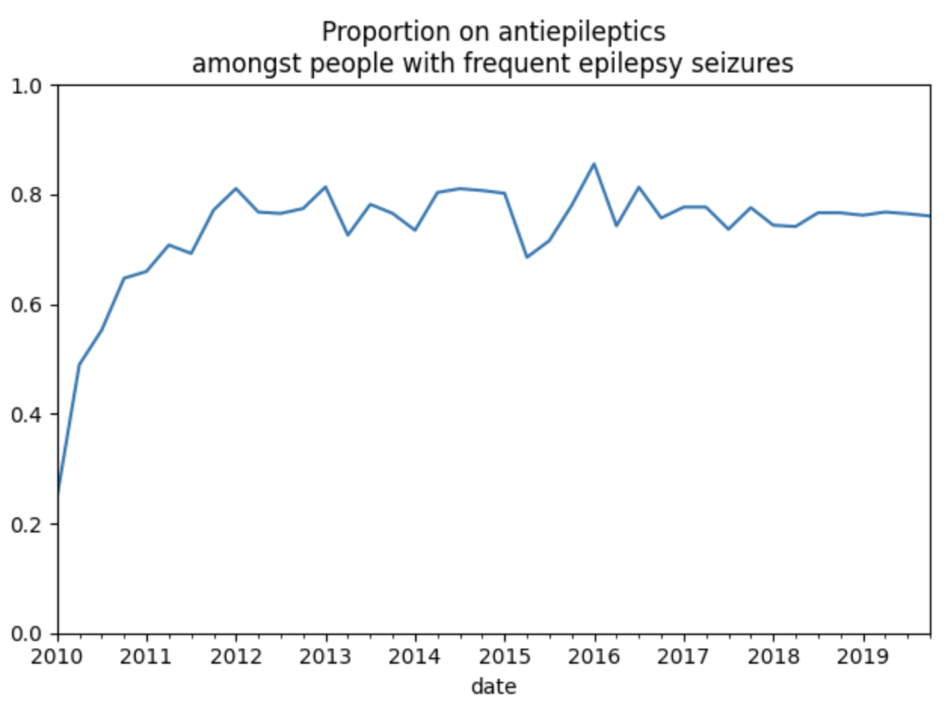
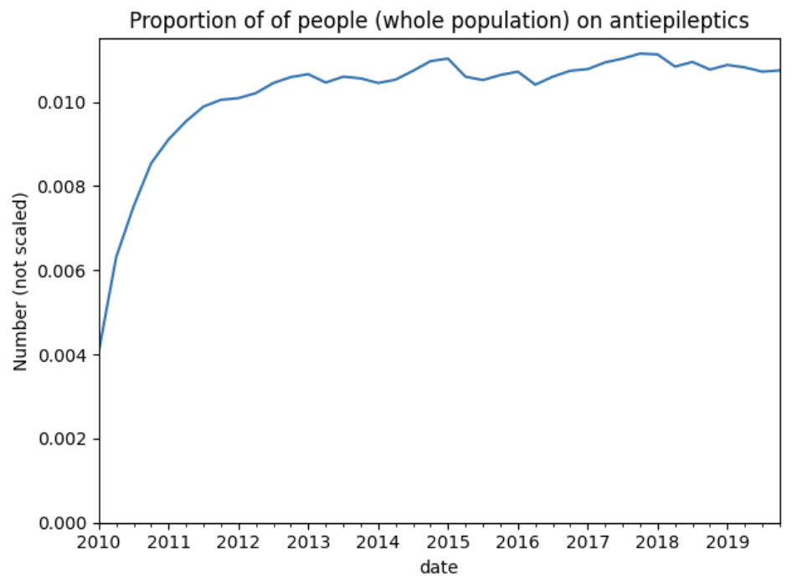

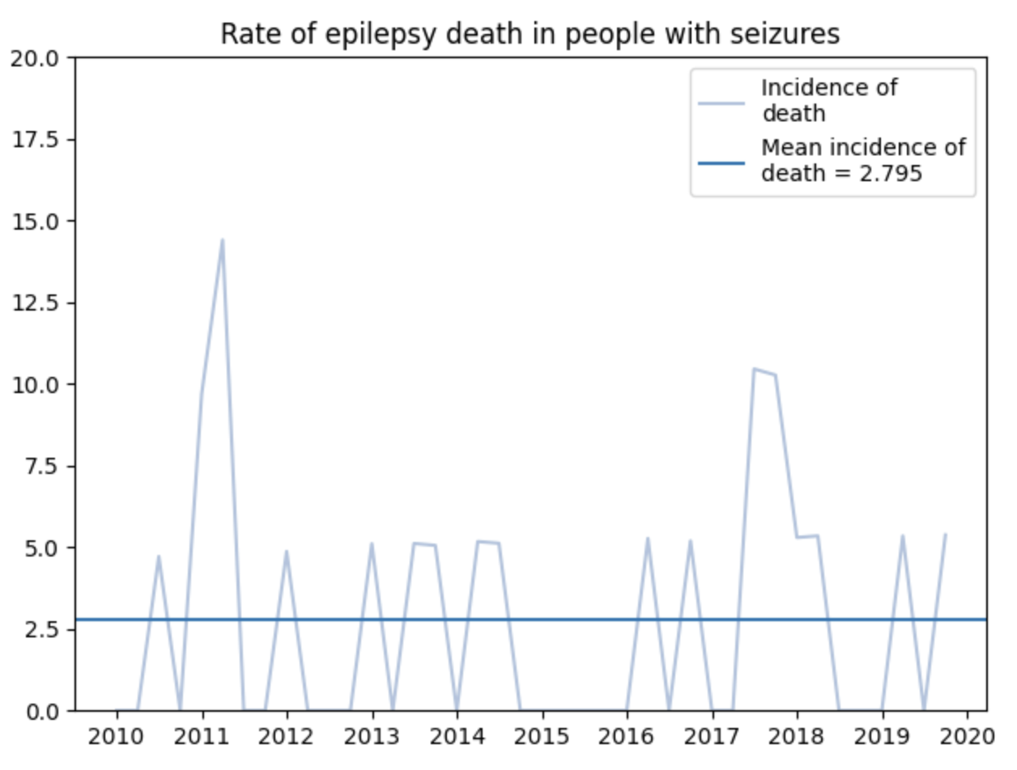
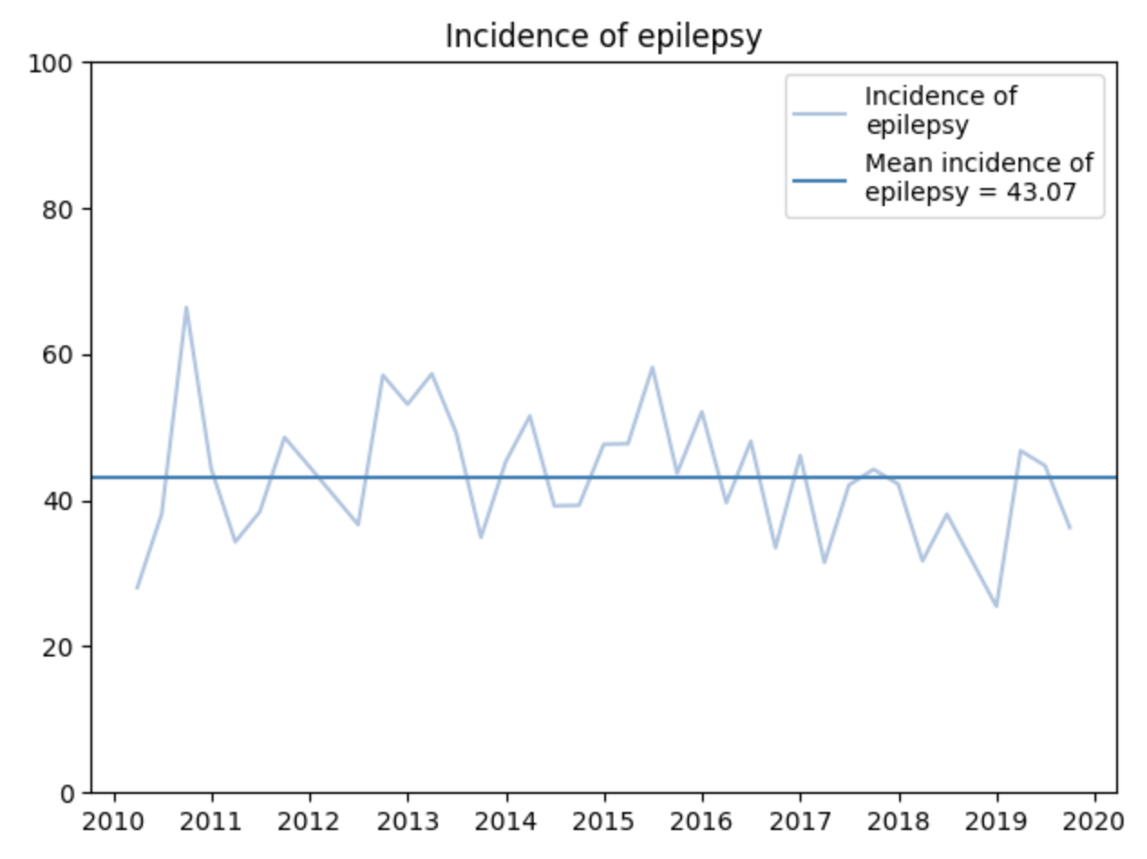
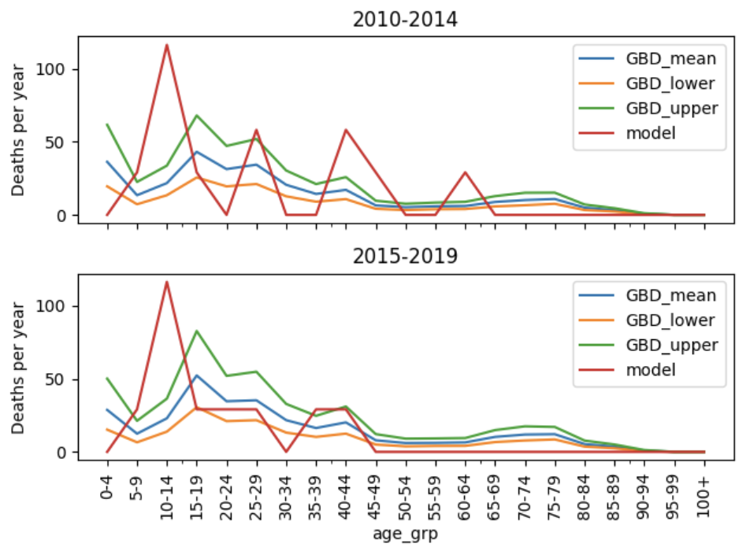
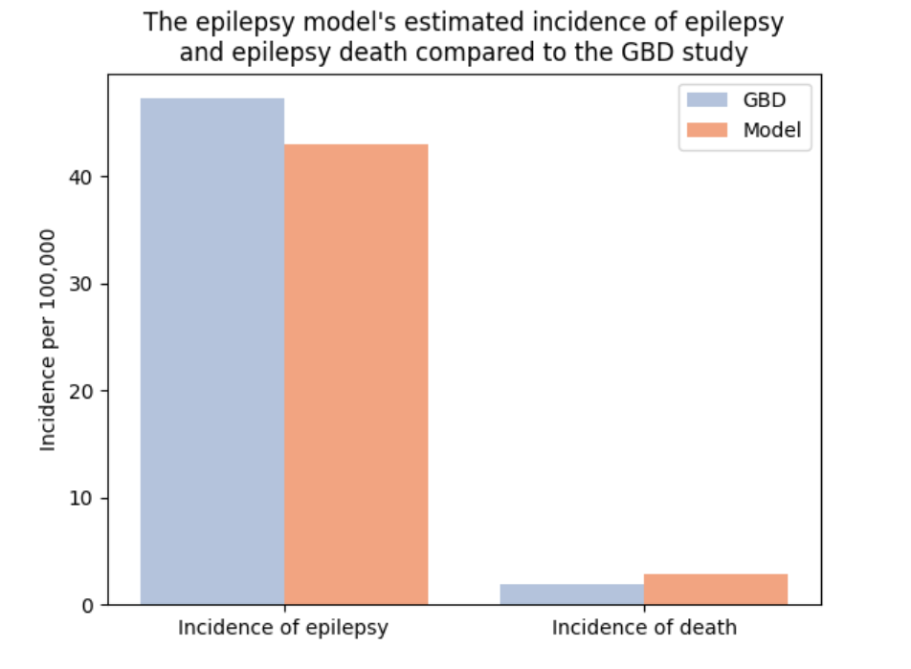

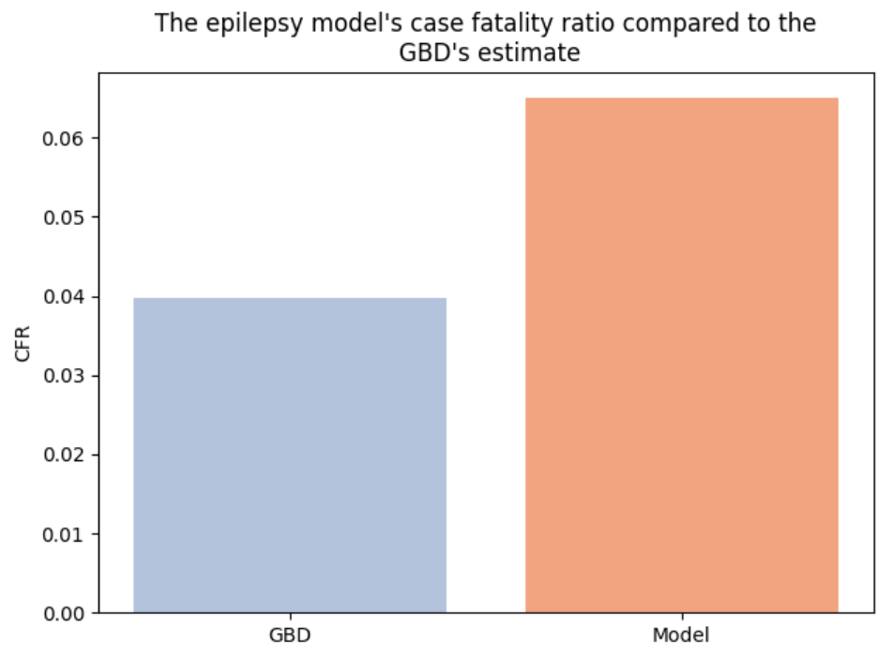

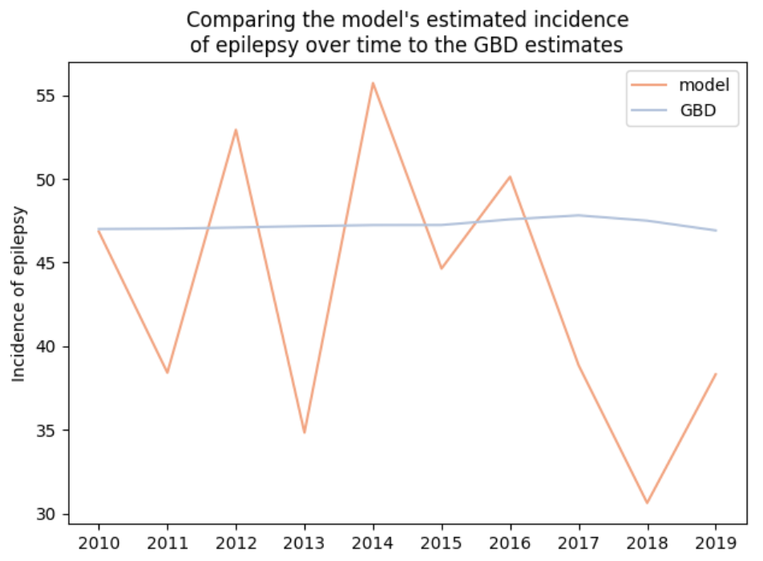
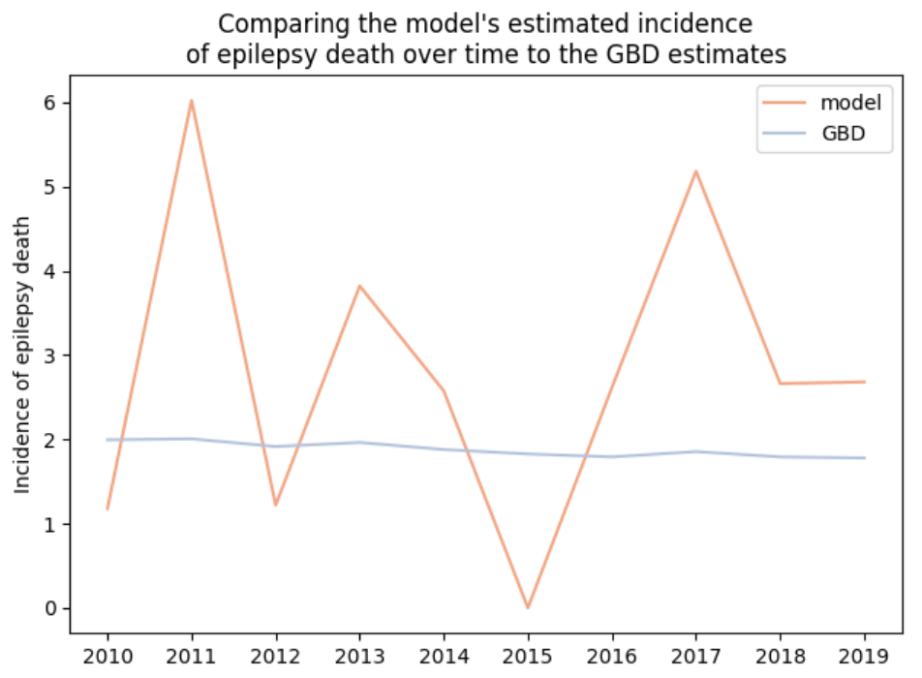

References
Ba-Diop et al. Epidemiology, causes, and treatment of epilepsy in sub-Saharan Africa. Lancet Neurol 2014; 13: 1029–44 2014
Dent et al. Prevalence of Active Epilepsy in a Rural Area in South Tanzania: A Door-to-Door Survey Epilepsia 2005, 46(12):1963–1969.
DHS. Malawi 2010, 2015/16 https://dhsprogram.com/
Faught et al. Patient characteristics and treatment patterns in patients with newly diagnosed epilepsy: A US database analysis. Epilepsy & Behavior 2018; 85 37–44.
GBD 2016 Epilepsy Collaborators. Global, regional, and national burden of epilepsy, 1990–2016: a systematic analysis for the Global Burden of Disease Study 2016 Lancet Neurology 18: 357–75 2019
Jost et al. Interventional programs to improve therapeutic management of people with epilepsy in low- and middle-income countries Epilepsy & Behavior 2018; 337-345 DOI: 10.1016/j.yebeh.2018.01.0112018
Munthali et al. Seeking care for epilepsy and its impacts on households in a rural district in southern Malawi’, African Journal of Disability 2013 2(1), Art. #54, 8 pages. http://dx.doi. org/10.4102/ajod.v2i1.54
Ngugi 2012 Prevalence, incidence and mortality of epilepsy in four health and demographic surveillance sites in subSaharan Africa. PhD thesis, London School of Hygiene & Tropical Medicine. https://researchonline.lshtm.ac.uk/682448/1/558374.pdf
Shorvon et al. Antiepileptic drug treatment of generalized tonic–clonic seizures: An evaluation of regulatory data and five criteria for drug selection. Epilepsy & Behavior 2018; 82 91–103.
Additional relevant references
Berg et al. Remission of Epilepsy after Two Drug Failures in Children: A Prospective Study. Ann Neurol 2009;65:510–519.
Chisholm, D., and WHO-CHOICE. 2005. “Cost-Effectiveness of First-Line Antiepileptic Drug Treatments in the Developing World: A Population-Level Analysis.” Epilepsia 46 (5): 751–59.
Jette et al. Saving lives by treating epilepsy in developing countries. Neurology 2014;82:552–553
Kwan et al. Early identification of refractory epilepsy. NEJM 2000 342: 314-9.
Newton et al. Epilepsy in poor regions of the world. Lancet 2012; 380: 1193–1201.
Salomon et al. Common values in assessing health outcomes from disease and injury: disability weights measurement study for the Global Burden of Disease Study 2010. Lancet 2012; 380: 2129–43.

Schiller et. Quantifying the response to antiepileptic drugs: effect of past treatment history. Neurology 2008;70:54–65.

Semah et al. Is the underlying cause of epilepsy a major risk factor for its recurrence ? Neurology 1998;51: 1256-1262

