Background 2

The Thanzi La Onse Model 2

General approach to decisions on modelling causal influences and effects of interventions 2

Demographic and social characteristics modelled 2

Undernutrition forms modelled 3

Conceptualisation of wasting model structure 4

Summary 4

Module properties 5

Prevalence of wasting at start of simulation 5

Incidence of wasting and disease progression 5

Health System Interactions 8

Parameters of the wasting module 9

Conceptualisation of stunting model structure 14

Summary 14

Module properties 14

Prevalence of stunting at start of simulation 15

Incidence of stunting and disease progression 15

Health System Interactions 16

Parameters of the stunting module 18

References 20

# Background

## The Thanzi La Onse Model

As part of the Thanzi La Onse program a model is being developed which aims to capture the health experiences of the population of Malawi and the consequent interactions with the health care system. The intent is that this model will help to inform future delivery of health care in Malawi. The model is an individual based model – which means we explicitly simulate the individual life and health experiences of a representative proportion of population of Malawi. The simulation initiates on 1 Jan 2010 and we attempt to simulate the attributes of the population at that point. We can run the model forward to any specified future time point. Each potential intervention and its associated diseases are being modelled. This is being divided into separate disease/intervention modules. This document describes the set of undernutrition modules: wasting, stunting, and micronutrient deficiencies.

## General approach to decisions on modelling causal influences and effects of interventions

This module was designed in the context of an overall approach to modelling causal effects in general and causal effects of interventions in particular. The overall intent is to adopt as simple a structure as can be conceived, whilst still capturing the essential elements of a disease and the interventions used to prevent or treatment. We include a causal link between a “variable” (by which we mean a characteristic or property of an individual, whether that be demographic, social or biologic), and risk of disease or another variable if there is strong evidence from an overall body of studies that such a causal link exists and is at least moderately strong. In informing such decisions we place particular value on RCTs or studies with a quasi-experimental design such as analyses based on an instrumental variable. There is no expectation that such studies will be from Malawi or even from Africa. If there are such local studies and in the unlikely event that they provide strong evidence to suggest that the causal link is substantively different in Malawi then the intent is that this is taken into account and the Malawi-specific link included.

In the special case of a potential causal variable which relates to whether an individual has experienced or is experiencing an intervention the intent is to only include interventions if there is substantial RCT evidence of their beneficial effect, based on trials with objectively ascertained clinical endpoints with low risk of serious bias. Whilst DCP-3 (and to some extent the Malawi EHP) provides an initial list of such interventions and the evidence to support them, where possible our intent has been to form our own opinion on intervention efficacy based on the source trials.

Unless there is evidence to the contrary, the intent is to summarize and incorporate intervention effects into the model as relative risks or rates rather than absolute differences due to the fact that such measures are less likely to differ substantively by context. Interactions between characteristics (on the multiplicative scale) are only to be incorporated if there is strong evidence. Again, we have not intended to rely on data from Malawi or Africa for such evidence but if local evidence exists which strongly suggests a different effect than elsewhere then the intent is that this modified effect is incorporated in the model.

## Demographic and social characteristics modelled

Based on data on the distribution of the population in Malawi according to geographic location we assign individuals a geographic location, which maps onto whether they are classified as living in a rural or urban area. Informed largely by data from the Malawi DHS, variables are also created indicating the person’s wealth level (based on 5 quintiles), whether the person has access to improved sanitation, clean drinking water, hand washing facilities, and whether they experience indoor air pollution (wood burning stove). We assign individuals a current education status (none, primary, secondary) which is updated 3 monthly from age 5 to 20. From age 15 BMI (in 5 groups) is assigned, as well as using tobacco, drinking excess alcohol, having low exercise, high salt intake, high sugar intake. The status with regard to such variables for individuals can change over time. The influences between these variables are described in detail in a separate document.

## Undernutrition forms modelled

### Definition of undernutrition

Undernutrition is defined as insufficient intake of energy and nutrients to meet an individual’s need to maintain good health1. In the literature, undernutrition and malnutrition are used interchangeably, although, the term malnutrition refers to all forms of deficiencies, excesses, or imbalances in a person’s intake of energy and/or nutrients2, including undernutrition, micronutrient-related malnutrition, and overnutrition. In Malawi, undernutrition in terms of protein-energy undernutrition and micronutrient deficiencies are considered of public health significance, particularly to the health of children. Overnutrition is modelled in TLO within other NDC modules that pertain to older ages (from 15 years of age onwards).

### Measures of nutritional status

There are several indicators used to measure nutritional imbalances resulting in undernutrition. The commonly used anthropometric measures in community studies are weight and height/length in combination with age and gender. These measurements are used to construct indices that are used to describe nutritional status of individuals or populations. The indices used in childhood are weight-for-height Z-score (WHZ), height-for-age Z-score (HAZ) and weight-for-age Z-score (WAZ). A Z-score is a measure of how far an observation is from the population mean as measured in standard deviations. A standard deviation score of a nutritional indicator for an individual = (individual’s value - median value of reference population)/ standard deviation value of reference population. The currently used reference population is the WHO multicentre Growth Reference Study (MGRS).

Table 1 - Key definitions of undernutrition

|  |  |
| --- | --- |
| **Terminology** | **Definition** |
| Weight-for-height/length | Measure of a child’s weight relative to the weight of a child of the same height or length in a reference population, expressed as a Z-score. Low weight-for-height (WHZ<-2) is known as wasting, the acute form of undernutrition |
| Height/length-for-age | Measure of a child’s height or length relative to the length or height of a child of the same age in a reference population, expressed as a Z-score. Low height-for-age (HAZ<-2) is known as stunting, a result of chronic or recurrent undernutrition |
| Weight-for-age | Measure of a child’s weight relative to the weight of a child of the same age in a reference population, expressed as a Z-score. Low weight-for-age is known as underweight |
| wasting | weight-for-height Z-score <-2 SD,  (severe wasting WHZ<-3, moderate wasting -3≥WHZ<-2) |
| stunting | height-for-age Z-score <-2 SD,  (severe stunting HAZ<-3, moderate stunting -3≥HAZ<-2) |
| underweight | weight-for-age Z-score <-2 SD,  (severe underweight WAZ<-3, moderate underweight -3≥WAZ<-3) |

The following sections describe the rationale for the model structures of wasting and stunting. As underweight can reflect wasting, stunting, or both, it is difficult to interpret and therefore, not included in the undernutrition modules.

# Conceptualisation of wasting model structure

## Summary

Wasting classification by the WHO guidelines has two categories: moderate (-3≤WHZ<-2) or severe (WHZ<-3). This definition of wasting does not include nutritional oedema (kwashiorkor), a form of acute undernutrition that results from similar causal pathways to wasting, or other forms of anthropometric measurements, such as mid-upper arm circumference (MUAC) tape, which is widely used in community-settings for the identification of acutely undernourished children aged 6-59 months.

Clinical acute malnutrition in children aged 6-59 months can be either moderate or severe. Table 2 shows the definition of moderate acute malnutrition (MAM) and severe acute malnutrition (SAM). SAM is defined by two distinct clinical identities: marasmus and kwashiorkor. Children with SAM are further classified according to the presence or absence of medical complications, and managed accordingly. Uncomplicated SAM includes children without signs of infections and with retained appetite which is regarded as indicative of the absence of severe metabolic disturbance. Complicated SAM includes children with clinical features of infection, metabolic disturbance, severe oedema, hypothermia, vomiting, severe dehydration, severe anaemia or a lack of appetite who require inpatient treatment3.

Table 2 - Key definitions of acute undernutrition

|  |  |
| --- | --- |
| **Terminology** | **Definition** |
| severe acute malnutrition (SAM) | severe wasting (WHZ<-3) and/or MUAC<115mm and/or bilateral oedema 4 |
| moderate acute malnutrition (MAM) | moderate wasting (-3≤WHZ<-2) and/or 115mm≤MUAC<125mm 4 |
| global acute malnutrition (GAM) | all acute malnutrition types (MAM + SAM)  WFH <−2 SD and/or MUAC <125 mm and/or oedema |
| marasmus | MUAC < 115mm in children aged 6-59 months or WHZ <-3 in children aged 0-59 months |
| kwashiorkor | Nutritional oedema, clinically diagnosed by bilateral pitting oedema |
| Marasmic kwashiorkor | Presents both features of marasmus and kwashiorkor |

For the wasting module, only definitions of MAM and SAM are used.

In the design of a model for acute malnutrition, the underlying ‘truth’ of an individual’s condition is determined by the weight-for-height Z-score, or wasting status, following the WHO 2006 Child Growth Standards. The clinical syndromes of MAM and SAM are further determined using MUAC measurement and presence of bilateral oedema.

The wasting module updates the acute nutritional status in the simulation for children under 5 years of age. This includes weight-for-height Z-score category (WHZ<-3, -3≤WHZ<-2, WHZ≥-2), presence of bilateral oedema (indicative of Kwashiorkor), MUAC measurement category (<115mm, 115mm to <125mm, ≥125mm), clinical severity of acute malnutrition (MAM, SAM), and complications in SAM. The module is responsible for assigning the prevalence of wasting at initiation of the simulation in 2010, the onset of new wasting episodes every month, changes between wasting states (with progression or recovery), death events due to SAM, and scheduling health system interactions where interventions are deployed.

## Module properties

Table 3 - Properties of the wasting module, and respective type and description

|  |  |  |
| --- | --- | --- |
| Property name | Type | Description |
| Properties related to wasting | | |
| un_ever_wasted | Boolean | ever had an episode of wasting (WHZ<-2) |
| un_WHZ_category | Categorical ['WHZ<-3', '-3<=WHZ<-2', 'WHZ>=-2'] | weight-for-height z-score category |
| un_clinical_acute_malnutrition | Categorical ['MAM', 'SAM'] | clinical acute malnutrition state based on WHZ and/or MUAC and/or oedema |
| un_last_wasting_date_of_onset | Date | Date of onset of last episode of wasting |
| un_wasting_death_date | Date | death date from (severe) wasting |
| Properties related to acute malnutrition | | |
| un_wasting_bilateral_oedema | Boolean | bilateral pitting oedema present in wasting episode |
| un_wasting_MUAC_category | Categorical ['<115mm', '115-<125mm', '>=125mm'] | MUAC measurement categories, based on WHO cut-offs |
| un_am_recovery/discharge_date | Date | Date of recovery or discharge date |
| un_SAM_with_complications | Boolean | medical complications in SAM episode |
| un_AM_treatment_type | Categorical ['standard_RUTF', 'soy_RUSF', 'CSB++', 'inpatient_care'] | treatment types for acute malnutrition |
| un_SAM_management_facility_type | Categorical ['outpatient', 'inpatient'] | treatment of SAM at facility level |

un_ prefix stands for undernutrition

## Prevalence of wasting at start of simulation

At initiation of simulation, the prevalence of wasting is set. Based on the DHS 2015-16 data, the mean and standard deviation of the normal distribution of WHZ scores for each age group: <6, 6-11, 12-23, 24-35, 36-47, 48-59 months are used to determine the probability of WHZ< -2 (wasted) for each age category. Then this probability of wasting is converted into odds of wasting, for which the odds ratios of risk factors are added to the linear model of wasting prevalence. Currently, the risk factors for wasting include household wealth, preterm birth, and gestational size. The severity of wasting (moderate 3≥WHZ<-2, or severe WHZ<-3) is also assigned based on the probability attained from the normal distribution of Z-scores.

A distribution of MUAC <115mm and presence of oedema is applied. These two indicators, together with wasting state, will then be used to compute the clinical acute malnutrition state: either MAM, or SAM, to which the interventions are targeted to. Clinical acute malnutrition is not determined by weight-for-height alone.

Treatment coverage and cure rates at initiation are applied. These prevalence parameters and respective values are listed in Table 4.

## Incidence of wasting and disease progression

The figure below (Figure 1) shows the proposed model structure for wasting (low weight-for-height), the acute form of undernutrition. It focuses on the natural history of wasting without input of the healthcare system interventions. A regular event, occurring every month, applies the incidence of new wasting cases by age, and updates the clinical acute malnutrition state for all children, it also applies the probability of progression to severe wasting of current cases, re-updating the clinical acute malnutrition state. Another regular event and applies the death rate for current SAM cases.

Figure 1 - Model structure of the natural history of acute malnutrition

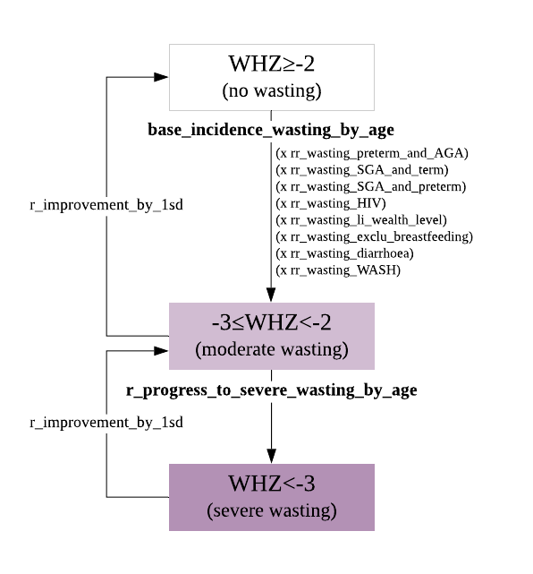

As shown in the proposed model structure, the incidence of wasting is dependent on age and several risk factors including, birth size (preterm birth, gestational age), HIV status, household wealth, exclusive breastfeeding until 6 months of age, prior episodes of diarrhoea, and components of WASH.

Once in a state of moderate wasting (-3≥WHZ<-2), the individual will remain in that state for a mean duration of MAM5, at the end of which they will either progress to severe wasting (WHZ<-3), recover naturally to a normal nutritional state of WHZ>-2, or will have died due to other comorbidities in other disease modules (moderate wasting and/or MAM is a major risk factor for other infectious diseases and death). The rate of progression to severe wasting depends solely on age, assuming all other risk factors associated with incidence remain constant for the individual. When in the severe wasting state, the individual will remain in that state for a mean duration of SAM5, at the end of which they will have either improved the nutritional state by 1 standard deviation (moderate wasting), or died.

Both MUAC measurement and the presence of bilateral oedema on both feet are indicators of severity of acute malnutrition. For the clinical classification of SAM or MAM, all three indicators (WHZ, MUAC, oedema) are used to determine clinical severity. As defined in Table 2, the diagnostic criteria for SAM in children aged 6-60 months is severe wating (WHZ<-3), and/or MUAC < 115, and/or clinical sign of bilateral oedema4. All three measures are considered independent indicators of SAM. Whereas the diagnostic criteria for MAM is moderate wasting (-3≤WHZ<-2) and/or MUAC ≥115mm and <125mm without oedema. Based on the wasting state, probabilities of MUAC measures and the presence of oedema is applied to the children. Figure 2 shows the relation between wasting states and other anthropometric/clinical factors that determine the clinical acute malnutrition state.

Figure 2 – Wasting state, MUAC and oedema in determining clinical acute malnutrition

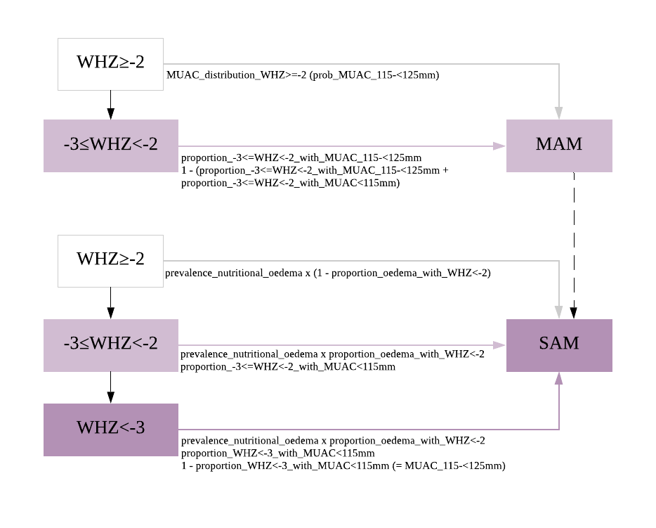

Parameter values and reference are listed in Table 4. The wasting module focuses on the incidence of wasting (low weight-for-height index), however, not all wasting cases will have the respective MUAC cut-off measure, and most nutritional oedema cases have WHZ≥-2 6. Particularly in Malawi, more children with acute undernutrition are detected with MUAC than with weight-for-height measure7. Therefore, detecting these cases that fulfil the clinical definition of acute malnutrition is also important.

Death is applied to SAM cases, not wasting (weight-for-height) alone. The risk factors for death due include young age, HIV status, clinical kwashiorkor (oedema only), marasmic kwashiorkor (wasting and oedema), and complications. SAM serves as the major risk factor for death from infectious diseases including diarrhoea and pneumonia.

Figure 3 - Death from SAM

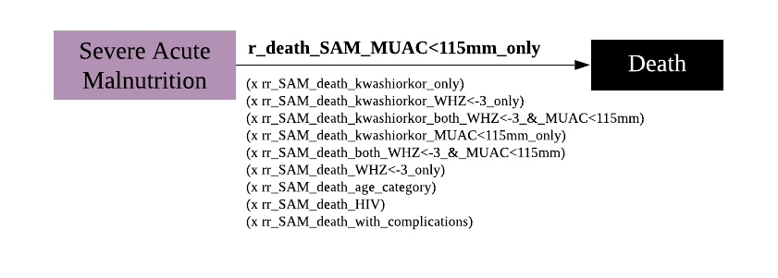

## Health System Interactions

Malawi Ministry of Health has implemented the community-based management of acute malnutrition (CMAM)8 approach since 2012, as part of the EHP. These guidelines guide the delivery of four components of CMAM:

* community outreach,
* supplementary feeding for MAM,
* outpatient care for SAM without medical complications, and
* inpatient care for SAM with medical complications.

### Community outreach

The community outreach component focuses on the community sensitisation, mobilisation, active case finding, referral, follow-up, and counselling

The community outreach component is not yet in the code.

### Supplementary feeding for MAM

Supplementary feeding programmes (SFP) provide support to children (0–15 years) and pregnant and lactating women (up to 6 months postpartum), including:

* Children with MAM, good appetite, and no medical complications
* Children discharged from inpatient care and outpatient care after recovery from SAM

There children are referred to SFP for continuum of care. The nutritional treatment is based on Super Cereal Plus (Corn Soy Blend ++ (CSB++))

### Outpatient Therapeutic Programme (OTP)

OTP provides home-based treatment and rehabilitation for children with SAM who have an appetite and no medical complications. Medical treatment in OTP, include, antibiotic treatment with amoxicillin, test all children for malaria using a rapid diagnostic test (mRDT), and treat accordingly, deworming treatment with albendazole or mebendazole, measles vaccination, vitamin A, iron and folic acid, zinc, ORS. Nutritional treatment in the OTP with Ready to use therapeutic foods (RUTF).

Children with severe acute malnutrition should be discharged from the nutritional treatment programme only when their:

* weight-for-height/length is at least ≥ -2 z score and they have had no oedema for at least 2 weeks, or
* mid-upper-arm circumference is ≥ 125 mm and they have had no oedema for at least 2 weeks.

### Nutrition Rehabilitation Unit (NRU)

Intensive inpatient therapeutic care should be provided in a specialised unit in the health facility (NRU) or in the children’s ward at a health facility with 24-hour care at the secondary or tertiary level. Inpatient care targets children 6 months–15 years with SAM who have medical complications or have no appetite (10– 20 percent of all SAM children), and children < 6 months who have SAM or have feeding difficulties and are not gaining weight or are losing weight.

Treatment for SAM in an inpatient setting involves following the 10 steps outlined by the WHO in two phases:

• Stabilisation phase (Phase 1). F-75 therapeutic milk is used to promote repair of physiological and metabolic functions and electrolyte balance.

• Transition phase in which the diet is changed to RUTF (or F-100) to increase the energy intake by about 30 percent, such that the child starts to gain weight.

• Rehabilitation Phase (Phase 2), in which the child is transferred to OTP to complete recovery where RUTF is given for nutritional treatment.

## Parameters of the wasting module

Table 4 list all the parameters used in modelling wasting and acute malnutrition.

Table 4 - Parameters of the wasting module and respective values

|  |  |  |  |  |  |
| --- | --- | --- | --- | --- | --- |
|  | **Parameter** | **Value** | **Source** | **Description** | **Notes** |
| **Prevalence** | prev_WHZ_distribution_age_0_5mo | [0.656, 1.397] | DHS 2015-16 | mean and standard deviation of weight-for-height z-scores distribution for <6 months old | WHZ distribution from the DHS 2015-16 dataset to model prevalence of wasting |
| prev_WHZ_distribution_age_6_11mo | [0.055, 1.286] | DHS 2015-16 | mean and standard deviation of weight-for-height z-scores distribution for 6-11 months old |
| prev_WHZ_distribution_age_12_23mo | [0.024, 1.090] | DHS 2015-16 | mean and standard deviation of weight-for-height z-scores distribution for 1 year old |
| prev_WHZ_distribution_age_24_35mo | [0.056, 1.046] | DHS 2015-16 | mean and standard deviation of weight-for-height z-scores distribution for 2 year old |
| prev_WHZ_distribution_age_36_47mo | [0.093, 0.966] | DHS 2015-16 | mean and standard deviation of weight-for-height z-scores distribution for 3 year old |
| prev_WHZ_distribution_age_48_59mo | [-0.031, 0.983] | DHS 2015-16 | mean and standard deviation of weight-for-height z-scores distribution for 4 year old |
| or_wasting_hhwealth_Q5 | 2.18 | 9 | odds ratio of wasting for poorest household wealth Q5 | Ref.  Q1 richest |
| or_wasting_hhwealth_Q4 | 2.03 | 9 | odds ratio of wasting for poorer household wealth Q4 |  |
| or_wasting_hhwealth_Q3 | 2.3 | 9 | odds ratio of wasting for middle household wealth Q3 |  |
| or_wasting_hhwealth_Q2 | 1.86 | 9 | odds ratio of wasting for richer household wealth Q2 |  |
| or_wasting_preterm_and_AGA | 2.2 | 10 | odds ratio of wasting if born preterm and adequate for gestational age | Used the pooled OR estimate for sub-Saharan Africa |
| or_wasting_SGA_and_term | 2.42 | 10 | odds ratio of wasting if born small for gestational age and term |
| or_wasting_SGA_and_preterm | 3.44 | 10 | odds ratio of wasting if born small for gestational age and preterm |
| **Incidence** | base_inc_rate_wasting_by_agegp | [0.024, 0.09, 0.15, 0.09, 0.06, 0.06] | 11 | baseline incidence rate of moderate acute malnutrition by age group [1-5, 6-11, 12-23, 24-35, 36-47, 48-59] | estimates will be calculated from the study dataset, currently rough estimates |
| rr_wasting_preterm_and_AGA | 2.11 | 10 | relative rate of wasting if born preterm and adequate for gestational age | Used the pooled relative risk estimate for sub-Saharan Africa |
| rr_wasting_SGA_and_term | 2.26 | 10 | relative rate of wasting if born small for gestational age and term |
| rr_wasting_SGA_and_preterm | 3.09 | 10 | relative rate of wasting if born small for gestational age and preterm |
| min_days_duration_of_wasting | 14 | assumed | minimum duration of wasting episode |  |
| average_duration_of_untreated_MAM | 81 | 5 | average duration of untreated MAM, assumed for moderate wasting | assumed to be duration for moderate wasting |
| **Progression** | progression_severe_wasting_by_agegp | [0.02, 0.03, 0.09, 0.05, 0.04, 0.03] | 11 | risk of progression to severe wasting (WHZ<-3) by age group | estimates will be calculated from the study dataset, currently dummy values |
| average_duration_of_untreated_SAM | 45 | 5 | average duration of untreated SAM, assumed for severe wasting | assumed to be duration for severe wasting |
| **Clinical acute malnutrition** | proportion_WHZ<-3_with_MUAC<115mm | 0.4012 | 7 | proportion of severe weight-for-height Z-score with MUAC<115mm | In the estimation of these values, it was assumed that all SAM cases would have WHZ<-2, and not a normal WHZ.  (1-0.4012) will be WHZ<-3 with MUAC between 115-125mm  (1-0.3358-0.4081) will be -3<=WHZ<-2 with normal MUAC >125mm |
| proportion_-3<=WHZ<-2_with_MUAC<115mm | 0.3358 | 7 | proportion of moderate weight-for-height Z-score with MUAC<115mm |
| proportion_-3<=WHZ<-2_with_MUAC_115-<125mm | 0.4081 | 7 | proportion of moderate weight-for-height Z-score with MUAC between 115mm and 125mm |
| proportion_mam_with_MUAC_115-<125mm_and_normal_whz | 0.536 | 7 | proportion of mam case with MUAC between 115mm and 125mm and normal/mild WHZ |
| proportion_mam_with_MUAC_115-<125mm_and_-3<=WHZ<-2 | 0.2846 | 7 | proportion of mam cases with both MUAC between 115mm and 125mm and moderate wasting |
| proportion_mam_with_-3<=WHZ<-2_and_normal_MUAC | 0.1787 | 7 | proportion of mam cases with moderate wasting and normal MUAC |
| MUAC_distribution_WHZ>=-2 | [15.1793, 1.20386] | MMS 2015 | mean and standard deviation of MUAC measurement distribution for children aged 6-59 months | Used to get MUAC cut-off in normal WHZ |
| prevalence_nutritional_oedema | 0.007 | 12 | Prevalence of nutritional oedema | prevalence of oedema in all children in Malawi |
| proportion_oedema_with_WHZ<-2 | 0.37 | 6 | proportion of oedematous malnutrition with concurrent wasting | used supplementary data to calculate this proportion (Malawi-specific) |
| prob_complications_in_SAM | 0.15 | 13 | probability of severe acute malnutrition with medical complications |  |
| **Interventions** | coverage_supplementary_feeding_program | 0.58 | 14 | coverage of supplementary feeding program for MAM in health centres | Malawi estimates |
| coverage_inpatient_care | 0.98 | 14 | coverage of inpatient care for complicated SAM in hospitals |
| coverage_outpatient_therapeutic_care | 0.82 | 14 | coverage of outpatient therapeutic care for SAM in health centres |
| recovery_rate_with_outpatient_therapeutic_care | 0.9 | 14 | (not used, using instead recovery rate using RUTF) national cure rate for outpatient therapeutic care |
| recovery_rate_with_standard_RUTF | 0.738 | 15 | recovery rate of SAM if given standard ready-to-use therapeutic food (RUTF) treatment | Value from a Cochrane review, lower than ‘recovery_rate_withoutpatient_therapeutic_care’ |
| recovery_rate_with_soy_RUSF | 0.805 | 16 | recovery rate of MAM if given soy ready-to-use supplementary food (RUSF) treatment | Malawi-specific |
| recovery_rate_with_CSB++ | 0.8 | 17 | recovery rate of MAM if given Corn Soy Blend ++ treatment | Malawi-specific |
| recovery_rate_with_inpatient_care | 0.704 | 18 | recovery rate of complicated SAM with inpatient care treatment | Pooled estimate for sub-Saharan Africa |
| **Death** | base_death_rate_untreated_SAM | 0.207 |  | baseline case fatality rate of untreated SAM |  |
| rr_SAM_death_with_complications | 4.08 |  | relative risk of death from complicated SAM | Dummy estimate, but shouldn’t all deaths go through complications first? |
| rr_SAM_death_WHZ<-3_only | 1.46 | 19 | relative risk of death if only having WHZ<-3 anthropometric indice, compared to MUAC<115mm only | Risk factors for Hospital-based case fatality rates. Used as risk factors for mortality without treatment. |
| rr_SAM_death_both_WHZ<-3_&_MUAC<115mm | 2.84 | 19 | relative risk of death if having both WHZ<-3 and MUAC<115mm anthropometric indice, compared to MUAC<115mm only |
| rr_SAM_death_kwashiorkor_only | 2.94 | 19 | relative risk of death if having kwashiorkor only, compared to (marasmus) MUAC<115mm only |
| rr_SAM_death_kwashiorkor_MUAC<115mm_only | 3.63 | 19 | relative risk of death if having kwashiorkor and MUAC<115mm, compared to (marasmus) MUAC<115mm only |
| rr_SAM_death_kwashiorkor_WHZ<-3_only | 7.97 | 19 | relative risk of death if having kwashiorkor and WHZ<-3, compared to (marasmus) MUAC<115mm only |
| rr_SAM_death_kwashiorkor_both_WHZ<-3_&_MUAC<115mm | 7.01 | 19 | relative risk of death if having kwashiorkor, WHZ<-3 and MUAC<115mm, compared to (marasmus) MUAC<115mm only |

Now, adding-in the nutritional health outcomes following the end of treatment.

Table 5 - Key terminology and definitions from CORTASAM 20

|  |  |
| --- | --- |
| **Terminology** | **Definition** |
| Relapse to severe wasting following treatment for severe wasting | “an episode of severe wasting within 6 months of being discharged from treatment for severe wasting as per current recommended criteria[1]” |
| Relapse to moderate wasting following treatment for moderate wasting | “an episode of moderate wasting within 6 months of being discharged from treatment for moderate wasting as per current recommended anthropometric criteria”. This should be divided into two categories of relapse:   * Relapse in children who were referred from severe wasting treatment programmes; and * Relapse in children who were direct admissions of primary moderate wasting cases |
| Relapse to severe wasting following treatment for moderate wasting | “an episode of severe wasting within 6 months of being discharged from treatment for moderate wasting as per current recommended criteria” |
| Relapse to moderate wasting following treatment for severe wasting | “an episode of moderate wasting within 6 months of being discharged from treatment for severe wasting as per current recommended criteria” |
| Ongoing episodes * | Cases of severe wasting within 6 months after exiting treatment before reaching recommended criteria |
| Regression * | Cases that regressed to a more severe form of wasting after incomplete recovery, within 6 months after exiting treatment before reaching recommended criteria |
| Reoccurrence | New episodes of wasting between 6 and 12 months post-discharge as per current recommended criteria |

*Distinct from relapse. These terms relate to cases of wasting that default during treatment and those who are discharged without meeting the current recommended anthropometric discharge criteria.

Figure 4 - Conceptual framework of wasting treatment outcomes

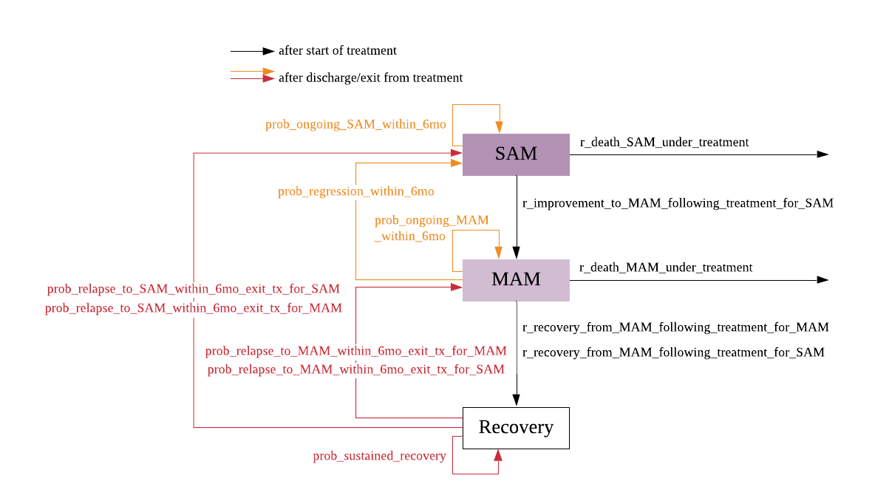

*Recovery: anthropometric criteria of WHZ>=-2 or MUAC >=125mm and no oedema for at least 2 weeks

Description: following the start of treatment, the individual child can either recover to the next improved nutritional state, continue in the same nutritional state as at the start of treatment, or die while under treatment. These processes are represented by the black arrows. The model updates the status of wasting 3 months after treatment.

Red and orange arrows denotes the processes that occur after discharge/exit from treatment. The red arrows denote the occurrences after discharge from treatment for moderate or severe wasting as per current recommended criteria. Whereas, the orange arrows denotes the occurrences after discharge from treatment before reaching the recommended criteria.

# Conceptualisation of stunting model structure

## Summary

In the design of a model for chronic malnutrition, the underlying ‘truth’ of an individual’s condition is determined by the height-for-age Z-score (HAZ), or stunting status (HAZ<-2), following the WHO 2006 Child Growth Standards. Stunting classification by the WHO guidelines has two categories: moderate (-3≤HAZ<-2) or severe (HAZ<-3).

Stunting is a result of complex multifactor interaction as represented in Figure 5, a conceptual framework of stunting developed by Fenske and colleagues. For the simplicity of the model, only a few of these variables, which are measurable, will serve as risk factors for stunting.

Figure 5 - Conceptual framework of stunting (source: Fenske 2013) 21

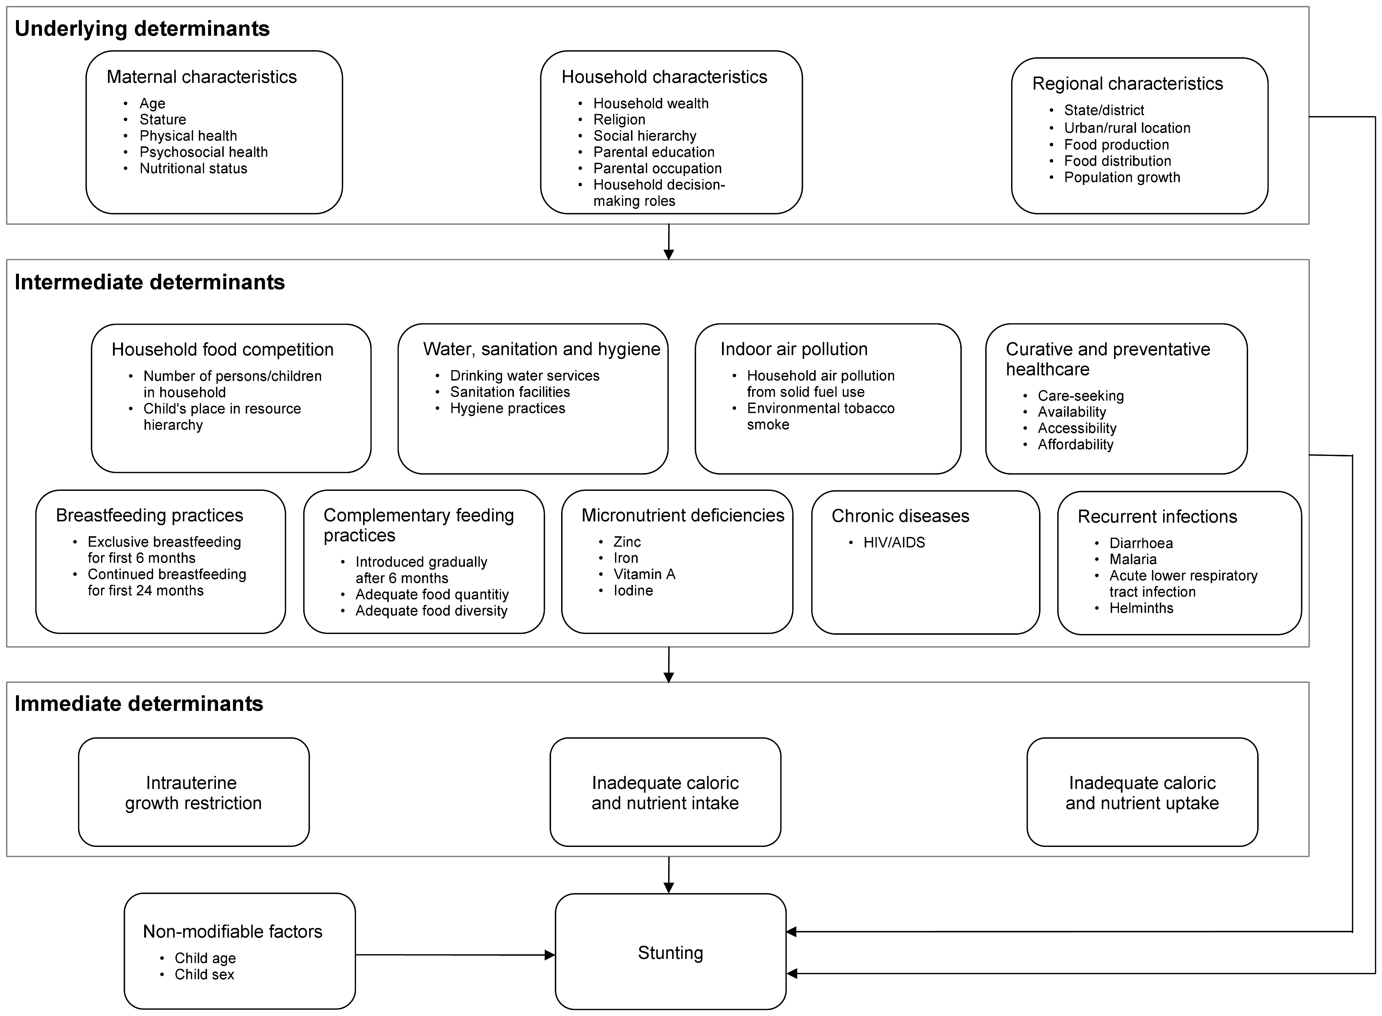

The stunting module updates the chronic nutritional status to all children under 5 years of age. It is responsible for assigning the prevalence at initiation of the simulation, the monthly incidence rate of stunting, changes between stunting states, and scheduling health system interactions where interventions are deployed. Death from stunting is not modelled, stunting serves as a risk factor for morbidity and mortality due to other diseases.

## Module properties

Table 6 - Properties of the stunting module, and respective type and description

|  |  |  |
| --- | --- | --- |
| **Property name** | **Type** | **Description** |
| **un_ever_stunted** | Boolean | ever had an episode of stunting (WHZ<-2) |
| **un_HAZ_category** | Categorical  ['HAZ<-3', '-3<=HAZ<-2', 'HAZ>=-2'] | height-for-age z-score category |
| **un_clinical_chronic_malnutrition** | Categorical  ['moderate_stunting', 'severe_stunting'] | clinical acute malnutrition state based on HAZ |
| **un_last_stunting_date_of_onset** | Date | date of onset of last episode of stunting |
| **un_stunting_recovery_date** | Date | Date of recovery |
| **un_CM_treatment_type** | Categorical  ['education_on_complementary_feeding', 'complementary_feeding_with_food_supplementation'] | treatment types for chronic malnutrition |

## Prevalence of stunting at start of simulation

At initiation, the prevalence of stunting is set. Based on the DHS 2015-16 data, the mean and standard deviation of the normal distribution of HAZ scores for each age group: <6, 6-11, 12-23, 24-35, 36-47, 48-59 months are used to determine the probability of HAZ< -2 (wasted) for each age category. Then this probability of stunting is converted into odds of stunting, for which the odds ratios of risk factors are added to the linear model of stunting prevalence. Prevalence parameters and respective values are listed in Table 7.

## Incidence of stunting and disease progression

The figure below (Figure 1) shows the proposed model structure for stunting (low height-for-age), the chronic form of undernutrition. It focuses on the natural history of stunting without input of the healthcare system interventions.

A regular event, occurring every month, applies the incidence of new stunting cases by age. Then, for each individual, a probability of progression to severe stunting in the next 3 months is applied, as well as the probability of natural improvement by 1 standard deviation – if severely stunted the child can improve to moderate stunting; if moderately stunted, the child can improve to no stunting. Most children once stunted, will remain stunted, as a result of chronic undernutrition.

Figure 6 - Model structure of the natural history of chronic malnutrition

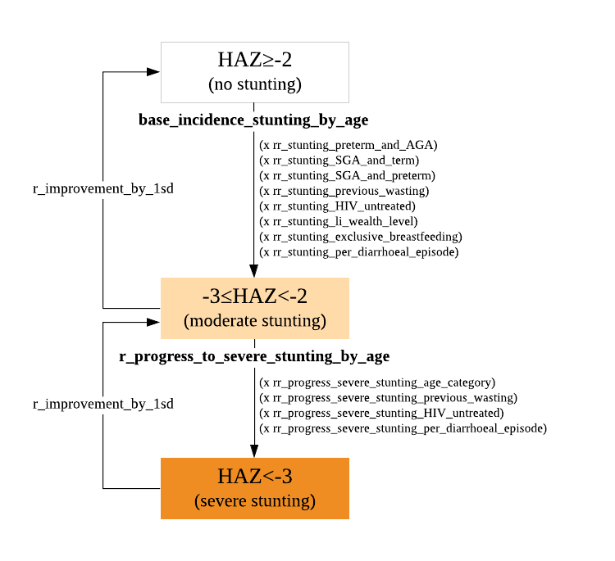

As shown in the proposed model structure, the incidence of stunting is dependent on age and several risk factors including, birth size (preterm birth, gestational age), HIV status, household wealth, exclusive breastfeeding until 6 months of age, prior episodes of diarrhoea, and prior wasting episodes.

Once in a state of moderate stunting (-3≥HAZ<-2), the individual will remain in that state for the following 3 months after onset, and a probability of stunting progression to severe is applied, as well as a probability of natural improvement of moderately stunted to normal height-for-age.

The rate of progression to severe wasting depends on age and risk factors that way have changed since first onset of stunting, such as, HIV under treatment, wasting episode during stunting, and diarrhoeal episodes since onset of stunting. All other risk factors associated with incidence are assumed to remain constant for the individual (immutable), such as birth outcomes, been exclusively breastfed, and wealth level. When in the severe stunting state (HAZ<-3), the individual will remain in that state for 3 months. After this period, the individual may recover to moderate stunting, but not fully recovered to non-stunting state.

## Health System Interactions

There is a monthly regular event that checks on the probability of recovery/improvement from stunting based on interventions. Sever stunting cannot revert back to normal state, the individual can only improve by 1 z-score.

Being a complex problem, there is no single nutrition intervention to address stunting in children, but rather multiple, complex and coordinated nutrition-sensitive and nutrition-specific interventions in partnership with other health and non-health actors in development22.

In Malawi’s Essential Health Package, relevant interventions for stunting include:

* Promotion of exclusive breastfeeding (part of the IMCI counselling part)
* Growth monitoring (checked in routine check-ups)
* De-worming (part of the IMCI routine medications)
* Micronutrient supplementation (part of the IMCI routine medications)
* Treatment of severe acute malnutrition

In the stunting module the interventions specific for stunting modelled are complementary feeding (education and supplementation). Other interventions above included in the EHP are applied when the child interacts with the health system.

Although a more comprehensive list of prevention interventions would be:

* zinc supplementation in pregnant women
* micronutrient or macronutrient supplementation in children
* nutrition education for pregnant women
* nutrition systems strengthening targeting children
* complementary feeding (education and supplementation)
* breastfeeding promotion
* multiple micronutrient supplementation
* balanced energy supplementation
* zinc for prevention
* improved sanitation
* water connection in the home
* improved water source
* handwashing with soap

## Parameters of the stunting module

Table 7 list all the parameters used in modelling stunting.

Table 7 - Parameters of the stunting module and respective values

|  |  |  |  |  |  |
| --- | --- | --- | --- | --- | --- |
|  | Parameter | Value | Source | Description | Notes |
| **Prevalence** | prev_HAZ_distribution_age_0_5mo | [-0.8482, 1.4163] | DHS 2015-16 | mean and standard deviation of height-for-age z-scores distribution for <6 months old |  |
| prev_HAZ_distribution_age_6_11mo | [-0.9940, 1.5044] | DHS 2015-16 | mean and standard deviation of height-for-age z-scores distribution for 6-11 months old |  |
| prev_HAZ_distribution_age_12_23mo | [-1.5221, 1.4312] | DHS 2015-16 | mean and standard deviation of height-for-age z-scores distribution for 1 year old |  |
| prev_HAZ_distribution_age_24_35mo | [-1.6692, 1.3435] | DHS 2015-16 | mean and standard deviation of height-for-age z-scores distribution for 2 year old |  |
| prev_HAZ_distribution_age_36_47mo | [-1.7973, 1.2124] | DHS 2015-16 | mean and standard deviation of height-for-age z-scores distribution for 3 year old |  |
| prev_HAZ_distribution_age_48_59mo | [-1.6201, 1.1154] | DHS 2015-16 | mean and standard deviation of height-for-age z-scores distribution for 4 year old |  |
| or_stunting_male | 1.38 | 9 | odds ratio of stunting for males |  |
| or_stunting_hhwealth_Q5 | 1.69 | 9 | odds ratio of stunting for poorest household wealth Q5 |  |
| or_stunting_hhwealth_Q4 | 1.48 | 9 | odds ratio of stunting for poorer household wealth Q4 |  |
| or_stunting_hhwealth_Q3 | 1.4 | 9 | odds ratio of stunting for middle household wealth Q3 |  |
| or_stunting_hhwealth_Q2 | 1.29 | 9 | odds ratio of stunting for richer household wealth Q2 |  |
| or_stunting_preterm_and_AGA | 2.13 | 10 | odds ratio of stunting if born preterm and adequate for gestational age | pooled OR estimate for sub-saharan africa |
| or_stunting_SGA_and_term | 2.36 | 10 | odds ratio of stunting if born small for gestational age and term |
| or_stunting_SGA_and_preterm | 5.95 | 10 | odds ratio of stunting if born small for gestational age and preterm |
| **Incidence** | base_inc_rate_stunting_by_agegp | [0.024,0.09,0.15,0.09,0.06, 0.06] | 11 | baseline incidence rate of stunting by age group [1-5, 6-11, 12-23, 24-35, 36-47, 48-59] | estimates will be calculated, currently dummy values |
| rr_stunting_preterm_and_AGA | 2.11 | 10 | relative rate of stunting if born preterm and adequate for gestational age |  |
| rr_stunting_SGA_and_term | 2.26 | 10 | relative rate of stunting if born small for gestational age and term |  |
| rr_stunting_SGA_and_preterm | 3.09 | 10 | relative rate of stunting if born small for gestational age and preterm |  |
| rr_stunting_prior_wasting | 1.93 | 23 | relative rate of stunting if prior wasting |  |
| rr_stunting_untreated_HIV | 1.5 | dummy | relative risk of stunting per unit decrease in wealth level |  |
| rr_stunting_wealth_level | 0.2 | 9 | relative risk of stunting per unit decrease in wealth level |  |
| rr_stunting_no_exclusive_breastfeeding | 1.4 | dummy | relative risk of stunting for children<2yo without exclusive breastfeeding |  |
| rr_stunting_no_continued_breastfeeding | 1.3 | dummy | relative risk of stunting for children<2yo without continued breastfeeding |  |
| rr_stunting_per_diarrhoeal_episode | 1.04 | 24 | Relative risk of stunting per 1 unit increase in diarrhoea episodes since birth |  |
| **Progression** | progression_severe_stunting_by_agegp | [0.02,0.03,0.09,0.05,0.04,0.03] | 11 | risk of progression to severe stunting (HAZ<-3) by age group |  |
| rr_progress_severe_stunting_previous_wasting | 1.93 | 23 | relative risk of severe stunting if wasting occurred during current stunting | Assumed same value as rr_stunting_prior_wasting |
| rr_progress_severe_stunting_untreated_HIV | 1.3 | dummy | relative risk of severe stunting if untreated HIV status |  |
| rr_progress_severe_stunting_per_diarrhoeal_episode | 1.04 | 24 | relative risk of severe stunting if per diarrhoeal episode |  |
| prob_remained_stunted_in_the_next_3months | 0.873 | 23 | probability of remaining stunted for the next 3 months |  |
| **Interventions** | coverage_supplementary_feeding_program | 0.58 | 14 | coverage of supplementary feeding program for MAM in health centres | Malawi estimates |
| un_effectiveness_complementary_feeding_promo_education_only_in_stunting_reduction | 0.25 | 24 | effectiveness of complementary feeding programme with education only in reducing stunting |  |
| un_effectiveness_complementary_feeding_promo_with_food_supplementation_in_stunting_reduction | 0.41 | 24 | effectiveness of complementary feeding programme with provision of supplementary foods in reducing stunting |  |
| un_effectiveness_zinc_supplementation_in_stunting_reduction | 0.15 | 24 | effectiveness of zinc supplementation in reducing stunting | Not yet used in the code |

# References

1. Maleta, K. Undernutrition. *Malawi Med. J.* 189–205 (2006).

2. Fact sheets - Malnutrition. Available at: https://www.who.int/news-room/fact-sheets/detail/malnutrition. (Accessed: 26th April 2021)

3. Williams, P. C. M. & Berkley, J. A. Guidelines for the treatment of severe acute malnutrition: a systematic review of the evidence for antimicrobial therapy. *Paediatrics and International Child Health* **38**, S32–S49 (2018).

4. *WHO child growth standards and the identification of severe acute malnutrition in infants and children*.

5. Isanaka, S., Grais, R. F., Briend, A. & Checchi, F. Estimates of the Duration of Untreated Acute Malnutrition in Children From Niger. *Am. J. Epidemiol.* **173**, 932–940 (2011).

6. Frison, S., Checchi, F. & Kerac, M. Omitting edema measurement: How much acute malnutrition are we missing? *Am. J. Clin. Nutr.* **102**, 1176–1181 (2015).

7. Grellety, E. & Golden, M. H. Weight-for-height and mid-upper-arm circumference should be used independently to diagnose acute malnutrition: Policy implications. *BMC Nutr.* **2**, 1–17 (2016).

8. Ministry of Health (MOH). *Malawi Guidelines for Community-Based Management of Acute Malnutrition, 2nd Edition*. (2016).

9. Ntenda, P. A. M. & Chuang, Y. C. Analysis of individual-level and community-level effects on childhood undernutrition in Malawi. *Pediatr. Neonatol.* **59**, 380–389 (2018).

10. Christian, P. *et al.* Risk of childhood undernutrition related to small-for-gestational age and preterm birth in low- and middle-income countries. *Int. J. Epidemiol.* **42**, 1340–1355 (2013).

11. Maleta, K., Virtanen, S. M., Espo, M., Kulmala, T. & Ashorn, P. Childhood malnutrition and its predictors in rural Malawi. *Paediatr. Perinat. Epidemiol.* **17**, 384–390 (2003).

12. Alvarez, J. L., Dent, N., Browne, L., Myatt, M. & Briend, A. Mid-Upper Arm Circumference (MUAC) shows strong geographical variations in children with edema: Results from 2277 surveys in 55 countries. *Arch. Public Heal.* **76**, 1–10 (2018).

13. Lenters, L., Wazny, K. & Bhutta, Z. A. Management of Severe and Moderate Acute Malnutrition in Children. in *Disease Control Priorities, Third Edition (Volume 2): Reproductive, Maternal, Newborn, and Child Health* 205–223 (The World Bank, 2016). doi:10.1596/978-1-4648-0348-2_ch11

14. Maleta, K. & Amadi, B. Community-based management of acute malnutrition (CMAM) in sub-Saharan Africa: Case studies from Ghana, Malawi, and Zambia. *Food Nutr. Bull.* **35**, S34–S38 (2014).

15. Schoonees, A., Lombard, M. J., Musekiwa, A., Nel, E. & Volmink, J. Ready-to-use therapeutic food (RUTF) for home-based nutritional rehabilitation of severe acute malnutrition in children from six months to five years of age. *Cochrane Database of Systematic Reviews* **2019**, (2019).

16. Stobaugh, H. C. *et al.* Including whey protein and whey permeate in ready-to-use supplementary food improves recovery rates in children with moderate acute malnutrition: A randomized, double-blind clinical trial. *Am. J. Clin. Nutr.* **103**, 926–933 (2016).

17. Lagrone, L., Cole, S., Schondelmeyer, A., Maleta, K. & Manary, M. J. Locally produced ready-to-use supplementary food is an effective treatment of moderate acute malnutrition in an operational setting. *Ann. Trop. Paediatr.* **30**, 103–108 (2010).

18. Desyibelew, H. D., Bayih, M. T., Baraki, A. G. & Dadi, A. F. The recovery rate from severe acute malnutrition among under-five years of children remains low in sub-Saharan Africa. A systematic review and meta-analysis of observational studies. *PLoS One* **15**, (2020).

19. Grellety, E. & Golden, M. H. Severely malnourished children with a low weight-for-height have a higher mortality than those with a low mid-upper-arm-circumference: I. Empirical data demonstrates Simpson’s paradox. *Nutr. J.* **17**, (2018).

20. CORTASAM. *GUIDANCE TO IMPROVE THE COLLECTING AND REPORTING OF DATA ON RELAPSE IN CHILDREN FOLLOWING TREATMENT IN WASTING PROGRAMMES*. (2020).

21. Fenske, N., Burns, J., Hothorn, T. & Rehfuess, E. A. Understanding child stunting in India: A comprehensive analysis of socio-economic, nutritional and environmental determinants using additive quantile regression. *PLoS One* **8**, e78692 (2013).

22. World Health Organization. *Reducing Stunting in Children: Equity considerations for achieving the Global Nutrition Targets 2025*. (2018).

23. Wright, C. M. *et al.* Wasting and Stunting in Infants and Young Children as Risk Factors for Subsequent Stunting or Mortality: Longitudinal Analysis of Data from Malawi, South Africa, and Pakistan. *J. Nutr.* (2021). doi:10.1093/jn/nxab054

24. Bhutta, Z. A. *et al.* What works? Interventions for maternal and child undernutrition and survival. *The Lancet* **371**, 417–440 (2008).

1. As per current standard WHO guidelines: upon reaching WHZ>=-2 or MUAC >=125mm and no oedema for at least 2 weeks