**Contraception module**

This module covers baseline contraception methods use (one of 10 methods or ‘not_using’), contraception initiation rates for each method by age, contraception failure (pregnancy), contraception initiation rates for each method after pregnancy, switching contraceptive methods, and discontinuation rates by age, as described in Figure 1, with events for initiation, failure, switching and discontinuation. It also determines fertility via the fertility schedule moved here from the Demography module. Descriptions of the parameters and properties and their sources are provided in Tables 1 and 2. For more details please see ResourceFile_Contraception.xlsx and the Stata analysis files indicated in the last column of Table 1. Output from this module, showing how it compares to United Nations World Population Prospects demographic projections and predicted changes in contraception use, is shown as Figures 2–5.

**Table 1 Parameters**

| **Parameter** | **Description** | **Calculated from** *data for model read from* |
| --- | --- | --- |
| fertility_schedule | Age-specific baseline fertility for 15-49 year old women from DHS 2010 analysis assuming not_using contraception. | This was calculated from the DHS data in Stata using Fertility_v3.do as explained in **Appendix 1**. Please note this sheet also has the proportion of each age who are not_using and who are using each of the 10 methods of contraception (**Table A1**)  *Read from ‘Age_spec fertility’ sheet from ResourceFile_Contraception.xlsx within TLOmodel/resources folder.* |
| contraception_initiation1 | Contraception initiation rates per month from not_using for each of the 10 methods or not_using (the remaining proportion of women) | This is taken from the ‘irate1_1116’ output from ‘initiation rates_age_stcox_2005_2016_5yrPeriods.do' Stata analysis of DHS contraception calendar data for DHS 2010 and 2016 surveys combined, as explained in **Appendix 2**. An analysis of initiation rates by year indicated a change (increase) in initiation rates in 2011 (**Figure A2.1**) so 2011-2016 initiation rates are used (**Table A2.1**).  *Read from ‘irate1_’ sheet from ResourceFile_Contraception.xlsx within TLOmodel/resources folder.* |
| contraception_initiation2 | Contraception initiation rates per month after pregnancy/ birth/ termination to each of the 10 methods of contraception or not_using (the remaining proportion of women) | This is taken from the ‘irate2_1116’ output from ‘initiation rates_age_stcox_2005_2016_5yrPeriods.do' Stata analysis of DHS contraception calendar data for DHS 2010 and 2016 surveys combined, as explained in **Appendix 2**. An analysis of initiation rates by year indicated a change (increase) in initiation rates in 2011 (**Figure A2.2**) so 2011-2016 initiation rates are used (**Table A2.2**).  *Read from ‘irate2_’ sheet from ResourceFile_Contraception.xlsx within TLOmodel/resources folder.* |
| contraception_switching | Contraception switching rates per month from each of the 10 contraception methods (**Table A3.1**) to another method (as per ‘contraception_switching matrix’ below) | This is taken from the contraception_failure_discontinuation_switching.csv output from 'failure discontinuation switching rates.do' Stata analysis of DHS 2016 contraception calendar data, as explained in **Appendix 3**.  *Read from ‘Switching’ sheet from ResourceFile_Contraception.xlsx within TLOmodel/resources folder* |
| contraception_switching_matrix | The proportion of switches from each contraceptive method that are to each of the other methods (**Table A3.2**) | This is taken from the output from line 144 of 'failure discontinuation switching rates.do' Stata analysis of DHS 2016 contraception calendar data, as explained in **Appendix 3**.  *Read from switching_matrix’ sheet from ResourceFile_Contraception.xlsx within TLOmodel/resources folder* |
| contraception_discontinuation | Contraception discontinuation rates per month for each of the 10 contraception methods back to ‘not_using’ (**Table A3.3**) | ‘This is taken from ‘contraception_failure_discontinuation_switching.csv’ output from 'failure discontinuation switching rates.do' Stata analysis of DHS 2016 contraception calendar data as explained in **Appendix 3**. Please note that we are just using the DHS 2016 data because reason for discontinuation is not in the 2005-2009 contraception calendar data meaning an analysis of whether discontinuation rates differ by year (or 5 year period like that done for initiation rates is not possible).  *Read from ‘Discontinuation’ sheet from ResourceFile_Contraception.xlsx within TLOmodel/resources folder in Contraception branch.* |
| contraception_failure | Contraception failure rates per month for each of the 10 contraception methods to Pregnancy (**Table A3.4**) | This is taken from ‘contraception_failure_discontinuation_switching.csv’ output from 'failure discontinuation switching rates.do' Stata analysis of DHS 2016 contraception calendar data as explained in **Appendix 3**. Please note that we are just using the DHS 2016 data because reason for discontinuation (failure) is not in the 2005-2009 contraception calendar data meaning an analysis of whether failure rates differ by year (or 5 year period like that done for initiation rates is not possible).  *Read from ‘Failure’ sheet from ResourceFile_Contraception.xlsx within TLOmodel/resources folder in Contraception branch.* |
| r_fail_under25 | Increase in Failure rate for under-25s | **Relative Risk (RR) of contraceptive failure = 2.2** for under-25s – taken from Guttmacher analysis (see **Appendix 4** and **Table A4.1**)  *Read from see ‘Guttmacher’ sheet (row 27) in ‘Failure + discontinuation rates_TC.xlsx’.*a |
| r_init1_age | proportional incremental change in contraception_initiation1 rate for each age in years of the woman (**Table A4.2**) | This is taken from Stata analysis line 250 of initiation rates_age_stcox_2005_2016_5yrPeriods.do: fracpoly: regress _d age_ // fracpoly regression using exact age (better fitting model, higher F statistic), as explained in **Appendix 4**. The results of this model are plotted in **Figure A4.1** and are used to calculate the proportionate difference in init1 rate from the average rate for each age in years, which is the content of the ‘r_inti1_age’ sheet (the dataframe for this parameter). b  *Read from ‘r_inti1_age’ sheet from ResourceFile_Contraception.xlsx within TLOmodel/resources folder. See the 'Initiation1 by age' worksheet of ResourceFile_Contraception.xlsx for the graph showing the results of the model of the proportional change in contraception_initiation1 rate for each age in years of the woman* |
| r_discont_age | proportional incremental change in contraception_discontinuation rate for each age in years of the woman (**Table A4.3**) | This is taken from Stata analysis Step 3.5 of 'failure discontinuation switching rates.do’: fracpoly: regress drate_allmeth age, as explained in **Appendix 4**. The results of this model are plotted in **Figure A4.2** and are used to calculate the proportionate difference in discontinuation rate from the average rate for each age in years, which is the content of the ‘r_discont_age’ sheet (the dataframe for this parameter).  *Read from ‘r_discont_age’ sheet from ResourceFile_Contraception.xlsx within TLOmodel/resources folder. See 'Discontinuation by age' worksheet of ResourceFile_Contraception.xlsx for the graph showing the results of the model of the proportional change in contraception_discontinuation rate for each age in years of the woman* |
| r_init_year | proportional change in contraception initiation rates for each year in time from 2010 to 2100 | World Population Prospects 2019 (WPP 2019) fertility data –medium variant population projections– were used.1 The relative increase in contraception initiation rate was calculated in relation to decreases in fertility over time (those observed to 2015, and expected to 2100) adjusted for concomitant reductions in discontinuation (r_discont_year below). Please see **Appendix 5**.  *Read from ‘r_init_year’ sheet from ResourceFile_Contraception.xlsx within TLOmodel/resources folder.* |
| r_discont_year | proportional change in contraception_discontinuation rate for each year in time from 2010 to 2100 | World Population Prospects 2019 (WPP 2019) fertility data –medium variant population projections– were used.1 The relative decrease in contraception discontinuation rate was calculated in relation to decreases in fertility over time (those observed to 2015, and expected to 2100). Only the proportion discontinuing due to “desire to become pregnant” was reduced. Please see **Appendix 5**.  *Read from ‘r_discont_year’ sheet from ResourceFile_Contraception.xlsx within TLOmodel/resources folder.* |

a Other potential ‘lifestyle’ variables potentially associated with increased rates of failure (marital status, parity, wealth, urban-rural, education) were not included because they were not significant for >50% of those using contraception and only significant for one or two minor contraception categories - see the Table in ‘Guttmacher’ sheet in ‘Failure + discontinuation rates_TC.xlsx’.

b Please note a similar analysis was done for init2 (contraception_initiation2) though the model was not significant. A simpler model with age and age-squared was also not significant, and a very simple model with just age although p=0.03 significant was not deemed significant enough (the init2 rates only changed by ~+/-10-15% throughout the 15-49 age range) to make it worth adding an additional parameter (r_init2_age), especially given contracetption_initation2 (initiation after pregnancy or birth) is much rarer than contraception_initiation1.



**Figure 1 Conception-Pregnancy conceptual diagram**

(this is in: Dropbox/Thanzi la Onse/05 - Resources/Model design/Contraception-Pregnancy.pdf)

**Table 2 Properties**

|  |  |  |
| --- | --- | --- |
| **Properties** | **Description** | **Categories** |
| co_contraception | 'Current contraceptive method' (categorical variable with 11 categories) | 'not_using', 'pill', 'IUD', 'injections', 'implant', 'male_condom', 'female_sterilization', 'other_modern', 'periodic_abstinence', 'withdrawal', 'other_traditional'* |
| co_date_of_childbirth | Due date of child for those who become pregnant | DATE |
| is_pregnant | Whether individual is currently pregnant† | True, False |
| date_of_last_pregnancy | Date of the last pregnancy of this individual† | DATE |

*These are the 11 categories of contraception ('not using' + 10 methods) from the DHS analysis of initiation,  
discontinuation, failure and switching rates. 'other modern' includes Male sterilization, Female Condom, Emergency contraception. 'other traditional' includes lactational amenohroea (LAM), standard days method (SDM), 'other traditional method'. Have replaced Age-spec fertility sheet in demography.xlsx (in this branch) with the one in contraception.xlsx (has 11 categories and one row for each age with baseline contraception prevalences for each of the 11 categories)

† This Property was previously in the Demography.py module.

**Output**

Figure 2 shows that the projected population according to this contraception module and the demography module fits well with the WPP 2019 projected population (medium variant scenario)1.

Figure 3 shows that the proportion of women using contraception increases from 2010–2070 – this is because of the added r_init_year and r_discont_year parameters reflecting decreasing fertility over time (the number of women using contraception over time remained fairly constant before these parameters were added).

Figure 4 shows that injections and implants, followed by female sterilization, are the main methods of contraception used. This follows the DHS 2010 and 2016 contraceptive calendar data and may need to be updated as health system contraception interventions are added.

Figure 5 shows the number of pregnancies each year goes down from 2010–2070 – this is also because of the added r_init_year and r_discont_year parameters reflecting decreasing fertility over time (pregnancies remained fairly constant over time before these parameters were added).

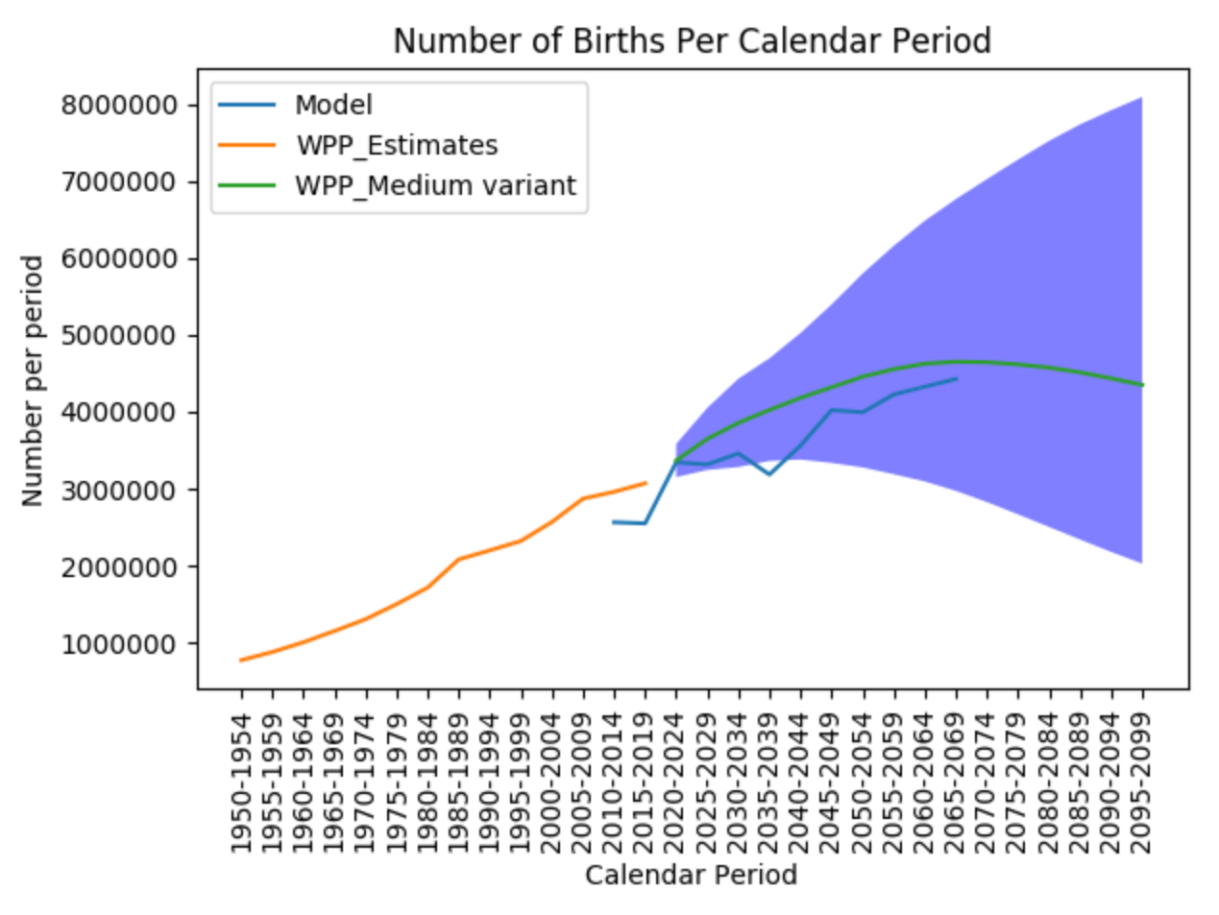

**Figure 2: Model and WPP predicted population**



**Figure 3: Contraception use 2010–2070 (simulation population size starts at n=1000)**

** Figure 4: Contraception use by method 2010–2070 (simulation population size starts at n=1000)**



**Figure 5: Proportion of women who are pregnant each year 2010–2070 (simulation population size starts at n=1000)**

**Contraception TODO**

* Interventions to increase contraception use including public health campaigns could be added. These are implicit within the projected increase of contraception use though (the r_init_year and r_discont_year parameters added to reflect WPP medium variant population scenario of falling fertility from 4.25 children per women in 2015-2020 to 1.94 children per women in 2095-2100). Ideally they should be costed and modelled as part of the health system though and reproduce the current r_init_year and r_discont_year parameters and population projections
* Contraception and Health system (given contraception available from many places not just health system). Tim H: let a fraction of those transaction trigger an HSI (based on DHS data?), so that we that represent some occupation some time of the health system
* Calibration: Use AIC to work out which model is the best to fit to calibrate population, pregnancy and contraception methods use distribution over time (would need to create some different options here to compare…)
* Make graphs showing contraceptive journeys of individual women over time to see if these are realistic

**Relatively minor issues**

* Init2 – need to consider reduced fertility (reduced probability of getting pregnant) in the months after birth when not using contraception – adjust failure rates for these women with RR? need to check against LAM in ‘other traditional’ though this maybe not reported for that many women of those who have recently given birth
* Add RR of lower baseline fertility rate and failure rate by HIV and Chlamydia (see Marston et al 2017 paper – need to link to these modules – HIV is now in Master as well so should be straightforward to do hopefully)
* Need to redo average over all ages of r_init1_fracpoly (bottom of Table 4.1) and r_discontinue_fracpoly (bottom of Table 4.2) accounting for population structure i.e. relative size of each age group rather than just as a simple average assuming all ages are equally sized. This could perhaps be done via predict following the fracpoly regression in Stata?
* Analysis and graphs – add for starts, stops, failures, switching
* Don’t need to include women pregnant at baseline (2010) as 2010-2020 run in should be sufficient to ensure pregnancies are right in 2020.
* Link DHS data to contraception calendar data – question 710 asks month and year of marriage so could link to contraception calendar data. Need to determine if there is an independent effect of marriage independently of age. But we don’t know when the marriage happened in relation to the contraception calendar so this can’t really be done.

PART 2 – Interventions for increasing contraception uptake and full bells and whistles model paper – Spring 2020

**Appendix 1:**  Calculation of fertility_schedule: Age-specific baseline fertility for 15-49 year old women from DHS 2010 analysis assuming not_using contraception

This analysis uses the individual recode dataset MWIR61FL.DTA from the Malawi DHS 2010 survey, downloaded from the DHS website with permission (<https://dhsprogram.com/data/available-datasets.cfm> accessed 15th October 2019) and was done by Tim Colbourn in Stata using Fertility_v3.do

Baseline fertility –i.e. fertility for those not using contraception– was calculated using the data on births in the last year for each woman, and estimates of the relative risk of pregnancy given each contraceptive method and the proportion of women using each contraceptive method, using the following formula:

[1] $F_{a }=F_{0a}r_{1}p_{1a}+F_{0a}r_{2}p_{2a}+…+F_{0a}r_{k}p_{ka}$

Where $F_{a }$ is total fertility of a woman aged *a, $F_{0a}$* is baseline fertility at age *a* (the parameter we are interested in), $r_{1}$, $r_{2}{…r}_{k}$ are the risks of pregnancy in one year of use for contraceptive methods 1, 2…*k* , i.e. 1 minus the effectiveness of the contraceptive method (see Table A.a. below), and $p_{1a}$, $p_{2a}$…. $p_{ka}$ are the proportion of women at age a using contraceptive methods 1, 2…*k* at age *a* (data obtained from Malawi DHS 2010 survey, Table A1).

**Table A.a effectiveness of contraceptive methods**

|  |  |  |
| --- | --- | --- |
| Contraceptive method | Effectiveness (one year of use) | *r* (risk of pregnancy in one year of use = 1 - effectiveness) |
| Pill | 0.91 | 0.09 |
| IUD | 0.992 | 0.008 |
| injections (DMPA) | 0.094 | 0.06 |
| Implant | 0.995 | 0.005 |
| Male condom | 0.7867 | 0.2133 |
| Female Sterilization | 0.995 | 0.005 |
| other modern (e.g. female condom) | 0.7867 | 0.2133 |
| periodic abstinence | 0.7867 | 0.2133 |
| Withdrawal | 0.7867 | 0.2133 |
| other traditional | 0.7867 | 0.2133 |

$F_{0a}$, baseline fertility at age *a* (i.e. fertility without contraception use) is calculated by rearranging equation [1] to:

[2] $F_{0a}={F'}_{a} / \sum_{i=k}^{i=1}{{r_{i}p}_{ia}}$

Where ${F'}_{a}$ is the observed total fertility (births in the last year, according to Malawi DHS 2010 data) per woman aged *a*, and $\sum_{i=k}^{i=1}{{r_{i}p}_{ia}}$ is the sum risk of pregnancy expected at age *a* weighted by the proportion using each contraception method (1 to *k*) across all women aged *a*.

**Table A1: Women’s baseline fertility and proportions not using contraception and using each contraception method by age in years (fertility_schedule parameter)** – grey cells add to 100%

| Age | Average pregnancies per year in those not using contraception | not using contraception | pill | IUD | injections | implant | male condom | female sterilization | other modern | periodic abstinence | withdrawal | other traditional |
| --- | --- | --- | --- | --- | --- | --- | --- | --- | --- | --- | --- | --- |
| 15 | 0.012 | 98.2% | 0.0% | 0.0% | 0.5% | 0.1% | 1.0% | 0.0% | 0.0% | 0.1% | 0.2% | 0.0% |
| 16 | 0.062 | 95.6% | 0.0% | 0.1% | 1.9% | 0.0% | 2.0% | 0.0% | 0.0% | 0.3% | 0.0% | 0.1% |
| 17 | 0.118 | 91.7% | 0.1% | 0.0% | 4.1% | 0.1% | 2.8% | 0.0% | 0.0% | 0.3% | 0.7% | 0.1% |
| 18 | 0.234 | 84.4% | 0.7% | 0.0% | 10.3% | 0.1% | 4.0% | 0.0% | 0.0% | 0.0% | 0.6% | 0.0% |
| 19 | 0.312 | 73.9% | 1.9% | 0.0% | 18.2% | 0.4% | 3.8% | 0.0% | 0.1% | 0.1% | 1.4% | 0.3% |
| 20 | 0.411 | 69.3% | 1.1% | 0.0% | 21.8% | 0.4% | 4.1% | 0.4% | 0.1% | 0.2% | 2.2% | 0.3% |
| 21 | 0.424 | 64.4% | 1.7% | 0.1% | 27.3% | 0.9% | 3.7% | 0.1% | 0.2% | 0.1% | 0.7% | 0.6% |
| 22 | 0.448 | 63.5% | 1.9% | 0.0% | 26.4% | 1.4% | 3.6% | 0.4% | 0.0% | 0.6% | 1.6% | 0.7% |
| 23 | 0.435 | 64.3% | 0.7% | 0.2% | 26.5% | 1.4% | 3.9% | 0.3% | 0.0% | 0.8% | 1.2% | 0.7% |
| 24 | 0.453 | 58.8% | 2.1% | 0.1% | 28.6% | 2.2% | 3.0% | 1.3% | 0.0% | 0.8% | 2.3% | 0.9% |
| 25 | 0.469 | 56.5% | 2.4% | 0.2% | 30.6% | 1.9% | 3.8% | 1.3% | 0.1% | 0.7% | 2.0% | 0.6% |
| 26 | 0.430 | 55.2% | 2.7% | 0.1% | 32.4% | 2.0% | 3.6% | 2.0% | 0.0% | 0.3% | 1.4% | 0.2% |
| 27 | 0.454 | 54.3% | 3.1% | 0.1% | 31.6% | 2.9% | 3.3% | 1.5% | 0.2% | 0.5% | 1.9% | 0.5% |
| 28 | 0.415 | 55.6% | 4.0% | 0.3% | 29.4% | 2.5% | 2.3% | 3.0% | 0.1% | 0.8% | 1.7% | 0.2% |
| 29 | 0.418 | 54.6% | 3.2% | 0.1% | 28.0% | 3.0% | 3.0% | 4.8% | 0.3% | 0.7% | 1.4% | 1.0% |
| 30 | 0.355 | 53.6% | 2.3% | 0.0% | 27.5% | 2.5% | 3.2% | 5.8% | 0.2% | 0.4% | 2.5% | 2.0% |
| 31 | 0.359 | 55.7% | 4.0% | 0.3% | 25.0% | 2.7% | 2.6% | 6.6% | 0.0% | 0.6% | 1.9% | 0.3% |
| 32 | 0.387 | 53.4% | 2.6% | 0.3% | 26.3% | 2.3% | 2.8% | 8.9% | 0.1% | 1.0% | 1.6% | 0.7% |
| 33 | 0.389 | 52.5% | 3.5% | 0.2% | 23.7% | 1.9% | 1.9% | 12.1% | 0.0% | 0.7% | 2.1% | 1.2% |
| 34 | 0.348 | 53.6% | 2.8% | 0.8% | 20.1% | 2.0% | 3.3% | 12.8% | 0.2% | 0.8% | 2.2% | 1.5% |
| 35 | 0.332 | 51.5% | 2.9% | 0.2% | 23.5% | 1.6% | 2.5% | 13.4% | 0.2% | 0.6% | 2.1% | 1.6% |
| 36 | 0.316 | 49.7% | 3.4% | 0.0% | 20.1% | 1.6% | 2.5% | 16.9% | 0.4% | 1.1% | 2.9% | 1.3% |
| 37 | 0.305 | 55.1% | 1.4% | 0.4% | 18.0% | 1.8% | 1.8% | 15.8% | 0.2% | 0.6% | 3.8% | 1.2% |
| 38 | 0.281 | 54.2% | 3.2% | 0.2% | 15.1% | 1.0% | 2.0% | 19.3% | 0.4% | 0.4% | 2.0% | 2.2% |
| 39 | 0.287 | 52.4% | 3.3% | 0.8% | 12.5% | 1.0% | 3.1% | 22.0% | 0.8% | 1.0% | 2.3% | 0.8% |
| 40 | 0.259 | 50.2% | 2.0% | 0.0% | 15.0% | 0.2% | 2.4% | 23.9% | 0.4% | 1.2% | 1.4% | 3.2% |
| 41 | 0.138 | 56.0% | 2.4% | 0.0% | 9.8% | 0.6% | 1.5% | 25.6% | 0.0% | 0.9% | 1.2% | 2.1% |
| 42 | 0.152 | 58.1% | 1.3% | 0.0% | 10.5% | 0.5% | 2.0% | 23.0% | 0.0% | 1.0% | 1.8% | 1.8% |
| 43 | 0.134 | 56.6% | 1.1% | 0.0% | 13.2% | 0.8% | 1.9% | 22.6% | 0.0% | 2.3% | 0.8% | 0.8% |
| 44 | 0.115 | 58.1% | 0.7% | 0.0% | 7.2% | 0.3% | 0.7% | 28.5% | 0.0% | 0.7% | 0.7% | 3.1% |
| 45 | 0.058 | 60.2% | 0.6% | 0.0% | 5.5% | 0.0% | 3.3% | 24.6% | 0.3% | 1.2% | 2.4% | 1.8% |
| 46 | 0.061 | 55.9% | 0.5% | 0.3% | 6.6% | 0.5% | 0.5% | 29.6% | 0.0% | 1.1% | 1.1% | 3.8% |
| 47 | 0.030 | 64.3% | 0.6% | 0.0% | 6.0% | 0.0% | 1.1% | 25.4% | 0.0% | 0.0% | 1.4% | 1.1% |
| 48 | 0.040 | 65.1% | 0.0% | 0.3% | 3.8% | 0.0% | 0.3% | 26.4% | 0.0% | 0.6% | 1.2% | 2.3% |
| 49 | 0.028 | 70.6% | 0.8% | 0.0% | 3.2% | 0.0% | 0.4% | 21.8% | 0.0% | 0.0% | 1.2% | 2.0% |

**Appendix 2: Explanation of initiation rates calculations**

These analysis use the eventsfile2010.dta dataset from the contraceptive calendar data from the Malawi DHS 2010 appended with the eventsfile2016.dta dataset from the contraceptive calendar data from the Malawi DHS 2016. The analysis follows the guidance from the DHS program, contained in the document: ‘DHS Contraceptive Calendar Tutorial, version 2 September 2018’.

contraception_initiation1

Initiation rates *I* for each contraception method (1 to *k*;1 is shown in formula [3]) from not using contraception were calculated using the following formula:

[3] $I_{1 }=\sum_{N}^{j}{i_{1}} / [(\sum_{N}^{j}{t}$)/12]

where *i* is an indicator variable of a contraception initiation event (to method 1 in formula [3]) denoted as the transition from not using contraception the previous month (marked 0 on the DHS contraceptive calendar) to using the particular contraception method the following month; *t* is the time at ‘risk’ (in months) of the contraception initiation i.e. the number of months of contraceptive calendar data for person *j* during which they were not using contraception. The contraception initiation events and time at risk are summed for all women (*N*) in the DHS contraception calendar datasets. The annual initiation rate is calculated by dividing the total time at risk in months by 12. Monthly initiation rates (which are used in the model) were calculated by dividing the initiation rate *I* by 12; and quarterly initiation rates were calculated by dividing the initiation rate *I* by 4 (Table A2.1).

contraception_initiation2

Initiation rates *I’* for each contraception method (1 to *k*;1 is shown in formula [4]) for the month following pregnancy, birth or termination (miscarriage, abortion, stillbirth) were calculated using the following formula:

[4] ${I'}_{1 }=\sum_{N}^{j}{{i'}_{1}} / \sum_{N}^{j}{t'}$

where *i'* is an indicator variable of a contraception initiation event (to method 1 in formula [4]) denoted as the transition from pregnancy, birth or termination the previous month (marked P, B, or T on the DHS contraceptive calendar) to using the particular contraception method the following month; *t’* is the single month at ‘risk’ of contraception initiation for woman *j* immediately after birth or termination of pregnancy. The contraception initiation events and month at risk are summed for all women (*N*) in the DHS contraception calendar datasets. As there is only a single month at ‘risk’ of contraception initiation for each woman *I’* (contraception_initiation2) is a monthly initiation rate (Table A2.2). Please note these rates are low as they are just for the month after pregnancy and then the remainder 99.5% who ‘initiate’ to ‘not_using’ i.e. 1 - $\sum_{k}^{1}{I'}$ are then subject to the usual monthly initiation rates *I* as per the model of contraception and pregnancy shown in Figure 1.

**Changes over time**

We calculated initiation rates over time by restricting the data to 5 year periods increasing by one year i.e. from 2005-2009 through to 2012-2016. For initiation from not using (contraception_initiation1) we observed a large increase in initiation rates in 2011 (Figure A2.1) and therefore use pooled 2011-2016 data as our contraception_initiation1 estimates (Table A2.1). For initiation following birth or termination (contraception_initiation2) we observe an increase in initiation rates over time, especially for injections and implants (Figure A2.2) and whilst not as dramatic as for contraception_initiation1 we see an increase in the rate of increase of initiation rate for a number of contraceptive methods in 2011 (Figure A2.2). We therefore also use pooled 2011-2016 data as our contraception_initiation2 estimates (Table A2.2).

**Table A2.1: Monthly, Quarterly and Annual Initiation rates to each type of contraception from not using (remainder is not using), 2011-2016 DHS data**

|  |  |  |  |  |  |  |  |  |  |  |  |
| --- | --- | --- | --- | --- | --- | --- | --- | --- | --- | --- | --- |
|  | pill | IUD | injections | implant | male condom | female sterilization | other modern | periodic abstinence | withdrawal | other traditional | not using |
| monthly | 0.14% | 0.04% | 1.54% | 0.37% | 0.23% | 0.10% | 0.01% | 0.01% | 0.04% | 0.02% | 97.50% |
| quarterly | 0.43% | 0.11% | 4.63% | 1.11% | 0.70% | 0.30% | 0.02% | 0.03% | 0.11% | 0.06% | 92.49% |
| annual | 1.71% | 0.43% | 18.52% | 4.46% | 2.82% | 1.19% | 0.08% | 0.12% | 0.45% | 0.25% | 69.98% |

**Table A2.2: Initiation rates to each type of contraception in the month after pregnancy, birth or termination (remainder is not using), 2011-2016 DHS data**

|  |  |  |  |  |  |  |  |  |  |  |  |
| --- | --- | --- | --- | --- | --- | --- | --- | --- | --- | --- | --- |
|  | pill | IUD | injections | implant | male condom | female sterilization | other modern | periodic abstinence | withdrawal | other traditional | not using |
| monthly | 0.044% | 0.009% | 0.601% | 0.144% | 0.052% | 0.124% | 0.003% | 0.006% | 0.015% | 0.064% | 98.938% |

**Figure A2.1**

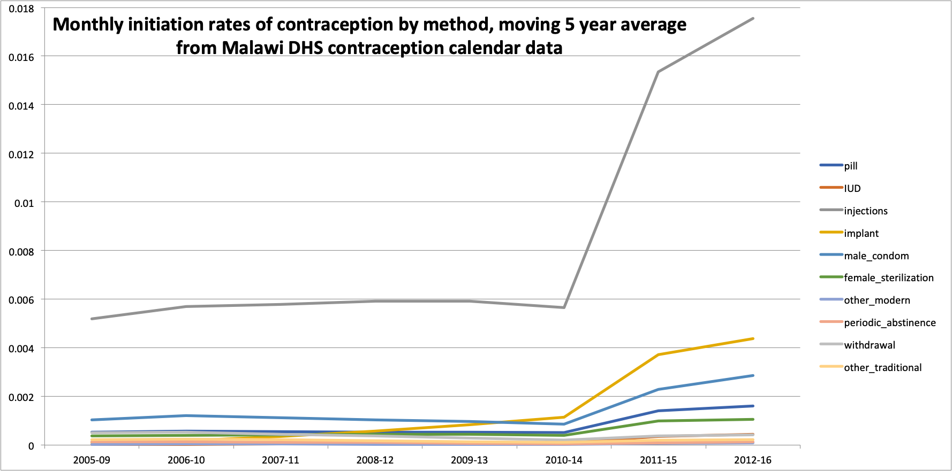

**Figure A2.2**



**Appendix 3 – Switching, Discontinuation, and Failure rates**

These analysis use the eventsfile.dta dataset from the contraceptive calendar data from the Malawi DHS 2016. The analysis follows the guidance from the DHS program, contained in the document: ‘DHS Contraceptive Calendar Tutorial, version 2 September 2018’. Contraception switching, discontinuation and failure rates were calculated as competing risks i.e. when a woman is on contraception she could stop using it for many reasons including switching to another method, discontinuing because of wanting to get pregnant or due to side effects (for example) or due to the method failing and her becoming pregnant. The risks of each of these things happening compete with each other so that the incidence rate of each thing happening has to take account of these alternative possibilities. We used the **stcompet** command in Stata.

contraception_switching

Switching rates *S* from each contraception method (1 to *k*;1 is shown in formula [5]) were calculated using the **stcompet** command in Stata, which uses the following formula2, 3 (please see contraception_switching_matrix below for the method the woman switches to):

[5] $$S_{1}(t)=\sum_{j:t_{(j)}≤t}{M_{1}(t_{(j-1)})} \frac{c_{(rj)}}{N_{j}}$$

where *j* denotes an individual woman on contraception in the dataset, *t* is the time (month) switching occurs, $j:t_{(j)}≤t$ is the time at ‘risk’ (in months) of the contraception switching i.e. the number of months of contraceptive calendar data for person *j* during which they were using the contraception method they switch from; $M_{1}(t_{(j-1)})$ is the Kaplan-Meir estimate of the overall survival function of staying on the same method (method 1 in formula [5]) of contraception (see formula [6]); this is scaled by $\frac{c_{(rj)}}{N_{j}}$ which is the proportion of all competing risks (for woman *j*), $N_{j}$, that the cumulative risk (*c*) of switching contraceptive methods (*r*) for women *j* i.e. $c_{(rj)}$ represents.

$N_{j}= \sum_{r=1}^{m}{N_{rj}}$ and $N_{rj}$ represents the number of women who change contraception status due to competing risk *r* at time *tj.* In this model r=1 is switching contraception methods and r=2 is any other change in contraception status (i.e. *m*=2, *r* can either be 1 or 2).

Monthly contraception switching rates were calculated for each contraceptive method using the above and are used in the model (Table A3.1). Quarterly switching rates could be obtained by multiplying these by 4 and annual switching rates could be obtained by multiplying these by 12.

We are not using the option of calculating standard errors surrounding the cumulative incidence of the competing risks model (for switching, or failure or discontinuation below), though this is an option in the **stcompet** Stata command.2, 3 This could be used in future stochastic versions of the contraception model.

Kaplan-Meir Estimate3 of the of the overall survival function of staying on contraception method 1 during time $0≤t≤t_{1}$:

[6] $$M_{1}\left(t_{\left(j-1\right)}\right)=\prod_{j:t_{(j)}≤t}{(1-}\frac{c_{(1j)}}{N_{j}}), 0≤t≤t_{1}$$

contraception_switching_matrix

The DHS 2016 contraceptive calendar data were used to determine the contraception method a women switched to after switching from a particular method. This switching matrix (Table A3.2) was calculated directly from the data as the proportion of the total switches from each of the 10 contraception methods (rows of Table A3.2) that were to each of the 9 other methods (columns of Table A3.2).

contraception_failure

Like contraception switching above, failure rates *F* for each contraception method were calculated using the **stcompet** command in Stata. Formula [5] can be substituted as:

[7] $$F_{1}(t)=\sum_{j:t_{(j)}≤t}{M_{1}(t_{(j-1)})} \frac{c_{(rj)}}{N_{j}}$$

where everything as in formula [5] and associated text except r=1 is failure of the contraception method and competing risks r=2 to r=7 are discontinuation of contraception due to a number of different reasons which sum together as the discontinuation rate (see below) (i.e. *m*=7, *r* can either be 1, 2, 3, 4, 5, 6 or 7).

Monthly contraception failure rates were calculated for each contraceptive method using the above and are used in the model (Table A3.3). Quarterly switching rates could be obtained by multiplying these by 4 and annual switching rates could be obtained by multiplying these by 12.

contraception_discontinuation

Contraception discontinuation is determined from the same model as contraception failure above. In formula [8] below r= $\sum_{r=7}^{r=2}{r}$, i.e. the sum of competing risks of discontinuation for all reasons for discontinuation (2 = “desire to become pregnant”, 3 = “other method related reason”, 4 = “side effects”, 5 = “ wanted more effective method”, 6 = “other fertility related reasons”, 7 = “other reason / don’t know”); r could also = 1 (failure of the contraception method, as above) as a competing risk. Discontinuation rate, D, is:

[8] $$D_{1}(t)=\sum_{j:t_{(j)}≤t}{M_{1}(t_{(j-1)})} \frac{c_{(rj)}}{N_{j}}$$

Monthly contraception discontinuation rates were calculated for each contraceptive method using the above and are used in the model (Table A3.4). Quarterly switching rates could be obtained by multiplying these by 4 and annual switching rates could be obtained by multiplying these by 12.

**Table A3.1 Monthly Switching rates from each contraceptive methods to a new method (see Table A3.2)**

|  |  |  |  |  |  |  |  |  |  |  |
| --- | --- | --- | --- | --- | --- | --- | --- | --- | --- | --- |
|  | pill | IUD | injections | implant | male condom | female sterilization | other modern | periodic abstinence | withdrawal | other traditional |
| monthly | 1.09% | 0.15% | 0.30% | 0.09% | 1.14% | 0.00% | 0.27% | 0.75% | 1.38% | 2.72% |

**Table A3.2 Switching matrix: proportion of those who switch from each contraception method that switch to each new method**

|  |  |  |  |  |  |  |  |  |  |  |  |
| --- | --- | --- | --- | --- | --- | --- | --- | --- | --- | --- | --- |
|  |  | **switch to** | | | | | | | | | |
|  |  | pill | IUD | injections | implant | male condom | female sterilization | other modern | periodic abstinence | withdrawal | other traditional |
| **switch from** | pill | 0.00% | 0.00% | 54.03% | 21.77% | 10.48% | 5.65% | 2.42% | 0.81% | 4.03% | 0.81% |
| IUD | 12.50% | 0.00% | 37.50% | 25.00% | 12.50% | 12.50% | 0.00% | 0.00% | 0.00% | 0.00% |
| injections | 26.28% | 2.67% | 0.00% | 44.77% | 10.69% | 7.57% | 0.89% | 0.89% | 4.45% | 1.78% |
| implant | 20.59% | 2.94% | 63.24% | 0.00% | 10.29% | 2.94% | 0.00% | 0.00% | 0.00% | 0.00% |
| male condom | 8.29% | 0.49% | 59.51% | 22.44% | 0.00% | 2.93% | 0.49% | 0.98% | 4.88% | 0.00% |
| other modern | 0.00% | 0.00% | 100.00% | 0.00% | 0.00% | 0.00% | 0.00% | 0.00% | 0.00% | 0.00% |
| periodic abstinence | 0.00% | 0.00% | 33.33% | 66.67% | 0.00% | 0.00% | 0.00% | 0.00% | 0.00% | 0.00% |
| withdrawal | 3.70% | 1.85% | 51.85% | 29.63% | 11.11% | 1.85% | 0.00% | 0.00% | 0.00% | 0.00% |
| other traditional | 0.00% | 0.00% | 73.91% | 14.49% | 5.80% | 5.80% | 0.00% | 0.00% | 0.00% | 0.00% |

**Table A3.3 Monthly Discontinuation rates from each contraceptive method to not using**

|  |  |  |  |  |  |  |  |  |  |  |
| --- | --- | --- | --- | --- | --- | --- | --- | --- | --- | --- |
|  | pill | IUD | injections | implant | male condom | female sterilization | other modern | periodic abstinence | withdrawal | other traditional |
| monthly | 4.96% | 1.11% | 3.34% | 0.63% | 5.04% | 0.00% | 3.33% | 4.23% | 4.23% | 4.98% |
|  |  |  |  |  |  |  |  |  |  |  |
|  |  |  |  |  |  |  |  |  |  |  |

**Table A3.4 Monthly Failure rates from each contraceptive method to Pregnancy**

|  |  |  |  |  |  |  |  |  |  |  |
| --- | --- | --- | --- | --- | --- | --- | --- | --- | --- | --- |
|  | pill | IUD | injections | implant | male condom | female sterilization | other modern | periodic abstinence | withdrawal | other traditional |
| monthly | 0.19% | 0.00% | 0.05% | 0.01% | 0.12% | 0.00% | 0.00% | 0.06% | 0.36% | 0.49% |

**Appendix 4 Differences by Age**

**Relative Risk (RR) of contraceptive failure** r_fail_under25 **= 2.2** for under-25s

This was calculated using the results of an analysis of 10 East African DHS contraceptive calendar surveys by the Guttmacher institute (see Table 9, page 52 of the report4). Those under 25 had statistically significantly higher failure rates than those over 25 for the following methods of contraception: pill, injectables, and periodic abstinence, and higher failure rates for almost all of the other contraception methods with data: implants, condom and withdrawal (see ‘Guttmacher’ sheet (row 27) in ‘Failure + discontinuation rates_TC.xlsx’). The relative risk of failure for under 25s compared to over 25s was then calculated as the average of the relative risks of failure in under 25s compared to over 25s for each method weighted by the proportion of all women aged 15-49 years in Malawi who use contraception that were using each method according to the 2010 DHS data (see ‘cprev2010.csv’ sheet in ‘Failure + discontinuation rates_TC.xlsx’).

**Proportional incremental change in contraception_initiation1 rate for each age in years of the woman:** r_init1_age

Cox regression of contraception initiation (_d in survival time stset data in Stata) with age as a covariate was undertaken to estimate how the initiation rate (see Appendix 2, formula [3]) varies by age. Given initiation rates vary non-linearly with increasing age we first used age and age squared (which was significantly associated with initiation) and then used an automated tool in Stata (the fracpoly command) to estimate the two best fitting powers of age (exact, not rounded to the nearest year). The results of these models are plotted in Figure A4.1, and shown in Table 4.1 as the parameter r_init1_age: the proportional incremental change in contraception_initition1 rate for each age in years of the woman relative to the average contraception_initiation1 rate for all women.

**Proportional incremental change in contraception_discontinuation rate for each age in years of the woman:** r_discont_age

Linear regression of contraception discontinuation rate with age as a covariate was undertaken to estimate how the discontinuation rate (see Appendix 3, formula [8]) varies by age. Given discontinuation rates vary non-linearly with increasing age we first used age and age squared (which was significantly associated with discontinuation) and then used an automated tool in Stata (the fracpoly command) to estimate the two best fitting powers of age (exact, not rounded to the nearest year). The results of these models are plotted in Figure A4.2, and shown in Table 4.2 as the parameter r_discont_age: the proportional incremental change in contraception_discontinuation rate for each age in years of the woman relative to the average contraception_discontinuation rate for all women.

**Table 4.1 Proportional incremental change in contraception_initiation1 rate (r_init1_age) for each age in years of the woman (this is calculated for each age relative to the average initiation rate across all ages according to the best fitting model = 0.34196)**

|  |  |  |
| --- | --- | --- |
| age | r_init1_fracpoly | r_init1_age |
| 15 | 0.4545 | 0.329 |
| 16 | 0.4187 | 0.225 |
| 17 | 0.3923 | 0.147 |
| 18 | 0.3726 | 0.090 |
| 19 | 0.3580 | 0.047 |
| 20 | 0.3472 | 0.015 |
| 21 | 0.3391 | -0.008 |
| 22 | 0.3333 | -0.025 |
| 23 | 0.3291 | -0.038 |
| 24 | 0.3261 | -0.046 |
| 25 | 0.3242 | -0.052 |
| 26 | 0.3231 | -0.055 |
| 27 | 0.3225 | -0.057 |
| 28 | 0.3224 | -0.057 |
| 29 | 0.3227 | -0.056 |
| 30 | 0.3232 | -0.055 |
| 31 | 0.3240 | -0.053 |
| 32 | 0.3249 | -0.050 |
| 33 | 0.3259 | -0.047 |
| 34 | 0.3271 | -0.044 |
| 35 | 0.3283 | -0.040 |
| 36 | 0.3295 | -0.036 |
| 37 | 0.3308 | -0.033 |
| 38 | 0.3321 | -0.029 |
| 39 | 0.3334 | -0.025 |
| 40 | 0.3348 | -0.021 |
| 41 | 0.3361 | -0.017 |
| 42 | 0.3373 | -0.014 |
| 43 | 0.3386 | -0.010 |
| 44 | 0.3398 | -0.006 |
| 45 | 0.3411 | -0.003 |
| 46 | 0.3423 | 0.001 |
| 47 | 0.3434 | 0.004 |
| 48 | 0.3446 | 0.008 |
| 49 | 0.3457 | 0.011 |
| Average: | 0.34196 |  |

**Figure A4.1 Contraception Initiation rate (all methods combined) by woman’s age in years, best fitting model is r_init1_fracpoly (blue line)**

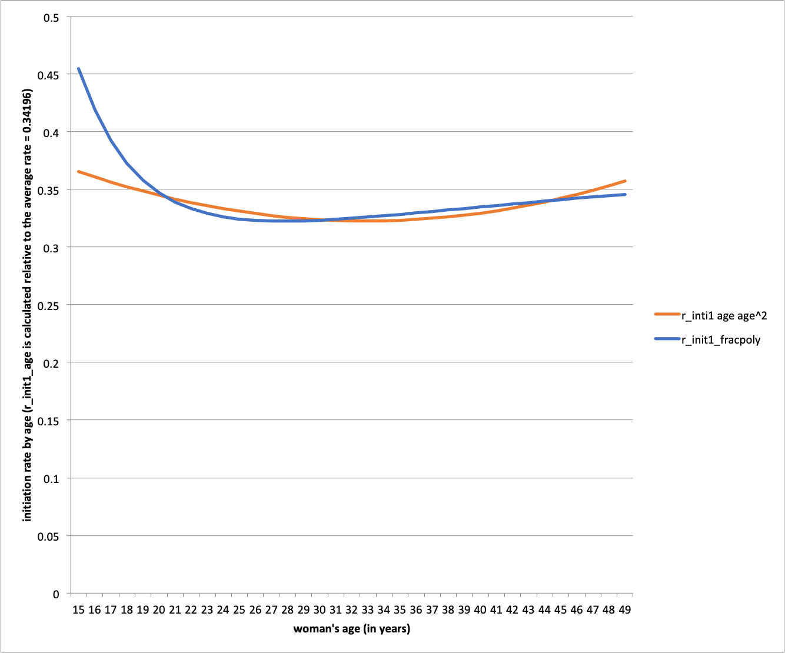

**Table 4.2 Proportional incremental change in contraception discontinuation rate (r_discont_age) for each age in years of the woman (this is calculated for each age relative to the average initiation rate across all ages according to the best fitting model = 0.05635)**

|  |  |  |
| --- | --- | --- |
| age | r_discontinue_fracpoly | r_discont_age |
| 15 | 0.0067 | -0.882 |
| 16 | 0.0209 | -0.629 |
| 17 | 0.0316 | -0.439 |
| 18 | 0.0397 | -0.295 |
| 19 | 0.0458 | -0.185 |
| 20 | 0.0505 | -0.102 |
| 21 | 0.0541 | -0.038 |
| 22 | 0.0569 | 0.011 |
| 23 | 0.0589 | 0.048 |
| 24 | 0.0605 | 0.075 |
| 25 | 0.0616 | 0.096 |
| 26 | 0.0625 | 0.110 |
| 27 | 0.0630 | 0.121 |
| 28 | 0.0634 | 0.127 |
| 29 | 0.0636 | 0.131 |
| 30 | 0.0637 | 0.133 |
| 31 | 0.0637 | 0.132 |
| 32 | 0.0636 | 0.131 |
| 33 | 0.0635 | 0.128 |
| 34 | 0.0633 | 0.124 |
| 35 | 0.0630 | 0.120 |
| 36 | 0.0627 | 0.115 |
| 37 | 0.0624 | 0.110 |
| 38 | 0.0621 | 0.104 |
| 39 | 0.0618 | 0.099 |
| 40 | 0.0615 | 0.093 |
| 41 | 0.0611 | 0.087 |
| 42 | 0.0608 | 0.080 |
| 43 | 0.0604 | 0.074 |
| 44 | 0.0601 | 0.068 |
| 45 | 0.0598 | 0.062 |
| 46 | 0.0594 | 0.056 |
| 47 | 0.0591 | 0.050 |
| 48 | 0.0588 | 0.044 |
| 49 | 0.0584 | 0.039 |
| Average: | 0.05625 |  |

**Figure A4.2 Contraception Discontinuation rate (all methods combined) by woman’s age in years, best fitting model is r_discont_fracpoly (blue line)**

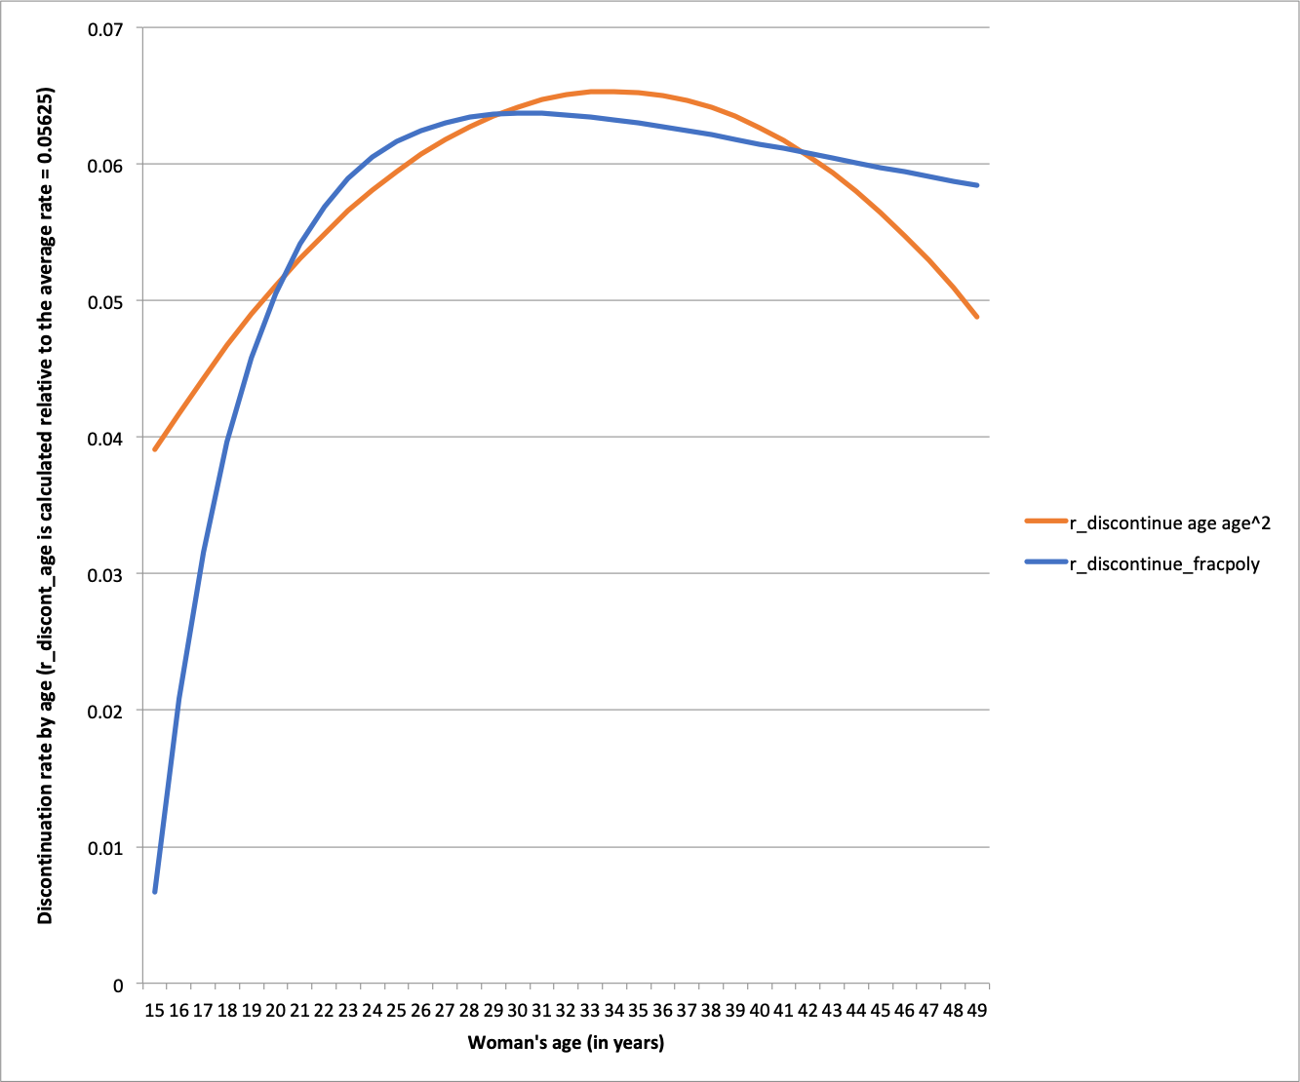

**Appendix 5 Proportional changes in contraception initiation and discontinuation rates, 2010–2100**

r_init_year

The proportional change in contraception initiation rates was calculated from the World Population Prospects (WPP) 2019 medium variant total fertility estimates (live births per woman) for Malawi (observed up to 2015-2020 and projected to 2095-2010).1 This data is presented in 5-year periods in the WPP and the medium variant projections reflect falling fertility from 7.60 births per woman during 1980–1985, to 5.73 during 2005–2010 to 425 during 2015–2020 (a rapid recent fall reflected in DHS data), to a projected (under the medium variant scenario) 2.82 during 2045–2050, 2.12 (just above replacement level of ~2.1) during 2080–2085, and 1.94 during 2095–2100.1 Values for each 5-year period were assumed to represent the midpoint year i.e. 2012 for 2010–2015 and 2017 for 2015–2020 (bold text in Table 5.1).

Total fertility was calculated for each year (Table 5.1) by interpolating from one 5 year period to the next by year by calculating the difference between the first and last years of the 5 year period, dividing by 5 and adding this amount, once, twice, three times and four times to the first, second, third and fourth years in between the first and last years of the 5 year period, respectively.

We use total fertility in 2013 as the base year as it is the mid point of 2011-2016, which was used for the base initiation rate (see last paragraph ‘changes over time’ of Appendix 2). Then r_init_year was initially calculated for each year as the ratio of total fertility in that year to total fertility in 2013 i.e. r_init_year increases (contraception initiation increases) as fertility falls over time. This, along with decreases in discontinuation (see below) can explain the expected fertility decreases over time and reproduce these (approximately) in the Thanzi La Onse model.

We don’t want to double count the fertility reduction by both increasing initiation and decreasing discontinuation in line with fertility decline. We only want to do this once, and given only 18.9% of the 6 reasons for discontinuation are "desire to become pregnant" (see 'drates_12m’ sheet in ResourceFile_Contraception) the relative changes in discontinuation rate (r_discont_year) should be scaled to only be 18.9% of those initially calculated in line with fertility declines. The relative changes in initiation rate (r_init_year) should be reduced by 18.9% accordingly (i.e. scaled by 81.1%). These are the estimates of the r_init_year and r_discont_year parameters used in the model (Table 5.1).

r_discont_year

The proportional change in contraception discontinuation rates was calculated using the same method as above for r_init_year except r_discont_year is calculated as the ratio of total fertility in 2013 (the base year) to total fertility in the year in question. This reflects the expected decrease in contraception discontinuation rates over time, which contribute to falling total fertility (Table 5.1).

Contraception discontinuation can be due to any of six reasons according to the contraception calendar data (“desire to become pregnant”, “other method related reason”, “side effects”, “ wanted more effective method”, “other fertility related reasons”, “other reason / don’t know”, also see last section of Appendix 3 ‘contraception_discontinuation’). As detailed above, we assume here that only “desire to become pregnant”, which constitutes 18.9% of all reasons for discontinuation, will reduce in line with projected secular declines in fertility. Therefore we have scaled the r_discont_year parameter to be only 18.9% of that initially calculated in line with total fertility declines (Table 5.1, see ‘Fert contracep proj interpol’ sheet in ResourceFile_Contraception for calculations).

**Table 5.1 Total fertility and proportional changes in contraception initiation and discontinuation rates, 2010–2100**

| year | fertility | r_init_year | r_discont_year |
| --- | --- | --- | --- |
| 2010 | 5.22000 | 0.92756 | 1.01848 |
| 2011 | 5.05000 | 0.95244 | 1.01174 |
| 2012 | **4.88**000 | 0.97905 | 1.00500 |
| 2013 | 4.75400 | 1.00000 | 1.00000 |
| 2014 | 4.62800 | 1.02209 | 0.99500 |
| 2015 | 4.50200 | 1.04542 | 0.99001 |
| 2016 | 4.37600 | 1.07009 | 0.98501 |
| 2017 | **4.25**000 | 1.09623 | 0.98001 |
| 2018 | 4.18266 | 1.11084 | 0.97734 |
| 2019 | 4.11532 | 1.12594 | 0.97467 |
| 2020 | 4.04798 | 1.14153 | 0.97200 |
| 2021 | 3.98064 | 1.15765 | 0.96933 |
| 2022 | **3.9133**0 | 1.17433 | 0.96666 |
| 2023 | 3.85422 | 1.18944 | 0.96432 |
| 2024 | 3.79514 | 1.20502 | 0.96197 |
| 2025 | 3.73606 | 1.22109 | 0.95963 |
| 2026 | 3.67698 | 1.23769 | 0.95729 |
| 2027 | **3.6179**0 | 1.25482 | 0.95494 |
| 2028 | 3.56726 | 1.26995 | 0.95294 |
| 2029 | 3.51662 | 1.28553 | 0.95093 |
| 2030 | 3.46598 | 1.30156 | 0.94892 |
| 2031 | 3.41534 | 1.31806 | 0.94691 |
| 2032 | **3.3647**0 | 1.33506 | 0.94490 |
| 2033 | 3.32308 | 1.34942 | 0.94325 |
| 2034 | 3.28146 | 1.36414 | 0.94160 |
| 2035 | 3.23984 | 1.37924 | 0.93995 |
| 2036 | 3.19822 | 1.39474 | 0.93830 |
| 2037 | **3.1566**0 | 1.41064 | 0.93665 |
| 2038 | 3.12134 | 1.42445 | 0.93525 |
| 2039 | 3.08608 | 1.43857 | 0.93385 |
| 2040 | 3.05082 | 1.45302 | 0.93246 |
| 2041 | 3.01556 | 1.46780 | 0.93106 |
| 2042 | **2.9803**0 | 1.48294 | 0.92966 |
| 2043 | 2.94836 | 1.49696 | 0.92839 |
| 2044 | 2.91642 | 1.51129 | 0.92713 |
| 2045 | 2.88448 | 1.52594 | 0.92586 |
| 2046 | 2.85254 | 1.54091 | 0.92459 |
| 2047 | **2.8206**0 | 1.55623 | 0.92333 |
| 2048 | 2.79442 | 1.56904 | 0.92229 |
| 2049 | 2.76824 | 1.58209 | 0.92125 |
| 2050 | 2.74206 | 1.59540 | 0.92021 |
| 2051 | 2.71588 | 1.60896 | 0.91917 |
| 2052 | **2.6897**0 | 1.62279 | 0.91813 |
| 2053 | 2.66502 | 1.63607 | 0.91716 |
| 2054 | 2.64034 | 1.64960 | 0.91618 |
| 2055 | 2.61566 | 1.66339 | 0.91520 |
| 2056 | 2.59098 | 1.67743 | 0.91422 |
| 2057 | **2.5663**0 | 1.69175 | 0.91324 |
| 2058 | 2.54552 | 1.70402 | 0.91242 |
| 2059 | 2.52474 | 1.71650 | 0.91159 |
| 2060 | 2.50396 | 1.72918 | 0.91077 |
| 2061 | 2.48318 | 1.74207 | 0.90994 |
| 2062 | **2.4624**0 | 1.75518 | 0.90912 |
| 2063 | 2.44272 | 1.76780 | 0.90834 |
| 2064 | 2.42304 | 1.78063 | 0.90756 |
| 2065 | 2.40336 | 1.79367 | 0.90678 |
| 2066 | 2.38368 | 1.80692 | 0.90600 |
| 2067 | **2.3640**0 | 1.82039 | 0.90522 |
| 2068 | 2.34568 | 1.83314 | 0.90449 |
| 2069 | 2.32736 | 1.84608 | 0.90376 |
| 2070 | 2.30904 | 1.85923 | 0.90304 |
| 2071 | 2.29072 | 1.87259 | 0.90231 |
| 2072 | **2.2724**0 | 1.88617 | 0.90158 |
| 2073 | 2.25568 | 1.89875 | 0.90092 |
| 2074 | 2.23896 | 1.91153 | 0.90026 |
| 2075 | 2.22224 | 1.92449 | 0.89960 |
| 2076 | 2.20552 | 1.93765 | 0.89893 |
| 2077 | **2.1888**0 | 1.95101 | 0.89827 |
| 2078 | 2.17404 | 1.96298 | 0.89768 |
| 2079 | 2.15928 | 1.97511 | 0.89710 |
| 2080 | 2.14452 | 1.98740 | 0.89651 |
| 2081 | 2.12976 | 1.99987 | 0.89593 |
| 2082 | **2.1150**0 | 2.01251 | 0.89534 |
| 2083 | 2.10182 | 2.02395 | 0.89482 |
| 2084 | 2.08864 | 2.03553 | 0.89430 |
| 2085 | 2.07546 | 2.04726 | 0.89377 |
| 2086 | 2.06228 | 2.05914 | 0.89325 |
| 2087 | **2.0491**0 | 2.07117 | 0.89273 |
| 2088 | 2.03746 | 2.08193 | 0.89227 |
| 2089 | 2.02582 | 2.09280 | 0.89181 |
| 2090 | 2.01418 | 2.10381 | 0.89134 |
| 2091 | 2.00254 | 2.11494 | 0.89088 |
| 2092 | **1.9909**0 | 2.12621 | 0.89042 |
| 2093 | 1.98146 | 2.13544 | 0.89005 |
| 2094 | 1.97202 | 2.14476 | 0.88967 |
| 2095 | 1.96258 | 2.15417 | 0.88930 |
| 2096 | 1.95314 | 2.16367 | 0.88892 |
| 2097 | **1.9437**0 | 2.17326 | 0.88855 |
| 2098 | 1.93426 | 2.18295 | 0.88817 |
| 2099 | 1.92482 | 2.19273 | 0.88780 |
| 2100 | 1.91538 | 2.20260 | 0.88743 |

**References**

1. United Nations Department of Economic and Social Affairs Population Division. World Population Prospects 2019, Volume I: Comprehensive Tables (ST/ESA/SER.A/426). , 2019.

2. Coviello V, Boggess M. Cumulative incidence estimation in the presence of competing risks. *Stata Journal* 2004; **4**(2): 103-12.

3. Choudhury JB. Non-parametric confidence interval estimation for competing risks analysis: application to contraceptive data. *Stat Med* 2002; **21**(8): 1129-44.

4. Polis CB, Bradley SEK, Bankole A, Onda T, Croft T, Singh S. Contraceptive Failure Rates in the Developing World: An Analysis of Demographic and Health Survey Data in 43 Countries ( <http://www.guttmacher.org/report/contraceptive-failure-rates-in-developing-world> accessed 25th November 2019). New York: Guttmacher Institute, 2016.