**Modelling of depression and use and effect of antidepressants within the Thanzi La Onse Model**

**Background: The Thanzi La Onse Model**

As part of the Thanzi La Onse programme a model is being developed which aims to capture the health experiences of the population of Malawi and their interactions with the health care system. The intent is that this model will help to inform future delivery of health care in Malawi. The model is an individual based model – which means we explicitly simulate the individual life and health experiences of a representative proportion of the population of Malawi. The simulation initiates on 1 Jan 2010 and we attempt to simulate the attributes of the population at that point. We can run the model forward to any specified future time point. Each potential intervention and its associated diseases are being modelled. This is being divided into separate disease/intervention modules. This document describes the module on depression and use of antidepressants.

**Background: General approach to decisions on modelling causal influences and effects of interventions**

This module was designed in the context of an overall approach to modelling causal effects in general and causal effects of interventions in particular. The overall intent is to adopt as simple a structure as can be conceived, whilst still capturing the essential elements of a disease and the interventions used to prevent or treat it. We include a causal link between a “variable” (by which we mean a characteristic or property of an individual, whether that be demographic, social or biologic), and risk of disease or another variable if there is strong evidence from an overall body of studies that such a causal link exists and is at least moderately strong. In informing such decisions we place particular value on RCTs or studies with a quasi-experimental design such as analyses based on an instrumental variable There is no expectation that such studies will be from Malawi or even from Africa. If there are such local studies and in the unlikely event that they provide strong evidence to suggest that the causal link is substantively different in Malawi then the intent is that this is taken into account and the Malawi-specific link included.

In the case of a potential causal variable which relates to whether an individual has experienced or is experiencing an intervention the intent is to only include interventions if there is substantial RCT evidence of their beneficial effect, based on trials with objectively ascertained clinical endpoints with low risk of serious bias. Whilst DCP-3 (and to some extent the Malawi EHP) provides an initial list of such interventions and the evidence to support them, where possible our intent has been to form our own opinion on intervention efficacy based on the source trials.

Unless there is evidence to the contrary, the intent is to summarize and incorporate intervention effects into the model as relative risks or rates rather than absolute differences due to the fact that such measures are less likely to differ substantively by context. Interactions between characteristics (on the multiplicative scale) are only to be incorporated if there is strong evidence. Again, we have not intended to rely on data from Malawi or Africa for such evidence but if local evidence exists which strongly suggests a different effect than elsewhere then the intent is that this modified effect is incorporated in the model.

**Background: Demographic and social characteristics modelled**

Based on data on the distribution of the population in Malawi according to geographic location we assign individuals a geographic location, which maps onto whether they are classified as living in a rural or urban area. Informed largely by data from the Malawi DHS, variables are also created indicating the person’s wealth level (based on 5 quintiles), whether the person has access to improved sanitation, clean drinking water, hand washing facilities, and whether they experience indoor air pollution (wood burning stove). We assign individuals a current education status (none, primary, secondary) which is updated 3 monthly from age 5 to 20. From age 15 we assign BMI in 5 categories, tobacco use status, drinking excess alcohol, having low exercise, high sugar intake, high salt intake, and marital status (never, currently, widowed/divorced). The status with regard to such variables for individuals can change over time. The influences between these variables are described in detail in a separate document.

**Approach to modelling depression and antidepressants: rationale for model structure and choice of parameter values**

Depression is assumed to be episodic, with an onset and a spontaneous resolution, and may recur. During an episode of depression, self-harm (defined as the cause of non-fatal injuries) or suicide events may occur. Diagnosis can result from seeking care following the infliction of in injuries from self-harm or when a person presents at care for another purpose subject to such an investigation being undertaken by the healthcare officer.

**Individual Properties modelled**

The model updates information on each individual with regard to depression status every 3 months as follows:

* whether the person is currently depressed;
* whether the person has ever been depressed;
* the date of onset and of resolution of the most recent episode of depression;
* whether the person has ever been diagnosed with depression (this episode or any prior episode)
* whether the person is currently taking antidepressants;
* whether the person has ever received a talking therapy intervention;
* whether the person has ever self harmed.

Transitions between these states is indicated in Figure 1. Where possible we used data from Malawi to inform rates of depression and resolution of depression and of starting and stopping anti-depressants. If data specific to Malawi were not available we considered data from nearby countries also.

**Onset of a depression episode**

The underlying risk of development of depression for a person in the reference group (i.e. a male aged 15-60 years, with no chronic symptoms, in wealth level 1-3) is assumed to be 0.0007 per 3 months (~280 per 100,000 population per year). This rate is chosen so as to generate an overall prevalence of depression in the model that matches that reported (Abas et al, 1997; Marwick et al, 2010; Udedi et al, 2014): see Table 2. It is note that this risk of development of depression is much higher than incidence in Todd et al 1999, but such a low risk as reported by Todd would be inconsistent with the available prevalence data and the assumption of the mean duration of an episode (see below).

As described in Table 2, the causal influences on the risk of a onset of an episode depression (among those not currently depressed) were assumed to be:

* Being age 60+ (based on Kohler at al 2017)
* *The presence of a chronic condition (for HIV this is based on Cohen et al 2009; Brandt et al 2009; for hypertension there was no association in SA Grimsrud et al 2009; likely the association is with chronic symptoms rather than diagnosis of a chronic condition)*
* Female gender (Kohler et al 2017);
* Current or recent (within the last year) pregnancy (we could not identify any specific estimate of this parameter for African countries; although it is clear that depression prevalence is relatively high in pregnancy and post-partum - the value used of 3-fold gives rise to relative prevalence consistent with observations);
* Wealth level (relative rate of depression 3-fold when in wealth level 4 or 5, compared with being in wealth level 1-3) (Kohler I et al 2017).
* Having had a previous depression is also strongly associated with incidence of depression. We did not identify data from Malawi on the parameter and assume a 50-fold effect in consideration of data on recurrence of depression and ever depression.
* Taking antidepressants
* HIV infection (1.8 times higher in HIV-positive individuals compared with HIV-negative individuals, based on Ciesla & Roberts, 2001)

**Resolution of a depression episode**

Based on episodes (Abas et al, 1997; Dow et al 2014), we assume that the duration of an episode (when the person does not benefit from any treatment and does not die) is distributed as shown in Table:

|  |  |  |
| --- | --- | --- |
| Fraction of persons with onset depression | 3 monthly - monthly risk of resolution | Mean duration (exponential distribution) |
| 20% | 0.20 | 1.25 years |
| 20% | 0.30 | 0.83 years |
| 20% | 0.50 | 0.50 years |
| 20% | 0.70 | 0.36 years |
| 20% | 0.95 | 0.26 years |
|  | Overall mean: | 0.64 years |

Table 1

The risk of resolution can be increased by treatments from which the person may have benefitted:

* If the person has ever had a talking therapy intervention (Barbui at al 2020), the relative risk of resolution is 1.1
* If the person is currently taking anti-depressants, the relative risk of resolution of depression is 1.5 (Hengartner 2017; Cipriani et al 2018; Furukawa et al 2016; Faria et 2017; Kirsch 2014).

**Signs and Symptoms**

The only outwardly visible indication of depression is the injuries that are inflicted in an event of self-harm.

**Risk of non-fatal self-harm and suicide**

The risk of suicide for each 3 month period during which the person is depressed is 0.00005 for males and 0.00001 for females (Chasimpha et al 2015).

The risk of self-harm is assumed to be 0.0005 per 3 months.

**Disability weights**

Disability weight for moderate depression is code 933 (current disability weight 0.40) and for severe depression 932 (current disability weight 0.66). Since we do not distinguish moderate from severe depression, and since moderate depression is approximately twice as prevalent as severe depression in Malawi (Kohler et al 2017) we use a disability weight = (2/3 x code (933)+ (1/3 x code 932) which for current values = 0.49.

**Diagnosis of Depression And Referral**

Persons that are inflicted with injuries through self-harm are assumed to seek emergency care whereupon they will be assessed for depression. Persons that attend a non-emergency generic appointment may also be assessed for depression (subject to the relevant staff cadres not working at over capacity [‘squeeze-factors’ are equal to zero]). The assessment process results in a positive diagnosis according to whether the person is currently depressed and is subject to error: the assessment is not perfectly sensitive and so that some persons that are depressed may not be diagnosed at such, but the assessment is assumed to be perfectly specific (i.e. no person without depression is falsely diagnosed as having depression).

Following a diagnosis, the person should be provided with a short one-off period of talking therapy, which is assumed to occur on the same day and the same facility as the diagnosis. The person should also be initiated on anti-depressants and an initial one month of anti-depressant medication is provided to the patient. Both of these services are subject to the capacity and utilisation of the health-system at that time and talking therapy is not provided if the relevant staff cadres are operating at above capacity (i.e. ‘squeeze-factors’ are greater than zero).

**Usage of Anti-depressants**

It is assumed that one month of antidepressant treatment is equal to the following consumable: Amitriptyline 25mg_100_CMST [Item_code 267]. Prescriptions of antidepressants are refilled monthly for as long as the persons remains taking anti-depressants. A person will cease taking anti-depressants through one of three means:

* The person remains depressed but stops taking antidepressants. This occurs with a probability of 20% for each successive 3 month period following initiation.
* The episode of depression is resolved, and the person chooses to stop. Stopping in this way occurs with a probability of 70% immediately upon resolution and with a probability of 70% for each successive 3 month period thereafter.
* If that medication is ever not available at the facility accessed by the person at the time it is rom accessed then the person ceases to take anti-depressants at that time and thereafter.

**Main Limitations**

The main limitations at this point are the uncertainty in uptake and use of antidepressants in Malawi. We expect to identify sources of data that will allow this uncertainty to be diminished. There is also uncertainty over the effect sizes for factors influencing incidence of depression. While multiple trials exist over the effectiveness of anti-depressants there are few placebo controlled comparisons. We make the simplifying assumption that antidepressants can be considered generically, although we recognise that there are differences in toxicity profile, even if not in effectiveness.

**Outstanding Issues**

We may wish to consider specific anti-depressant drugs in future and/or whether a person is on 2nd line ART.

The use of drugs should be checked. Here we assume that everyone remains on the first line but there may be significant use of the second line (Fluoxetine 20mg_1000_CMST [Item code 268]).

Chronic Conditions to be defined.

From HSSP2: There is a 100% vacancy rate for clinical psychologist and consultant psychiatrist positions. Although the GoM trains at least 20 psychiatric nurses and psychiatric clinical officers every year, the number of psychiatric staff actively doing mental health activities is very low due to general shortage of nurses in the health system. There are no mental health counsellors in public health system.

**Contributors to this module**

Jerome Wright, University of York.

**Figure 1. Diagrams illustrating model structure and parameters.**

*Need to include rr_depr_hiv*

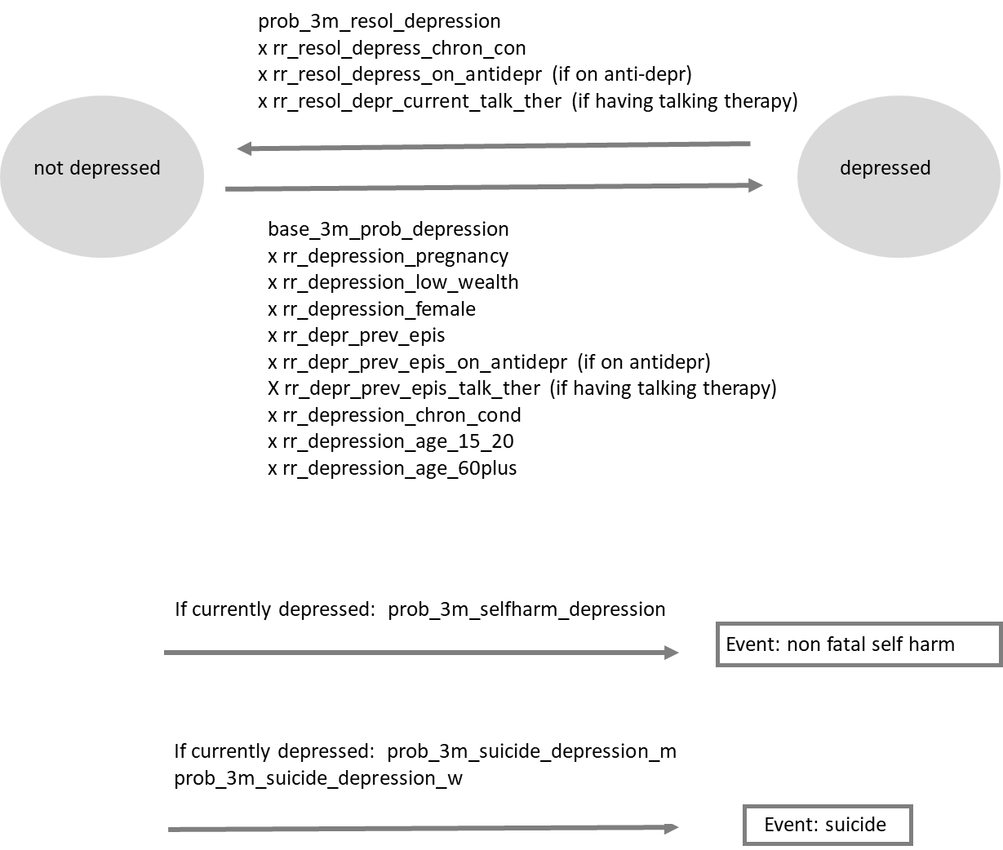

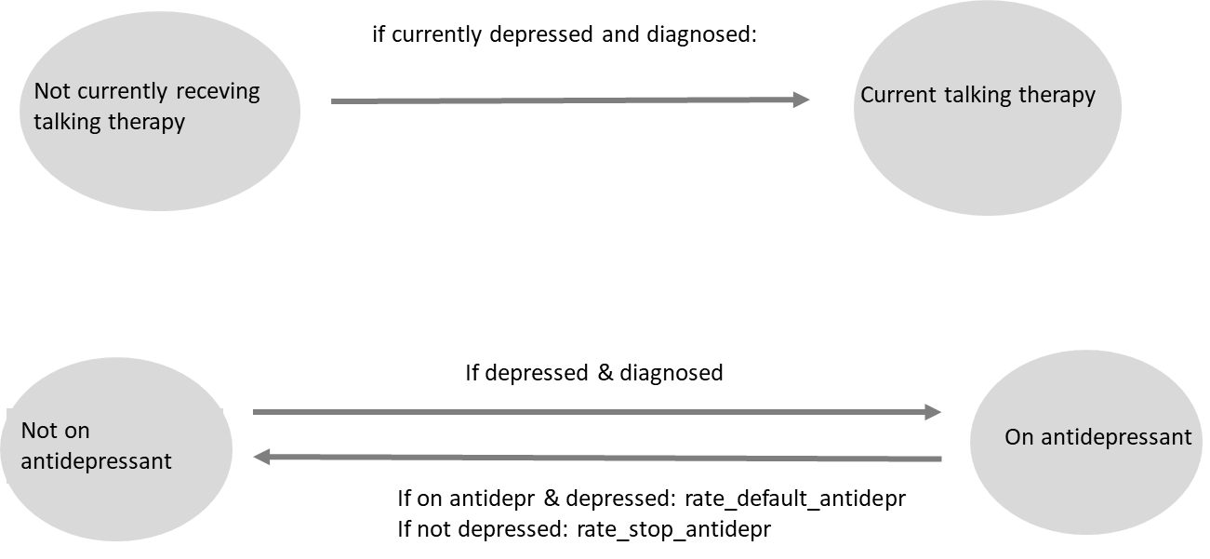

**Table 3. Model outputs and observed data from Malawi+** (model output values will change when updating calibration when HSIs are in place)

|  |  |  |
| --- | --- | --- |
|  | **Model Output** | **Observed data** |
| Overall prevalence of current moderate/severe depression in people aged 15+: | 7.9%  (men 5.7%, women 10%) | 9% in adults 45+  (men 6%, women 10%)  Kohler et al. 2017 PHQ-9;  Kim et al 2015, 19% in adolescents with HIV, BDI-II  Malava et al 2018, 12% in people under care for HIV  Maclean et al 2015, 8% in female sex workers |
| Ever depression in people age 50: | 37% | No data identified |
| Prevalence of antidepressant use amongst people currently depressed | <0.1% | No data identified |
| Prevalence of antidepressant use amongst people ever depressed | <0.1% | No data identified |
| Rate of serious non fatal self harm incidents 100,000 adults age 15+ per year | 22 | No data identified |
| Rate of suicide per 100,000 adults age 15+ per year | 7 | Suicide rate in adults in Karonga study 26.1 per 100,000 person years in adult men (age 15+) and 8.0 per 100,000 person years in adult women. Chasimpha et al BMC Public Health 2015. WHO: rate in whole population 3.7 /100,000 |

Table 2

Table 3: Demonstration of the effect of interventions (due to the low incidence of self harm and suicide this is subject to stochastic error until we can run the model on larger numbers)

**References**

Abas MA, Broadhead JC. Depression and anxiety among women in an urban setting in Zimbabwe

Psychological Medicine Jan 1997 Volume: 27 Issue: 1 Pages: 59-71 DOI: 10.1017/S0033291796004163

Brandt R. The mental health of people living with HIV/AIDS in Africa: a systematic review, African Journal of AIDS Research 2009, 8:2, 123-133, DOI: 10.2989/AJAR.2009.8.2.1.853

Chasimpha et al. Patterns and risk factors for deaths from external causes in rural Malawi over 10 years: a prospective population-based study. BMC Public Health (2015) 15:1036 DOI 10.1186/s12889-015-2323-z

Cipriani et al. Comparative efficacy and acceptability of 21 antidepressant drugs for the acute treatment of adults with major depressive disorder: a systematic review and network meta-analysis. Lancet 2018; 391: 1357–66

Cohen, MH et al. Prevalence and Predictors of Posttraumatic Stress Disorder and Depression in HIV-Infected and At-Risk Rwandan Women. J Womens Health 2009, Volume: 18 Issue: 11 Pages: 1783-1791 DOI: 10.1089/jwh.2009.1367

Dow A et al. Postpartum Depression and HIV Infection Among Women in Malawi. JAIDS 2014

Volume: 65 Issue: 3 Pages: 359-365 DOI: 10.1097/QAI.0000000000000050

Dunner DL et al. Primary Care Companion. Preventing recurrent depression: long term treatment for major depressive disorder. J Clinical Psychiatry 2007 9(3).

Faria V, et al. Do You Believe It? Verbal Suggestions Influence the Clinical and Neural Effects of Escitalopram in Social Anxiety Disorder: A Randomized Trial. eBiomedicine https://doi.org/10.1016/j.ebiom.2017.09.031

Furukawa TA et al. Placebo response rates in antidepressant trials: a systematic review of published and unpublished double-blind randomised controlled studies. Lancet Psychiatry 2016; 3: 1059–66

Furukawa TA et al Initial severity of major depression and efficacy of new generation antidepressants: individual participant data meta-analysis. Acta Psychiatr Scand 2018: 137: 450–458

Grimsrud a et al. The Association between Hypertension and Depression and Anxiety Disorders: Results from a Nationally-Representative Sample of South African Adults. PLOS ONE 2009 4(5): e5552 DOI: 10.1371/journal.pone.0005552

Hengartner M. Methodological Flaws, Conflicts of Interest, and Scientific Fallacies: Implications for the Evaluation of Antidepressants’ Efficacy and Harm. Fronters in Psychiatry 2017 doi: 10.3389/fpsyt.2017.00275

Keller MB, Keller RJ. Implications of Failing to Achieve Successful Long-Term Maintenance Treatment of Recurrent Unipolar Major Depression. Biol Psychiatry 1998;44:348–360

Kim et al. Factors associated with depression among adolescents living with HIV in Malawi. BMC Psychiatry 2015; 15:264

Kirsch I. Antidepressants and the Placebo Effect. Zeitschrift fur Psychologie 2014; Vol. 222(3):128–134

Kohler IV at al. The Demography of Mental Health Among Mature Adults in a Low-Income, High-HIV-Prevalence Context. Demography 2017; 54:1529–1558

Leucht C, Huhn M, Leucht S. Amitriptyline versus placebo for major depressive disorder. Cochrane Database of Systematic Reviews 2012, Issue 12. Art. No.: CD009138. DOI: 10.1002/14651858.CD009138.pub2.

Malawi DHS 2010, 2015/16 <https://dhsprogram.com/>

Marwick K et al. Prevalence of depression and anxiety disorders in HIV-positive outpatients in rural Tanzania. AIDS Care 2010 22(4): 415-419 DOI: 10.1080/09540120903253981

Salomon et al. Common values in assessing health outcomes from disease and injury: disability weights measurement study for the Global Burden of Disease Study 2010. Lancet 2012; 380: 2129–43.

Todd C et al. The onset of common mental disorders in primary care attenders in Harare, Zimbabwe Psychological Medicine, 1999, 29, 97-104.

Udedi et al . Health service utilization by patients with common mental disorder identified by the Self-Reporting Questionnaire in a primary care setting in Zomba, Malawi: A descriptive study. International Journal of Social Psychiatry 2014, Vol. 60(5) 454–461

WHO <http://apps.who.int/gho/data/node.main.MHSUICIDE5YEARAGEGROUPS?lang=en>

Barbui et al. Efficacy of psychosocial interventions for mental health outcomes in low-income and middle-income countries: an umbrella review. Lancet Psychiatry 2020; 7: 162–72