**Modelling of key personal characteristics (“Lifestyle”) within the Thanzi La Onse Model**

**Background: The Thanzi La Onse Model**

As part of the Thanzi La Onse program a model is being developed which aims to capture the health experiences of the population of Malawi and the consequent interactions with the health care system. The intent is that this model will help to inform future delivery of health care in Malawi. The model is an individual based model – which means we explcitly simulate the individual life and health experiences of a representative proportion of population of Malawi. The simulation initiates on 1 Jan 2010 and we attempt to simulate the attributes of the population at that point. We can run the model forward to any specified future time point. Each potential intervention and its associated diseases are being modelled. This is being divided into separate disease/intervention modules. This document describes the module on basic “lifestyle” characteristics.

**Demographic and social characteristics modelled**

Based on data on the distribution of the population in Malawi according to geographic location we assign individuals a geographic location, which maps onto whether they are classified as living in a rural or urban area. Informed largely by data from the Malawi DHS, “properties” (often referred to here as “variables”) are also created indicating the person’s wealth level (based on 5 quintiles), whether the person has access to improved sanitation, clean drinking water, hand washing facilities, and whether they experience indoor air pollution (wood burning stove), as well as whether they have high salt and sugar intake. We assign individuals a current education status (none, primary, secondary) which is updated 3 monthly from age 5 to 20. From age 15 on we assign variables for using tobacco, drinking excess alcohol, having low exercise and for body mass index. Body mass index is a 5 category variable ((1: < 18, 2: 18-25, 3: 25-29.9, 4: 30-34.9, 5: 35+, 0 before age 15). Marital status (never, currently, widowed/divorced) is also assigned. The status with regard to such variables for individuals can change over time. The influences between these variables/properties are described in Figure 1.

**Model Parameters**

Description of parameters and proposed values can be seen in 04 - Methods Repository > ResourceFile_Lifestyle_Enhanced. Some of these values are shown in Figure 1 below.

**Main Limitations**

We aim to capture the strong causal links between lifestyle properties (as shown by the arrows in Figure 1). There are likely other causal links of lesser importance that we do not capture at this point. While we capture a range of lifestyle characteristics there are others not captured at this point (such as type of employment).

|  |  |
| --- | --- |
| **Table 1. Description of personal, demographic and social variables** | |
| **Variable** | **Description** |
| li_urban | currently urban (true/false) |
| li_wealth | wealth level (1-5, 1 is highest wealth) |
| li_bmi | bmi category (1: < 18, 2: 18-25, 3: 25-29.9, 4: 30-34.9, 5: 35+, 0 before age 15) |
| li_exposed_to_campaign_weight_reduction | exposed to public health campaign to reduce over-weight and obesity |
| li_tob | currently using tobacco (true/false) |
| li_date_not_tob | date quit tobacco use |
| li_exposed_to_campaign_quit_smoking | exposed to public health campaign to quit smoking |
| li_in_ed | currently in education (true/false) |
| li_ed_lev | education level attained (so far) |
| li_low_ex | current low exercise (true/false) |
| li_exposed_to_campaign_exercise_increase | exposed to public health campaign to increase exercise |
| li_ex_alc | current excess alcohol (true/false) |
| li_exposed_to_campaign_alcohol_reduction | exposed to public health campaign to reduce alcohol consumption |
| li_mar_stat | marital status (never, current, previous) |
| li_unimproved_sanitation | unimproved sanitation (true/false) |
| li_no_clean_drinking_water | no clean drinking water (true/false) |
| li_high_salt | high salt intake (true/false) |
| li_exposed_to_campaign_salt_reduction | exposed to public health campaign to reduce salt intake |
| li_high_sugar | high sugar intake (true/false) |
| li_exposed_to_campaign_sugar_reduction | exposed to public health campaign to reduce sugar intake |

**Figure 1. Directed acyclic graph describing causal relationships between personal, demographic and social variables included in model.**

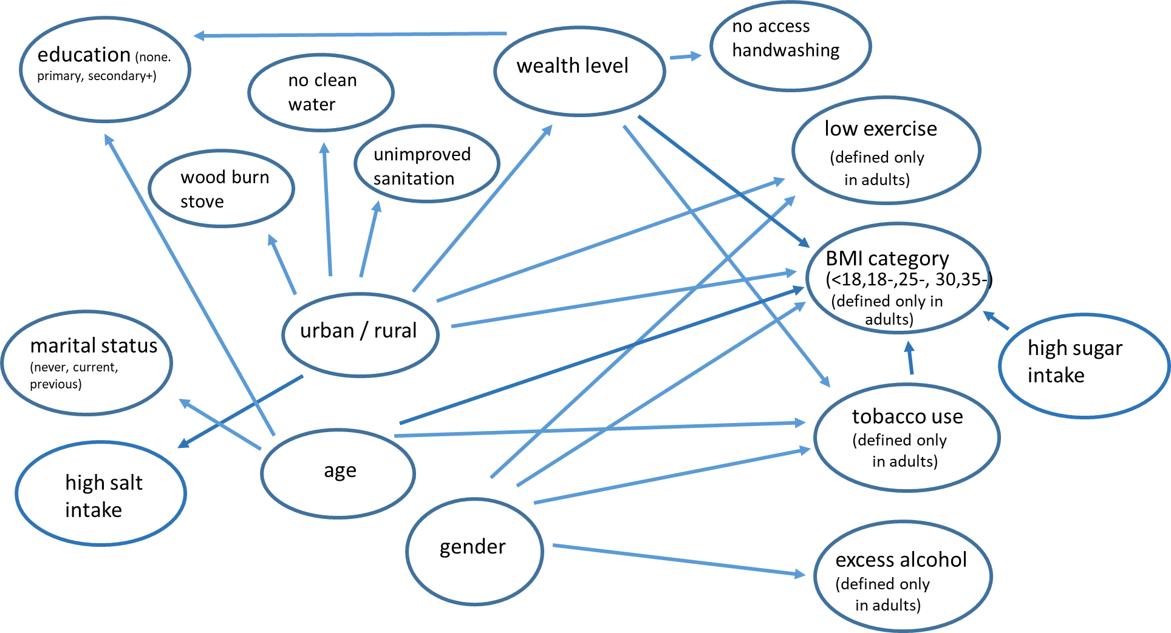

**Figure 2. Properties and parameters determining changes in property level**

**(a) (b)**

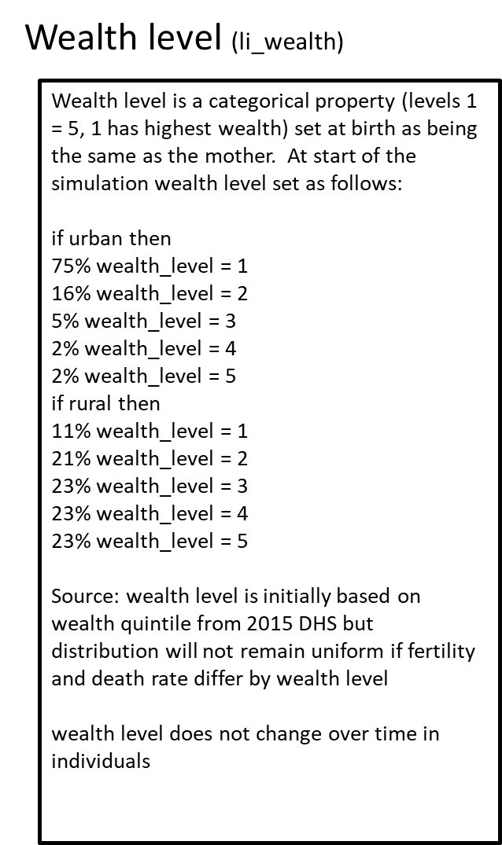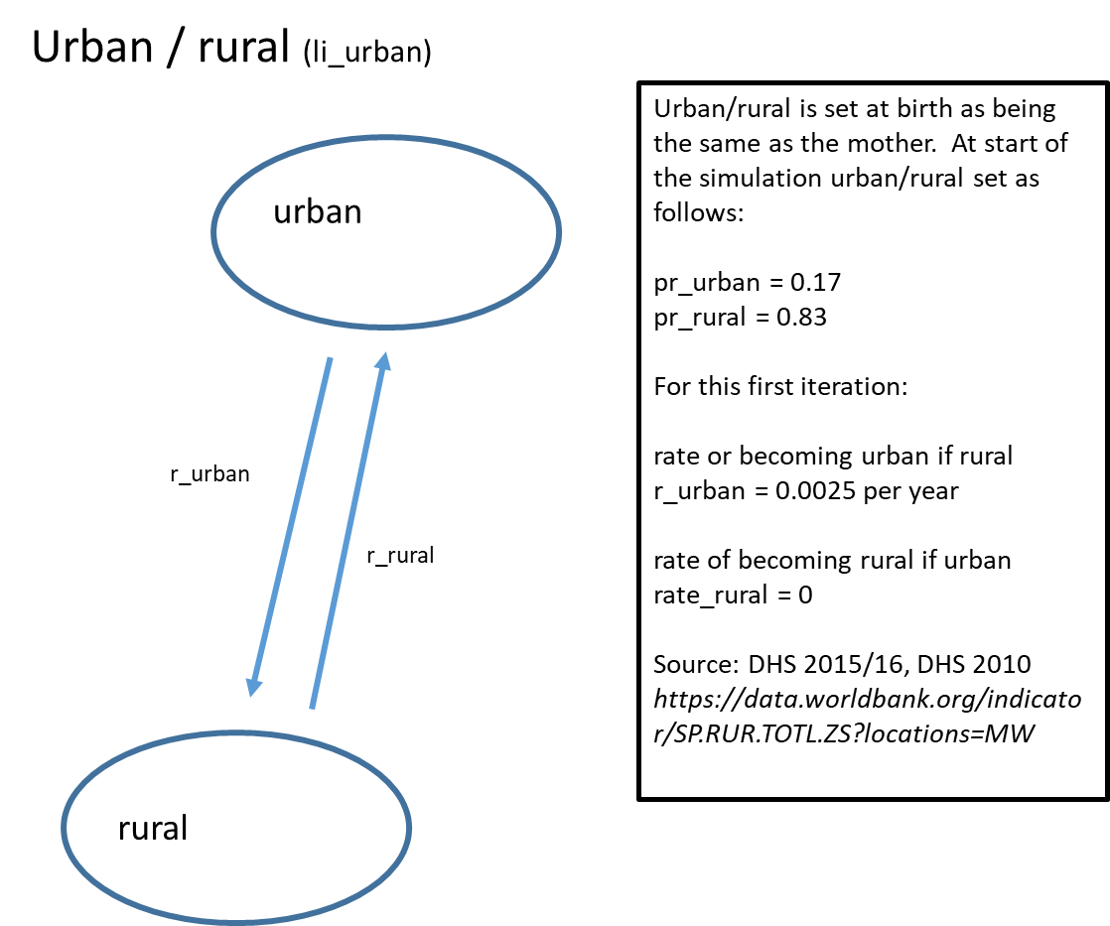

**(c)**

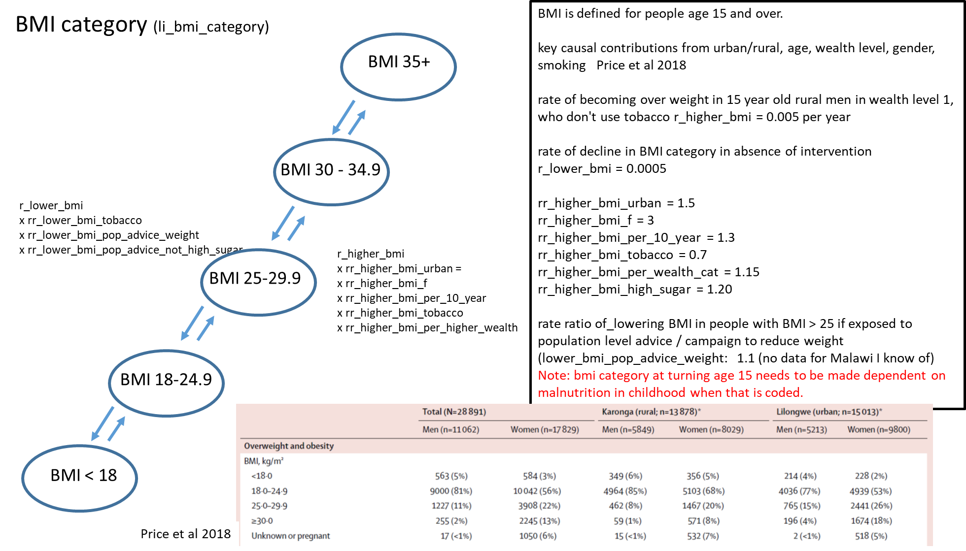

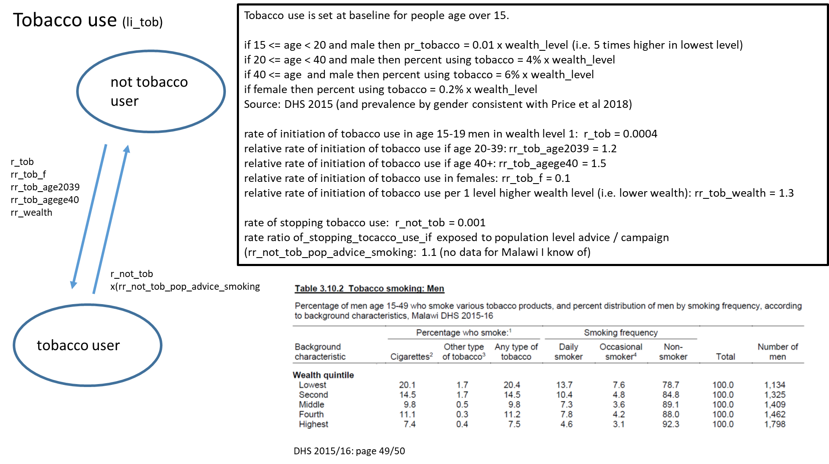**(d)**

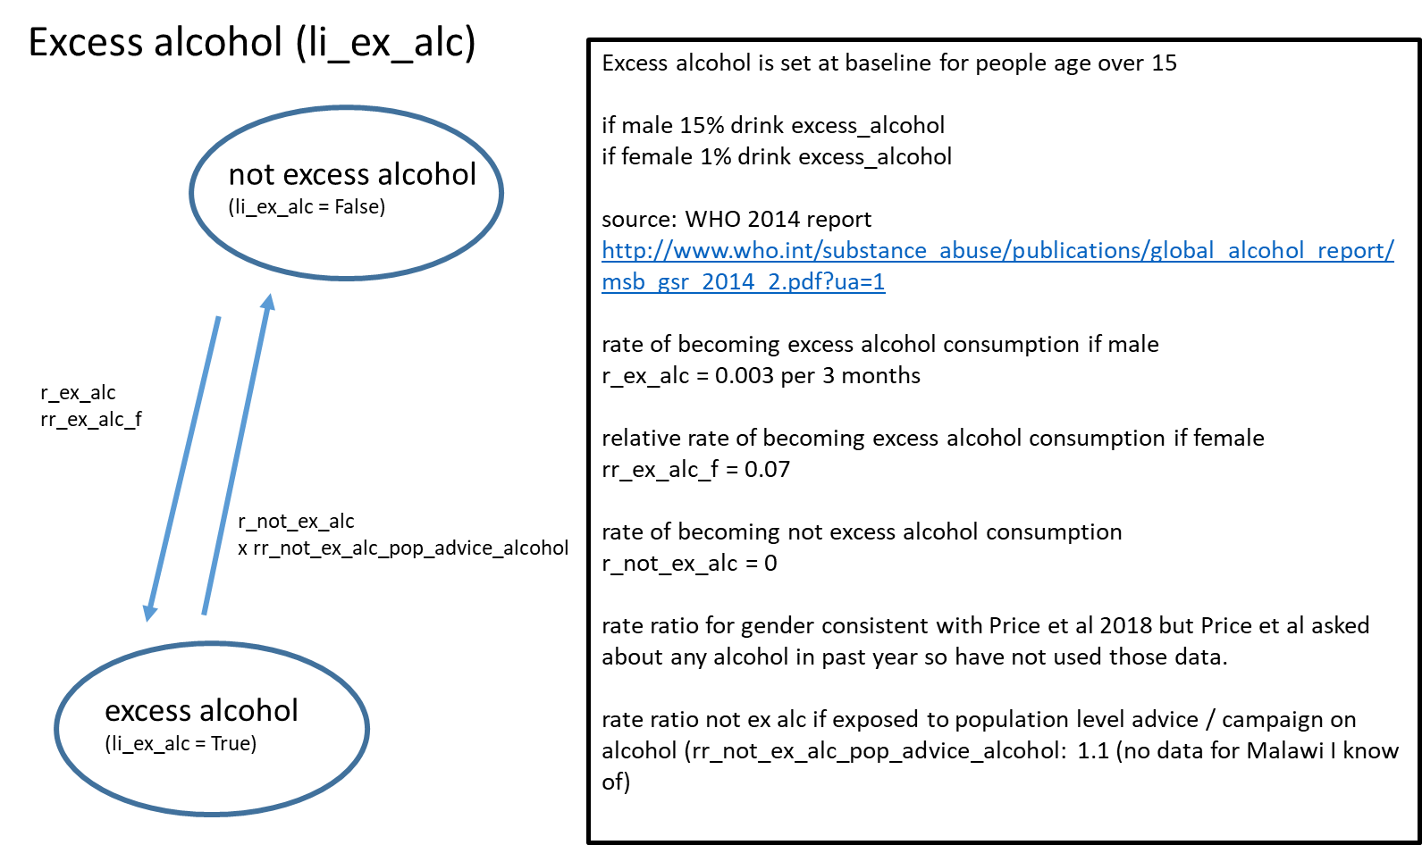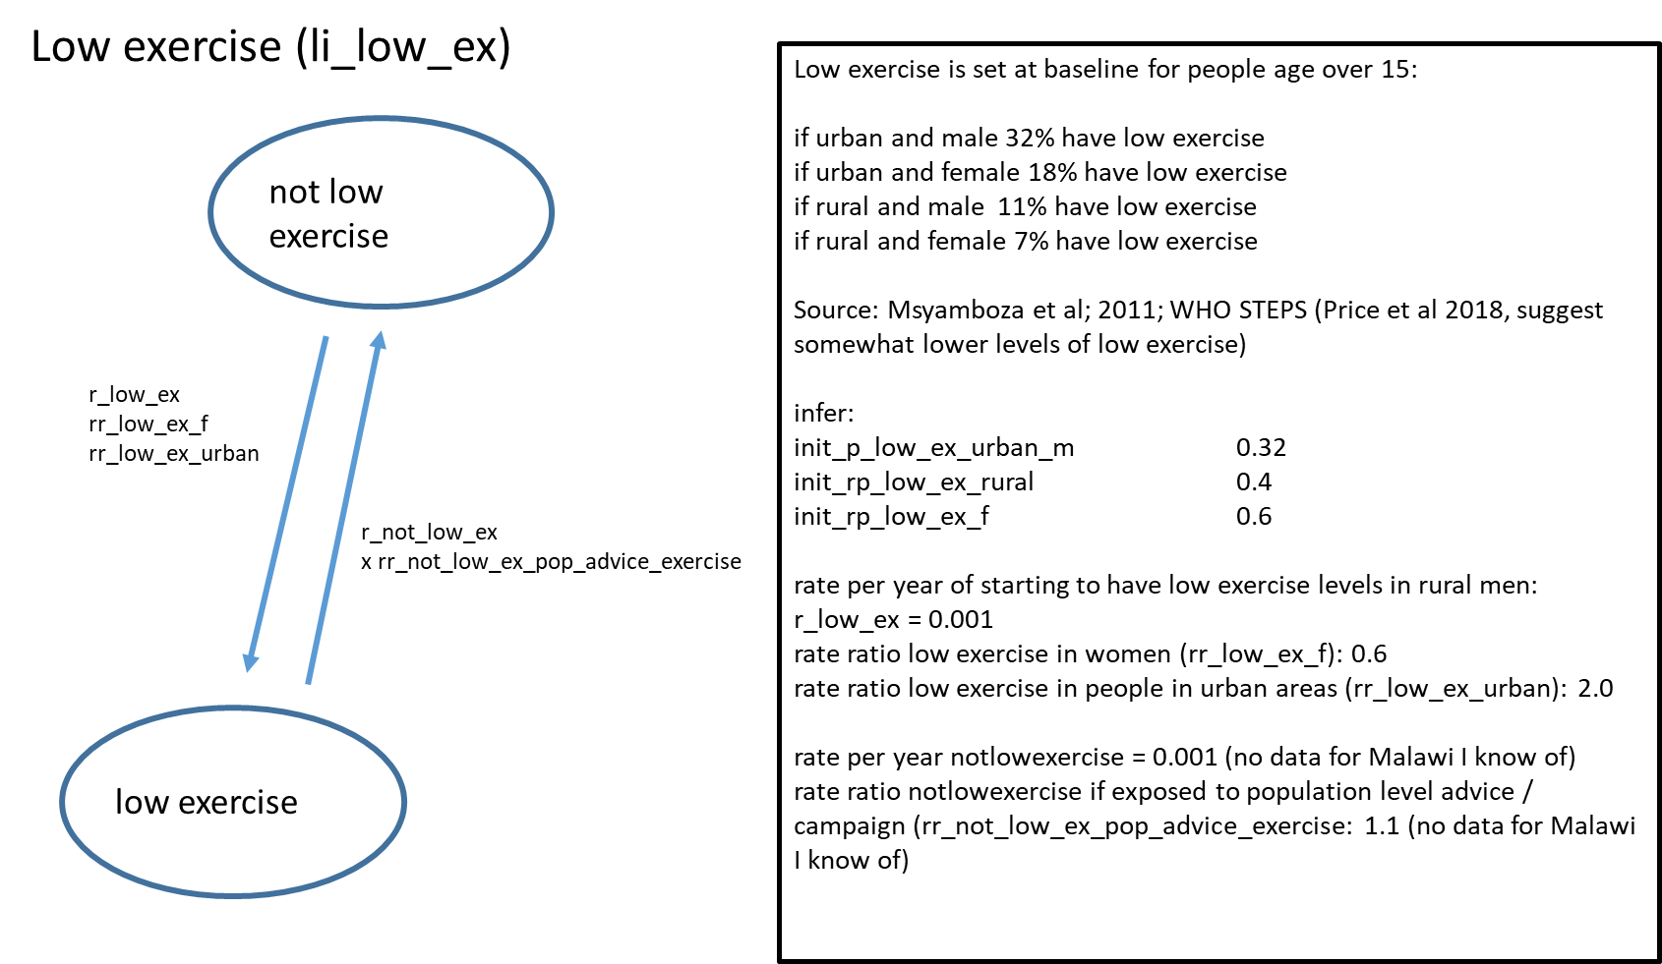**(e) (f)**

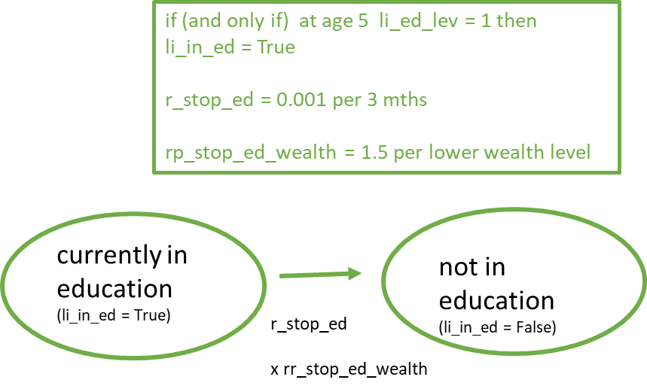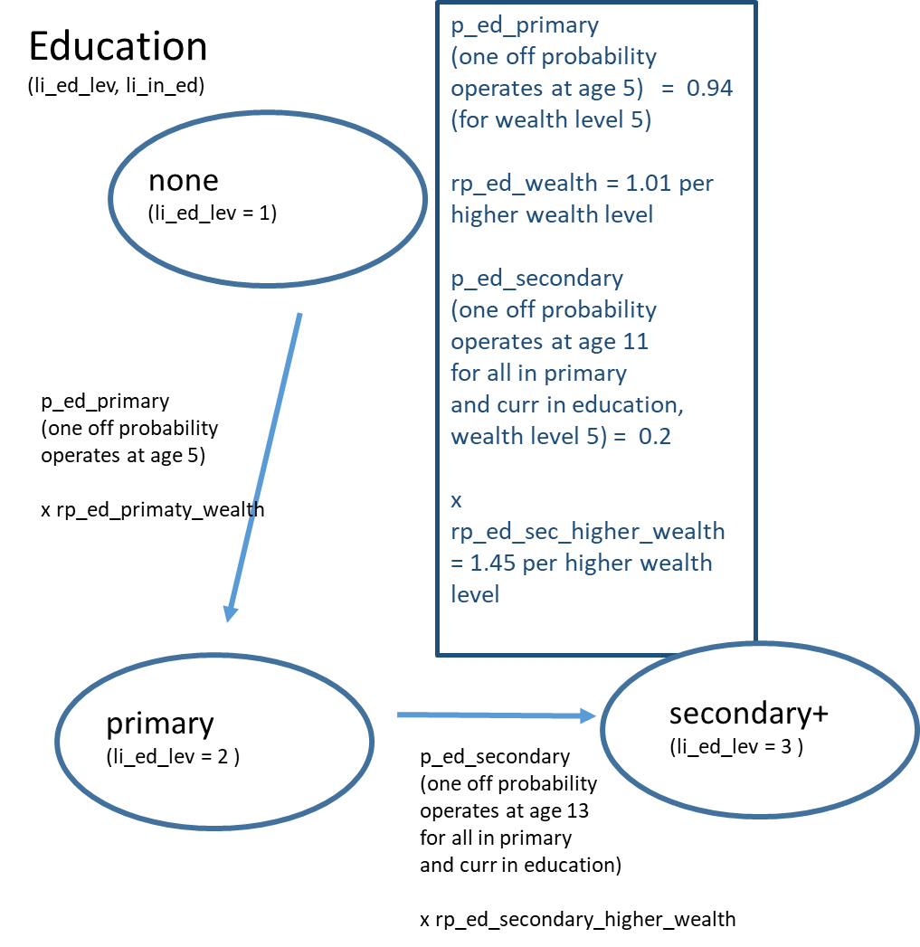**(g)**

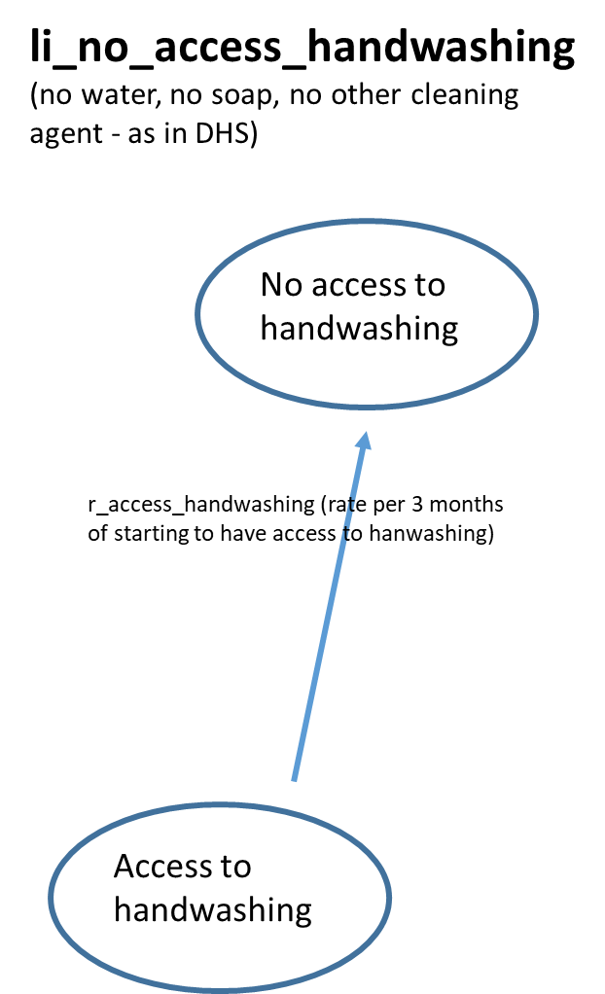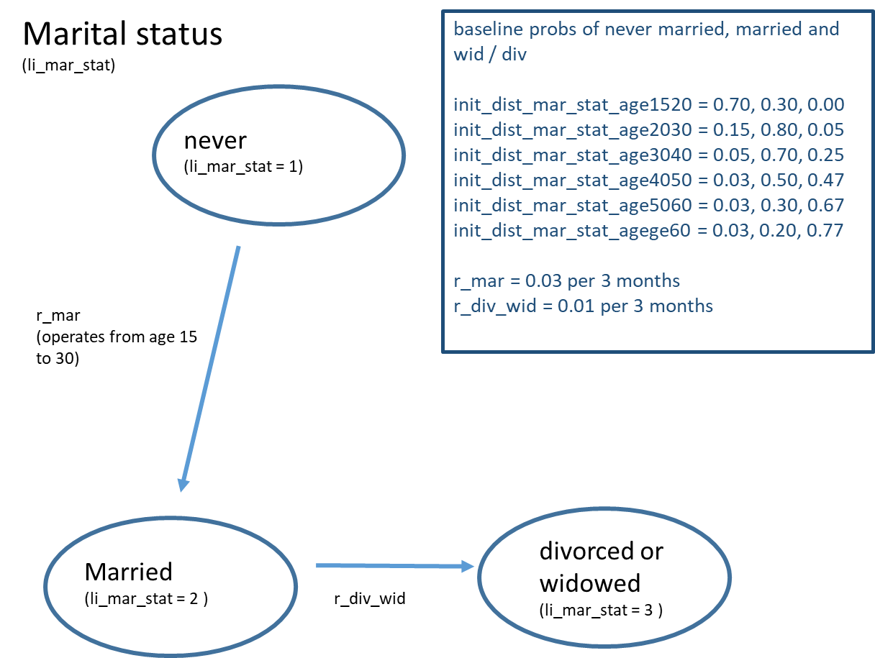**(h) (i)**

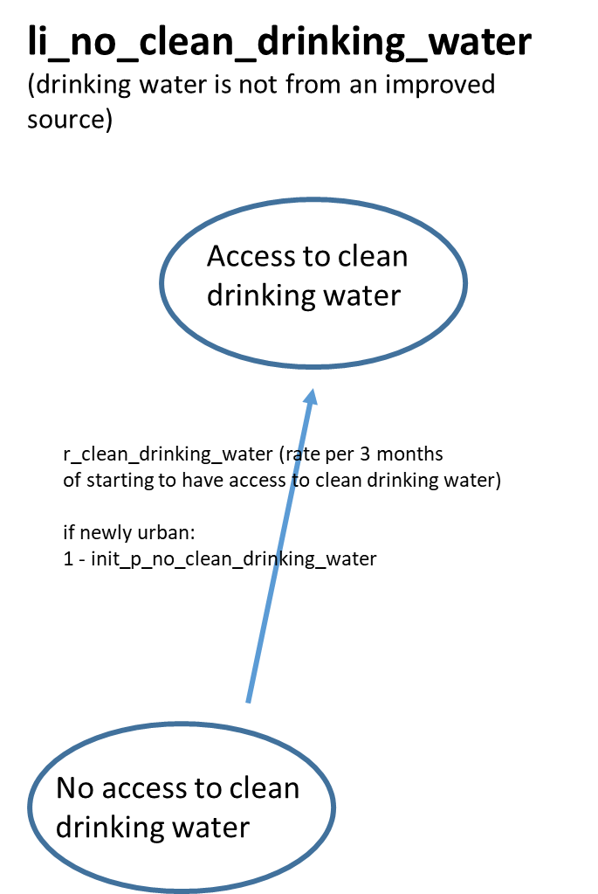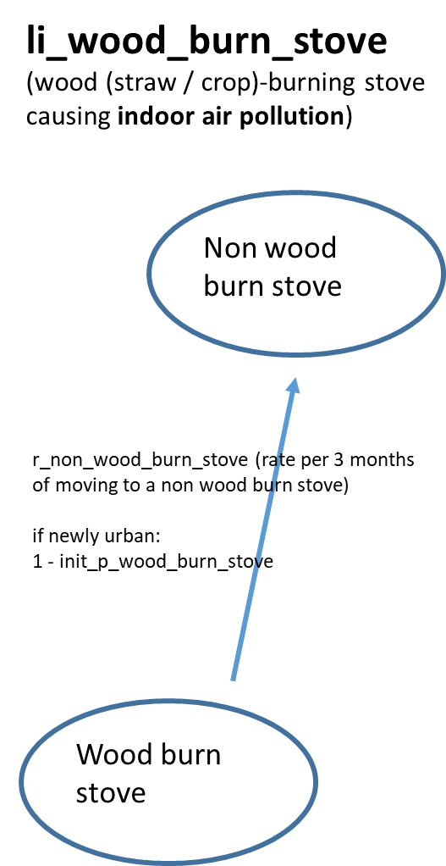**(j) (k)**

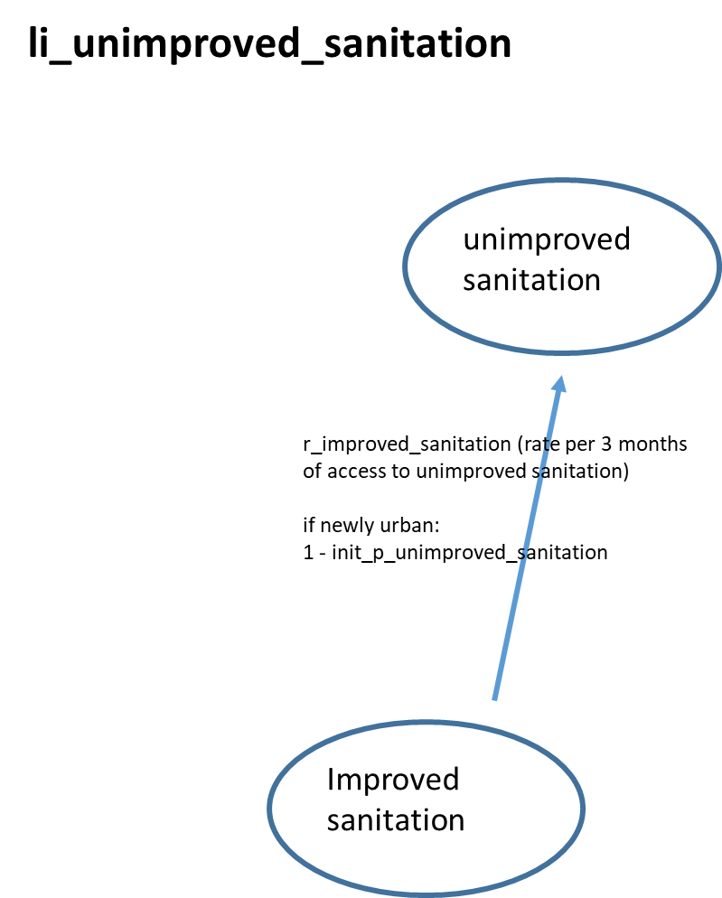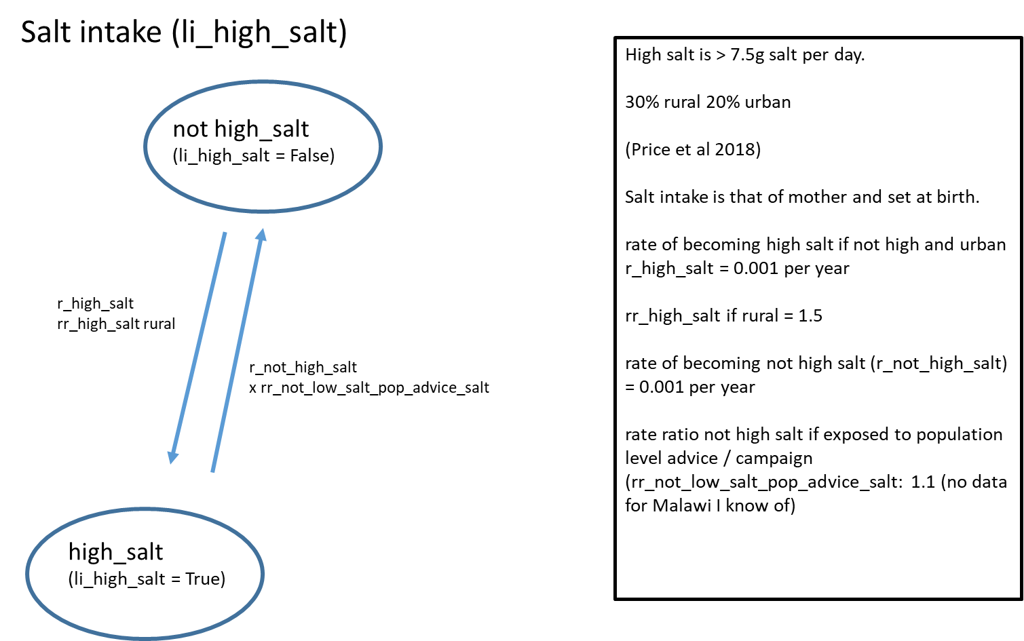**(l) (m)**

**(n)**

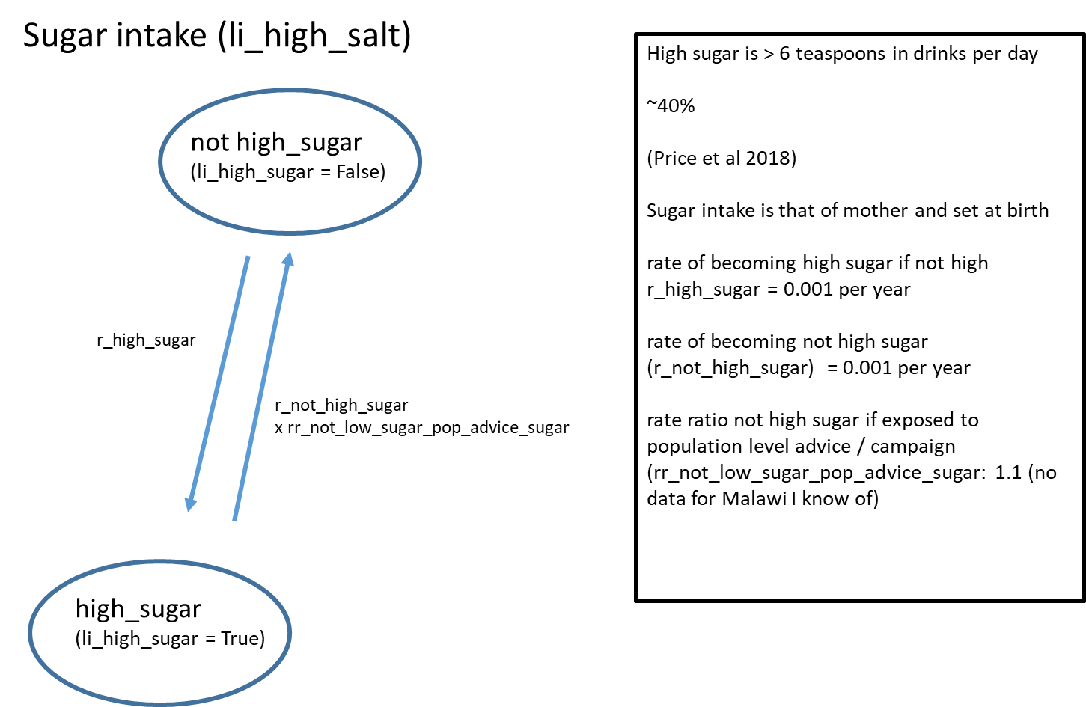

**Table 2. Model outputs for 2019** (and observed data as available)

|  |  |  |
| --- | --- | --- |
| **Characteristic (for 2019)** | **Model output\*** | **Observed data** |
| proportion urban | 18.1% | 16% (2018 Population census) |
| distribution of wealth level of urban people (wealth level 1 to 5, 5 is lowest wealth) | 70%, 16%, 7%, 4%, 4% | 75%, 16%, 5%, 2%, 2% (DHS 2015) |
| distribution of wealth level of rural people (wealth level 1 to 5, 5 is lowest wealth) | 11%, 22%, 21%, 23%, 23% | 11%, 21%, 22%, 23%, 23% (DHS 2015) |
| proportion of 6 / 12 /16 / 19 year olds in education | 95% / 91% / 73% / 58% | 85% / 95% / 75% / 35% (DHS 2015) |
| proportion of all adults age 20+ with at least some secondary education | 61% |  |
| BMI categories for urban adult men / women (age range 30-39) | < 18: 9% / 1%; 18 – 24: 76% / 62%; 25-29: 12% / 20%; 30-34: 2% /6%; 35+ 1% / 11% | < 18: 4% / 2%; 18 – 24: 77% / 53%; 25-29: 15% / 26%; >= 30-34: 4% / 18% (Price et al; median age ~ 30) |
| BMI categories for rural adult men / women (age range 30-39) | < 18: 22% / 5%; 18 – 24: 68% / 75%; 25-29: 10% / 15%; 30-34: 0% / 2%; 35+: 0% / 2% | < 18: 6% / 5%; 18 – 24: 85% / 68%; 25-29: 8% / 20%; >= 30-34: 1% / 8% (Price et al; median age ~ 34) |
| proportion of men / women with excess alcohol consumption | 3% / 0.1% | 2% / 0.3% alcohol dependence  15% / 1% heavy episodic drinking  (for 2010; WHO 2014) |
| proportion of urban men / women with low exercise | 22% / 16% | 32% / 18%  Msyamboza et al; 2011; WHO STEPS |
| proportion of rural men / women with low exercise | 13% / 9% | 11% / 7%  Msyamboza et al; 2011; WHO STEPS |
| proportion of people with high salt intake | 34% | ~27% (Price et al 2018; weighting by urban rural) |
| proportion of people with high sugar intake | 39% | ~ 37% (6 or more sugary drinks per day; Price et al 2018) |
| proportion of people with no access handwashing | 66% | 58% |
| proportion of urban people with wood burn stove | 28% | 26% (DHS 2015) |
| proportion of rural people with wood burn stove | 93% | 94% (DHS 2015) |
| proportion of urban people with unimproved sanitation | 4% | 4% (DHS 2015) |
| proportion of rural people with unimproved sanitation | 15% | 19% (DHS 2015) |
| proportion of urban people with no clean drinking water | 3% | 2% (DHS 2015) |
| proportion of rural people with no clean drinking water | 13% | 15% (DHS 2015) |
| marital status distribution of 25 year olds (never, current, previous) | 24% / 58% / 18% | no comparable data identified |
| marital status distribution of 50 year olds (never, current, previous) | 3% / 36% / 61% | no comparable data identified |

* Outputs obtained for Oct 2019 if model is run (with population of 10,000 in 2010) with parameter values as in 04 - Methods Repository > ResourceFile_Lifestyle_Enhanced

**References**

DHS 2015/16, DHS 2010 https://data.worldbank.org/indicator/SP.RUR.TOTL.ZS?locations=MW

Price A, et al. Prevalence of obesity, hypertension, and diabetes, and cascade of care in sub-Saharan Africa: a cross-sectional,population-based study in rural and urban Malawi. Lancet Diabetes & Endocrinol 2018; 6: 208–22

Msyamboza et al; The Burden of Selected Chronic Non-Communicable Diseases and Their Risk Factors in Malawi: Nationwide STEPS Survey 2011 PLoS One

Msyamboza et al; The burden of hypertension and its risk factors in Malawi: nationwide population-based STEPS survey. International Health 4 (2012) 246–252

WHO 2014 report http://www.who.int/substance_abuse/publications/global_alcohol_report/msb_gsr_2014_2.pdf?ua=1

Amberbir et al. Systematic Review of Hypertension and Diabetes Burden, Risk Factors, and Interventions for Prevention and Control in Malawi The NCD BRITE Consortium. Global Heart 2019

2018 Malawi Population and Housing National Statistical Office May 2019 Main Report <http://www.nsomalawi.mw/images/stories/data_on_line/demography/census_2018/2018%20Malawi%20Population%20and%20Housing%20Census%20Main%20Report.pdf>