**Modelling of measles within the Thanzi La Onse Model**

**Background: The Thanzi La Onse Model**

As part of the Thanzi La Onse program a model is being developed which aims to capture the health experiences of the population of Malawi and the consequent interactions with the health care system. The intent is that this model will help to inform future delivery of health care in Malawi. The model is an individual based model – which means we explicitly simulate the individual life and health experiences of a representative proportion of the population of Malawi. The simulation initiates on 1 Jan 2010 and we attempt to simulate the attributes of the population at that point. We can run the model forward to any specified future time point. Each potential intervention and its associated diseases are being modelled. This is being divided into separate disease/intervention modules. This document describes the module on SARS-CoV-2 transmission and COVID-19 disease.

**Background: General approach to decisions on modelling causal influences and effects of interventions**

This module was designed in the context of an overall approach to modelling causal effects in general and causal effects of interventions in particular. The overall intent is to adopt as simple a structure as can be conceived, whilst still capturing the essential elements of a disease and the interventions used to prevent or treatment. We include a causal link between a “variable” (by which we mean a characteristic or property of an individual, whether that be demographic, social or biologic), and risk of disease or another variable if there is strong evidence from an overall body of studies that such a causal link exists and is at least moderately strong. In informing such decisions we place particular value on RCTs or studies with a quasi-experimental design such as analyses based on an instrumental variable. There is no expectation that such studies will be from Malawi or even from Africa. If there are such local studies and in the unlikely event that they provide strong evidence to suggest that the causal link is substantively different in Malawi, then the intent is that this is taken into account and the Malawi-specific link included.

In the special case of a potential causal variable which relates to whether an individual has experienced or is experiencing an intervention the intent is to only include interventions if there is substantial RCT evidence of their beneficial effect, based on trials with objectively ascertained clinical endpoints with low risk of serious bias. Whilst DCP-3 (and to some extent the Malawi EHP) provides an initial list of such interventions and the evidence to support them, where possible our intent has been to form our own opinion on intervention efficacy based on the source trials.

Unless there is evidence to the contrary, the intent is to summarize and incorporate intervention effects into the model as relative risks or rates rather than absolute differences due to the fact that such measures are less likely to differ substantively by context. Interactions between characteristics (on the multiplicative scale) are only to be incorporated if there is strong evidence. Again, we have not intended to rely on data from Malawi or Africa for such evidence but if local evidence exists which strongly suggests a different effect than elsewhere then the intent is that this modified effect is incorporated in the model.

**Background: Demographic and social characteristics modelled**

Based on data on the distribution of the population in Malawi according to geographic location we assign individuals a geographic location, which maps onto whether they are classified as living in a rural or urban area. Informed largely by data from the Malawi DHS, variables are also created indicating the person’s wealth level (based on 5 quintiles), whether the person has access to improved sanitation, clean drinking water, hand washing facilities, and whether they experience indoor air pollution (wood burning stove). We assign individuals a current education status (none, primary, secondary) which is updated 3 monthly from age 5 to 20. From age 15 we assign BMI in 5 categories, tobacco use status, drinking excess alcohol, having low exercise, high sugar intake, high salt intake, and marital status (never, currently, widowed/divorced). The status with regard to such variables for individuals can change over time. The influences between these variables are described in detail in a separate document.

**Model structure**

**Variables modelled**

This module updates the properties relating to measles infection status, symptoms and treatment. The natural history model of measles follows a susceptible – infected – recovered structure with an age-dependent mortality rate applied to all infected cases. Immunity to measles following infection is lifelong. The properties associated with this module are measles infection status, date of onset of measles and currently on treatment for measles complications.

Figure 1. Natural history model of measles infection.

**Incidence of measles infection**

Measles incidence is simulated through a poll which runs every month using a fixed annual attack rate based on pre-EPI estimates. In 1980 162,686 measles cases were reported in a population of 6.163 million, giving an annual incidence rate per capita (*r* = cases / population) of 0.0264. We convert this to an individual probability of infection (*P*) and apply the risk of infection to everyone currently uninfected in the population:

Seasonality in measles incidence is captured in a phenomenological way using a transmission function (*β*) in discrete time which oscillates through the year using a sinusoidal function around a baseline rate (*β0*) with amplitude scaled by *β1* and a phase shift.(Ferrari, Grais et al. 2008)

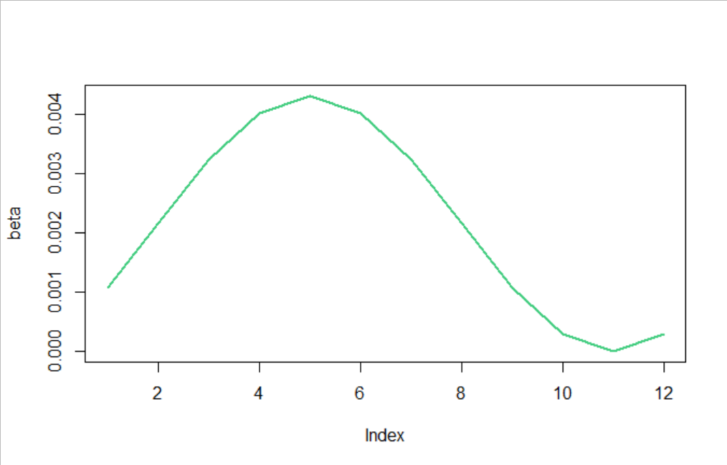

Figure 2. Sample output of the seasonality in the measles transmission function (*β*) through each month of the year (1-12).

The measles vaccine, which was introduced as a single dose in 1980 and a two-dose regimen in 2015, protects against measles infection and disease with 85% (one dose) and 99% (two doses) efficacy. This vaccine has been administered in combination with the rubella vaccine since 2018. The reality may be that the vaccine protects against disease and not infection, but we assume that people who have been vaccinated and get infected would not be infectious and therefore do not contribute to transmission. Children under 6 months are protected by maternal immunity. As the probability of infection remains constant each year, it is the changes in vaccine coverage which drive the incidence of measles cases. We assume that naturally acquired and vaccine-derived immunity are both lifelong. (Strebel, Papania et al. 2018)

**Symptoms due to measles infection**

At the time of infection, each symptom associated with measles is assigned using an age-dependent probability with onset between 7-21 days post-infection (Figure 3).(Centers for Disease Control and Prevention (CDC) 2015) We assume the probabilities of symptoms are constant in those aged >30 years.(Perry and Halsey 2004) Fever, rash and conjunctivitis are present for all those infected and the remaining symptoms occur with probability shown in Figure 3. Symptoms will self-resolve without interventions between 7-14 days after onset.

Figure 3. Age-dependent probabilities of each symptom associated with measles infection. Fever, rash and conjunctivitis occur in all cases.

**Mortality**

The probability of death due to measles is age-dependent and will occur between 3-7 days of symptom onset. Pneumonia is most common complication accounting for the majority of measles deaths although diarrhoea, otitis media and encephalitis are also associated with risk of death.(Moss and Griffin 2006) We therefore randomly poll all infected individuals using the age-dependent probability of death without consideration to which symptoms have been assigned.(Wolfson, Grais et al. 2009)

**Disability weights**

The disability weights associated with measles use the symptoms generated for each individual and map these directly to moderate and severe measles infection. Individuals presenting with respiratory symptoms and/or encephalitis are classified as severe measles cases (definition: has a high fever and pain, and feels very weak, which causes great difficulty with daily activities), whilst all other symptoms map to moderate measles infection (definition: has a fever and aches, and feels weak, which causes some difficulty with daily activities). The DALY weight for moderate and severe measles infections are 0.051 (lower bound 0.032, upper bound 0.074) and 0.133 (lower bound 0.088, upper bound 0.19) respectively.

**Health system interactions**

**Care Seeking & diagnosis**

An individual’s propensity to seek care is governed by the healthcare-seeking algorithm, which uses the current symptoms present along with age, sex and location to predict their likelihood of attending a healthcare facility. Having a rash or otitis media will increase this likelihood by a factor of 2.5 and encephalitis will trigger emergency healthcare-seeking.

The characteristic rash present for all measles cases makes diagnosis straightforward and there are no additional clinical / laboratory tests required for confirmation.

**Treatment for measles**

Treatment for measles is dependent on the clinical presentation and presence of secondary complications such as pneumonia.(World Health 2019) There are three treatment packages available for measles cases; uncomplicated measles cases are treated with vitamin A, those with pneumonia are additionally treated with antibiotics and cases with diarrhoea are given oral rehydration salts.

One meta-analysis showed an estimated reduction in measles mortality of 62% (19-82%) following two doses of vitamin A.(Sudfeld, Navar et al. 2010) Another study suggested that there was no significant impact of vitamin A on mortality or morbidity for measles cases with pneumonia.(Wu, Ni et al. 2005) Given the complexity in determining the proportion of cases presenting with severe diarrhoea and/or pneumonia and the estimated impact of treatment on these secondary complications, there are no definitive guidelines for measles treatment (type of antibiotic or duration of treatment etc.) and so we assume that any treatment will reduce an individual’s probability of dying by 20-60%. This random draw is performed at the time that the death is scheduled to occur in the simulation and will govern whether the individual will recover or die.

**Main Limitations**

* Difficult to disentangle the specific causes of death in measles cases (diarrhoea versus pneumonia) and therefore it is complex parameterising the impact of treatment
* Some studies suggest associations between measles mortality and overcrowding, malnutrition and vitamin A deficiency although the evidence is ambiguous and currently not strong enough to support including any of these factors as risks in this model.(Wolfson, Grais et al. 2009)
* We do not include treatment for encephalitis given that this would be unavailable at many district-level health facilities
* Currently mortality is not linked to symptoms, but a refinement in future could be to link higher mortality rates to those with pneumonia and encephalitis (particularly untreated measles cases)

**Table 1. Description of parameters and proposed values**

|  |  |  |
| --- | --- | --- |
| Parameter name | Value | Notes |
| beta_baseline | 0.00216 | Baseline measles transmission probability |
| beta_scale | 1 | Scale value for measles transmission probability sinusoidal function |
| phase_shift | 5 | Phase shift for measles transmission probability sinusoidal function |
| period | 12 | Period for measles transmission probability sinusoidal function |
| vaccine_efficacy_1 | 0.85 | Efficacy of first measles vaccine dose against measles infection |
| vaccine_efficacy_2 | 0.99 | Efficacy of second measles vaccine dose against measles infection |
| prob_severe | 0.05 | Probability of severe measles infection, requiring hospitalisation |
| risk_death_on_treatment | 0.38 | Risk of scheduled death occurring if on treatment for measles complications |

**Model outputs**

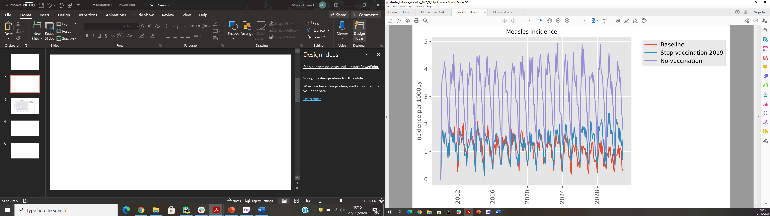

Figure 4. Sample model outputs showing the monthly incidence per 1000 people at baseline (assuming current vaccination trends remain constant), stopping vaccination for measles in 2019 and if no measles vaccination had ever been available. The reported data pre-EPI, i.e. with no vaccination available, show approximately 2 infections per 1000 people per month (equivalent to an annual per capita incidence rate 0.0264).

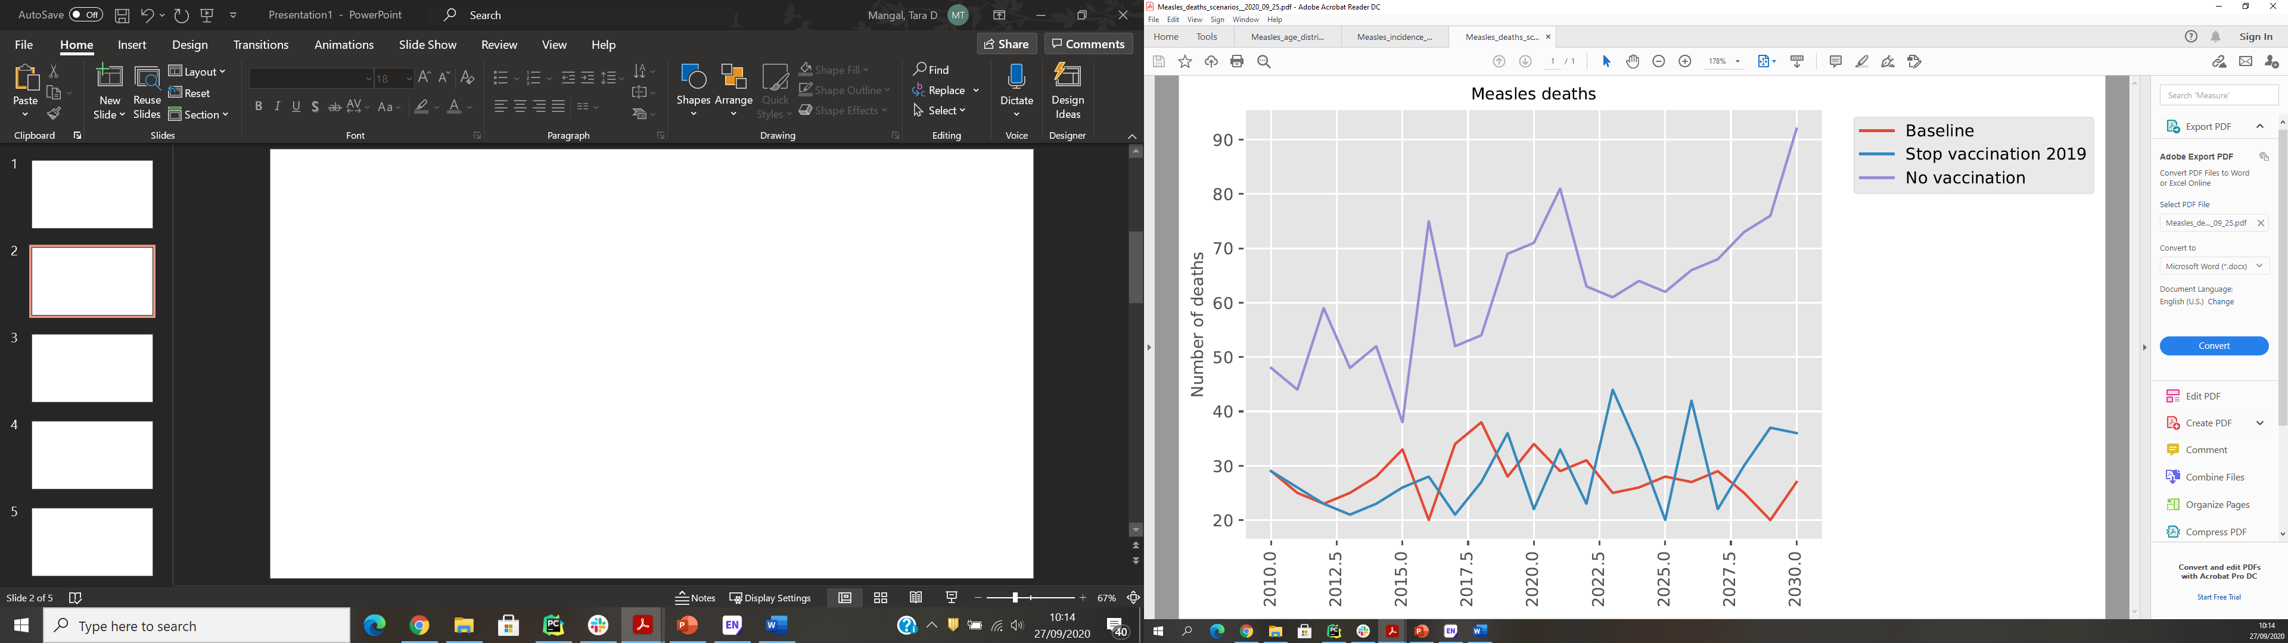

Figure 5. Sample model outputs showing the measles-attributable deaths at baseline (assuming current vaccination trends remain constant), stopping vaccination for measles in 2019 and if no measles vaccination had ever been available.

**References**

Centers for Disease Control and Prevention (CDC) (2015). Epidemiology and Prevention of Vaccine-Preventable Diseases. K. A. Hamborsky J, Wolfe S,. Washington D.C. Public Health Foundation.

Ferrari, M. J., R. F. Grais, N. Bharti, A. J. K. Conlan, O. N. Bjørnstad, L. J. Wolfson, P. J. Guerin, A. Djibo and B. T. Grenfell (2008). "The dynamics of measles in sub-Saharan Africa." Nature **451**(7179): 679-684.

Moss, W. J. and D. E. Griffin (2006). "Global measles elimination." Nature Reviews Microbiology **4**(12): 900-908.

Palumbo, P., L. Hoyt, K. Demasio, J. Oleske and E. Connor (1992). "Population-based study of measles and measles immunization in human immunodeficiency virus-infected children." The Pediatric infectious disease journal **11**(12): 1008-1014.

Perry, R. T. and N. A. Halsey (2004). "The Clinical Significance of Measles: A Review." The Journal of Infectious Diseases **189**(Supplement_1): S4-S16.

Strebel, P. M., M. J. Papania, P. A. Gastañaduy and J. L. Goodson (2018). 37 - Measles Vaccines. Plotkin's Vaccines (Seventh Edition). S. A. Plotkin, W. A. Orenstein, P. A. Offit and K. M. Edwards, Elsevier**:** 579-618.e521.

Sudfeld, C. R., A. M. Navar and N. A. Halsey (2010). "Effectiveness of measles vaccination and vitamin A treatment." Int J Epidemiol **39 Suppl 1**(Suppl 1): i48-55.

Wolfson, L. J., R. F. Grais, F. J. Luquero, M. E. Birmingham and P. M. Strebel (2009). "Estimates of measles case fatality ratios: a comprehensive review of community-based studies†." International Journal of Epidemiology **38**(1): 192-205.

World Health, O. (2019). "Measles vaccines: WHO position paper, April 2017 - Recommendations." Vaccine **37**(2): 219-222.

Wu, T., J. Ni and J. Wei (2005). "Vitamin A for non‐measles pneumonia in children." Cochrane Database of Systematic Reviews(3).