# Background: The Thanzi La Onse Model

The Thanzi La Onse (TLO) model is an individual based model, aiming to predict Malawi’s population health, accounting for numerous health conditions and the resulting interaction with the health system. The interaction with the health system is determined by both health seeking behaviour and the availability of medical care. The intention of the model is for it to be used to help quantify the health conditions which Malawi is most burdened with, using an epidemiological modelling structure; and then use the information generated by the model to inform the provision of health care in Malawi. Population health is measured as the sum of its individual components, i.e. as the health of the individuals within the population, with disability-adjusted life years being used as the central metric of health burden. The model will run from January 1st 2010 and will run up to a predetermined date. The epidemiology component of the TLO model is a set of sub-models, which make use of the overall TLO modelling structure to manipulate individuals within the population, to representative of the disease they intend to model. The road traffic injuries (RTI) model is one of these sub-models which represents the injuries that occur as a result of road traffic accidents, including injuries to road vehicle occupiers, cyclists and pedestrians.

## Background: General approach to decisions on modelling causal influences and effects of interventions

This module was designed in the context of an overall approach to modelling causal effects in general and causal effects of interventions in particular. The overall intent is to adopt as simple a structure as can be conceived, whilst still capturing the essential elements of a disease and the interventions used to prevent or treatment. We include a causal link between a “variable” (by which we mean a characteristic or property of an individual, whether that be demographic, social or biologic), and risk of disease or another variable if there is strong evidence from an overall body of studies that such a causal link exists and is at least moderately strong. In informing such decisions we place particular value on RCTs or studies with a quasi-experimental design such as analyses based on an instrumental variable. There is no expectation that such studies will be from Malawi or even from Africa. If there are such local studies and in the unlikely event that they provide strong evidence to suggest that the causal link is substantively different in Malawi then the intent is that this is taken into account and the Malawi-specific link included.

In the special case of a potential causal variable which relates to whether an individual has experienced or is experiencing an intervention the intent is to only include interventions if there is substantial RCT evidence of their beneficial effect, based on trials with objectively ascertained clinical endpoints with low risk of serious bias. Whilst DCP-3 (and to some extent the Malawi EHP) provides an initial list of such interventions and the evidence to support them, where possible our intent has been to form our own opinion on intervention efficacy based on the source trials.

Unless there is evidence to the contrary, the intent is to summarize and incorporate intervention effects into the model as relative risks or rates rather than absolute differences due to the fact that such measures are less likely to differ substantively by context. Interactions between characteristics (on the multiplicative scale) are only to be incorporated if there is strong evidence. Again, we have not intended to rely on data from Malawi or Africa for such evidence but if local evidence exists which strongly suggests a different effect than elsewhere then the intent is that this modified effect is incorporated in the model.

## Background: Demographics and social characteristics measured

Based on data on the distribution of the population in Malawi according to geographic location we assign individuals a geographic location, which maps onto whether they are classified as living in a rural or urban area. Informed largely by data from the Malawi DHS, variables are also created indicating the person’s wealth level (based on 5 quintiles), whether the person has access to improved sanitation, clean drinking water, hand washing facilities, and whether they experience indoor air pollution (wood burning stove). We assign individuals a current education status (none, primary, secondary) which is updated 3 monthly from age 5 to 20. We assign individuals a current education status (none, primary, secondary) which is updated 3 monthly from age 5 to 20. From age 15 on BMI (in 5 groups) is assigned, as well as using tobacco, drinking excess alcohol, having low exercise, high salt intake, high sugar intake. The status with regard to such variables for individuals can change over time. The influences between these variables are described in detail in a separate document.

# Approach to modelling road traffic injuries

This model was developed with the intention of providing a representation of the wide variety of injuries and subsequent health outcomes of injuries resulting from road traffic accidents. This module predicts the following:

1. Who has been injured in a road traffic accident,
2. Who died on the scene of the crash,
3. What injuries did each person received as a result of the crash,
4. Who sought health care due to their injury,
5. What treatment this person requires, and,
6. The health outcome of this person with treatment or without treatment

The approach for predicting the above will be discussed in turn below.

## Approach to modelling road traffic injuries: Who has been injured in a road traffic accident?

Demographics associated with road traffic injuries

Road traffic injuries differ from some of the other disease models in the TLO model, in that the mechanism in which they occur is abiotic. There isn’t a causal pathogen behind road traffic injuries or biological reason why one person would be involved in a road traffic accident over another, so the reasons for certain demographics being more likely to be involved in a road traffic injury are likely due to behaviour, for example 84.3% of road traffic crashes in Kenya were attributable to human behaviour (i.e. speed, alcohol and driving practises) (Odero, Khayesi, and Heda 2003). There is a trend both in Malawi and globally, of young adult males being most commonly involved in road traffic injuries (Schlottmann et al. 2017; Global Health Data 2017). The male gender and age are often associated with a higher relative risk of being having a road traffic injury (Gathecha et al. 2018).

Currently there isn’t a Malawi specific breakdown of relative risk factors associated with each age group and gender, so initially I used a study from Kenya (Gathecha et al. 2018). However, the resultant age and gender demographics produced by the road traffic injuries model were not representative of the Malawian population (using the GBD RTI demographics data), and so without a Malawi specific parameter set, I fitted ‘manufactured’ levels of relative risk to certain age groups and the male gender. Whilst the risk factors associated with age and gender are not data driven, they allow full control over which demographic groups the model predicts will be injured, and so allow us to closely represent the road traffic injuries epidemic through design.

### Lifestyle characteristics associated with road traffic injuries

Further to the age and gender demographics, driving whilst not sober is also associated with a higher relative risk of road traffic injuries. There are many intoxicants which will place the user at a higher risk of road traffic injury, however, alcohol is the only one that is being modelled explicitly in the TLO structure. In Kamuzu Central Hospital in Malawi, 24.9% of those reporting with road traffic injuries either tested positive for alcohol use or reported alcohol use (Sundet et al. 2020). Assuming that the results of Sundet et al. are representative of Malawi as a whole, it would appear that alcohol is a significant risk factor for road traffic injuries, with Sundet et al. recording an odds ratio of 13.5.

#### Relative risk of road traffic injuries from alcohol

The relationship of alcohol and road traffic injuries differs from the relationship between alcohol and other health conditions, in that it is the immediate effects of alcohol consumption rather than the detrimental long-term effects of excessive consumption that results in the higher risk of injuries. Currently, there is no short-term intoxication status in the model, however it would play a part in road traffic injuries, unintentional injuries, violence related injuries and presumably other diseases where alcohol intoxication influences decision making leading to health risk behaviours.

There is limited information on alcohol drinking behaviour Malawi, but it would appear that most of the population abstain from alcohol (77.8%) and of the drinking population 25% consume 15 units or more in the last week, 48.2% consumed 5 or more units on more than one occasion in the last week, 0.7% consumed 1-2 drinks per day in the last week, the mean units consumed per week was 12.6 and of all the alcohol consumed, 69% was consumed by high consumers n= 5297 (Clausen et al. 2009). Data like this could be used to form a model of alcohol consumption, but in an effort to avoid overcomplication in the model I have left this approach for now.

In the interim, I am modelling the effects of alcohol consumption on road traffic injuries using the lifestyle module’s property li_ex_alc, i.e. the Boolean property of whether they consume excess alcohol. There are a number of estimates for the relative risk of alcohol consumption on road traffic injuries, one which currently is in use is from a study in Tanzania (Staton et al. 2018) (I am using this estimate rather than the one in Sundet et al. as it produces better results with this li_ex_alc approach).

## Approach to modelling road traffic injuries: Who died on the scene of the crash?

Some portion of those who are injured in a road traffic accident will inevitably perish before receiving care. In reality, this will differ from person to person, changing with how the person uses the road, i.e. are they a pedestrian, a cyclist, motorcyclist or in a car. Another relevant factor and the force of the collision, with high collision speeds increasing the likelihood of death and injury as well as the severity of injury. In an effort to manage model complexity, these factors aren’t included in the model. Specifically, we do not consider the role the person in the crash or the speed of the collision. Instead, we use a fixed proportion of those involved in road traffic accidents to account for death on scene. The proportion of those selected for pre-hospital mortality is based on the proportion of patients brought in dead into Kamuzu Central hospital (1.8%) (Mulima et al. 2021). Estimates from other LMIC countries typically falling within a range of 2-6% (Reid et al. 2018; Boniface et al. 2016; Parkinson et al. 2013; van Hoving et al. 2015; Ibrahim et al. 2017).

## Approach to modelling road traffic injuries: What injuries did each person receive as a result of the crash?

### Quantifying injury health burden

Road traffic injuries is an umbrella term, covering all injuries that result from road accidents. They range from mild injuries, such as lacerations to severe and life-threatening injuries such as traumatic brain injuries. To further complicate the wide range of injuries that can possibly occur, multiple injuries often occur, meaning that the injured person has a greater threat to life, a greater disability burden and will likely require more medical care.

As well as predicting which injuries each person had, I needed to find a way to quantify the injuries to predict mortality and morbidity. Morbidity was quantified using DALYs, with DALY weights being assigned for each injury the person had, the DALY weights taken from the 2013 GBD study and where the DALY weights from the 2013 GBD study were too vague (not specified at a diagnosable injury level), I used DALY weights from a multinational study on injury DALY weights (Gabbe et al. 2016).

To predict mortality with access to medical care, I used the commonly used Injury Severity Score (ISS) (Baker et al. 1974), a metric which used information on the number, body location and severity of injuries to assign a score, which can then be used to predict mortality. To predict mortality without access to medical care, I used the military Abbreviated Injury Scale (M-AIS) (Champion et al. 2010), a metric devised by the US military to predict the likelihood for mortality due to injuries in a combat situation. Unfortunately this was the only metric I could find quantifying the probability of mortality outside of a hospital setting. For more detail on the metrics used to quantify injury severity see Table 1.

|  |  |  |  |
| --- | --- | --- | --- |
| Metric | Use | Description | Reference |
| Abbreviated injury score (AIS) | To quantify the severity of singular injuries, used to derive the military AIS score and the ISS score. | A measure of injury severity from 1 to 6, where 1 is a mild injury and 6 is almost certainly fatal. | (Gennarelli and Wodzin 2006) |
| Injury severity score (ISS) | To quantify the severity of multiple injuries, used to predict mortality with medical treatment in the model. | A metric to quantify a person’s injuries, taking the sum of squares highest AIS scores of the three most injured body regions. | (Baker et al. 1974) |
| Military-AIS score | To quantify the severity of singular injuries and predict the probability of mortality with delayed or unavailable treatment. Used in the model to predict mortality without medical care. | An altered version of the AIS score, generally increasing the severity score of each injury by 1. | (Champion et al. 2010) |

Table 1: The metrics used to quantify injury severity and mortality in different settings.

To predict the injuries that arise from road traffic injuries, and to quantify their health burden I need to predict how many injuries a person has, predict where they are on the person’s body (to use the ISS score) and predict the exact injury the person has (to assign DALY weights for specific injuries and for the ISS and M-AIS). This was done in a three-step process:

1. Choose the number of injuries
2. Choose where they are located on the body
3. Choose what each injury is, based on their location.

### Approach for choosing the number of injuries

For Malawi, I could not find any open information about the distribution of number of injuries people had from road accidents. There is a report of the average number of injuries experienced per person in Kamuzu Central Hospital showing an average of 1.48 injuries per person (Sundet et al. 2018). As such, to assign a number of injuries to people in the population I initially fit a negative exponential distribution, to a data number of different studies across SSA (Madubueze et al. 2010; Sanyang et al. 2017; Ganveer and Tiwari 2005; Akinpelu et al. 2007; Thanni and Kehinde 2006). However, the resulting distributions didn’t produce a similar number of injuries per person as reported in a Sundet et al. (2018). Possibly due to the fact that the distributions were based on injury patients who had shown up to hospital already, who would likely be more severely injured than those who didn’t show up to hospital. To solve this issue, I used Azure batch computing to run the model for a number of different negative exponential distributions and calculated the average number of injuries of people who used the health system. The best fitting distribution was used to predict the number of injuries of those injured in road traffic accidents Table 2.

|  |  |
| --- | --- |
| Number of injured body regions | Probability |
| 1 | 0.73 |
| 2 | 0.19 |
| 3 | 0.05 |
| 4 | 0.014 |
| 5 | 0.004 |
| 6 | 0.0009 |
| 7 | 0.0002 |
| 8 | 0.00007 |

Table 2: The fitted distribution of number of injured body regions used in the road traffic injuries model, calibrated using Azure batch computing.

### Approach for choosing where the injuries were located on the body

I could not find a Malawi specific breakdown of injury location on the body which went into the detail I needed, however there were plenty of reports from other LMIC countries, see Table 3.

|  |  |  |  |  |  |  |  |  |  |  |
| --- | --- | --- | --- | --- | --- | --- | --- | --- | --- | --- |
| Study | Head  (%) | | Face  (%) | Neck  (%) | Thorax  (%) | Abdomen  (%) | Spine  (%) | Upper Extremity  (%) | | Lower Extremity  (%) |
| (Ranti et al. 2015),  Nigeria, n=118 | 14.8 | | 11.7 | 1.5 | 5.6 | 5.6 | 3.1 | 16.3 | | 41.3 |
| (Ngaroua et al. 2014), Cameroon, n=1257 | 43.2 | | | | 5.3 | 5.6 | 2.5 | 8.7 | | 35.7 |
| (Romão et al. 2003), Mozambique | 38 | - | | - | - | - | - | 22 | | 21 |
| (Agnihotri and Joshi 2006), Nepal, n=217 | 58.06 | | | 0.92 | 4.15 | 1.38 | 1.38 | 28.57 | | 50.69 |
| (Zafar et al. 2018), Nepal, Rwanda, Sierra Leone, Uganda, n=304 | 36.5 | | | | 9.9 | 19.7 | 9.5 | 32.2 | | |
| (Otieno et al. 2004),  Kenya, n=202 | 16.51 | 14.8 | | 16.51 | 13.3 | 6.7 | 0 | 17.4 | 31.3 | |
| (Tyson et al. 2015), Malawi, n=4901 | 47.32 | - | | - | 4.9 | 3.9 | 47.32 | 51.82 | 51.82 | |
| CIREN dataset, USA | 10.1 | 11.7 | | 3.2 | 16.6 | 11.1 | 10 | 17.6 | 19.7 | |

Table 3: The percentage of injuries by body region in various studies. 1Study pooled percentage of head and neck injuries. 2Study pooled head and spine injuries, also pooled extremity injuries.

To predict the location of injuries on the body, I used data from the studies reported in Table 2 that did not pool their estimates, namely the CIREN data set, and the results of Otieno et al. and Ranti et al. to inform the model. Taking an average of the three studies as shown in Table 4.

|  |  |  |  |  |  |  |  |  |
| --- | --- | --- | --- | --- | --- | --- | --- | --- |
| Study | Head  (%) | Face  (%) | Neck  (%) | Thorax  (%) | Abdomen  (%) | Spine  (%) | Upper Extremity  (%) | Lower Extremity  (%) |
| (Ranti et al. 2015),  Nigeria, n=118 | 14.8 | 11.7 | 1.5 | 5.6 | 5.6 | 3.1 | 16.3 | 41.3 |
| CIREN dataset, USA | 10.1 | 11.7 | 3.2 | 16.6 | 11.1 | 10 | 17.6 | 19.7 |
| (Otieno et al. 2004),  Kenya, n=202 | 13.81 | 14.8 | 2.71 | 13.3 | 6.7 | 0 | 17.4 | 31.3 |
| Estimated distribution from Ranti et al., (2015) and Otieno et al., (2004) | 14.38 | 13.25 | 2.1 | 9.45 | 6.12 | 1.55 | 16.85 | 36.3 |

Table 4: The studies used to estimate the distribution of injured body regions and the final estimates. 1Estimated from CIREN and Ranti et al., (2015).

### Approach for choosing what injuries we should expect to see from each body location

In deciding on what injuries should be expected to occur in each body location, I primarily used A&E reports on road traffic injuries from African countries, however, often I could not find information on what I was looking for. In which case I used data from countries outside of Africa or manufactured injury type distributions with the aid of GBD data.

Many of the studies reported on particular body regions, giving a clear breakdown of what injuries can be expected to occur per body region, and some reported more generally. Notably, injuries to the skin, i.e. lacerations or burns were often not broken down by distinct body regions. This makes sense as lacerations and burns are found throughout the body, but meant that I had to extrapolate from the available data to fit with the model’s design. However, I found a distribution of minor wounds from a study in Sweden (Malm et al. 2008), which I used in combination with the GBD 2017 estimation that 25.9% of all injuries are lacerations to create the expected distribution of lacerations on the body in the model, see Table 5. For full calculations see appendix.

|  |  |  |  |
| --- | --- | --- | --- |
| AIS body region | Percent of lacerations found in this body part | Percent of injuries in body region | Percent of injuries in this body region that are lacerations |
| Head | 14.1% | 14.38 | 25.4% |
| Face | 10% | 13.25 | 19.5% |
| Neck | 0.6% | 2.1 | 7.4% |
| Thorax | 17.9% | 9.45 | 49.1% |
| Abdomen | 2.6% | 6.12 | 11% |
| Spine | 0% | 1.55 | 0% |
| Upper extremity | 28.6% | 16.85 | 44% |
| Lower extremity | 26.2% | 36.3 | 18.7% |

Table 5: The distribution of laceration by location, and the estimated percent of injuries per body region which are lacerations

Furthermore, I took a study which reported the distribution of burns in a number of hospitals in China and combined this with the GBD 2017 estimation that 2% of all injuries are burns to model the distribution of burns from RTIs (Tian et al. 2018), see Table 6. The calculations of these values are given in the appendix.

|  |  |  |  |
| --- | --- | --- | --- |
| AIS body region | Percent of burns found in this body part | Percent of injuries in body region | Percent of injuries in this body region that are burns |
| Head | 7.3% | 14.38 | 1.02% |
| Face | 6.7% | 13.25 | 1.01% |
| Neck | 1% | 2.1 | 1% |
| Thorax | 20% | 9.45 | 4.2% |
| Abdomen | 12% | 6.12 | 3.9% |
| Spine | 0% | 1.55 | 0% |
| Upper extremity | 27% | 16.85 | 3.2% |
| Lower extremity | 26% | 36.3 | 1.43% |

Table 6: The distribution of laceration by location, and the estimated percent of injuries per body region which are lacerations

The remaining injuries are taken directly from a variety of studies, the breakdown of injury location by region is given in Table 7.

|  |  |  |  |
| --- | --- | --- | --- |
| Body region (percent in all injuries) | Injury type (prevalence in location) | AIS scores (range or percent) | Studies used |
| Head (14.38%) | Open wound (25.4%)  Burn (1.01%)  Fracture: (5%)  Traumatic brain injury (68.59%) | 1  4  2 (91%)  3 (9%)  TBI AIS distribution:  3 (66.7%)  4 (24.3%)  5 (9%) | (Eaton et al. 2017; Carroll et al. 2010) |
| Face (13.25%) | Open wounds (19.5%)  Burns (1.01%)  Fractures (45.31%):  Soft tissue injury (33.9%):  Eye injury (0.28%) | 1  4  1 (35%)  2 (75%)  1  1 | (Hassan 2016) |
| Neck (2.1%) | Open wounds (7.4%)  Burns (1%)  Soft tissue injury (0.9%):  Internal bleeding (89.8%):  Dislocation (0.9%): | 1  3  2 (50%)  3 (50%)  1 (55%)  3 (45%)  2 (33.3%)  3 (66.6%) | (Kasantikul, Ouellet, and Smith 2003) |
| Thorax (9.45%) | Open wounds (49.1%)  Burns (4.2%)  Internal bleeding (18.9%):  Internal organ injury (7%)  Fracture (4.9%)  Soft tissue injury (15.9%) | 1  3  1 (50%)  3 (50%)  3 (100%)  2 (80%)  4 (20%)  1 (54%)  2 (11%)  3 (34%) | (Okugbo, Okoro, and Irhibogbe 2012) |
| Abdomen (6.12%) | Open wounds (11%)  Burns (3.9%)  Internal organ injury (85.1%) | 1  3  2 (5.6%)  3 (91%)  4 (3.4%) | (Ruhinda et al. 2008) |
| Spine (1.55%) | Spinal cord injury (63.6%):  Spinal cord lesion at neck level (42.1%)  Spinal cord lesion below neck level (57.9%)  Fracture (36.4%):  Vertebrae fracture | 3 (6%)  4 (28%)  5 (50%)  6 (16%)  3 (11%)  4 (31.5%)  5 (57.5%)  2 | (Biluts et al. 2015; Stephan et al. 2015) |
| Upper Extremity (16.85%) | Open wound (44%)  Burn (3.2%)  Fracture (49.1%)  Other Injury (2.5%)  Amputation (1.2%)  (Grudziak et al. 2019)) | 1  3  2  2  2 (94.7%)  3 (5.3%) | GBD Malawi 2017 |
| Lower Extremity (36.3%) | Open wound (18.7%)  Burn (1.45%)  Fracture (74.3%)  Other Injury (4%)  Amputation (1.55%) | 1  3  1 (5%)  2 (75%)  3 (20%)  2 (100%)  2 (47.5%)  3 (48.8%)  4 (3.7%) | GBD Malawi 2017 |

Table 7: Distribution of injuries in the model, by location, category and severity with reference to the source used to inform the distribution of injury.

#### Storing injury information

In all injuries, I have used a code to denote what injury each person has. This determines that DALY weight associated with the injury, the treatment required and the recovery time. The format of the code is: (location)(category)(severity)(exact injury). Location is a number from 1-8 where 1 is a head injury, 2 is a face injury, 3 is a neck injury, 4 is a thorax injury, 5 is an abdomen injury, 6 is a spine injury, 7 is an upper extremity injury and 8 is a lower extremity injury.

Category is a number from 1-11 where 1 is a fracture, 2 is a dislocation, 3 is a traumatic brain injury, 4 is a soft tissue injury, 5 is an internal organ injury, 6 is internal bleeding, 7 is a spinal cord injury, 8 is and amputation, 9 is an eye injury, 10 is a laceration and 11 is a burn.

Severity is the AIS score for that injury and is between 1 and 6.

Exact injury is used for some injuries where the injury could not be distinguished from the location, category and severity alone, using letters to distinguish between injuries. For example, a fractured hip and a fractured pelvis are in the same location (8), of the same type (1) and of the same severity (3), but have different DALY weights associated with them. As such, we use ‘exact injury’ and letters a and b to store the differences between these injuries.

## Approach to modelling road traffic injuries: Who sought health care due to their injury?

There is limited information for road traffic injury specific health seeking behaviour, in that there are some reports of the percent sought care for road traffic injuries, but none for Malawi. In a study based in various LMIC countries, the percent sought care varied, with 65.52% seeking care due to RTI in Rwanda, 65.33% in Sierra Leone and 85% in Uganda (Zafar et al. 2018).

Ordinarily with disease modules, each condition will have a number of symptoms associated with it, each adjusting the likelihood of seeking health care. I have chosen not to go down this route as given the large variety of injuries handled by the model would mean that it is unlikely that I will find the right information to model each injuries’ symptoms effect on healthcare seeking. Instead, I use the overall injury severity (the ISS score) to determine health seeking behaviour. I use the commonly used injury severity category boundaries to determine which of two symptoms the person will have. The injury severity category boundaries I use are mild injury (ISS 1-8), moderate (ISS 9-14) and severe (ISS 15+). Those with a mild injury will have the generic injury symptom assigned to them and seek health care based on the health seeking behaviour model and those with a moderate or severe injury will have an emergency symptom assigned to them and automatically seek healthcare. This produces an overall percentage of healthcare seeking that falls within the range reported by Zafar et al. (2018), however to establish a complete acceptable parameter range for the ISS score at which we assign an emergency symptom, I used Azure batch computing to run the model for multiple values of the parameter which determines when an emergency symptom is assigned, finding several parameter values which produce an overall percentage of health seeking behaviour which falls within the acceptable range Figure 1.

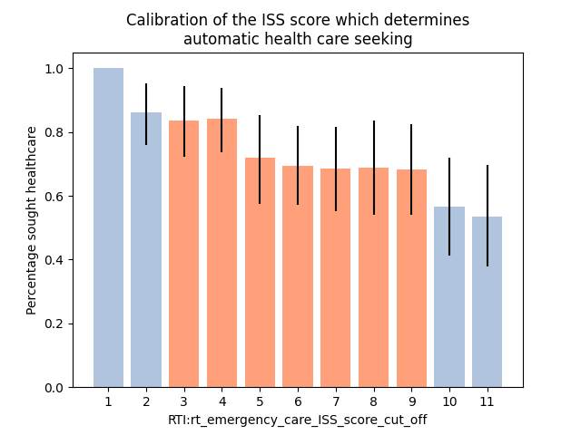

Figure 1: Establishing the parameter space for rt_emergency_case_ISS_score_cut_off. Values of this parameter between 3 and 9 result in a percentage of health seeking behaviour in the population matching the results of Zafar et al. 2018.

## Approach to modelling road traffic injuries: What treatment this person requires?

The treatment each person requires will be dependent on what injuries they have, as such the interaction with the health system needs to be flexible, adjusting to meet the needs of the patient.

If a person seeks healthcare, their first interaction takes place in the generic appointments. Currently, both function in the same way, but those with the generic injury symptom turn up at the ‘GenericFirstApptAtFacilityLevel1’ and those with the emergency appointment turn up at ‘GenericEmergencyFirstApptAtFacilityLevel1’. When they turn up at either of the appointments, they have their injuries diagnosed, with the appointment footprint being altered if they require an x-ray/ct-scan in order to diagnose their injuries. After the patient’s injuries are diagnosed, the proceed to the RTI module specific injury treatments.

Road traffic injuries can lead to extended periods of hospitalization, so to ensure that those who are injured remain in in-patient care when needed, a HSI event ‘RTI_MedicalIntervention’ is used to determine how long they will remain in the health system for and create a treatment plan for them, scheduling the surgeries, casts, burn treatments that each patient requires. To determine a patient’s length of stay, I use the ISS score to change the appointment footprint, based on the findings of (Lee et al. 2016) see Table 8.

|  |  |  |  |  |  |
| --- | --- | --- | --- | --- | --- |
| ISS score | Less than 4 | 4 to 8 | 9 to 15 | 16 to 24 | More than 25 |
| Mean LOS (s.d.) | 4.97 (4.86) | 8.91 (5.93) | 15.46 (11.16) | 24.73 (17.03) | 30.86 (34.03) |

Table 8: The relationship between a person's injury severity and their length of stay.

Some people will require admission to the HDU/ICU unit. Reportedly 6% of patients coming in to Kamuzu Central Hospital for road traffic injuries required admission to higher levels of care (Purcell et al. 2021). Currently, I am assuming that the most severe injuries are those that need higher levels of care, so the model currently admits those with ISS scores in the top 6% into HDU/ICU, see Figure 1.

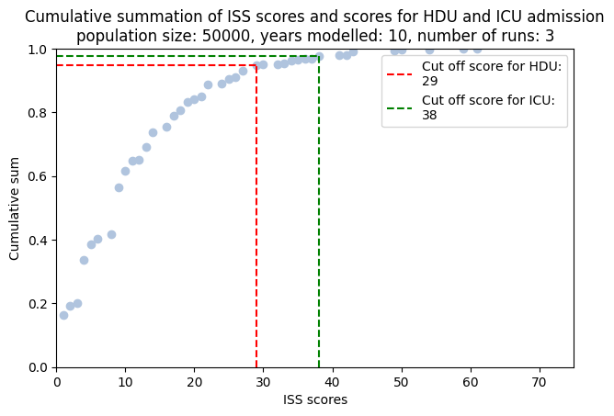

Figure 2: The ISS scores corresponding to criteria for HDU/ICU admission

The length of stay in ICU is informed by a study in Malawi (Wong et al. 2020). Wong et al. show those with a head injury were found to require a longer stay in the ICU. The parameter values for HDU/ICU length of stay are given in

|  |  |  |
| --- | --- | --- |
| ISS score | Head injury | No Head injury |
| Mean LOS (s.d.) | 8.4 (6.4) | 4.8 (6) |

The actual care for injuries is handled with a number of different HSI events. These are:

* ‘RTI_Fracture_Cast’, which treats fractures which can be casted by using the plaster of Paris consumables and gives out slings to fractures of the shoulder/upper arm
* ‘RTI_Suture’ which provides the consumables and performs stitching up of lacerations
* ‘RTI_Burn_Management’ which provides consumables which cleans and dresses burns
* ‘RTI_Tetanus_Vaccine’ which provides tetanus vaccines to those with burns and lacerations
* ‘RTI_Acute_Pain_Management’ which provides pain medicine for all injuries
* ‘RTI_Major_Surgeries’ which handles major surgeries, where major surgeries are defined as ‘surgeries that include extensive work such as entering a body cavity, removing an organ or altering the body’s anatomy’
* ‘RTI_Minor_Surgeries’ which handles minor surgeries
* ‘HSI_RTI_Shock_Treatment’ which treats patients going into shock
* ‘RTI_Open_Fracture_Treatment’ which handles the treatment of open fractures

The injuries treated, resources consumed and sources used for the design of each health system interaction event is given in Table 9.

|  |  |  |  |
| --- | --- | --- | --- |
| RTI_Fracture_Cast | | | |
| ‘code’ – Injury treated | Appointment footprint | Consumables requested | Source |
| ‘712a’ – broken clavicle, scapula, humerus  ‘712b’ – broken hand/wrist  ‘712c’ – broken radius/ulna  ‘811’ – Fractured foot  ‘812’ – broken tibia/fibula  '813a' - Broken hip  '813b' - broken pelvis  '813c' - broken femur  '822a' - dislocated hip  '822b' - dislocated knee | AccidentsandEmerg | Plaster of Paris (POP) 10cm x 7.5cm slab_12_CMST for fractures requiring a cast  Bandage, crepe 7.5cm x 1.4m long , when stretched for fractures requiring a sling (best fit in consumables df) | Assumed to be provided as care is fairly basic and consumable requirement in consumable dataframe |
| RTI_Suture | | | |
| ‘1101’ – Laceration to the head  ‘2101’ – Laceration to the face  ‘3101’ – Laceration to the neck  ‘4101’ – Laceration to the thorax  ‘5101’ – Laceration to the abdomen  ‘7101’ – Laceration to the upper extremity  ‘8101’ – Laceration to the lower extremity | Over5OPD  Or  Under5OPD | Suture pack for stitching  Cetrimide 15% + chlorhexidine 1.5% solution.for dilution _5_CMST for cleaning | Malawian national treatment guidelines |
| RTI_Burn_Management | | | |
| ‘1114’ – Burns to the head  ‘2114’ – Burns to the face  ‘3113’ – Burns to the neck  ‘4113’ – Burns to the thorax  ‘5113’ – Burns to the abdomen  ‘7113’ – Burns to the upper extremities  ‘8113’ – Burns to the lower extremities | MinorSurg accounting for wound debridement | Cetrimide 15% + chlorhexidine 1.5% solution.for dilution _5_CMS for wound cleaning  Dressing, paraffin gauze 9.5cm x 9.5cm (square)_pack of 36_CMST for wound dressing  ringer’s lactate (Hartmann’s solution), 500 ml_20_IDA for hydration if burns are severe | Malawian national treatment guidelines |
| RTI_Tetanus_Vaccine | | | |
| ‘1101’ – Laceration to the head  ‘2101’ – Laceration to the face  ‘3101’ – Laceration to the neck  ‘4101’ – Laceration to the thorax  ‘5101’ – Laceration to the abdomen  ‘7101’ – Laceration to the upper extremity  ‘8101’ – Laceration to the lower extremity  ‘1114’ – Burns to the head  ‘2114’ – Burns to the face  ‘3113’ – Burns to the neck  ‘4113’ – Burns to the thorax  ‘5113’ – Burns to the abdomen  ‘7113’ – Burns to the upper extremities  ‘8113’ – Burns to the lower extremities | Over5OPD  Or  Under5OPD | Tetanus toxin vaccine (TTV) | Malawian national treatment guidelines |
| RTI_Acute_Pain_Management | | | |
| All | Over5OPD  Or  Under5OPD | For mild pain:  Give Paracetamol 500mg_1000_CMST or diclofenac sodium 25 mg, enteric coated_1000_IDA (DON’T GIVE DICLOFENAC TO UNDER 16s OR PREGNANT WOMEN)  For moderate pain:  tramadol HCl 100 mg/2 ml, for injection_100_IDA  For severe pain:  morphine sulphate 10 mg/ml, 1 ml, injection (nt)_10_IDA | Malawian national treatment guidelines |
| RTI_Major_Surgeries | | | |
| FRACTURES:  ‘112’ – Depressed skull fracture  '811' - fractured foot  ’812' - fracture tibia/fibula  ‘813a’ – Fractured hip  ‘813b’ – Fractured pelvis  ‘813c’ – Fractured femur  ‘414’ – Flail chest | MajorSurg | (CONSUMABLES FOR ALL)  Halothane (fluothane)_250ml_CMST  Chlorhexidine 1.5% solution_5_CMST  Scalpel blade size 22 (individually wrapped)_100_CMST  Cannula iv (winged with injection pot) 20_each_CMST  Giving set iv administration + needle 15 drops/ml_each_CMST  ringer's lactate (Hartmann's solution), 1000 ml_12_IDA  Suture pack  Gauze, absorbent 90cm x 40m_each_CMST  Pethidine, 50 mg/ml, 2 ml ampoule  Ampicillin injection 500mg, PFR_each_CMST  Disposables gloves, powder free, 100 pieces per box  surgical face mask, disp., with metal nose piece_50_IDA  Syringe, Autodisable SoloShot IX | Surgical treatment of foot and tibia/fibula (Chagomerana et al. 2017)  Surgical treatment of depressed skull fracture (Eaton et al. 2017)  Surgical treatment of fractured hip/pelvis/femur  (Lavy et al. 2007)  Surgical treatment of Flail chest (Bach 2004) |
| SOFT TISSUE INJURIES:  ‘342’ – Soft tissue injury of the neck  ‘343’ – Soft tissue injury of the neck | MajorSurg | Assumed capacity to treat this |
| Thoroscopy treated injuries:  ‘441’ – Closed pneumothorax  ‘443’ – Open pneumothorax  ’463’ – Haemothorax  ‘453a’ – Diaphragm rupture  ‘453b’ – Lung contusion | MajorSurg | Paediatric handbook for Malawi |
| INTERNAL BLEEDING:  ‘361’ – Internal bleeding in neck  ‘363’ – Internal bleeding in neck | MajorSurg | Assumed capacity to treat this |
| TRAUMATIC BRAIN INJURIES THAT REQUIRE A CRANIOTOMOY  ‘133a’ – Subarachnoid hematoma  ‘133b’ – Brain contusion  ‘133c’ – Intraventricular haemorrhage  ‘133d’ – Subgaleal hematoma  ‘134a’ – Epidural hematoma  ‘134b’ – Subdural hematoma  ‘135’ – diffuse axonal injury | MajorSurg | (Eaton et al. 2017; Lavy et al. 2007) |
| Laparotomy  ‘552’ – Injury to Intestine, stomach and colon  ‘553’ – Injury to Spleen, Urinary bladder, Liver, Urethra, Diaphragm  ‘554’ – Injury to kidney | MajorSurg | (Lavy et al. 2007) |
| AMPUTATIONS  ‘782a’ – Amputated finger  ‘782b’ – Unilateral arm amputation  ‘782c’ – Amputated thumb  ‘783’ – Bilateral arm amputation  ‘882’ – Amputated toe  ‘883’ – Unilateral lower limb amputation  ‘884’ – Bilateral lower limb amputation | MajorSurg | (Grudziak et al. 2019)s |
| RTI_Minor_Surgeries | | | |
| ‘211’ – Facial fractures  ‘212’ – Facial fractures  ‘291’ – Injury to the eye  ‘241’ – Soft tissue injury of the face  ‘322’ – Dislocation in the neck  ‘323’ – Dislocation in the neck  ‘722’ – Dislocated shoulder  ‘822a’ – Dislocated hip  ‘822b’ – Dislocated knee  '811' - fractured foot  '812' - fractures tibia/fibula  '813a' - Fractured hip  '813b' - Fractured pelvis  '813C' - Fractured femur | MinorSurg | Lidocaine HCl (in dextrose 7.5%), ampoule 2 ml  Chlorhexidine 1.5% solution_5_CMST  Scalpel blade size 22 (individually wrapped)_100_CMST  Cannula iv (winged with injection pot) 20_each_CMST  Giving set iv administration + needle 15 drops/ml_each_CMST  ringer's lactate (Hartmann's solution), 1000 ml_12_IDA  Suture pack  Gauze, absorbent 90cm x 40m_each_CMST  Pethidine, 50 mg/ml, 2 ml ampoule  Ampicillin injection 500mg, PFR_each_CMST  Disposables gloves, powder free, 100 pieces per box  surgical face mask, disp., with metal nose piece_50_IDA  Syringe, Autodisable SoloShot IX  External fixator (for lower limb fractures only) | (Mkandawire, Ngulube, and Lavy 2008)  Fractures reference  (Chagomerana et al. 2017) |
| HSI_RTI_Shock_Treatment | | | |
| '361' - Sternomastoid m. hemorrhage/ Hemorrhage, supraclavicular triangle/  Hemorrhage, posterior triangle/  Anterior vertebral vessel hemorrhage/ Neck muscle hemorrhage  '363' - Hematoma in carotid sheath/  Carotid sheath hemorrhage  '461' - Chest wall bruises/haematoma '463' – Haemothorax  '813bo' - Open fracture of the pelvis '813co' - Open fracture of the femur  '813do' - Open fracture of the foot '813eo' - Open fracture of the tibia/fibula/ankle/patella | AccidentsandEmerg | ringer's lactate (Hartmann's solution), 1000 ml_12_IDA  Dextrose (glucose) 5%, 1000ml_each_CMST  Cannula iv (winged with injection pot) 20_each_CMST  Blood, one unit  Oxygen, 1000 liters, primarily with oxygen cylinders | Malawi treatment guidelines |
| RTI_Open_Fracture_Treatment | | | |
| '813bo' - Open fracture of the pelvis  '813co' - Open fracture of the femur  '813do' - Open fracture of the foot  '813eo' - Open fracture of the tibia/fibula/ankle/patella | MinorSurg | ceftriaxon 500 mg, powder for injection_10_IDA  Cetrimide 15% + chlorhexidine 1.5% solution.for dilution _5_CMST  Dressing, paraffin gauze 9.5cm x 9.5cm (square)_pack of 36_CMST  Suture pack  If wound contaminated:  Metronidazole, injection, 500 mg in 100 ml vial | (Schade et al. 2020) |

Table 9: The list of injuries treated in each health system interaction event, the appointment footprint requested, consumables required and evidence used for including the intervention

The diagnosis tool required, treatment recovery time for each injury is given in the Appendix.

## Approach to modelling road traffic injuries: The health outcome of this person with treatment or without treatment

The health outcomes of the model are determined by whether they have treatment or not, without treatment patients are at a higher risk of mortality and carry a greater disability burden

If the person receives treatment, then at the end of their stay in care we determine whether they survive or not based on their ISS score. There are not any Malawi-specific estimates for mortality that are linked to the ISS score, but I found estimates from other countries related to the ISS score (Saidi, Mutiso, and Ogengo 2014; Kuwabara et al. 2010). The probability of in-hospital mortality was determined by the bounds reported in Kuwabara et al. (2010), however the probabilities of mortality associated with particular ISS score boundaries were scaled up to produce an in hospital mortality equivalent to that of Kamuzu Central Hospital (Tyson et al. 2015). If the person does not receive treatment, at a fixed interval of time we determine whether they survive or not based on their MAIS score. The parameters used to determine mortality are given in Table 10.

|  |  |  |
| --- | --- | --- |
| Context | Parameter value | Source |
| Death with treatment   * ISS score less than or equal to 9 * ISS score between 10 and 15 * ISS score between 16 and 24 * ISS score between 25 and 35 * ISS score greater than 35 | 0.013  0.019  0.055  0.23  0.4 | (Kuwabara et al. 2010) scaled to produce the overall in-hospital reported in (Tyson et al. 2015). |
| Death without treatment   * MAIS 1 – 2 * MAIS 3 * MAIS 4 * MAIS 5 * MAIS 6 | 0  0.05  0.31  0.59  0.83 | (Champion et al. 2010) |

Table 10: Parameter values used to determine mortality with and without a health system

# Model structure

## Variables modelled

The variables modelled in the module are given in Table 11. Broadly they describe the transition through the injury to treatment process, keeping track of the type of injuries, the severity of the injuries and the health burden the injuries provide.

### Model progression parameters

The model asks the following in order:

* Where they involved in a road traffic accident?
* Did they die on the scene of the crash?
* Did they seek care?
* Did they receive care?
* Where they left permanently disabled from their injuries?
* Did they die from their injuries?

Whether a person has been involved in a road traffic accident each month is stored in ‘rt_road_traffic_inc’ (Y/N) and the date of the injury is stored in ‘rt_date_inj’. Whether they died on the scene of the crash is stored in ‘rt_imm_death’ (Y/N). If they attempted to seek that month is stored in ‘rt_diagnosed’ (Y/N). If they receive medical treatment that month is stored in ‘rt_med_int’ (Y/N). Whether their injuries have left them permanently disabled is stored in ‘rt_perm_disabled’ (Y/N), whether they died from their injuries after seeking care is stored in 'rt_post_med_death' (Y/N), whether they died from their injuries without seeking care is stored in ‘rt_no_med_death’ (Y/N) and the date in which the module checks whether they died without seeking care is 'rt_date_death_no_med'. Finally, whether they died from their injuries after seeking care, but the care was not available is stored in ‘rt_unavailable_med_death’ (Y/N).

### Parameters used to categorise injuries

Variables relevant to the epidemiology of road traffic injuries are:

* The number of injuries
* The type of injuries
* The severity of the injuries
* The health burden of injuries in context of the health system

The number of injuries produced by the model is capped at 8, with ‘rt_injury_1’ through ‘rt_injury_8’ storing the location, type and severity of each individual injury produced by the model (see the Appendix for the full list of injuries produced by the model).

The overall severity of a person’s injuries is stored in ‘rt_inj_severity’ where the injury can be ‘none’, ‘mild’ and ‘severe’. Another relevant measure of injury severity is whether they have polytrauma or not stored in ‘rt_polytrauma’ (Y/N). Polytrauma is defined as having severe injuries in two distinct body regions.

The health burden of injuries is quantified with three metrics. To quantify the probability of mortality with medical intervention, we use their ISS score, a commonly used metric to quantify the severity of injuries. This is stored in ‘rt_ISS_score’. To quantify the probability of mortality without medical intervention, we use the Military Abbreviated injury score, a metric developed to quantify injury severity in a military context. We assume that this is representative of road traffic injuries without medical intervention and store this score in ‘rt_MAIS_military_score’.

Finally, to quantify the level of disability non-fatal injuries provide we use disability adjusted life years. DALYs rely on DALY weights for their calculation, we store the sum total of the DALY weights for each person’s injuries in ‘rt_disability’. Non-fatal injuries will often not result in permanent disability and so we need to remove the DALY weight for each injury when it is healed. We store the dates to remove the DALY weight for each injury in 'rt_date_to_remove_daly'.

The full list of variables modelled in this module is given in Table 11.

|  |  |
| --- | --- |
| Property | Type and description |
| 'rt_road_traffic_inc': | BOOL === involved in a road traffic injury, |
| 'rt_inj_severity': | CATEGORICAL === Injury status relating to road traffic injury: none, mild, severe (Possible values are: ['none', 'mild', 'severe']), |
| 'rt_injury_1': | CATEGORICAL === Codes for injury 1 from RTI |
| 'rt_injury_2': | CATEGORICAL === Codes for injury 2 from RTI |
| 'rt_injury_3': | CATEGORICAL === Codes for injury 3 from RTI |
| 'rt_injury_4': | CATEGORICAL === Codes for injury 4 from RTI |
| 'rt_injury_5': | CATEGORICAL === Codes for injury 5 from RTI |
| 'rt_injury_6': | CATEGORICAL === Codes for injury 6 from RTI |
| 'rt_injury_7': | CATEGORICAL === Codes for injury 7 from RTI |
| 'rt_injury_8': | CATEGORICAL === Codes for injury 8 from RTI |
| 'rt_ISS_score': | INT === The ISS score associated with the injuries resulting from a road traffic accident, |
| 'rt_perm_disability': | BOOL === whether the injuries from an RTI result in permanent disability, |
| 'rt_polytrauma': | BOOL === polytrauma from RTI, |
| 'rt_imm_death': | BOOL === death at scene True/False, |
| 'rt_diagnosed': | BOOL === Person has had their injuries diagnosed, |
| 'rt_date_to_remove_daly': | LIST === List of dates to remove the daly weight associated with each injury, |
| 'rt_post_med_death': | BOOL === death in following month despite medical intervention True/False, |
| 'rt_no_med_death': | BOOL === death in following month without medical intervention True/False, |
| 'rt_unavailable_med_death': | BOOL === death in the following month without medical intervention being able to be provided, |
| 'rt_recovery_no_med': | BOOL === recovery without medical intervention True/False, |
| 'rt_disability': | REAL === disability weight for current month, |
| 'rt_date_inj': | DATE === date of latest injury, |
| 'rt_med_int': | BOOL === whether this person is currently undergoing medical treatment, |
| 'rt_MAIS_military_score': | INT === the maximum AIS-military score, used as a proxy to calculate the probability of mortality without medical intervention, |
| 'rt_date_death_no_med': | DATE === the date which the person has is scheduled to die without medical intervention |
| 'rt_injuries_to_cast' | LIST === 'A list of injuries that are to be treated with casts' |
| 'rt_injuries_for_minor_surgery' | LIST === 'A list of injuries that are to be treated with a minor' |
| 'rt_injuries_for_major_surgery' | LIST === 'A list of injuries that are to be treated with a minor' |
| 'rt_injuries_to_heal_with_time' | LIST === 'A list of injuries that heal without further treatment' |
| 'rt_injuries_for_open_fracture_treatment' | LIST === 'A list of injuries that with open fracture’ |
| 'rt_in_icu_or_hdu' | BOOL === 'whether this person is currently in ICU for RTI' |
| 'rt_debugging_DALY_wt' | REAL === ‘The true value of the DALY weight burden’ |
| ‘rt_in_shock’ | BOOL === 'whether this person is currently in shock due to RTI' |

Table 11: Variables modelled in this module

## Model diagrams

The overall structure of the model is shown in Figure 3 and the breakdown of the overall module structure into its component parts is shown in subsequent figures. The process of assigning people to be involved in road traffic accidents is shown in Figure 4. The process used to assign injuries and symptoms to people is shown in Figure 5. The health system events used in the road traffic injuries model are shown in Figure 6. The metrics used to produce the model’s health outcomes are given in Figure 7.

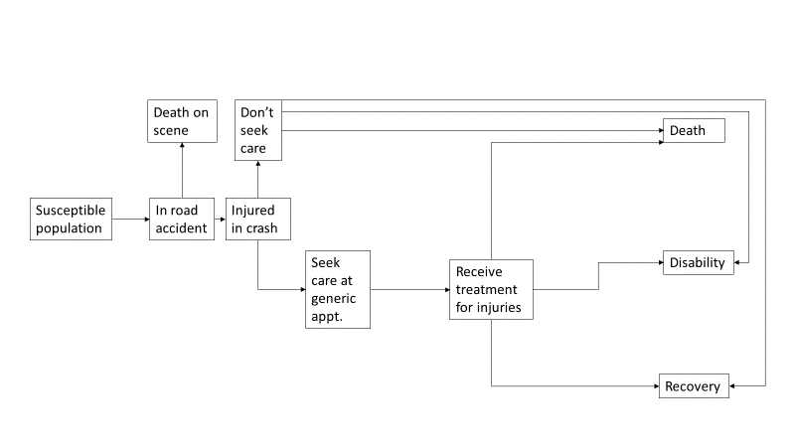

Figure 3: The module structure

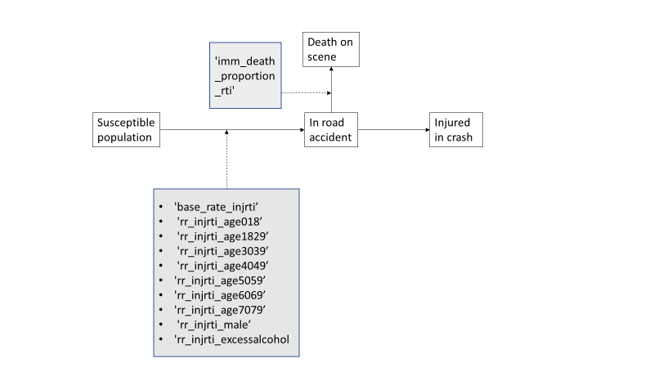

Figure 4: The parameters used in deciding who is injured in a road accident

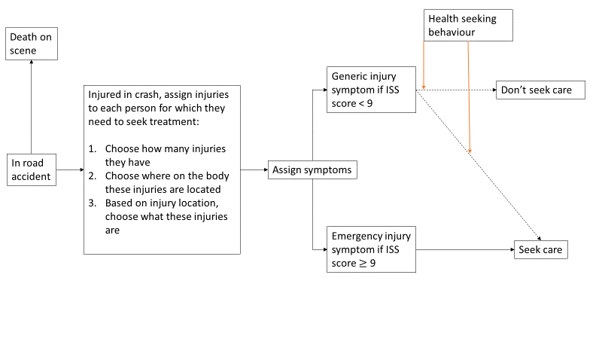

Figure 5: The process used to decide the number and type of injuries assigned to those who do not die on the scene of the crash, and the relationship between injuries assigned and health seeking behaviour

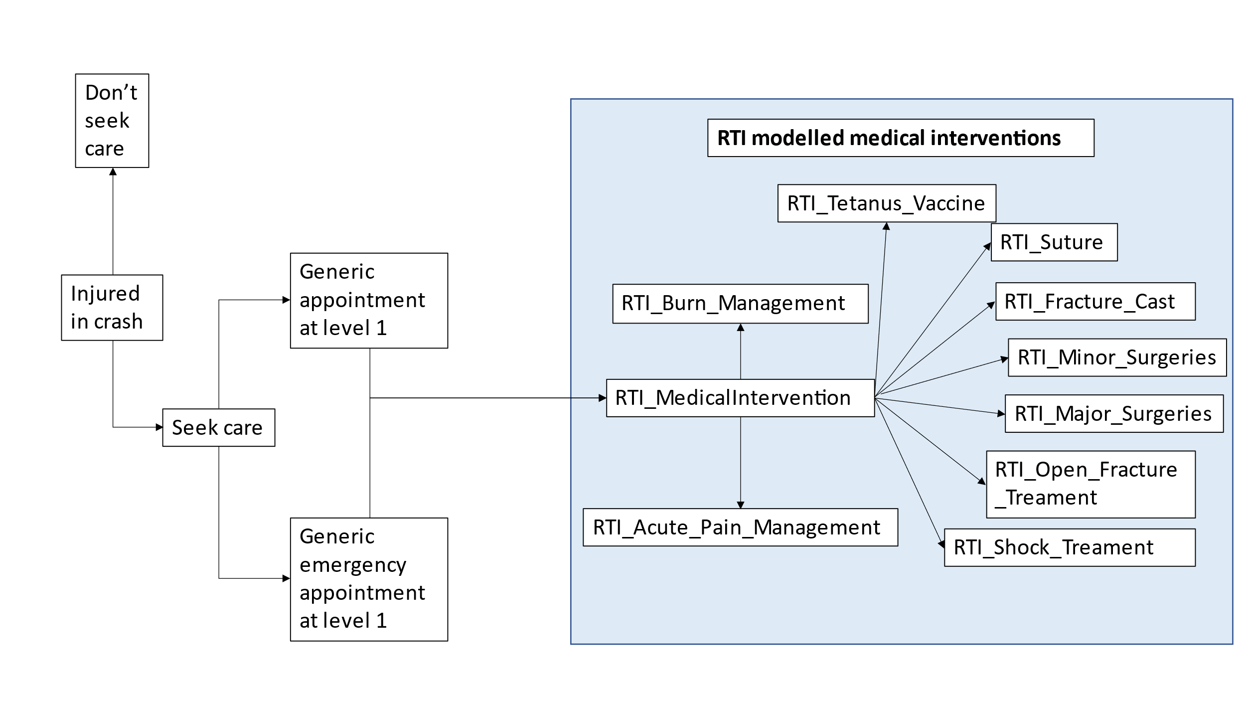

Figure 6: The interaction with the health system post injury, showing the various health system interaction events

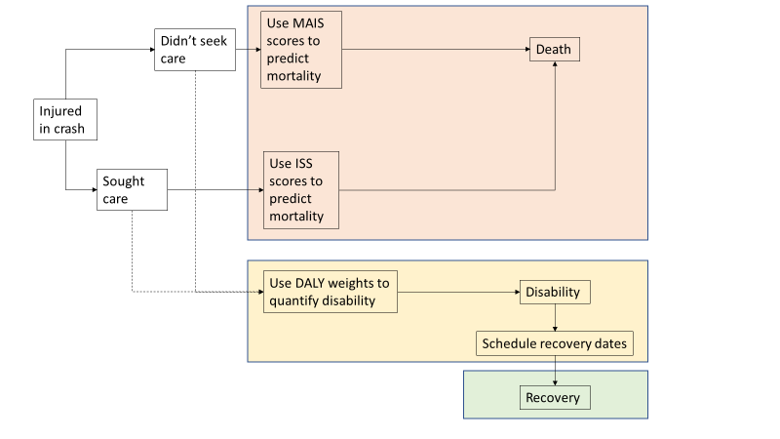

Figure 7: The metrics used to predict mortality and quantify disability for those who sought care and didn't seek care.

## Parameters used

|  |  |  |
| --- | --- | --- |
| Parameter name | Value | Description and ref |
| 'base_rate_injrti' | 0.007262, | Base rate of injury, calibrated to the average incidence of RTI from 2010 to 2019, GBD data |
| 'rr_injrti_age04' | 0.5 | Relative risk of RTI between ages 0 and 4, chosen to fit the incidence of deaths in 2010 GBD data |
| 'rr_injrti_age59' | 0.7 | Relative risk of RTI between ages 5 and 9, chosen to fit the incidence of deaths in 2010 GBD data |
| rr_injrti_age1017 | 0.9 | Relative risk of RTI between ages 10 and 17, chosen to fit the incidence of deaths in 2010 GBD data |
| 'rr_injrti_age1829' | 1.33, | Relative risk of RTI between ages 18 and 29, chosen to fit GBD demographics |
| 'rr_injrti_age3039' | 1.4, | Relative risk of RTI between ages 30 and 39, chosen to fit GBD demographics |
| 'rr_injrti_age4049' | 1.15, | Relative risk of RTI between ages 40 and 49, chosen to fit GBD demographics |
| 'rr_injrti_age5059' | 1.15, | Relative risk of RTI between ages 50 and 59, chosen to fit GBD demographics |
| 'rr_injrti_age6069' | 1.15, | Relative risk of RTI between ages 60 and 69, chosen to fit GBD demographics |
| 'rr_injrti_age7079' | 1.15, | Relative risk of RTI between ages 70 and 79, chosen to fit GBD demographics |
| 'rr_injrti_male' | 1.1, | Relative risk of RTI of being male, chosen to fit GBD demographics |
| 'rr_injrti_excessalcohol' | 6.53, | Relative risk of RTI for consuming excessive alcohol (Staton et al. 2018). |
| 'imm_death_proportion_rti' | 0.018, | Proportion of those who are injured in a road traffic injury wo die before reaching hospital (Mulima et al. 2021). |
| 'prob_perm_disability_with_treatment_severe_TBI' | 0.199, | Probability of those with traumatic brain injury who remain disabled post treatment (Eaton et al. 2017). |
| 'prob_perm_disability_with_treatment_sci' | 0.436, | Probability of those with spinal cord injury who remain disabled post treatment (Eaton et al. 2019). |
| ‘prob_death_iss_less_than_9’ | 0.012336, | Probability of death with medical care for an injury with an ISS score less than 9, calibrated with Azure (Kuwabara et al. 2010; Tyson et al. 2015) |
| ‘prob_death_iss_10_15’ | 0.018679 | Probability of death with medical care for an injury with an ISS score between 10 and 15, calibrated with Azure (Kuwabara et al. 2010; Tyson et al. 2015) |
| ‘prob_death_iss_16_24’ | 0.052763 | Probability of death with medical care for an injury with an ISS score between 16 and 24, calibrated with Azure (Kuwabara et al. 2010; Tyson et al. 2015) |
| ‘prob_death_iss_25_35’ | 0.225426 | Probability of death with medical care for an injury with an ISS score between 25 and 35, calibrated with Azure (Kuwabara et al. 2010; Tyson et al. 2015) |
| ‘prob_death_iss_35_plus’ | 0.383308 | Probability of death with medical care for an injury with an ISS score greater than 35, calibrated with Azure (Kuwabara et al. 2010; Tyson et al. 2015) |
| 'prob_death_TBI_SCI_no_treatment' | 0.9, | Probability of dying from a traumatic brain injury without treatment (Khan et al. 2004) |
| 'prop_death_burns_no_treatment' | 0.6, | Probability of dying from burns without treatment (Khan et al. 2004) |
| 'prob_death_fractures_no_treatment' | 0.1, | Probability of dying from a fracture injury without treatment (Khan et al. 2004) |
| 'prob_TBI_require_craniotomy' | 0.124, | Probability a traumatic brain injury will require major surgery in the form of a craniotomy (Eaton et al. 2017) |
| 'prob_exploratory_laparotomy' | 0.319, | Probability that abdominal trauma will result in exploratory laparotomy surgery (Ruhinda et al. 2008) |
| ‘head_prob_112’ | 0.0455 | The probability that this person’s head injury is a skull fracture (Eaton et al. 2017). |
| ‘head_prob_113’ | 0.0045 | The probability that this person’s head injury is a basilar skull fracture (Eaton et al. 2017) |
| ‘head_prob_133a’ | 0.09149906 | The probability that this person’s head injury is a Subarachnoid hematoma (Carroll et al. 2010; Global Health Data 2017) |
| ‘head_prob_133b’ | 0.301946898 | The probability that this person’s head injury is a Brain contusion (Carroll et al. 2010; Global Health Data 2017) |
| ‘head_prob_133c’ | 0.013724859 | The probability that this person’s head injury is a Intraventricular haemorrhage (Carroll et al. 2010; Global Health Data 2017) |
| ‘head_prob_133d’ | 0.050324483 | The probability that this person’s head injury is a Subgaleal hematoma (Carroll et al. 2010; Global Health Data 2017) |
| ‘head_prob_134a’ | 0.086670324 | The probability that this person’s head injury is a Epidural hematoma (Carroll et al. 2010; Global Health Data 2017) |
| ‘head_prob_134b’ | 0.080003376 | The probability that this person’s head injury is a subdural hematoma (Carroll et al. 2010; Global Health Data 2017) |
| ‘head_prob_135’ | 0.061731 | The probability that this person’s head injury is a Diffuse axonal injury/midline shift (Carroll et al. 2010; Global Health Data 2017) |
| head_prob_1101 | 0.253536 | The probability that this person’s head injury is a laceration (Malm et al. 2008; Global Health Data 2017) |
| head_prob_1114 | 0.010564 | The probability that this person’s head injury is a burn (Tian et al. 2018; Global Health Data 2017) |
| face_prob_211 | 0.158585 | The probability that this person’s facial injury is a Facial fracture (nasal/unspecified) (Hassan 2016) |
| face_prob_212 | 0.294515 | The probability that this person’s facial injury is a Facial fracture (mandible/zygomatic) (Hassan 2016) |
| face_prob_241 | 0.339 | The probability that this person’s facial injury is a soft tissue injury (Hassan 2016) |
| face_prob_2101 | 0.194845 | The probability that this person’s facial injury is a laceration (Malm et al. 2008; Global Health Data 2017) |
| face_prob_2114 | 0.010255 | The probability that this person’s facial injury is a burn (Tian et al. 2018; Global Health Data 2017) |
| face_prob_291 | 0.0028 | The probability that this person’s facial injury is an eye injury (Hassan 2016) |
| neck_prob_3101 | 0.06972 | The probability that this person’s neck injury is an be a laceration (Malm et al. 2008; Global Health Data 2017) |
| neck_prob_3113 | 0.01428 | The probability that this person’s neck injury is an be a burn (Tian et al. 2018; Global Health Data 2017) |
| neck_prob_342 | 0.004 | The probability that this person’s neck injury is an be a vertebral artery laceration (Kasantikul, Ouellet, and Smith 2003) |
| neck_prob_343 | 0.004 | The probability that this person’s neck injury is an be a pharynx contusion (Kasantikul, Ouellet, and Smith 2003) |
| neck_prob_361 | 0.495 | The probability that this person’s neck injury is an be a Sternomastoid m. hemorrhage/ Hemorrhage, supraclavicular triangle/  Hemorrhage, posterior triangle/  Anterior vertebral vessel hemorrhage/ Neck muscle hemorrhage (Kasantikul, Ouellet, and Smith 2003) |
| neck_prob_363 | 0.405 | The probability that this person’s neck injury is an be a Hematoma in carotid sheath/  Carotid sheath hemorrhage (Kasantikul, Ouellet, and Smith 2003) |
| neck_prob_322 | 0.00264 | The probability that this person’s neck injury is an be a Atlanto-occipital subluxation (Kasantikul, Ouellet, and Smith 2003) |
| neck_prob_323 | 0.00536 | The probability that this person’s neck injury is an be a Atlanto-axial subluxation (Kasantikul, Ouellet, and Smith 2003) |
| thorax_prob_4101 | 0.49036 | The probability that this person’s thorax injury is an be a laceration (Malm et al. 2008; Global Health Data 2017) |
| thorax_prob_4113 | 0.04264 | The probability that this person’s thorax injury is a burn (Tian et al. 2018; Global Health Data 2017) |
| thorax_prob_461 | 0.0945 | The probability that this person’s thorax injury is a Chest wall bruises/haematoma (Okugbo, Okoro, and Irhibogbe 2012) |
| thorax_prob_463 | 0.0945 | The probability that this person’s thorax injury is a Haemothorax (Okugbo, Okoro, and Irhibogbe 2012) |
| thorax_prob_453a | 0.0539 | The probability that this person’s thorax injury is a Lung contusion (Okugbo, Okoro, and Irhibogbe 2012) |
| thorax_prob_453b | 0.0161 | The probability that this person’s thorax injury is a Diaphragm rupture (Okugbo, Okoro, and Irhibogbe 2012) |
| thorax_prob_412 | 0.0392 | The probability that this person’s thorax injury is a Fractured rib(s) (Okugbo, Okoro, and Irhibogbe 2012) |
| thorax_prob_414 | 0.0098 | The probability that this person’s thorax injury is a Flail chest (Okugbo, Okoro, and Irhibogbe 2012) |
| thorax_prob_441 | 0.08586 | The probability that this person’s thorax injury is a Chest wall lacerations/avulsions (Okugbo, Okoro, and Irhibogbe 2012) |
| thorax_prob_442 | 0.01749 | The probability that this person’s thorax injury is a Surgical emphysema (Okugbo, Okoro, and Irhibogbe 2012) |
| thorax_prob_443 | 0.05565 | The probability that this person’s thorax injury is a Closed pneumothorax/ open pneumothorax (Okugbo, Okoro, and Irhibogbe 2012) |
| abdomen_prob_5101 | 0.11026 | The probability that this person’s abdomen injury is a laceration (Malm et al. 2008; Global Health Data 2017) |
| abdomen_prob_5113 | 0.03874 | The probability that this person’s abdomen injury is a burn (Tian et al. 2018; Global Health Data 2017) |
| abdomen_prob_552 | 0.047656 | The probability that this person’s abdomen injury is an Injury to stomach/  intestines/  colon (Ruhinda et al. 2008) |
| abdomen_prob_553 | 0.77441 | The probability that this person’s abdomen injury is an Injury to spleen/  Urinary bladder/  Liver/  Urethra/  Diaphragm (Ruhinda et al. 2008) |
| abdomen_prob_554 | 0.028934 | The probability that this person’s abdomen injury is an Injury to kidney (Ruhinda et al. 2008) |
| spine_prob_612 | 0.364 | The probability that this person’s spine injury is a Fracture vertebrae (Biluts et al. 2015) |
| spine_prob_673a | 0.015840216 | The probability that this person’s spine injury is a Spinal cord injury at neck level (Biluts et al. 2015; Stephan et al. 2015) |
| spine_prob_673b | 0.040731984 | The probability that this person’s spine injury is a Spinal cord injury below neck level (Biluts et al. 2015; Stephan et al. 2015) |
| spine_prob_674a | 0.074477731 | The probability that this person’s spine injury is a Spinal cord injury at neck level (Biluts et al. 2015; Stephan et al. 2015) |
| spine_prob_674b | 0.116490809 | The probability that this person’s spine injury is a Spinal cord injury below neck level (Biluts et al. 2015; Stephan et al. 2015) |
| spine_prob_675a | 0.134791137 | The probability that this person’s spine injury is a Spinal cord injury at neck level (Biluts et al. 2015; Stephan et al. 2015) |
| spine_prob_675b | 0.210827163 | The probability that this person’s spine injury is a Spinal cord injury below neck level (Biluts et al. 2015; Stephan et al. 2015) |
| spine_prob_676 | 0.04284096 | The probability that this person’s spine injury is a Spinal cord injury at neck level (Biluts et al. 2015; Stephan et al. 2015) |
| upper_ex_prob_7101 | 0.43896 | The probability that this person’s upper extremity injury is a laceration (Malm et al. 2008; Global Health Data 2017) |
| upper_ex_prob_7113 | 0.03304 | The probability that this person’s upper extremity injury is a burn (Tian et al. 2018; Global Health Data 2017) |
| upper_ex_prob_712a | 0.10802 | The probability that this person’s upper extremity injury is a Fracture to Clavicle, scapula, humerus  (Global Health Data 2017) |
| upper_ex_prob_712b | 0.28969 | The probability that this person’s upper extremity injury is a Fracture to Hand/wrist  (Global Health Data 2017) |
| upper_ex_prob_712c | 0.09329 | The probability that this person’s upper extremity injury is a Fracture to Radius/ulna (Global Health Data 2017) |
| upper_ex_prob_722 | 0.025 | The probability that this person’s upper extremity injury is a dislocated shoulder (Global Health Data 2017) |
| upper_ex_prob_782a | 0.00750024 | The probability that this person’s upper extremity injury is a Amputated finger (Global Health Data 2017) |
| upper_ex_prob_782b | 0.00102276 | The probability that this person’s upper extremity injury is a Unilateral arm amputation (Global Health Data 2017) |
| upper_ex_prob_782c | 0.002841 | The probability that this person’s upper extremity injury is an amputated thumb (Global Health Data 2017) |
| upper_ex_prob_783 | 0.000636 | The probability that this person’s upper extremity injury is a bilateral arm amputation (Global Health Data 2017) |
| lower_ex_prob_8101 | 0.186094109 | The probability that this person’s lower extremity injury is a laceration (Malm et al. 2008; Global Health Data 2017) |
| lower_ex_prob_8113 | 0.014007083 | The probability that this person’s lower extremity injury is a burn (Tian et al. 2018; Global Health Data 2017) |
| lower_ex_prob_811 | 0.023610948 | The probability that this person’s lower extremity injury is a foot fracture (Global Health Data 2017) |
| lower_ex_prob_813do | 0.013281158 | The probability that this person’s lower extremity injury is an open foot fracture (Global Health Data 2017; Court-Brown et al. 2012) |
| lower_ex_prob_812 | 0.354164215 | The probability that this person’s lower extremity injury is a Fracture to patella, tibia, fibula, ankle (Global Health Data 2017) |
| lower_ex_prob_813eo | 0.199217371 | The probability that this person’s lower extremity injury is an open Fracture to patella, tibia, fibula, ankle (Global Health Data 2017; Court-Brown et al. 2012) |
| lower_ex_prob_813a | 0.029513685 | The probability that this person’s lower extremity injury is a Hip fracture (Global Health Data 2017) |
| lower_ex_prob_813b | 0.023610948 | The probability that this person’s lower extremity injury is a Pelvis fracture (Global Health Data 2017) |
| lower_ex_prob_813bo | 0.005902737 | The probability that this person’s lower extremity injury is an open Pelvis fracture (Global Health Data 2017; Court-Brown et al. 2012) |
| lower_ex_prob_813c | 0.076765094 | The probability that this person’s lower extremity injury is a Femur fracture (Global Health Data 2017) |
| lower_ex_prob_813co | 0.01177596 | The probability that this person’s lower extremity injury is an open Femur fracture (Global Health Data 2017; Court-Brown et al. 2012) |
| lower_ex_prob_822a | 0.037338982 | The probability that this person’s lower extremity injury is a Dislocated hip (Global Health Data 2017) |
| lower_ex_prob_822b | 0.002383339 | The probability that this person’s lower extremity injury is a Dislocated knee (Global Health Data 2017) |
| lower_ex_prob_882 | 0.00731139 | The probability that this person’s lower extremity injury is an Amputation of toes (Global Health Data 2017) |
| lower_ex_prob_883 | 0.007511491 | The probability that this person’s lower extremity injury is a unilateral amputation (Global Health Data 2017) |
| lower_ex_prob_884 | 0.007511491 | The probability that this person’s lower extremity injury is a bilateral (Global Health Data 2017) |
| 'prob_depressed_skull_fracture' | 0.14, | Probability that the person’s skull fracture is depressed and will require surgery (Eaton et al. 2017) |
| 'prob_dislocation_requires_surgery' | 0.01, | Dummy variable used to account for the fact that some dislocations will require surgery |
| 'prob_mild_burns' | 0.56, | Probability that a burn is mild and does not require IV fluid replacement (Nthumba 2016) |
| 'rr_injrti_mortality_polytrauma' | 2.2, | Relative risk of mortality from road traffic injuries for people with polytrauma (Tyson et al. 2015) |
| 'mean_los_ISS_less_than_4' | 4.97, | Mean length of stay for those with ISS score less than 4 (Lee et al. 2016) |
| 'sd_los_ISS_less_than_4' | 4.86, | Variation in length of stay for those with ISS score less than 4 (Lee et al. 2016) |
| 'mean_los_ISS_4_to_8' | 8.91, | Mean length of stay for those with an ISS score between 4 and 8 (Lee et al. 2016) |
| 'sd_los_ISS_4_to_8' | 5.93, | Variation length of stay for those with an ISS score between 4 and 8 (Lee et al. 2016) |
| 'mean_los_ISS_9_to_15' | 15.46, | Mean length of stay for those with an ISS score between 9 and 15 (Lee et al. 2016) |
| 'sd_los_ISS_9_to_15' | 11.16, | Variation in length of stay for those with an ISS score between 9 and 15 (Lee et al. 2016) |
| 'mean_los_ISS_16_to_24' | 24.73, | Mean length of stay for those with an ISS score between 16 and 24 (Lee et al. 2016) |
| 'sd_los_ISS_16_to_24' | 17.03, | Variation in length of stay for those with an ISS score between 16 and 24 (Lee et al. 2016) |
| 'mean_los_ISS_more_than_25' | 30.86, | Mean length of stay for those with an ISS score greater than 25 (Lee et al. 2016) |
| 'sd_los_ISS_more_that_25' | 34.03, | Variation length of stay for those with an ISS score greater than 25 (Lee et al. 2016) |
| 'number_of_injured_body_regions_distribution' | [0.462, 0.224, 0.123, 0.083, 0.051, 0.031, 0.016, 0.01]], | The distribution of the number of injuries  (Gabbe et al. 2014) |
| 'injury_location_distribution' | [[1, 2, 3, 4, 5, 6, 7, 8], [0. 736, 0. 194, 0.051, 0.0135, 0. 0036, 0. 0009, 0. 00025, 0.00006]], | The distribution of injury location (Ranti et al. 2015; Otieno et al. 2004) CIREN data set |
| 'rt_emergency_care_ISS_score_cut_off' | (3-9), default 9 | Cut off ISS score for being assigned the emergency symptom (above) or not |
| 'prob_death_MAIS3' | 0.05, | Probability of death without medical intervention for MAIS score of 3 (Champion et al. 2010). |
| 'prob_death_MAIS4' | 0.31, | Probability of death without medical intervention for MAIS score of 4 (Champion et al. 2010). |
| 'prob_death_MAIS5' | 0.59, | Probability of death without medical intervention for MAIS score of 5 (Champion et al. 2010). |
| 'prob_death_MAIS6' | 0.83, | Probability of death without medical intervention for MAIS score of 6 (Champion et al. 2010). |
| 'prob_open_fracture_contaminated' | 0.1 | Probability that an open fracture is contaminated |
| 'femur_fracture_skeletal_traction_mean_los' | 52 | Mean length of stay for femur fractures treated with skeletal traction |
| 'other_skeletal_traction_los' | 42 | Mean length of stay for other fractures treated with skeletal traction |
| 'prob_foot_frac_require_cast' | 0.613 | Probability that a foot fracture requires a cast |
| 'prob_foot_frac_require_maj_surg' | 0.263 | Probability that a foot fracture requires major surgery |
| 'prob_foot_frac_require_min_surg' | 0.038 | Probability that a foot fracture requires minor surgery |
| 'prob_foot_frac_require_amp', | 0.086 | Probability that a foot fracture requires amputation |
| 'prob_tib_fib_frac_require_traction' | 0.025 | Probability that a tibia/fibula fracture requires skeletal traction |
| 'prob_tib_fib_frac_require_cast', | 0.71 | Probability that a tibia/fibula fracture requires a cast |
| 'prob_tib_fib_frac_require_maj_surg', | 0.066 | Probability that a tibia/fibula fracture requires major surgery |
| 'prob_tib_fib_frac_require_min_surg', | 0.175 | Probability that a tibia/fibula fracture requires minor surgery |
| 'prob_tib_fib_frac_require_amp', | 0.024 | Probability that a tibia/fibula fracture requires amputation |
| 'prob_femural_fracture_require_major_surgery', | 0.187 | Probability that a femur fracture requires major surgery |
| 'prob_femural_fracture_require_minor_surgery', | 0.007 | Probability that a femur fracture requires minor surgery |
| 'prob_femural_fracture_require_cast', | 0.024 | Probability that a femur fracture requires a cast |
| 'prob_femural_fracture_require_traction', | 0.777 | Probability that a femur fracture requires skeletal traction |
| 'prob_femural_fracture_require_amputation', | 0.005 | Probability that a femur fracture requires amputation |
| 'prob_pelvis_fracture_traction', | 0.71 | Probability that a pelvis fracture requires skeletal traction |
| 'prob_pelvis_frac_major_surgery', | 0.12 | Probability that a pelvis fracture requires major surgery |
| 'prob_pelvis_frac_cast', | 0.12 | Probability that a pelvis fracture requires a cast |
| 'prob_pelvis_frac_minor_surgery', | 0.05 | Probability that a pelvis fracture requires minor surgery |
| 'prob_dis_hip_require_maj_surg', | 0.167 | Probability that a dislocated hip requires major surgery |
| 'prob_dis_hip_require_cast', | 0.333 | Probability that a dislocated hip requires a cast |
| 'prob_hip_dis_require_traction', | 0.5 | Probability that a dislocated hip requires skeletal traction |
| 'hdu_cut_off_iss_score' | 29 | Cut-off ISS score for entry in the high dependency unit/ intensive care unit |
| 'mean_icu_days', | 4.8 | The mean length of stay in the ICU unit without a head injury |
| 'sd_icu_days', | 6 | The standard deviation of ICU days for those in the ICU unit without a head injury |
| 'mean_tbi_icu_days', | 8.4 | The mean length of stay in the ICU unit with a head injury |
| 'sd_tbi_icu_days' | 6.4 | The standard deviation of ICU days for those in the ICU unit with a head injury |

Table 12: Model parameters

## Disability weights

|  |  |  |  |  |  |
| --- | --- | --- | --- | --- | --- |
| Sequela | Health state name | Health state lay description | Disability weight | Lower | Upper |
| Unspecified skull fracture | Fracture of skull (short or long term, with or without treatment) | has a broken skull, but does not have brain damage. The broken area is painful and swollen. | 0.195 | 0.119 | 0.149 |
| Basilar skull fracture | Fracture of basilar skull (short or long term, with or without treatment) | has a broken skull, but does not have brain damage. The broken area is painful and swollen. | 0.149 | 0.1 | 0.197 |
| Epidural hematoma | Traumatic brain injury | Bleeding in the outer membrane of the brain | 0.185 | 0.153 | 0.217 |
| Subdural hematoma | Traumatic brain injury | Gathering of blood between the inner layer of the dura mater and the arachnoid mater of the meninges surrounding the brain. | 0.21 | 0.187 | 0.234 |
| Subarachnoid haemorrhage | Traumatic brain injury | A subarachnoid haemorrhage is an uncommon type of stroke caused by bleeding on the surface of the brain. | 0.214 | 0.188 | 0.241 |
| Brain contusion | Traumatic brain injury | Bruise of the brain tissue. | 0.174 | 0.139 | 0.209 |
| Intraventricular haemorrhage | Traumatic brain injury | Bleeding in the brain's ventricular system | 0.174 | 0.139 | 0.209 |
| Diffuse axonal injury | Traumatic brain injury | Form of traumatic brain injury. It happens when the brain rapidly shifts inside the skull as an injury is occurring. The long connecting fibers in the brain called axons are sheared as the brain rapidly accelerates and decelerates inside the hard bone of the skull. | 0.239 | 0.165 | 0.313 |
| Subgaleal hematoma | Traumatic brain injury | Subgaleal hemorrhage or hematoma is bleeding in the potential space between the skull periosteum and the scalp galea aponeurosis. | 0.174 | 0.139 | 0.209 |
| Midline shift | Traumatic brain injury | A midline shift occurs when the pressure exerted by the buildup of blood and swelling around the damaged brain tissues is powerful enough to push the entire brain off-center. | 0.239 | 0.165 | 0.313 |
| Facial fracture | Fracture of facial bones | has a broken cheek bone or a broken nose or chipped teeth, with swelling and severe pain. | 0.067 | 0.044 | 0.91 |
| Soft tissue injury | Soft tissue injury in face |  | 0.008 | 0.003 | 0.015 |
| Eye injury | Eye injury | has an injury to one eye, which causes pain and difficulty seeing. | 0.054 | 0.035 | 0.081 |
| Soft tissue injury | Superficial injury to neck |  | 0.1 | 0.053 | 0.148 |
| Internal bleeding | Internal bleeding in the neck |  | 0.1 | 0.053 | 0.148 |
| Dislocation | Dislocation of neck vertebrae |  | 0.187 | 0.173 | 0.201 |
| Chest wall bruises/haemotoma | Internal bleeding in the chest |  | 0.143 | 0.083 | 0.202 |
| Haemothorax | Internal bleeding in the chest | Accumulation of blood within the pleural cavity. | 0.143 | 0.083 | 0.202 |
| Lung contusion | Internal organ injury in chest | Bruise of the lung caused by chest trauma. | 0.205 | 0.179 | 0.231 |
| Diaphragm rupture | Internal organ injury in chest | Tear of the diaphragm | 0.205 | 0.179 | 0.231 |
| Rib fracture | Fracture of the rib(s) | has a broken rib that causes severe pain in the chest, especially when breathing in. The person has difficulty with daily activities such as dressing. | 0.187 | 0.167 | 0.207 |
| Flail chest | Fracture and detachment of multiple ribs | A segment of the rib cage breaks due to trauma and becomes detached from the rest of the chest wall. Two of the symptoms of flail chest are chest pain and shortness of breath. | 0.211 | 0.132 | 0.29 |
| Chest wall lacerations/avulsions | Soft tissue injury in chest |  | 0.143 | 0.083 | 0.202 |
| Closed pneumothorax | Soft tissue injury in chest | Closed pneumothorax is when air or gas gets in the pleural space without any outside wound. | 0.164 | 0.137 | 0.192 |
| Open pneumothorax | Soft rissue injury in chest | An open pneumothorax occurs when air accumulates between the chest wall and the lung as the result of an open chest wound or other physical defect. | 0.164 | 0.137 | 0.192 |
| Surgical emphysema | Soft tissue injury in chest | Surgical emphysema (or subcutaneous emphysema) occurs when air/gas is located in the subcutaneous tissues (the layer under the skin). | 0.164 | 0.137 | 0.192 |
| Abominal organ injury | Internal organ injury in abdomen | Injury to one of the abdominal's internal organs | 0.182 | 0.162 | 0.203 |
| Spinal cord injury at neck level with treatment | Spinal cord injury | is paralyzed from the neck down, with no feeling or control over any part of the body below the neck, and no urine or bowel | 0.589 | 0.415 | 0.748 |
| Spinal cord injury at neck level without treatment | Spinal cord injury | is paralyzed from the neck down, with no feeling or control over any part of the body below the neck, and no urine or bowel control. Arms and legs are in fixed, bent positions, and the person gets frequent infections and pressure sores. | 0.732 | 0.544 | 0.871 |
| Spinal cord injury below neck level with treatment | Spinal cord injury | is paralyzed from the waist down, cannot feel or move the legs and has difficulties with urine and bowel control. The person uses a wheelchair to move around. | 0.296 | 0.198 | 0.414 |
| Spinal cord injury below neck level without treatment | Spinal cord injury | is paralyzed from the waist down, cannot feel or move the legs and has difficulties with urine and bowel control. Legs are in fixed, bent positions, and the person gets frequent infections and pressure sores. | 0.623 | 0.434 | 0.777 |
| Fracture of vertebrae | Fracture of vertebral column (short or long term, with or without treatment) | has broken back bones and is in pain, but still has full use of arms and legs. | 0.111 | 0.075 | 0.156 |
| Fracture of clavicle, scapula or humerus | Fracture of clavicle, scapula or humerus (short or long term, with or without treatment) | has a broken shoulder bone, which is painful and swollen. The person cannot use the affected arm and has difficulty with getting dressed. | 0.035 | 0.021 | 0.053 |
| Fracture of hand short term with or without treatment | Fracture of hand (short term, with or without treatment) | has a broken hand, causing pain and swelling. | 0.01 | 0.005 | 0.019 |
| Fracture of hand (long term, without treatment) | Fracture of hand (long term, without treatment) | has stiffness in the hand and a weak grip. | 0.014 | 0.007 | 0.025 |
| Fracture of radius or ulna (short term, with or without treatment) | Fracture of radius or ulna (short term, with or without treatment) | has a broken forearm, which causes severe pain, swelling, and limited movement. | 0.028 | 0.016 | 0.046 |
| Fracture of radius or ulna (long term, without treatment) | Fracture of radius or ulna (long term, without treatment) | had a broken forearm in the past that did not heal properly, causing some pain and limited movement in the elbow and wrist. The person has difficulty with daily activities such as dressing. | 0.043 | 0.028 | 0.064 |
| Dislocation of shoulder (long term, with or without treatment) | Dislocation of shoulder (long term, with or without treatment) | has a shoulder that is out of joint, causing pain and difficulty moving. The person has difficulty with daily activities such as dressing and cooking. | 0.062 | 0.041 | 0.088 |
| Amputation of finger(s) | Amputation of finger(s), excluding thumb | has lost a finger of one hand. At times there is pain and tingling in the stump | 0.005 | 0.002 | 0.01 |
| Amputation of thumb | Amputation of thumb (long term) | has lost one thumb, causing some difficulty in using the hand, pain, and tingling in the stump | 0.011 | 0.005 | 0.021 |
| Unilateral upper limb amputation with treatment | Amputation of one upper limb (long term, with treatment) | has lost one hand and part of the arm, leaving pain and tingling in the stump. The person has an artificial arm that makes it possible to lift objects and do daily activities such as cooking, with some extra effort | 0.039 | 0.024 | 0.059 |
| Unilateral upper limb amputation without treatment | Amputation of one upper limb (long term, without treatment) | has lost one hand and part of the arm, leaving pain and tingling in the stump. The person needs help from others to lift objects or do daily activities such as cooking. | 0.118 | 0.079 | 0.167 |
| Bilateral upper limb amputation with treatment | Amputation of both upper limbs (long term, with treatment) | has lost part of both arms, leaving pain and tingling in the stumps. The person has two artificial arms that make it possible to do daily activities, with a great deal of extra effort | 0.123 | 0.081 | 0.176 |
| Bilateral upper limb amputation without treatment | Amputation of both upper limbs (long term, without treatment) | has lost part of both arms, leaving pain and tingling in the stumps. The person needs a great deal of help from others to do even basic daily activities such as eating and using the toilet, and the person is very limited in other activities. | 0.383 | 0.251 | 0.525 |
| Fracture of foot short term with or without treatment | Fracture of foot | has a broken foot bone, which causes pain, swelling, and difficulty walking. | 0.026 | 0.015 | 0.043 |
| Fracture of foot long term without treatment | Fracture of foot bones (long term, without treatment) | had a broken foot in the past that did not heal properly. The person now has pain in the foot and has some difficulty walking. | 0.026 | 0.015 | 0.042 |
| Fracture of patella, tibia or fibula or ankle (short term, with or without treatment) | Fracture of patella, tibia or fibula or ankle (short term, with or without treatment) | has a broken shin bone, which causes severe pain, swelling, and difficulty walking. | 0.05 | 0.032 | 0.075 |
| Fracture of patella, tibia or fibula or ankle (long term, with or without treatment) | Fracture of patella, tibia or fibula or ankle (long term, with or without treatment) | had a broken shin bone in the past that did not heal properly. The person has pain in the knee and ankle, and has difficulty walking. | 0.055 | 0.036 | 0.081 |
| Fracture of neck of femur (short term, with or without treatment) | Fracture of neck of femur (short term, with or without treatment) | has broken a hip and is in pain. The person cannot stand or walk, and needs help washing, dressing, and going to the toilet. | 0.258 | 0.172 | 0.356 |
| Fracture of neck of femur (long term, with treatment) | Fracture of neck of femur (long term, with treatment) | had a broken hip in the past, which was fixed with treatment. The person can only walk short distances, has discomfort when moving around, and has some difficulty in daily activities. | 0.058 | 0.038 | 0.084 |
| Fracture of neck of femur (long term, without treatment) | Fracture of neck of femur (long term, without treatment) | had a broken hip bone in the past, which was never treated and did not heal properly. The person cannot get out of bed and needs help washing and going to the toilet. | 0.402 | 0.269 | 0.541 |
| Fracture of pelvis (short term) | Fracture of pelvis (short term) | has a broken pelvis bone, with swelling and bruising. The person has severe pain, and cannot walk or do daily activities. | 0.279 | 0.188 | 0.384 |
| Fracture of pelvis (long term) | Fracture of pelvis (long term) | had a broken pelvis in the past and now walks with a limp. There is often pain in the back and groin, and when urinating and sitting for a long time. | 0.182 | 0.123 | 0.253 |
| Fracture, other than femoral neck (short term, with or without treatment) | Fracture, other than femoral neck (short term, with or without treatment) | has a broken thigh bone. The person has severe pain and swelling and cannot walk. | 0.111 | 0.074 | 0.156 |
| Fracture, other than femoral neck (long term, without treatment) | Fracture, other than femoral neck (long term, without treatment) | had a broken thigh bone in the past, which was never treated and did not heal properly. The person now has a limp and discomfort when walking. | 0.042 | 0.027 | 0.063 |
| Dislocation of hip (long term, with or without treatment) | Dislocation of hip (long term, with or without treatment) | walks with a limp and feels discomfort when walking. | 0.016 | 0.008 | 0.028 |
| Dislocation of knee (long term, with or without treatment) | Dislocation of knee (long term, with or without treatment) | has a knee out of joint, causing pain and difficulty moving the knee, which sometimes gives way. The person needs crutches for walking and help with self-care such as dressing. | 0.113 | 0.075 | 0.16 |
| Amputation of toe(s) | Amputation of toe(s) | has lost one toe, leaving occasional pain and tingling in the stump. | 0.006 | 0.002 | 0.012 |
| Unilateral lower limb amputation with treatment | Amputation of one lower limb (long term, with treatment) | has lost part of one leg, leaving pain and tingling in the stump. The person has an artificial leg that helps in moving around. | 0.039 | 0.023 | 0.059 |
| Unilateral lower limb amputation without treatment | Amputation of one lower limb (long term, without treatment) | has lost part of one leg, leaving pain and tingling in the stump. The person does not have an artificial leg, has frequent sores, and uses crutches. | 0.173 | 0.118 | 0.24 |
| Bilateral lower limb amputation with treatment | Amputation of both lower limbs (long term, with treatment) | has lost part of both legs, leaving pain and tingling in the stumps. The person has two artificial legs that make moving around possible, with extra effort. | 0.088 | 0.057 | 0.124 |
| Bilateral lower limb amputation without treatment | Amputation of both lower limbs (long term, without treatment) | has lost part of both legs, leaving pain, tingling, and frequent sores in the stumps. The person has great difficulty moving around, has episodes of depression and anxiety, and needs help from others to do many daily activities. | 0.443 | 0.297 | 0.589 |
| Burns 20% total burned surface area (short term with or without treatment) | Burns > 20% TBSA | has a painful burn over a large part of the body. Parts of the burned area have lost feeling and the person feels anxious and unwell. | 0.314 | 0.211 | 0.441 |
| Burns >20% total burned surface area or >10% total burned surface area if head/neck or hands/wrist involved (long term with treatment) | Burns < 20% TBSA treated | has scars caused by burns over a large part of the body. The scars are frequently painful and itchy and the person is often sad. | 0.135 | 0.092 | 0.19 |
| Burns >20% total burned surface area or >10% total burned surface area if head/neck or hands/wrist involved (long term without treatment) | Burns < 20% TBSA untreated | has severe disfiguring and itchy scars caused by burns over a large part of the body. The person cannot move some joints feels sad and has great difficulty with self-care such as dressing and toileting. | 0.455 | 0.302 | 0.601 |

# Model calibration

## Calibrating the number of injuries assigned per person

To determine the number of injuries to assign to people I initially fitted a negative exponential curve to data from various A&E reports (Madubueze et al. 2010; Sanyang et al. 2017; Ganveer and Tiwari 2005; Akinpelu et al. 2007; Thanni and Kehinde 2006). Most reports found from the Sub-Sharan African region were limited in that they reported only the ratio of single vs multiple injuries in patients. I converted this information into datapoints fitting a negative-exponential curve to the probability of a single injury and probability of multiple injuries. We also assumed that injured persons could have no more than 8 injuries and each injury would occur in a different body region.

## Calibrating in-hospital mortality

In this model we use an injured person’s injury severity score (ISS) to determine whether or not they survive their injuries. For Malawi, there are currently no recorded percentages of mortality for any given ISS score. There is however a recording of an overall in-hospital mortality percentage from road traffic injuries in Kamuzu central hospital, reporting a 4% in-hospital mortality (Tyson et al. 2015). To parameterise the in-hospital mortality we took the probability of mortality for a given ISS score reported in Kuwabara et al. (2010) and then scaled the studies’ results so that the model’s predicted in-hospital mortality matched the level reported by Tyson et al. (2018) Table 12. Using Azure batch computing we tested a number of scale factors (variable X in Table 12) to find the best fitting scaling factor, and from that finding the best fitting parameter values to determine in-hospital mortality.

|  |  |  |  |  |  |
| --- | --- | --- | --- | --- | --- |
| ISS score boundary | ISS < 9 | 10 < ISS < 15 | 16 < ISS < 24 | 25 < ISS < 35 | 36 < ISS |
| Percent mortality in boundary | 0.9 | 1.3 | 3.7 | 16 | 37 |
| Scaled parameter values | 0.9*X | 1.3*X | 3.7*X | 16*X | 37*X |

Table 13: The percentage in-hospital mortality for each ISS score boundary reported by Kuwabara et al. (2010) and the process used to scale the model’s predicted in-hospital mortality to the level reported by Tyson et al. (2015).

From this process we find a set or parameters which produce a suitably close percentage of in-hospital mortality (3.93%) Figure 7. The best fitting parameter values are given in Table 12.

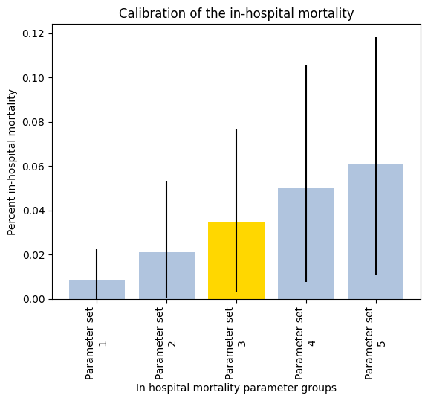

Figure 8: Calibration of in-hospital mortality to the results of Tyson et al. (2015) by scaling the results of Kuwabara et al. (2010) using Azure batch computing.

## Calibrating the incidence of road traffic injuries

The overall level in which road traffic injury occurs in the population is determined by a base rate of injury, from this base rate of injury people are then determined to be more or less likely to be involved in a collision based on lifestyle choices and demographic factors. We calibrated the level of injury in the model population to be equivalent to the GBD’s average estimated incidence of RTI per 100,000 person years from 2010 to 2019. We chose this calibration target as this is one of the few estimates of the occurrence of RTIs in Malawi and other models in the TLO project use the GBD estimates for guidance.

The calibration process was performed as follows. We conducted an initial search for values of the parameter ‘base_rate_injrti’ which produced an average incidence of RTI within the upper and lower bounds of the GBD estimates. From this point we used Azure batch computing to run the model multiple times for differing parameter values of ‘base_rate_injrti’, and therefore established a parameter space for ‘base_rate_injrti’ as shown in

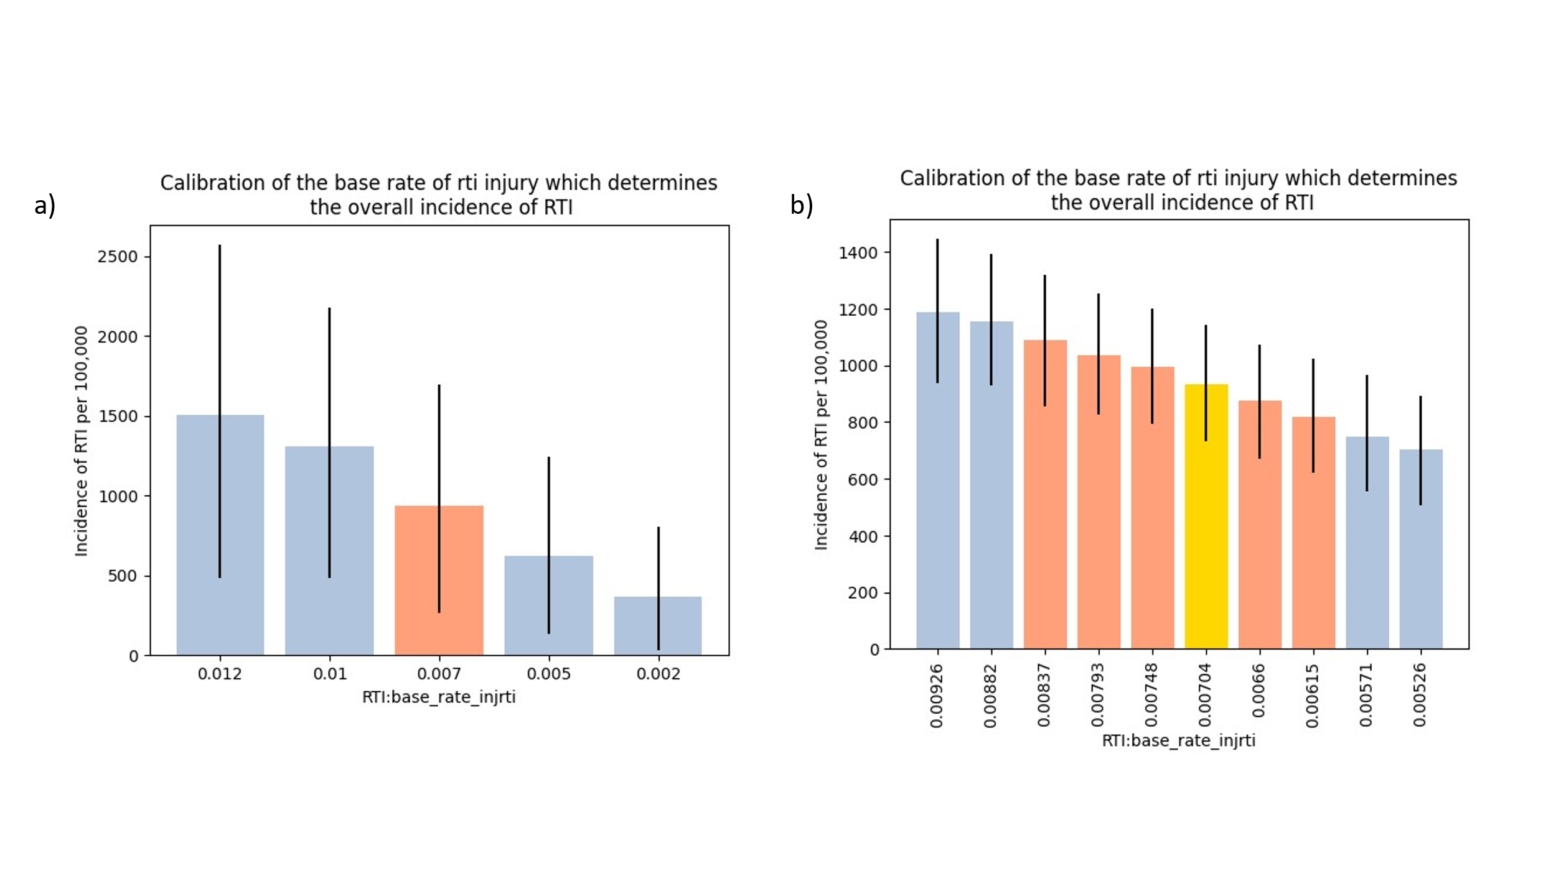

Figure 9: The calibration method used for 'base_rate_injrti'. Panel a shows the initial search where an appropriate parameter value for our model was found, panel b shows the established parameter space for the base rate of injury which produces results with the bounds determined by the GBD study, the best fitting parameter value for ‘base_rate_injrti’ in our search is shown in the gold bar.

## Calibrating health seeking behaviour

Health seeking behaviour is determined by the symptom assigned to an injured person. If the person has the generic injury symptom assigned to them then their decision to seek healthcare or not will be determined by the health seeking behaviour module. If they have the severe injury symptom assigned to them then they will always seek healthcare. We need to determine at what level of injury severity we should assign the severe injury symptom to injured persons. This level is controlled by the parameter ‘rt_emergency_care_ISS_score_cut_off’, injured persons with an ISS score above this parameter will have the severe injury symptom assigned to them. Our aim here is to produce a percentage of injured persons seeking healthcare within the bounds reported by Zafar et al. (2018), a study which investigated health seeking behaviour due to RTIs in a number of Sub-Saharan Africa countries. The lowest percentage of HSB reported in the study was in Rwanda, at 65.33%; the highest was found in Uganda at 85%. To find this value we used Azure batch computing to run the model multiple times with varying values of ‘rt_emergency_care_ISS_score_cut_off’, recording the percentage of health seeking behaviour recorded in the model. We initially searched over a wide parameter space as shown in Figure 7. We then reduced the parameter space searched to find more potential parameter values, hence establishing our parameter space for ‘rt_emergency_care_ISS_score_cut_off’ as being between 3 and 9.

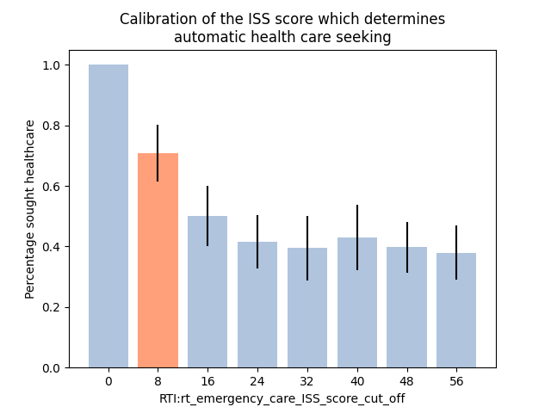

Figure 10: Calibrating health seeking behaviour. We ran the model multiple times for varying values of rt_emergency_care_ISS_score_cut_off and calculated the mean overall percentage of health seeking behaviour reported in the model. In this initial search only one parameter value fell into the percentage of health seeking behaviour reported in Zafar et al. (2018), rt_emergency_care_ISS_score_cut_off = 8, denoted with the orange bar.

# Model outputs

|  |  |  |  |
| --- | --- | --- | --- |
| Metric | Model | Data | Source (Figure) |
| **Number of RTIs and number of deaths produced by model** | | | |
| Number of deaths in 2010 | Just over 2000 | Just over 2000 | GBD data (Figure 6) |
| Incidence of road traffic injuries | 15.98 | Lower: 5.1 per 100,000 person years  Middle: 20 per 100,00 person years  Upper: 35 per 100,000 person years | (Samuel et al. 2012)  (Samuel et al. 2012)  The WHO  (Figure 7) |
| In-hospital mortality | 3% | 4% | (Tyson et al. 2015)  (Figure 8) |
| **Demographics of those involved in road traffic accidents** | | | |
| Gender ratio | M:F 62:38 | M:F 59:41 | GBD data from all years  (Figure 9) |
| Age demographics | See Figure 10 | See Figure 11 | Age demographics of those with a road traffic injury in the model resembles that of the GBD 2017 age demographic data for road traffic injury |
| Alcohol | 29% of those injured had li_ex_alc | 24.9% | (Sundet et al. 2020)  (Figure 12) |
| **Injuries produced by the model** | | | |
| The incidence of the injuries by type | See Figure 13 | See Figure 13 | The type of injury category produced by the model was fit to the GBD 2017 data, so a close match was expected to be seen.  (Figure 13) |
| The severity distribution of injuries produced by the model | 76% mild, 24% severe | 70.9% mild, 29.1% severe  93% mild, 6% severe  60% mild, 40% severe | (Zimmerman et al. 2012) (Tanzania)  (Sango et al. 2016) (Mali)  (Juillard et al. 2015)  (Cameroon)  (Figure 14) |
| The per-injury fatality ratio | 0.013 | 0.014 | GBD data (Figure 15) |
| **Health seeking behaviour produced by the model** | | | |
| The percentage of those injured who sought care | 70.8% sought care | 65.52% (Rwanda)  85% (Uganda) | (Zafar et al. 2018)  (Figure 16) |

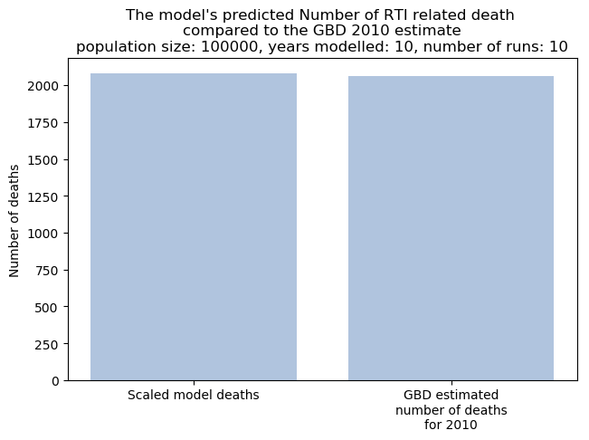

Figure 11: Deaths from road traffic injuries produced by the model and scaled by population size compared to the GBD 2010 number of deaths estimates

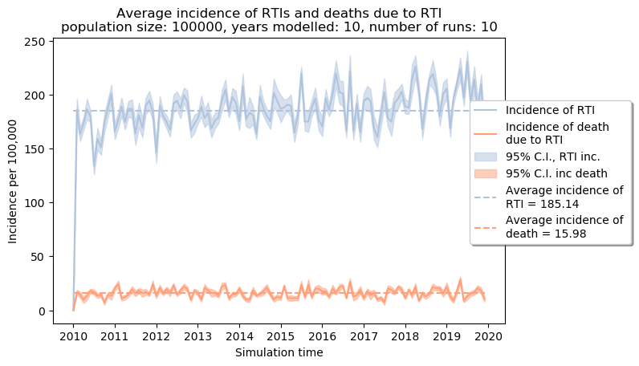

Figure 12: Incidence of road traffic injuries and incidence of death due to RTI.

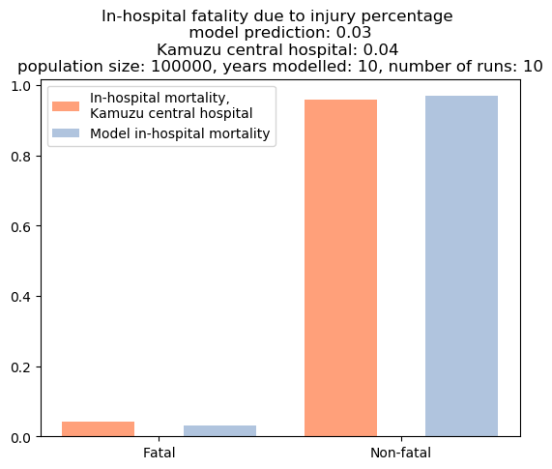

Figure 13: In-hospital mortality produced by the model compared to in-hospital mortality in Kamuzu central hospital.

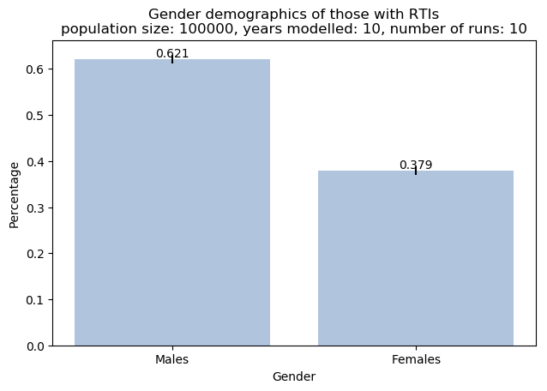

Figure 14: Gender demographics of those involved in a road traffic injury.

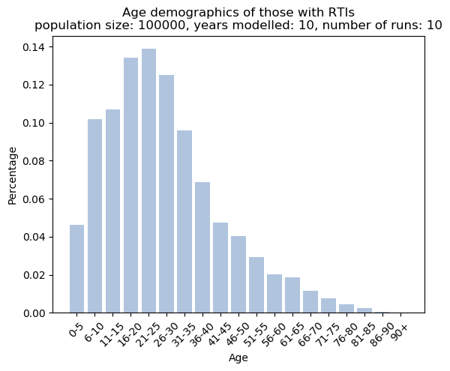

Figure 15: Breakdown of those with road traffic injuries by age in the model.

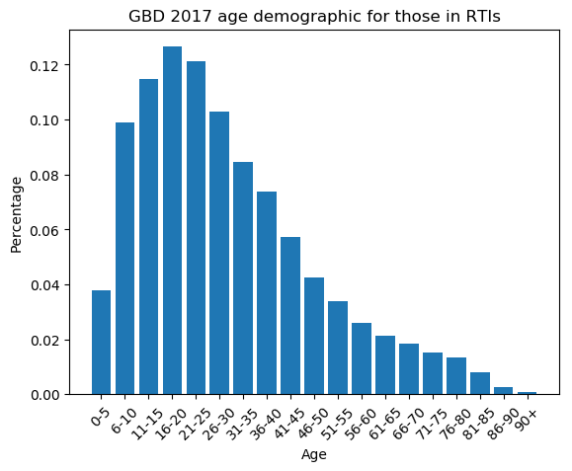

Figure 16: GBD 2017 age demographic data of those with road traffic injuries

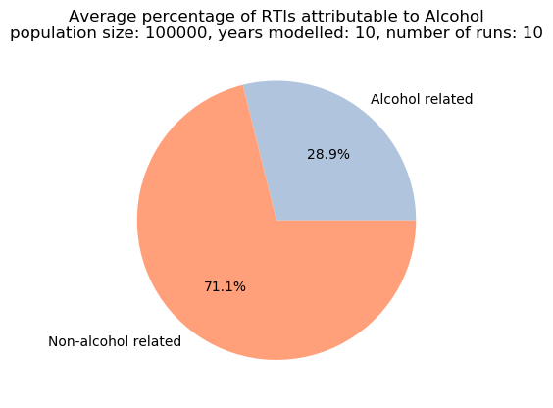

Figure 17: The model's predicted percentage of those with road traffic injuries who consume excessive alcohol.

.

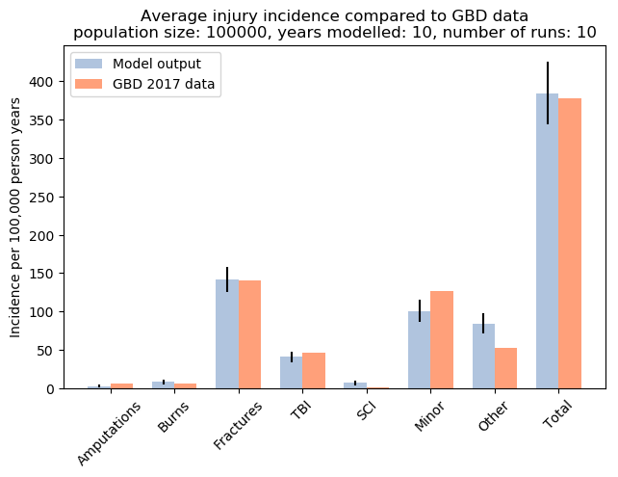

Figure 18: The incidence of injuries produced by the model by category

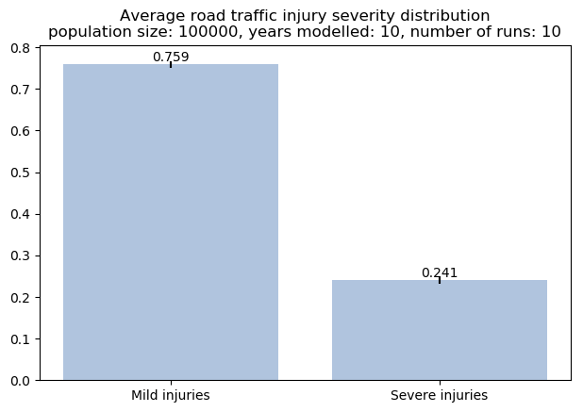

Figure 19: The severity categories of injuries produced by the model.

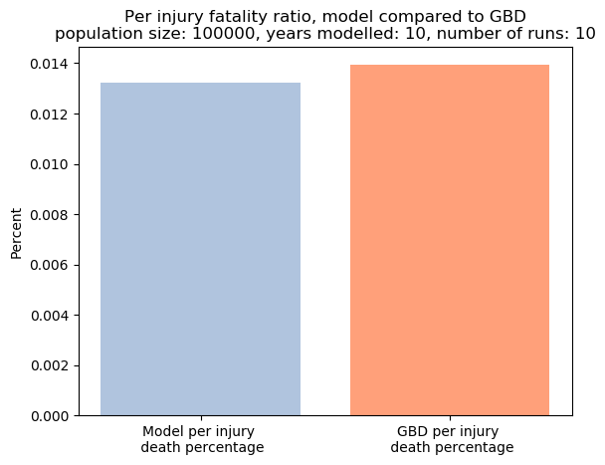

Figure 20: Per-injury fatality ratio compared to GBD data

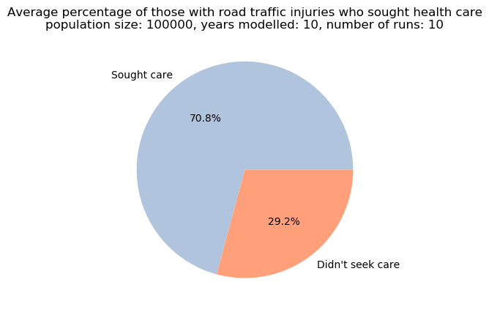

Figure 21: Health seeking behaviour in the model

# Things to include in the next iteration of the model

* Open fractures in other parts of the body – in the current iteration of the model open fractures only occur in the lower extremities. I haven’t yet found information on open fractures in other parts of the body, when found these should be incorporated as the epidemiology and treatment of open fractures is different
* Find a way of predicting the occurrence of shock in RTI patients that fits in with the current RTI framework. This will require consultation with someone with a medical background
* Possibly include a model of daily alcohol consumption rather than rely on li_ex_alc to make alcohol based predictions
* Try and include links between road safety measures and other aspects of RTI epidemiology, e.g. injury severity.

# References

Agnihotri, A K, and H S Joshi. 2006. “Pattern of Road Traffic Injuries: One Year Hospital-Based Study in Western Nepal.” *International Journal of Injury Control and Safety Promotion* 13 (2): 128–30. https://doi.org/10.1080/17457300500310236.

Akinpelu, O.V., O.A., Oladele, Y.B. Amusa, O.K. Ogundipe, A.A. Adeolu, and E.O. Komolafe. 2007. “Review of Road Traffic Accident Admissions in a Nigerian Tertiary Hospital.” *Review of Road Traffic Accident Admissions in a Nigerian Tertiary Hospital* 12 (1): 63–67. https://www.ajol.info/index.php/ecajs/article/view/136897.

Bach, O. 2004. “Musculo Skeletal Trauma in an East African Public Hospital.” *Injury* 35 (4): 401–6. https://doi.org/10.1016/S0020-1383(03)00290-0.

Baker, S. P., B. O’Neill, W. Haddon, and W. B. Long. 1974. “The Injury Severity Score: A Method for Describing Patients with Multiple Injuries and Evaluating Emergency Care.” *Journal of Trauma* 14 (3): 187–96. https://doi.org/10.1097/00005373-197403000-00001.

Biluts, Hagos, Mersha Abebe, Tsegazeab Laeke, Abenezer Tirsit, and Addisalem Belete. 2015. “PATTERN OF SPINE AND SPINAL CORD INJURIES IN TIKUR ANBESSA HOSPITAL, ETHIOPIA.” *Ethiopian Medical Journal* 53 (2): 75–82. http://www.ncbi.nlm.nih.gov/pubmed/26591295.

Boniface, Respicious, Lawrence Museru, Othman Kiloloma, and Victoria Munthali. 2016. “Factors Associated with Road Traffic Injuries in Tanzania.” *Pan African Medical Journal* 23. https://doi.org/10.11604/pamj.2016.23.46.7487.

Carroll, Christopher P, Joseph A Cochran, Janet P Price, Clare E Guse, and Marjorie C Wang. 2010. “The AIS-2005 Revision in Severe Traumatic Brain Injury: Mission Accomplished or Problems for Future Research?” In *Annals of Advances in Automotive Medicine - 54th Annual Scientific Conference*, 233–38.

Chagomerana, Maganizo B., Jared Tomlinson, Sven Young, Mina C. Hosseinipour, Leonard Banza, and Clara N. Lee. 2017. “High Morbidity and Mortality after Lower Extremity Injuries in Malawi: A Prospective Cohort Study of 905 Patients.” *International Journal of Surgery* 39 (March): 23–29. https://doi.org/10.1016/j.ijsu.2017.01.047.

Champion, Howard R., John B. Holcomb, Mary M. Lawnick, Timothy Kelliher, Mary Ann Spott, Michael R. Galarneau, Donald H. Jenkins, et al. 2010. “Improved Characterization of Combat Injury.” *The Journal of Trauma: Injury, Infection, and Critical Care* 68 (5): 1139–50. https://doi.org/10.1097/TA.0b013e3181d86a0d.

Clausen, Thomas, Ingeborg Rossow, Nirmala Naidoo, and Paul Kowal. 2009. “Diverse Alcohol Drinking Patterns in 20 African Countries.” *Addiction*. https://doi.org/10.1111/j.1360-0443.2009.02559.x.

Court-Brown, Charles M., Kate E. Bugler, Nicholas D. Clement, Andrew D. Duckworth, and Margaret M. McQueen. 2012. “The Epidemiology of Open Fractures in Adults. A 15-Year Review.” *Injury*. https://doi.org/10.1016/j.injury.2011.12.007.

Eaton, Jessica, Asma Bilal Hanif, Joanna Grudziak, and Anthony Charles. 2017. “Epidemiology, Management, and Functional Outcomes of Traumatic Brain Injury in Sub-Saharan Africa.” *World Neurosurgery* 108 (December): 650–55. https://doi.org/10.1016/j.wneu.2017.09.084.

Eaton, Jessica, Cornelius Mukuzunga, Joanna Grudziak, and Anthony Charles. 2019. “Characteristics and Outcomes of Traumatic Spinal Cord Injury in a Low-Resource Setting.” *Tropical Doctor* 49 (1): 62–64. https://doi.org/10.1177/0049475518808969.

Gabbe, Belinda J., Pam M. Simpson, Ronan A. Lyons, Shanthi Ameratunga, James E. Harrison, Sarah Derrett, Suzanne Polinder, Gabrielle Davie, and Frederick P. Rivara. 2014. “Association between the Number of Injuries Sustained and 12-Month Disability Outcomes: Evidence from the Injury-VIBES Study.” Edited by Hemachandra Reddy. *PLoS ONE* 9 (12): e113467. https://doi.org/10.1371/journal.pone.0113467.

Gabbe, Belinda J, Ronan A Lyons, Pamela M Simpson, Frederick P Rivara, Shanthi Ameratunga, Suzanne Polinder, Sarah Derrett, and James E Harrison. 2016. “Disability Weights Based on Patient-Reported Data from a Multinational Injury Cohort.” *Bull World Health Organ*. https://doi.org/10.2471/BLT.16.172155.

Ganveer, Gunjan B, and Rajnarayan R Tiwari. 2005. “Injury Pattern among Non-Fatal Road Traffic Accident Cases: A Cross-Sectional Study in Central India.” *Article in Indian Journal of Medical Sciences* 59 (1). https://doi.org/10.4103/0019-5359.13812.

Gathecha, Gladwell Koku, Christine Ngaruiya, Wilfred Mwai, Ann Kendagor, Scholastica Owondo, Loise Nyanjau, Duncan Kibogong, Wilson Odero, and Joseph Kibachio. 2018. “Prevalence and Predictors of Injuries in Kenya: Findings from the National STEPs Survey 11 Medical and Health Sciences 1117 Public Health and Health Services.” *BMC Public Health* 18 (S3). https://doi.org/10.1186/s12889-018-6061-x.

Gennarelli, Thomas A., and Elaine Wodzin. 2006. “AIS 2005: A Contemporary Injury Scale.” *Injury* 37 (12): 1083–91. https://doi.org/10.1016/j.injury.2006.07.009.

Global Health Data. 2017. “GBD Results Tool | GHDx.” *Institue for Health Metrics and Evaluation*.

Grudziak, Joanna, Cornelius Mukuzunga, Caroline Melhado, Sven Young, Leonard Banza, Bruce Cairns, and Anthony Charles. 2019. “Etiology of Major Limb Amputations at a Tertiary Care Centre in Malawi.” *Malawi Medical Journal* 31 (4): 244–48. https://doi.org/10.4314/mmj.v31i4.5.

Hassan, Saidi. 2016. “Major Injury Cases in Nairobi: Characterization of Contexts, Outcomes and Injury Documentation.” University of Nairobi.

Hoving, D. J. van, H. J. Lategan, L. A. Wallis, and W. P. Smith. 2015. “The Epidemiology of Major Incidents in the Western Cape Province, South Africa.” *South African Medical Journal* 105 (10): 831–34. https://doi.org/10.7196/SAMJnew.7766.

Ibrahim, Nasiru A., Abdul Wahab O. Ajani, Ibrahim A. Mustafa, Rufai A. Balogun, Mobolaji A. Oludara, Olufemi E. Idowu, and Babatunde A. Solagberu. 2017. “Road Traffic Injury in Lagos, Nigeria: Assessing Prehospital Care.” *Prehospital and Disaster Medicine*. https://doi.org/10.1017/S1049023X17006410.

Juillard, Catherine J., Kent A. Stevens, Martin Ekeke Monono, Georges Alain Etoundi Mballa, Marquise Kouo Ngamby, Jolion McGreevy, Gill Cryer, and Adnan A. Hyder. 2015. “Analysis of Prospective Trauma Registry Data in Francophone Africa: A Pilot Study from Cameroon.” *World Journal of Surgery* 38 (10): 2534–42. https://doi.org/10.1007/s00268-014-2604-1.

Kasantikul, Vira, James V. Ouellet, and T. A. Smith. 2003. “Head and Neck Injuries in Fatal Motorcycle Collisions as Determined by Detailed Autopsy.” *Traffic Injury Prevention* 4 (3): 255–62. https://doi.org/10.1080/15389580309878.

Khan, Mahmud, Şahin Kavuncubaşı, Adnan Kısa, Nermin Özgülbaş, Simten Malhan, Ergün Öksüz, Beyhan Aksoy, and Cenk Sözen. 2004. “Cost Effectiveness Final Report.” Ankara.

Kuwabara, Kazuaki, Shinya Matsuda, Yuichi Imanaka, Kiyohide Fushimi, Hideki Hashimoto, Koichi B. Ishikawa, Hiromasa Horiguchi, et al. 2010. “Injury Severity Score, Resource Use, and Outcome for Trauma Patients within a Japanese Administrative Database.” *Journal of Trauma - Injury, Infection and Critical Care* 68 (2): 463–70. https://doi.org/10.1097/TA.0b013e3181a60275.

Lavy, Chris, Alistair Tindall, Colin Steinlechner, Nyengo Mkandawire, and Sandy Chimangeni. 2007. “Surgery in Malawi - A National Survey of Activity in Rural and Urban Hospitals.” *Annals of the Royal College of Surgeons of England* 89 (7): 722–24. https://doi.org/10.1308/003588407X209329.

Lee, Jung Soo, Yeo Hyung Kim, Jae Sung Yun, Sang Eun Jung, Choong Sik Chae, and Min Jae Chung. 2016. “Characteristics of Patients Injured in Road Traffic Accidents According to the New Injury Severity Score.” *Annals of Rehabilitation Medicine* 40 (2): 288–93. https://doi.org/10.5535/arm.2016.40.2.288.

Madubueze, Christian C., Christian O. Onyebuchi Chukwu, Njoku I. Omoke, Odion P. Oyakhilome, and Chidi Ozo. 2010. “Road Traffic Injuries as Seen in a Nigerian Teaching Hospital.” *International Orthopaedics 2010 35:5* 35 (5): 743–46. https://doi.org/10.1007/S00264-010-1080-Y.

Malm, Sigrun, Maria Krafft, Anders Kullgren, Anders Ydenius, and Claes Tingvall. 2008. “Risk of Permanent Medical Impairment (RPMI) in Road Traffic Accidents.” In *Annals of Advances in Automotive Medicine - 52nd Annual Scientific Conference*, 52:93–100.

Mkandawire, Nyengo, Christopher Ngulube, and Christopher Lavy. 2008. “Orthopaedic Clinical Officer Program in Malawi: A Model for Providing Orthopaedic Care.” In *Clinical Orthopaedics and Related Research*, 466:2385–91. https://doi.org/10.1007/s11999-008-0366-5.

Mulima, Gift, Laura N. Purcell, Rebecca Maine, Erica C. Bjornstad, and Anthony Charles. 2021. “Epidemiology of Prehospital Trauma Deaths in Malawi: A Retrospective Cohort Study.” *African Journal of Emergency Medicine* 11 (2): 258–62. https://doi.org/10.1016/j.afjem.2021.03.011.

Ngaroua, D, NM Neossi, Jérémie Mbo Amvene, A Chichom Mefire, and NJ Eloundou. 2014. “Epidemiology and Pattern of Road Traffic Injuries in Ngaoundéré , Cameroon : A Retrospective Hospital Based Study Prior to the Implementation of a Formal Trauma Registry.” *The Journal of Medicine and Health Sciences* 15 (June): 1–8.

Nthumba, Peter. M. 2016. “Burns in Sub-Saharan Africa: A Review.” *Burns* 42 (2): 258–66. https://doi.org/10.1016/j.burns.2015.04.006.

Nwosu, C, M O Babalola, M H Ibrahim, and S I Suleiman. 2017. “Major Limb Amputations in a Tertiary Hospital in North Western Nigeria.” *Afri Health Sci* 17 (2): 508. https://doi.org/10.4314/ahs.v17i2.26.

Odero, Wilson, Meleckidzedeck Khayesi, and P. M. Heda. 2003. “Road Traffic Injuries in Kenya: Magnitude, Causes and Status of Intervention.” *Injury Control and Safety Promotion*. https://doi.org/10.1076/icsp.10.1.53.14103.

Okugbo, Su, E Okoro, and Pe Irhibogbe. 2012. “Chest Trauma in a Regional Trauma Centre.” *Journal of the West African College of Surgeons* 2 (2): 91–101. http://www.ncbi.nlm.nih.gov/pubmed/25452986.

Otieno, Tobias, John C. Woodfield, Peter Bird, and Andrew G. Hill. 2004. “Trauma in Rural Kenya.” *Injury* 35 (12): 1228–33. https://doi.org/10.1016/j.injury.2004.03.013.

Parkinson, F., S. Kent, C. Aldous, G. Oosthuizen, and D. Clarke. 2013. “Road Traffic Crashes in South Africa: The Burden of Injury to a Regional Trauma Centre.” *South African Medical Journal* 103 (11): 850–52. https://doi.org/10.7196/SAMJ.6914.

Purcell, Laura N., Gift Mulima, Emily Nip, Avital Yohan, Jared Gallaher, and Anthony Charles. 2021. “Police Transportation Following Vehicular Trauma and Risk of Mortality in a Resource-Limited Setting.” *World Journal of Surgery*. https://doi.org/10.1007/s00268-020-05853-z.

Ranti, Babalola O, Yakub Saheed, Olakulehin O Adebayo, and Oluwadiya Kehinde. 2015. “Injury Pattern among Patients with Road Traffic Crash Presenting At a Tertiary Health Facility.” *IOSR Journal of Dental and Medical Sciences (IOSR-JDMS) e-ISSN* 14 (5): 71–75. https://doi.org/10.9790/0853-14537175.

Reid, T D, P. D. Strassle, J. Gallaher, J. Grudziak, C. Mabedi, and A. G. Charles. 2018. “Anatomic Location and Mechanism of Injury Correlating with Prehospital Deaths in Sub-Saharan Africa.” *World Journal of Surgery* 42 (9): 2738–44. https://doi.org/10.1007/s00268-018-4577-y.

Romão, Francelina, Hanifa Nizamo, Domingos Mapasse, Momede Mussá Rafico, João José, Simão Mataruca, M. Lúcia Efron, Lucas O Omondi, Thelma Leifert, and Joaquim M.L.Marungo Bicho. 2003. “Road Traffic Injuries in Mozambique.” *Injury Control and Safety Promotion* 10 (1–2): 63–67. https://doi.org/10.1076/icsp.10.1.63.14112.

Ruhinda, G., P. Kyamanywa, D. Kitya, and F. Bajunirwe. 2008. “Abdominal Injury at Mbarara Regional Referral Hospital, Uganda.” *East and Central African Journal of Surgery* 13 (2): 29–36. https://www.ajol.info/index.php/ecajs/article/view/136648.

Saidi, Hassan, Ben Kasyoka Mutiso, and Julius Ogengo. 2014. “Mortality after Road Traffic Crashes in a System with Limited Trauma Data Capability.” https://doi.org/10.1186/1752-2897-8-4.

Samuel, Jonathan C., Edward Sankhulani, Javeria S. Qureshi, Paul Baloyi, Charles Thupi, Clara N. Lee, William C. Miller, Bruce A. Cairns, and Anthony G. Charles. 2012. “Under-Reporting of Road Traffic Mortality in Developing Countries: Application of a Capture-Recapture Statistical Model to Refine Mortality Estimates.” Edited by Vittoria Colizza. *Plos One* 7 (2): e31091. https://doi.org/10.1371/journal.pone.0031091.

Sango, Hammadoum A, Jean Testa, Nicolas Meda, Benjamin Contrand, Mamadou S. Traore, Pascal Staccini, and Emmanuel Lagarde. 2016. “Mortality and Morbidity of Urban Road Traffic Crashes in Africa: Capture-Recapture Estimates in Bamako, Mali, 2012.” *PLoS ONE* 11 (2). https://doi.org/10.1371/journal.pone.0149070.

Sanyang, Edrisa, Corinne Peek-Asa, Paul Bass, Tracy L. Young, Babanding Daffeh, and Laurence J. Fuortes. 2017. “Risk Factors for Road Traffic Injuries among Different Road Users in the Gambia.” *Journal of Environmental and Public Health* 2017. https://doi.org/10.1155/2017/8612953.

Schade, Alexander Thomas, Master Yesaya, Jeremy Bates, Claude Martin, and William James Harrison. 2020. “The Malawi Orthopaedic Association/Ao Alliance Guidelines and Standards for Open Fracture Management in Malawi: A National Consensus Statement.” *Malawi Medical Journal* 32 (3): 112–19. https://doi.org/10.4314/mmj.v32i3.2.

Schlottmann, Francisco, Anna F. Tyson, Bruce A. Cairns, Carlos Varela, and Anthony G. Charles. 2017. “Road Traffic Collisions in Malawi: Trends and Patterns of Mortality on Scene.” *Malawi Medical Journal* 29 (4): 301–5. https://doi.org/10.4314/mmj.v29i4.4.

Staton, Catherine A., Joao Ricardo Nickenig Vissoci, Nicole Toomey, Jihad Abdelgadir, Patricia Chou, Michael Haglund, Blandina T. Mmbaga, Mark Mvungi, and Monica Swahn. 2018. “The Impact of Alcohol among Injury Patients in Moshi, Tanzania: A Nested Case-Crossover Study.” *BMC Public Health* 18 (1). https://doi.org/10.1186/s12889-018-5144-z.

Stephan, Katharina, Stephan Huber, Sandra Häberle, Karl Georg Kanz, Volker Bühren, Martijn Van Griensven, Bernhard Meyer, Peter Biberthaler, Rolf Lefering, and Stefan Huber-Wagner. 2015. “Spinal Cord Injury - Incidence, Prognosis, and Outcome: An Analysis of the TraumaRegister DGU.” *Spine Journal* 15 (9): 1994–2001. https://doi.org/10.1016/j.spinee.2015.04.041.

Sundet, Mads, Joanna Grudziak, Anthony Charles, Leonard Banza, Carlos Varela, and Sven Young. 2018. “Paediatric Road Traffic Injuries in Lilongwe, Malawi: An Analysis of 4776 Consecutive Cases.” *Tropical Doctor* 48 (4): 316–22. https://doi.org/10.1177/0049475518790893.

Sundet, Mads, Chifundo Kajombo, Gift Mulima, Stig Tore Bogstrand, Carlos Varela, Sven Young, Asbjørg S. Christophersen, and Hallvard Gjerde. 2020. “Prevalence of Alcohol Use among Road Traffic Crash Victims Presenting to a Malawian Central Hospital: A Cross-Sectional Study.” *Traffic Injury Prevention*. https://doi.org/10.1080/15389588.2020.1819990.

Thanni, L. O.A., and O. A. Kehinde. 2006. “Trauma at a Nigerian Teaching Hospital: Pattern and Documentation of Presentation.” *African Health Sciences* 6 (2): 104–7. https://doi.org/10.5555/afhs.2006.6.2.104.

Tian, Hao, Liangxi Wang, Weiguo Xie, Chuanan Shen, Guanghua Guo, Jiaqi Liu, Chunmao Han, et al. 2018. “Epidemiologic and Clinical Characteristics of Severe Burn Patients: Results of a Retrospective Multicenter Study in China, 2011–2015.” *Burns & Trauma* 6: 2011–15. https://doi.org/10.1186/s41038-018-0118-z.

Tyson, Anna F., Carlos Varela, Bruce A. Cairns, and Anthony G. Charles. 2015. “Hospital Mortality Following Trauma: An Analysis of a Hospital-Based Injury Surveillance Registry in Sub-Saharan Africa.” *Journal of Surgical Education* 72 (4): e66–72. https://doi.org/10.1016/j.jsurg.2014.09.010.

Wong, Abby, Meghan Prin, Laura N. Purcell, Clement Kadyaudzu, and Anthony Charles. 2020. “Intensive Care Unit Bed Utilization and Head Injury Burden in a Resource-Poor Setting.” *American Surgeon*. https://doi.org/10.1177/0003134820950282.

Zafar, Syed Nabeel, Joseph K. Canner, Neeraja Nagarajan, Adam L. Kushner, Shailvi Gupta, Tu M. Tran, Neeraja Nagarajan, et al. 2018. “Road Traffic Injuries: Cross-Sectional Cluster Randomized Countrywide Population Data from 4 Low-Income Countries.” *International Journal of Surgery* 52 (April): 237–42. https://doi.org/10.1016/j.ijsu.2018.02.034.

Zimmerman, Karen, Ali A. Mzige, Pascience L. Kibatala, Lawrence M. Museru, and Alejandro Guerrero. 2012. “Road Traffic Injury Incidence and Crash Characteristics in Dar Es Salaam: A Population Based Study.” *Accident Analysis and Prevention* 45 (March): 204–10. https://doi.org/10.1016/j.aap.2011.06.018.

# Appendix

## Codes, their associated injury and their treatment

|  |  |  |  |
| --- | --- | --- | --- |
| Code | Injury | Treatment | Estimated recovery time |
| '112' | ‘Unspecified’ skull fracture | Either heal with time or RTI_Major_Surgery | 7 weeks |
| '113' | Basilar skull fracture | Heal with time | 7 weeks |
| '133a' | Subarachnoid hematoma | Either heal with time or RTI_Major_Surgery | 6 months |
| 'P133a' | Subarachnoid hematoma (Permanent) | N/A | Never |
| '133b' | Brain contusion | Either heal with time or RTI_Major_Surgery | 6 months |
| 'P133b' | Brain contusion (Permanent) | N/A | Never |
| '133c' | Intraventricular haemorrhage | Either heal with time or RTI_Major_Surgery | 6 months |
| 'P133c' | Intraventricular haemorrhage (Permanent) | N/A | Never |
| '133d' | Subgaleal hematoma | Either heal with time or RTI_Major_Surgery | 6 months |
| 'P133d' | Subgaleal hematoma (Permanent) | N/A | Never |
| '134a' | Epidural hematoma | Either heal with time or RTI_Major_Surgery | 6 months |
| 'P134a' | Epidural hematoma (Permanent) | N/A | Never |
| '134b' | Subdural hematoma | Either heal with time or RTI_Major_Surgery | 6 months |
| 'P134b' | Subdural hematoma (Permanent) | N/A | Never |
| '135' | Diffuse axonal injury/midline shift | Either heal with time or RTI_Major_Surgery | 6 months |
| 'P135' | Diffuse axonal injury/midline shift (Permanent) | N/A | Never |
| '1101' | Laceration to the head | RTI_Suture | 2 weeks |
| '1114' | Burn to the head | RTI_Burn_Management | 4 weeks |
| '211' | Facial fracture (nasal/unspecified) | RTI_Minor_Surgery | 7 weeks with surgery |
| '212' | Facial fracture (mandible/zygomatic) | RTI_Minor_Surgery | 7 weeks with surgery |
| '241' | Soft tissue injury to face | RTI_Minor_Surgery | 1 month |
| '2101' | Laceration to the face | RTI_Suture | 2 weeks |
| '2114' | Burn to the face | RTI_Burn_Management | 4 weeks |
| '291' | Eye injury | RTI_Minor_Surgery | 7 weeks |
| '342' | Soft tissue injury in neck (vertebral artery laceration) | RTI_Major_Surgery | 6 weeks |
| '343' | Soft tissue injury in neck (pharynx contusion) | RTI_Major_Surgery | 6 weeks |
| '361' | Sternomastoid m. hemorrhage/ Hemorrhage, supraclavicular triangle/  Hemorrhage, posterior triangle/  Anterior vertebral vessel hemorrhage/ Neck muscle hemorrhage | RTI_Major_Surgery | 1 week |
| '363' | Hematoma in carotid sheath/  Carotid sheath hemorrhage | RTI_Major_Surgery | 1 week |
| '322' | Atlanto-occipital subluxation | Heal with time or RTI_Minor_Surgery | 6 months if surgery required, 7 weeks otherwise |
| '323' | Atlanto-axial subluxation | Heal with time or RTI_Minor_Surgery | 6 months if surgery required, 7 weeks otherwise |
| '3101' | Laceration to the neck | RTI_Suture | 2 weeks |
| '3113' | Burn to the neck | RTI_Burn_Management | 4 weeks |
| '412' | Fractured rib(s) | Heal with time | 5 weeks |
| '414' | Flail chest | RTI_Major_Surgery | 1 year |
| '461' | Chest wall bruises/haematoma | Heal with time | 1 week |
| '463' | Haemothorax | RTI_Major_Surgery | 1 week |
| '453a' | Lung contusion | RTI_Major_Surgery | 6 weeks |
| '453b' | Diaphragm rupture | RTI_Major_Surgery | 6 weeks |
| '441' | Chest wall lacerations/avulsions | RTI_Major_Surgery | 2 weeks |
| '442' | Surgical emphysema | Heal with time | 2 weeks |
| '443' | Closed pneumothorax/ open pneumothorax | RTI_Major_Surgery | 2 weeks |
| '4101' | Laceration to the thorax | RTI_Suture | 2 weeks |
| '4113' | Burn to the thorax | RTI_Burn_Management | 4 weeks |
| '552' | Injury to stomach/  intestines/  colon | Heal with time or RTI_Major_Surgery | 3 months |
| '553' | Injury to spleen/  Urinary bladder/  Liver/  Urethra/  Diaphragm | Heal with time or RTI_Major_Surgery | 3 months |
| '554' | Injury to kidney | Heal with time or RTI_Major_Surgery | 3 months |
| '5101' | Laceration to the abdomen | RTI_Suture | 2 weeks |
| '5113' | Burn to the abdomen | RTI_Burn_Management | 4 weeks |
| '612' | Fracture vertebrae | Heal with time | 9 weeks |
| '673a' | Spinal cord injury at neck level | RTI_Major_Surgery | Currently never |
| 'P673a' | Spinal cord injury at neck level (Permanent) | RTI_Major_Surgery | Never |
| '673b' | Spinal cord injury below neck level | RTI_Major_Surgery | Currently never |
| 'P673b' | Spinal cord injury below neck level (Permanent) | RTI_Major_Surgery | Never |
| '674a' | Spinal cord injury at neck level | RTI_Major_Surgery | Currently never |
| 'P674a' | Spinal cord injury at neck level (Permanent) | RTI_Major_Surgery | Never |
| '674b' | Spinal cord injury below neck level | RTI_Major_Surgery | Currently never |
| 'P674b' | Spinal cord injury below neck level (Permanent) | RTI_Major_Surgery | Never |
| '675a' | Spinal cord injury at neck level | RTI_Major_Surgery | Currently never |
| 'P675a' | Spinal cord injury at neck level (Permanent) | RTI_Major_Surgery | Never |
| '675b' | Spinal cord injury below neck level | RTI_Major_Surgery | Currently never |
| 'P675b' | Spinal cord injury below neck level (Permanent) | RTI_Major_Surgery | Never |
| '676' | Spinal cord injury at neck level | RTI_Major_Surgery | Currently never |
| 'P676' | Spinal cord injury at neck level (Permanent) | RTI_Major_Surgery | Never |
| '712a' | Fracture to Clavicle, scapula, humerus | RTI_Fracture_Cast | 10 weeks |
| '712b' | Fracture to Hand/wrist | RTI_Fracture_Cast | 10 weeks |
| '712c' | Fracture to Radius/ulna | RTI_Fracture_Cast | 10 weeks |
| '722' | Shoulder dislocation | Heal with time/ RTI_Minor_Surgery | 7 weeks with surgery or 12 weeks without |
| '782a' | Amputated finger | RTI_Major_Surgery | Never |
| 'P782a' | Amputated finger (Permanent) | N/A | Never |
| '782b' | Unilateral arm amputation | RTI_Major_Surgery | Never |
| 'P782b' | Unilateral arm amputation (Permanent) | RTI_Major_Surgery | Never |
| '782c' | Thumb amputation | RTI_Major_Surgery | Never |
| 'P782c' | Thumb amputation (Permanent) | RTI_Major_Surgery | Never |
| '783' | Bilateral arm amputation | RTI_Major_Surgery | Never |
| 'P783' | Bilateral arm amputation (Permanent) | RTI_Major_Surgery | Never |
| '7101' | Laceration to the upper extremity | RTI_Suture | 2 weeks |
| '7113' | Burn to the upper extremity | RTI_Burn_Management | 4 weeks |
| '811' | Foot fracture | RTI_Fracture_Cast,  RTI_Major_Surgeries,  RTI_Minor_Surgeries | 10 weeks |
| '812' | Fracture to patella, tibia, fibula, ankle | Heal with time (skeletal traction),  RTI_Fracture_Cast,  RTI_Major_Surgeries,  RTI_Minor_Surgeries | 10 weeks |
| '813a' | Hip fracture | Heal with time (skeletal traction),  RTI_Fracture_Cast,  RTI_Major_Surgeries,  RTI_Minor_Surgeries | 9 months |
| '813b' | Pelvis fracture | Heal with time (skeletal traction),  RTI_Fracture_Cast,  RTI_Major_Surgeries,  RTI_Minor_Surgeries | 10 weeks |
| '813c' | Femur fracture | Heal with time (skeletal traction),  RTI_Fracture_Cast,  RTI_Major_Surgeries,  RTI_Minor_Surgeries | 4 months |
| '822a' | Dislocated hip | RTI_Fracture_Cast,  RTI_Major_Surgeries | 7 weeks with surgery or 2 months without |
| '822b' | Dislocated Knee | Either heal with time or RTI_Fracture_Cast, | 7 weeks or 6 weeks without |
| '882' | Amputation of toes | RTI_Major_Surgeries | Never |
| 'P882' | Amputation of toes (permanent) | RTI_Major_Surgeries | Never |
| '883' | Unilateral leg amputation | RTI_Major_Surgeries | Never |
| 'P883' | Unilateral leg amputation (permanent) | RTI_Major_Surgeries | Never |
| '884' | Bilateral leg amputation | RTI_Major_Surgeries | Never |
| 'P884' | Bilateral leg amputation (permanent) | RTI_Major_Surgeries | Never |
| '8101' | Laceration to the lower extremity | RTI_Suture | 2 weeks |
| '8113' | Burn to the lower extremity | RTI_Burn_Management | 4 weeks |
| 813bo | Open fracture of the pelvis | HSI_RTI_Open_Fracture_Treatment | 7 months |
| 813co | Open fracture of the femur | HSI_RTI_Open_Fracture_Treatment | 7 months |
| 813do | Open fracture of the foot | HSI_RTI_Open_Fracture_Treatment | 7 months |
| 813eo | Open fracture of the tibia/fibula/ankle/patella | HSI_RTI_Open_Fracture_Treatment | 7 months |

Table 14: The injury codes used in the module, with the injury names associated with the code, the treatment plan and the estimated recovery time

## Laceration distribution calculations

|  |  |  |  |
| --- | --- | --- | --- |
| AIS body region | Percent of lacerations found in this body part | Percent of injuries in body region | Percent of injuries in this body region that are lacerations |
| Head | 14.1% | 14.38 | 25.4% |
| Face | 10% | 13.25 | 19.5% |
| Neck | 0.6% | 2.1 | 7.4% |
| Thorax | 17.9% | 9.45 | 49.1% |
| Abdomen | 2.6% | 6.12 | 11% |
| Spine | 0% | 1.55 | 0% |
| Upper extremity | 28.6% | 16.85 | 44% |
| Lower extremity | 26.2% | 36.3 | 18.7% |

The GBD study estimates 25.9% of all injuries are lacerations, here I use results from a Swedish study to parameterise where these injuries occur in the body (Malm et al. 2008). Of the 25.9% of lacerations that occur to people, 14.1% occur in the head region in the Malm et al. study. Head injuries contribute 14.1% of 25.9% to the total lacerations which is 3.6319%. Some percentage of the 14.38% of injuries that occur to the head will be assigned to lacerations, to work out the values for this we calculate the following:

Finally, we have the estimate that 25.4% of head injuries are lacerations.

Equivalent process for facial injuries:

10% of 25.9% is 2.59%

Equivalent process for neck injuries:

0.6% of 25.9% is 0.1554%

Equivalent process for thorax injuries:

17.9% of 25.9% is 4.6361%

Equivalent process for abdomen injuries:

2.6% of 25.9% is 0.6734%

Equivalent process for spine injuries:

0% of 25.9% is 0%

Equivalent process for upper extremity injuries:

28.6% of 25.9% is 7.4074%

Equivalent process for lower extremity injuries:

26.2% of 25.9% is 6.7858%

## Burn distribution calculations

|  |  |  |  |
| --- | --- | --- | --- |
| AIS body region | Percent of burns found in this body part | Percent of injuries in body region | Percent of injuries in this body region that are burns |
| Head | 7.3% | 14.38 | 1.02% |
| Face | 6.7% | 13.25 | 1.01% |
| Neck | 1% | 2.1 | 1% |
| Thorax | 20% | 9.45 | 4.2% |
| Abdomen | 12% | 6.12 | 3.9% |
| Spine | 0% | 1.55 | 0% |
| Upper extremity | 27% | 16.85 | 3.2% |
| Lower extremity | 26% | 36.3 | 1.43% |

The GBD study estimates 2% of all injuries are burns, here I use results from a Chinese study to parameterise where these injuries occur in the body (Tian et al. 2018)(Malm et al. 2008)(Malm et al. 2008)(Malm et al. 2008)(Malm et al. 2008)(Malm et al. 2008)(Malm et al. 2008)(Malm et al. 2008)(Malm et al. 2008)(Malm et al. 2008)(Malm et al. 2008)(Malm et al. 2008)(Malm et al. 2008)(Malm et al. 2008)(Malm et al. 2008)(Malm et al. 2008)(Malm et al. 2008)(Malm et al. 2008)(Malm et al. 2008)(Malm et al. 2008)(Malm et al. 2008)(Malm et al. 2008)(Malm et al. 2008)(Malm et al. 2008). Of the 2% of burns that occur to people, 7.3% occur in the head region in the Tian et al. study. Head injuries contribute 7.3% of 2% to the total burns which is 0.146%. Some percentage of the 14.38% of injuries that occur to the head will be assigned to lacerations, to work out the values for this we calculate the following:

Finally, we have the estimate that 1.02% of head injuries are burns.

Equivalent process for facial injuries:

6.7% of 2% is 0.134%

Equivalent process for neck injuries:

1% of 2% is 0.02%

Equivalent process for thorax injuries:

20% of 2% is 0.4%

Equivalent process for abdomen injuries:

12% of 2% is 0.24 %

Equivalent process for spine injuries:

0% of 2% is 0%

Equivalent process for upper extremity injuries:

27% of 2% is 0.54%

Equivalent process for lower extremity injuries:

26% of 2% is 0.52%

## Head injury specifics

|  |  |  |
| --- | --- | --- |
| Study (location) | **Broad injury category (%)**:  Specific injury category (%) | AIS score |
| (Eaton et al. 2017) (Malawi) | **Skin wounds: (18.5%)**  Open wounds (76%)  Burns (24%)  **Fracture: (19.5%)**  Unspecified fracture (91%)  Basilar skull fracture (9%)  **Traumatic brain injury (62%)**  Epidural hematoma (13%)  Subdural hematoma (12%)  Subarachnoid haemorrhage (13%)  Contusion (43%)  Intraventricular haemorrhage (2%)  Diffuse axonal injury (4%)  Subgaleal hematoma (7%)  Midline shift (6%) | 1  4  2  3  4  4  3  3  3  5  3  5 |
| (Hassan 2016) (Kenya) | **Fractures: (26%)**  (Unspecified)  **Traumatic brain injury (74%):**  Intracerebral/subarachnoid  Haemorrhage (15%)  Subdural hematoma (11%)  Brain contusions (8%)  Head injury not specified (52%)  extradural hematoma (15%) | 1-3  2  3  2  3 |

## Facial injury specifics

|  |  |  |
| --- | --- | --- |
| Study (location) | **Broad injury category (%)**:  Specific injury category (%) | AIS score |
| (Hassan 2016) (Kenya) | **Skin wounds (13%):**  Open wounds (81%)  Burns (19%)  **Fractures (40.9%):**  Mandible (54%)  Nasal (19%)  Zygomatic (11%)  Unspecified (16%)  **Soft tissue (45.7%):**  Soft tissue/ unspecified  **External organ injury (0.4%)**  Injury to eye | 1  4  2  1  2  1  1  1 |

## Neck injury specifics

|  |  |  |
| --- | --- | --- |
| Study (location) | **Broad injury category (%)**:  Specific injury category (%) | AIS score |
| (Kasantikul, Ouellet, and Smith 2003) (Thailand) | **Skin wounds (12%):**  Open wounds (66%)  Burns (33%)  **Soft tissue injury (0.9%):**  Vertebral artery laceration (50%)  Pharynx contusion (50%)  **Internal bleeding (86.2%):**  Sternomastoid m. hemorrhage (12%)  Hemorrhage, supraclavicular triangle (18%)  Hemorrhage, posterior triangle (18%)  Anterior vertebral vessel hemorrhage (3%)  Hematoma in carotid sheath (24%)  Carotid sheath hemorrhage (21%)  Neck muscle hemorrhage (2%)  **Dislocation (0.9%):**  Atlanto-axial subluxation (66.6%)  Atlanto-occipital subluxation (33.3%) | 1  3  2  3  1  1  1  1  3  3  1  3  2 |

## Thorax injury specifics

|  |  |  |
| --- | --- | --- |
| Study (location) | **Broad injury category (%)**:  Specific injury category (%) | AIS score |
| (Okugbo, Okoro, and Irhibogbe 2012) (Nigeria) | **Skin wounds (51%):**  Open wounds (51%)  Burns (49%)  **Internal bleeding (20%):**  Chest wall bruises/haematoma (50%)  Haemothorax (50%)  **Internal organ injury (7%):**  Lung contusion (77%)  Diaphragm rupture (23%)  **Fracture (5%):**  Fractured ribs (80%)  Flail chest (20%)  **Soft tissue injury (17%):**  Chest wall lacerations/avulsions (54%)  Closed pneumothorax (20%)  Open pneumothorax (14%)  Surgical emphysema (11%) | 1  4  1  3  3  3  2  4  1  3  3  ? say 2 |

## Abdominal injury specifics

|  |  |  |
| --- | --- | --- |
| Study (location) | **Broad injury category (%)**:  Specific injury category (%) | AIS score |
| (Ruhinda et al. 2008) (Uganda) | **Skin wounds (11%):**  Open wounds (55%)  Burns (45%)  **Internal organ injury (89%):**  Spleen (53.9%)  Urinary bladder (4.5%)  Intestines (3.4%)  Liver (7.9%)  Urethra (23.6%)  Stomach (1.1%)  Diaphragm (1.1%)  Colon (1.1%)  Kidney (3.4%) | 1  3  3  3  2  3  3  2  3  2  4 |

## Spinal injury specifics

|  |  |  |
| --- | --- | --- |
| Study (location) | **Broad injury category (%)**:  Specific injury category (%) | AIS score |
| (Biluts et al. 2015) (Ethiopia) | **Spinal cord injury (63.6%):**  Spinal cord lesion at neck level (42.1%)  Spinal cord lesion below neck level (57.9%)  **Fracture (36.4%):**  Vertebrae fracture | 3 (6%)  4 (28%)  5 (50%)  6 (16%)  3 (11%)  4 (31.5%)  5 (57.5%)  (Stephan et al. 2015)  2 |

## Upper extremity injury specifics

|  |  |  |
| --- | --- | --- |
| Study (location) | **Broad injury category (%)**:  Specific injury category (%) | AIS score |
| GBD and other studies (Grudziak et al. 2019; Nwosu et al. 2017)) | **Skin wounds (38%):**  Open wounds (63%)  Burns (37%)  **Fracture (94.3%)**  Clavicle, scapula, humerus (22%)  Hand/wrist (59%)  Radius/ulna (19%)  **Other Injury (0.3%)**  Dislocation of shoulder  **Amputation (5.4%)**  Bilateral upper arm (5%)  Fingers (63%)  Unilateral upper limb (8%)  Thumb (24%)  (Amputation percentage in original GBD data seems extraordinarily high, | 1  3  2  2  2  2  3  2  2  2 |

## Lower extremity injury specifics

|  |  |  |
| --- | --- | --- |
| Study (location) | **Broad injury category (%)**:  Specific injury category (%) | AIS score |
| Global burden of disease  Open fracture sources:  (Court-Brown et al. 2012; Chagomerana et al. 2017) | **Skin wounds (15%):**  Open wounds (66%)  Burns (33%)  **Fracture (70%)**  Foot except ankle (5%)   * Normal foot fracture (64%) * Open foot fracture (36%)   Hip (4%)  Patella, tibia, fibula, ankle (75%)   * Normal fracture (64%) * Open fracture (36%)   Pelvis (4%)   * Normal fracture (80%) * Open fracture (20%)   Femur other than femoral neck (12%)   * Normal fracture (86.7%) * Open fracture (13.3%)   **Other Injury (1.9%)**  Dislocation of hip (94%)  Dislocation of knee (6%)  **Amputation (14.1%)**  Bilateral lower limb (3.7%)  Unilateral lower limb (48.8%)  Toe/toes (47.5%) | 1  3  1  3  3  2  3  3  3  3  3  2  2  4  3  2 |