Schistosomiasis Module

Table of Contents

1. Summary 2

2. Structure of the Schistosomiasis modules 2

2.1. Modules attributes 3

3. Individual properties managed by Schistosomiasis module 3

4. Schistosomiasis Natural History 4

4.1. Age groups 5

4.2. Harbouring rates 5

4.3. Births 6

4.4. Mortality 6

4.5. Initial worm burden distribution 6

4.6. Infections intensities 7

4.7. Initial Symptoms assignment 7

4.8. New infections 8

4.9. Natural death of adult worms 10

5. Developing symptoms & seeking treatment 11

6. Mass-Drug Administration (MDA) 13

7. Treatment 14

8. DALYs calculation 14

9. Updating parameter value on selected date 15

10. Calibrating the parameters – S.haematobium only 15

10.1. Baseline prevalence 15

10.2. Clumping parameter and R0 16

11. Example model outputs 17

12. Limitations 20

13. Next steps & usage recommendation 21

14. References 22

# Summary

The schistosomiasis module is responsible for modelling the S.mansoni and S. haematobium infections in Malawi, interaction of infected individuals with the Health System in order to receive treatment and Mass-Drug Administration Programmes.

Schistosomiasis is one of the most prevalent Neglected Tropical Diseases, endemic in 78 countries in the world (“WHO Schistosomiasis Fact Sheet,” n.d.) with S.mansoni and S.haematobium, causing intestinal and urogenital infections respectively, most endemic in Sub- Saharan Africa (Mtethiwa et al., 2015). Studies have shown that nationally around 40-50% of population of Malawi is at risk of acquiring schistosomiasis (Bowie et al., 2004), with S.mansoni more prevalent in the Northern and Central part of the country and S.haematobium in the Southern part (Mtethiwa et al., 2015).

Currently the main medication used for treatment of schistosomiasis worldwide is praziquantel, which is a safe, cheap and effective method of treating infections for most of the population. According to the Malawi standard treatment guidelines pages 364-365 (Ministry of Health, 2015), when a S.mansoni or S.haematobium infection is confirmed by a laboratory test, an patient above 4 years old is treated with a 40mg/kg dose of praziquantel and a patient below 4 years old with a 20mg/kg dose.

Preventive chemotherapy in form of mass-drug administration (MDA) is rolled out in various countries in order to control and eliminate schistosomiasis worldwide. However, the current formulation of praziquantel has not been approved to be used in large-scale preventive chemotherapy for children under 5 years old. (WHO, 2010; World Health Organization, 2013).

The main purpose of this module is to model the spread of infections of schistosomiasis and corresponding symptoms in population of Malawi and to investigate the impact of introduction of a new formulation of praziquantel in 2022, safe for use in the MDA programmes for children under 5 years old (currently in clinical trials[1], (“Pediatric Praziquantel Consortium,” n.d.)).

This module has been developed as part of the MRes in Epidemiology, Evolution and Control of Infectious Diseases programme at Imperial College London, Oct 2019-March 2020. The thesis written based on this module and analysis done can be used as another source of information about this module (available at Dropbox). This document is largely coinciding with the Methods section from the thesis, with additional level of detail added here were that was needed. The analysis done for the purpose of the MRes project did not include symptoms and Health System Interactions (seeking treatment), so these are only described in this document.

# Structure of the Schistosomiasis modules

The following Schistosomiasis modules have been developed

1. *Schisto* – governs the general properties and events for both types of schistosomiasis, that is scheduling HSI events, MDA campaigns and Treatment events. Properties managed by this module have a prefix ‘ss’.
2. *Schisto_Haematobium* – models the transmission of S.haematobium infection. Prefix ‘sh’.
3. *Schisto_Mansoni* – models the transmission of S.mansoni infection. Prefix ‘sm’.

Both *Schisto_Haematobium* and *Schisto_Mansoni* require the *Schisto* module to be registered, however it is not necessary to include both haematobium and mansoni modules in the simulations.

*Schisto_Haematobium* and *Schisto_Mansoni* modules are carbon copies of one another, but with different parameters applied and manage separate set of properties. However, all the methods and events called by these two modules are identical, and therefore in this write-up a we will refrain from specifying the infection type where the same process works both for both. By the prefix ‘sx’we denote either Schisto_Haematobium property with prefix ‘sh’ or Schisto_Mansoni, with prefix ‘sm’.

### Parameters spreadsheet

All parameters, expect for the daly weights, are read upon the registration of the module from the ResourceFile_Schisto.xlsx. The spreadsheet contains

Table Contents of the resource spreadsheet

|  |  |
| --- | --- |
| **Sheet name** | **Description** |
| Parameters | The transmission models for haematobium & mansoni modules, or the general health seeking behaviour params for the Schisto module |
| DALYs | Description of the DALYs, not used in the modules |
| District_Params_haematobium | Parameters for specific districts relating to the haematobium infection: alpha param for the gamma distribution (for the harbouring rates), initial reservoir size, R0_value) |
| District_Params_mansoni | As above but for S.mansoni |
| MDA_historical_Coverage | Frequency and coverage per each district for each of the age groups in the historical 2015-2018 MDA campaigns |
| MDA_prognosed_Coverage | Frequency and coverage per each district for each of the age groups in the simulated MDA campaigns |

### Modules attributes

Module *Schisto* has one default attribute, mda_execute, set default to True. If mda_execute = True, the MDA events are scheduled and executed. If you do not want to execute the MDA events, register *Schisto* module like this:

sim.register(schisto.Schisto(resourcefilepath=resourcefilepath, mda_execute=False))

Modules *Schisto_Haematobium* and *Schisto_Mansoni* have one attribute as well, symptoms_and_HSI set default to False. If symptoms_and_HSI = False, the symptoms are not assigned and no one seeks treatment. If you do want to include symptoms and seeking treatment, register the modules in this way:

sim.register(schisto.Schisto_Haematobium(resourcefilepath=resourcefilepath, symptoms_and_HSI=True)

This attribute is tied to its module, so it is possible to have symptoms and seeking treatment for *Schisto_Haematobium*, but not *Schisto_Mansoni*. The rationale behind adding this parameter is that the morbidity of schistosomiasis is an extremely complex process, dependent on many factors like age and worm burden of an individual. Moreover, the treatment seeking behaviour re the schistosomiasis is not well specified and most, if not all, published schistosomiasis are completely risregarding the treatment in any other way than mass-drug administration. More on this topic can be found in the thesis attached.

If you want to have symptoms due to schistosomiasis present, but not induce any treatment seeking, simply change the *prob_seeking_healthcare* parameter to 0 in the parameters spreadsheet ResourceFile_Schisto.xls.

### Advice for running

The parameters have been fitted to only 6 districts and only S.haematobium infections. To run the analysis for those 6 districts only, add the following in the demography.py file:

self.parameters['pop_2010'] = pd.read_csv(

Path(self. resourcefilepath) / 'ResourceFile_Population_2010_Schisto_districts.csv'

)

This will ensure that the population will consist only of people in these specified districts.

Additionally, add the following line to the Schisto_Haematobium class:

params['list_of_districts'] = ['Blantyre', 'Chiradzulu', 'Mulanje', 'Nsanje', 'Nkhotakota', 'Phalombe']

Finally, do not register Schisto_Mansoni module.

# Individual properties managed by Schistosomiasis module

Table Individual properties managed by the general Schisto module (prefix ‘ss’)

|  |  |  |
| --- | --- | --- |
| **Property** | **Description** | **Values** |
| ss_scheduled_hsi_date | Date of scheduled seeking healthcare for schistosomiasis symptoms | Date |
| ss_last_PZQ_date | Date of the most recent treatment with praziquantel | Date |

Table Individual properties managed by the Schisto_Haematobium (prefix ‘sh’) and Schisto_Mansoni (prefix ‘sm’) modules. Here we denote with the prefix ‘sx’, that the same property is applied with the prefix ‘sh’ or ‘sm’ to a relevant schistosomiasis module

|  |  |  |
| --- | --- | --- |
| **Property** | **Description** | **Values** |
| sx_infection_status | Schistosomiasis infection status | Categorical:  Non-infected,  Low-infection,  High-infection |
| sx_aggregate_worm_burden | Worm burden of an individual, i.e. number of schistosome worms carried by the host | Integer |
| sx_symptoms | Symptoms of infection | List of categorical  Schisto_Haematobium:  Anemia,  Fever,  Haematuria,  Hydronephrosis,  Dysuria,  Bladder pathology  Schisto_Mansoni:  Anemia,  Fever,  Ascites,  Diarrhoea,  Vomit  Hepatomegaly  or NaN (no symptoms) |
| sx_start_of_prevalent_period | Date of the start of the infection | Date |
| sx_start_of_high_infection | Date of the start of the high-intensity infection | Date |
| sx_harbouring_rate | Rate of harbouring worms, drawn from Gamma(alpha) distribution | Real, non-negative |
| sx_prevalent_days_this_year | Days with infection this year | Real, non-negative |
| sx_high_inf_days_this_year | Days with high-inensity infection this year | Real, non-negative |

# Schistosomiasis Natural History

The main idea behind the schistosomiasis model developed for this project is that every individual with a positive worm burden (WB) contributes to the total worm reservoir, from which people acquire new worms with a rate dependent on their age and the randomly assigned harbouring rate. With the increasing number of worms carried by the human host, the intensities of their infections increase, causing high-intensity infections if the worm burden is higher than a defined threshold. The worms can be killed with praziquantel, upon administration of which the worm burden decreases according to praziquantel’s efficacy. The schema is presented in Figure 1.

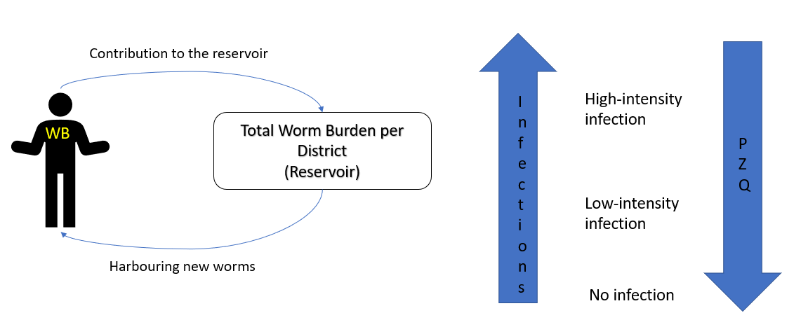

Figure Structure of a natural history model of schistosomiasis infections. WB – Worm burden (number of worms carried by the human host).

### Age groups

The main purpose of building this module was to study the impact of including children below 5 years old in the Mass-Drug Administration programmes. In the context of MDA programmes for control and elimination of schistosomiasis, the population is often split into 3 age groups, as defined in Table 3.

Table Age groups used in the module

|  |  |  |
| --- | --- | --- |
| **Group abbreviation** | **Group description** | **Age range (inclusive)** |
| PSAC | Pre-school age children | 0 – 4 years |
| SAC | School age children | 5 – 14 years |
| Adults | - | 15+ years |

Throughout the module these age groups are used to assign prevalence of schistosomiasis infections, relative risks of obtaining the infection and coverage of MDA programmes.

### Harbouring rates

Every person’s predisposition of harbouring many or few worms depends on genetic, behavioural and environmental factors. To account for that, upon initialisation of the population and upon the birth of new individuals, we assign a random value hri defined as a harbouring rate of individual i. The harbouring rates are drawn from a gamma distribution with a district-dependent shape parameter k:

(1)

Using a gamma distribution with a low k we ensure that few people will carry many worms (high worm burden) and most people will have relatively low risks of harbouring worms, as observed in the autopsy studies (Cheever, 1968). The distribution of worm burden in the population we will observe will hence be negative binomial with the clumping parameter that can be approximated with the gamma distribution shape parameter. Therefore, the typical notation for the gamma distribution parameter α was replaced here with the notation of the clumping parameter of the NegBin parameter k.

The parameter k indicates how ‘clumped’ the high risks of infection are among the population. We assume that this parameter is constant across the age-groups and throughout the simulation period but varies by district. These parameters have been calibrated to the baseline prevalence of infection in every district, as will be explained in section 10.

### Births

Upon birth, the newborns are assumed to be uninfected regardless of whether their mothers were infected. We also assume that there is no maternal immunity to the schistosome worms, meaning that the newborns are susceptible to harbouring new worms immediately.

### Mortality

Schistosomiasis infections increase the risk of acquiring viruses such as HPV or HIV (Mosunjac et al., 2003; Ndeffo Mbah et al., 2013), and developing serious, life-threatening conditions such as bladder cancer or kidney failure (Gryseels et al., 2006; Mosunjac et al., 2003; Olveda et al., 2013; Vennervald and Dunne, 2004). However, this is typically due to chronic, untreated infections or multiple reinfections and not directly caused by a single schistosomiasis infection, and therefore it is not included in the model at this stage.

Mortality due to schistosomiasis-induced complications/infections, such as HIV or cancer will be in the future covered by other TLO modules.

### Initial worm burden distribution

The baseline prevalence in Malawi for each of the districts was used to fit the parameters to the model.

The prevalence data for urogenital infections was combined from two sources: data downloaded from <http://espen.afro.who.int/countries/malawi> and filtered for S.haematobium infections throughout years 2002-2013 and (*Malawi NTD Master Plan 2015-2020*, 2014; WHO, n.d.)[2]. Where data for multiple locations within one district was found, an unweighted mean was used in the model as prevalence, in other cases where only one point-estimate was provided, that value was used in the model. For Zomba City no data was found, therefore value for Zomba district was used. For two of the districts, Dowa and Rumphi, the prevalence of S.haematobium infections in the sources used was estimated to be 0% and that was applied in the model.

For the intestinal schistosomiasis, all data was extracted from <http://espen.afro.who.int/countries/malawi> . For 12 out of 32 districts the prevalence of S.mansoni infection was 0%.

To assign the initial worm burden in the population, the following steps are taken for each district:

1. We calculate the total number of worms to distribute within the district, by multiplying the mean worm burden by the total number of people in the district. The initial worm burden is taken from the ResourceFile_Schisto.xlsx file, sheet ‘District_Params_haematobium’ or ‘District_Params_mansoni’, column Reservoir. The process of calibrating this value is described later in this document, in section 10.
2. We sample with replacement from the list of all indices of people living in the given district, with probability of selecting a given index equal to the product of the harbouring rate and the exposure rate.

In the module we assume no mixing of individuals between the districts, therefore districts with initial MWB equal to 0 will not observe any infections during the whole simulation.

For all the worms distributed, a date of the natural death of worms is scheduled (see section 4.9).

### Infections intensities

The intensity of infection is strongly related to the worm burden of the host. It is not possible to directly measure the number of worms carried by an infected person, however typically the intensity of infection is assessed by the measurable number of eggs per ml of urine (epml) or per gram stool (epg).

WHO defines a high intensity infection as one in which the number of eggs per ml epml or epg exceeds some threshold. We do not represent epml or epg in the model directly, but we assume a linear relationship between the number of eggs excreted and WB, making allowance for the rate of egg production per pair of worms for each type of the fluke. Using this relationship and WHO guidelines in deciding on the intensity of infection, we can derive the thresholds of low and high intensity infections in the model that correspond to the definition used by WHO, using the following formula:

From that we derived the thresholds of a high-intensity:

All values used in the calculations are shown in the Table 4.

Table High-intensity infections thresholds and their derivation.

|  |  |  |  |  |
| --- | --- | --- | --- | --- |
| **Fluke type** | **WHO high-intensity infection threshold** | **Eggs per worm pair** | **Threshold derivation** | **Reference (for eggs per worm pair)** |
| S.haematobium | 500 epml | 52 epml | High_WB = 500/52 * 2 = 19.2 | (Truscott et al., 2017) |
| S.mansoni | 400 epg | 0.14 epg | High_WB = 400/0.14 * 2 = 5714 THIS IS CLEARLY WRONG!!! I set to 40 now | (de Vlas et al., 1993) |

As it it unknown what should be the threshold of the high-intensity infection for the pre-school aged children (PSAC), there is a separate parameter for high-intensity infection threshold among the PSAC (see the thesis for more information).

### Initial Symptoms assignment

In this module, the focus is on common, early-stage symptoms that may prompt healthcare-seeking behaviour and not their chronic implications such as cancer or kidney failure. Symptoms used in the model were hence narrowed down to the schistosomiasis symptoms for which the DALYs weights were defined and available.

We assume that only the people with high-intensity infections can develop symptoms.

It is assumed that persons with high intensity infections have a risk of developing each of a set of symptoms, that is assumed to be independent of the presence of any other symptoms. That risk is taken to be equal to the observed prevalence of each respective symptom, as reported in (van der Werf et al., 2003), <https://www.sciencedirect.com/science/article/pii/S0001706X03000299>

Table Schistosomiasis symptoms and their prevalence among the infected populations

|  |  |  |
| --- | --- | --- |
| **Symptom** | **Prevalence** | **Reference** |
| Anaemia | 0.9 | Assumption |
| Fever | 0.3 | Assumption |
| Haematuria | 0.625 | Table 2 (van der Werf et al., 2003) |
| Dysuria | 0.2857 |
| Hydronephrosis | 0.083 | Table 2 (van der Werf et al., 2003), value for moderate hydronephrosis |
| Bladder pathology | 0.7857 | Table 2 (van der Werf et al., 2003), value for minor bladder pathology |
| Ascites | 0.0054 | Table 3 (van der Werf et al., 2003) |
| Diarrhoea | 0.0144 |
| Vomit | 0.0172 |
| Hepatomegaly | 0.1574 |

Although it is not directly included in the table above or used in the model, the probability that none of the symptoms of S.haematobium or S.mansoni infection is assigned to and infected individual can be calculated from:

Where:

Ps = probability of developing symptom s

S = set of all symptoms dependent on the infections type (urogenital or intestinal)

Using the equation above we derive, that the

0.004

0.057

### New infections

New infections are assigned independently in every district. Assignment of new infections happens in steps described below.

1. Calculating the size of the reservoir

As explained earlier and shown in figure 1, every person contributes to the total reservoir of infectious material. We do not model the reservoir explicitly by the number of schistosome eggs, as this would demand including the dynamics of miracidia, intermediate hosts (snails) and cercariae released into the water. Instead, the reservoir will indirectly model the force of infection.

The details of this model can be found in (Anderson et al., 2015; Farrell et al., 2017; Truscott et al., 2017). The reservoir is modelled by summing all individuals’ contribution to the total worm reservoir, that is the mean worm burden per age group multiplied by the age-dependent exposure rate. The exposure rate allows to accommodate for the increased input of the eggs to the environment by the people who spend more time in contact with water, and who are at the same time more exposed. This value is then multiplied by R0, defined here as the average number of female offspring produced by a female worm that effectively infects the definitive human host and survives to maturate into adults.

Mathematically, this can be described by the following equations:

(2)

Where:

Ldistrict = Size of the reservoir of infectious material

R0 district= Basic reproduction number in the *district*

A = {PSAC, SAC, Adult}

Betaa = exposure rate for group *a*

P(a,district) = Normalised size of the population in age group *a*

MWB = mean of the worm burdens of individuals of age *a* and in district *district*

1. Generating numbers of newly harboured worms

For each individual, a number of newly harboured worms is then randomly sampled from a Poisson distribution, accounting for the mean worm burden in the district, the harbouring rate of the individual, and their exposure rate, as per the equation below:

(3)

Where:

NewWormsi, a, district = Worm burden of individual *i*, belonging to the age group *a* and living in district *district*

Poiss() = random variable drawn from a Poisson distribution

hri = harbouring rate of individual *i*

Betaa = exposure rate of age group *a* (see parameters values)

Ldistrict = mean worm burden in *district*, as per equation (2)

1. Increasing the worm burden

We say that a new worm has been successfully harboured if the cercariae managed to penetrate the skin, mature into an adult worm and establish itself in the human host organism. This is a density-dependent process, which can be expressed in terms of a probability of successful establishment of the new worms in the host carrying n-worms, as given in (Chan et al., 1995):

(4)

where *fec* is a constant fecundity parameter of the worms.

For every person who is assigned a positive number of new worms, a random variable is generated from *Bernoulli(p)* with probability p as given in equation (4). The value of this variable, True or False, determines whether the establishment of the new worms succeeded, and hence the worm burden increases, or failed, in which case the worm burden does not change.

The increase in the worm burden for an individual *i* of age *a* with current worm burden = *n* is effectively drawn from .

1. For people whose worm burden needs to increase due to successful establishment of new worms, the increment happens only after a period of the worms’ maturation. An event SchistoMatureWorms is scheduled to happen in the randomly chosen day from *sim.date + Uniform(30,55)* days (0 to 30 days of infection event within next month + 25 to 30 days of the maturation period for the worm (Anderson and May, 1992).; the distribution that arises from this sum is in fact trapezoidal, not Uniform(30,55), but for simplicity we disregard the lowest and highest values of the correct distribution).

This event, when triggered:

* 1. increases the ‘sx_aggregate_worm_burden’,
  2. changes the ‘sx_infection_status’ to High- or Low-infection upon comparing the current worm burden with the thresholds,
  3. if the change in the infection status took place, the ‘sx_start_of_prevalent_period’ and/or ‘sx_start_of_high_inf’ properties are updated.
  4. if the infection status changed to High-infection, schedules the SchistoDevelopSymptoms event to happen immediately

All parameters are fixed throughout the whole simulation.

Table Parameters used in generating new infections

|  |  |  |
| --- | --- | --- |
| **Parameter** | **Value** | **Reference** |
| R0 | Depending on the district & infection type | Fitted |
| Fecundity (S.haematobium) | 0.005 | (Truscott et al., 2017) |
| Fecundity (S.mansoni) | 0.0006 | (Chan et al., 1995) |
| β _PSAC | 0.3 | (Truscott et al., 2017) |
| β _SAC | 1 |
| β_Adults | 0.05 |
| Worm lifespan (S.haematobium) | 6 [years] | Table 4 in (Anderson et al., 2016) |
| Worm lifespan (S.mansoni) | 4 [years] |

### Natural death of adult worms

The average lifespan of an adult worm within a human host is about 6 years for S.haematobium and 4 years for S.mansoni (Anderson et al., 2016). The natural death of the adult worms is an important factor in the schistosomiasis modelling, as it is potentially one of the reasons the mean worm burden drops rapidly in the population above 20 years old: the worms harboured in the childhood die and the frequency of exposure to the infested water decreases, therefore decreasing substantially the risk of acquiring new worms.

In this module, we assume that the adult worms die exactly *worm_lifespan* years after maturating within the human host, where *worm_lifespan* is a parameter related to either Schisto_Haematobium or Schisot_Mansoni modules and equal either 6 or 4 years respectively (however this can be changed in the Resources spreadsheet). The decrease in the number of worms is executed by the *SchistoWormsNatDeath* event, which is scheduled upon the maturation of worms to happen *worm_lifespan* - years later. To assure that the worms have not been killed by praziquantel before they die naturally, the last day of praziquantel treatment *ss_last_pzq_date* is checked: if it is more than *worm_lifespan* - years ago, the worms have been killed by praziquantel and therefore the worm burden is not decreased.

# Developing symptoms & seeking treatment

When the infection status is changed to ‘High-infection’, and the module attribute symptoms_and_HSI is set to True, *SchistoDevelopSymptoms* event is triggered.

*SchistoDevelopSymptoms* executes the following steps:

* 1. Randomly chooses symptoms for the infection in the same manner as for the initial symptoms; it is possible that no symptom will be chosen, in that case the infection continuous to be symptomless and nothing happens.
  2. If at least one symptom is chosen:
     1. ‘sx_onset_of_the_symptoms’ is changed to self.sim.date,
     2. Random draw from *Bernoulli(prob_seeking_healthcare)* determines whether the individual will seek treatment or not,
     3. If the *True* value is drawn, the HSI_SchistoSeekTreatment is scheduled to happen in a random date between now+’delay_till_hsi_a’ and now+’delay_till_hsi_b’, using the uniform distribution.

The Health System Interaction diagram is shown in Figure 2.

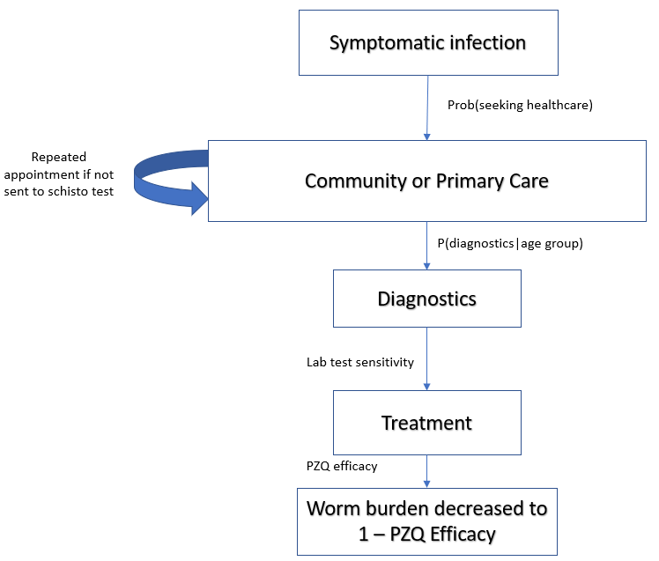

Figure Health system interactions structure

The only way to get treated of the infection is to be administered a praziquantel pill, either thoruhg MDA (described later in this document) or via interaction with a health system.

The praziquantel pill will only be administered by the health care professional if schistosomiasis is suspected, the patient is sent to the laboratory urine or stool test, depending on the symptoms, and the diagnosis is confirmed. If urogenital infection is suspected, a urine filtration is performed. In case of suspected intestinal infection, a Kato-Katz stool smear test is a default test method. The probability of a patient being sent to such a laboratory test depends on whether an individual is a child or an adult. As schistosomiasis is a childhood disease, the patient is much more likely to be referred for a schistosomiasis confirmation test if they are a child rather than adult (personal communication with Andrew Nguluwe). In our model, this probability is not dependent on the symptoms experienced by the patient. A random draw from Bernoulli(prob_sent_to_lab_test_children) or Bernoulli(prob_sent_to_lab_test_adults) determines whether the individual is sent to the laboratory test or not.

If the patient is sent to the test, schistosomiasis infection is correctly identified. For simplicity, we assume that this test’s sensitivity and specifity are equal to 100%, i.e. all cases are correctly identified as either negative or positive. In the case of the positive result, the patient is treated as soon as the appropriate consumable, "Praziquantel, 600 mg (donated)", becomes available. SchistoTreatmentEvent, described elsewhere in this document, is then triggered.

If a person is not sent to the schisto test, a new appointment is scheduled, by generating a random date n-days in the future, where n is sampled from Uniform(days_repeated_hsi_a, days_repeated_hsi_b).

Table Parameters used in the Health Seeking event

|  |  |  |
| --- | --- | --- |
| **Parameter** | **Value** | **Reference** |
| prob_seeking_healthcare | 0.4 | Ng’ambi et al. (in preparation) |
| delay_till_hsi_a | 14 days | Assumption |
| delay_till_hsi_b | 120 days | Assumption |
| prob_sent_to_lab_test_children | 0.9 | Assumption |
| prob_sent_to_lab_test_adults | 0.4 | Assumption |
| delay_till_hsi_a_repeated | 5 days | Assumption |
| delay_till_hsi_a_repeated | 20 days | Assumption |
| Lab test sensitivity & specificity | 100% | Assumption |

# Mass-Drug Administration (MDA)

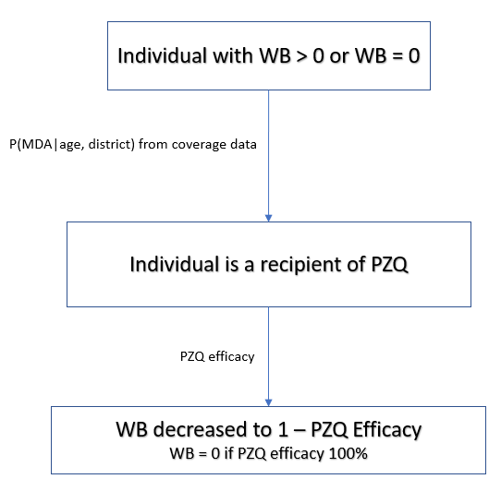

Figure MDA event structure

Mass-Drug administration event is an event of distributing praziquantel pills to a fraction of the population regardless of their infections’ status and without a prior diagnosis. One dose is administered to every individual covered by the programme. In the model, the individuals selected for treatment are sampled randomly from each age group according to the coverage.

For years 2015 – 2018 the data regarding the coverage of MDA programmes in every district of Malawi, collected by The Department of Schistosomiasis and Soil-Transmitted Helminths (Malawi Ministry of Health, Community Health Science Unit) was used in the model. The data consists of the coverage information of the school-based programmes and the community treatment. Pre-school aged children (PSAC) were not included in the programme, as per the WHO guidelines (World Health Organization, 2013). After that, the coverage and frequency of MDA is varied in every simulation.

The details of the MDA events executed in the simulations are listed in Table 8. All parameter values are uploaded to the module from the ResourceFile_Schisto.xlsx.

Table 9 MDA events details. The compliance was assumed to be 100% in all scenarios analysed.

|  |  |  |  |  |
| --- | --- | --- | --- | --- |
| **MDA events** | **Reference** | **Treatment frequency** | **PSAC coverage** | **Sheet name in the ResourceFile_Schisto.xlsx** |
| MDA in each district in 2015 -2018 (SAC and Adults) | MDA Malawi data; for 2016 the coverage data were interpolated from years 2015, 2017, 2018 | Annual | 0% | MDA_historical_Coverage |
| MDA in each district in years following 2018 | Simulated scenarios | Annual | 0%, 25%, 50% | MDA_prognosed_Coverage |
| Biannual | 0%, 50% |  |

When a person whose worm burden is equal to 0 is administered a praziquantel pill, the medication does not have any effect. The medication has no effect on the maturating worms either.

When a person carrying adult worms is administered a pill, the event *SchistoTreatmentEvent* is triggered, described in the section 7.

# Treatment

The only way to get treated is through an appropriate dose of praziquantel via seeking treatment for the symptoms experienced or the Mass-drug administration. Both of these events are described in detail in other sections.

*SchistoTreatmentEvent*, when triggered, follows the steps:

1. Clears all the existing symptoms.
2. Decreases the worm_burden according to the PZQ_efficacy parameter:

For simplicity the efficacy of praziquantel is at the moment set to 100%, but it is not hardcoded and can be easily changed in the ResourceFile_Schisto.xlsx spreadsheet containing all parameter values used in the simulation. The efficacy reported in the studies is around 86-99% (Anderson et al., 2016).

1. Updates the ‘’sx_infection_status” according to the new worm burden and the intensity thresholds
2. Calculates the total period of being infected during this year and updates the property ‘sx_prevalent_days_this year’
3. Calculates the total period of having a high-infection during this year and updates the property ‘sx_high_inf_days_this year’
4. Clears the date of start of prevalent period and the date of start of high-infection.

# DALYs calculation

YLDs are calculated by the HealthBurden module, using the weights shown in the table below.

Table DALYs weights assigned to the schistosomiasis symptoms

|  |  |  |  |
| --- | --- | --- | --- |
| **Symptom** | **Weight definition** | **DALY Weight (lower limit-upper limit)** | **DALYs TLO code** |
| Anemia | Moderate anemia due to schistosomiasis.  Anemia, moderate.  Feels moderate fatigue, weakness, and shortness of breath after exercise, making daily activities more difficult. | 0.052 (0.034-0.076) | 258 |
| Fever | Mild schistosomiasis.  Infectious disease, acute episode, mild.  Has a low fever and mild discomfort, but no difficulty with daily activities. | 0.006 (0.002-0.012) | 262 |
| Haematuria* | - | 0 | - |
| Hydronephrosis | Hydronephrosis due to schistosomiasis.  Abdominopelvic problem, mild.  Has some pain in the belly that causes nausea but does not interfere with daily activities. | 0.011 (0.005-0.0.021) | 260 |
| Dysuria | Dysuria due to schistosomiasis. Abdominopelvic problem, mild. Has some pain in the belly that causes nausea but does not interfere with daily activities. | 0.011 (0.005-0.021) | 263 |
| Bladder pathology | Bladder pathology due to schistosomiasis. Abdominopelvic problem, mild. Has some pain in the belly that causes nausea but does not interfere with daily activities. | 0.011 (0.005-0.021) | 264 |
| Ascites | Ascites due to schistosomiasis.  Abdominopelvic problem, moderate.  Has pain in the belly and feels nauseous. The person has difficulties with daily activities. | 0.114 (0.078-0.159) | 261 |
| Diarrhoea | Mild diarrhea due to schistosomiasis.  Diarrhea, mild.  Has diarrhea three or more times a day with occasional discomfort in the belly. | 0.074 (0.049-0.104) | 259 |
| Vomit | Hematemesis due to schistosomiasis.  Gastric bleeding.  Vomits blood and feels nauseous. | 0.325 (0.209-0.462) | 254 |
| Hepatomegaly | Hepatomegaly due to schistosomiasis.  Abdominopelvic problem, mild.  Has some pain in the belly that causes nausea but does not interfere with daily activities. | 0.011 (0.005-0.021) | 257 |

*no DALYs weights corresponding directly to haematuria alone were found, therefore a value of 0 was assumed

# Updating parameter value on selected date

*SchistoChangeParameterEvent* allows to schedule a change in a parameter value. This can be used to simulate an impact of intervention not modelled directly by the module, e.g. campaign for increasing the knowledge and awareness about schistosomiasis. This event can only be called by the general Schisto module.

Example: we want to update the probability of being sent to schistosomiasis confirmation lab test for adults from the default value of 0.4 to 0.6 on the 1st Jan 2019, due to a hypothetical intervention of changing the clinical guidelines. The event should be scheduled in the following way:

*sim.schedule_event(SchistoChangeParameterEvent(self, ‘prob_sent_to_lab_test_adults’, 0.6), pd.Timestamp(year=2019, month=1, day=1))*

# Calibrating the parameters – S.haematobium only

### Baseline prevalence

The prevalence data for urogenital infections were combined from two sources: data downloaded from <http://espen.afro.who.int/countries/malawi> and filtered for S.haematobium infections throughout years 2002-2013, and (*Malawi NTD Master Plan 2015-2020*, 2014; WHO, n.d.)[3]. Where data for multiple locations within one district was found, an unweighted mean was used in the model as prevalence, in other cases where only one point-estimate was provided, that value was used in the model.

As obtaining an equilibrium in the low-prevalence districts proves to be very parameter-sensitive process, we decided to limit the analysis to the six districts with the highest prevalence according to the data available: Blantyre, Chiradzulu, Mulanje, Nkhotakota, Nsanje and Phalombe.

### Clumping parameter and R0

Parameters k and R0 were calibrated to the given prevalence of every district, following the equations below, following the methodology from (Anderson and May, 1992; Truscott et al., 2019)

Parameters k, P, MWB and R0 are all district dependent, but for simplicity, we drop the district-index here.

(7a)

(7b)

(7c)

(7d)

(7e)

Applying equations 7a – 7e to the baseline prevalence, we obtain the calibrated parameters k and R0 for every district of interest. The results of these calculations are shown in Table 10.

*Table 11 District-related parameter values*

|  |  |  |  |
| --- | --- | --- | --- |
| **District** | **Baseline S.haematobium prevalence** | **k** | **R0** |
| Blantyre | 26.90% | 0.10761581 | 1.12955718 |
| Chiradzulu | 34.43% | 0.1377 | 1.14141286 |
| Mulanje | 36.00% | 0.144 | 1.14495939 |
| Nkhotakota | 29.80% | 0.11918824 | 1.13320576 |
| Nsanje | 31.33% | 0.12533333 | 1.13558784 |
| Phalombe | 47.00% | 0.188 | 1.18410058 |

# Example model outputs

Figure 4 (Left) Distribution of the worm burden in the total population after running simulation for 25 years. The fitted negative binomial distribution has a clumping parameter k = 0.1238771 and mean = 13.5984 (performed with R statistical software). (Right) Age distribution of the worm burdens in the population

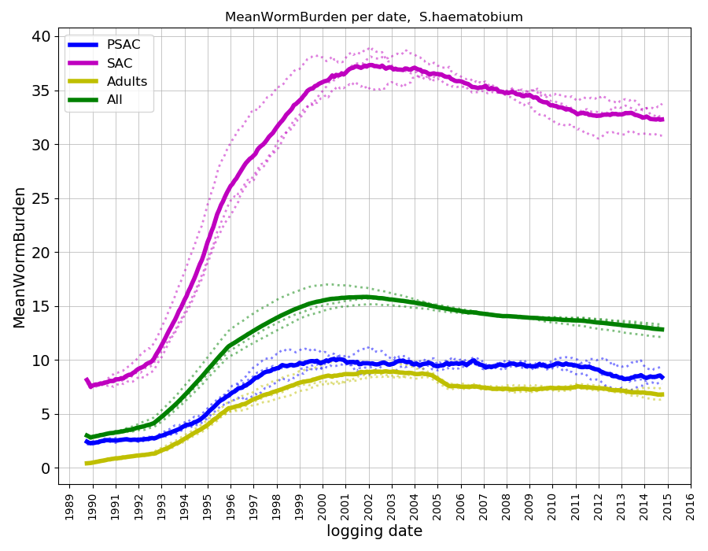

Figure 5 Mean worm burden of S.haematobium over 25 years. The individual simulations are shown with dotted lines and the averages with the solid lines.

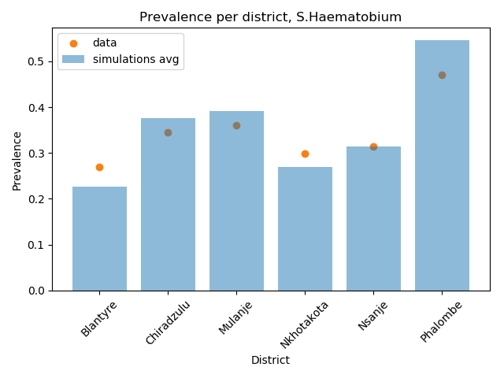

Figure 6 Prevalence per district after 25 years of the simulation without MDA. Orange dots denote the prevalence from the data, and the height of the bar shows the average prevalence per district from the model simulations

Figure 7 Prevalence changes upon MDA campaigns in years 2015-2018, according to the Malawi data. Each line is a result of one of the 18 simulations.

Figure 8 Prevalence (top row) and the changes in the mean worm burden (bottom row) upon various MDA strategies. The graphs in the left column are for PSAC, and in the right column for SAC. The individual simulations are shown with a dotted line and their average with a solid line. Notice the different scales on the y-axis for PSAC and SAC.

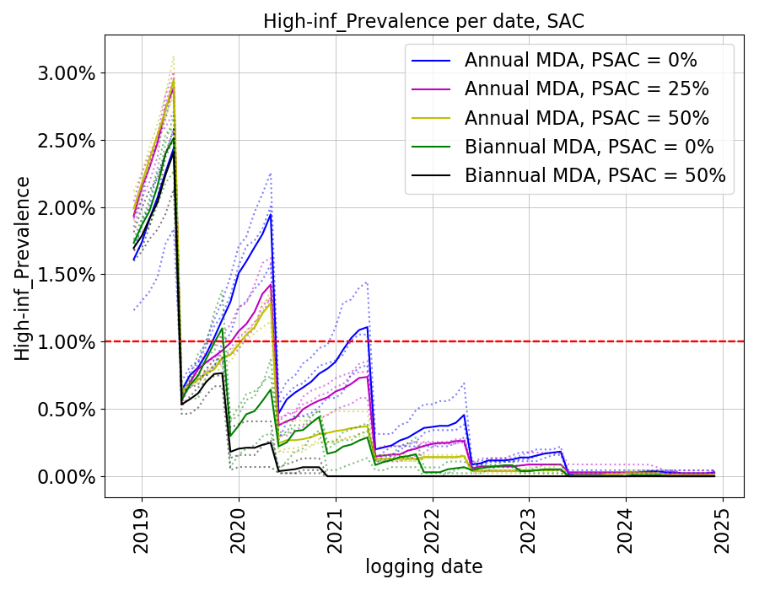

Figure 9 High infection prevalence (20+ worms) in SAC depending on the MDA strategy. The red line denotes the 1% elimination as a public health problem target.

# Limitations

The full life cycle of schistosomiasis infection is complex and requires modelling the dynamics of the schistosomes’ various life stages, miracidia, snail-stage, including the dynamics of the snails' populations, and cercariae. In many existing models if schistosomiasis infection, the simplifications are introduced, based on the fact that the lifespans of the adult worms are multiple magnitudes higher than the preceding life stages (Anderson and May, 1985). These models can be found in e.g. (Anderson and May, 1992; Basáñez et al., 2012; Chan et al., 1995; Truscott et al., 2017). In the model developed in this project, we used the main assumptions from the ICL schistosomiasis model (Truscott et al., 2017) and its stochastic version from (Farrell et al., 2017), for example, that the worm burden among the population is highly aggregated. As our model will be in the future used alongside other disease modules, such as HIV or bladder cancer, and with a sophisticated framework of the TLO model, it was necessary to include some simplifications.

The TLO schistosomiasis model neglects the probability of mating, which is important in the low-prevalence districts, where the mean worm burden is lower and hence the probability of a male and female worm mating within the human host is decreased. Probability of mating is one of the vital issues that drive the population of schistosomes extinct in the areas with low schistosome densities, however, the eradication and elimination were not intended to be one of the objectives of this study. We do however take into account the density-dependent fecundity of worms through including the probability of establishing a worm in a host, dependent on a number of adult worms already established.

Some people have elevated risks of acquiring schistosomiasis infection than others. This is caused by a variety of biological, environmental and behavioural factors, such as genetic predisposition, compromised immunity, proximity to the infested water reservoir, or having a profession that requires prolonged contact with water, e.g. farmers, fisherman or irrigation workers. In the model, we generate those risks and predispositions randomly, disregarding all available information about the age, profession, or place of living of the individual. We do however include the tendency of children to spend more time in contact with the water by using exposure rates to estimate the risk of acquiring new infection, as well as their increased input of the infectious material to the environment. The proximity to the infested water reservoir is also covered to some extent through using observational data from Malawi to estimate the initial prevalence in each of the districts separately and further assuming no mixing of individuals between the districts. Because of this, we preserve the higher risks of infections in high-prevalent districts, which might be caused by a larger density of water reservoirs, rural areas and poverty (Moyo et al., 2016; Osakunor et al., 2018).

In this module, we do not consider maternal immunity or immunity gained due to being exposed to multiple infections during a lifetime. To our knowledge, the immunity to schistosome worms have not been well studied and hence there is a lack of data that could be incorporated to model that phenomenon. The immunity is still indirectly incorporated in the model by using relative risks of acquiring infection depended on the age of an individual (e.g. such risk is much lower for adults than children).

To estimate the initial prevalence, we calculated the average prevalence of S.haematobium infections within each district of Malawi. However, schistosomiasis is a highly localised disease dependent on the proximity of the water reservoir with infected snails. As a consequence, the prevalence within the district can vary highly between the schools or villages (Bowie et al., 2004; Gryseels et al., 2006; Makaula et al., 2014).

In all the MDA scenarios we assumed systematic compliance to be equal to 100%. This is unlikely to be the case in the reality, and it is unlikely that the coverage reported in the data we used to estimate the impact of the MDA treatment that has already taken place were as high as reported. Nevertheless, with the already low levels of schistosomiasis in Malawi, systematic compliance would doubtfully modify the results and their implications in a significant way.

Long, untreated or many re-infections of schistosomiasis might lead to several serious complications, that this model does not cover. Severe infections in the childhood might cause the growth impairment and reduce learning abilities, causing long-term and irreversible implications in terms of quality of life in the adulthood (King et al., 2005; Olveda et al., 2013; Phiri et al., 2008). Moreover, urogenital schistosomiasis infections in women have been found to increase the risk of acquisition of HIV and HPV (Mosunjac et al., 2003; Ndeffo Mbah et al., 2013). They also may lead to developing serious conditions such as bladder cancer or kidney failure (Gryseels et al., 2006; Mosunjac et al., 2003; Olveda et al., 2013; Vennervald and Dunne, 2004) or inflammation of internal organs. Moreover, the studies have shown that prenatal exposure to schistosomiasis and other soil-transmitted helminths might is correlated to a reduction in childhood diseases vaccinations (Osakunor et al., 2018)

Such severe complications would increase the death rate of affected individuals (Gryseels et al., 2006; Vennervald and Dunne, 2004). However, as this death is not directly related to the schistosomiasis infections, we decide to disregard the death due to schistosomiasis in this module. We also do not model the “worsening” of the symptoms, prompting individual to be more likely to seek treatment. Although adding this feature to the model is straightforward, it is not possible to estimate this probability reliably.

In the module, the probability of being sent to a schistosomiasis laboratory confirmation test does not depend on the prevalence of schistosomiasis infections in a given district or a symptom presented to the doctor. This is however not likely to be true in the real life, as this probability will be higher in the districts, or even communities, where schistosomiasis is known to be a highly prevalent infection. In communities where not only the healthcare professionals, but also other inhabitants are aware of the infection and its treatment, the probability of seeking treatment on symptoms onset is likely to be higher as well. It is possible to easily include such an option of providing these probabilities per district, however it would be extremely difficult to realistically estimate these values.

# Next steps & usage recommendation

The schistosomiasis module presented here can be updated to model the transmission and health system interactions for the Soil-Transmitted Helminths, as the models of these infections are in general similar, differ only in the parameters. The MDA campaigns in Malawi typically involve distributing praziquantel and the STH medications together, so it would make sense to utilise the general *Schisto* module and its MDA events to include treating STH infections as well.

A great source of information about this are (Anderson et al., 2016; Truscott et al., 2016).

If any of the schistosomiasis modules is to be used alongside other modules, such as BladderCancer or HIV, I recommend the following:

* Commenting out the properties of Schisto_Haematobium or Schisto_Mansoni, only keeping 3 properties: ‘sx_infection_status’, ‘sx_aggregate_worm_burden’, ‘sx_harbouring_rate’
* Commenting out all lines including the calculations of the prevalent days or high-infection days, and start of the prevalence periods (essentially all lines that use the properties commented out in the previous step)
* Keeping the default False values of symptoms_and_HSI attribute for the module used
* The transmission model assumes that the disease is endemic and in the equilibrium; that is not the case at the current time in Malawi, as there have been efforts made to decrease the levels of schistosomiasis in the country. Therefore, it is necessary to let the simulation run for at least 15 years and then execute the 4 rounds of historical MDA, followed by annual MDA with coverag: PSAC-0%, SAC-80%, Adults-50%.

Author of the module:

Iwona Hawryluk, i.hawryluk19@imperial.ac.uk

# References

Anderson, R., Turner, H., Farrell, S., Yang, J., Truscott, J., 2015. What is required in terms of mass drug administration to interrupt the transmission of schistosome parasites in regions of endemic infection? Parasit. Vectors 8, 553. https://doi.org/10.1186/s13071-015-1157-y

Anderson, R.M., May, R.M., 1992. Infectious diseases of humans. Oxford University Press, USA.

Anderson, R.M., May, R.M., 1985. Helminth Infections of Humans: Mathematical Models, Population Dynamics, and Control. Adv. Parasitol. 24, 1–101. https://doi.org/10.1016/S0065-308X(08)60561-8

Anderson, R.M., Turner, H.C., Farrell, S.H., Truscott, J.E., 2016. Studies of the Transmission Dynamics, Mathematical Model Development and the Control of Schistosome Parasites by Mass Drug Administration in Human Communities. Adv. Parasitol. 94, 199–246. https://doi.org/10.1016/BS.APAR.2016.06.003

Basáñez, M.-G., McCarthy, J.S., French, M.D., Yang, G.-J., Walker, M., Gambhir, M., Prichard, R.K., Churcher, T.S., 2012. A Research Agenda for Helminth Diseases of Humans: Modelling for Control and Elimination. PLoS Negl. Trop. Dis. 6, e1548. https://doi.org/10.1371/journal.pntd.0001548

Bowie, C., Purcell, B., Shaba, B., Makaula, P., Perez, M., 2004. A national survey of the prevalence of schistosomiasis and soil transmitted helminths in Malawi. BMC Infect. Dis. 4, 49. https://doi.org/10.1186/1471-2334-4-49

Chan, M.S., Guyatt, H.L., Bundy, D.A.P., Booth, M., Fulford, A.J.C., Medley, G.F., 1995. The development of an age structured model for schistosomiasis transmission dynamics and control and its validation for Schistosoma mansoni. Epidemiol. Infect. 115, 325–344. https://doi.org/10.1017/S0950268800058453

Cheever, A.W., 1968. A quantitative post-mortem study of Schistosomiasis mansoni in man. Am. J. Trop. Med. Hyg. 17, 38–64. https://doi.org/10.4269/ajtmh.1968.17.38

de Vlas, S., Nagelkerke, N., Habbema, J., 1993. Statistical models for estimating prevalence and incidence of parasitic diseases. Stat. Methods Med. Res. 2, 3–21. https://doi.org/10.1177/096228029300200102

Farrell, S.H., Truscott, J.E., Anderson, R.M., 2017. The importance of patient compliance in repeated rounds of mass drug administration (MDA) for the elimination of intestinal helminth transmission. Parasit. Vectors 10, 291. https://doi.org/10.1186/s13071-017-2206-5

Gryseels, B., Polman, K., Clerinx, J., Kestens, L., 2006. Human schistosomiasis. Lancet 368, 1106–1118. https://doi.org/10.1016/S0140-6736(06)69440-3

King, C.H., Dickman, K., Tisch, D.J., 2005. Reassessment of the cost of chronic helmintic infection: a meta-analysis of disability-related outcomes in endemic schistosomiasis. Lancet 365, 1561–1569. https://doi.org/10.1016/S0140-6736(05)66457-4

Makaula, P., Sadalaki, J.R., Muula, A.S., Kayuni, S., Jemu, S., Bloch, P., 2014. Schistosomiasis in Malawi: A systematic review. Parasites and Vectors 7, no pagination.

Malawi NTD Master Plan 2015-2020, 2014.

Ministry of Health, M., 2015. Malawi standard treatmetn guidelines.

Mosunjac, M.., Tadros, T., Beach, R., Majmudar, B., 2003. Cervical schistosomiasis, human papilloma virus (HPV), and human immunodeficiency virus (HIV): a dangerous coexistence or coincidence? Gynecol. Oncol. 90, 211–214. https://doi.org/10.1016/S0090-8258(03)00191-4

Moyo, V.B., Changadeya, W., Chiotha, S., Sikawa, D., 2016. Urinary schistosomiasis among preschool children in Malengachanzi, Nkhotakota District, Malawi: Prevalence and risk factors. Malawi Med. J. 28, 10–14. https://doi.org/10.4314/mmj.v28i1.3

Mtethiwa, A.H.N., Nkwengulila, G., Bakuza, J., Sikawa, D., Kazembe, A., 2015. Extent of morbidity associated with schistosomiasis infection in Malawi: A review paper. Infect. Dis. Poverty 4, 1–8. https://doi.org/10.1186/s40249-015-0053-1

Ndeffo Mbah, M.L., Poolman, E.M., Drain, P.K., Coffee, M.P., van der Werf, M.J., Galvani, A.P., 2013. HIV and *Schistosoma haematobium* prevalences correlate in sub-Saharan Africa. Trop. Med. Int. Heal. 18, 1174–1179. https://doi.org/10.1111/tmi.12165

Olveda, D.U., Li, Y., Olveda, R.M., Lam, A.K., Chau, T.N.P., Harn, D.A., Williams, G.M., Gray, D.J., Ross, A.G.P., 2013. Bilharzia: Pathology, Diagnosis, Management and Control. Trop. Med. Surg. 1. https://doi.org/10.4172/2329-9088.1000135

Osakunor, D.N.M., Woolhouse, M.E.J., Mutapi, F., 2018. Paediatric schistosomiasis: What we know and what we need to know. PLoS Negl. Trop. Dis. 12, e0006144. https://doi.org/10.1371/journal.pntd.0006144

Pediatric Praziquantel Consortium [WWW Document], n.d. URL http://www.pediatricpraziquantelconsortium.org/schistosomiasis (accessed 11.22.19).

Phiri, K.S., Calis, J.C.J., Faragher, B., Nkhoma, E., Ng’oma, K., Mangochi, B., Molyneux, M.E., van Hensbroek, M.B., 2008. Long Term Outcome of Severe Anaemia in Malawian Children. PLoS One 3, e2903. https://doi.org/10.1371/journal.pone.0002903

Truscott, J.E., Gurarie, D., Alsallaq, R., Toor, J., Yoon, N., Farrell, S.H., Turner, H.C., Phillips, A.E., Aurelio, H.O., Ferro, J., King, C.H., Anderson, R.M., 2017. A comparison of two mathematical models of the impact of mass drug administration on the transmission and control of schistosomiasis. Epidemics 18, 29–37. https://doi.org/10.1016/J.EPIDEM.2017.02.003

Truscott, J.E., Ower, A.K., Werkman, M., Halliday, K., Oswald, W.E., Gichuki, P.M., McHaro, C., Brooker, S., Njenga, S.M., Mwandariwo, C., Walson, J.L., Pullan, R., Anderson, R., 2019. Heterogeneity in transmission parameters of hookworm infection within the baseline data from the TUMIKIA study in Kenya. Parasites and Vectors 12. https://doi.org/10.1186/s13071-019-3686-2

Truscott, J.E., Turner, H.C., Farrell, S.H., Anderson, R.M., 2016. Soil-Transmitted Helminths: Mathematical Models of Transmission, the Impact of Mass Drug Administration and Transmission Elimination Criteria. Adv. Parasitol. 94, 133–198. https://doi.org/10.1016/bs.apar.2016.08.002

van der Werf, M.J., de Vlas, S.J., Brooker, S., Looman, C.W.., Nagelkerke, N.J.., Habbema, J.D.F., Engels, D., 2003. Quantification of clinical morbidity associated with schistosome infection in sub-Saharan Africa. Acta Trop. 86, 125–139. https://doi.org/10.1016/S0001-706X(03)00029-9

Vennervald, B.J., Dunne, D.W., 2004. Morbidity in schistosomiasis: An update. Curr. Opin. Infect. Dis. 17, 439–447. https://doi.org/10.1097/00001432-200410000-00009

WHO, 2010. Report of a meeting to review the results of studies on the treatment of schistosomiasis in preschool-age children. Geneva, Switzerland.

WHO, n.d. ESPEN - Expanded Special Project for Elimination Of Neglected Tropical Diseases.

WHO Schistosomiasis Fact Sheet [WWW Document], n.d. URL https://www.who.int/en/news-room/fact-sheets/detail/schistosomiasis

World Health Organization, 2013. Schistosomiasis: progress report 2001 - 2011, strategic plan 2012 - 2020. World Health Organization.

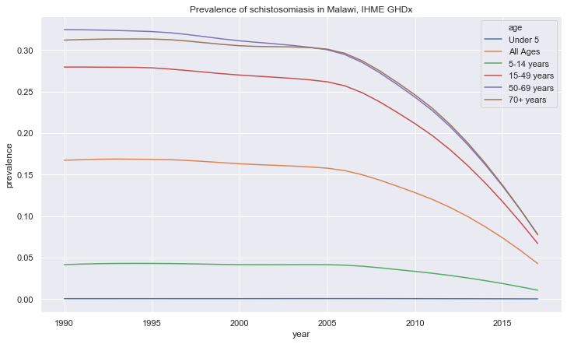

1. <http://www.pediatricpraziquantelconsortium.org/schistosomiasis>), accessed 22/11/2019
2. [http://espen.afro.who.int/system/files/content/resources/MALAWI_NTD_Master_Plan_2015_2020.pdf](http://espen.afro.who.int/system/files/content/resources/MALAWI_NTD_Master_Plan_2015_2020.pdf%20)
3. [http://espen.afro.who.int/system/files/content/resources/MALAWI_NTD_Master_Plan_2015_2020.pdf](http://espen.afro.who.int/system/files/content/resources/MALAWI_NTD_Master_Plan_2015_2020.pdf%20)