GOURMET GATEWAY

Project Design

By

Group4

Introduction

The intended software project is called Gourmet Gateway. Some small businesses might have a hard time compared to bigger companies. The purpose of Gourmet Gateway is to be a restaurant ordering system for small restaurants to make the orders faster and to get their food to more people. The application will be written in C++ in Visual Studio code.

Architecture
- The application will be written in C++ in Visual Studio code.
- Implementing a modular approach by using functions
- two Text Files that can be read by the program that lists the things in the menu and to store order information.
- classes used for taking orders and to return/display order information.
- Arrays for drink or food sizes and types of food like types of pizzas or burgers.
- In the class an interface displays and allows interaction with Base options without type or size and the option to complete order. With the arrays mentioned earlier displaying secondary options
- a Function to calculate and then display/return to the class for order info the total price after the customer completes the order.

Program ran

Menu displayed

Main options and complete order options displayed

⬇

Menu item selected

Customization options for food sizes displayed

Customer selects size

Customization options for type

Customer selects type

Item added to total and receipt

⬇

Complete Order selected

Displays receipt

Displays total price

stores receipt and total in the text file

exits the program

Use Cases
- Organizes functional requirements
- Functions: Organizes code and prevents repetition of code
- Text Files: allows for receiving and storing of information.
- Classes: Organizes code
- Arrays: used for item sizes and pizza types as options after the base option is picked and use the price associated with the item and its size to put in the total cost before returning you to the main options.
- Base options and secondary options: allows for customization of items
- Function to calculate: Organizes code and prevents repetition of code. Adds up the price.

UML
Main class
std::string filename = "menu.txt";
Base options will be Drink, Burger, Fries, Nuggets, and Pizza. And the option to exit the program

Taking_orders class
string Sizes[] = {"Small", "Medium", "Large"};
string PizzaTypes[] = {"Pepperoni", "Sausage", "Cheese", "Custom"};
Int total = 0;

Return_orders class
Returns order information and total
std::ofstream output_file("orders.txt");
Total();

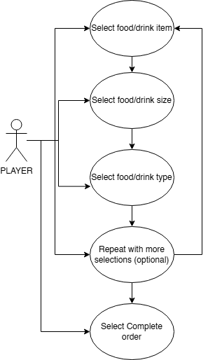

Test Cases

taking orders
- interaction with Base and complete order/exit Test: check to see if it allows you to interact with the base order options. Then check that the complete order/exit option works.
- File list for things in menu (Teresa Newman) Test: Check to see if the program reads the text file and outputs it into the terminal.

secondary options
- food sizes Test: check that when you select the base option it prompts for what size you want it and that when you select the food size it adds the item and price to order information and total price correctly.
- types of food Test: check that when you select a base option that has multiple types it prompts you to select what type you want.

return/display order information
- calculate total price Test: check that the total price is correct regardless of how many items you select.
- display/return total price Test: check that it displays.
- 1 text file to save order in. + ways to store order info in it. Test: check that it put the order info in the text document and it is the correct information.

Summary
The software development project required creating the Gourmet Gateway app as a restaurant ordering system for small restaurants to make the orders faster and to get their food to more people. This design document contains The architecture requirements, the customer Use Case scenarios, the Unified Modeling Language (UML) diagram, and the Test Cases.

