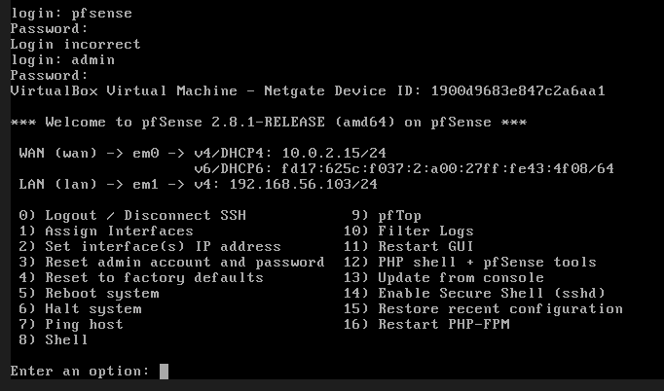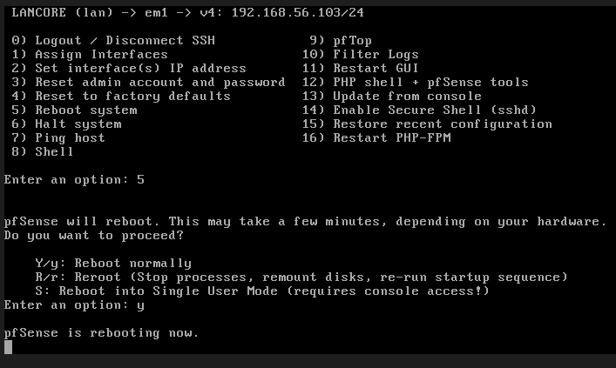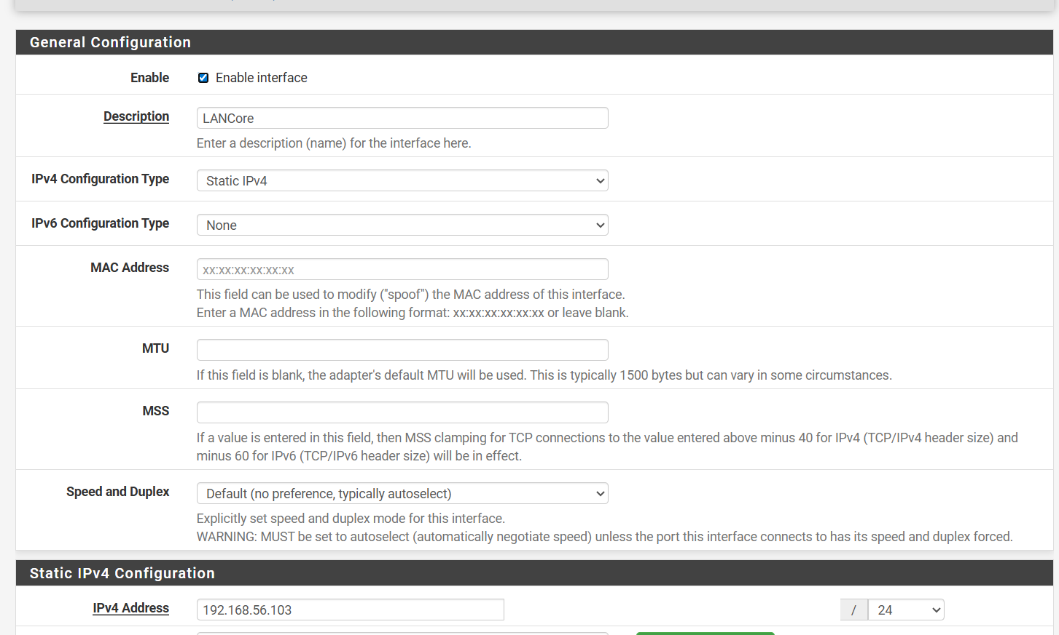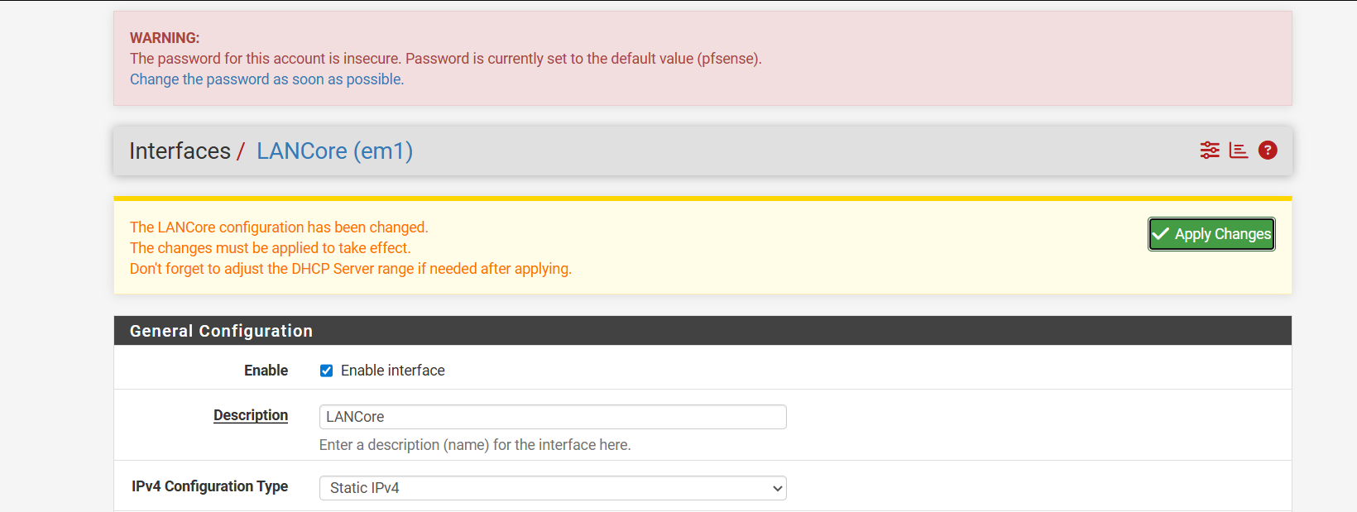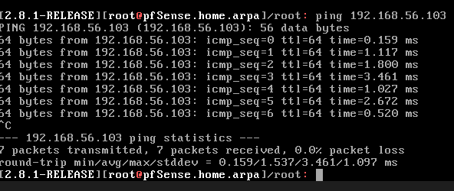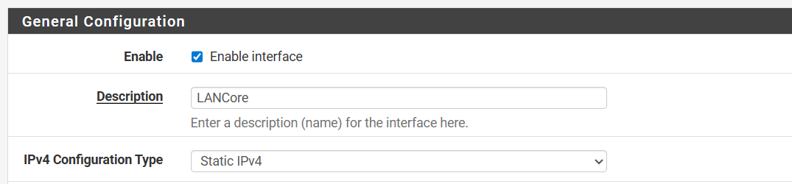
After setting mtu to 600 a small network change is occurred. Eventhough change occurred no connectivity issues are occurred.
In firewall/rules/lancore I observed changes in states. In firewall rules lancore states are changing. I observed one state before mtu modification and another state after mtu modification.

