**Software Design**

**Document**

**for**

**Viper Rocks!**

**Version 2.0.0 approved**

**Prepared by Tony Lau,**

**California State University - Los Angeles**

**February 20th, 2025**

Table of Contents................................................................................................................... pg 2

Revision History..................................................................................................................... pg 3

1. Introduction................................................................................................................ pg 4
   1. Purpose........................................................................................................... pg 4
   2. Document Conventions…………………….................................................. pg 4
   3. Intended Audience and Reading Suggestions................................................ pg 4
   4. System Overview........................................................................................... pg 5
2. 2. System Architecture................................................................................................... pg 6
3. 3. User Interface.............................................................................................................. pg 9
   1. Overview of User Interface.......................................................................... pg 9
   2. Screen Frameworks or Images..................................................................... pg 10
4. 4. Glossary....................................................................................................................... pg 15
5. 5. References................................................................................................................... pg 15

**Revision History**

| Name | Date | Reason For Changes | Version |
| --- | --- | --- | --- |
| Tony | 2/20/25 | First draft | 1.0.0 |
| Tony | 3/20/25 | Checkpoint 1; System Architecture and User Interface mostly finished | 1.1.0 |
| Tony | 4/20/25 | Checkpoint 1; System Architecture and User Interface updated | 1.2.0 |
| Everyone | 5/2/25 | Checkpoint 2; Collaboration with NASA confirmed; User Interface updated again | 2.0.0 |

# 1. Introduction

## 1.1 Purpose

This Software Design Specification Document (SDD) serves as a blueprint for developing the

VIPER Rocks! citizen science application. It comprehensively details the core functionalities

and architecture of the application, encompassing elements like the scouting, sizing, and

classification tasks, user account creation, badge system, user interface design, and database

structure. By meticulously recording all this information, this SDD equips the development team

with the necessary guidance to construct a robust and well-organized system.

## 1.2 Document Conventions

This SRS follows the typographical conventions of using bold for headings, bullet points for shorter information, and Times New Romans font at Size 12. Each higher-level requirement is to be inherited by the detailed requirement.

## 1.3 Intended Audience and Reading Suggestions

This Software Design Document caters to a diverse audience with varying technical background and interests. Here is a breakdown of the different types of readers and their primary concerns:

**● Software Developers**

○ This document is for the people who want to understand and update the technical

specifications and architecture of the software. It equips them to understand,

maintain, and update the software’s core functionalities.

**● Project Managers**

○ This document allows them to understand how the software components interact

to fulfill project requirements. It aids in planning development tasks, resource

allocation, and overall project management.

**● Users (Citizen Scientists)**

○ They will focus on the sections that explain how to utilize the VIPER Rocks!

application effectively. This includes understanding its capabilities and limitations

for contributing to scientific discovery.

**● Testers**

○ This document outlines the software’s requirements and design. Utilize this

information to plan and execute comprehensive test cases, ensuring the

application functions as intended.

## 1.4 System Overview

VIPER Rocks! is a web-based application designed for NASA’s Jet Propulsion Laboratory (JPL)

that encourages citizen scientists with different backgrounds to contribute to the VIPER mission.

By analyzing images captured by VIPER on its journey to the South Pole of the Moon, anyone

can play a vital role in lunar exploration.

The application guides citizen scientists through a three-step process to analyze lunar rocks:

**Scouting:**

* Citizen scientists examine provided images to determine an approximate number of rocks. This allows the system to subdivide the original image into small sub-images. This will help partition the workload evenly for the sizing task.

**Sizing:**

* Using the subdivided images from the scouting task, citizen scientists will utilize the sizing tool to trace and highlight various rocks in order to get their measurement. By analyzing rock size, scientists can map the lunar surface, determine rock size-frequency distributions (providing information on age, exposure history, and regolith maturity), and the VIPER Rocks! application can leverage this data to create boundaries around individual rocks for citizen scientists to classify.

**Classification:**

* Citizen scientists will be able to organize an individual rock’s shape into categories: angular, sub-angular, sub-rounded, and rounded. For more difficult rocks, there is an ambiguous category. Assessing shape information will allow scientists to have a better understanding on rock shape-frequency distributions. This will provide insight into how surface materials structurally degrade in the polar environment and allow for comparisons between polar and non-polar surfaces.

As citizen scientists complete these tasks, their contributions are recorded in a central database.

This collective effort allows scientists to analyze vast amounts of data, ultimately leading to a

deeper understanding of the Moon’s geological makeup.

# 2. System Architecture

This section provides a high-level overview of the VIPER Rocks! application’s architecture and

decomposes the system into its major modules/components.

**System Purpose and Goals**

The VIPER Rocks! system is a citizen science platform designed to engage the public in assisting NASA's research on lunar rocks. It functions as a tool and information bank to support future NASA exploration missions by leveraging the power of citizen scientists. Here’s a breakdown of its key goals:

* Crowdsourced Rock Scouting, Sizing, and Classification: Enable citizen scientists to participate in processing rock imagery provided by NASA’s VIPER mission, contributing valuable data for scientific analysis.
* Data Collection and Aggregation: Collect and aggregate results from citizen scientists to contribute to creating a comprehensive dataset for research purposes.
* Scientific Discovery: Support NASA JPL’s research efforts by providing a platform for citizen scientists to contribute to discovering and analyzing potential rock features, geological information, and more.

**System Functionality Breakdown**

The VIPER Rocks! system can be viewed as a website-driven project offering the following core functionalities:

* Secure User Access: Controls and regulates access to the website through a login and security system, ensuring authorized user participation.
* User Interface Management: Provide networked access to various user interface (UI) pages, allowing users to interact with the system for registration, login, task completion, and viewing results.
* Data Communication and Management: Manages data transfer (user information, rock images, task results, etc.) within a secure network environment.
* Citizen Science Workflow: Provides functionalities for a range of interface-specific tools citizen scientists use for scouting, sizing, and classification tasks.
* Administrator Workflow: Provides functionalities for a range of interface-specific tools users use with administrator roles for data analysis and management.
* Essential Utilities: Supports an assortment of powerful and essential utilities that contribute to the overall system operation, such as data storage, user management, and communication functionalities.

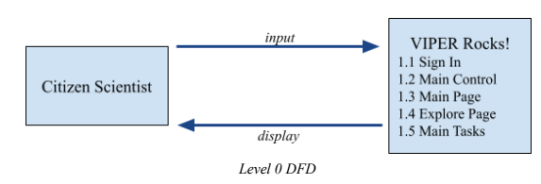

The system involves the citizen scientist user and the VIPER Rocks! application. The citizen scientist will give input and the system will return the corresponding module.

1.1 Sign In: User registration and login

1.2 Main Control: Connects and controls the different modules.

1.3 Main Page: The main landing page of the website.

1.4 Explore Page: The dashboard page that leads to the different rock image processing tasks:

scouting, sizing, and classification. Additional functionality will be added to display information

relevant to citizen scientists as needed.

1.5 Main Tasks: Involve the three different rock image processing tasks: scouting, sizing,

and classification.

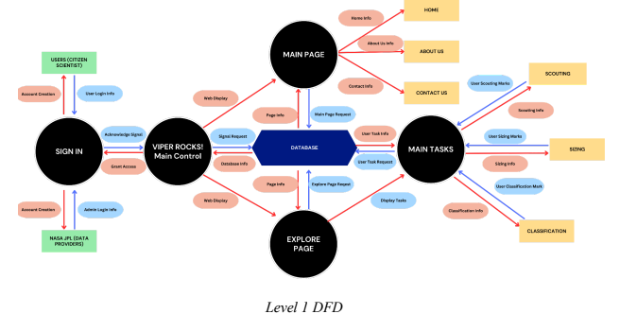

The VIPER Rocks! Data Flow Diagram (DFD) Level 1 highlights the major system components

and their interactions. The DFD utilizes arrows to represent the flow of data, with red arrows

signifying user-generated content and blue arrows indicating internal system data processing.

**System Components:**

The DFD is divided into several key areas, each represented by a circle:

* 1.1 Sign-In manages user and administrator login functionalities. Users provide credentials for system access. Administrators can also interact with external data providers (e.g. NASA JPL) for secure and authorized data retrieval.
* 1.2 VIPER Rocks! Main Control: The central processing unit that receives requests from various components and the database, coordinating responses throughout the system.
* 1.3 Main Page: Serves as a central hub after successful login. It provides navigation options (“Home,” “About Us,” “Contact Us”), retrieves relevant information from the database for display, and interacts with the Main Control unit for further actions.
* 1.4 Explore Page: Allows users to browse and request different tasks. This page interacts with the database to retrieve information on available tasks for user participation.
* 1.5 Main Tasks: The core user interaction point within the system. It comprises three main activities: Scouting, Sizing, and Classification. Users contribute data through these tasks, which are then stored in the database.

There is also the database which is responsible for processing and storing all data requests and retrievals. It interacts with various components to manage data flow throughout the application.

**Data Flow:**

1. Users interact with the Sign In component, providing credentials.

a. Valid credentials grant access.

b. Invalid credentials result in an error message.

2. The Main Control receives a request from the Sign-in component.

a. Upon successful login, the Main Control directs the user to the Main Page.

3. The Main Page retrieves information (e.g., navigation options, content) from the

database and displays it to the user.

4. Users can navigate from the Main Page to the Explore Page to view available tasks.

5. The Explore Page interacts with the database to retrieve task information and displays it

for user selection.

6. Users contribute data through the Main Tasks section (Scouting, Sizing, Classification).

7. The Main Tasks component interacts with the database to store the user-contributed data.

8. Throughout the process, the Main Control unit receives requests from various components and facilitates communication with the database, ensuring smooth system operation.

# 3. User Interface

## 3.1 Overview of User Interface

VIPER Rocks! follow Explorer 1: JPL’s Design System using React, Typescript, and

TailwindCSS.

From the user’s perspective, VIPER Rocks! presents a seamless and user-friendly interface that

facilitates an engaging and educational experience. The initial step involves creating an account

where the users provide a strong password and store it securely with salting and hashing—emphasizing data collection for scientific purposes while ensuring privacy.

The home page welcomes users with an optional tutorial and showcases VIPER’s mission,

purpose, and user feedback. JPL News Feed will be present for regular users from the science

team, and contact information for bug reports or queries from JPL will add transparency—integration with OAuth, Facebook, Google login, Discord, and GitHub for

optional log in.

The scouting page introduces the distribution of rocks within an image and a sizing task with intuitive desktop and mobile tools that enrich the scouting experience and lead to a separate menu for the classification task. The general design incorporates a side-daw navigation bar for tools, offering a unified experience across mobile and desktop platforms.

In summary, VIPER Rocks! aims to empower users to contribute meaningfully to scientific endeavors, providing a well-designed, educational, and rewarding platform while ensuring data security and accuracy—the detailed user manual supplements this overview, offering comprehensive guidance on system functionality.

## 3.2 Screen Frameworks or Images

These can be mockups or actual screenshots of the various UI screens and popups.

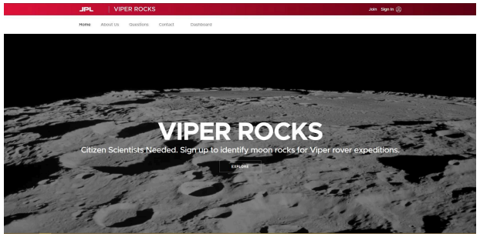

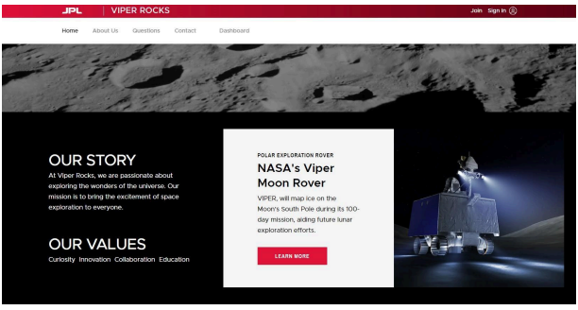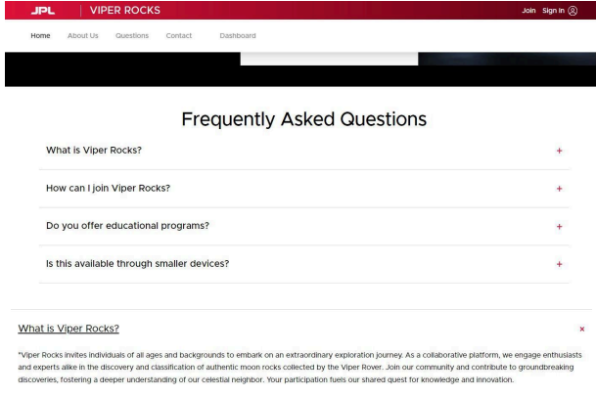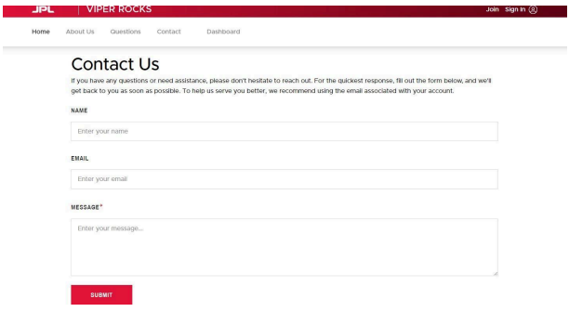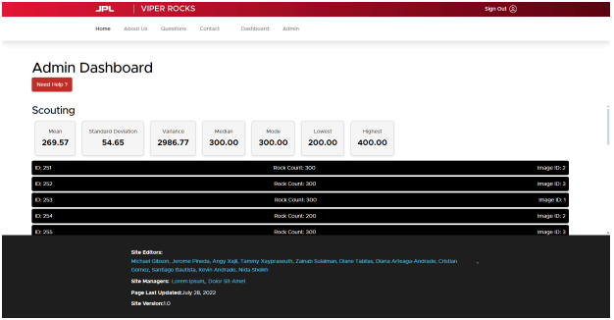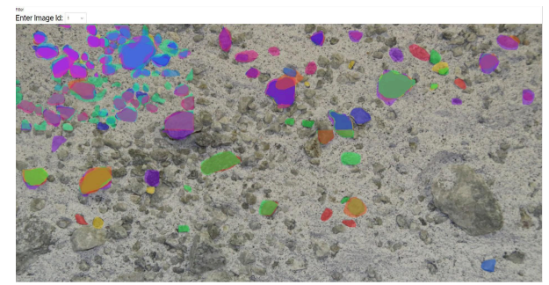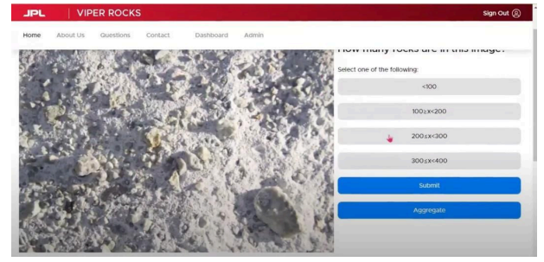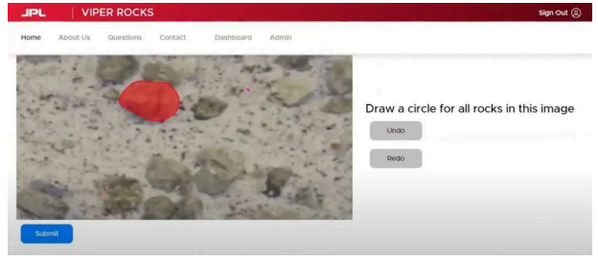

# 4. Glossary

API - Application Programming Interface

COPPA - Children's Online Privacy Protection Act

GDPR - EU General Data Protection Regulation

NASA - National Aeronautics and Space Administration

Selenology - Term for Lunar Geology

SRS / SRD - Software Requirements Specification (Document)

UI - User Interface

VIPER - Volatiles Investigating Polar Exploration Rover

Regolith - a region of loose unconsolidated rock and dust that sits atop a layer of bedrock

# 5. References

* Software Design Document (SRS)