Software Requirements Specification

for

Viper Rocks!

Version 2.0.0 approved

Prepared by Tony Lau,

California State University - Los Angeles

February 20th, 2025

**Table of Contents**

Table of Contents................................................................................................................. pg 2

Revision History................................................................................................................... pg 3

1. Introduction..................................................................................................................... pg 3

1.1. Purpose............................................................................................................. pg 3

1.2. Intended Audience and Reading Suggestions.................................................. pg 4

1.3. Product Scope................................................................................................... pg 4

1.4. Definitions, Acronyms, and Abbreviations ..................................................... pg 4

2. External Interface Requirements..................................................................................... pg 5

2.1. User Interfaces.................................................................................................... pg 5

1.2. Hardware Interfaces……………………………................................................ pg 11

1.3. Software Interfaces............................................................................................. pg 11

1.4. Communications Interfaces………………........................................................ pg 11

3. Legal and Ethical Considerations…...…........................................................................... pg 12

Appendix A: Glossary............................................................................................................ pg 12

Revision History

| Name | Date | Reason For Changes | Version |
| --- | --- | --- | --- |
| Tony | 2/20/25 | First draft | 1.0.0 |
| Tony | 3/20/25 | Checkpoint 1; mainly wording update | 1.1.0 |
| Tony | 4/20/25 | Checkpoint 2; Mockups updated, collaboration with NASA added, UI components updated, clearly defined checklist of Americans with Disabilities Act | 1.2.0 |
| Everyone | 5/2/25 | Finalize SRS; updated UI components, legal and ethical considerations updated | 2.0.0 |

# **1. Introduction**

The VIPER Rocks! project is a thrilling initiative that empowers citizen scientists, both amateur and expert, to participate in unraveling the mysteries of lunar geology. This project, developed in collaboration with NASA's Volatiles Investigating Polar Exploration Rover (VIPER) mission, leverages the power of citizen science to map and classify lunar rocks encountered during VIPER's historic exploration of the Moon's South Pole.

Ultimately, VIPER Rocks! plays a vital role in supporting NASA's long-term vision: establishing a sustainable presence on the Moon. By mapping and analyzing the distribution of ice and other resources near the Moon's South Pole, VIPER Rocks! paves the way for future missions to Mars and beyond.

This Software Requirements Specification (SRS) serves as a comprehensive guide to the technical aspects of the VIPER Rocks! project. It outlines the requirements, features, and functionality of the software that will enable citizen scientists to contribute to lunar geology research. The document also contains the project's objectives, user interfaces, technical approach, and testing strategies to ensure the successful development of VIPER Rocks!

**1.1 Purpose**

This SRS is intended for various stakeholders involved in the VIPER Rocks! project, including

software developers, project managers, data analysts, beta testers, and anyone interested in the

technical details of the application. It provides a reference for understanding the project's scope,

technical requirements, and functionality. It is organized for various types of readers, and each

type of reader may interpret this document differently:

**1.2 Intended Audience and Reading Suggestions**

* Software Developers may focus on the detailed technical requirements outlined in the document
* Project Managers may focus on the document to reference scope and technical aspects
* Data Analysts may focus on the specific data requirements, formats, and process of data collection
* The general audience may focus on the overall description of the system as well as the technical approach for a comprehensive understanding

**1.3 Product Scope**

**1.3.1 Product**:

"VIPER Rocks!" citizen science website

**1.3.2 Description**:

The VIPER Rocks! software will enable citizen scientists to actively participate in mapping and classifying lunar rocks encountered during NASA's VIPER mission. It will facilitate the scientific analysis of lunar rock populations and enhance our understanding of lunar geology. The software will allow users to measure rock size and classify rock shape, on both mobile and desktop displays.

**1.3.3 Objectives**:

The software aims to enhance the science return of the VIPER mission and engage the public in lunar exploration. The objectives include creating this citizen science platform and improving our understanding of lunar rock populations.

**1.4 Definitions, Acronyms, and Abbreviations**

VIPER - Volatiles Investigating Polar Exploration Rover

SRS / SRD - Software Requirements Specification (Document)

UI - User Interface

NASA - National Aeronautics and Space Administration

Selenology - Term for lunar geology

GDPR - EU general data protection regulation

COPPA - Children's Online Privacy Protection Act

# **2. External Interface Requirements**

**2.1 User Interfaces**

USDS: <https://designsystem.digital.gov/>

NASAWDS: <https://github.com/bruffridge/nasawds>

We will be sticking with all the dark and blue versions of NASA components. Below are the components we will make use of:

Buttons:

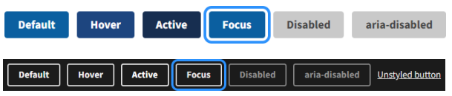

Icon List: <https://designsystem.digital.gov/components/icon/>

Alert List:

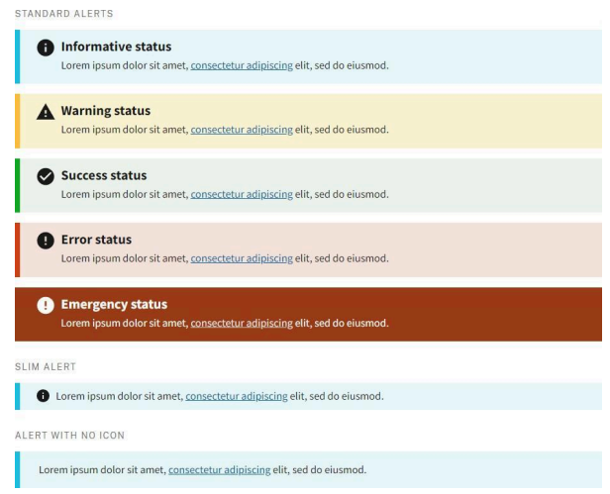

Headers, Footers, Radio Buttons:

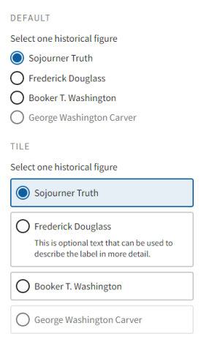

Select: 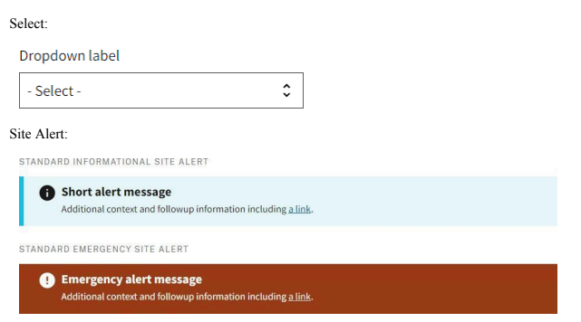Site Alerts:

Step Indicators:



Tags:

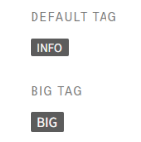

Text Inputs:

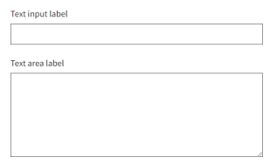

Typefaces: Source Sans Pro, Public Sans, Roboto Mono, Merriweather

The following five images are draft mockups of the landing and scouting pages:

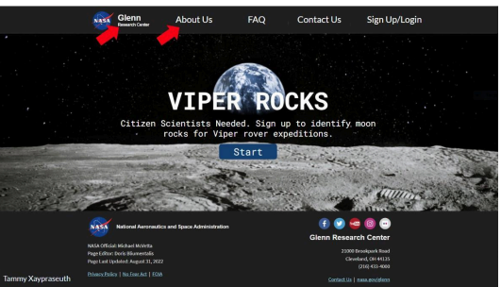

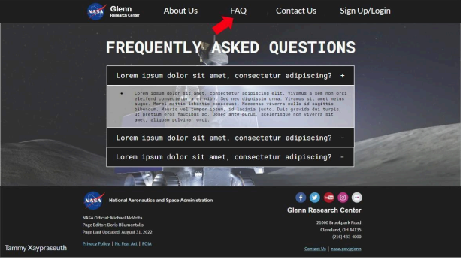

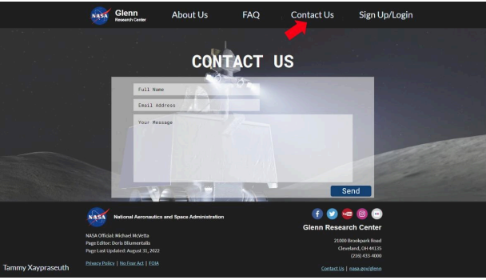

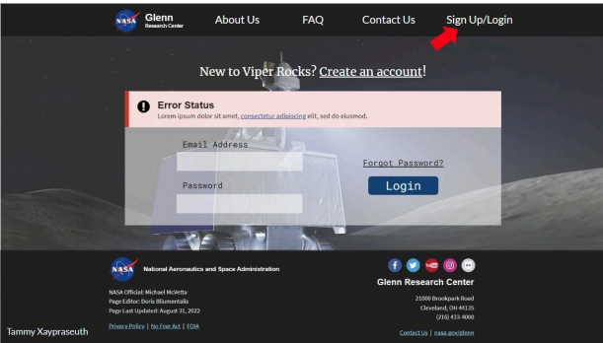

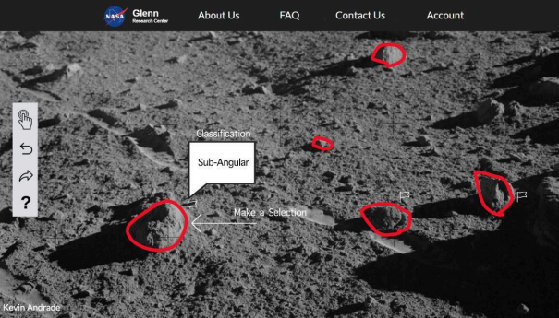

As per the Americans with Disabilities Act, we will adhere closely to the following checklist based on the Act’s guidelines:

1. Read the law documentation

2. All media files and maps should have an “alt” tag

3. All your online forms should have descriptive html tags

4. All hyperlinks should have a descriptive anchor text

5. All pages on your website have “skip navigation” links

6. All the text content should be structured using proper heading tags

7. All PDF files should be accessible

8. All videos should have subtitles, transcripts, and audio description

9. The color contrast of your web pages should be sufficient according to WCAG

10. All fonts should be accessible

11. All HTML tables should be populated with column headers, row identifiers, and

cell information

12. All audio files on your website should have a written caption

13. All call-to-action buttons on your website should have an accessible name and an

ARIA label

14. All your website should be accessible with keyboard navigation

15. Have a website accessibility policy page

16. Have easily locatable contact information to allow users to request

accessibility information

17. Test your website accessibility according to the Website Content Accessibility Guidelines

18. Automate your website accessibility check to prevent missing critical accessibility issues

We will also look to and reference the USWDS and NASA Guidelines for guidance on accessible designs.

**2.2 Hardware Interfaces**

The following are different input systems that will be kept in mind while developing this web application. Users will need a mobile device or personal computer. If they have a personal computer, they will require a mouse and keyboard or a trackpad.

**2.3 Software Interfaces**

The following are software interfaces that will be used for this product

* React 18.2.0
* MySQL 8.0
* MongoDB 7.0
* Javascript - version TBD
* Node.js 20.17.0 LTS

**2.4 Communications Interfaces**

Users will need an email if they choose to contact the team. The team’s emails are listed on the website for anybody to contact.

# **3. Legal and Ethical Considerations**

The VIPER Rocks! citizen science project aims to engage the public with lunar science research by collecting and analyzing user-generated data. However, this raises various legal and ethical considerations that must be addressed to ensure the protection of users and the responsible conduct of scientific research.

Privacy:

* The project must clearly inform users about the types of data collected through the application and how it will be used.
* User consent must be obtained explicitly before collecting any personal information.
* Secure data transfer protocols and robust data storage systems must be implemented to prevent unauthorized access.

Security:

* The security of the user’s data must be maintained. Methods will be implemented to ensure it stays secure and private.
* The project will implement secure user authentication mechanisms to prevent unauthorized access to accounts and data.

The legal and ethical considerations outlined above highlight important issues that must be addressed. It is crucial for us to ensure these concerns are handled properly for the development and operation of the VIPER Rocks! project.

# **Appendix A: Glossary**

LUNAR - Lunar Uplink for Navigation and Analysis of Reconnaissance