MPC-MAP Assignment No. 2 - Report

Author: Tomáš Linek

Date: 02.04.2026

Task 1
Two maps have been created for testing motion control: one simpler and one more complex, each 15x15 in size.
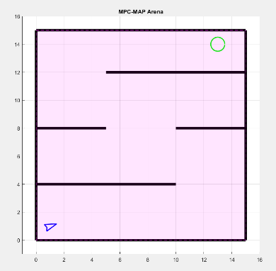
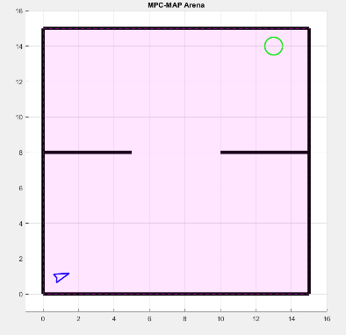

Figure 2 – week3 map complex

Figure 1 – week3 map 1

Task 2
Three defined paths on the created map. The first path is a straight line, the second is a straight line with added sine function, and the third consists of two arcs
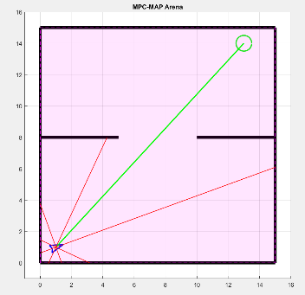
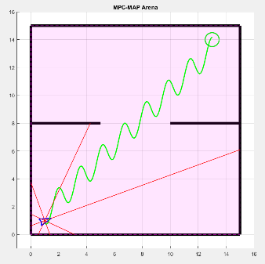
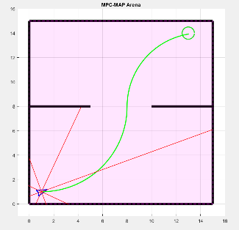

Figure 3 – Path 1 – straight line
Figure 4 – Path 2 – with added sine
Figure 5 – Path 3 - arcs

Task 3
To make the robot follow the path, a feedback linearization path-following algorithm has been implemented and tested on the paths created in Task 2 and on the path on the map in Figure 2. The feedback linearization algorithm has two parameters, kappa and epsilon.
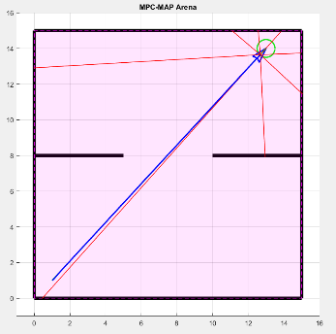
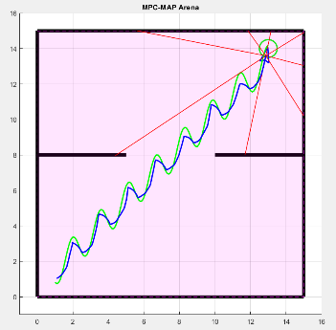
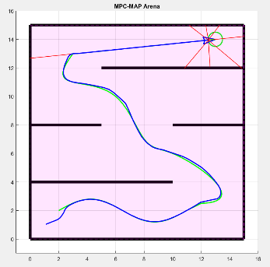
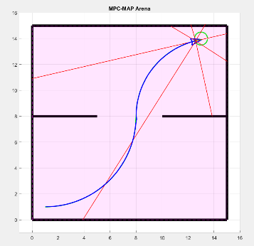
Kappa is a gain of distance error of point P from the path and acts as a P controller. The higher the kappa, the higher the control action in response to the error. Epsilon represents the look-ahead distance (distance between robot and point P). A larger epsilon gives a smoother but less accurate path following. The parameters were set to kappa = 6 and epsilon = 0.25.
Figure 9 – Combined path following
Figure 8 – Arc path following
Figure 7 – Sine path following
Figure 6 – Line path following

