MPC-MAP Assignment No. 3 - Report

Author: Tomáš Linek

Date: 10.04.2026

Task 1
The prediction function has been implemented. The predicted pose of the particles is based on the calculated linear and angular robot speed from the control input. To increase the variance of the particles, I added noise to the new predicted position of each particle. I also tried adding noise to the calculated robot speeds, but I got worse localization results.

Task 2
The functions compute_lidar_measurement and weight_particles have been implemented. For weight calculation, two methods have been implemented: the first using a normal distribution and the second using Euclidean distance. Robot localization performed better using Euclidean distance, so I chose this method.

Task 3
The function resample_particles has been implemented using Thrun's heuristic algorithm. To mitigate the kidnapped robot problem, 10% of all particles are set to a random position on the map. For random distribution of particles across the map, a new function input was added to access the map limits.

Task 4
Most important parameters are number of randomly distributed particles during resample step and the value of noise in prediction step. The low number of randomly distributed particles leads to stack the estimated pose in wrong position and not convergent to the position of robot, on the other hand to high number leads to poor pose estimation. With too little noise in prediction step, the estimated position does change between similar parts of the map, with too much noise, the localization becomes unstable. The major issue was to find the cause of unexpected failures in the position estimate using the particle filter. These failures were caused by the weights being set to NaN in cases where the lidar did not detect any wall.

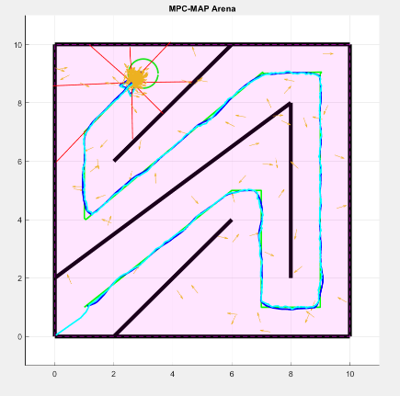
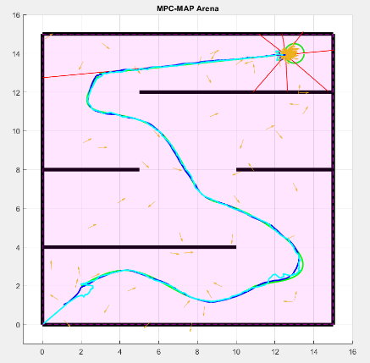
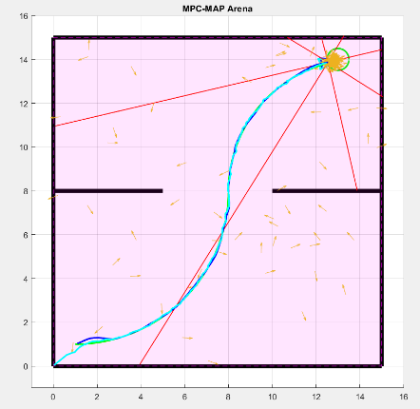
Figures 1, 2, and 3 show the testing of the implemented particle filter, where the robot follows the path based on the estimated pose from the particle filter.
Figure 3 – Third path following
Figure 2 – Second path following
Figure 1 – First path following

