MPC-MAP Assignment No. 5 - Report

Author: Tomáš Linek

Date: 25.04.2026

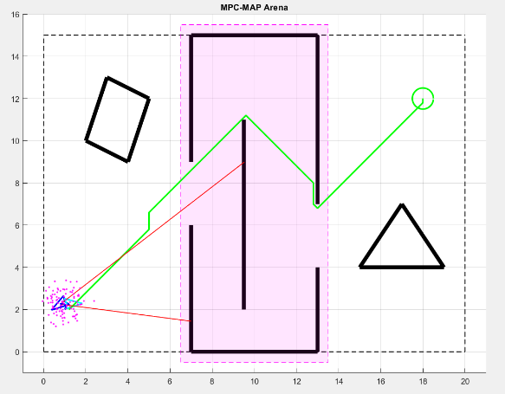
Task 1
The A* algorithm was selected and implemented to find the optimal path between the starting pose and the goal. The robot's estimated pose was used as the starting position. For navigation within the occupancy grid, eight possible directions of movement were set. The resulting path planned by the A* algorithm is shown in Figure 1.

Figure 1 – Path planning

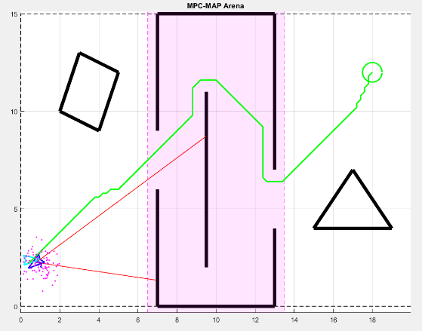
Task 2
Obstacle clearance was ensured by dilating walls using 2D convolution. Any cell with a post-convolution value greater than zero was redefined as an obstacle. The clearance was set to 0.4 m.

Figure 2 – Path planning – obstacle clearance

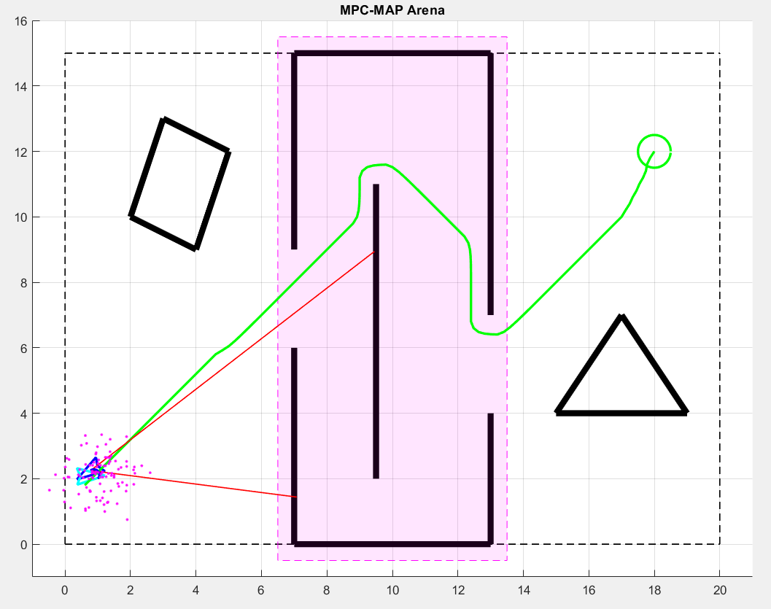
Task 3
An iterative method was used for path smoothing. This method uses two parameters: alpha and beta. The alpha parameter defines how closely the new path follows the original path, and the beta parameter affects the smoothness of the new path. Based on experimental testing, alpha = 0.2 and beta = 0.4 were chosen as the optimal balance. The final smoothed path is shown in Figure 3.

Figure 3 – Path planning – smoothed

