MPC-MAP Assignment No. 1 - Report

Author: Tomáš Linek

Date: 28.03.2026

Task 2
GNSS std: 0.5141, 0.5018
Lidar std: 0.0506, 0.0496, 0.0492, 0.0494, 0.0494, 0.0498, 0.0498, 0.0497
Based on the calculated values, the standard deviation can be considered consistent across individual LiDAR channels and both GNSS axes.
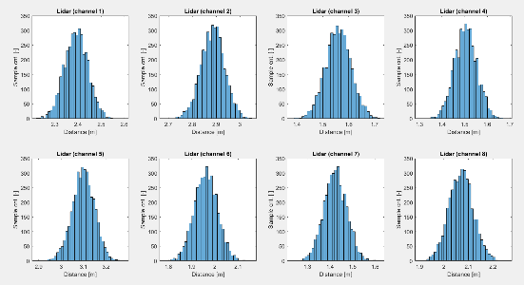
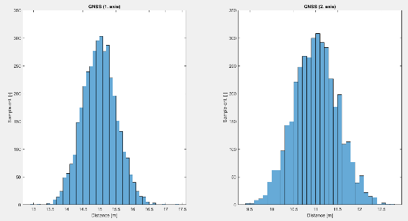

Figure 1 – GNSS histogram
Figure 2 – LiDAR histogram

Task 3
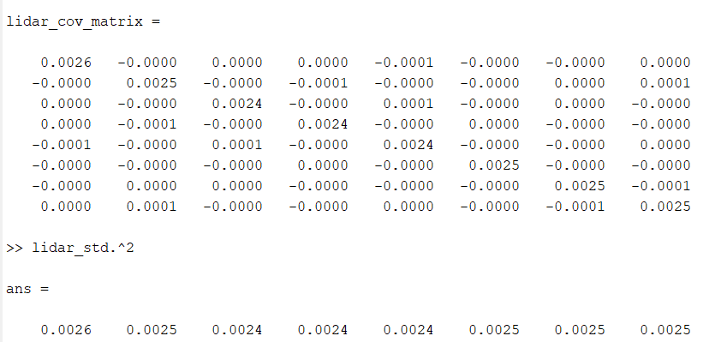
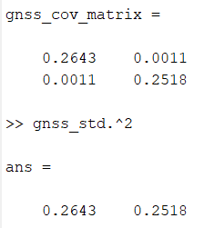
From Figures 3 and 4 we can see that the covariance matrix for the GNSS is of size 2x2 and for LiDAR 8x8, and also that the values on the main diagonal are equal to the variance of the channels/axes.

Figure 4 – LiDAR covariance matrix and channels variance
Figure 3 – GNSS covariance matrix and axes variance

Task 4
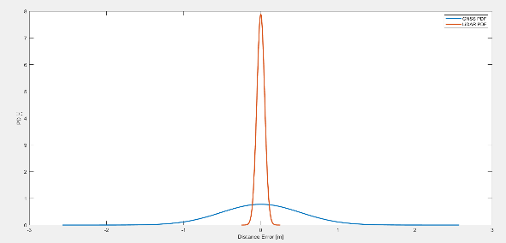
Calculated probability density function of the normal distribution for the 1st LiDAR channel and the X GNSS axis.

Figure 5 – PDF (red – 1st LiDAR channel, blue – X GNSS axis)

Task 5
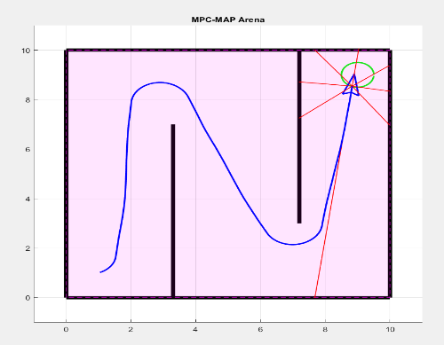
Potential sources of uncertainty in the robot's motion could be wheel slip, differences in wheel diameters or differences in motor characteristics.

Figure 6 – Robot open loop control – map indoor_1

