MPC-MAP Assignment No. 4 - Report

Author: Tomáš Linek

Date: 18.04.2026

Task 1
The initialization procedure and the trajectory from start to goal have been implemented. During initialization, the robot stands still for 100 iterations, then the mean and covariance matrix are calculated from the collected GNSS data.

Task 2
The ekf_predict function has been implemented using the EKF prediction step due to the nonlinear differential drive kinematics. Also, the kf_correct function has been implemented for the correction phase, as the measurement model is linear.

Task 3
The initial belief has been set to the start pose and the sigma matrix to zeros. The measurement noise matrix has been filled with values obtained in the first assignment.
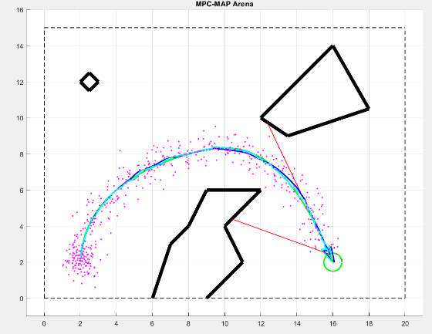
Figure 1 shows the path following based on EKF pose estimation after the process noise matrix has been tuned.

Figure 1 – Path following – known initial pose

Task 4
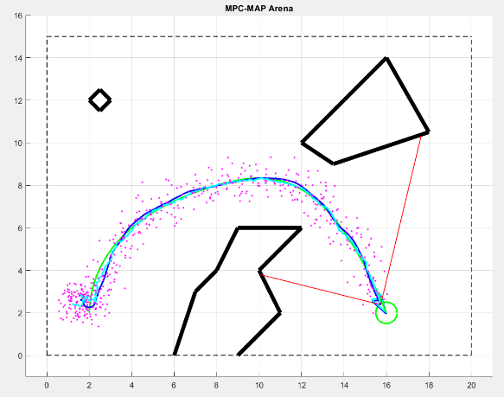
The initialization procedure from Task 1 has been utilized to determine the initial belief. I also changed the robot's initial pose to test the filter's convergence. Figure 2 captures how the estimated pose converges to the real pose values, even though the initial orientation was unknown.
Figure 2 – Path following – unknown initial pose

