We were walking through a quiet industrial block near the edge of town when we noticed a narrow passage that looked unusually restricted compared to the surrounding area. The entrance had been temporarily modified, with a notice attached to the frame as part of some ongoing maintenance work. Nothing else in the environment suggested anything unusual, but the posted notice made it clear that some actions were not allowed at that moment. We briefly stopped to take a photo before continuing on our way. Here is the photo of the signs.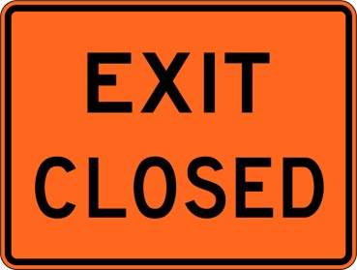
Peter like these words in the picture below.

