ELE432
Advanced Digital Design
Preliminary Work 3
Multicycle Processor RISC-V
Name: Emre Kerim Kaymak |  |  |  | Number: 2220357045

Q1) HOURS SPENT
Approximately 5 hours has been spent on this homework, 2 hours of writing the code, 1 hour of debugging, I was quite lucky that the code worked in the first iteration this time. The remaining 2 hours were used for drawing schematics as well and also to prepare this document.
Q2) HIERARCHICAL DIAGRAM
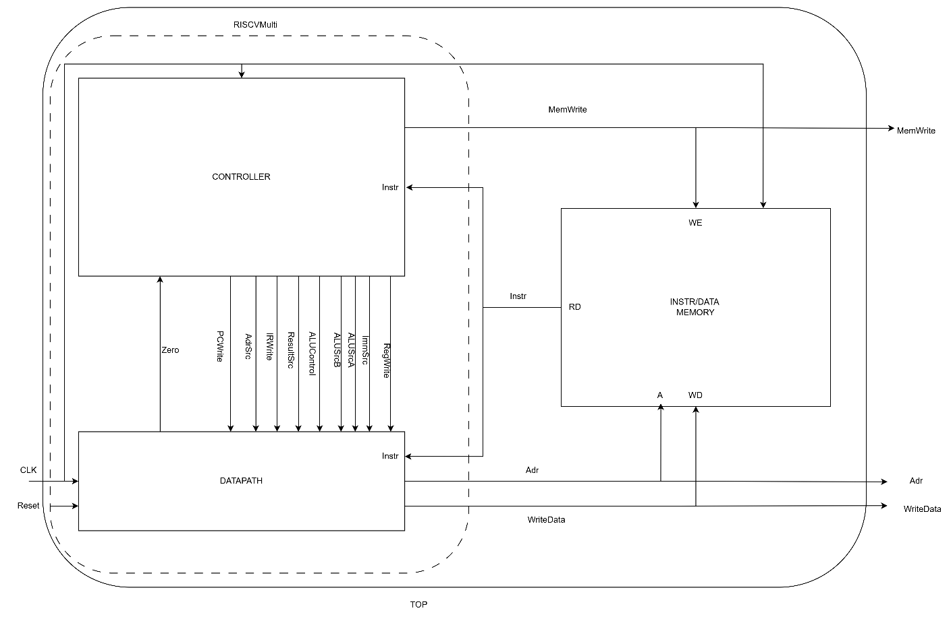

Q3) SYSTEM VERILOG CODE
module top(
input logic clk, reset,
output logic [31:0] WriteData, DataAdr,
output logic MemWrite
);

// ================= INTERNAL SIGNALS =================

// PC path
logic [31:0] PC, PCNext, OldPC;

// Memory
logic [31:0] Adr, ReadData, Data;

// Instruction
logic [31:0] Instr;

// Register file
logic [31:0] RD1, RD2;
logic [31:0] RD1_reg, RD2_reg;

// ALU
logic [31:0] SrcA, SrcB, ALUResult, ALUOut;
logic Zero;

// Immediate
logic [31:0] ImmExt;

// Result
logic [31:0] Result;

// Control signals
logic [1:0] ImmSrc, ALUSrcA, ALUSrcB, ResultSrc;
logic [2:0] ALUControl;
logic AdrSrc;
logic IRWrite, PCWrite, RegWrite;

// ================= CONTROLLER =================
controller ctrl (
.clk(clk),
.reset(reset),
.op(Instr[6:0]),
.funct3(Instr[14:12]),
.funct7b5(Instr[30]),
.zero(Zero),

.immsrc(ImmSrc),
.alusrca(ALUSrcA),
.alusrcb(ALUSrcB),
.resultsrc(ResultSrc),
.adrsrc(AdrSrc),
.alucontrol(ALUControl),
.irwrite(IRWrite),
.pcwrite(PCWrite),
.regwrite(RegWrite),
.memwrite(MemWrite)
);
// ================= PC REGISTER =================
always_ff @(posedge clk or posedge reset) begin
if (reset)
PC <= 32'b0;
else if (PCWrite)
PC <= PCNext;
end

// ================= OLD PC REGISTER =================
always_ff @(posedge clk) begin
if (IRWrite)
OldPC <= PC;
end

// ================= ADDRESS MUX =================
assign Adr = (AdrSrc) ? Result : PC;

// ================= MEMORY =================
mem memory (
.clk(clk),
.WE(MemWrite),
.A(Adr),
.WD(RD2_reg),
.RD(ReadData)
);

// ================= INSTRUCTION REGISTER ================
always_ff @(posedge clk) begin
if (IRWrite)
Instr <= ReadData;
end

// ================= DATA REGISTER =================
always_ff @(posedge clk) begin
Data <= ReadData;
end

// ================= REGISTER FILE =================
regfile rf (
.clk(clk),
.reset(reset),
.WE3(RegWrite),
.A1(Instr[19:15]),
.A2(Instr[24:20]),
.A3(Instr[11:7]),
.WD3(Result),
.RD1(RD1),
.RD2(RD2)
);

// ================= RD1 / RD2 PIPE REGISTERS =================
always_ff @(posedge clk) begin
RD1_reg <= RD1;
RD2_reg <= RD2;
end

// ================= IMMEDIATE =================
sign_extend imm (
.instr(Instr),
.Immsrc(ImmSrc),
.dataout(ImmExt)
);
// ================= SRC A MUX =================
always_comb begin
case (ALUSrcA)
2'b00: SrcA = PC;
2'b01: SrcA = OldPC;
2'b10: SrcA = RD1_reg;
default: SrcA = 32'b0;
endcase
end

// ================= SRC B MUX =================
always_comb begin
case (ALUSrcB)
2'b00: SrcB = RD2_reg;
2'b01: SrcB = ImmExt; // ← your correction
2'b10: SrcB = 32'd4; // ← your correction
default: SrcB = 32'b0;
endcase
end

// ================= ALU =================
myALU alu (
.SrcA(SrcA),
.SrcB(SrcB),
.ALUControl(ALUControl),
.zerof(Zero),
.ALUResult(ALUResult)
);

// ================= ALU OUTPUT REGISTER =================
always_ff @(posedge clk) begin
ALUOut <= ALUResult;
end

// ================= RESULT MUX =================
always_comb begin
case (ResultSrc)
2'b00: Result = ALUOut;
2'b01: Result = Data;
2'b10: Result = ALUResult;
default: Result = 32'b0;
endcase
end

// ================= PC NEXT =================
assign PCNext = Result;

// ================= OUTPUTS =================
assign WriteData = RD2_reg;
assign DataAdr = Adr;

endmodule
module regfile (
input logic clk,
input logic reset,
input logic WE3,
input logic [4:0] A1,
input logic [4:0] A2,
input logic [4:0] A3,
input logic [31:0] WD3,
output logic [31:0] RD1,
output logic [31:0] RD2
);

logic [31:0] rf [31:0];

always_ff @(posedge clk or posedge reset) begin
if (reset) begin
for (int i = 0; i < 32; i++)
rf[i] <= 32'b0;
end
else if (WE3 && (A3 != 5'b0)) begin
rf[A3] <= WD3;
end
end

always_comb begin
RD1 = (A1 == 5'b0) ? 32'b0 : rf[A1];
RD2 = (A2 == 5'b0) ? 32'b0 : rf[A2];
end

endmodule

module sign_extend (
input logic [31:0] instr,
input logic [1:0] Immsrc,
output logic [31:0] dataout
);
always_comb begin
case (Immsrc)
2'b00: // I-type
dataout = {{20{instr[31]}}, instr[31:20]};
2'b01: // S-type
dataout = {{20{instr[31]}}, instr[31:25], instr[11:7]};
2'b10: // B-type
dataout = {{20{instr[31]}}, instr[7], instr[30:25], instr[11:8], 1'b0};
2'b11: // J-type
dataout = {{12{instr[31]}}, instr[19:12], instr[20], instr[30:21], 1'b0};
default:
dataout = 32'b0;
endcase
end
endmodule
module controller(
input logic clk,
input logic reset,
input logic [6:0] op,
input logic [2:0] funct3,
input logic funct7b5,
input logic zero,

output logic [1:0] immsrc,
output logic [1:0] alusrca, alusrcb,
output logic [1:0] resultsrc,
output logic adrsrc,
output logic [2:0] alucontrol,
output logic irwrite, pcwrite,
output logic regwrite, memwrite
);

// ========= OPCODE CONSTANTS =========
localparam [6:0]
LW = 7'b0000011,
SW = 7'b0100011,
RT = 7'b0110011,
IT = 7'b0010011,
JAL = 7'b1101111,
BEQ = 7'b1100011;

// ========= STATE TYPE =========
typedef enum logic [3:0] {
FETCH,
DECODE,
MEMADR,
MEMREAD,
MEMWB,
MEMWRITE,
EXECUTER,
ALUWB,
EXECUTEL,
JAL_S,
BEQ_S
} state_t;

state_t state_cur, state_next;

logic [1:0] ALUOp;

// ALU DECODER
aludec alu_decoder (
.opb5(op[5]),
.funct3(funct3),
.funct7b5(funct7b5),
.ALUOp(ALUOp),
.ALUControl(alucontrol)
);

//INSTR DECODER
instrdec instr_decoder (
.op(op),
.ImmSrc(immsrc)
);

// ================= STATE REGISTER =================
always_ff @(posedge clk or posedge reset) begin
if (reset)
state_cur <= FETCH;
else
state_cur <= state_next;
end

// ================= NEXT STATE LOGIC =================
always_comb begin
state_next = state_cur;

case (state_cur)

FETCH: state_next = DECODE;

DECODE: begin
case (op)
LW, SW: state_next = MEMADR;
RT: state_next = EXECUTER;
IT: state_next = EXECUTEL;
JAL: state_next = JAL_S;
BEQ: state_next = BEQ_S;
default:state_next = FETCH;
endcase
end

MEMADR: begin
if (op == LW) state_next = MEMREAD;
else state_next = MEMWRITE;
end

MEMREAD: state_next = MEMWB;
MEMWB: state_next = FETCH;
MEMWRITE: state_next = FETCH;

EXECUTER: state_next = ALUWB;
EXECUTEL: state_next = ALUWB;
BEQ_S: state_next = FETCH;
ALUWB: state_next = FETCH;
JAL_S: state_next = ALUWB;

endcase
end
// ================= OUTPUT LOGIC =================
always_comb begin
// ===== DEFAULTS =====
//immsrc = 2'b00;
alusrca = 2'b00;
alusrcb = 2'b00;
resultsrc = 2'b00;
adrsrc = 1'b0;

irwrite = 1'b0;
pcwrite = 1'b0;
regwrite = 1'b0;
memwrite = 1'b0;

ALUOp = 2'b00;
/*
// ===== IMM SRC based on opcode =====
case (op)
LW, IT: immsrc = 2'b00;
SW: immsrc = 2'b01;
BEQ: immsrc = 2'b10;
JAL: immsrc = 2'b11;
default: immsrc = 2'b00;
endcase
*/

// ===== STATE-BASED OUTPUTS =====
case (state_cur)

FETCH: begin
alusrca = 2'b00;
alusrcb = 2'b10;
irwrite = 1'b1;
pcwrite = 1'b1;
resultsrc = 2'b10;
adrsrc = 1'b0;
ALUOp = 2'b00;
end

DECODE: begin
alusrca = 2'b01;
alusrcb = 2'b01;
ALUOp = 2'b00;
end

MEMADR: begin
alusrca = 2'b10;
alusrcb = 2'b01;
ALUOp = 2'b00;
end

MEMREAD: begin
adrsrc = 1'b1;
resultsrc = 2'b00;
end
MEMWB: begin
resultsrc = 2'b01;
regwrite = 1'b1;
end

MEMWRITE: begin
resultsrc = 2'b00;
adrsrc = 1'b1;
memwrite = 1'b1;
end

EXECUTER: begin
alusrca = 2'b10;
alusrcb = 2'b00;
ALUOp = 2'b10;
end

EXECUTEL: begin
alusrca = 2'b10;
alusrcb = 2'b01;
ALUOp = 2'b10;
end

ALUWB: begin
resultsrc = 2'b00;
regwrite = 1'b1;
end

JAL_S: begin
alusrca = 2'b01;
alusrcb = 2'b10;
ALUOp = 2'b00;
resultsrc = 2'b00;
pcwrite = 1'b1;
end

BEQ_S: begin
alusrca = 2'b10;
alusrcb = 2'b00;
ALUOp = 2'b01;
resultsrc = 2'b00;
if (zero)
pcwrite = 1'b1;
end

endcase
end

endmodule
module aludec(input logic opb5,
input logic [2:0] funct3,
input logic funct7b5,
input logic [1:0] ALUOp,
output logic [2:0] ALUControl);
logic RtypeSub;
assign RtypeSub = funct7b5 & opb5; // TRUE for R-type subtract instruction
always_comb
case(ALUOp)
2'b00: ALUControl = 3'b000; // addition
2'b01: ALUControl = 3'b001; // subtraction
default: case(funct3) // R-type or I-type ALU
3'b000: if (RtypeSub)
ALUControl = 3'b001; // sub
else
ALUControl = 3'b000; // add, addi
3'b010: ALUControl = 3'b101; // slt, slti
3'b110: ALUControl = 3'b011; // or, ori
3'b111: ALUControl = 3'b010; // and, andi
default: ALUControl = 3'bxxx; // ???
endcase
endcase
endmodule

module instrdec(
input logic [6:0] op,
output logic [1:0] ImmSrc
);

always_comb
case(op)
7'b0110011: ImmSrc = 2'b00; // R-type
7'b0010011: ImmSrc = 2'b00; // I-type ALU
7'b0000011: ImmSrc = 2'b00; // lw
7'b0100011: ImmSrc = 2'b01; // sw
7'b1100011: ImmSrc = 2'b10; // beq
7'b1101111: ImmSrc = 2'b11; // jal
default: ImmSrc = 2'b00;
endcase

endmodule

module mem (
input logic clk,
input logic WE, // write enable
input logic [31:0] A, // address
input logic [31:0] WD, // write data
output logic [31:0] RD // read data
);

logic [31:0] RAM [0:63];

// Initialize memory from file
initial begin
$readmemh("memfile.txt", RAM);
end

// Write (synchronous)
always_ff @(posedge clk) begin
if (WE) begin
RAM[A[31:2]] <= WD;
end
end

// Read (asynchronous)
assign RD = RAM[A[31:2]];

endmodule
module adder_n #(
parameter N = 32
) (
input logic [N-1:0] a,
input logic [N-1:0] b,
input logic cin,
output logic [N-1:0] sum,
output logic cout
);
assign {cout, sum} = a + b + cin;
endmodule

module myALU #(
parameter N = 32
)(
input logic [31:0] SrcA,
input logic [31:0] SrcB,
input logic [2:0] ALUControl,
output logic zerof,
output logic [31:0] ALUResult
);

logic [31:0] Bmux;
logic [31:0] sum;
logic cout;
logic overflow;
logic cin;

assign Bmux = SrcB ^ {32{ALUControl[0]}}; //basically take invert if 1 o.w. 0
assign cin = ALUControl[0];

adder_n #(.N(32)) adder_inst (
.a (SrcA),
.b (Bmux),
.cin (cin),
.sum (sum),
.cout(cout)
);
assign overflow =
(ALUControl[1] == 1'b0) &&
(SrcA[31] == Bmux[31]) &&
(sum[31] != SrcA[31]);

// ALU Operations

always_comb begin
case (ALUControl)

3'b000: ALUResult = sum; // ADD
3'b001: ALUResult = sum; // SUB
3'b010: ALUResult = SrcA & SrcB; // AND
3'b011: ALUResult = SrcA | SrcB; // OR
3'b100: ALUResult = SrcA ^ SrcB; // XOR

3'b101: // SLT (signed)
ALUResult = {31'b0, (overflow ^ sum[31])};

3'b110: ALUResult = SrcA >> SrcB[4:0]; // SRL
3'b111: ALUResult = SrcA << SrcB[4:0]; // SLL

default: ALUResult = 32'b0;
endcase

zerof = (ALUResult == 32'b0);
end

endmodule

Q4) KEY SIGNALS FOR FIRST 3 INSTRUCTIONS
STEP | PC | INSTR | STATE | RESULT (in hex)
3 | 00 | 00500113 | FETCH | 4
4 | 04 | 00500113 | DECODE | X
5 | 04 | 00500113 | EXECUTEL | X
6 | 04 | 00500113 | ALUWB | 5
7 | 04 | 00500113 | FETCH | 8
8 | 08 | 00C00193 | DECODE | X
9 | 08 | 00C00193 | EXECUTEL | X
10 | 08 | 00C00193 | ALUWB | C
11 | 08 | 00C00193 | FETCH | C
12 | 0C | FF718393 | DECODE | X
13 | 0C | FF718393 | EXECUTEL | X
14 | 0C | FF718393 | ALUWB | 3
15 | 10 | FF718393 | FETCH | 10

Q5) SIMULATION WAVEFORMS
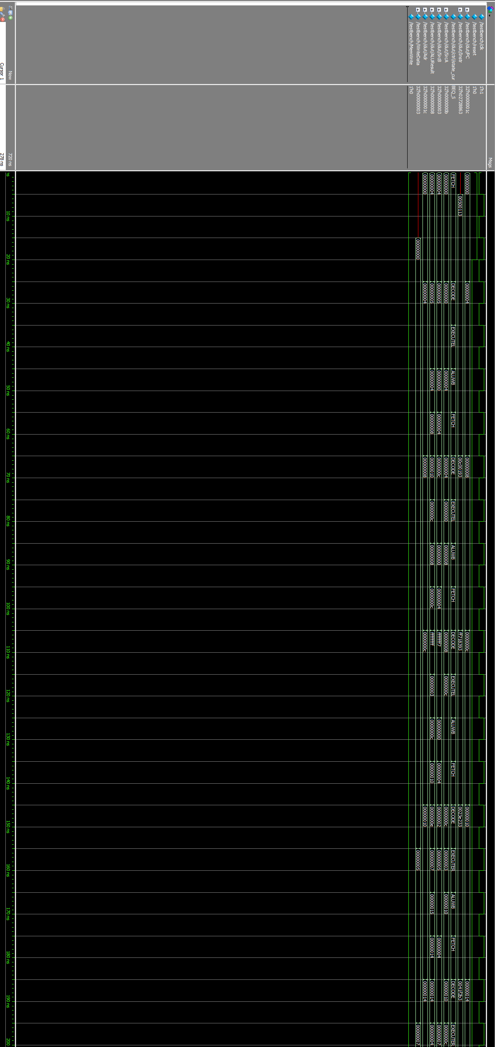

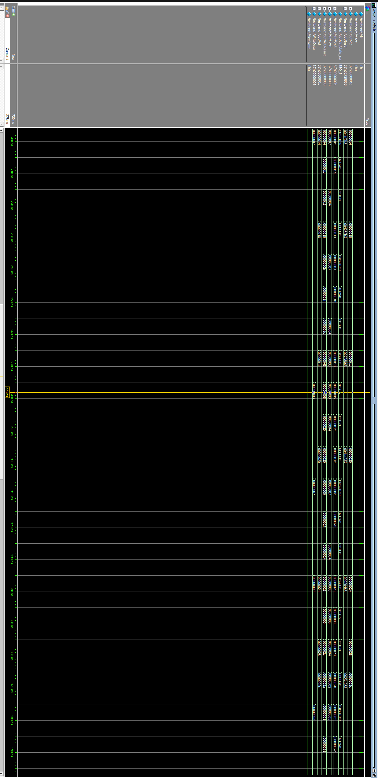
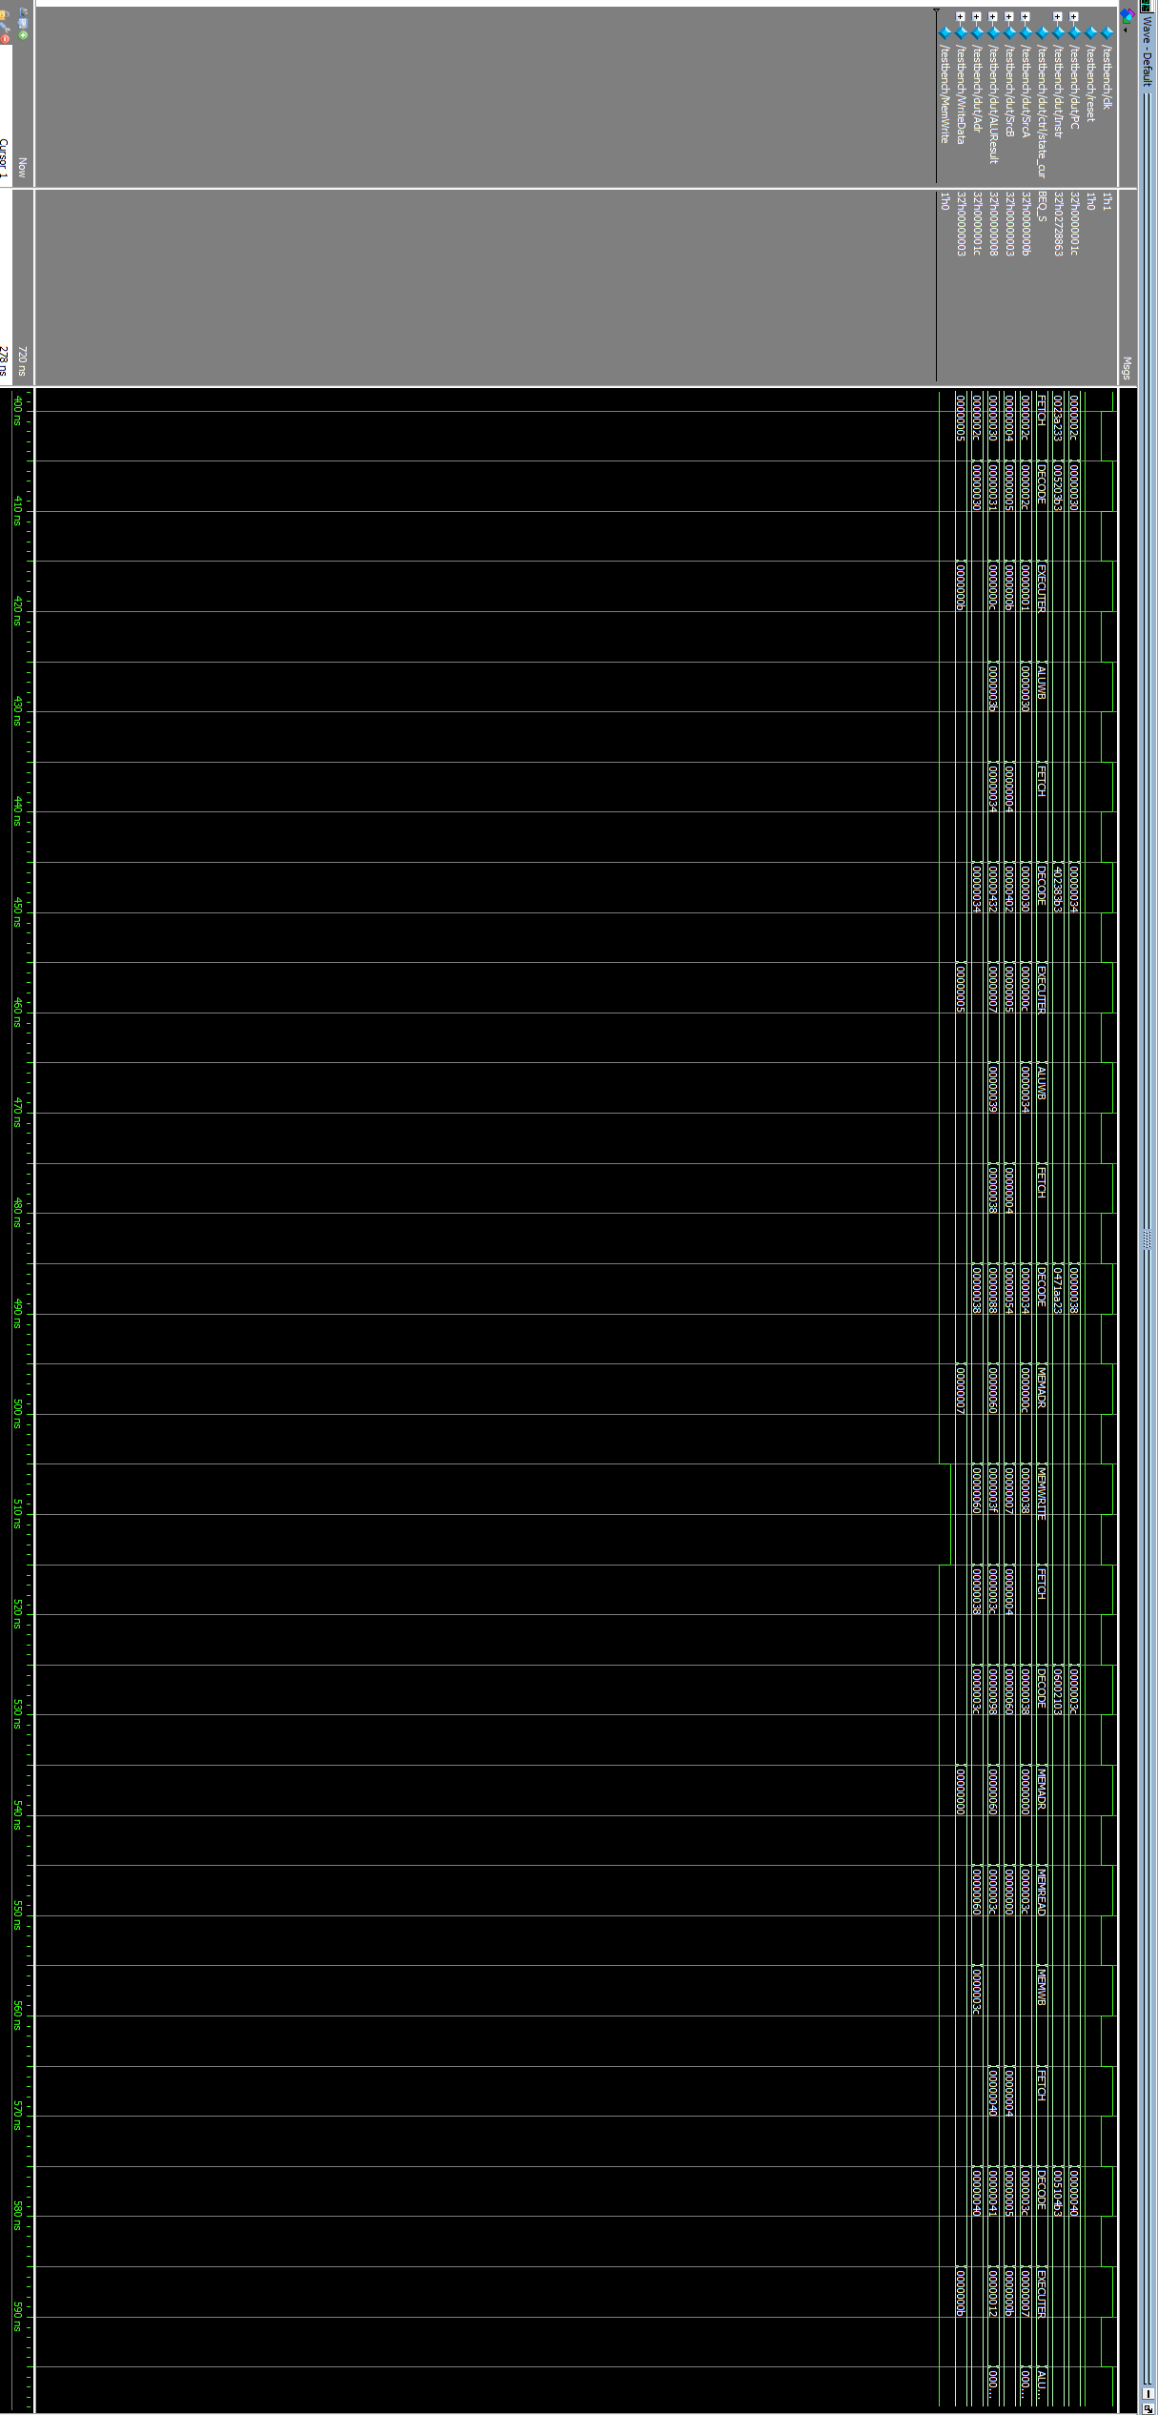
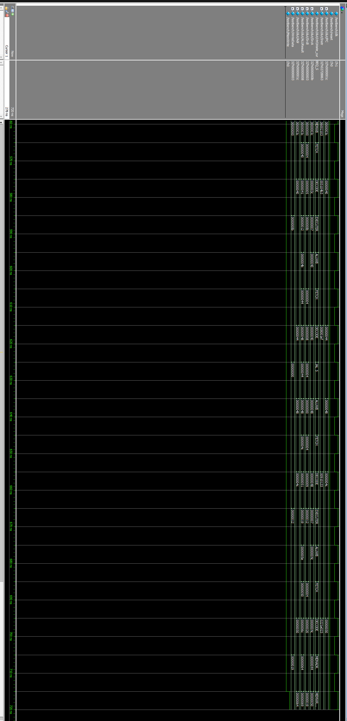
At the end of the last page, the confirmation that the test vector is correct can be checked, as given is the riscvtest.s file “# If successful, it should write the value 25 to address 100”, here it can clearly be seen that this is correct.
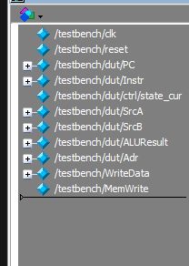
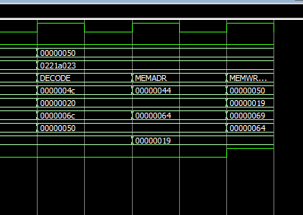
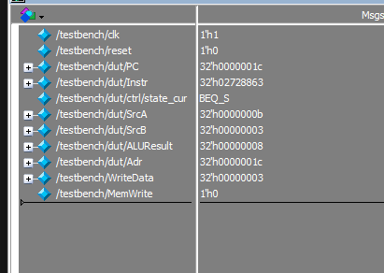
A zoomed in part of the page is given:
A slight problem is that every instruction seem to happen a PC in delay meaning at a PC + 4 of what is the required by the file. Otherwise, no other serious problem can be observed.
Q6) GITHUB LINK
https://github.com/TM-LEONARDO/RISC_V-MULTICYCLE-PROCESSOR_-PRELIMINARY/tree/main

