**REPORT**

CI7300: Data Management and Governance

Coursework: Database Design & Development

**1. Introduction:**

Every individual agency now-a-days maintains a database to keep each document record and fetch them properly and efficiently when needed. It helps the agencies to manage their overall work in a proper and perfect way. Delphi Promotions is a promotion company and it handles advertising campaigns in order to promote the products of its clients. Based on suitable portfolio, the client chooses a particular campaign and Delphi produces specific adverts and arranges for the advertising space on relevant mediums. Delphi requires the tracking of its clients and campaigns with respective details properly in order to maintain efficiency, accuracy and scalability. This report aims at the design and development of a database for Delphi Promotions. This database will be useful to keep the record of all staffs, clients, campaigns, advertisements with their respective components and placements, meeting details. The job of overall management and dealing with the clients will become easier using this database. It will help the company to prevent the losses that may happen in dealing all the business using only paper trails. The company will also be able to maintain further communication with their clients after the respective campaign is finished. This will help the marketing sector of the company to flourish in future.

**Aims:**

1. Identify the necessary data and objects handled by the promotion company.
2. Develop the class diagram showing the interactions between objects of different classes.
3. Develop the database maintaining the interactions and using necessary constraints implied by the company.
4. Develop queries to fetch out necessary data as per the requirements of the company.
5. Use the efficiency of data management through the database for further marketing.

**Objectives:**

1. To keep the staff and client details for better management.
2. To keep the details of each of the campaign in order to monitor their status and update them efficiently when needed.
3. To maintain the details of staffs who attended the meetings in order to monitor their performance.
4. To help the clients in nominating suitable staff as their contact in corresponding campaign.
5. To assist the campaign managers in monitoring the status of each adverts and the job of placements.
6. To find out the eligible list of staff those can be assigned as account manager for clients.

**2. Class Diagram**

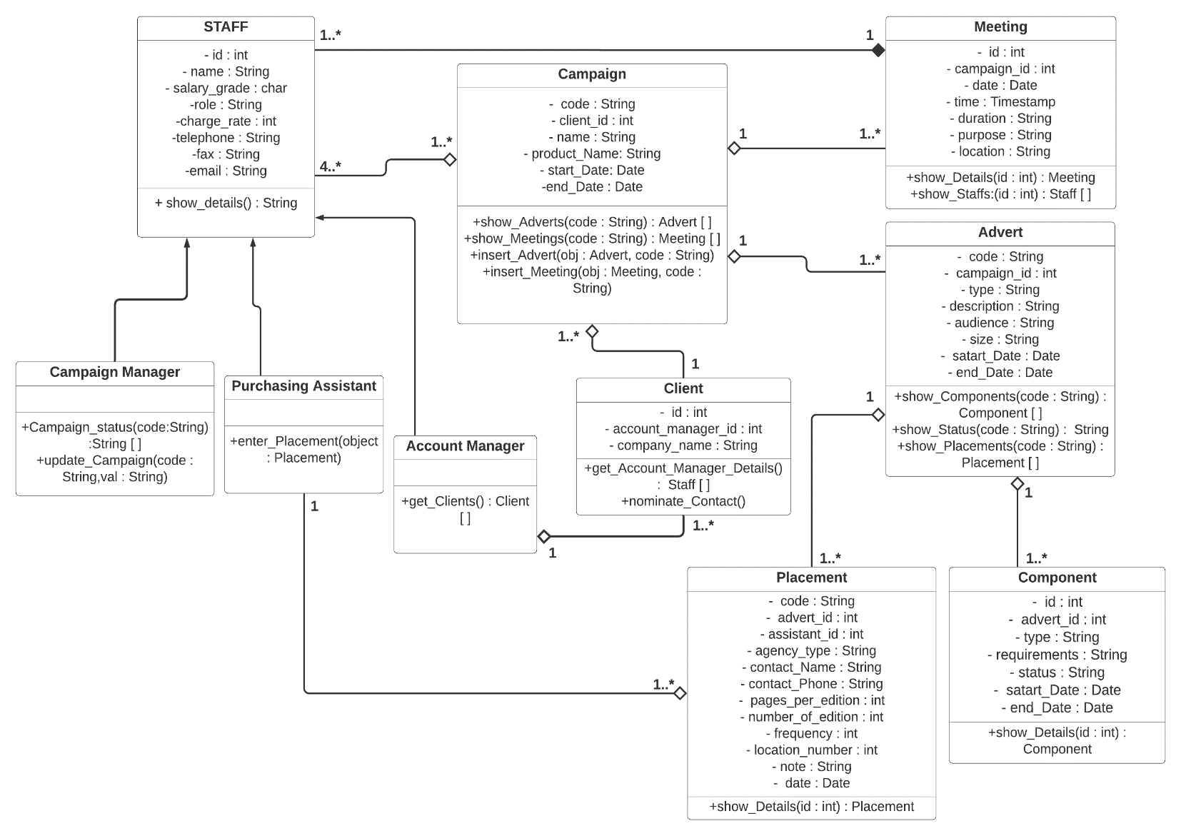

**Figure:** Class diagram of Delphi system

**Assumptions:**

1. A staff of the company of any particular role can work in one or more than one campaigns.
2. Each campaign has exactly one client but each client can involve in more than one campaigns.
3. Each campaign can have multiple adverts but each advert will belong to exactly one campaign. The campaign finishes when all of its adverts are completed.
4. Each advert can have multiple components but each component belongs to exactly one advert according to their respective requirements. The advert finishes when the design of all the components inside that advert is completed.
5. Each advert can have multiple placements but each placement belongs to exactly one advert. Each placement is supervised by a placement assistant who is a staff of the promotion company attached to that campaign.
6. Each component will have a status column which can hold three values. Not started, ongoing and ready.

**Constraints:**

1. Each table in the database has an id which is a primary key. This id uniquely identifies each row and it can’t be null.
2. Campaign, advert and placement tables maintain a code that uniquely identifies each object and can’t be null. This code will be useful for the application developer to query the database.
3. Each one to many relation in the database will be identified by a foreign key which can’t be null and the type of this key need to match the value type in the parent table. This foreign key will need the on delete cascade option enabled.
4. Tables with start and end date attributes will include check constraint with condition that start date is lower than end date.
5. Attributes that can’t have null values will need the not null option enabled.

**3. Implementation**

This section represents the definitions of the tables in the database.

1. SALARY Table

CREATE TABLE SALARY

(

SALARY_ID NUMBER,

SALARY_GRADE VARCHAR2(20) not null,

SALARY NUMBER not null,

constraint salary_pk PRIMARY KEY(SALARY_ID)

);

1. STAFF Table

CREATE TABLE STAFF

(

STAFF_ID NUMBER,

STAFF_NAME VARCHAR2(50) not null,

SALARY_ID NUMBER not null,

STAFF_ROLE VARCHAR2(40) not null,

CHARGE_OUT_RATE NUMBER not null,

TELEPHONE_NO VARCHAR2(30) not null,

FAX_NO VARCHAR2(30) not null,

EMAIL_ID VARCHAR2(40) not null,

constraint staff_pk PRIMARY KEY(STAFF_ID),

constraint staff_fk_1 FOREIGN KEY(SALARY_ID) references

SALARY(SALARY_ID) on delete cascade

);

1. CLIENT Table

CREATE TABLE CLIENT

(

CLIENT_ID NUMBER,

COMPANY_NAME VARCHAR2(40) not null,

ACC_MANAGER_ID NUMBER not null,

constraint client_pk PRIMARY KEY(CLIENT_ID),

constraint client_fk_1 FOREIGN KEY(ACC_MANAGER_ID) references

STAFF(STAFF_ID) on delete cascade

);

1. CAMPAIGN Table

CREATE TABLE CAMPAIGN

(

CAMPAIGN_ID NUMBER,

CAMPAIGN_NAME VARCHAR2(50) not null,

CAMPAIGN_CODE VARCHAR2(15) not null unique,

CLIENT_ID NUMBER not null,

CAMPAIGN_PRODUCT VARCHAR2(40) not null,

START_DATE DATE,

END_DATE DATE,

constraint campaign_pk PRIMARY KEY(CAMPAIGN_ID),

constraint campaign_fk_1 FOREIGN KEY(CLIENT_ID) references CLIENT(CLIENT_ID) on

delete cascade,

constraint campaign_date_check CHECK(END_DATE > START_DATE)

);

1. MEETING Table

CREATE TABLE MEETING

(

MEETING_ID NUMBER,

CAMPAIGN_ID NUMBER not null,

DATE_and_TIME TIMESTAMP not null,

DURATION VARCHAR2(20) not null,

PURPOSE VARCHAR2(300) not null,

LOCATION VARCHAR2(100) not null,

constraint meeting_pk PRIMARY KEY(MEETING_ID),

constraint meeting_fk_1 FOREIGN KEY(CAMPAIGN_ID) references

CAMPAIGN(CAMPAIGN_ID) on delete cascade

);

1. STAFF_CAMPAIGN Table

This table is an intermediate table and it stores the data that represents the many to many relation in between STAFF and CAMPAIGN tables.

CREATE TABLE STAFF_CAMPAIGN

(

STAFF_CAMPAIGN_ID NUMBER,

STAFF_ID NUMBER not null,

CAMPAIGN_ID NUMBER not null,

constraint staff_campaign_pk PRIMARY KEY(STAFF_CAMPAIGN_ID),

constraint staff_campaign_fk_1 FOREIGN KEY(STAFF_ID) references STAFF(STAFF_ID)

on delete cascade,

constraint staff_campaign_fk_2 FOREIGN KEY(CAMPAIGN_ID) references

CAMPAIGN(CAMPAIGN_ID) on delete cascade,

constraint staff_campaign_unique UNIQUE(STAFF_ID, CAMPAIGN_ID)

);

1. STAFF_MEETING Table

This table represents the many to many relation between STAFF and MEETING tables.

CREATE TABLE STAFF_MEETING

(

STAFF_MEETING_ID NUMBER,

STAFF_ID NUMBER not null,

MEETING_ID NUMBER not null,

constraint staff_meeting_pk PRIMARY KEY(STAFF_MEETING_ID),

constraint staff_meeting_fk_1 FOREIGN KEY(STAFF_ID) references STAFF(STAFF_ID)

on delete cascade,

constraint staff_meeting_fk_2 FOREIGN KEY(MEETING_ID) references

MEETING(MEETING_ID) on delete cascade,

constraint staff_meeting_unique UNIQUE(STAFF_ID, MEETING_ID)

);

1. ADVERT Table

CREATE TABLE ADVERT

(

ADVERT_ID NUMBER,

ADVERT_CODE VARCHAR2(15) not null unique,

CAMPAIGN_ID NUMBER not null,

ADVERT_TYPE VARCHAR2(20) not null,

BRIEF_DESC VARCHAR2(400) not null,

AUDIENCE VARCHAR2(300) not null,

ADVERT_SIZE VARCHAR2(300) not null,

START_DATE DATE,

END_DATE DATE,

constraint advert_pk PRIMARY KEY(ADVERT_ID),

constraint advert_check_date CHECK(END_DATE > START_DATE),

constraint advert_fk_1 FOREIGN KEY(CAMPAIGN_ID) references

CAMPAIGN(CAMPAIGN_ID) on delete cascade

);

1. COMPONENT Table

CREATE TABLE COMPONENT

(

COMPONENT_ID NUMBER,

ADVERT_ID NUMBER not null,

TYPE VARCHAR2(100) not null,

REQUIREMENTS VARCHAR2(250) not null,

STATUS VARCHAR2(100) not null,

START_DATE DATE,

END_DATE DATE,

constraint component_pk PRIMARY KEY(COMPONENT_ID),

constraint component_date_check CHECK(END_DATE > START_DATE),

constraint component_fk_1 FOREIGN KEY(ADVERT_ID) references

ADVERT(ADVERT_ID) on delete cascade

);

1. PLACEMENT Table

CREATE TABLE PLACEMENT

(

PLACEMENT_ID NUMBER,

ADVERT_ID NUMBER not null,

ASSISTANT_ID NUMBER not null,

PLACEMENT_CODE VARCHAR2(30) not null,

PL_AGENCY_TYPE VARCHAR2(100) not null,

CONTACT_NAME VARCHAR2(100) not null,

CONTACT_PHONE VARCHAR2(50) not null,

PAGES_PER_EDITION NUMBER,

NUMBER_OF_EDITION NUMBER,

FREQUENCY VARCHAR2(100),

NUMBER_OF_LOCATIONS NUMBER,

NOTE VARCHAR2(300),

PLACEMENT_DATE DATE,

constraint placement_pk PRIMARY KEY(PLACEMENT_ID),

constraint placement_fk_1 FOREIGN KEY(ADVERT_ID) references

ADVERT(ADVERT_ID) on delete cascade,

constraint placement_fk_2 FOREIGN KEY(ASSISTANT_ID) references STAFF(STAFF_ID)

on delete cascade

);

**4. Queries**

This section represents the queries that demonstrates the requirements of the system.

1. This query represents the staff information inside a particular campaign.

SELECT S.STAFF_ID, S.STAFF_NAME, S.STAFF_ROLE, S.CHARGE_OUT_RATE CHARGE_RATE_PER_HR_in_GBP, S.TELEPHONE_NO, S.FAX_NO, S.EMAIL_ID

FROM STAFF S JOIN STAFF_CAMPAIGN SC

ON S.STAFF_ID = SC.STAFF_ID

WHERE SC.CAMPAIGN_ID =

(

SELECT CAMPAIGN_ID

FROM CAMPAIGN

WHERE CAMPAIGN_CODE = 'C01'

);

1. This query provides the staff information who are working as contact person. It includes the number of campaigns each staff worked as a contact person. This will help the clients to nominate contact persons from the staffs.

SELECT S.STAFF_ID ID, S.STAFF_NAME NAME, SA.SALARY SALARY, S.CHARGE_OUT_RATE CHARGE_RATE, S.TELEPHONE_NO, S.EMAIL_ID, S.FAX_NO,

(

SELECT COUNT(*)

FROM STAFF_CAMPAIGN

WHERE STAFF_ID = S.STAFF_ID

GROUP BY CAMPAIGN_ID

) NUMBER_OF_CAMPAIGNS

FROM STAFF S JOIN SALARY SA

ON S.SALARY_ID = SA.SALARY_ID

WHERE UPPER(S.STAFF_ROLE) = 'CONTACT PERSON';

1. This query gives the advert details of a particular campaign. It will help to generate the summary sheet of a campaign.

SELECT ADVERT_CODE, ADVERT_TYPE, BRIEF_DESC, AUDIENCE, ADVERT_SIZE, START_DATE, END_DATE

FROM ADVERT

WHERE CAMPAIGN_ID =

(

SELECT CAMPAIGN_ID

FROM CAMPAIGN

WHERE CAMPAIGN_CODE = 'C01'

);

1. This query gives the placement details inside a particular advert. It will help the campaign manager to watch the placements of the adverts inside his/her own campaign.

SELECT P.PLACEMENT_CODE, A.ADVERT_CODE, P.ASSISTANT_ID, S.STAFF_NAME ASSISTANT_NAME, P.PL_AGENCY_TYPE AGENCY_TYPE, P.CONTACT_NAME, P.CONTACT_PHONE, P.FREQUENCY, P.NOTE, P.PLACEMENT_DATE

FROM PLACEMENT P JOIN ADVERT A

ON P.ADVERT_ID = A.ADVERT_ID

JOIN STAFF S

ON P.ASSISTANT_ID = S.STAFF_ID

WHERE P.ADVERT_ID =

(

SELECT ADVERT_ID

FROM ADVERT

WHERE ADVERT_CODE = 'A03'

);

1. This query provides the ongoing components inside a particular campaign. It will help the campaign manager to know which adverts in the campaign are ongoing and which are ready to be delivered.

SELECT COMPONENT_ID, TYPE, REQUIREMENTS, STATUS, START_DATE, END_DATE

FROM COMPONENT

WHERE ADVERT_ID IN

(

SELECT ADVERT_ID

FROM ADVERT

WHERE CAMPAIGN_ID = (SELECT CAMPAIGN_ID FROM CAMPAIGN WHERE

CAMPAIGN_CODE = ‘C01’)

) AND UPPER(STATUS) = 'ONGOING';

1. This query gives the details of each meeting that happened in a particular campaign. Each meeting also shows the number of staffs that attended that meeting.

SELECT M.DATE_AND_TIME, M.DURATION, M.PURPOSE, M.LOCATION,

(

SELECT COUNT(*)

FROM STAFF_MEETING

WHERE MEETING_ID = M.MEETING_ID

GROUP BY MEETING_ID

) STAFFS

FROM MEETING M

WHERE M.CAMPAIGN_ID =

(

SELECT CAMPAIGN_ID

FROM CAMPAIGN

WHERE CAMPAIGN_CODE = 'C01'

);

1. **Conclusion**

The database designed for the promotion company meets all of the stated requirements. The staff and the client table maintain the records of all the staffs and clients. Each client detail includes the staff id working as an account manager for that client. The campaign table, advert and meeting table holds the records of all campaigns with their corresponding adverts and meeting details. This meets the requirements of managing all the campaigns in a systematic way. The component and placement table holds the component and placement details of a particular advert. It will help the campaign manager to monitor the status of each advert within the campaign and to monitor the placements of the adverts in their respective mediums.

According to the assumption, the design of the database can change in several ways.

The company can have adverts which are restricted inside a fixed number of types. The system can maintain a separate table for the adverts and there will be a many to many relation in between campaigns and adverts and a separate table will represent this relation where each row will have a different column stating the description of that particular advert.

The one to many relation between campaigns and adverts won’t be needed.

Each advert can have components from a list with fixed number of things. This situation will require a many to many relation between advert and components and it will be represented by a separate intermediate table. Each row in this table will have starting and ending date column.

The company can have a fixed number of placement agencies. The database will maintain a separate table maintaining the details of the placement agencies. There will be a many to many relation between the adverts and placement agencies maintaining the details of each advertising placement. The one to many relation between adverts and placement agencies will be omitted.

Each placement may include more than one assistant belonging to the company staff. The system will require the one to many relation between staffs and placements replaced by a many to many relation represented by an intermediate table.

The company may want to balance the workload between the account managers. The clients will be assigned more than one account managers and an intermediate table between the staffs and the clients will represent this many to many relation.

The database of the overall system will evolve according to the scenario of the business, assumptions about the relations, and constraints about the attributes inside the tables of the database. The entire report represents the aim to develop the database for the company, class diagram showing the higher level details of each class including the relation among them, assumptions on which the database is developed, constraint those are maintained in the table, structure of individual tables, queries to demonstrate the effectiveness of the system and the alternatives which can be followed to extend the scope of the system.