**Demiurge Usability Test**

Thomas Gilchrist

Date

**Introduction**

Demiurge is a third-person bullet hell game, set in a science fiction world. The player must explore the planet they have crash-landed on, using their energy shield to reflect the projectiles of the planet’s inhabitants, while also returning fire with their chargeable weapon.

One of the developers conducted a usability test to identify problems with the game’s combat system, using two methodologies and utilizing online surveys and evaluation forms to capture user responses.

**Executive Summary**

The developer conducted the test in two parts. First, three experts conducted an on-site heuristic evaluation in the studio, recording their findings in an evaluation document assessing the general usability of the game.

After this test had been performed, a group of users were given the game to play at home. After a short period of playing the game alone, the users were then asked to complete a short online survey to examine their experience with the usability of the game.

**Methodology**

**Heuristic Evaluation**

The first usability test performed was a heuristic evaluation carried out by three experts. The experts were given the game to play and a set of heuristics by which to assess the game.

**Details**

The following heuristics were used in the evaluation:

* Burden on Player: How much time and effort the player needs to spend interacting with the interface. This can be an indicator of how intuitive the combat system is.
* Feedback for Player: If the game provides some form of feedback to the player, to aid in interaction and immersion.
* Help and Documentation: How well is the game's tutorial implemented and how effective is it in aiding the player learn the game.
* Status and Score: The ways in which the game provides the player with an indication of important information or progress.
* Gameplay and Story Integration: How well was the game's story tied to, and expressed through, the gameplay?
* Navigation

**Controls**

None of the experts had played the game until this point. Each expert was given the game to play for ten minutes before starting their evaluation, which helped to ensure that all of them had a basic understanding of the game before beginning to evaluate. In addition to this, they received no outside tutorial or assistance with the game, meaning that their assessment of the intuitiveness of the combat system was not altered due to prior knowledge of it.

Each expert used the same computer and controller (a mouse and keyboard) to prevent any controller differences from changing their perceptions of the game's usability.

**Recording**

Each expert noted their findings in the provided evaluation document. It was not mandatory to fill out all the sections of the document, only those where the expert identified issues or felt it was important to note an observation.

**Sample**

Heuristics taken from following paper:

Heather Desurvire and Charlotte Wiberg. 2009. Game Usability Heuristics (PLAY) for Evaluating and Designing Better Games: The Next Iteration. In *Proceedings of the 3d International Conference on Online Communities and Social Computing: Held as Part of HCI International 2009*(OCSC '09), A. Ant Ozok and Panayiotis Zaphiris (Eds.). Springer-Verlag, Berlin, Heidelberg, 557-566. DOI=http://dx.doi.org.ezproxy.falmouth.ac.uk/10.1007/978-3-642-02774-1_60

**Survey**

In addition to the evaluation, a survey was given to a group of users after they had played the game. The survey included ten questions using a 5-point score system that aimed to examine the usability of the game, particularly the combat system.

The survey contained the following questions.

**Details**

1. How intuitive were the game's controls?
2. How clear were the game's objectives?
3. How responsive did you find the character?
4. How easy was it to aim?
5. How clear was the status of your character?
6. How often did you use the shield to reflect projectiles?
7. How engaged did you feel while playing the game?
8. How visually clear was the game during combat?
9. How you enjoyable did you find the combat?
10. How likely would you be to recommend this game to a friend?

**Controls**

The participants were given the game to play for ten minutes, without further instruction, before being given the survey to complete.

**Recording**

The scoring system of the survey used a five-point scale - Not at All, Not Very, Unsure, Somewhat, Completely - to give the user enough options to encompass their thoughts but also allow quantitative data to be gathered easily.

**Sample**

**Results**

**Heuristics**

Burden on Player:

Generally few issues were found in this criteria, although one expert noted that the player was sometimes hindered by problems with the interface, citing the crosshair getting stuck on terrain as an example.

Feedback for Player:

Several experts noted that the feedback in combat was not very satisfying as the audio and visual effects were limited. One expert also pointed out that the player’s charge bar was ambiguous as to what it was showing and that they were unsure what it was or why it was changing.

Help and Documentation:

All three experts raised concerns over the game’s tutorial system (signposts on the ground that the player can walk up to and read). It was noted that there was nothing forcing the player to read the signs or anything to stop them from walking past without reading them at all, which could easily lead to the player skipping the tutorial without meaning to. This was reinforced by one of the experts not realising that the signposts were interactive and simply ignoring them.

Additionally, it was a point of concern that the tutorial, even when read, did not explain that reflecting projectiles charged the player’s weapon, which is a core mechanic in the game.

Status and Score:

The lack of progress indication was a common issue, as the game does not provide any form of objective or direction indication. Despite this, one expert found the NPC characters throughout the level to be enough indication of direction.

A larger concern raised was that enemies did not have a health bar to display their status, which could leave the player confused or frustrated in combat.

Gameplay and Story Integration:

The separation of the game’s story and gameplay was a large issue here. One expert noted that the NPC character who delivered the story was easily missed and there was nothing preventing the player from ignoring them while another pointed out that the gameplay is entirely independent of the story and that some form of interactivity between the villain the and the player in the gameplay could have helped to fix this.

However, one expert did portray the story in a positive light, saying that the ability to ignore the story meant it did not distract from the gameplay, and that the placement of the NPC throughout the level allowed the player to naturally follow the storyline as they progressed through the level.

Navigation:

The camera was the main point of concern regarding navigation with experts noting that the lack of camera acceleration/deceleration, as well as lack of an orientation reset function, left the navigation feeling rough and unpolished.

**Survey**

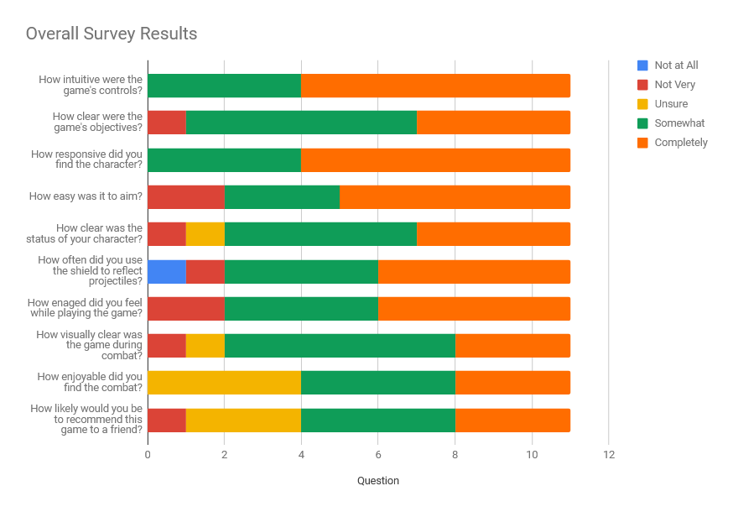

**Recommendations**

**Conclusion**