Item Recognition Report

In modern image recognition tasks, achieving high accuracy and efficiency is paramount. In our recent experiments, we delved deep into understanding the influence of various parameters like color temperature, exposure, and contrast on the recognition accuracy of objects such as books, Rubik's cubes, and keys. The results were promising and showcased the prowess of our model in varied conditions.

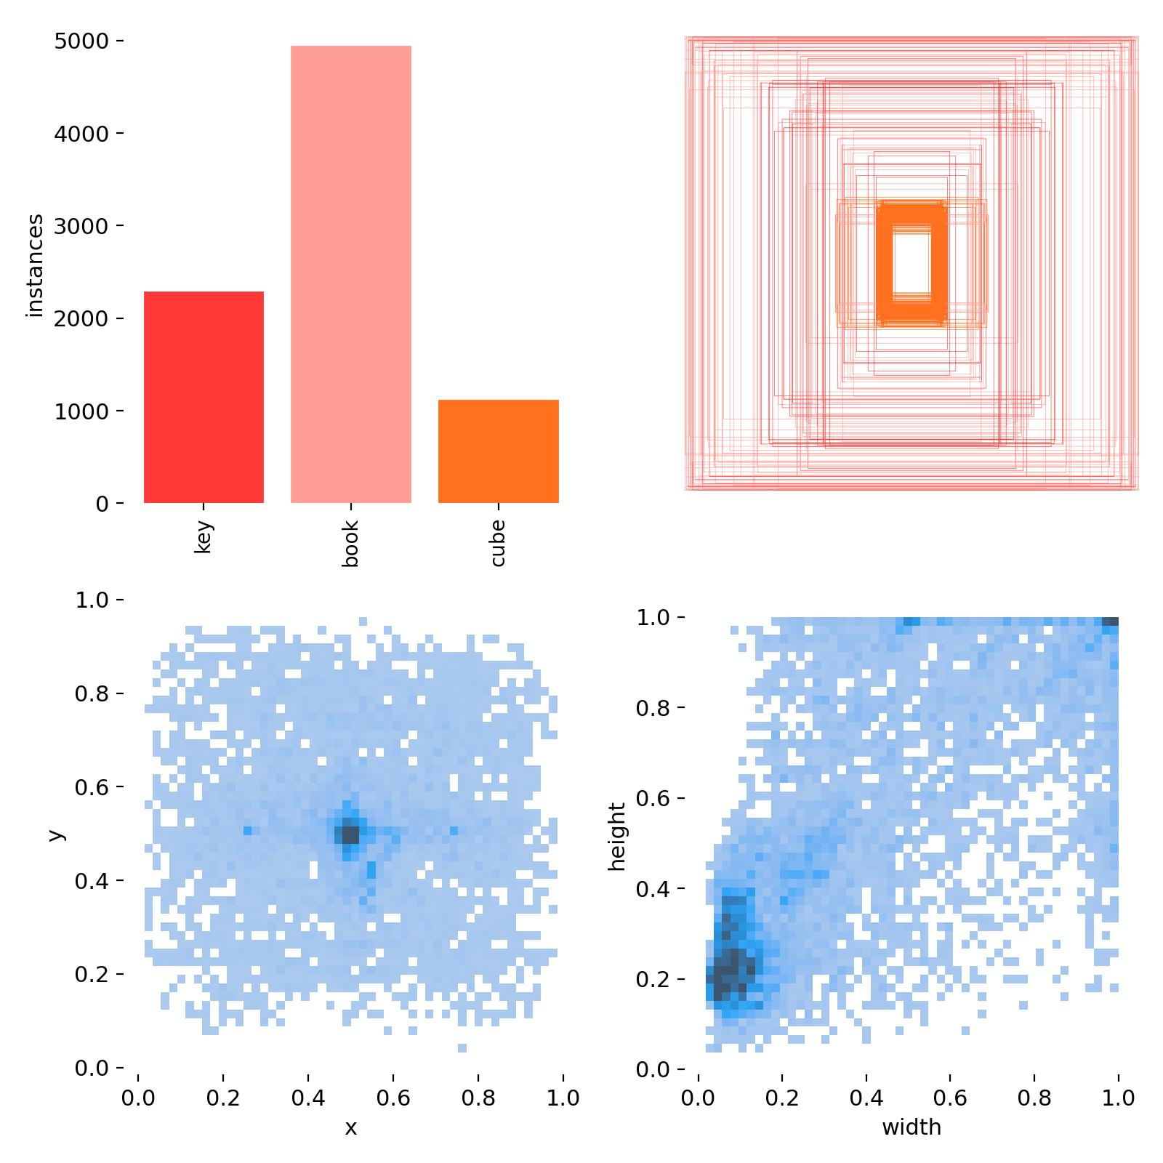

Warm color temperature Normal exposure Normal contrast:

Average Recognition Accuracy: 97.64%

False Positive Rate: 1.88%

Recognition Time: 16.66ms

Cool color temperature Normal exposure Normal contrast:

Average Recognition Accuracy: 94.26%

False Positive Rate: 1.48%

Recognition Time: 26.42ms

Normal color temperature Overexposure Normal contrast:

Average Recognition Accuracy: 90.86%

False Positive Rate: 1.27%

Recognition Time: 25.37ms

Normal color temperature Underexposure Normal comparison:

Average Recognition Accuracy: 94.13%

False Positive Rate: 0.25%

Recognition Time: 45.15ms

Normal color temperature Normal exposure High contrast:

Average Recognition Accuracy: 96.13%

False Positive Rate: 0.72%

Recognition Time: 48.33ms

Normal color temperature Normal exposure Low contrast:

Average Recognition Accuracy: 90.23%

False Positive Rate: 1.02%

Recognition Time: 18.23ms