Chat JTDAN

**GOAL**

#### Software Design Document

Name (s):

Mubeen S.

Aya Samaha

Tigran Manukyan

Nora Qizi

COMP 490/L

Date: (11/25/2023)

**TABLE OF CONTENTS**

***1.0*** ***INTRODUCTION 2***

***1.1*** ***Purpose 2***

***1.2*** ***Scope 2***

***1.3*** ***Overview 2***

***1.4*** ***Reference Material 2***

***1.5*** ***Definitions and Acronyms 2***

***2.0*** ***SYSTEM OVERVIEW 3***

***3.0*** ***SYSTEM ARCHITECTURE 4***

***3.1*** ***Architectural Design 4***

***3.2*** ***Interface Description 5***

***3.3*** ***Decomposition Description 5***

***3.4*** ***Design Rationale 6***

***4.0*** ***Component Design/Detailed Design 7***

***5.0*** ***HUMAN INTERFACE DESIGN 8***

***5.1*** ***Overview of User Interface 8***

***5.2*** ***Screen Images 10***

***6.0*** ***REQUIREMENTS MATRIX 13***

## INTRODUCTION

## Purpose

There is no targeted audience; it's available to all consumers. Whether you're a tech-savvy enthusiast, a busy professional, a student trying to manage their time , or anyone in between, our product is tailor-made to enhance your lifestyle. We believe in inclusivity and accessibility for all, which is why we've made sure that everyone can succeed using our app “Goal!” We made sure that our app could be used in a variety of ways for example:

1. Students struggle sometimes with time management and with getting all their assignments on time. Organizing a healthy schedule on how to get all their work done on time is crucial and I can stand by that since I’m a student myself. Thus, The intended use in this case would be that “Goal!” keeps up with the list of tasks you assign to it by sending reminders of when a separate task is due and as well keeping track of the progress made daily depending on how many tasks have been completed that day. This is displayed via a statistical graph in the app.
2. Doctors as well have a lot on their plate. We made “Goal!” an app that has ease of use which means making it user-friendly a top priority of ours. You don't need to be tech savvy to enjoy our product. It’s intuitive and straightforward to anyone now doctors could simply open the app and add in when their next appointment with their patient is going to be. Just by setting a time and date for when the event is taking place.

## Scope

The Software Requirements specification document for “Goal” application, developed by the CSUN group, known as “Chat JTDAN”, delineates the creation of a software solution designed to facilitate efficient task organization and management. The primary aim of this application is to empower users by streamlining their workflow, augmenting productivity, and ensure effective task tracking and completion.

## Overview

In this SDD we will go through the construction of our application Goal! .The SDD explains the features and requirements that will be met. Furthermore, this document goes into detail of the interface's design and how the users will be able to maneuver through the app.

## Reference Material

N/A

## Definitions and Acronyms

N/A

## SYSTEM OVERVIEW

The Goal app addresses the widespread challenge of staying motivated and attaining short-term, realistic goals. It provides a full mobile solution, initially unique to Android, to help users organize, schedule and complete activities. The program makes it easier to manage bigger life goals and their related subtasks by giving users the tools they need to efficiently define, track, and achieve goals.

The app appears as a useful companion in a world where people frequently struggle to reconcile their objectives and obligations. The software seeks to smoothly integrate into users' lives, providing a handy platform to keep motivated and focused on both urgent chores and wider life objectives. With a user-centric design, the app transforms into a digital ally for anyone looking to improve their work management and goal achievement abilities.

The design of the app is focussed on simplicity, accessibility, and functionality. Users may create and name key tasks, as well as provide descriptions and set completion deadlines. Subtasks with particular details help to further break down bigger goals into manageable components. A user-friendly calendar highlights task timelines visually, enabling effective time management. The app's navigation is simple, with sections dedicated to primary chores, a calendar, and statistics. Users may effortlessly navigate between different parts, maintaining a consistent user experience. A potential point system adds a gamified element, encouraging rivalry and collaboration, assuming future internet access.

Incorporating feedback methods, such as task completion pop-ups and reminders, adds a helpful element to the user experience. Goal aspires to be more than simply an app by combining a user-friendly design with strong task management tools; it aspires to be a companion that aids and celebrates users in their pursuit of personal and professional successes.

## SYSTEM ARCHITECTURE

## Architectural Design

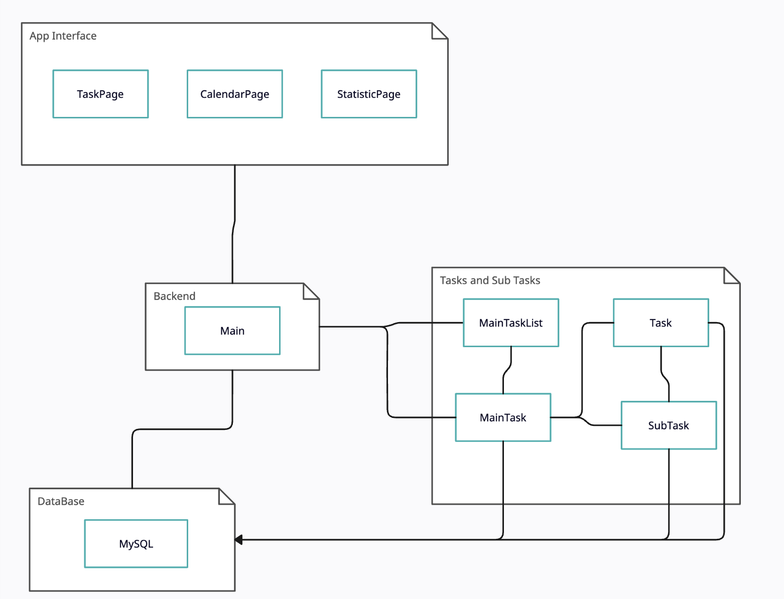

## Interface Design

The outline for the task page, calendar page and statistic page is as follows. Task page will include a header called “home” . There will be a navigation bar at the bottom in order to switch back and forth from different pages which include the (Tasks, Calendar and StatisticsPage). Users will also be able to view their profiles from the top left there will be a drop menu which will contain their account information. Moving onto the TaskPage where users will be able to add their tasks and main details such as (title, SubTakes, due date and status). If the task is completed users will be able to edit that with a simple tap on the side of the task marking it as completed as well as edit the task and or delete task. CalenderPage will include a header and the calendar view of a monthly calendar which displays any tasks due on a certain date will be highlighted and ability to click on the set tasks in the calendar to view not only that but they also be able to add tasks in CalenderPage on the calendar view not having to go back to the TaskPage to add a new task. Finally the StatisticsPage users will be able to view their progress of completed tasks, total number of tasks set and how many tasks are left to complete. This will be represented in forms of graphs/charts. Which will provide insights on the users completion rates.

## Decomposition Description

The App interface pages oversee handling information going in and out of each page. Whenever new data or an update of an existing data is required from the Database, the task page that needs the data requests the appropriate information from the main class, the main class then sends a query to the Database, and returns the appropriate items after sorting out what is needed. This way the main class acts as a sort of middleman, it not only protects what data is accessed by the higher classes, but also allows for the main class to sort the data before passing it on to the higher classes.

Whenever a new main or sub task is created, or if an existing task is edited, the task classes respectively have access to the database. So, they can themselves change the database however they see fit. This streamlines the transfer of data, it allows for the task to edit any specific data, without having to go to another class, and without having to create a new task and destroy the old one.

The main class will also be in charge of keeping track of the main tasks list and the subtasks, this way the main class can sort any data received from the database before passing it onto the higher classes. It also allows for any changes that are requested from the higher classes to be passed to the appropriate task class.

## 3.4 Design Rationale

The rationale for the app is to keep the experience for the user as intuitive as possible. The idea is that there would be no “learning curve” in order to access the full functionality of the app.

With simplicity in mind, we decided that some users would prefer seeing tasks in a scroll-able text window format, but others would prefer seeing tasks in a more visual calendar format. Both of these views would be able to have access to the full-functionality of the app. From clicking a button details would appear on specific tasks and from either view the user can click a clearly labeled button to add/remove tasks and sub-tasks.

We also decided that we wanted to include a page view of statistical information. This would give performance analysis on tasks and subtasks that were or were not completed on time with visual representations too.

One of the statistical ideas we decided to drop was options to compare task statistics with other users. This though would require additional infrastructure in order for user statistical information to be shared with other users. In addition to this, it could potentially create privacy issues for the users.

At the bottom of the task viewing screens and statistics screen,there will be a tab with icons that the user can push to switch between screen views. One of these icons will be for the default scroll-able text window screen. Another icon shall be in order to switch to the Calendar view. One more icon will switch the user to the statistics page.

## COMPONENT DESIGN/DETAILED DESIGN

4.1.1 Class Diagrams

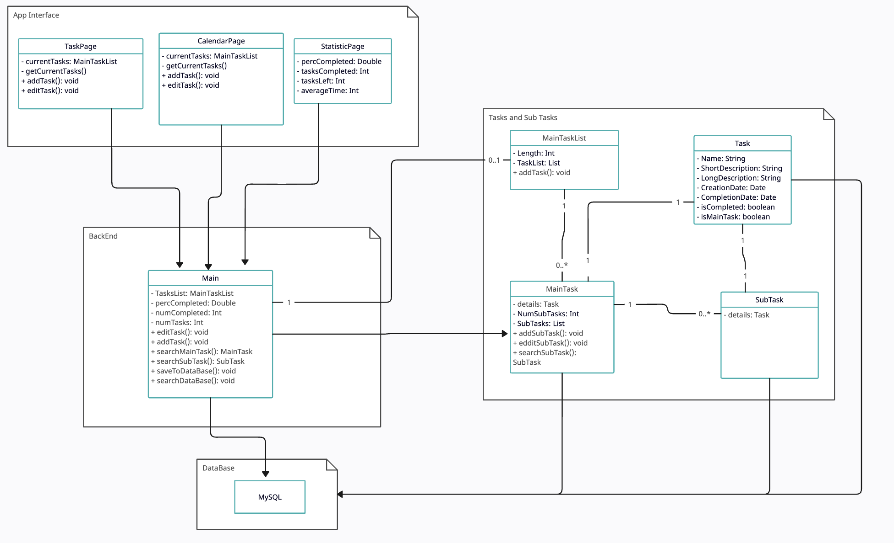

4.1.2 Database Schema 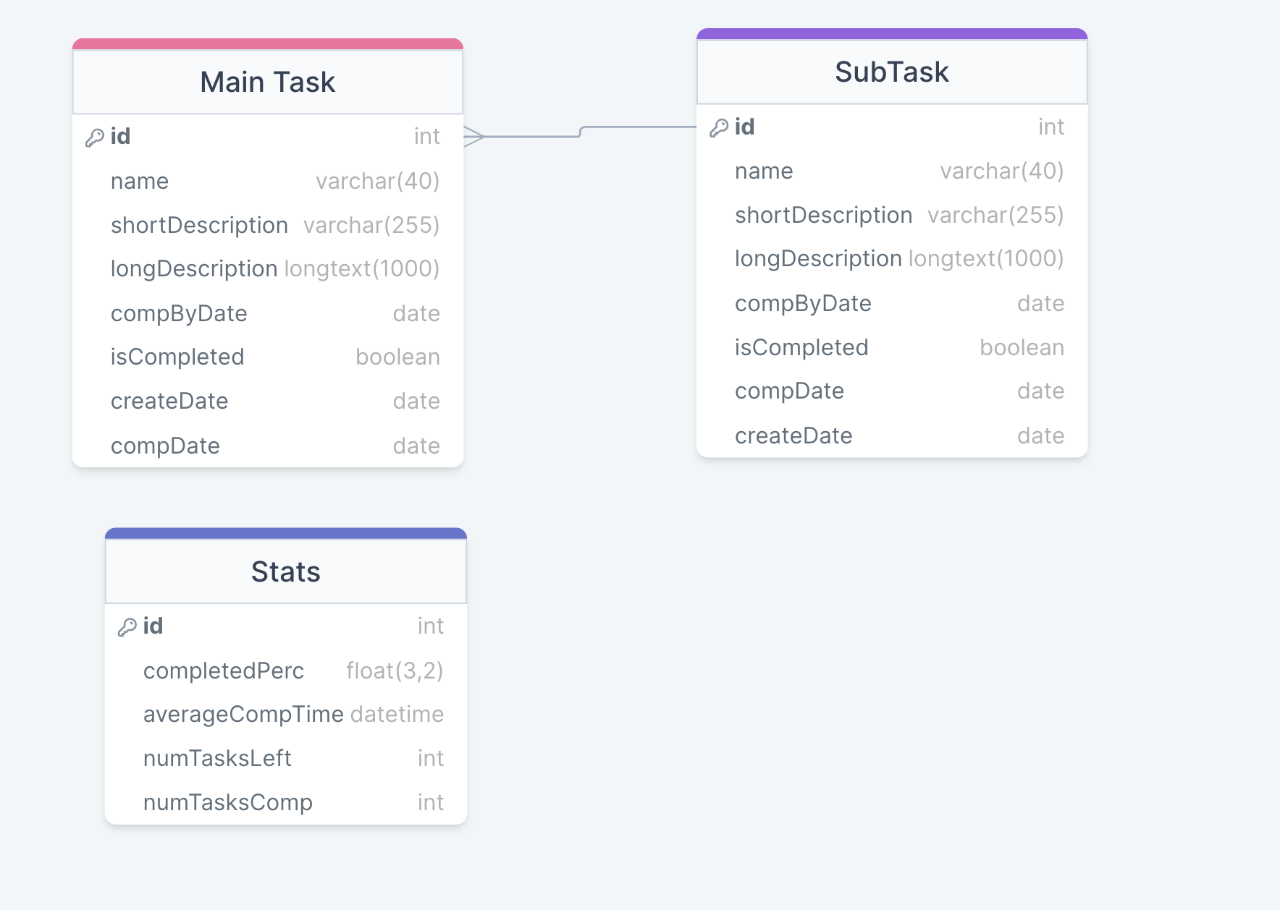

## 

## 5.0 Human Interface Design

## 5.1 Overview of User Interface

**Home Page:**

* **Header:** Displayed as "Home."
* **Navigation Bar:** Located at the bottom for seamless switching between pages (Tasks, Calendar, StatisticsPage).
* **Profile Access:** Top left corner with a dropdown menu containing account information.

**Task Page:**

* **Adding New Tasks:**
  + Users initiate adding new main tasks via a dedicated button.
  + Input details such as title, due date, short description, and notes for the task.
  + Users have the option to create subtasks for each main task.
* **Task Management:**
  + Tasks are listed on the page with names and short descriptions.
  + Clicking on a main task opens a detailed page, displaying all information and links to subtasks.
  + Checkboxes indicate task completion status.
  + Edit or delete tasks with simple taps.

**Calendar Page:**

* **Header:** Displayed with the calendar view of a monthly calendar.
* **Task Highlighting:**
  + Tasks due on a specific date are highlighted in the calendar.
  + Users can click on highlighted tasks to view details.**Navigation:**
  + Arrows allow users to move between months.

**Statistics Page:**

* **Progress Insights:**
  + Users can view insights into their progress, including completed tasks, total tasks set, and remaining tasks.
  + Represented through graphs/charts for a visual understanding of completion rates.
* **User Interface:**
  + Accessible through the bottom navigation bar.
  + Provides valuable insights into task completion trends and patterns.

**Feedback Information:**

* **Task Completion Feedback:**
  + Pop-ups congratulate or motivate the user when a task is marked as completed.
  + Visual indicators, such as checkboxes, reflect completion status.
* **Reminders:**
  + Users receive reminders when a task is approaching its due date.
  + Gentle nudges to keep users on track.
* **Graphical Representations:**
  + The Statistics Page uses charts and graphs to visually represent task completion statistics.
  + Clear, intuitive visualizations provide immediate feedback on user progress.

The Goal app is designed to be a user-friendly and efficient tool, ensuring that users can seamlessly navigate, manage tasks, and gain valuable insights into their goal accomplishment journey. The integration of visual feedback and reminders enhances the overall user experience, promoting engagement and motivation.

## 5.2 Screen Images

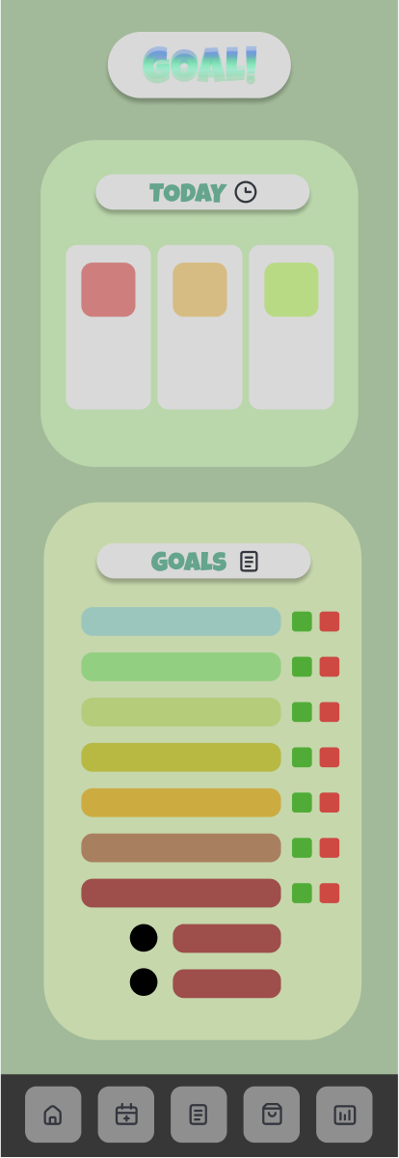 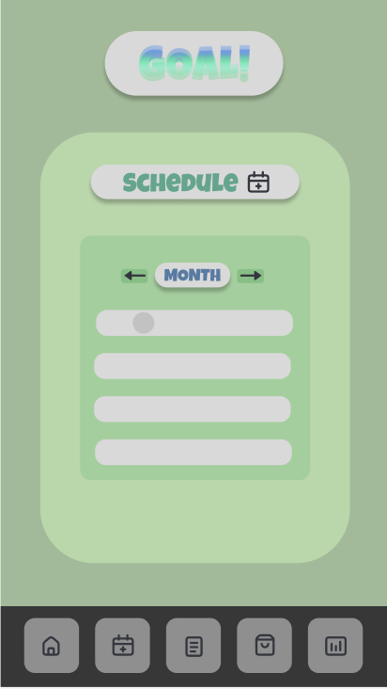

**Figure 5.1: Home Page** **Figure 5.2: Calendar Page**

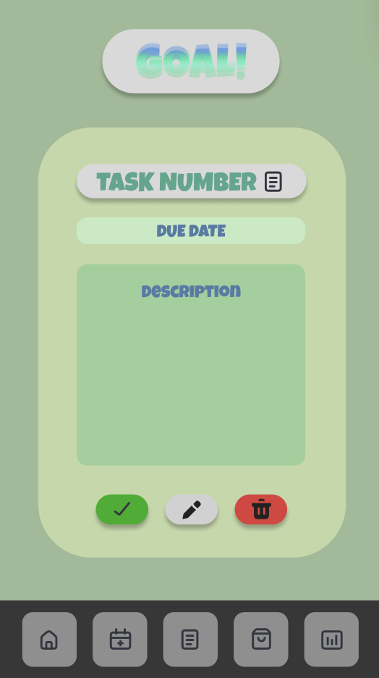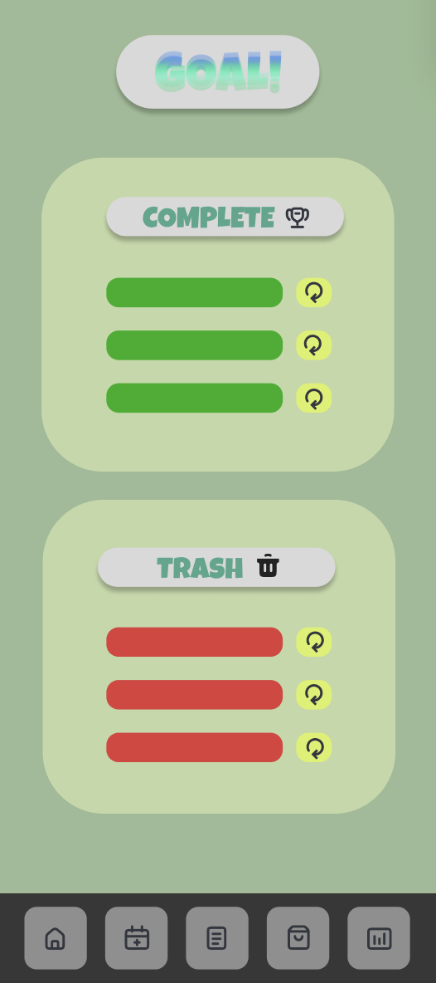

**Figure 5.3: Task Page**  **Figure 5.4: All Tasks Page**

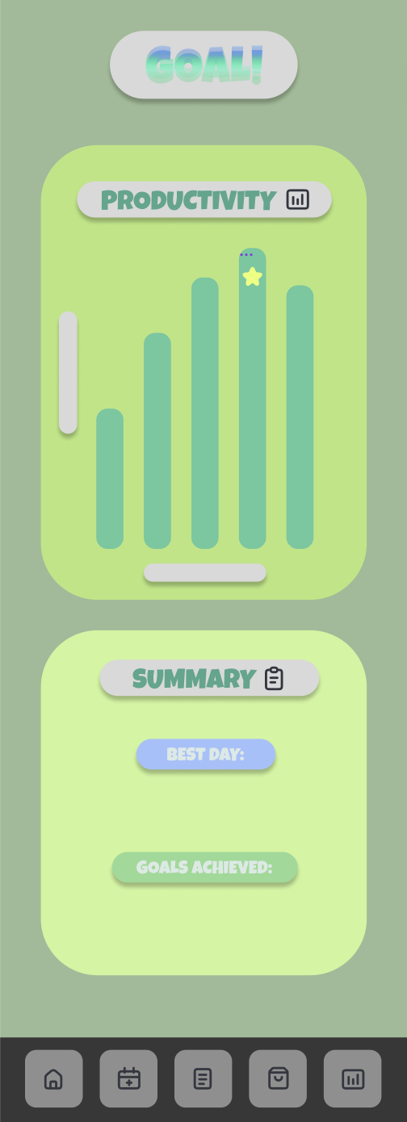

**Figure 5.5: Statistic Page**

## 6.0 REQUIREMENTS MATRIX

| **SRS Req. ID** | **Paragraph Title** | **Satisfied** | **Component Number** |
| --- | --- | --- | --- |
| FUNC_SRS_1.00 | The program shall have a button to add new main tasks which will allow the user to enter information about the task. | Yes | Figure 5.1 |
| FUNC_SRS_1.01 | The program shall allow the user to enter a due date or a completion by date for the task. | Yes | Figure 5.3 |
| FUNC_SRS_1.02 | The program shall allow the user to enter a short description for the task. | Yes | Figure 5.3 |
| FUNC_SRS_1.03 | The program shall allow the user to create subtasks for each task. | Yes | Figure 5.1 |
| FUNC_SRS_1.04 | The program shall allow the user to enter notes for the task, or other important information about the task. | Yes | Figure 5.3 |
| FUNC_SRS_2.00 | The program shall have a page displaying all the main tasks. | Yes | Figure 5.1 |
| FUNC_SRS_2.01 | The main tasks on this page shall show their name, and their short descriptions. | Yes | Figure 5.1 |
| FUNC_SRS_2.02 | Once clicked on the main task, a page shall open that will have all the information of said task, as well as links to subtasks. | Yes | Figure 5.3 |
| FUNC_SRS_2.03 | There shall be a check box that indicates whether a task is completed or not. | Yes | Figure 5.1 |
| FUNC_SRS_3.00 | The program shall have a calendar page. | Yes | Figure 5.2 |
| FUNC_SRS_3.01 | The calendar page shall allow the user to see completion by dates. | Yes | Figure 5.2 |
| FUNC_SRS_3.02 | The calendar page shall allow the user to also see which tasks are due when the user taps on a particular date. | Yes | Figure 5.2 |
| FUNC_SRS_3.03 | The calendar page shall have arrows to allow users to move from month to month. | Yes | Figure 5.2 |
| FUNC_SRS_4.00 | The program shall have buttons at the bottom of the page to allow the user to switch between pages. | Yes | Figure 5.1 |
| FUNC_SRS_4.01 | The buttons shall be for the main task page, calendar page and statistics page. | Yes | Figure 5.1 |
| FUNC_SRS_5.00 | There shall be a statistics page, which will have different statistics about completed tasks. | Yes | Figure 5.5 |