Here are the recommended steps for installing a Nordic task for their Aktiva software:

1. Start Aktiva.
   1. At the “Log in” window, enter the typical information. This is the information I use: 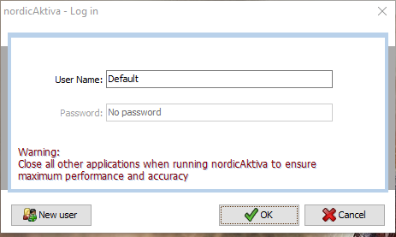
2. Go to “File -> Browse User Paradigms” in the upper left corner.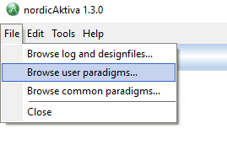
3. This will open Windows explorer at the desired path. In my case, explorer opened here: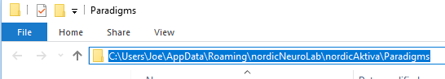

You must save the paradigms in this folder under a folder with the same name as the main script for the task. In this example, I will be using the Episodic Memory task code.

1. Download the Episodic Memory task code. It is located here on github: <https://github.com/heffjos/CHESS-STUDY> Click the “Clone or download” green button and select “Download zip”. You can download this zip file anywhere.
2. Extract it anywhere. I extracted it in the same folder as the zip file for convenience.
3. Usually, there is one folder layer from the extracted files that is not needed. For instance in my extraction, the output was like so “CHESS-STUDY-master -> CHESS-STUDY-master -> Aktiva files”. We do not need the top-level CHESS-STUDY-master directory. We move the directory below it.
4. Move the appropriate “CHESS-STUDY-master” directory to the path found in 3. This directory should still be open in explorer from 3 if you have not closed it.
5. Rename the directory to match the main script. The man script name in this case is “EpisodicMemory.xml”. Exclude the “.xml” for the folder name.

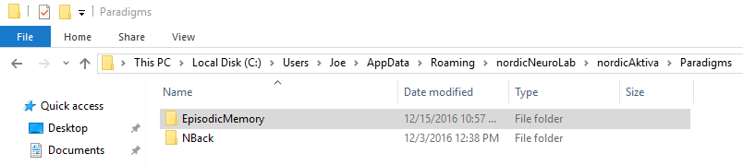

1. Now go back to Aktiva. Press the red button once. This will restart the patient information entry.

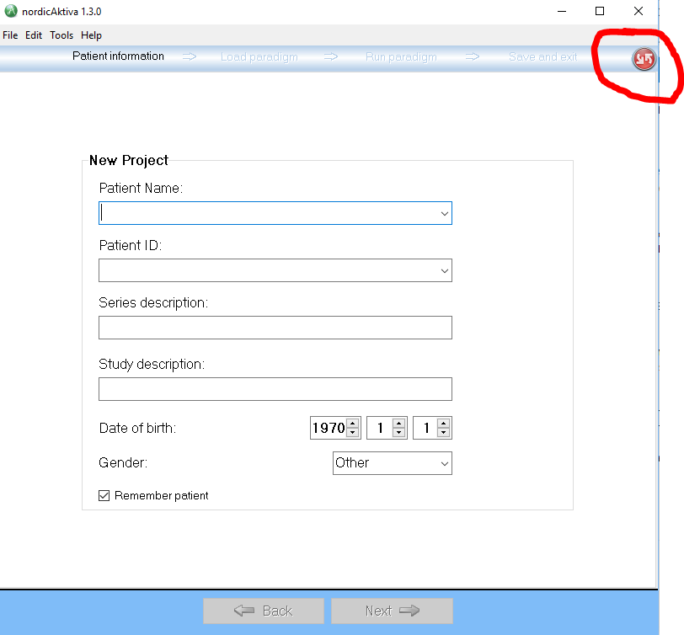

Pressing the red button, may or may not work at this stage. You will either have to restart Aktiva or go to the next stage by entering information and clicking “Next” and then press the red button.

1. Do not put the participant’s name in Patient Name. We want the participants to remain as anonymous as possible.
2. For Patient ID, enter the participant identifier.
3. For “Series description” and “study description”, enter anything meaningful.
4. Exclude date of birth and gender as these are identifying information as well.
5. After all information is entered, click “Next”.
6. The tasks should appear under “Select Paradigm”:

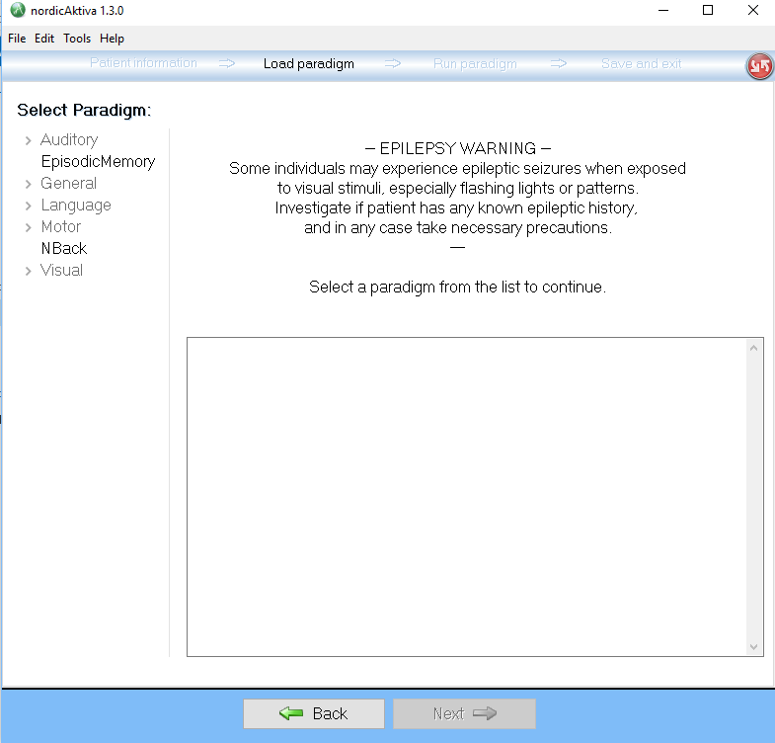

1. Select the “EpisodicMemory” task. This will open information for the task:

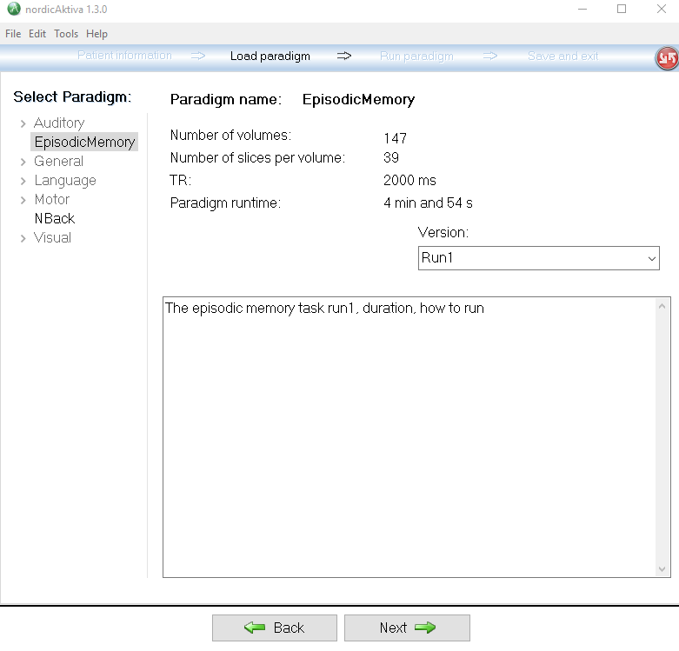

1. Runs 1 and 2 are to be run at timepoint 1 and runs 3 and 4 at timepoint 2.
2. Select the appropriate run and select “Next”. In this example, I will be using “Run1”.
3. Click the green button to run the paradigm. When running in the scanner, the “Run Mode” should be set to “Synchronize”. Since we do not have the sync box or a scanner, we are running in “Simluate” mode:

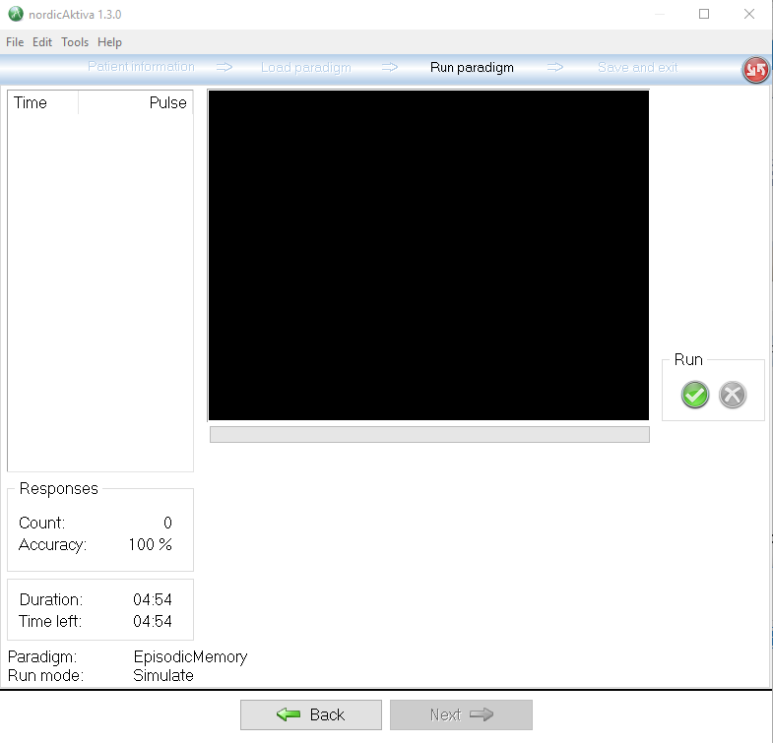

The run mode is changed by selecting “Edit -> Run mode” at the top.

1. When the scan is finished, make sure to select “Save results” in the upper right hand corner:

