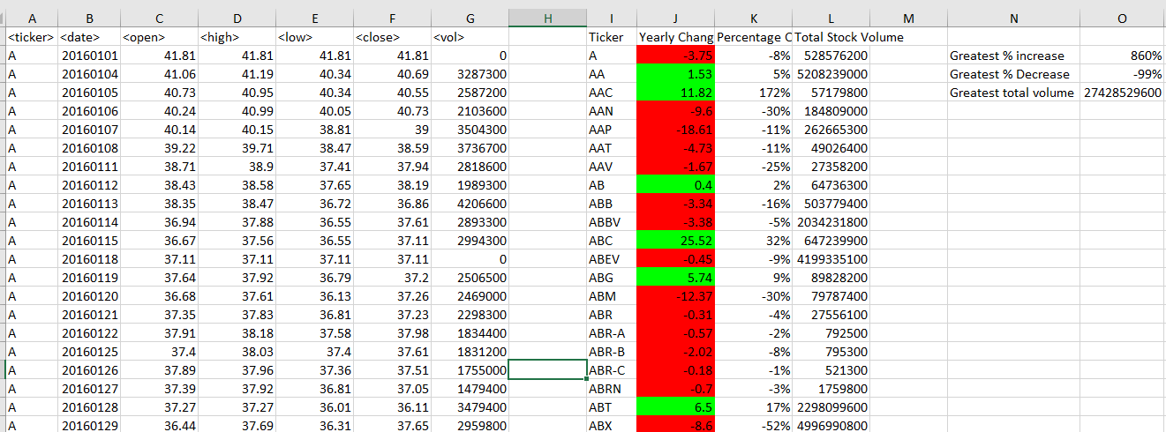

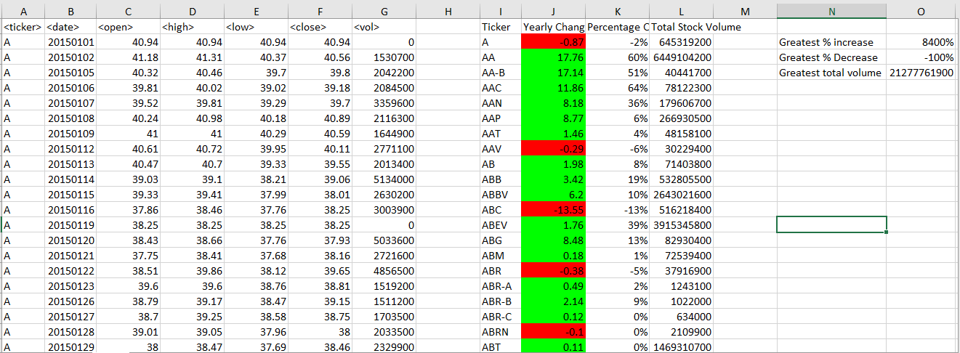

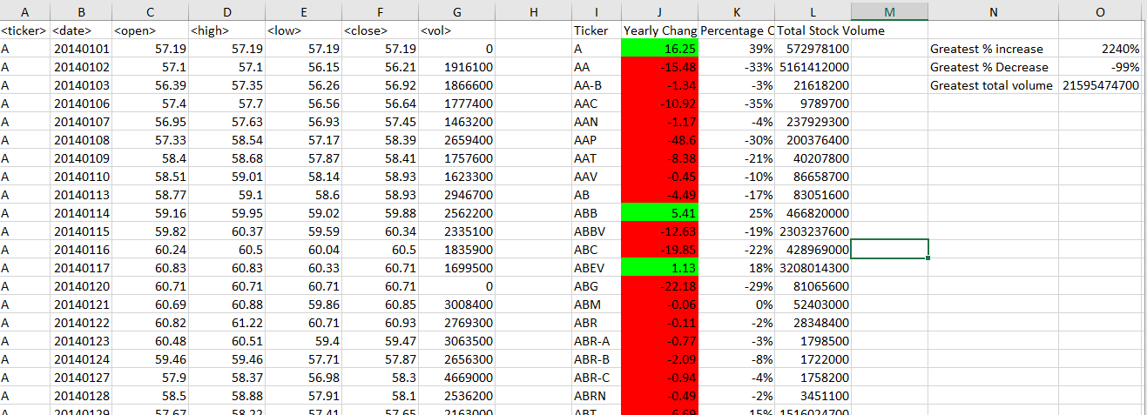

Sub StockData()

For Each ws In Worksheets

' Set an initial variable for ticker name

Dim Ticker As String

' Set an initial variable for holding the total Stock Volume per ticker

Dim StockVolume As Double

StockVolume = 0

' Keep track of the location for each stock in the summary table

Dim Summary_Table_Row As Integer

Summary_Table_Row = 2

Dim YearlyChange As Double

Dim PercentChange As Double

OpenValue = 0

startrow = 2

NextOpenValue = 0

' get the last raw value to iterate through last ticker

lastRow = ws.Cells(Rows.Count, 1).End(xlUp).Row

' Loop through all Stocke ticker till last raw

For i = 2 To lastRow

' Check if we are still within the same ticker, if it is not...

If ws.Cells(i + 1, 1).Value <> ws.Cells(i, 1).Value Then

'Defining variable and inintial value for capturing first and next open value

If OpenValue = 0 Then

startrow = 2

NextOpenValue = i + 1

OpenValue = ws.Cells(2, 3)

Else

startrow = NextOpenValue

OpenValue = ws.Cells(startrow, 3)

NextOpenValue = i + 1

End If

' Set the Ticker

Ticker = ws.Cells(i, 1).Value

' Add to theTotal volume

StockVolume = StockVolume + ws.Cells(i, 7).Value

' Calculate Yearly change

YearlyChange = OpenValue - ws.Cells(i, 6)

' Calculate total percent change change

If YearlyChange = 0 Then

PercentChange = 0

Else

PercentChange = YearlyChange / ws.Cells(i, 3)

End If

' Print the Stock TIcker in the Summary Table

ws.Range("i" & Summary_Table_Row).Value = Ticker

' Print the Total Stock Volume to the Summary Table

ws.Range("L" & Summary_Table_Row).Value = StockVolume

' Print Yearly change in summary table --------------------

ws.Range("J" & Summary_Table_Row).Value = YearlyChange

If ws.Range("J" & Summary_Table_Row) < 0 Then

ws.Range("J" & Summary_Table_Row).Interior.ColorIndex = 3

Else

ws.Range("J" & Summary_Table_Row).Interior.ColorIndex = 4

End If

' Print percent change in summaru table --------------------

ws.Range("K" & Summary_Table_Row).Value = PercentChange

ws.Range("K" & Summary_Table_Row).Style = "Percent"

' Add one to the summary table row for next ticker summary

Summary_Table_Row = Summary_Table_Row + 1

' Reset the Stock Volume

StockVolume = 0

' If the ticker in next row is same

Else

' Add to the Brand Total

StockVolume = StockVolume + ws.Cells(i, 7).Value

End If

Next i

ws.Range("I1").Value = "Ticker"

ws.Range("J1").Value = "Yearly Change"

ws.Range("K1").Value = "Percentage Change"

ws.Range("L1").Value = "Total Stock Volume"

ws.Range("N2").Value = "Greatest % increase"

Dim rng As Range

Dim dblMax As Double

'Set range from which to determine largest value-- search to get syntex

Set rng = ws.Range("K2:K" & Summary_Table_Row - 1 & "")

dblMax = Application.WorksheetFunction.Max(rng)

dblMin = Application.WorksheetFunction.Min(rng)

'Displays largest value

ws.Range("O2").Value = dblMax

ws.Range("N3").Value = "Greatest % Decrease"

ws.Range("O3").Value = dblMin

ws.Range("N4").Value = "Greatest total volume"

Set rng2 = ws.Range("L2:L" & Summary_Table_Row - 1 & "")

dblMax2 = Application.WorksheetFunction.Max(rng2)

ws.Range("O4").Value = dblMax2

Next ws

End Sub