THIN I.C.E. M.O.R. Generator
User’s Manual

This manual is meant to be used with the THIN I.C.E. M.O.R. Generator Version 3.1.x . Let’s take a minute to understand how versions work, what they mean, and why version numbers are important to you.
I: Definition of a version: A version number is a unique number or set of numbers assigned to a specific release of a program.
Typically, as updates and entirely new editions of a program or driver are released, the version number will increase. This means that you can usually compare the version number of the software installed on your computer with the version number being released to see if you already have the latest version installed.
Version numbers are usually divided into sets of numbers, separated by decimal points. Usually, a change in the leftmost number indicates a major change in the software or driver. Changes in the rightmost number typically indicate very minor changes. Changes in other numbers represent varying degrees of changes.
For example, you may have a program installed that reports itself as version 3.2.34. The next release of the program may be version 3.2.87 which would suggest that several iterations were tested internally and now a slightly improved version of the program is available.
A future release of 3.4.2 would suggest that more substantial updates are included. Version 4.0.2 might be a major new release.
II: Installation:
This software is usually available at our company website, www.strikerlandservices.com. It can be made available in other forms, such as from a flash drive, on a disk, downloaded from the “Z” drive, etc. The program comes in a standalone installation package, and installs on your computer like any other program would, like so:
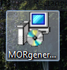
Once you have downloaded the program, or obtained the program through whatever means you deem appropriate, you may double click the icon entitled MORgeneratorV2 to begin the installation process. That Icon should look something like this:

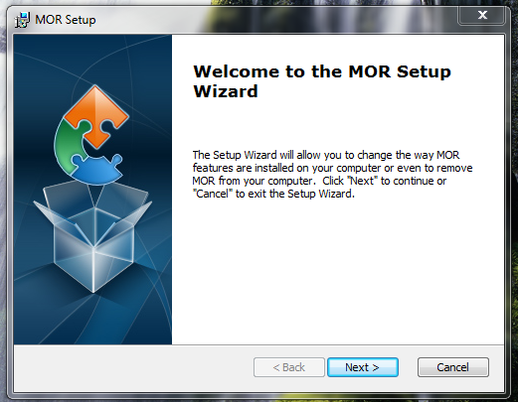
Once you’ve double clicked that icon, you will see a series of installation prompts. The first one, pictured here, is simply an introduction screen. Simply click “next”. You may click “yes” “allow” and any other prompt required to install the program. Please be sure not to change the directory the program installs into (C:\MOR). It is very important for this program to be installed into this directory.

Once this installation process is finished, you will see an Icon on your desktop. It will look like this:
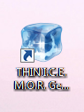

Double click this icon to begin using the THIN I.C.E. M.O.R. Generator.
You will be looking at something like this:
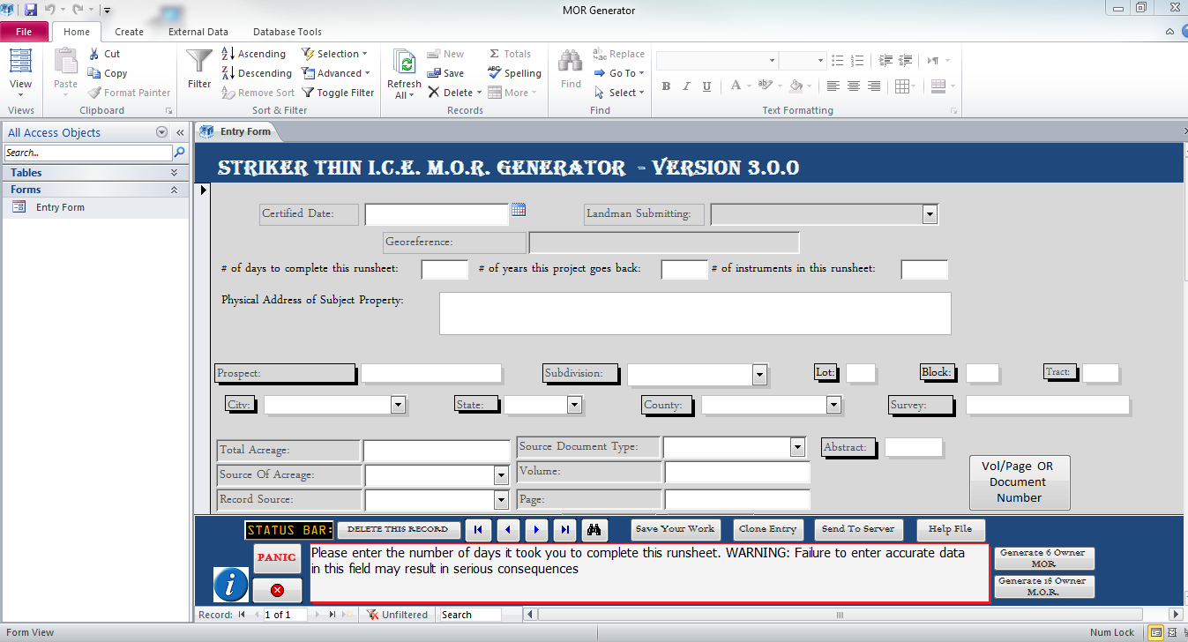

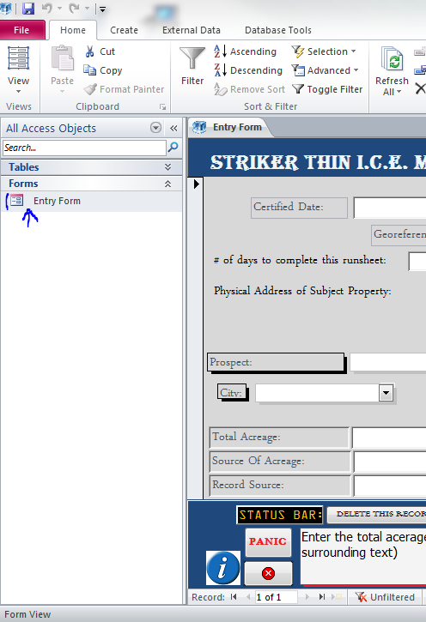
III: Using the program:
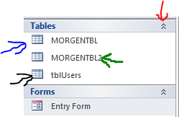
The THIN I.C.E. M.O.R. Generator is a simple program, with several built in features to assist you in its usage. Let’s have a look at how to operate this program. To the left you see a cut-off of the Main Screen. The arrow (in blue) is pointing to the “Entry Form” link. Should you ever find the form closed, you would click this link. The link pictured left is located within the “Navigation Pane”. Also notice the blue bar above the “tables Bar” in the navigation pane. If you were to click the double arrows on the right side of that blue bar (Red Arrow Figure 2), you would see the “tables” menu expand. The MORGENTBL (Blue Arrow Figure 2) is your primary table, in which all your data is stored. MORGENTBL2 (Green Arrow Figure 2) is best left alone, but contains all the “pre-fill” data within this program. TblUsers (Black Arrow Figure 2) is where all the names of people who use this program are stored. If your name is not in this program, you may add an entry to this table to add your name to the program. You may not ever run into a reason to access these tables. Their viewing or usage is not required to use the generator. You may hide this navigation pane if you wish, by clicking the double arrows pointing to the left at the top left corner of the navigation pane.
Figure 1
Figure 2
Next, Let’s have an in depth look at your “dashboard” :
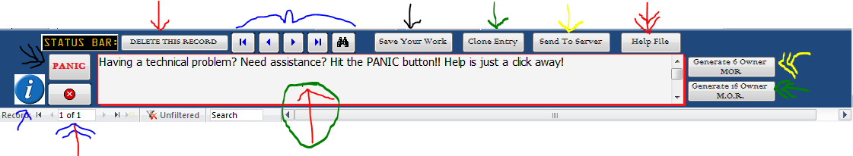
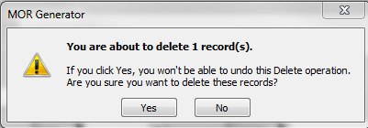
The Single Red Arrow points to your “Delete” Button. Clicking this button will delete the current record you are working on. You probably won’t use this button too often. You will be prompted with an “are you sure” window to prevent accidental deletions.
The Big Blue “bracket” Sign highlights the navigational controls of the data. The furthermost left arrow will bring you to the first document in the database; the next button (single arrow pointing left) will scroll through records one record at a time. The arrows pointing to the right do the same thing, just in the other direction. The binoculars will help you find and or replace text within a record.
The “Save Your Work” button (Black Arrow) is self-explanatory. Simply click this to fail-safe save your work. Keep in mind that this program also has an auto-save feature, as well.
The “Clone Entry” button (Single Green Arrow) is made to assist you in the event that you wish to “copy” everything you typed in the current record to a new record. For example, you are doing a run sheet in which almost everything, save for the Georeference (Which MUST be different per every MOR) and a few small details are the same, and you do not wish to re-type every bit of that data again. Simply click the “Clone Entry” button, change what needs to be changed, and save that entry. It will become a new entry. TO clarify, you must ALWAYS have a different Georeference to establish a new entry into the system. There can never be a duplicate Georeference Number in this system.
The “Send To Server” button (Single yellow arrow) ends all the data in your local storage table (the MORGENTBL) to a database in the server, and joins it with all the other data everyone else has sent in so that we may create reports, send the data to clients, etc. There are two ways in which you can send this data to use, from in the office (Simply click the “Send to Server” button while connected to the internet within the office) OR from anywhere in the world with a valid internet connection (Simply connect to the VPN, ensure that your “Z” drive is mapped and that you can open it, and then click the “Send to server” button.) You do not have to be connected to the internet to enter data into the MOR generator, but you DO have to be connected to the internet to send it to the server.
The “Help File” button (Double Red Arrows) will open what you’re reading now. You probably clicked that button to see this document.
The “Generate 6 Owner MOR” Button (Double Yellow Arrow) will generate an MOR that supports up to 6 owners. If you have more than 6 owners then you will want to use the “Generate 18 Owner MOR” (Double Green Arrows) instead. The 6 person MOR will add your math up for you at the bottom. The 18 person will not.
The “Intel-tip bar” (Red arrow in a green circle) is where the program explains things to you and gives you helpful hints on the operation of the program. It is a good idea to read and pay attention to what this little bar says.
The “Record Number” area (Red and blue double arrow) is where you can see what number your record is (Your Document’s Database Number), and see where you are in the world of navigating your documents. If you already know your document’s database number, you can enter that here. You may also notice the same navigation buttons as the ones above, they are simply smaller. Either set of navigational buttons work.
The “I” button (Single blue arrow) is the End User License Agreement. This document is your license to use this software. It is recommended you read this document once. You’ll probably want to forget about it after that.
The “Panic” button (Double Black Arrow) opens an email directly to our I.T. Team. If you do not use outlook, this button is useless to you. Alternative to outlook, you may send glitch reports, Ask questions and more by sending an email to panic@strikerlandservices.com
The Big Red X is the quit button. Self-explanatory. There is a fail-safe “are you sure” window here too.
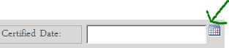
IV: Entering the Data:
Most of the fields in the MOR Generator are self-explanatory. We’ll go into short detail about some of the finer points now.
Figure 3
Date Fields: All date fields in this program have a “Calendar” feature built in. You do not have to use this feature if it is not to your advantage to do so, but you must type a date in a certain format: mm/dd/yyyy in order to correctly enter it.
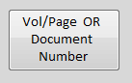
Auto-fill Fields: Any field with an arrow or drop down capability is an auto-fill field. The uses of the automated entries in these fields are not mandated, and can be overridden by simply typing over the auto-fill with what you want to be in the field.
Figure 4
Vol / Page Button: Let’s say, for example, that instead of your source document having a document number, it has a volume and page (or vice versa). Double clicking this button will change the fields to accommodate this problem. WARNING: If you have text entered in these fields, it will ALL show up, so make sure one or the other is empty. For example, if you entered VOL / PAGE but change to needing to enter a document number, then you must DELETE the Vol / Page info before you enter the document number info. Simply clicking the button will not delete your previous entry.
Multi-Owner Tab System: Simply click a new tab per owner to enter up to 18 owners. Notice that owners one through 9 have a drop-down auto-fill in the “first Name” box. This is filled with common owners within our current projects, and will auto-fill their addresses for you.
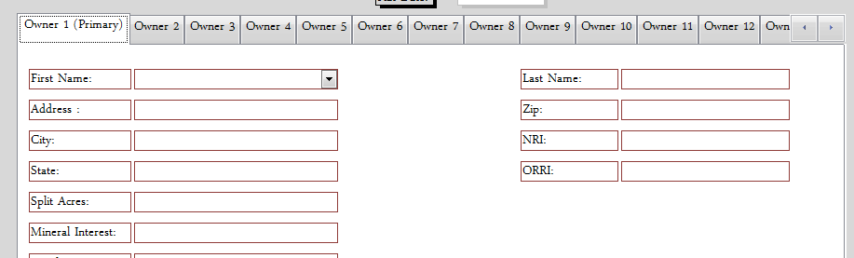
Once you have filled all this in, You may save your work, and hit “generate M.O.R.” (Whichever button corresponders to the number of owners you have entered)

V: The Generated M.O.R.:
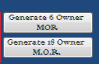
Once you see which MOR you want to generate, either the 6 person MOR or the 18 person MOR, click the corresponding button in the generator. You will then see two word documents, which do not pop up usually, but go onto your windows desktop toolbar as tabbed applications, as shown below.
One of these tabs will be a generated document. The program automatically generates the highest record number in your database. This will usually be the last entry into your database. This is done for convenience, as the program is designed with the process in mind that you will enter data into the database and then generate your MOR, one at a time. However, this may not always be the case, and so as not to change your method of operation, the program supports segmented generation (generating multiple documents, like say document 13 to document 19) and individual ordered generation (picking a certain record out of the list of records to generate, singularly) as well as simply generating a document for all of the records in your database (this is not usually recommended, but has its uses).
To control and select your document to be generated, you must be on the TEMPLATE, not the automatically generated document. The template is the OTHER document generated by the generator when you click the “generate MOR “button.
VI: The Template: Below you see the Template, entitled MORTEMP3. The 18 owner is MORTEMP2. You must never change the name of this template for any reason!
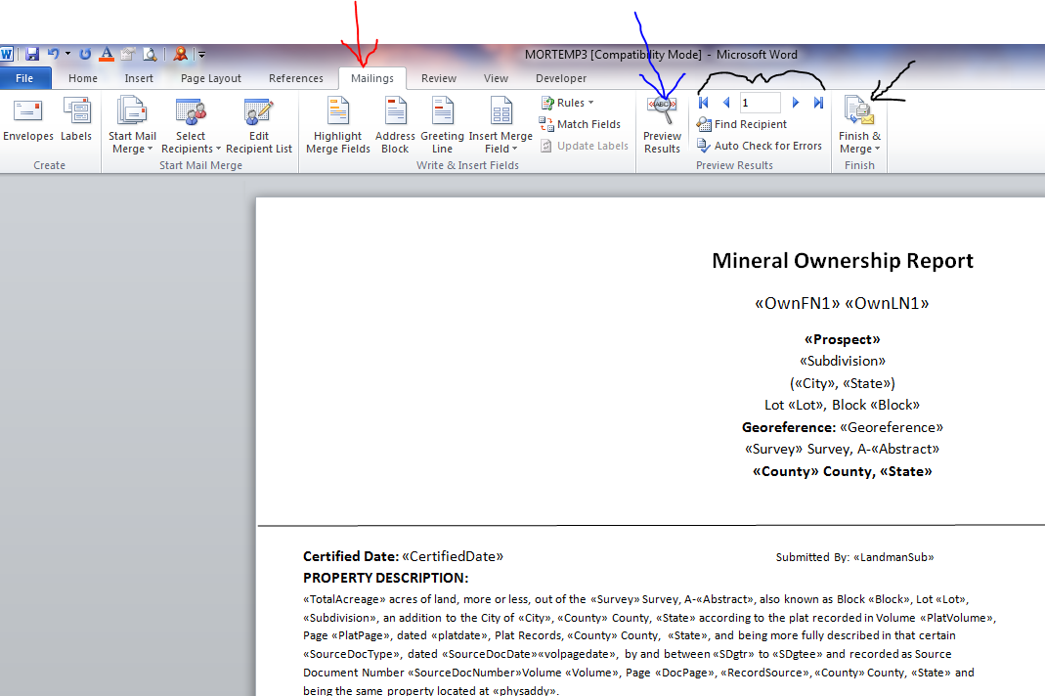
Notice that the template is on the Mailings Tab (Red Arrow). You must stay on this tab to operate the program.

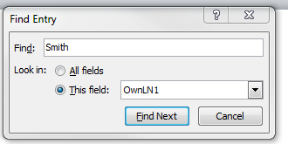
The blue arrow points to the “Preview Results” Button. Notice that the template, by default, shows you a bunch of gibberish that resembles ad-libs. If you click the “Preview Results” button, you’ll notice the template changes to a preview of the document to be generated. If you wish to select a certain document out of the database, and you don’t know the record number, you can scan through them all in real-time preview by leaving this button selected and using the navigational buttons (black bracket) to navigate to the record number the document corresponds to in your database.
The “Navigational Buttons” in the template do the same thing as the navigational button in the data entry form of this program. You can scan back and forth by clicking the arrows. You may also use the Find Recipient Button to search your records by any field, for instance if you knew the Georeference, or name, you could search all fields or one field specifically for that information, and if it finds it, it should return the result. This allows for easy generation of any document within your database.

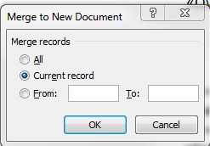
The “Finish and Merge” Button is how you tell word to generate your selected MOR.

Clicking this button will give you three choices. They are rather self-explanatory as well, but in general, you will want to select “Edit Individual Documents”. You will then be shown a “Merge to new document” window with the choice pictured here. Notice you can select “all, which will generate ALL of the documents in your database as covered earlier. “Current Record” will generate the record you are looking at in the template, or the record whose record number in your database corresponds with the record number in the navigational area of the template (See black bracket). For a deeper example, if you want to generate record 5 of 19 in your database, but your template says 18 of 19, and you click “Finish and merge”, you will only generate document 18. If you wanted to generate record 5, you would need to be sure the navigational area in the template corresponds to the record number you wanted to generate. Lastly, you can generate multiple documents in an order, for example, if you entered five MORs, 14 to 19, and you didn’t generate until the end, you could select the “from” button and type 14 to 19 in the boxes, and generate them all.
Once you have generated a document, you must paste your picture in the space allotted for the picture, and you may need to delete some white space before and after the picture to even things up and make it look presentable. ALWAYS read over your generated document for accuracy. You may also manually enter additional information to the generated MOR, but be advised anything you enter directly into a generated MOR will NOT be transmitted to the corporate database, as you did not enter it into the database in the first place.

