C64-ROM-Adapter-LongBoard Rev. 1.1
Description

Introduction

The board serves for adapting a CHARACTER (U5, 4k, 2332), KERNAL (U4, 8k, 2364) or BASIC (U3, 8k, 2364) ROM to a 39SF010A (16x8k) / 39SF020A (32x8k) / 39SF040A (64x8k) 5V FLASH-ROM. The pin out of both ICs are slightly different and need adaptation. Furthermore, it allows to access different character sets (up to 32/64/128), kernals (up to 16/32/64) or basics (up to 16/32/64) or a combination of these three ROM typs which can be selected via DIP switch or/and the pin header (A12 to A18) on the module.
The pin header is connected in a way, that the selection can either be accomplished with switches or a microcontroller like an Arduino etc.
Only one ROM-type (KERNAL or BASIC or CHARACTER) at the same time is allowed.
You can program the FLASH-ROM before soldering or with a special program adaptor after soldering. The second way allows you to reprogram the FLASH-ROM later without resoldering. On the BACK view there are the program pads JA13 to JA18, JWE1 and JOE1.
It should be possible to use the ROM-Adapter in a 1541 floppy drive with 24 pol ROMs (2364) too.

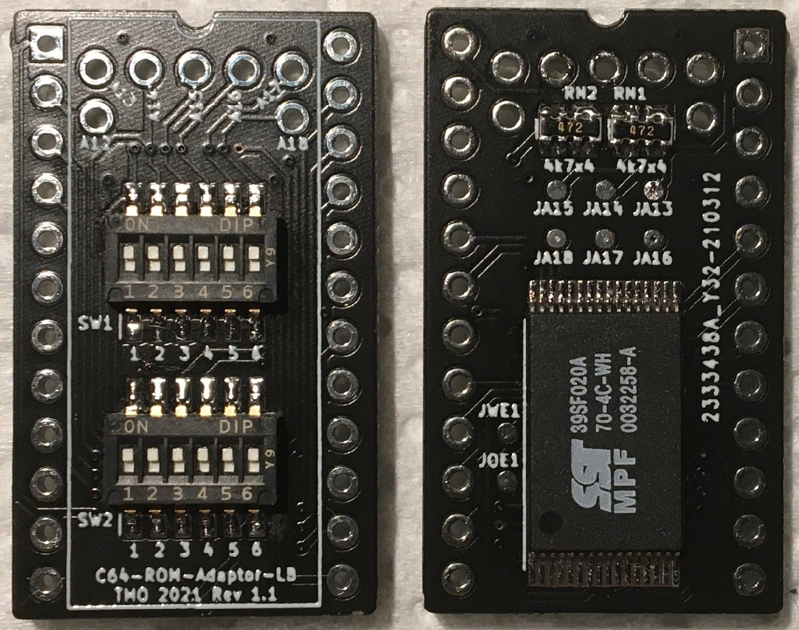
Figure 1: TOP and BACK view

Progam / ROM mode selection

Mode | SW1 |  |  |  |  |  | SW2
Mode | 1 | 2 | 3 | 4 | 5 | 6 | 1 | 2 | 3 | 4 | 5 | 6
Program | off | off | off | off | off | off | off | off | on | off | off | off
ROM | x | x | x | x | x | x | x | x | x | on | on | off
Table 1: Program / ROM mode selection

x: Referred to ROM type / BANK selection

SW1 / 1: A13 SW2 / 1: A12
SW1 / 2: A14 SW2 / 2: A12 enable
SW1 / 3: A15 SW2 / 3: ROM select
SW1 / 4: A16 SW2 / 4: #OE
SW1 / 5: A17 SW2 / 5: #WE
SW1 / 6: A18 SW2 / 6: n.c.

ROM type selection

The ROM type is selected at DIP switch SW2. For ROMs, like KERNAL or BASIC, select ROM type 8k (2364). For ROMs, like CHARACTER SET, select ROM type 4k (2332).

Mode | SW1 |  |  |  |  |  | SW2
Mode | 1 | 2 | 3 | 4 | 5 | 6 | 1 | 2 | 3 | 4 | 5 | 6
4k | x | x | x | x | x | x | x | on | off | on | on | off
8k | x | x | x | x | x | x | off | off | on | on | on | off
Table 2: ROM type selection

x: Referred to BANK selection 4k/8k-ROM

Bank selection 4k-ROM (2332) CHARACTER SET

For example: 1Mbit Flash ROM type 39SF010A

SW1/4 | SW1/3 | SW1/2 | SW1/1 | SW2/1 | 4k Block | Addr. Offset
A16 | A15 | A14 | A13 | A12
on | on | on | on | on | #0 | 0x0000
on | on | on | on | off | #1 | 0x1000
on | on | on | off | on | #2 | 0x2000
on | on | on | off | off | #3 | 0x3000
on | on | off | on | on | #4 | 0x4000
on | on | off | on | off | #5 | 0x5000
on | on | off | off | on | #6 | 0x6000
on | on | off | off | off | #7 | 0x7000
on | off | on | on | on | #8 | 0x8000
on | off | on | on | off | #9 | 0x9000
on | off | on | off | on | #10 | 0xA000
on | off | on | off | off | #11 | 0xB000
on | off | off | on | on | #12 | 0xC000
on | off | off | on | off | #13 | 0xD000
on | off | off | off | on | #14 | 0xE000
on | off | off | off | off | #15 | 0xF000
off | on | on | on | on | #16 | 0x10000
off | on | on | on | off | #17 | 0x11000
off | on | on | off | on | #18 | 0x12000
off | on | on | off | off | #19 | 0x13000
off | on | off | on | on | #20 | 0x14000
off | on | off | on | off | #21 | 0x15000
off | on | off | off | on | #22 | 0x16000
off | on | off | off | off | #23 | 0x17000
off | off | on | on | on | #24 | 0x18000
off | off | on | on | off | #26 | 0x19000
off | off | on | off | on | #26 | 0x1A000
off | off | on | off | off | #27 | 0x1B000
off | off | off | on | on | #28 | 0x1C000
off | off | off | on | off | #29 | 0x1D000
off | off | off | off | on | #30 | 0x1E000
off | off | off | off | off | #31 | 0x1F000
Table 3: Selection of Flash ROM memory blocks 4k
Switch = ON corresponds to a LOW level (binary 0), a switch = OFF to a HIGH level. Do not confuse the C64 memory address and the EPROM memory address. They have the address Bit A0 to A11 in common, but the rest is different. Each of the 4k blocks appears between address $D000 and $DFFF of the C64.

Bank Selection 8k-ROM (2364) KERNAL, BASIC

For example: 1Mbit Flash ROM type 39SF010A

SW1/4 | SW1/3 | SW1/2 | SW1/1 | 8k Block | Addr. Offset
A16 | A15 | A14 | A13
on | on | on | on | #0 | 0x0000
on | on | on | off | #1 | 0x2000
on | on | off | on | #2 | 0x4000
on | on | off | off | #3 | 0x6000
on | off | on | on | #4 | 0x8000
on | off | on | off | #5 | 0xA000
on | off | off | on | #6 | 0xC000
on | off | off | off | #7 | 0xE000
off | on | on | on | #8 | 0x10000
off | on | on | off | #9 | 0x12000
off | on | off | on | #10 | 0x14000
off | on | off | off | #11 | 0x16000
off | off | on | on | #12 | 0x18000
off | off | on | off | #13 | 0x1A000
off | off | off | on | #14 | 0x1C000
off | off | off | off | #15 | 0x1E000
Table 4: Selection of Flash ROM memory blocks 8k
Switch = ON corresponds to a LOW level (binary 0), a switch = OFF to a HIGH level. Do not confuse the C64 memory address and the EPROM memory address. They have the address Bit A0 to A12 in common, but the rest is different. Each of the 8k blocks appears between address $E000 and $FFFF of the C64.

Bank Selection for 2Mbit Flash ROMs

For the 2Mbit Flash ROM 39SF020A the selection of the lower and higher 1Mbit takes place through SW1/5 (A17).
The configuration of the 1 Mbit banks is analogous to the 1Mbit 39SF010A Flash ROM.

Bank Selection for 4Mbit Flash ROMs

For the 4Mbit Flash ROM 39SF040A the selection of the lower and higher 2Mbit takes place through SW1/6 (A18).
The configuration of the 2 Mbit banks is analogous to the 2 Mbit 39SF020A Flash ROM.

BOM ROM adaptor
U1 SST 39SF010A-70-4C or SST 39SF020A-70-4C or SST 39SF040A-70-4C
RN1 4 x 4k7 SMD 0603 resistor array
RN2 4 x 4k7 SMD 0603 resistor array
SW1 DIP switch, SPST 6 1,27mm half slide, DHN-06-V-T/R (distributor: LCSC.com)
SW2 DIP switch, SPST 6 1,27mm half slide, DHN-06-V-T/R (distributor: LCSC.com)
pin header 1x 12 pol precision pin header, straight, round pins (connection to the socket)
pin header 1x 12 pol precision pin header, straight, round pins (connection to the socket)
pin header 2x 5 pol angled, square pins (connection to switch or arduino, three pins has to be
removed)

Programming

With the >C64-Prog-Adapter-LB Rev 1.0< it‘s possible to progam the C64-ROM-Adapter as a DIL-32 compliant. Programers are for expamle the TL866 or the Batronix Barlino BX32P.

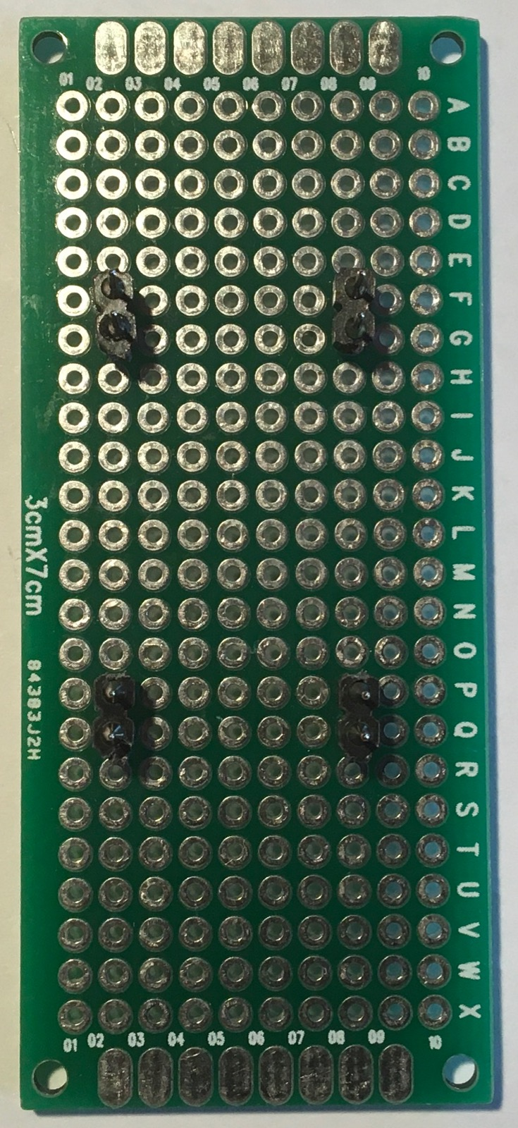
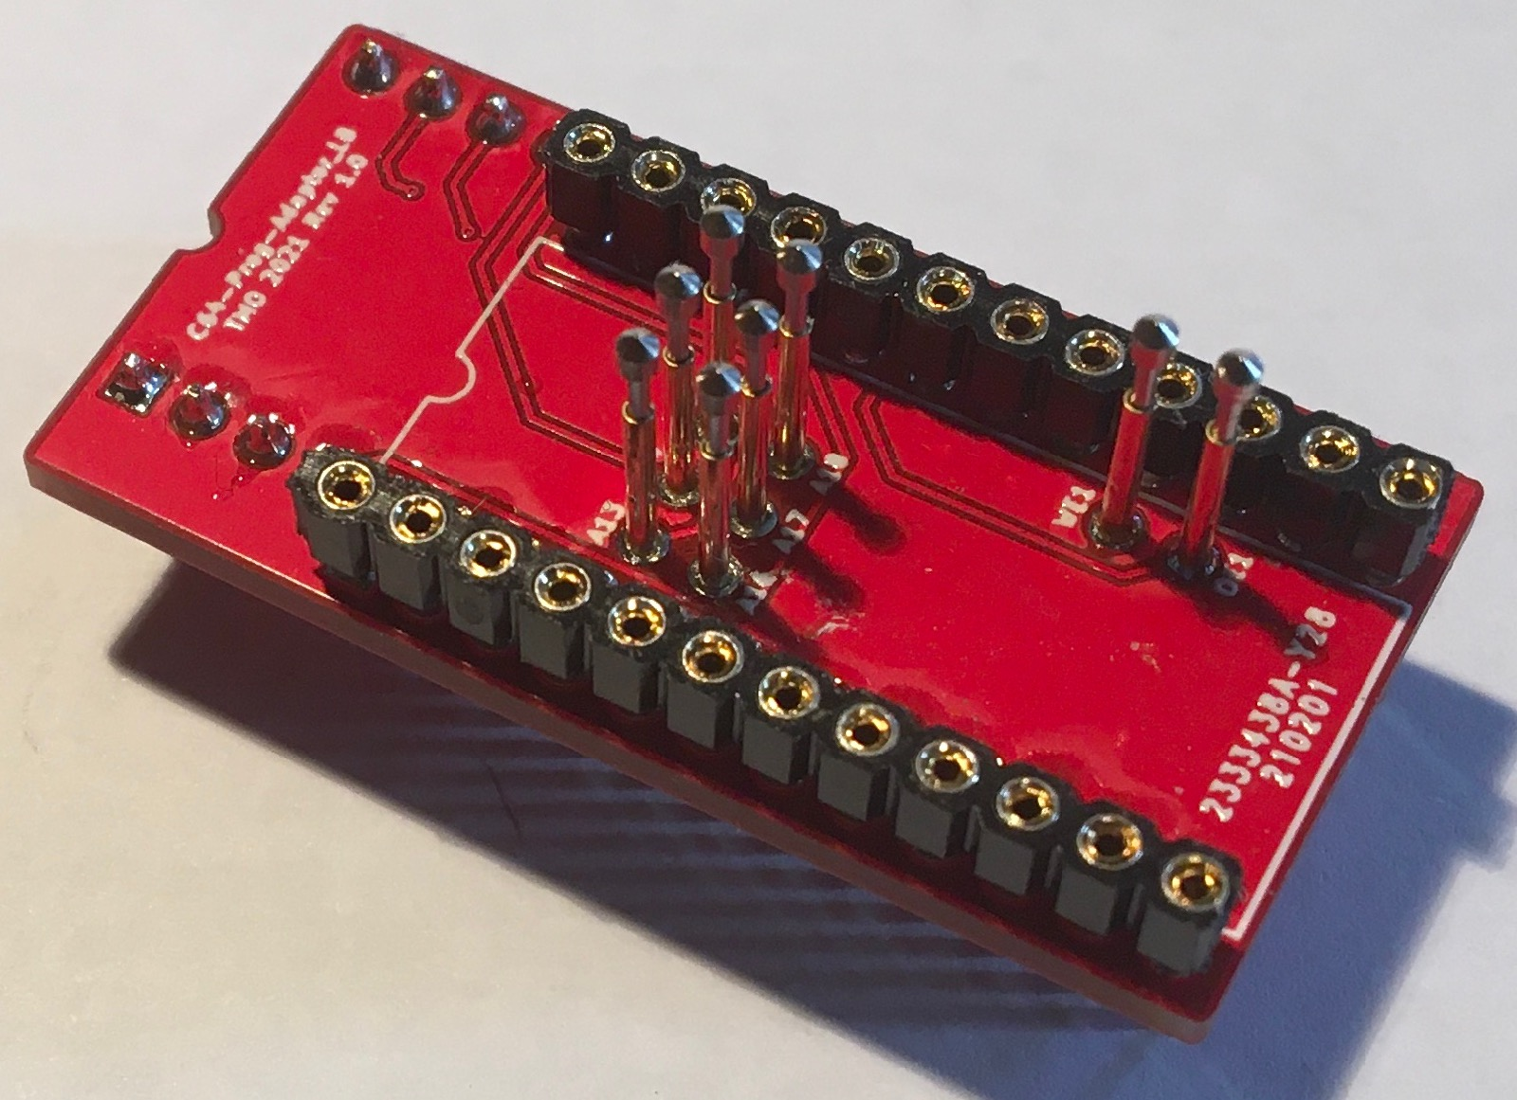
Figure 2: C64-Prog-Adapter-LB
A simple assembly aid using a breadboard is helpful for assembling the pogo pins.

Figure 3: pogo pin assembly aid

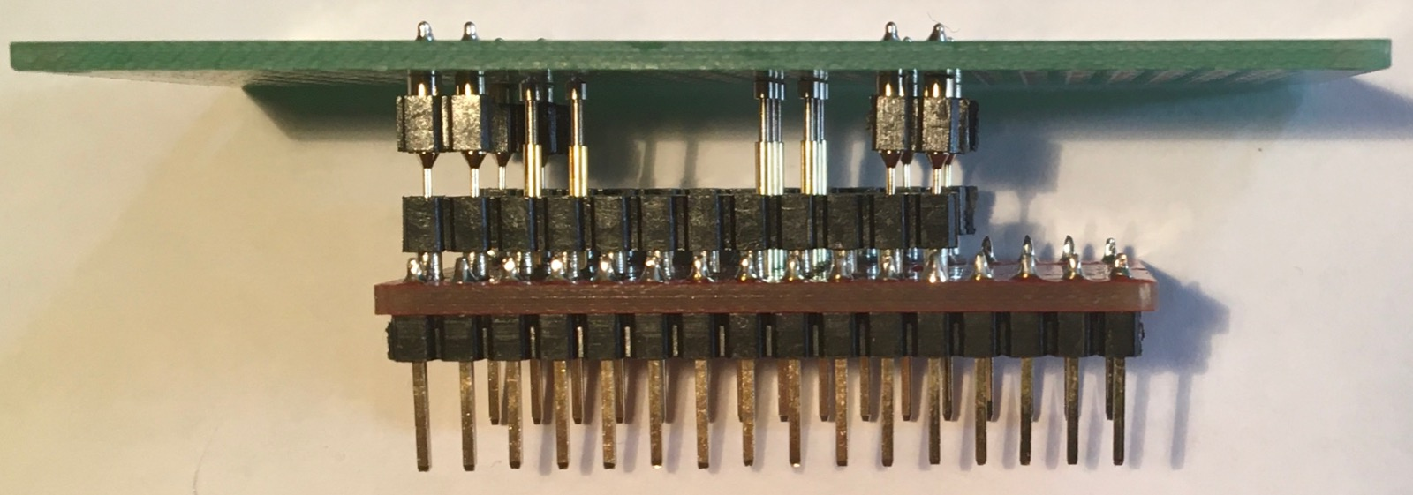
Figure 4: assembly aid and C64-Prog-Adapter-LB

Bilding a ROM file

As an example for the 1Mbit flash rom SST 39SF010A.

MACOS: open the terminal and use command cat

cat kernal1.bin kernal2.bin kernal3.bin kernal4.bin kernal5.bin kernal6.bin kernal7.bin kernal8.bin kernal9.bin kernal10.bin kernal11.bin kernal12.bin kernal13.bin kernal14.bin basic.bin char1.bin char2.bin > romC64.bin

Windows: open the shell

copy /b kernal1.bin + kernal2.bin + kernal3.bin + kernal4.bin + kernal5.bin + kernal6.bin + kernal7.bin + kernal8.bin + kernal9.bin + kernal10.bin + kernal11.bin + kernal12.bin + kernal13.bin + kernal14.bin + basic.bin + char1.bin + char2.bin romC64.bin

The ROM file must now have a size of 131072 bytes! If not, check the size of the kernals, basics, and char sets.

BOM Prog adaptor
pogo pin 6x P75-E2, head diameter 1,3mm, pin diameter 1,0mm
socket 1x 12 pol precision female socket, round (connection to C64-ROM-Adapter)
socket 1x 12 pol precision female socket, round (connection to C64-ROM-Adapter)
pin header 1x 16 pol straight, square pins (connection to programer)
pin header 1x 16 pol straight, square pins (connection to programer)

Note of thanks
This ROM Adaptor was inspired by knusis from forum64.

