TrainSpeedo Rev. 1.0
Description

The project is based on this source:
https://dcc-arduino.weebly.com/scale-speedometer.html

Introduction

This project is a "real size" speedometer for miniature trains, cars and anything you wish to measure.
It can calculate the speed of the object between 2 measuring points along the track (or road) by counting milliseconds between passages at the start and end gates. If you enter the distance between those gates (in dm) and the used scale (ex. H0 = 1:87) in to the Arduino, it will calculate the actual "real" speed of the object if it were on a 1:1 scale in the real world. This is a useful tool for measuring and calibrating the speed of your model trains on the layout, in order to be able to set and control their speed in the PC or central station for a realistic run on the tracks.
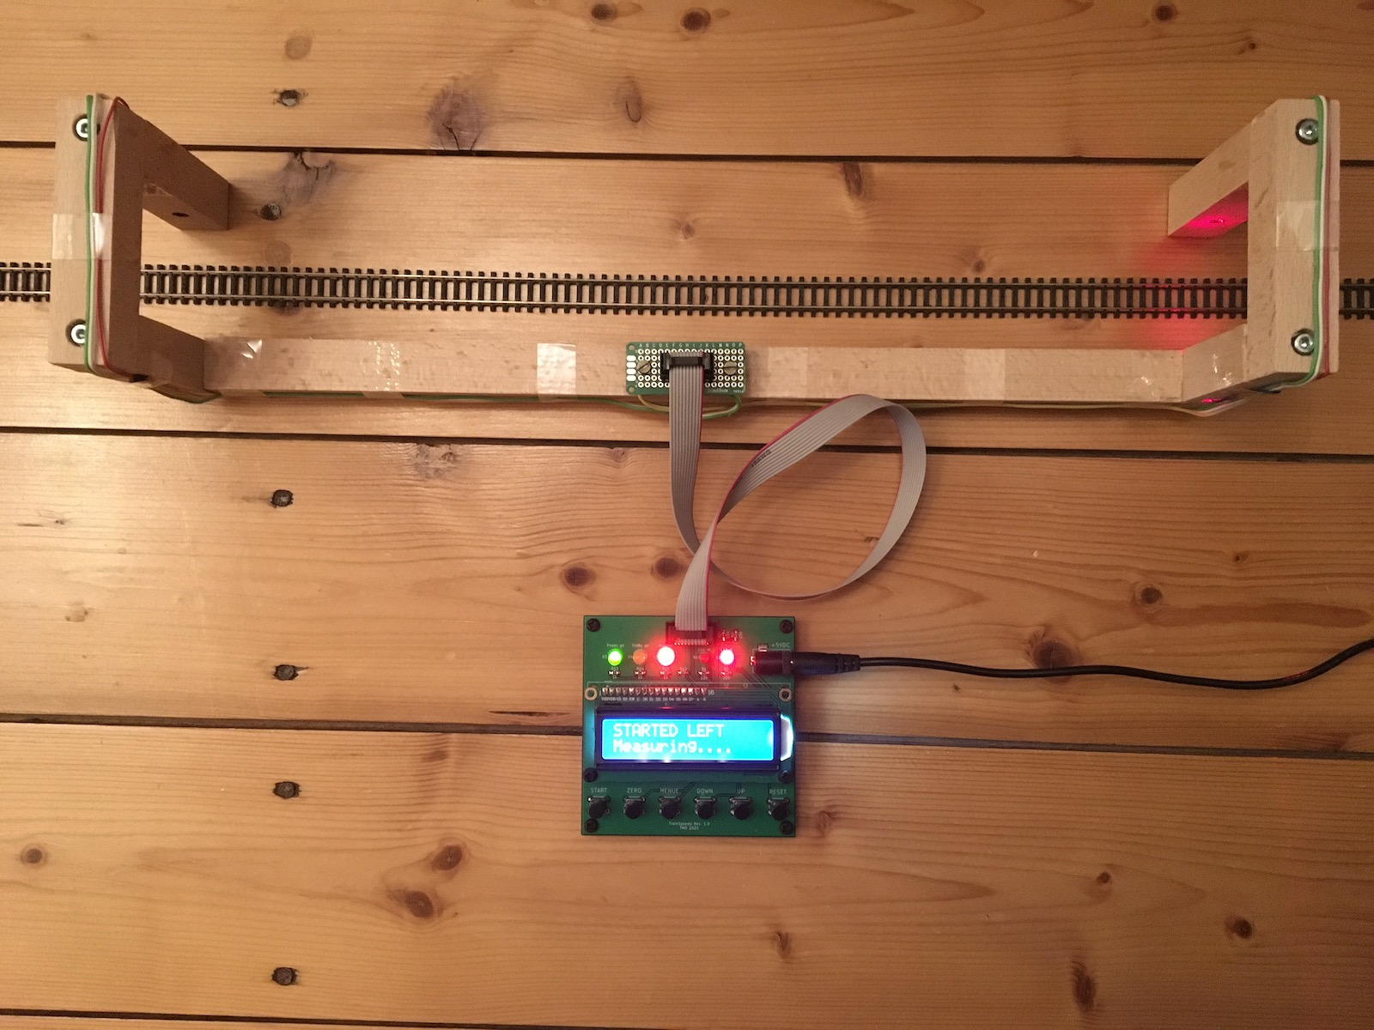

2 detectors are set up along the track, at a known distance (in dm) from each other. When a train runs by one of the detectors, the timer is started, the switch is auto-disabled (to eliminate double counts or other forms of interference) and only when the object passes by the other detector, will the timer be stopped and will the module calculate the speed based on time , distance and scale factors.
Due to the auto-disable fuction of the detectors, the system can calculate either LTR or RTL (left to right or right to left) moving objects with the same accuracy.
The commands :
-- START button : use this one to trigger the circuit and put it in stand-by so it will start measuring when an boject enters the test track section.
-- ZERO button : to clear the display or to interrupt an ongoing measurement (bypass)
-- MENU button : enters the 3 menu levels
* first push : enter the menu and go to the input screen for track length
* 2nd push : record the current setting and go to screen for scale input
* 3rd push : record the scale factor and go to the confirm / exit screen
* 4th push : confirm and store the new values or return to old ones and then go to main mode. (exit menu)
-- UP / DOWN buttons : used to increment / decrement or change the values in the menu screen.
-- RESET button (optional) : for a full reset of the device (however, scale and length are stored in EEPROM and will be remembered)

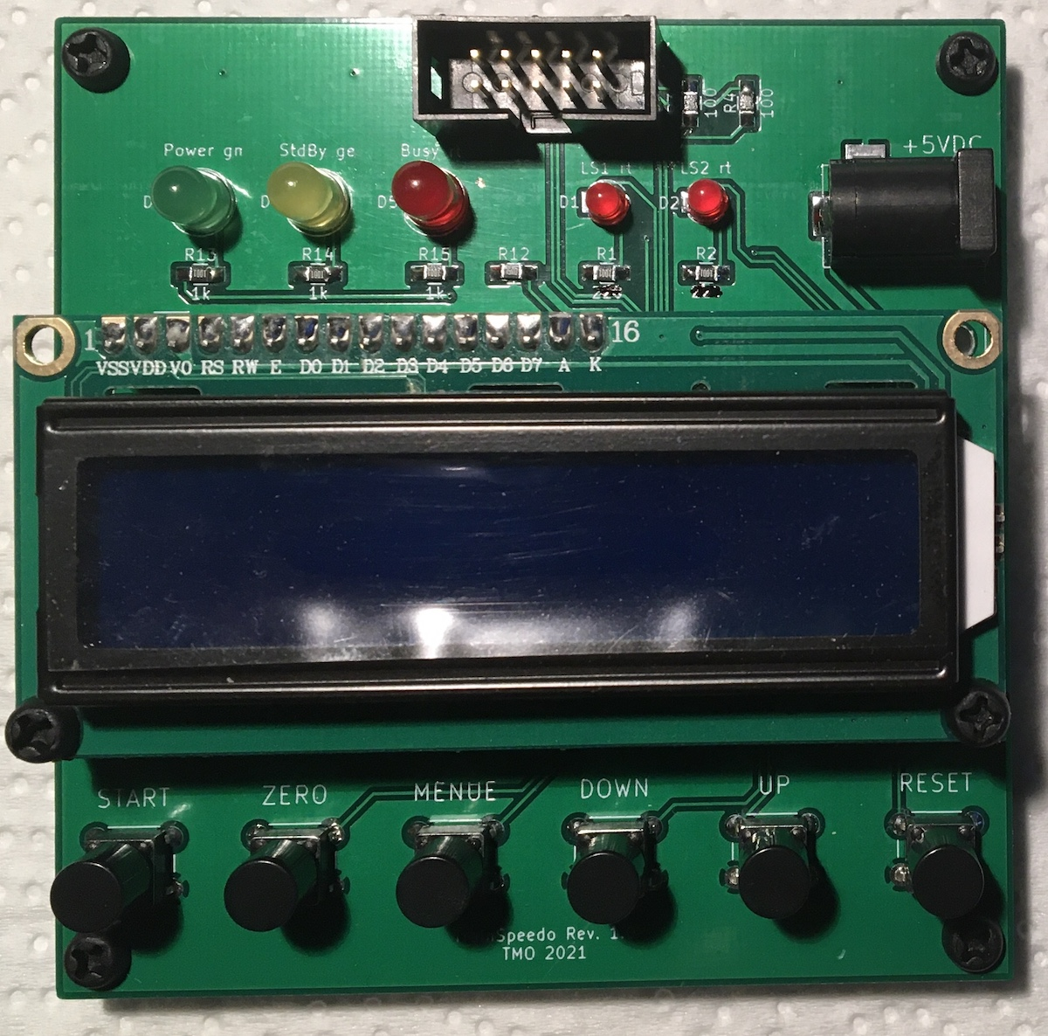

Detection

Detection is done using two Laser-LED / Transistor combinations, which create a "light vault" at each end of the measuring track/road.
The swithcing is "to ground" so when an object breaks the beam, the counter will start.
instead of IR vaults, you can also use conventional switches (contact switches), reed switches (magnetic), manual switches (like a stopwatch works) or any kind of detection that can swith a contact to ground.

Speed conversion formulas

We measure the distance between detectors in dm (decimeters) .
We measure the time in ms (milliseconds).
We measure the scale in units (ex. 87 = scale H0 = 1:87, 160 = Scale N = 1:160) after some calculations (1000 ms in a second -- 1 m/s = 3.6 km/h -- 100 mm in a dm ) here is the formula :
speed (km/h) = 360 * Distance (dm) * Scale (units) / Time (ms)
So a train covering 6 dm in 3838 ms at scale H0 (87) would be going 48 km/h in reality.

BOM
Reference Value Library Library Ref
C1, C2 22p SMD 0805 Device C
C3 100n SMD 0805 Device C
D1, D2 LS2 rt, LED 3mm Device LED
D3 Power gn, LED 5mm Device LED
D4 StdBy ge, LED 5mm Device LED
D5 Busy rt, LED 5mm Device LED
LD1, LD2 Laserdiode rt Device Laserdiode_1C2A
R1, R2 1k SMD 0805 Device R
R3, R4 100 SMD 0805 Device R
R5, R6, R9, R10 2k2 SMD 0805 Device R
R7, R8, R11 10k SMD 0805 Device R
R12 75 SMD 0805 Device R
R13, R14, R15 1k SMD 0805 Device R
RV1 10k Trimmer 5mm Device R_POT
Q1, Q2 SFH300 THT Sensor_Optical SFH300
Q3, Q4, Q5, Q6 BC337 THT Transistor_BJT BC337
SW1, SW2, SW3 5mm THT Switch SW_Push
SW4, SW5, SW6 5mm THT Switch SW_Push
U1 ATmega328-AU MCU_Microchip_Atmega ATmega328-AU
U2 RC1602A Display_Character RC1602A
Y1 16MHz THT Device Crystal
J1 Barrel Jack Connector 5,5mm / 2,1mm female
J2 2x5 female Connector_Generic Conn_02x05_Odd_Even
J3 2x3 male Connector_Generic Conn_02x03_Odd_Even
J4 1x2 male Connector_Generic Conn_01x02
J5 2x5 male Connector_Generic Conn_02x05_Odd_Even

Power supply

A plug-in power supply with output 5VDC 1-3A with a barrel connector 5.5mm / 2.1mm can be used. The positive pole must be on the inside.

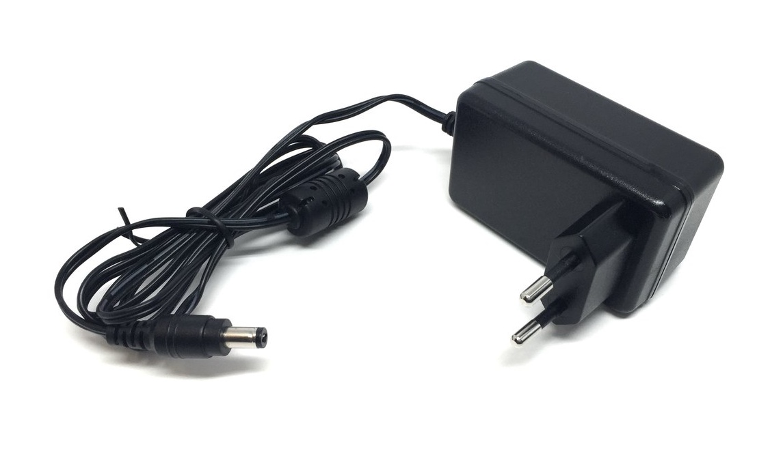

Buildung the firmware

The firmware was created with the Arduino software 1.8.15. For this it is necessary to integrate the minicore library into the Arduino software.

https://github.com/MCUdude/MiniCore

The following parameters are to be set in the Tools menu:
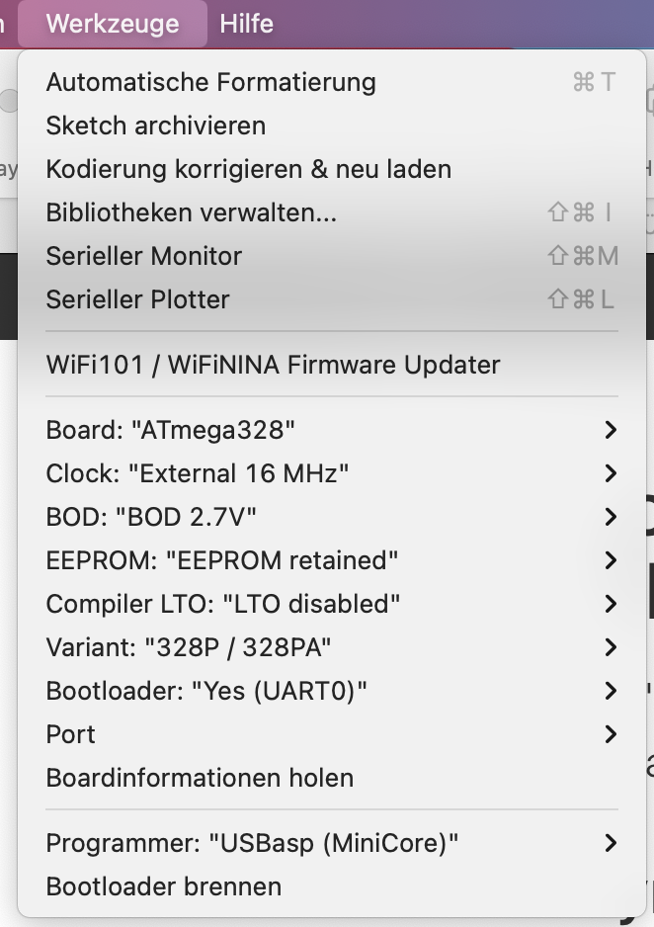

The next step is to compile and export the firmware in the Sketch menu.


Now two .hex files have been created. The hex file without bootloader can now be used as a finished firmware and loaded into the Atmega.

Programming

For programming, the display must be removed and jumper J4 opened.

The ATmega is programmed via the ISCP interface J3. The fuses must be set before programming the firmware.

Fuses:
- EXTENDED: 0xFD
- HIGH: 0xDE
- LOW: 0xF7 -> externer Full.swing Crystal (hier: 16MHz, wie Arduino UNO, NANO)

I used the Pololu Programmer v2.1 with the software AVRFuses 1.5.2 and the Pololu Configuratuins Utility under macos.

Initial start-up

The contrast of the display can be adjusted with the trimmer RV1 until characters are visible.

Jumper J4 must be closed.

When starting up for the first time or after programming firmware, the model scale and the measuring distance must be set using the MENUE, UP, DOWN buttons.

For example:

Scale:
H0 : 87
N : 160

Measuring distance between the detectors (photoelectric barrier):
4 : 40cm
10 : 100cm

Release notes :

*1* due to limitations in EEPROM writeable values (0-254) the length of measurement is limited to 254 decimeters, meaning 25,5 M (approx 70 ft) which should cover most purposes. Bear in mind that the speed calculations are done in cm/s but the length of the test track is in dm (decimeters) when you enter it in the menu. All internal conversions are done by the Arduino module.
*2* for wiring and component saving reasons, ALL pull up resistors (internal ones) must be enabled on the input channels.

Revision 1.0:

The following changes are taken into account in revision 1.0a.

1. A bridge from pin 1 to pin 5 must be added to the underside of the board (see picture).
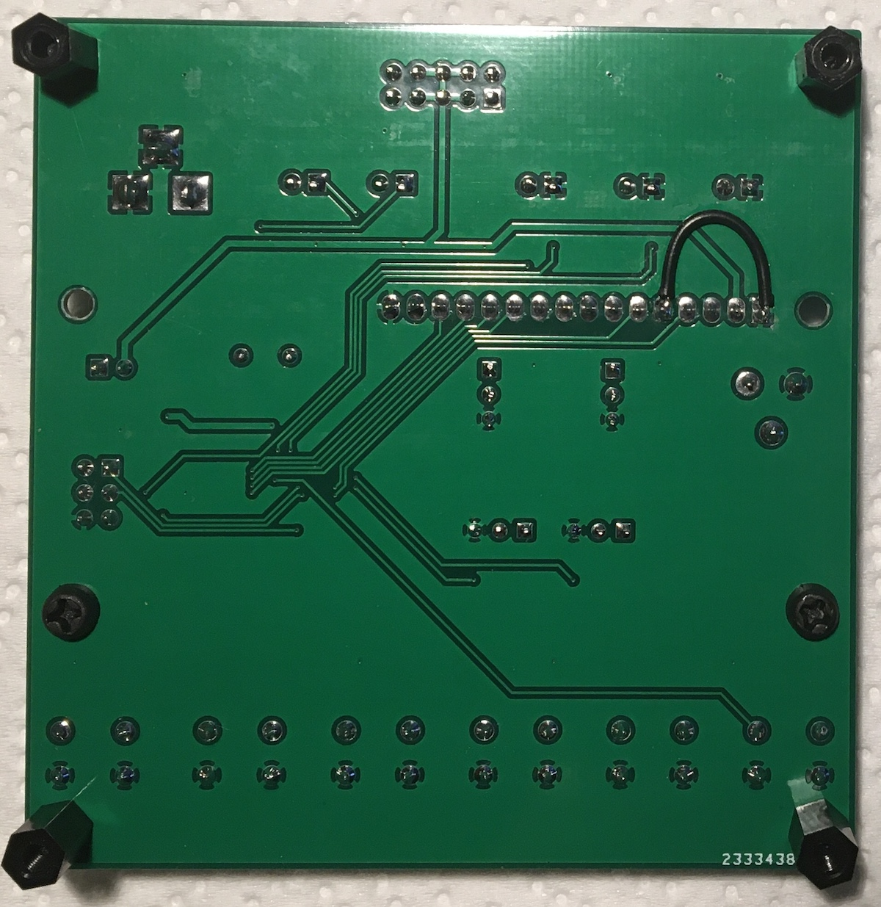
2. Changed component values C1, C2, R1, R2 and R12 compared to the board labeling.

C1, C2: 22p SMD 0805
R1, R2: 1k SMD 0805
R12: 75 SMD 0805

