PulmoAID: Multimodal Fusion of CT and Clinical Data with LLM-Aided Explainability Improves Lung Cancer Screening
Tushar Mehta

Abstract— Early-stage lung cancer screening is error-prone when CT is used alone. We present PulmoAID, an explainable multimodal approach that fuses CT-derived features with demographic/clinical variables and a language-model signal from clinical text to provide improved diagnostics. Using an NLST-based cohort (train n = 689; test n = 495), we compare CT-only, clinical-only, and fused models across standard classifiers. The best hybrid model based on a logistic regression on VGG16 slice features plus clinical predictors achieves 91% accuracy (precision 0.86, recall 0.91, F1 0.88), outperforming CT-only (F1 0.62) and clinical-only (F1 0.70) baselines. On the held-out test set, fusion reduces both false negatives and false positives relative to CT-only, indicating more reliable screening decisions. For transparency, Grad-CAM highlights image regions influencing predictions and SHAP quantifies contributions of age, smoking history, and text-derived signals; an LLM converts these into brief, plain-language rationales linked to each case, helping patients understand their diagnostics and build confidence in their prescribed treatment. Overall, PulmoAID combines lightweight classifiers with LLM-enabled explainability to improve screening performance and deliver better patient outcomes.

INTRODUCTION
Lung cancer (LC) is the leading cause of cancer death worldwide, largely due to late detection, with >1.8 million deaths in 2020 [1,2]. It arises from abnormal cell growth forming tumors that impair lung function. Detecting cancerous cells in their initial stages is crucial because it can significantly improve treatment outcomes, devise personalized treatment plans and improve the likelihood of survival [3-5]. Treating cancer at an advanced stage is often more expensive due to the need for complex treatments, such as chemotherapy or extensive surgery [6].
CT is the standard non-invasive tool for LC screening, but manual reads are time-consuming, subject to inter-observer variability, and can blur benign conditions (e.g., infection, scarring) with malignancy, leading to potential diagnostic delays and errors in high-volume or resource-limited settings [7–11]. This motivates the need for automated diagnostic systems that not only analyze imaging data but also leverage complementary patient information. Multimodal fusion, combining CT with structured clinical variables and text-derived features from large language models (LLMs) has the potential to boost accuracy, provide clear explanations, and capture context that single-modality systems miss.
While CNNs (e.g., VGG16, ResNet) perform well on CT alone, image-only models, they do not capture the clinical context. There are numerous prior studies on multimodal methods which rely on late fusion that limits cross-modal interactions [10,12–15]. Another valuable modality can come from unstructured clinical text, physician notes. NLP, especially large language models (LLMs), can surface semantic cues, temporal patterns, and symptom links missing from structured fields; fusing these text-derived features with imaging and clinical data yields a richer, more holistic patient representation [16].
Alongside improved prediction, explainability is critical for clinical adoption. Visualization tools such as Gradient-weighted Class Activation Mapping (Grad-CAM) [17] and Shapley Additive exPlanations (SHAP) [18] have become standard for interpreting CNN decisions. Yet, these tools often produce technical outputs that are best understood by ML developers, not clinicians. LLMs present an emerging capability to bridge this gap by generating patient-specific, natural language explanations that contextualize predictions within a patient’s broader clinical profile [19].
Proposal
The overall aim of this research is to design a multimodal, LLM-enabled diagnostic framework that fuses radiological, structured clinical, and unstructured text data to deliver accurate, interpretable, and accessible lung cancer diagnostics. This system has to be effective in both high-resource and low-resource healthcare environments, where early, explainable screening can reduce mortality and economic burden.
We designed a multimodal fusion method that combines medical imaging with clinical data and reports to improve the accuracy of early-stage lung cancer detection. This approach leverages the strengths of each modality to enhance diagnosis and ensure more accurate disease screening. We integrated advanced transfer learning and LLM methodologies to extract insights from rich clinical and imaging data derived from the National Lung Screening Trial (NLST) [20].
We hypothesized that transfer learning models using 3D features extracted from medical images will outperform VGG16-like 2D models applied to individual CT slices in terms of binary classification accuracy. Furthermore, we hypothesized that fusing features extracted from the 3D transfer learning models with features derived from clinical reports via NLP and key demographic predictors will deliver the high fidelity required for personalized medicine.
We systematically defined the design space for our multimodal diagnostic framework to evaluate the impact of different predictor types, feature extraction strategies, and classification algorithms. For CT feature extraction, we implemented multiple transfer learning backbones, including 3D ResNet [21], MedicalNet [22], and 2D VGG16 to capture diverse spatial and contextual representations. We trained a variety of machine learning classifiers, including logistic regression, XGBoost, random forest, k-nearest neighbors, and naïve Bayes, each with specific hyperparameter grids. We optimized hyperparameters through exhaustive or randomized search over learning rates, solvers, numbers of estimators, and smoothing parameters for traditional ML models, as well as network depth, optimizers, batch size, and epochs for deep learning architectures. (Table 1).
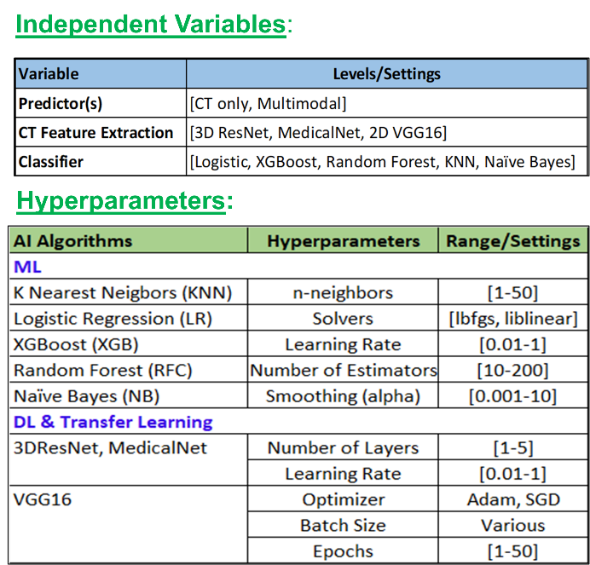
TABLE I. Independent variables and corresponding hyperparameter ranges explored in the design space.

methods
This section describes the complete end-to-end workflow for our proposed multimodal lung cancer diagnostic system. The framework integrates standardized pre-processing of longitudinal 3D chest CT scans, deep feature extraction via transfer learning with pre-trained 2D and 3D convolutional neural networks, and fusion of imaging features with structured demographic, clinical, and sentiment score (Fig. 1).
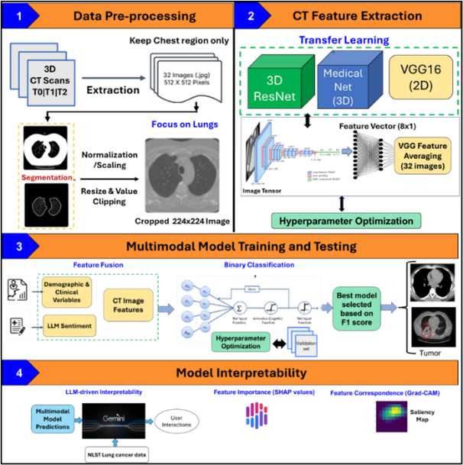
Figure 1. Overview of the multimodal lung cancer diagnostic pipeline.
- Imaging Data Acquisition and Preprocessing
We used longitudinal 3D chest CTs (T0/T1/T2) from public sources (e.g., NLST; ~53k high-risk participants, ages 55–74). The training set comprised 310 cancer (58,042 images) and 369 non-cancer (50,898) subjects; the test set had 312 cancer (58,982) and 183 non-cancer (30,519) subjects, with accompanying clinical/demographic data [20]. Scans were axial-slice selected, intensity-normalized, and resized to match pretrained backbones. For 2D CNNs, lungs were semi-automatically segmented to remove non-pulmonary anatomy; each volume was resampled to 32 axial slices/patient, saved as 512×512 JPEGs, and standardized for uniform inputs.
- Feature Extraction from Imaging
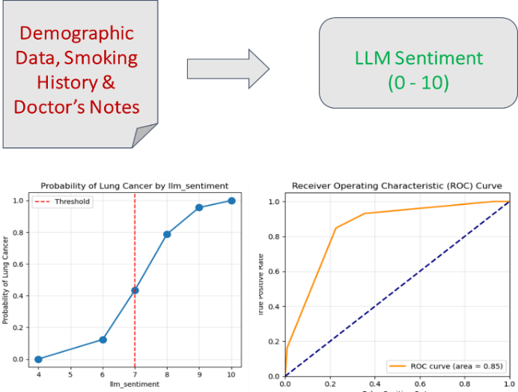
We compared (1) VGG16 (2D) fine-tuned on lung-nodule labels; 2D slice features were averaged across 32 slices for a fixed-length patient vector; (2) 3D ResNet, using 3D convolutions to learn volumetric/spatiotemporal patterns; and (3) MedicalNet (3D ResNet family with medical pretraining) to accelerate convergence and improve generalization on limited labeled data.
(a)
(b)
(c)
Figure 2. (a) LLM-derived sentiment score generated from demographic information, and doctor’s notes. (b) Plot depicts the increasing probability of lung cancer as a function of LLM sentiment. (c) Plot presents the ROC curve for the LLM sentiment model.
We fine-tuned all backbones via hyperparameter search (learning rate, batch size, layer freezing). Due to inconsistent slice thickness/availability, 2D CNNs outperformed 3D models. Final conv features were flattened and fed to dense layers to capture high-dimensional spatial patterns.
- Structured Clinical Data
We curated age, sex, smoking status, comorbidities, and family history, applied one-hot encoding for categorical variables, and concatenated these with image embeddings to form a multimodal feature set.
- Clinical Notes via LLM
De-identified notes were tokenized and embedded using a Gemini-based pipeline. A fine-tuned LLM produced a cancer-likelihood sentiment score (≥7 = high risk; Fig. 2), which we vectorized and appended to each patient’s predictors.
- Multimodal Training
We combined (i) latent CT features, (ii) demographics, and (iii) the LLM sentiment score, and trained a fully connected classifier for binary tumor prediction. Using stratified splits, we iteratively tuned hyperparameters and selected the final model by F1 score to balance precision and recall under class imbalance.
- Explainability
We used Grad-CAM to localize influential CT regions and SHAP to quantify contributions from tabular and LLM-derived features. Outputs were surfaced in a patient-facing interface that generated brief, natural-language rationales for each prediction.
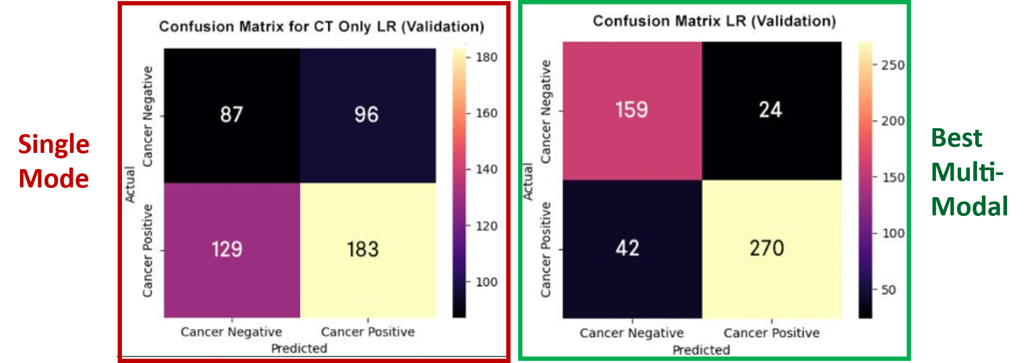
We deploy an integrated PulmoAID pipeline that fuses CT features, structured clinical data, and LLM-derived text signals. For imaging, we use a truncated VGG16 backbone (pre-classifier) to retain rich spatial/contextual information before multimodal fusion.
(a)
(b)

RESULTS
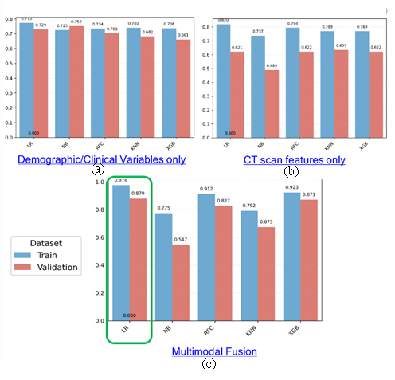
We evaluated PulmoAID on 495 test patients (annotated CTs + clinical records) using accuracy, precision, recall, and F1. The best model trained on 689 patients with a 20% validation split achieved 91% accuracy, 86% precision, 91% recall, and 88% F1. Multimodal fusion outperformed single-modality baselines: image-only model with F1 = 0.62 and structured-only model with F1 = 0.70. Adding LLM-derived text features improved all metrics by 7–10% (Fig. 3).
Figure 3. Binary classifier performance (F1 score) for five models: Logistic Regression (LR), Naïve Bayes (NB), Random Forest Classifier (RFC), K-nearest Neighbors (KNN), and XGBoost (XGB), evaluated on three input configurations: (a) demographic/clinical variables only, (b) CT scan features only, and (c) multimodal fusion (clinical + imaging + LLM-derived features). Results are shown for both training and validation datasets.
Binary Classifier Comparisons
We compared five binary classifiers—Logistic Regression (LR), Naïve Bayes (NB), Random Forest Classifier (RFC), K-nearest Neighbors (KNN), and XGBoost (XGB)—across three experimental setups:
- Structured demographic/clinical variables only
- CT scan features only
- Multimodal fusion of structured, imaging, and LLM-derived features
For structured variables alone, F1 scores on the testing set ranged from 0.734 (NB) to 0.781 (XGB), with LR achieving 0.752. For CT features alone, performance was lower overall, with NB scoring 0.489 and RFC scoring 0.704 on validation. The multimodal fusion model achieved the highest scores in every classifier.
Fig. 4 compares confusion matrices. The CT-only logistic regression shows weak discrimination with many errors (FN = 129, FP = 96) on 495 test patients. The multimodal fusion model (imaging + structured clinical data) markedly improves results—TP = 270, TN = 159, FN = 42, FP = 24—highlighting how non-imaging features boost generalizability and early-malignancy sensitivity.

Figure 4. Confusion matrices comparing (a) single-modality (CT-only) and (b) multimodal logistic regression models on the testing set.
Interpretability Graphs
Fig. 5 shows Grad-CAM maps for the original CT and eight latent features, highlighting image regions driving PulmoAID’s predictions. Several features activate around radiologically salient findings—spiculated margins, central lobar masses, and cavitary lesions—confirming clinically meaningful focus. Other features remain low-intensity for this case, indicating minimal contribution and patient-specific feature selection. Overall, the visualizations support the model’s interpretability and clinical relevance.
SHAP analysis further revealed the relative contributions of non-imaging features. Smoking history, age, and genetic predisposition were among the most influential structured variables, while sentiment indicators from physician notes were top contributors among LLM-derived features.
LLM-enabled Virtual Doctor
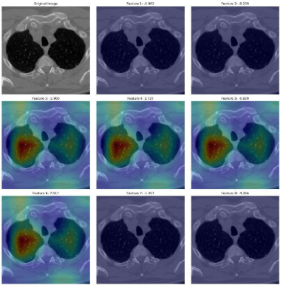
To enhance interpretability, PulmoAID includes a “Virtual Doctor” conversational engine that converts inputs and model outputs into plain-language diagnostic summaries and rationale (Fig. 6). This GenAI-powered feature enhances interpretability and transparency in lung cancer diagnostics by translating complex data into structured, explainable reasoning. In functional tests of the web app with mock low-resource inputs, inference latency averaged <2 s and remained robust across varied input sizes, indicating scalability for resource-limited settings. Together, these results support PulmoAID as a reliable, clinically relevant multimodal AI for earlier lung-cancer detection with transparent explanations.
Original
Feature 1
Feature 2
Feature 3
Feature 4
Feature 5
Feature 6
Feature 7
Feature 8
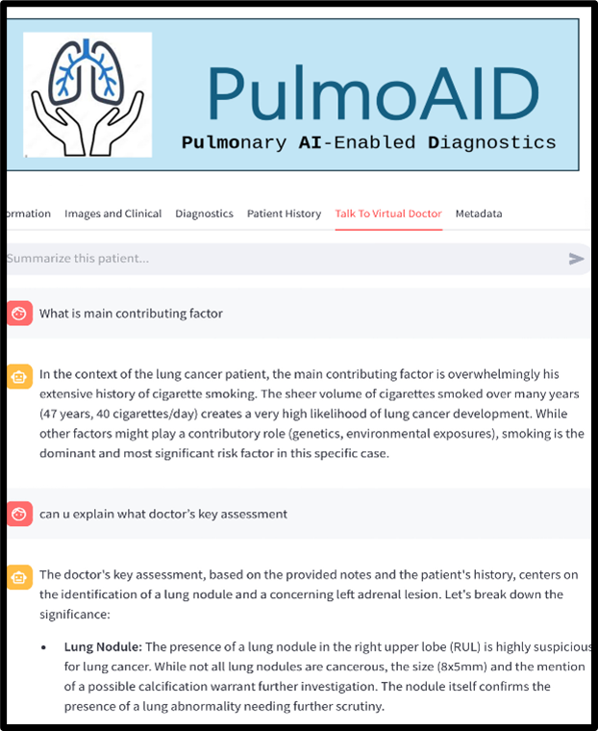
Figure 5. Grad-CAM overlays on lung CT localize model attention, with warmer colors indicating higher importance.
Figure 6. Virtual Doctor provides key diagnostic insights from both patient history and imaging data.
SYSTEM DESIGN AND DEPLOYMENT
PulmoAID is a modular, end-to-end lung cancer diagnostics system delivered via a lightweight web app for both high- and low-resource settings. A microservices architecture separates data ingestion, preprocessing, inference, visualization, and user interaction, enabling independent updates and horizontal scale. The stack includes Pandas (ETL), PyTorch (models), and Matplotlib (explainability); artifacts are versioned in GitHub for reproducibility. A Streamlit front end supports uploads of CT scans and structured data, real-time predictions, Grad-CAM views, and LLM (Gemini) virtual doctor conversation engine with secure, session-tracked PDF exports. Back-end services use MongoDB Atlas for inputs, predictions, and logs; the system is Docker-containerized for cloud or on-prem deployment. HIPAA-aligned controls (encryption, access, audit trails) are enforced. In low-bandwidth simulations, preloaded weights and compressed outputs kept latency <3 s, positioning PulmoAID as a scalable, secure, clinically usable assistant (Fig. 7).

DISCUSSION
This study demonstrates the power and practicality of multimodal fusion for lung-cancer diagnostics. By combining CT-derived visual features with language-based insights from clinical notes and key demographics, our approach substantially outperforms image-only baselines: the fusion model (2D VGG16 slice embeddings + clinical predictors in a logistic-regression head) achieved F1 = 0.88 versus 0.62 for the CT-only model. These gains reflect the value of integrating structural features (imaging) with contextual signals (history, risk factors, comorbidities) that are often invisible to purely vision models. Notably, a 2D transfer-learning strategy surpassed more complex 3D CNNs (3D-ResNet, MedicalNet), likely due to slice-thickness variability and inconsistent volumetric coverage across datasets, suggesting that simpler, slice-based pipelines can be more robust and generalizable in practice. The LLM-based text pipeline further improved performance and interpretability by surfacing clinically meaningful rationales. This approach not only improves diagnostic accuracy but also delivers near-instant diagnostics and natural language explanations for telemedicine and global public health initiatives.
We translate these findings into PulmoAID, a scalable, secure, and intuitive web platform that functions as a “digital radiologist” at the point of care, well suited to rural clinics, underserved regions, and emergency settings. By turning multimodal evidence into clear, human-readable recommendations (with Grad-CAM visualizations and natural-language explanations), PulmoAID can help reduce diagnostic delays, narrow disparities, and support more equitable, personalized decision-making.
Limitations & Next Steps
The current model is trained and validated on publicly available datasets, which may not fully capture the heterogeneity of real-world populations. Variations in imaging Protocols, electronic health record formats, and linguistic differences in clinical notes may impact generalizability. Furthermore, reliance on Gemini for LLM integration raises considerations around computational cost and external API dependency, which could affect deployment success in highly constrained environments.
To achieve further adoption of PulmoAID, there is an opportunity to deepen EHR and telemedicine integration for seamless point-of-care use, with continued attention to trust, transparency, governance, and privacy.
Taking together, these advances position PulmoAID as a practical, interpretable, and scalable foundation for AI-assisted pulmonary diagnostics, with a clear path to real-world impact.
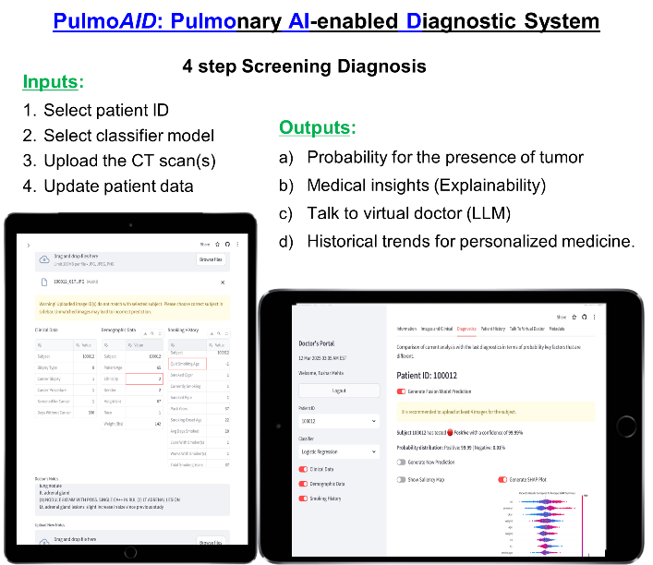
(b)
(a)
Figure 7. PulmoAID platform interface illustrates the end-to-end flow from data input to model-assisted diagnostic output. (a) Structured patient metadata (e.g., demographics, smoking history) and imaging files are uploaded through a secure web interface. (b) Outputs include risk prediction, Grad-CAM visualizations for interpretability, and a LLM-generated natural explanation, forming a multimodal, explainable diagnostic report designed for clinician review and decision support.

Acknowledgment
This research used NLST data obtained from the National Cancer Institute (NCI) Cancer Data Access System (CDAS). We gratefully acknowledge the National Lung Screening Trial (NLST) participants and study teams.

References
- World Health Organization, “Cancer fact sheet: Lung cancer statistics,” WHO, 2020. [Online]. Available: https://www.who.int
- American Cancer Society, “What is lung cancer?,” ACS, 2020. [Online]. Available: https://www.cancer.org
- National Cancer Institute, “Lung cancer types and stages,” NCI, 2020. [Online]. Available: https://www.cancer.gov
- Mayo Clinic, “Non-small cell lung cancer,” Mayo Clinic, 2020. [Online]. Available: https://www.mayoclinic.org
- R. L. Siegel, K. D. Miller, and A. Jemal, “Cancer statistics, 2020,” CA Cancer J. Clin., vol. 70, no. 1, pp. 7–30, Jan. 2020.
- D. Jones and R. Patel, “Economic burden of misdiagnoses in lung cancer patients,” Lancet Oncol., vol. 21, no. 11, pp. 1456–1462, Nov. 2020, doi: 10.1016/S1470-2045(20)30389-7.
- Radiological Society of North America, “Computed tomography and its role in lung cancer screening,” RSNA, 2020. [Online]. Available: https://www.rsna.org
- Lung Cancer Research Foundation, “Challenges in CT-based lung cancer diagnosis,” LCRF, 2020. [Online]. Available: https://www.lungcancerresearchfoundation.org
- F. O’Sullivan and J. R. O’Neill, “CT imaging in early lung cancer detection,” Radiology, vol. 293, no. 3, pp. 530–546, Dec. 2020, doi: 10.1148/radiol.2020200456.
- A. Smith and Y. Wang, “Artificial intelligence in lung cancer imaging: Current trends and challenges,” J. Thorac. Oncol., vol. 15, no. 9, pp. 1413–1427, Sep. 2020, doi: 10.1016/j.jtho.2020.05.008.
- S. F. Yang and L. M. Chen, “Improving CT scan diagnostics for lung cancer in low-resource settings,” Int. J. Cancer, vol. 147, no. 12, pp. 3458–3467, Dec. 2020.
- K. Simonyan and A. Zisserman, “Very deep convolutional networks for large-scale image recognition,” in Proc. Int. Conf. Learn. Represent., 2014, pp. 1409–1556. [Online]. Available: https://doi.org/10.48550/arXiv.1409.1556
- K. He, X. Zhang, S. Ren, and J. Sun, “Deep residual learning for image recognition,” in Proc. IEEE Conf. Comput. Vis. Pattern Recognit. (CVPR), Las Vegas, NV, USA, 2016, pp. 770–778.
- S.-C. Huang, A. Pareek, S. Seyyedi, I. Banerjee, and M. P. Lungren, “Fusion of medical imaging and electronic health records using deep learning: a systematic review and implementation guidelines,” npj Digit. Med., vol. 3, art. no. 136, 2020. [Online]. Available: (DOI: 10.1038/s41746-020-00341-z)
- N. Nikolaou et al., “A machine learning approach for multimodal data fusion for survival prediction in cancer patients,” Precision Oncol., vol. 9, art. no. 128, May 2025.
- Y. Nam, “Multimodal large language models: A new era in medical imaging,” Korean J. Radiol., vol. 26, no. 5, pp. 321–331, May 2025, doi: 10.3348/kjr.2025.0599.
- Selvaraju, R.R., Cogswell, M., Das, A. et al., “Grad-CAM: Visual Explanations from Deep Networks via Gradient-Based Localization,” 2017 IEEE International Conference on Computer Vision (ICCV), pp. 618–626, 2017.DOI: 10.1109/ICCV.2017.74
- Lundberg, S.M. and Lee, S.I., “A Unified Approach to Interpreting Model Predictions,” Advances in Neural Information Processing Systems, vol. 30, 2017. [Online]. Available: https://proceedings.neurips.cc/paper_files/paper/2017/file/8a20a8621978632d76c43dfd28b67767-Paper.pdf
- F. Gaber et al., “Evaluating large language model workflows in clinical decision support,” Digit. Med., vol. 8, art. no. 84, July 2025. DOI: doi: 10.1038/s41746-025-01684-1 [Online].
- National Cancer Institute, “National Lung Screening Trial (NLST) dataset,” NIH, 2011. [Online]. Available: https://www.cancer.gov
- K. Hara, H. Kataoka, and Y. Satoh, “Can spatiotemporal 3D CNNs retrace the history of 2D CNNs and ImageNet?” in Proc. IEEE Conf. Comput. Vis. Pattern Recognit., 2018, pp. 6546–6555.
- S. Chen, K. Ma, and Y. Zheng, “Med3D: Transfer learning for 3D medical image analysis,” arXiv preprint arXiv:1904.00625, 2019. [Online]. Available: https://doi.org/10.48550/arXiv.1904.00625

