Explainable AI for Brain Tumor Detection: A Hybrid Approach for Robust and Accessible MRI Diagnostics
Tushar Mehta
Abstract— Brain tumors, the 5th most common cancer worldwide, affect 400,000 people annually with a survival rate of just 34%. Early detection via MRI is critical, as malignant tumors can double in size within 20 days. However, regions with limited access to radiologists face high misdiagnosis rates (4%) and diagnostic delays of up to 150 days. To address these challenges, a novel hybrid algorithm combining transfer learning with machine learning techniques has been developed, achieving a 98% accuracy and F1-score for tumor detection. For classification, pixel-based methods like XGBoost proved to be the best classifier for detecting Glioma, Meningioma, and Pituitary tumors, reaching 94% accuracy. The model's explainability is enhanced through feature importance and saliency maps, providing insights for medical professionals. This technology has been integrated into NeuroAID, an AI-powered tool for accessible and interpretable brain tumor screening, particularly benefiting underserved regions.

Introduction
Brain tumors result from the abnormal growth of brain cells, forming masses that can impair brain function and become life-threatening. In 2020, approximately 251,329 people worldwide died from primary cancerous brain tumors [1]. Early detection is crucial for improving survival rates, but traditional diagnostic methods like MRI scans are labor-intensive, error-prone, and dependent on specialized radiologists. Furthermore, MRI can detect abnormalities but struggles to distinguish between tumors and other conditions like infections or strokes, limiting its utility. Poor access and long processing times in many underdeveloped regions result in late diagnosis and higher healthcare costs [2,3].
To address these challenges, researchers have explored automated methods for brain tumor detection, but existing approaches often suffer from low accuracy and high false-positive rates [3]. Consequently, there is a need for more reliable and efficient methods to accurately identify brain tumors. In recent years, machine learning and deep learning methods have shown potential in enhancing medical diagnostics. These technologies are especially valuable in regions with limited access to healthcare professionals, such as parts of Africa, and Asia. However, medical image classification models require large datasets to achieve high accuracy, which are not always available. In such cases, transfer learning is used, adapting pre-trained models to related tasks, significantly improving detection accuracy [4,5].
Proposal
In this study, we propose and evaluate feature-based deep transfer learning fusion techniques for the screening and classification of brain tumors using MRI scans. Specifically, the models VGG16 and ResNet50 are analyzed independently and in combination to enhance model performance and accuracy. These are contrasted with pixel-based algorithms such as K-nearest neighbors, Naïve Bayes, Random Forest, XGBoost, and Logistic Regression. An essential component of this research is the integration of Explainable Artificial Intelligence (XAI), which is pivotal in the medical field to enhance interpretability and transparency[6,7]. XAI provides clinicians and patients with insights into the decision-making process of the AI model, detailing the critical features that drive classification, Fig. 1.This interpretability is crucial for ensuring the reliability, fairness, and ethical use of AI in clinical settings, especially in areas where medical image diagnostics are subjective and heavily influenced by the expertise of the radiologist [8,9].
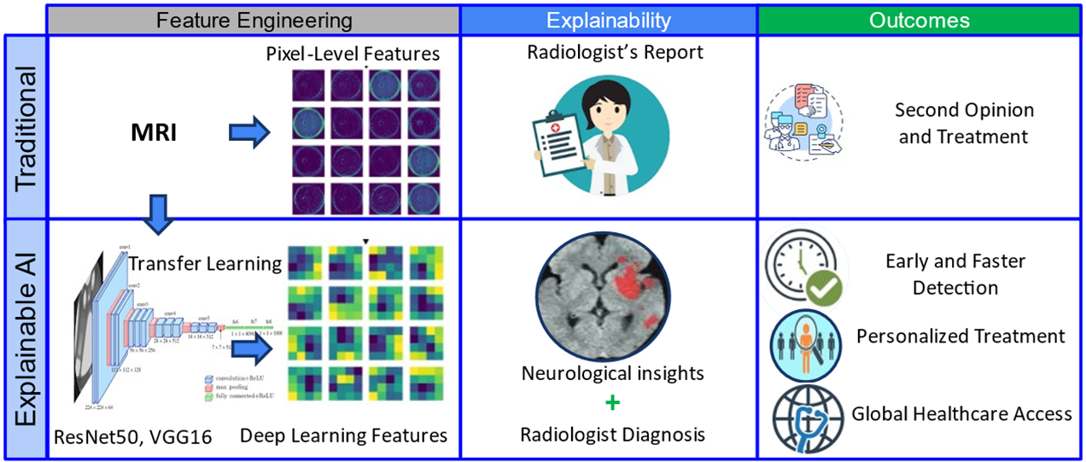
Figure 1. XAI-enabled diagnostics as a lifesaver in underserved regions.
The central research question posed in this study is whether hybrid feature-based deep learning models can offer a robust and effective solution for the early screening and classification of brain tumors for global health applications. Also, for classification of glioma, meningioma, and pituitary tumors, efficacy of pixel-based machine learning models over feature-based models is evaluated based on inherent spatial dependency of tumors.
In designing robust and efficient models for detection and classification, several algorithms and their hyperparameters are evaluated as part of the independent variables design space, described in table 1. The performance of each algorithm for a given set of testing/validations scans is evaluated using a confusion matrix, which quantifies the model’s ability to correctly and incorrectly classify tumor presence or type. This information is used to evaluate model performance in terms of dependent variables described in Fig. 2.
Table 1. Design space depicting different algorithms and hyperparameters
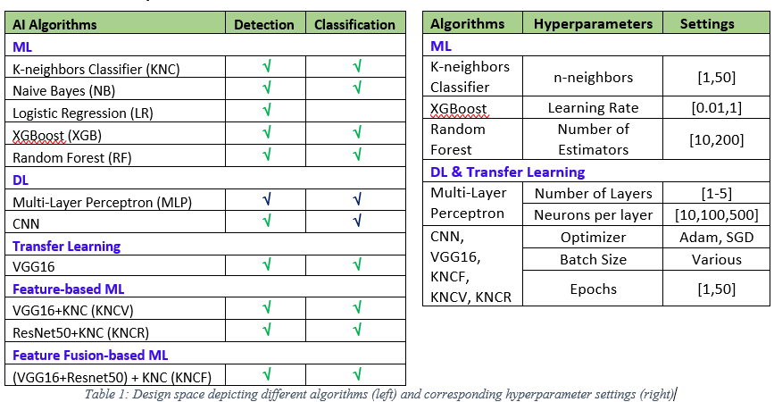
Additionally, the computational efficiency of each model is taken into account. Training time is considered as a secondary dependent variable. In this study, all models are trained on consistent data partitions and use standardized MRI scans at a resolution of 150x150 pixels. Image augmentation and preprocessing techniques are applied uniformly across the models to ensure a fair comparison of performance.. As an experimental control, model accuracy and precision achieved on the training partition is cross validated on the testing partition to achieve significant lift.
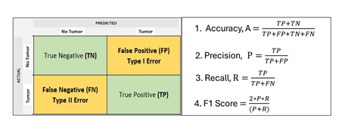
Figure 2. Confusion matrix with performance metrics

Methods
MRI Data Sets
This study uses two publicly available datasets from Kaggle for brain tumor detection via MRI scans. The first dataset includes MRI images of 300 patients, where each grayscale image (150x150 pixels) is labeled either as "No Tumor" or "Tumor." Around 61.3% of the patients have tumors, while 38.7% do not, providing data for binary classification. The second dataset consists of an augmented version with 7,023 MRI scans categorized into four classes: glioma, meningioma, pituitary tumors, and no tumor. The images have a higher resolution of 512x512 pixels and include three different brain views: axial, coronal, and sagittal. The dataset is split into 5,712 training and 1,311 testing images supporting multi class classification and training of the detection models.
Model Development and Testing
The aim of the project was to build models with high accuracy while minimizing false positives and false negatives. To achieve this, the F1 score was prioritized in selecting the best-performing models based on the following steps:
- Data Preparation: For machine learning and deep learning models, images were resized to 150x150 pixels and reduced to 1 channel to meet memory constraints.
- Preprocessing: The darker edges of the MRI images were cropped to focus on the brain region, followed by normalization of pixel intensities to the 0-1 range. For transfer learning, all 3 channels were used, while deep learning models employed a single channel, flattened into 22500 pixels for machine learning [10].
- Labeling: Tumor types were encoded numerically: 0 for no tumor, 1 for Glioma, 2 for Meningioma, and 3 for Pituitary.
- Data Augmentation: To expand the dataset, horizontal flipping was applied, effectively doubling the dataset.
- Data Partitioning: 80% training and 20% testing.
- Hyperparameter Optimization: Key settings for each algorithm were optimized to maximize F1 score.
Neurological Insights based on Model Explainability
To gain insights from the models, feature importance plots and heat maps were generated to identify features associated with each target class. For subject-specific explainability, saliency maps were developed. Comparing saliency maps of MRI scans with and without tumors provided a deeper understanding of tumor characteristics. The code for model development, training, and testing is available on GitHub: https://github.com/TMRmehta/NeuroAID.

Results

Parametric Sensitivities

A key step in determining the optimal training parameters for each model was conducting parametric study for accuracy, precision, and F1 score with respect to hyperparameters, Fig. 3. For XGBoost, the study identified the learning rate as a critical hyperparameter, with the optimal value determined to be 0.41. For the Random Forest classifier, the number of estimators was the key focus. In deep learning and transfer learning models, parameters such as the number of epochs and optimizers were varied to optimize model performance. As an example, for the VGG16 model, five epochs were found to be optimal based on the evaluation of accuracy and loss as a function of epochs. Further studies on neural network models involved testing different architectures to optimize factors like convolution templates, and batch size.
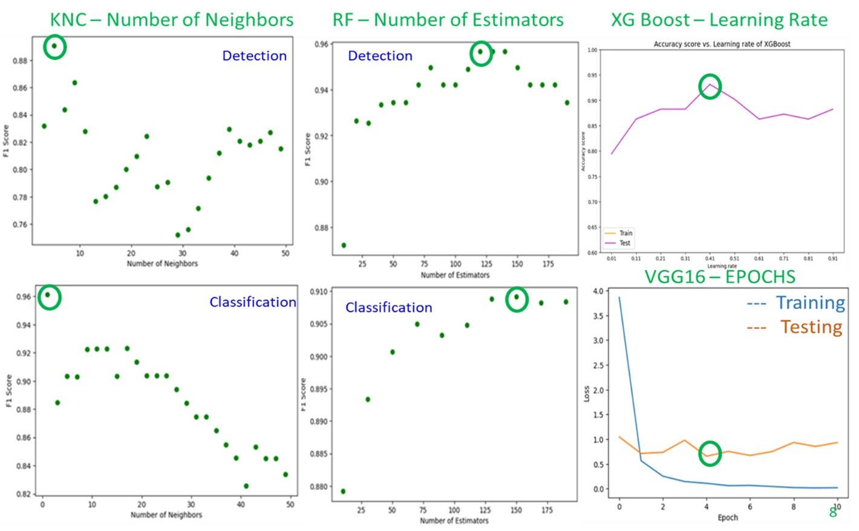
Figure 3. Parametric study: optimal hyperparameter selection

Confusion Matrices

For the detection model (binary classification), the confusion matrix is a 2x2 grid where the top right cell represents false positives (Type I error), and the bottom left cell represents false negatives (Type II error), Fig. 4. Minimizing both types of errors is crucial, as Type I errors may result in unnecessary treatments, while Type II errors could delay necessary medical intervention. A model with lower off-diagonal values signifies better performance and a higher F1-score [10]. For the multi-class classification problem, the confusion matrix is 4x4, and the off-diagonal cells indicate misclassifications.

Performance Metrics

The performance metrics of various detection and classification algorithms were evaluated using precision, recall, and F1-score derived from the confusion matrix (Table 2). KNCR, a K-nearest neighbor clustering model using ResNet50 features, demonstrated the best results with an F1-score of 0.97 and accuracy of 0.98. Another model, KNCV, which used VGG16 for feature extraction, performed similarly well but with fewer features, making it suitable for scenarios with limited computational resources. For the more challenging classification task, XGBoost achieved the highest performance, with an F1-score of 0.97 and accuracy of 0.94, performing equally well across all tumor classes. 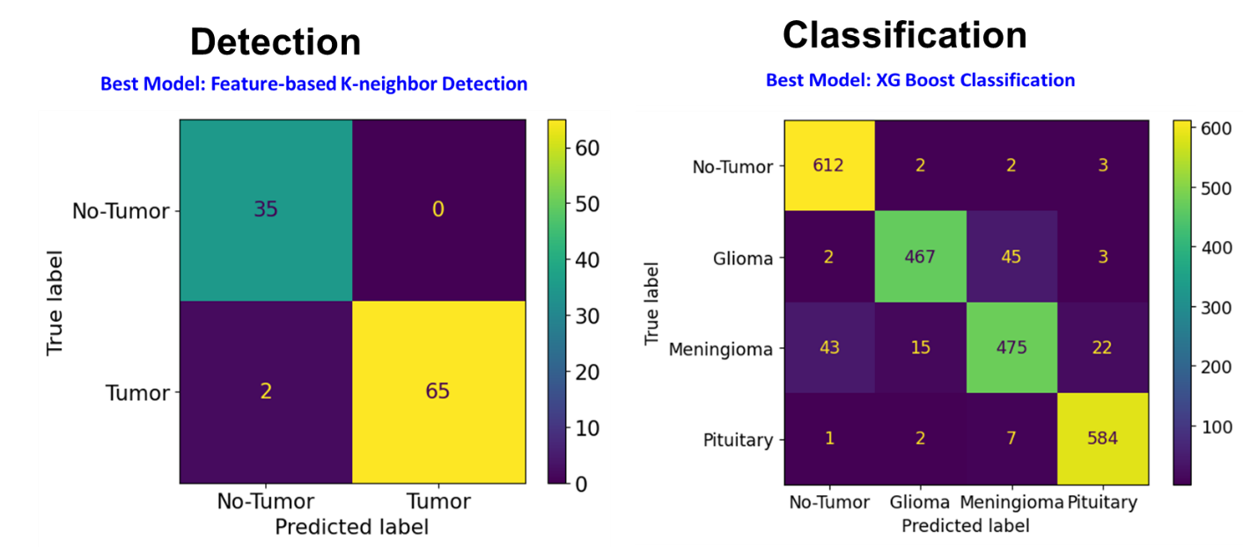
Figure 4. Confusion matrices for best models for detection and classification

Training and testing times per epoch were manageable for the detection task, but for classification using deep learning and transfer learning, training times varied between 15 minutes to an hour, depending on model complexity.
Table 2. Performance metrics for various detection/classification algorithms

Explainability

Explainability for the machine learning models was assessed at the model level through a feature importance plot, which highlights the most important pixels used for tumor detection. These top 10 pixels provide critical insights into tumor presence within MRI scans. The feature importance is determined by correlating pixel intensity with class differentiation across the entire model. In addition, a heat map overlay was generated on the MRI scans to visualize which regions of the brain the AI model focused on when detecting tumors, Fig. 5. This mirrors the visual diagnostics typically used by radiologists. For CNN and deep learning models, it’s possible to extract important pixels at the individual scan level, providing personalized insights into which areas of the scan contributed to the classification. Furthermore, SHAP plots were used to demonstrate how key features (pixels) contributed to the model’s prediction., high intensity pixels on heatmap are indicative of regions where the algorithms found abnormal growth of cells as captured in the MRI.

Discussion

This study developed a three-stage explainable brain tumor diagnostic framework using MRI scans to detect and classify tumors (glioma, meningioma, pituitary) with high accuracy. The framework integrates transfer learning models with advanced machine learning techniques. The best detection model, using ResNet50 for feature extraction and K-nearest neighbors (KNN) for classification, achieved 98% accuracy and 0.98 F1-score. Meanwhile, XGBoost was identified as the most accurate classifier, reaching a 94% accuracy. The

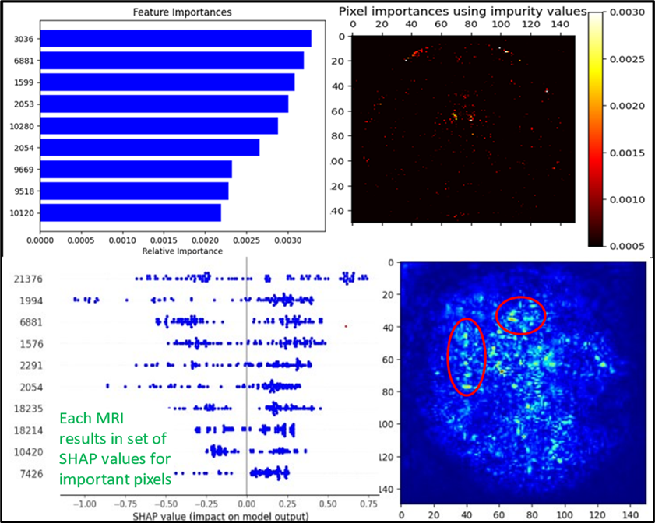
Figure 5. Explainability: Identify the affected areas of the brain.

explainability of the models was a key focus, using feature importance plots and saliency maps to identify important MRI features, helping clinicians understand model predictions at both the model and individual patient levels.

The final product, NeuroAID, is a web-based application that incorporates these best-in-class models for real-time brain tumor detection. The system can be expanded to include other tumor types and improved by integrating datasets and patient-specific features like lifestyle factors and time-based MRI analysis. These enhancements could improve prediction accuracy and better track tumor progression, making the tool more effective for real-world clinical use, Fig. 6.

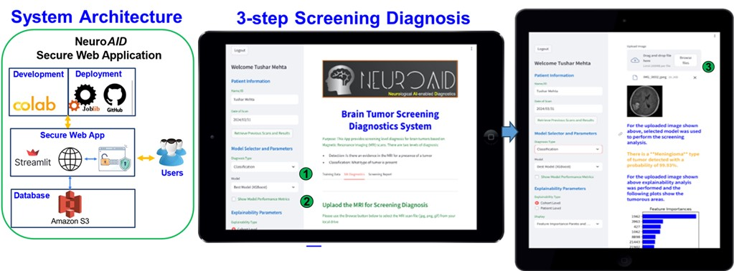
Figure 6. NeuroAid Application: system architecture and web interface

References
- Miller, K., et al. “Brain and other central nervous system tumor statistics, 2021.” CA: a cancer journal for clinicians, 2021, pp. 381-406.
- McFaline-Figueroa, J Ricardo, and Eudocia Q Lee. “Brain Tumors.” The American journal of medicine vol. 131,8 (2018): 874-882.
- Mabray, M., et al. “Modern brain tumor imaging.” Brain tumor res. and treatment, 2015, pp. 8-23.
- Cè, Maurizio et al. “Artificial Intelligence in Brain Tumor Imaging: A Step toward Personalized Medicine.” Current oncology, 2023.
- Shah, Faisal Muhammad et al. “Brain Tumor Segmentation Techniques on Medical Images - A Review.” (2019).
- Yan et.al. "An Explainable Brain Tumor Detection Framework for MRI Analysis" Applied Sciences 13, no. 6: 3438. (2023)
- Kumar, Sandeep et al. “Brain Tumor Classification Using Deep Neural Network and Transfer Learning.” Brain Topography 36 (2023).
- Patel et.al. “A survey on Brain Tumor detection using deep learning” (2020).
- Khan, Md Saikat Islam et al. “Accurate brain tumor detection using deep convolutional neural network.” Comput. and structural biotechnology journal vol. 20 4733-4745. (2022).
- Simonyan, K, et al. “Very Deep Convol. Networks for Large-Scale Image Recognition.” Int. Conf. on Learning, 2014, pp. 1409-1556.

