1. Напишите скрипт для суммы OrderQty для каждого года и зимних месяцев из Production.WorkOrder в виде транспонированной матрицы:

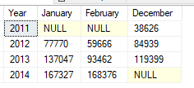

SELECT [Year], [January] AS January, [February] AS February, [December] AS December

FROM

(SELECT DISTINCT YEAR(DueDate) AS Year, format(DueDate,'MMMM') AS Month, OrderQty

FROM Production.WorkOrder

WHERE format(DueDate,'MMMM') = 'December' OR format(DueDate,'MMMM') = 'January' OR format(DueDate,'MMMM') = 'February') AS PWO

PIVOT

(

SUM (OrderQty)

FOR Month IN ( [January], [February], [December] )

) AS PVT

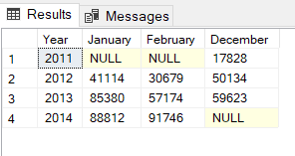

У меня другой результат появился((