**Решите следующие задачи:**

1. Покажите всех менеджеров, которые имеют в подчинении больше 6-ти сотрудников.

SELECT MANAGER_ID, COUNT(EMPLOYEE_ID) AS Count_Employee

FROM EMPLOYEES

GROUP BY MANAGER_ID

HAVING COUNT(EMPLOYEE_ID)>6

1. Вывести min и max зарплату с вычетом commission_pct для каждого департамента. (commission_pct на базе указывается в процентах).

SELECT DISTINCT D.DEPARTMENT_NAME,

MIN(SALARY) AS MIN,

MAX(SALARY)-(MAX(SALARY)*COMMISSION_PCT/100) AS MAX

FROM DEPARTMENTS AS D JOIN E.EMPLOYEES AS E ON

D.DEPARTMENT_ID= E. EMPLOYEE_ID

GROUP BY D.DEPARTMENT_NAME

1. Вывести только регион, где работают больше всего людей.

--1

SELECT TOP 1 WITH TIES R.REGION_NAME, COUNT (E. EMPLOYEE_ID) AS CNT

FROM REGION AS R JOIN LOCATION AS L ON R.REGION_ID=L.COUNTRY_ID

JOIN DEPARTMENTS AS D ON L.LOCATION_ID=D. LOCATION_ID

JOIN EMPLOYEES AS E ON D.DEPARTMENT_ID= E. EMPLOYEE_ID

GROUP BY R.REGION_NAME

ORDER BY DESC

--2

WITH TEMP AS

(

SELECT R.REGION_NAME, COUNT (E. EMPLOYEE_ID) AS CNT

FROM REGION AS R JOIN LOCATION AS L ON R.REGION_ID=L.COUNTRY_ID

JOIN DEPARTMENTS AS D ON L.LOCATION_ID=D. LOCATION_ID

JOIN EMPLOYEES AS E ON D.DEPARTMENT_ID= E. EMPLOYEE_ID

GROUP BY R.REGION_NAME

)

SELECT R.REGION_NAME

FROM TEMP

WHERE CNT=(SELECT MAX(CNT) FROM TEMP)

1. Найдите разницу в процентах между средней зп по каждому департаменту от общей средней (по всем департаментам).

SELECT DEPARTMENT_ID,

AVG (SALARY) – (SELECT AVG (SALARY) FROM EMPLOYEES),

[PERSENT] = ROUND(100*1.0*( AVG (SALARY) – (SELECT AVG (SALARY) FROM EMPLOYEES)) / SUM(AVG (SALARY) – (SELECT AVG (SALARY) FROM EMPLOYEES)) OVER (), 0)

FROM EMPLOYEES

GROUP BY DEPARTMENT_ID

A SIMILAR TASK FOR [Production].[Product]:

SELECT AVG([StandardCost]) AS AVG

FROM Production.Product

SELECT Color, AVG([StandardCost]) AS AVG

FROM Production.Product

GROUP BY Color

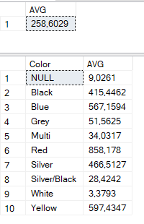

SELECT Color, AVG([StandardCost]) - (SELECT AVG([StandardCost]) FROM [Production].[Product]) AS AVG,

**[percentage] = ROUND(100 * 1.0 * (AVG([StandardCost]) - (SELECT AVG([StandardCost]) FROM [Production].[Product])) / SUM(AVG([StandardCost]) - (SELECT AVG([StandardCost]) FROM [Production].[Product])) OVER(), 0)**

FROM [Production].[Product]

GROUP BY Color

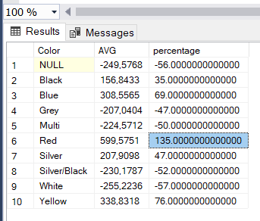

1. Найдите людей, кто проработал больше, чем 10 лет в одном департаменте.

SELECT FIRST_NAME, LAST_NAME, COUNT(DEPARTMENT_ID) AS CNT

FROM EMPLOYEES

WHERE YEAR(HIRE_DATE)>=YEAR(GETDATE())-10

GROUP BY FIRST_NAME, LAST_NAME

1. Найдите людей, кто занимает 5-10 место по размеру зарплаты.

SELECT DISTINCT FIRST_NAME, LAST_NAME

FROM

(

SELECT FIRST_NAME, LAST_NAME, DENSE_RANK() OVER (ORDER BY SALARY) AS LEVEL_SALARY

FROM EMPLOYEES

) S

WHERE LEVEL_SALARY IN (5,6,7,8,9,10)

