**Отчет**

**Домашняя работа 10**

1. **Напишите скрипт для суммы OrderQty для каждого года и зимних месяцев из Production.WorkOrder в виде транспонированной матрицы.**

SELECT NumberYear, [December], [January], [February]

FROM

(SELECT YEAR(StartDate) AS NumberYear, DATENAME(month, StartDate) AS Month_Name, OrderQty

FROM Production.WorkOrder

GROUP BY YEAR(StartDate), DATENAME(month, StartDate), OrderQty

HAVING DATENAME(month, StartDate) IN ('December', 'January', 'February')

) AS SourceTable

PIVOT

(SUM(OrderQty)

FOR Month_Name IN ([December], [January], [February])

) AS PivotTable

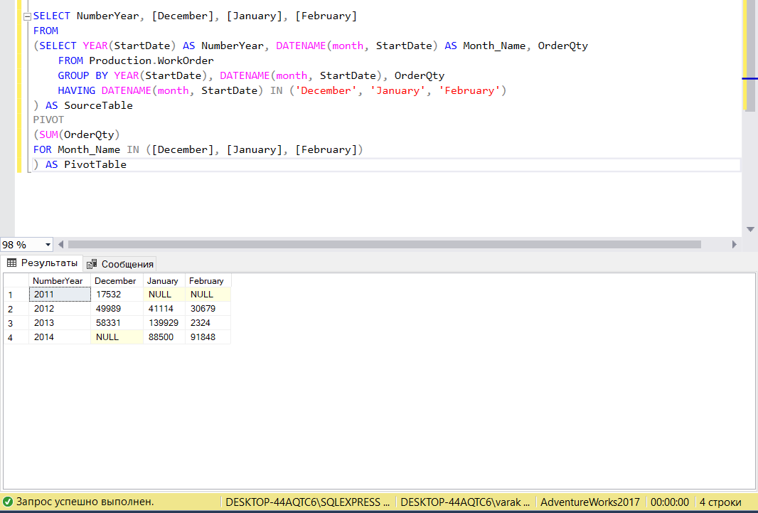

SELECT NumberYear, [December], [January], [February]

FROM

(SELECT YEAR(DueDate) AS NumberYear, DATENAME(month, DueDate) AS Month_Name, OrderQty

FROM Production.WorkOrder

GROUP BY YEAR(DueDate), DATENAME(month, DueDate), OrderQty

HAVING DATENAME(month, DueDate) IN ('December', 'January', 'February')

) AS SourceTable

PIVOT

(SUM(OrderQty)

FOR Month_Name IN ([December], [January], [February])

) AS PivotTable

