**Задание 1 и Задание 4**

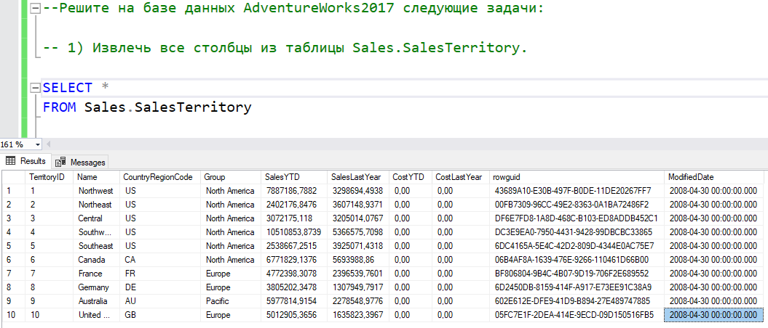

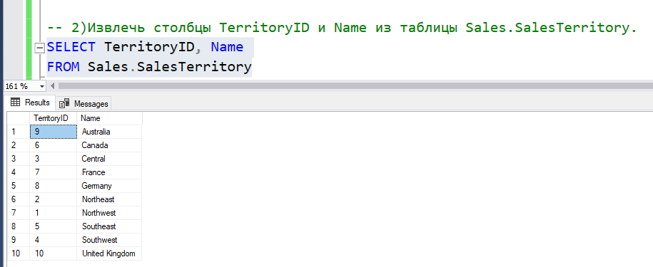

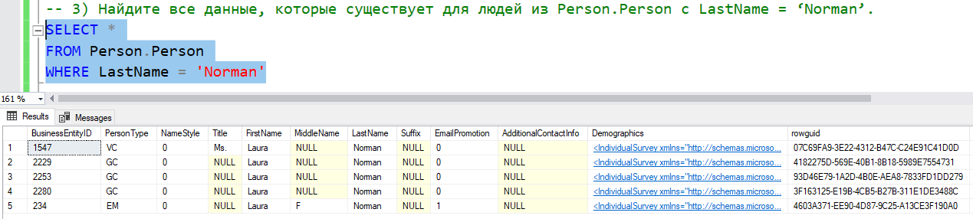

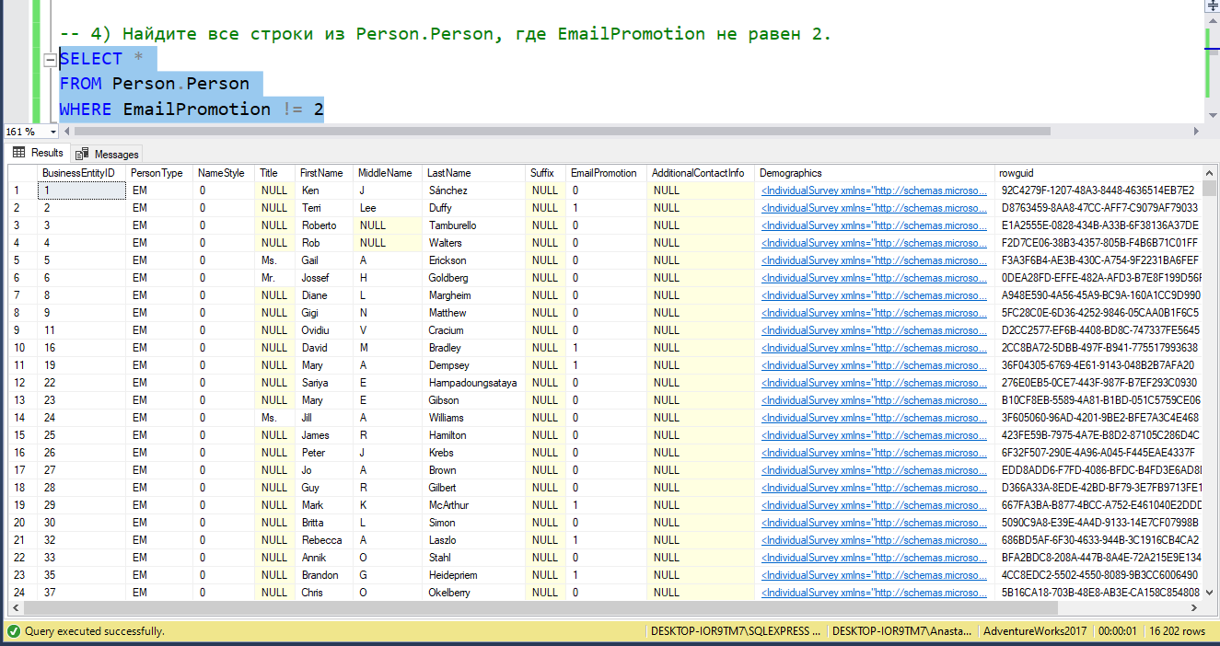

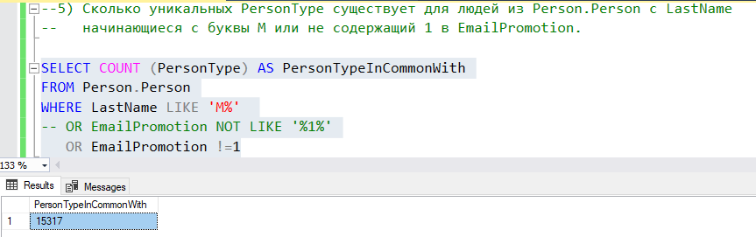

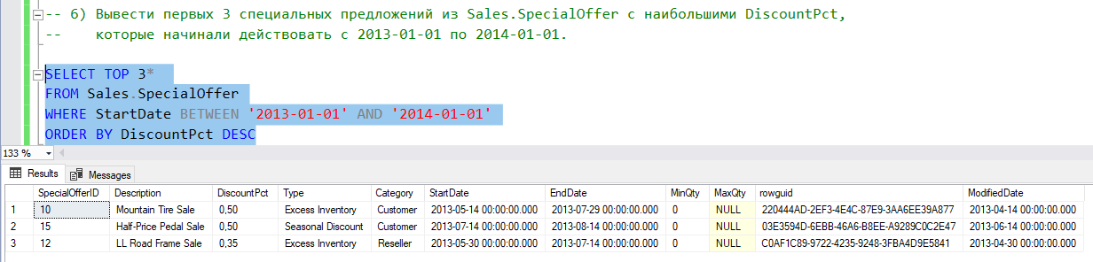

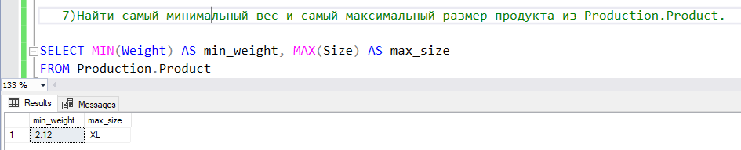

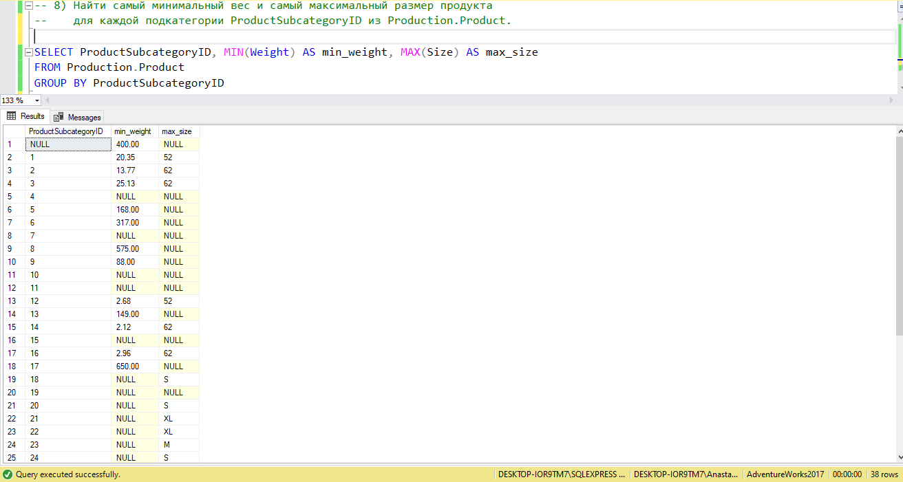

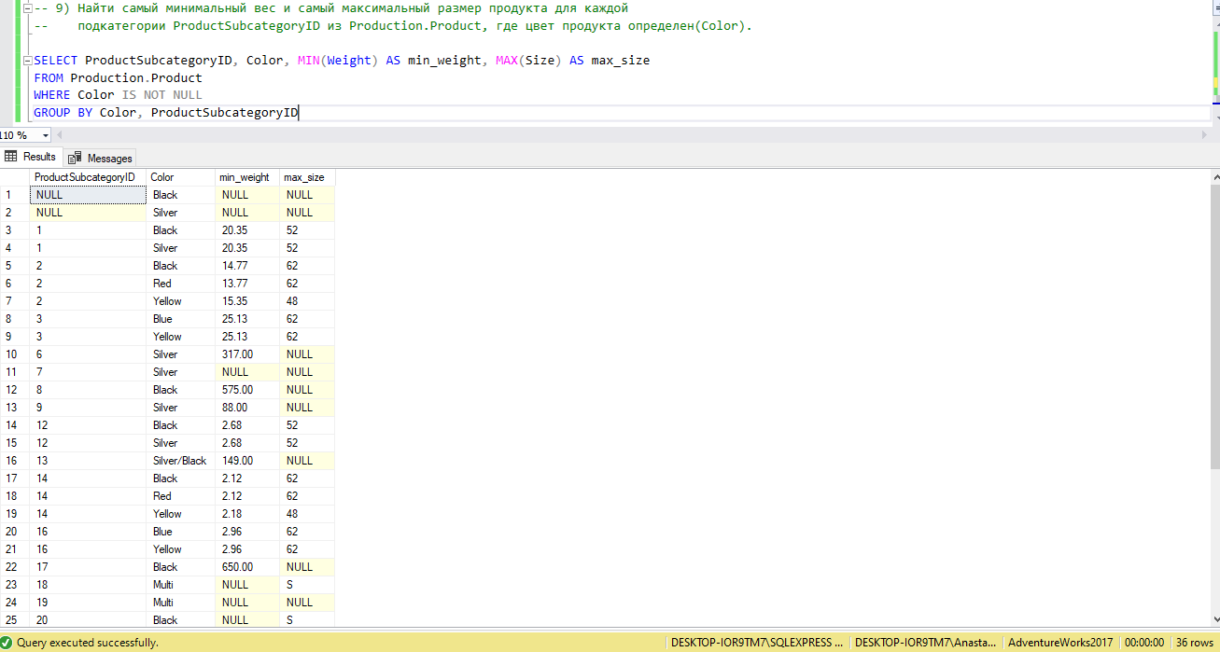

**Задние 3**

**Примеры агрегатных функций:**

[APPROX_COUNT_DISTINCT](https://docs.microsoft.com/ru-ru/sql/t-sql/functions/approx-count-distinct-transact-sql?view=sql-server-ver15), [CHECKSUM_AGG](https://docs.microsoft.com/ru-ru/sql/t-sql/functions/checksum-agg-transact-sql?view=sql-server-ver15), [COUNT_BIG](https://docs.microsoft.com/ru-ru/sql/t-sql/functions/count-big-transact-sql?view=sql-server-ver15), [GROUPING](https://docs.microsoft.com/ru-ru/sql/t-sql/functions/grouping-transact-sql?view=sql-server-ver15), [GROUPING_ID](https://docs.microsoft.com/ru-ru/sql/t-sql/functions/grouping-id-transact-sql?view=sql-server-ver15), [STDEV](https://docs.microsoft.com/ru-ru/sql/t-sql/functions/stdev-transact-sql?view=sql-server-ver15), [STDEVP](https://docs.microsoft.com/ru-ru/sql/t-sql/functions/stdevp-transact-sql?view=sql-server-ver15), [STRING_AGG](https://docs.microsoft.com/ru-ru/sql/t-sql/functions/string-agg-transact-sql?view=sql-server-ver15), [VAR](https://docs.microsoft.com/ru-ru/sql/t-sql/functions/var-transact-sql?view=sql-server-ver15), [VARP](https://docs.microsoft.com/ru-ru/sql/t-sql/functions/varp-transact-sql?view=sql-server-ver15)