1. Создайте вашу базу данных: таблицы, ограничения, ключи.

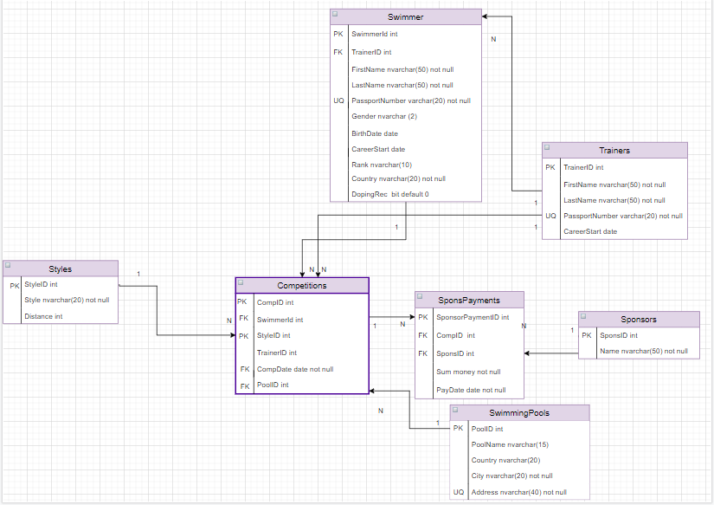

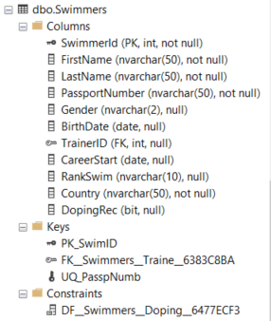CREATE TABLE Swimmers

(

SwimmerId INT IDENTITY(1,1)

, CONSTRAINT PK_SwimID PRIMARY KEY (SwimmerId),

FirstName NVARCHAR(50) NOT NULL,

LastName NVARCHAR(50) NOT NULL,

PassportNumber NVARCHAR(50) NOT NULL

, CONSTRAINT UQ_PasspNumb UNIQUE (PassportNumber),

Gender NVARCHAR(2),

BirthDate date,

TrainerID int FOREIGN KEY REFERENCES Trainers(TrainerID),

CareerStart date,

RankSwim NVARCHAR(10),

Country NVARCHAR(50) NOT NULL,

DopingRec bit DEFAULT '0'

);

SELECT*

FROM Swimmers

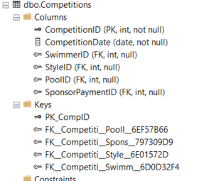CREATE TABLE Competitions

(

CompetitionID INT IDENTITY(1,1)

, CONSTRAINT PK_CompID PRIMARY KEY (CompetitionID),

CompetitionDate date NOT NULL,

SwimmerID int FOREIGN KEY REFERENCES Swimmers(SwimmerId)

);

ALTER TABLE Competitions

ADD

StyleID int FOREIGN KEY REFERENCES Styles(StyleId)

;

ALTER TABLE Competitions

ADD

PoolID int FOREIGN KEY REFERENCES SwimmingPools(PoolId)

;

ALTER TABLE Competitions

ADD

SponsorPaymentID int FOREIGN KEY REFERENCES SponsorPayments(SponsorPaymentID)

;

SElECT *

FROM Competitions

CREATE TABLE Styles

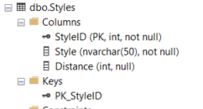(

StyleID INT IDENTITY(1,1)

, CONSTRAINT PK_StyleID PRIMARY KEY (StyleID),

Style NVARCHAR(50) NOT NULL,

Distance INT

);

SELECT *

FROM Styles

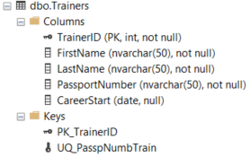CREATE TABLE Trainers

(

TrainerID INT IDENTITY(1,1)

, CONSTRAINT PK_TrainerID PRIMARY KEY (TrainerID),

FirstName NVARCHAR(50) NOT NULL,

LastName NVARCHAR(50) NOT NULL,

PassportNumber NVARCHAR(50) NOT NULL

, CONSTRAINT UQ_PasspNumbTrain UNIQUE (PassportNumber),

CareerStart date

);

SELECT *

FROM Trainers

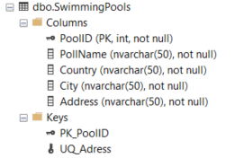CREATE TABLE SwimmingPools

(

PoolID INT IDENTITY(1,1)

, CONSTRAINT PK_PoolID PRIMARY KEY (PoolID),

PollName NVARCHAR(50) NOT NULL,

Country NVARCHAR(50) NOT NULL,

City NVARCHAR(50) NOT NULL,

Address NVARCHAR(50) NOT NULL

,CONSTRAINT UQ_Adress UNIQUE (Address)

);

SELECT *

FROM SwimmingPools

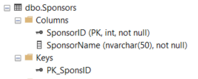CREATE TABLE Sponsors

(

SponsorID INT IDENTITY(1,1)

, CONSTRAINT PK_SponsID PRIMARY KEY (SponsorID),

SponsorName NVARCHAR(50) NOT NULL

);

SELECT *

FROM Sponsors

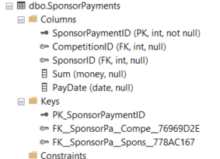 CREATE TABLE SponsorPayments

(

SponsorPaymentID INT IDENTITY(1,1)

, CONSTRAINT PK_SponsorPaymentID PRIMARY KEY (SponsorPaymentID),

CompetitionID int FOREIGN KEY REFERENCES Competitions(CompetitionID),

SponsorID int FOREIGN KEY REFERENCES Sponsors(SponsorID),

Sum money,

PayDate date

);

SELECT *

FROM SponsorPayments

1. Напишите скрипт для получения 1 млн человек с различными именами и фамилиями.

Создаем 2 таблицы с помощью сайта <https://mockaroo.com/> с именами и фамилиями по 1000 позиций каждая, применяем к ним CROSS JOIN, и получаем 1 млн сочетаний имен с фамилиями.

