1. Напишите скрипт для суммы OrderQty для каждого года и зимних месяцев из Production.WorkOrder в виде транспонированной матрицы:

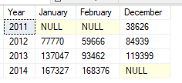

SELECT Year, [1] AS January , [2] AS February, [12] AS December

FROM

(SELECT OrderQty, MONTH (DueDate) AS Month, YEAR (DueDate) as Year

FROM [Production].[WorkOrder]

) AS SourceTable

PIVOT

(SUM (OrderQty)

FOR Month IN ([1],[2],[12])

) AS PivotTable

ORDER BY Year

