Домашняя работа №8

Архитектура MS SQL

Задания

1. Создайте вашу базу данных: таблицы, ограничения, ключи.

create database SWIMMING_Comp;

use SWIMMING_Comp

go

create table Styles

(StyleID int identity,

Style nvarchar(20) not null,

Distance int,

constraint PK_Styles_Comp primary key(StyleID))

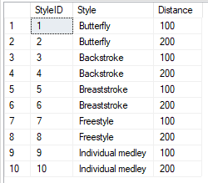

create table Trainer

(TrainerID int identity,

FirstName nvarchar(50) not null,

LastName nvarchar(50) not null,

PassportNumber varchar(20) unique not null check(len(PassportNumber)>=5),

Gender nchar (1) check (Gender like '[mf]'),

CareerStart date,

Rank nvarchar(10),

constraint PK_Trainer_Swimmer primary key(TrainerID))



create table Swimmer

(SwimmerID int identity,

TrainerID int,

FirstName nvarchar(50) not null,

LastName nvarchar(50) not null,

PassportNumber nvarchar(20) unique not null check(len(PassportNumber)>=5),

Gender nchar (1) check (Gender like '[mf]'),

BirthDate date check(year(getdate())-year(BirthDate) between 18 and 35),

CareerStart date,

Rank nvarchar(10),

Сountry nvarchar(20) not null,

DopingRec bit default 0,

constraint FK_Swimmer_Trainer foreign key(TrainerID)

references Trainer([TrainerID]),

constraint PK_Swimmer_Comp primary key (SwimmerID))



create table Sponsors

(SponsID int identity,

Name nvarchar(50) not null,

constraint PK_sponsors_paym primary key (SponsID))



create table SwimPools

(PoolID int identity,

Name nvarchar(15),

Сountry nvarchar(20),

City nvarchar(20) not null,

Address nvarchar(40) unique not null,

constraint PK_Pools_Comp Primary key(PoolID))



create table Disqualification

(DisqID int identity(101,101),

Term decimal(5,2) not null,

Reason nvarchar(40),

constraint PK_Disq_Comp primary key (DisqID))

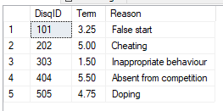

create table Competitions

(SwimmerId int,

CompID int identity,

StyleID int,

ResTime time,

DisqID int,

CompDate date not null,

PoolID int,

constraint PK_Comp primary key(CompID),

constraint FK_Comp_Swim foreign key(SwimmerId)

references [Swimmer]([SwimmerID]),

constraint FK_Comp_Style foreign key(StyleID)

references Styles([StyleID]),

constraint FK_Comp_Pools foreign key(PoolID)

references SwimPools(PoolID ),

constraint FK_Comp_Disq foreign key (DisqID)

references Disqualification(DisqID),

constraint CK_Comp_resORdisq CHECK((ResTime IS NULL AND DisqID IS NOT NULL)

OR (ResTime IS NOT NULL AND DisqID IS NULL)))



create table SponsPayments

(CompID int not null,

SponsID int not null,

Sum money not null,

PayDate date not null,

constraint FK_Paym_Comp foreign key(CompID)

references Competitions(CompID),

constraint FK_Paym_Spons foreign key(SponsID)

references Sponsors(SponsID))



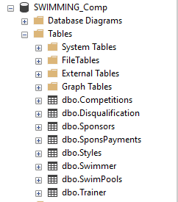

2. Придумала только SELF JOIN ((

select [dbo].[MOCK_names].[first_name],

m2.[last_name]

into MLNmocks

from [dbo].[MOCK_names], [dbo].[MOCK_names] m2