**Дана таблица людей People. Поля: ID, FirstName, ParentName, LastName, ID_Father, ID_Mother. Для всех Дмитриев выведите их ФИО и ФИО их отцов.**

SELECT *

FROM [dbo].[People]

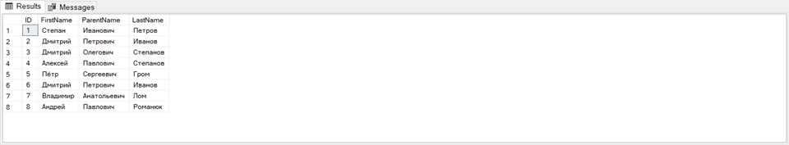

WITH People_CDE --(ID, FirstName, LastName, ParentName)

AS

(SELECT *

FROM People

WHERE FirstName=N'Дмитрий')

SELECT FirstName, CONCAT (ParentName, ' ', FirstName, ' ', LastName) as 'FoolName',

CONCAT (ParentName, ' ', LastName) as 'FoolNameDad'

FROM People_CDE

