--Задание 1

--a)

SELECT *

FROM Sales.SalesTerritory

Screenshot-1.1

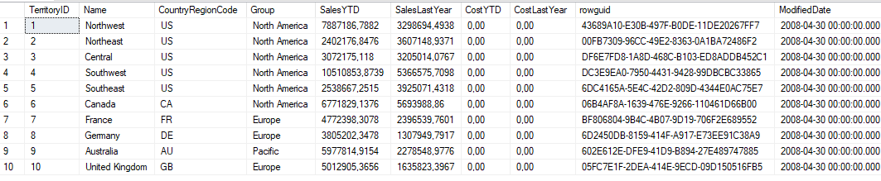

--b)

SELECT TerritoryID, Name

FROM Sales.SalesTerritory

Screenshot-1.2

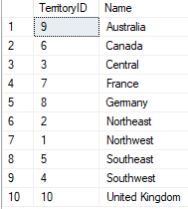

--c)

SELECT *

FROM Person.Person

WHERE LastName LIKE 'Norman'

Screenshot-1.3



--d)

SELECT *

FROM Person.Person

WHERE EmailPromotion != 2

Screenshot-1.4

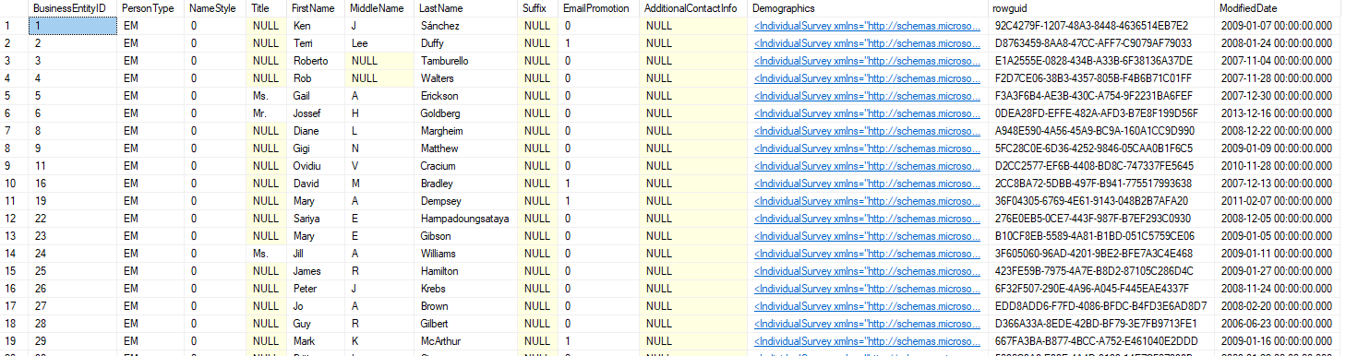

--Задание 3

APPROX_COUNT_DISTINCT

CHECKSUMM_AGG

COUNT_BIG

GROUPING

GROUPING_ID

STDEV

STDEVP

STRING_AGG

VAR

VARR

--Задание 4

--a)

SELECT COUNT (DISTINCT PersonType) AS UniquePersonTypes

FROM Person.Person

WHERE LastName LIKE 'M%'

OR EmailPromotion NOT LIKE 1

Screenshot-4.1



--b)

SELECT TOP 3 *

FROM Sales.SpecialOffer

WHERE StartDate BETWEEN '2013-01-01' AND '2014-01-01'

ORDER BY DiscountPct DESC

Screenshot-4.2



--c)

SELECT MIN(Weight) AS MinWeight, MAX(SIZE) as MaxSize

FROM Production.Product

Screenshot-4.3



--d)

SELECT MIN(Weight) AS MinWeight, MAX(SIZE) as MaxSize

FROM Production.Product

GROUP BY ProductSubcategoryID

Screenshot-4.4

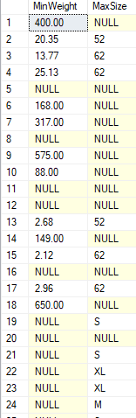

--e)

SELECT MIN(Weight) AS MinWeight, MAX(SIZE) AS MaxSize, ProductSubcategoryID

FROM Production.Product

WHERE Color IS NOT NULL

GROUP BY ProductSubcategoryID

Screenshot-4.5

