Задание №3

Все значения должны быть разными, не повторяться

Задание №4

а)

1.

SELECT UnitMeasureCode

FROM Production.UnitMeasure

WHERE UnitMeasureCode LIKE 'T%'



2.

SELECT DISTINCT COUNT (UnitMeasureCode) as cnt

FROM Production.UnitMeasure

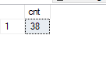

3.

INSERT INTO Production.UnitMeasure

VALUES ('TT1','Test 1','2020-09-09 00:00:00.000'),

('TT2','Test 2',GETDATE())

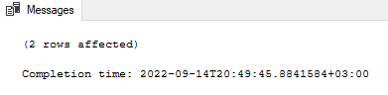

4.

SELECT UnitMeasureCode

FROM Production.UnitMeasure

WHERE UnitMeasureCode LIKE 'T%'

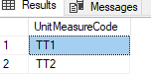

b)

1.

SELECT [UnitMeasureCode],[Name],[ModifiedDate]

INTO Production.UnitMeasureTest

FROM [Production].[UnitMeasure]

WHERE UnitMeasureCode LIKE 'T%'

OR UnitMeasureCode LIKE 'CAN'

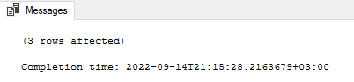

2.

SELECT [UnitMeasureCode],[Name],[ModifiedDate]

INTO Production.UnitMeasureTest

FROM [Production].[UnitMeasure]

WHERE UnitMeasureCode LIKE 'T%'

OR UnitMeasureCode LIKE 'CAN'

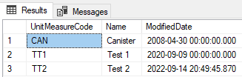

c)

UPDATE Production.UnitMeasureTest

SET UnitMeasureCode = 'TTT'

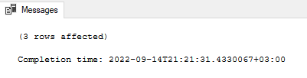

Result

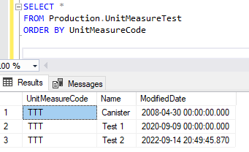

d)

DELETE Production.UnitMeasureTest

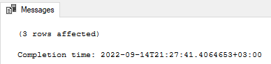

Result

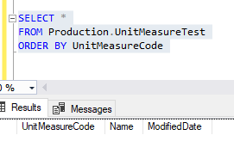

e)

SELECT *,AVG(OrderQty) OVER (PARTITION BY LineTotal) AS "Avg"

,MIN(OrderQty) OVER (PARTITION BY LineTotal) AS "Min"

,MAX(OrderQty) OVER (PARTITION BY LineTotal) AS "Max"

FROM Sales.SalesOrderDetail

WHERE SalesOrderID IN (43659,43664)

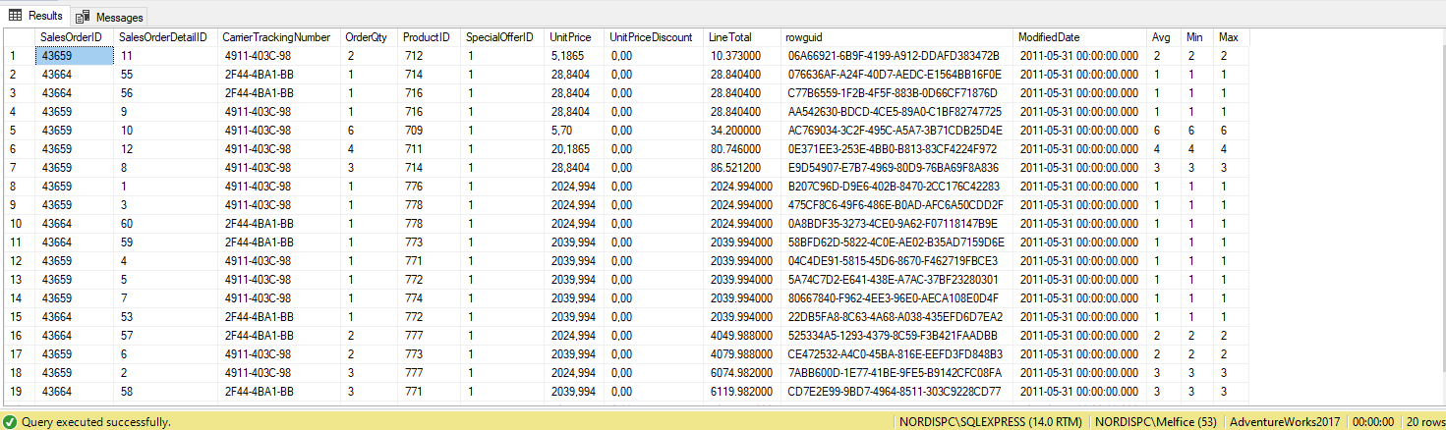

g)

SELECT DATEADD(DAY,1, EOMONTH(GETDATE(),-1)) as DayOneOfMonth,

DATENAME(WEEKDAY, DATEADD(DAY,1, EOMONTH(GETDATE(),-1))) as Day_of_the_week,

CASE

WHEN DATENAME(WEEKDAY, DATEADD(DAY,1, EOMONTH(GETDATE(),-1))) = 'Saturday'

THEN CONCAT(DATEPART(DAY,DATEADD(DAY,3, EOMONTH(GETDATE(),-1))),' ',DATENAME(WEEKDAY, DATEADD(DAY,3, EOMONTH(GETDATE(),-1))),' ',DATEPART(YEAR,EOMONTH(GETDATE(),-1)))

WHEN DATENAME(WEEKDAY, DATEADD(DAY,1, EOMONTH(GETDATE()))) = 'Sunday'

THEN CONCAT(DATEPART(DAY,DATEADD(DAY,2, EOMONTH(GETDATE(),-1))),' ',DATENAME(WEEKDAY, DATEADD(DAY,2, EOMONTH(GETDATE(),-1))),' ',DATEPART(YEAR,EOMONTH(GETDATE(),-1)))

ELSE CONCAT(DATEPART(DAY,DATEADD(DAY,1, EOMONTH(GETDATE(),-1))),' ',DATENAME(WEEKDAY, DATEADD(DAY,1, EOMONTH(GETDATE(),-1))),' ',DATEPART(YEAR,EOMONTH(GETDATE(),-1)))

END AS First_bloody_day

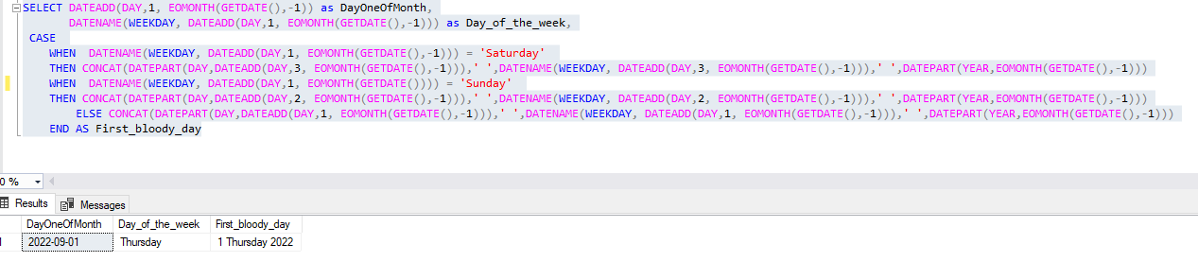

Задание №5

count(1) = 4

count(name) = 2

count(id) = 4

count(*) = 4